Network Topologies

Topologies

Logical Topologies

A logical topology describes how the hosts access the medium and communicate on the network. The two most common types of logical topologies are broadcast and token passing. In a broadcast topology, a host broadcasts a message to all hosts on the same network segment. There is no order that hosts must follow to transmit data. Messages are sent on a First In, First Out (FIFO) basis.

Token passing controls network access by passing an electronic token sequentially to each host. If a host wants to transmit data, the host adds the data and a destination address to the token, which is a specially-formatted frame. The token then travels to another host with the destination address. The destination host takes the data out of the frame. If a host has no data to send, the token is passed to another host.

Physical Topologies

A physical topology defines the way in which computers, printers, and other devices are connected to a network. The figure provides six physical topologies.

Bus

In a bus topology, each computer connects to a common cable. The cable connects one computer to the next, like a bus line going through a city. The cable has a small cap installed at the end called a terminator. The terminator prevents signals from bouncing back and causing network errors.
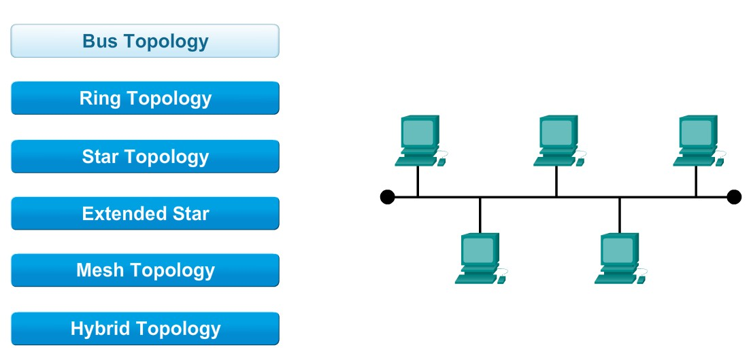

Ring

In a ring topology, hosts are connected in a physical ring or circle. Because the ring topology has no beginning or end, the cable is not terminated. A token travels around the ring stopping at each host. If a host wants to transmit data, the
host adds the data and the destination address to the token. The token continues around the ring until it stops at the host with the destination address. The destination host takes the data out of the token.
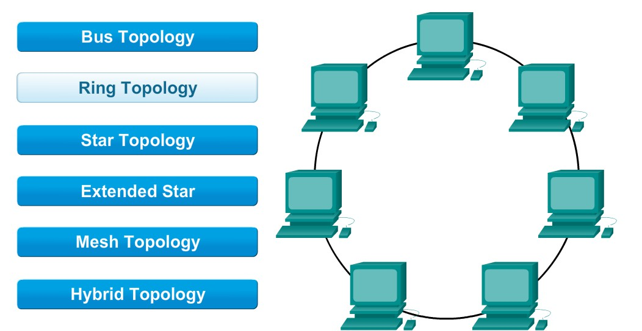

Star

The star topology has a central connection point, which is normally a device such as a hub, switch, or router. Each host on a network has a cable segment that attaches the host directly to the central connection point. The advantage of a star topology is that it is easy to troubleshoot. Each host is connected to the central device with its own wire. If there is a problem with that cable, only that host is affected. The rest of the network remains operational.
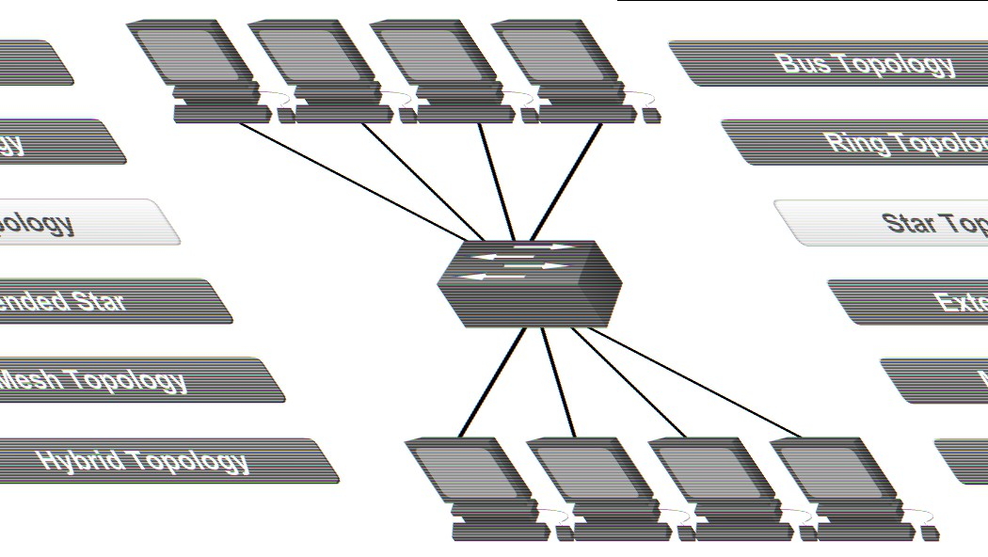

Hierarchical
A hierarchical or extended star topology is a star network with an additional networking device connected to the main networking device. Typically, a network cable connects to one switch, and then several other switches connect to the first switch. Larger networks, such as those of corporations or universities, use the hierarchical star topology.
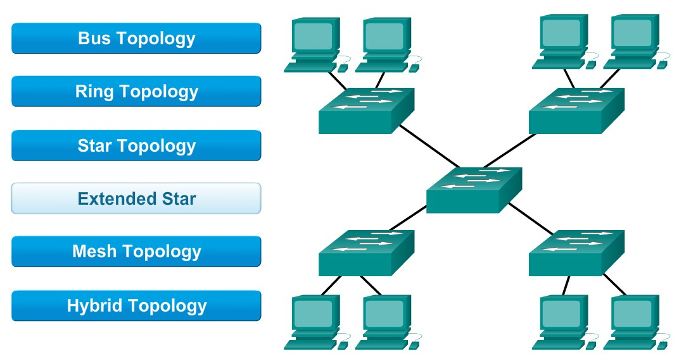

Mesh

The mesh topology connects all devices to each other. When every device is connected to every other device, a failure of any cable or device along a connection does not affect the network. The mesh topology is used in WANs that interconnect LANs.
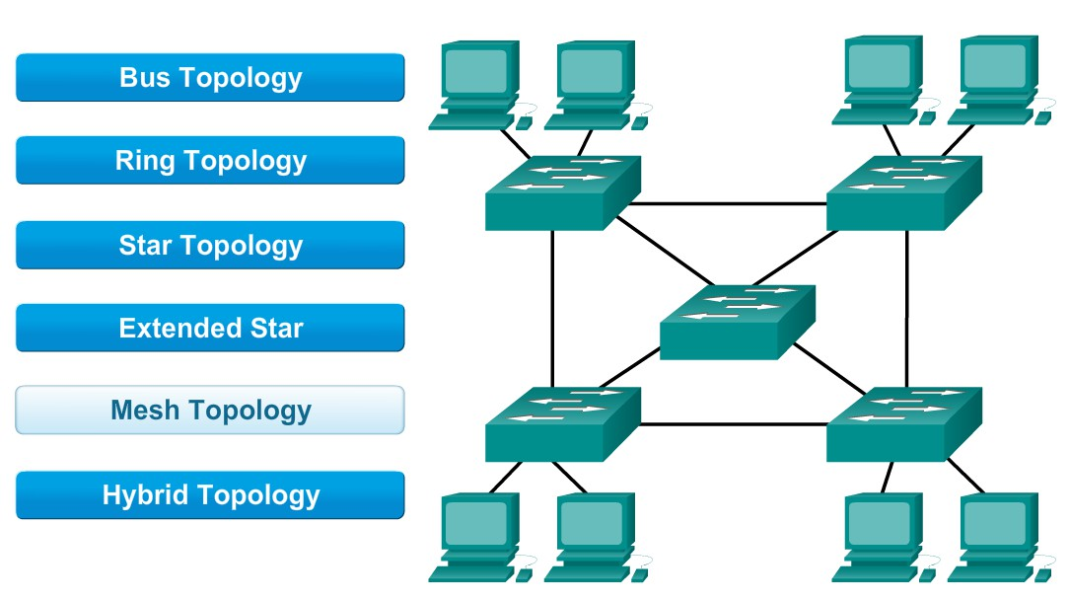
Hybrid

A hybrid topology is a combination of two or more basic network topologies, such as a star-bus, or star-ring topology. The advantage of a hybrid topology is that it can be implemented for a number of different network environments.

The type of topology determines the capabilities of the network, such as ease of setup, speed, and cable lengths. LAN
architecture describes both the physical and logical topologies used in a network.
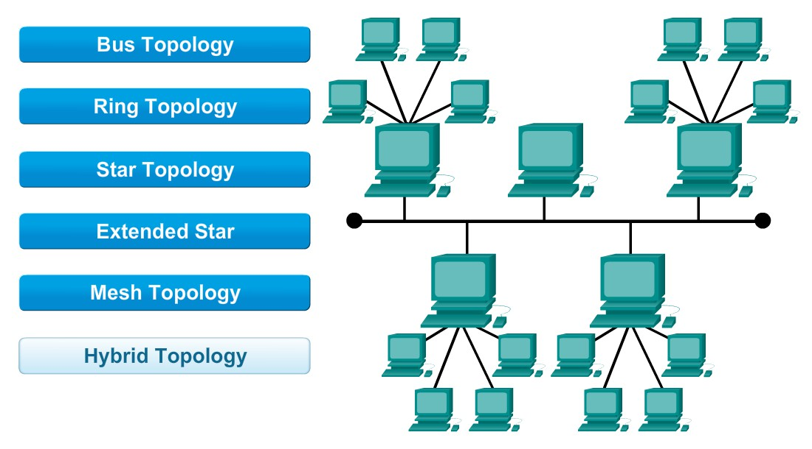

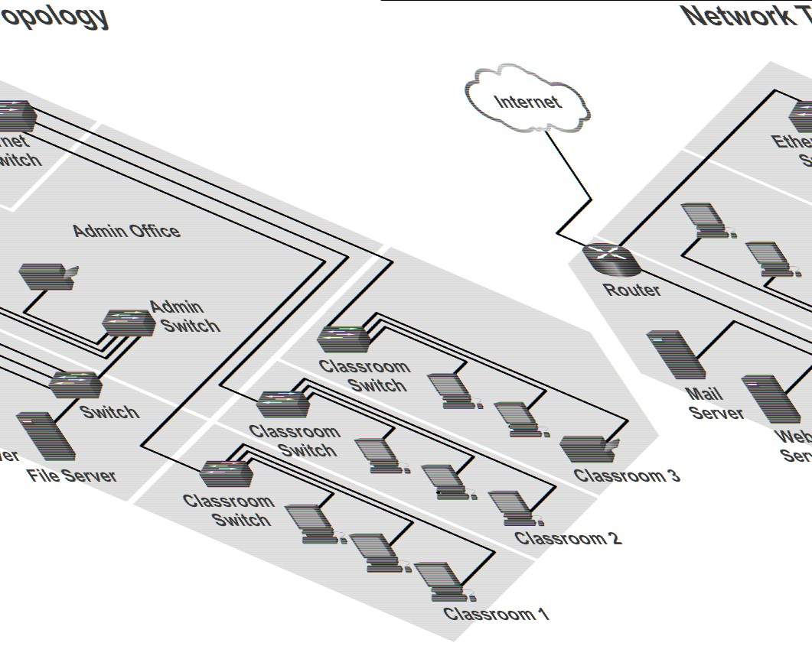Topologies

Understanding the needs of the customer and determining the general layout of the new network are required to properly determine the network topology. These network decisions need to be discussed with the customer:

• Cable and wireless standards

• Expandability

• Number and location of users

The number of users and the estimated amount of future growth determines the initial physical and logical topology of the network. An inspection, called a site survey, should be done early in the project. A site survey is a physical
inspection of the building that helps determine a basic physical topology. Create a checklist to record the needs of your customer to determine the physical topology:

• Location of users’ computers

• Position of network equipment, such as switches and routers

• Position of the servers

A floor plan or blueprint is helpful to determine the physical layout of equipment and cables. The physical layout is often based on available space, power, security, and air conditioning. The figure shows a typical network topology. If a floor plan or blueprint is not available, make a drawing of where the network devices will be located, including the location of the server room, printers, end stations, and cable runs. This drawing can be used for discussions when the customer makes the final layout decisions.

