Employee Data Dashboard Report

Gender Distribution
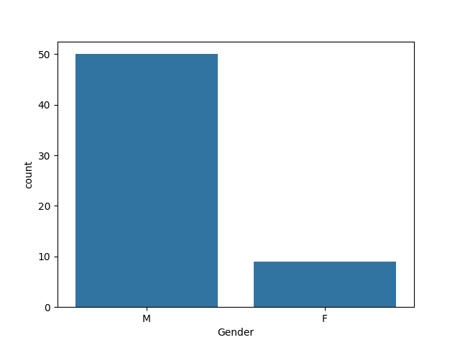

Department Distribution
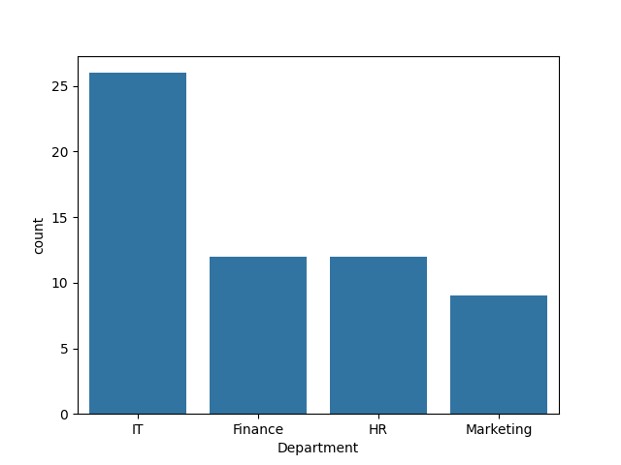

Age Distribution
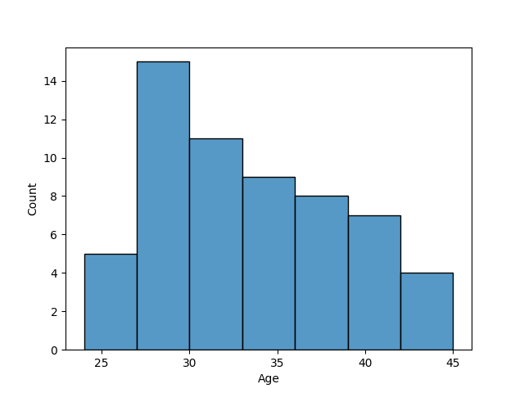

Salary vs Experience
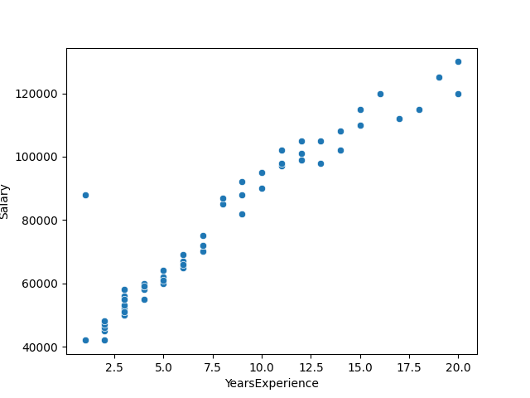

Key Insights
Most employees are male and IT department has highest count.
Majority employees fall in mid age group.
Salary increases with experience with some variation.

