KWOC-Project report

*December 27, 2016*

**KWOC PROCEEDINGS**

CHOOSING A PROJECT

I had enrolled into KWoC and it now it was time to choose the projects in which we want to work. It was very confusing as which project to work on as there were many projects trying to find out a project which suited me better.

I choose [morse-talk](https://github.com/morse-talk/morse-talk) as my project that I want to work on. My mentor for this project was Himanshu Misra(github handle @**[OrkoHunter](https://github.com/OrkoHunter)).**Along with him another person  who mentored me during the entire project was Sir Sebastian Celles(github handle @[**scls19fr**](https://github.com/scls19fr)**).**

COMMITTING ON GITHUB

The project consisted of functions to decode and encode functions and some other features. I thought of developing a graphical user interface(GUI) to decode and encode in morsecode .I started developing the project.I made a GUI and made my first Pull Request(PR) to  [morse-talk](https://github.com/morse-talk/morse-talk) My first GUI looked like this.

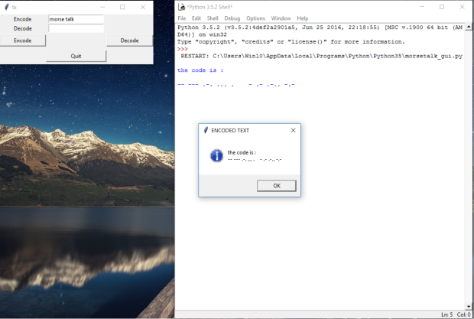

My first GUI was not so great and also my code didn’t followed PEP8 norms nor it was put in the right directoty of the project file.It had a lot of mistakes. I wanted my PR to be merged so I worked on it.My mentor,Himanshu Misra, suggested me with an idea for the design of the GUI.He told me get rid of buttons and messageboxes. He told that it will be very good if the GUI dynamically shows the output when the user inputs in the entry fields. I started building a GUI from scratch keeping this thing in mind.I was successful in making it.My second generation GUI looked like this.

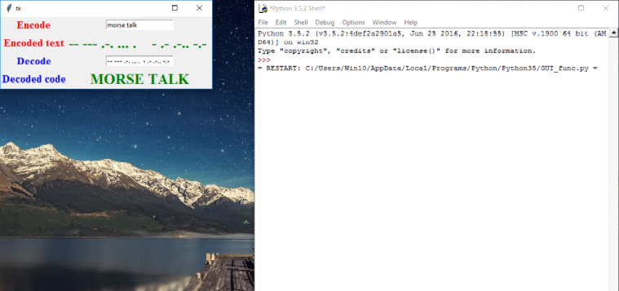

The GUI dynamically printed the output as per text inputted in the entry fields. Now the GUI was almost ready. But the program had a lot of bugs which could further cause problems. I had little knowledge about Github and programming ethics. My mentors told me that my program should follow PEP8 norms.I found about PEP8 on net and made changes to my program. My mentor told me to close this PR as there was a lot of commits in this PR and the project has undergone a lot of changes. So I closed my first PR and created another.

Himanshu Misra gave me another suggestion that the output shown were disabled to be copied by the user. So I decided to use text boxes to print the output. Now the user could copy the text and use it anywhere else as per requirement. My third generation GUI looked like this.

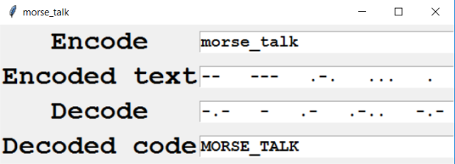

My mentors told that since I was adding an entirely new function to the library so I had to change the *setup.py* of the project.

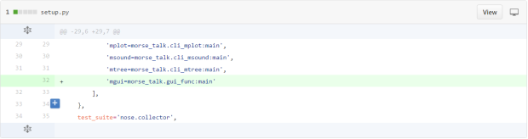

I was also told to change the *README.md* file as I had added a new feature to the project and it is to be highlighted.

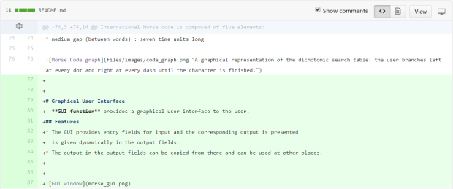

But one problem always persisted that my TRAVIS CI was not building successfully. My mentors provided a lot of help in solving this problem and afterwards a successful built was created.

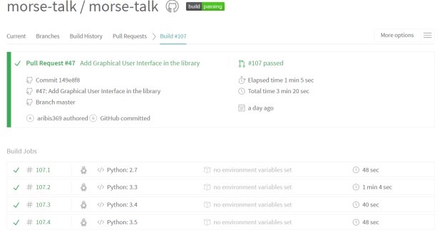

Finally my PR was merged to the main project.

u

I had to do a total of 30 commits(including major and minor commits ,but was later squashed into a single commit) changing 4 files. I had a lot of conversation with my mentors on the Github platform and also via e-mail. They supported me and taught me lot during this project. It was a great learning experience.

Report by:

Arindam Biswas (github handle @aribis369)