**CLOUD COMPUTING**

**LAB NO. 3**



**SUBMITTED TO:**

Engr. Shohaib

**SUBMITTED BY:**

**Name:** Amina Noor

**Reg No.** 2023-BSE-007

**Semester:** V-A

**CLOUD COMPUTING**

**LAB NO. 3**

**Task List:**

**Prerequisites**

**Step 1)** Check an SSH key

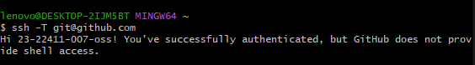

**Step 2)** Create the repo on GitHub

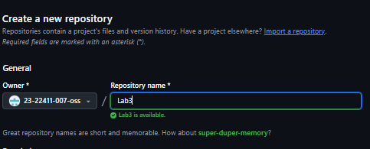

**Step 3)** Clone the repo locally

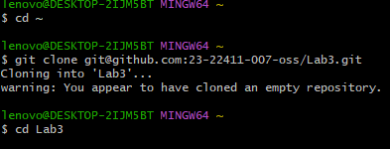

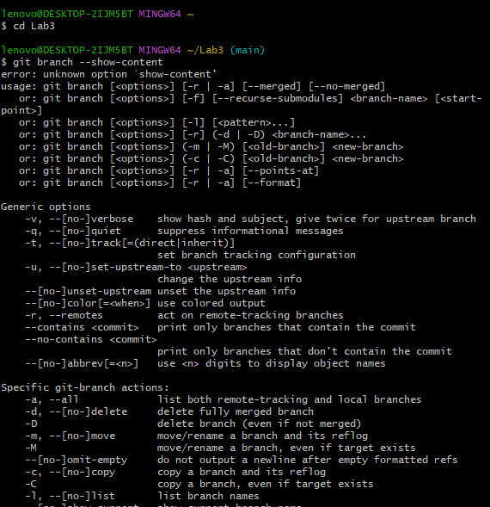

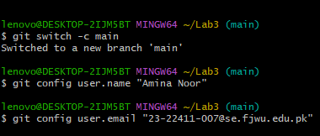

**Task 1 – Handling Local and Remote Commit Conflicts (Pull vs Pull --rebase)**

**Step A** — Prepare initial README

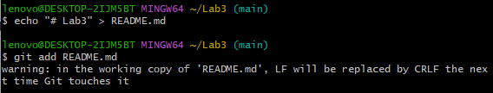

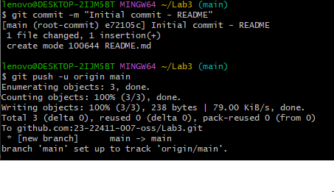

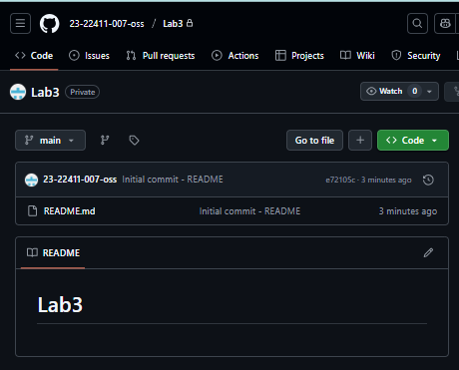

**Step B** **— Make a remote edit**

On GitHub, open README.md. Click the pencil. Add a line exactly.

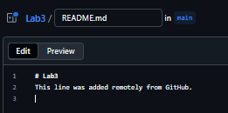

Click on commit changes, the following dialogue box will appear.

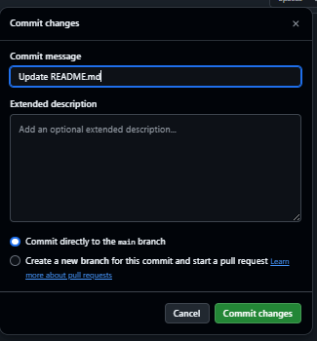

Again click on commit changes, to save the changes made in README.md.

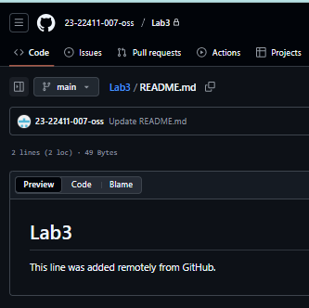

**Step C** — Make a local edit and commit it

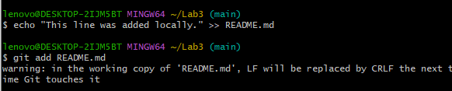

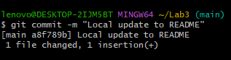

**Step D** — Attempt to push and capture the rejection

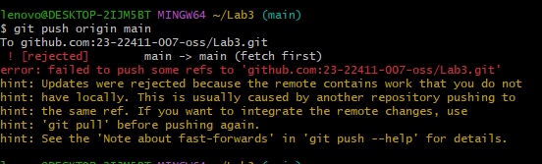

Step E — Pull and merge

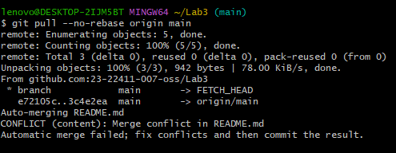

There’s a merge conflict, Git will print conflict messages. Resolve conflicts manually.

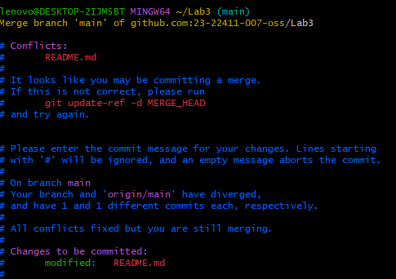

Step F — Push after merge

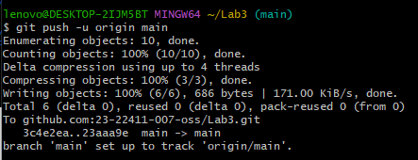

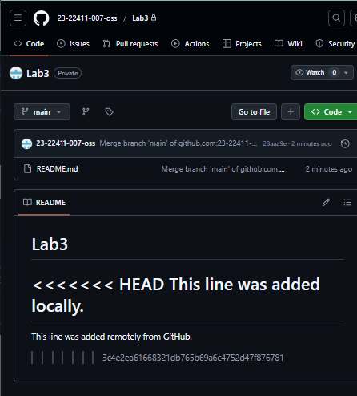

**Repeat but fix using rebase**

Step G — Make another remote edit

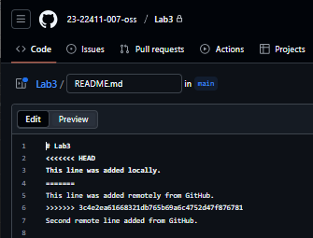

Step H — Make another local change and commit

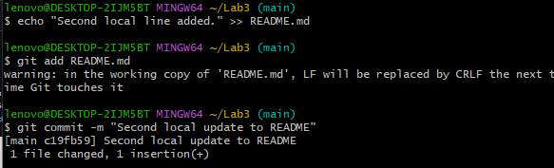

Step I — Pull with rebase

Merge conflict arise:

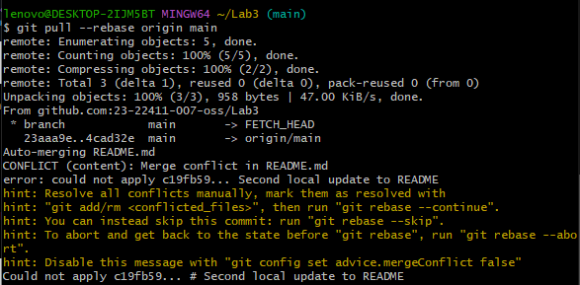

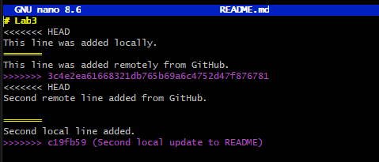

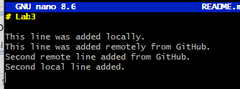

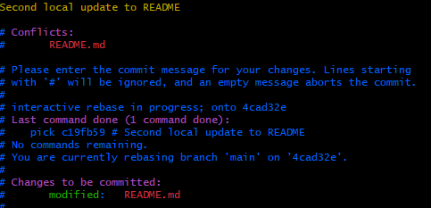

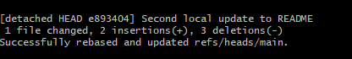

Step J — Push after rebase

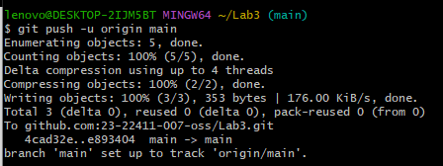

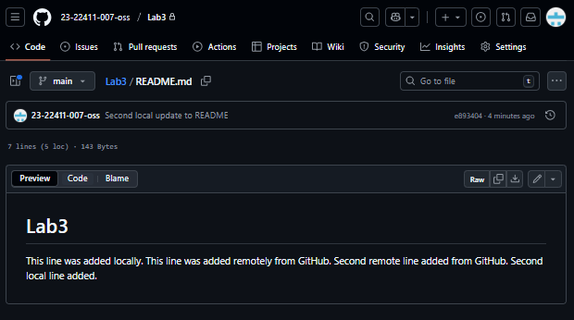

**Task 2 – Creating and Resolving Merge Conflicts Manually**

Step A — Make a **remote conflicting change** on GitHub

* Open README.md on your GitHub Lab3 repo. Find the line you edited before (e.g., This line was added remotely from GitHub.). Change it to something else.

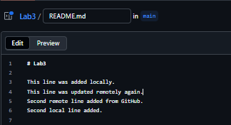

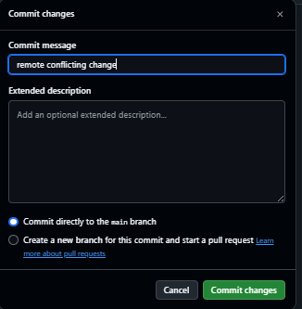

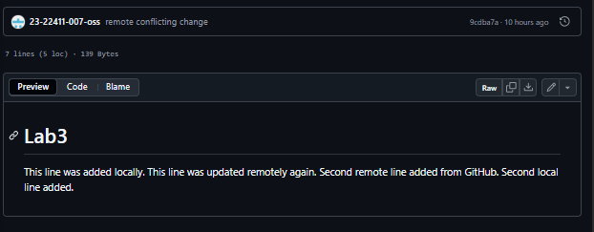

Step B — Make a **local conflicting change**

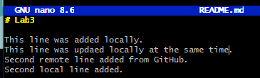

Step C — Stage and commit the local change

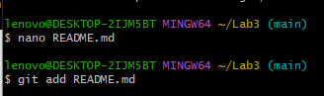

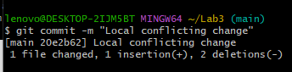

Step D — Try to push local commit

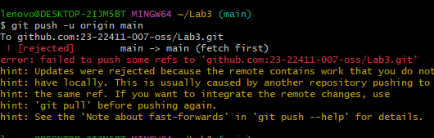

Step E — Pull with rebase to bring in remote changes

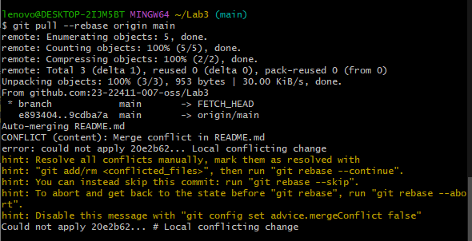

Step F — Resolve the conflict manually

With conflict:

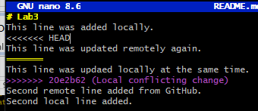

After resolving conflict:

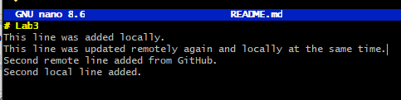

As shown below, merge completed.

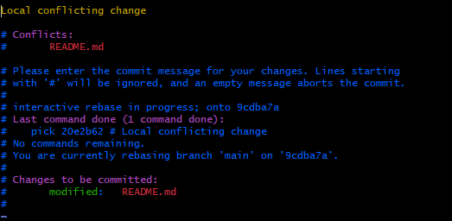

Step G — Mark the conflict as resolved and continue rebase

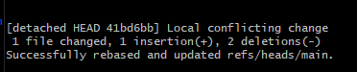

Step H — Push your resolved changes

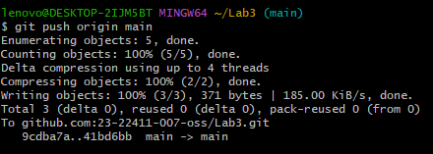

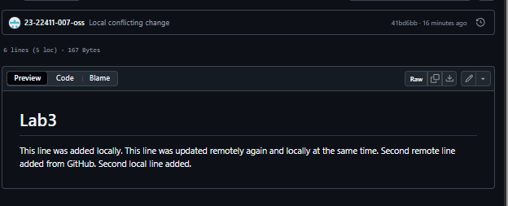

**Task 3 – Managing Ignored Files with .gitignore and Removing Tracked Files**

### Step A — Create a folder and files

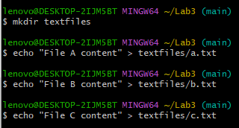

Step B — Add and commit the new directory

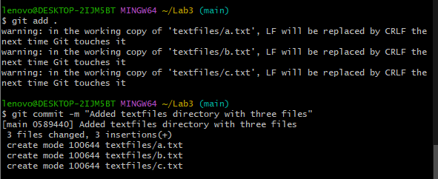

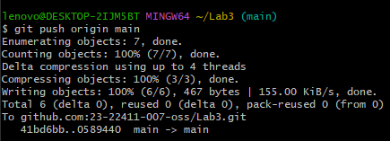

Step C — Create a .gitignore file



Step D — Add and commit .gitignore

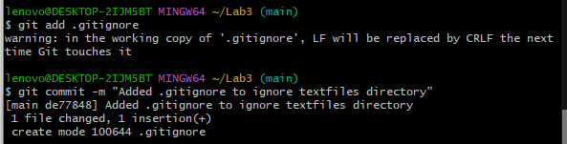

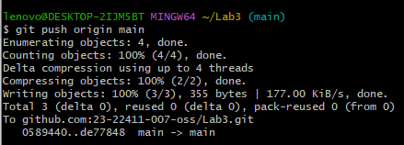

Step E — Check GitHub

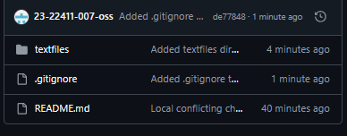

Step F — Remove tracked files (but keep them locally)

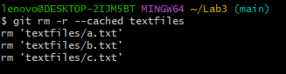

Step G — Commit and push the removal

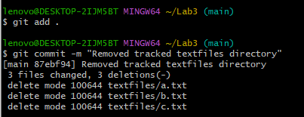

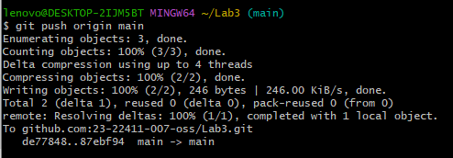

Step H — Verify on GitHub

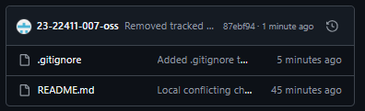

**Task 4 – Create Temporary Changes and Use git stash**

Step A — Create a feature branch



Step B — Make an initial change and commit

1. Open a file, for example README.md, and add a few test lines:

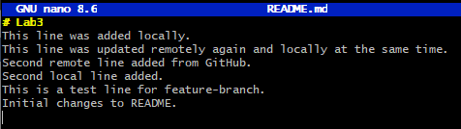

1. Stage and commit the changes:

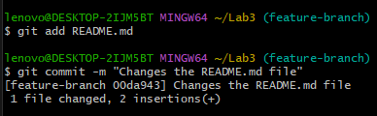

Step C — Make additional changes **without committing**

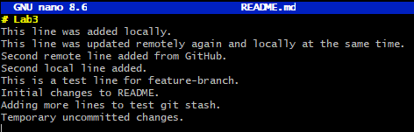

Step D — Try to switch back to main branch

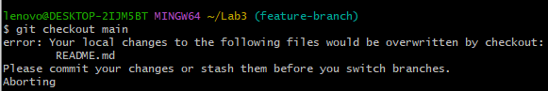

Step E — Stash your changes

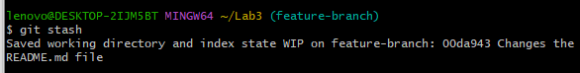

Step F — Switch back to main branch

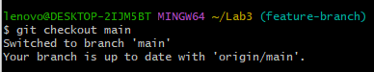

Step G — Switch back to feature branch



Step H — Check working directory status

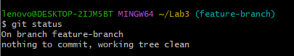

Step I — Restore your stashed changes

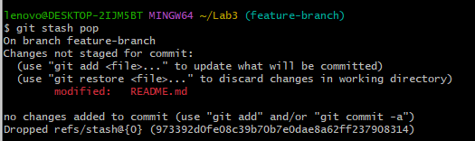

**Task 5 – Checkout a Specific Commit Using git log**

Step A — View commit history

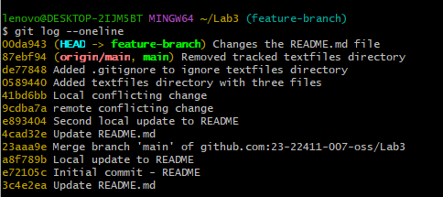

Step B — Copy a previous commit hash

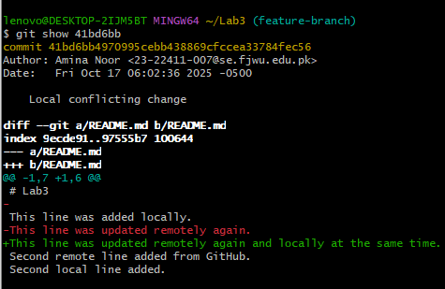

Step C — Checkout that commit

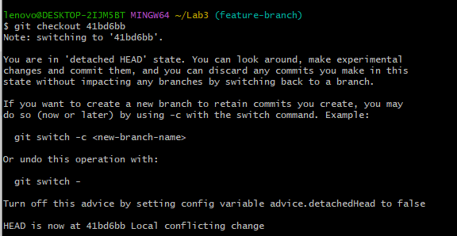

Step D — Return to the main branch

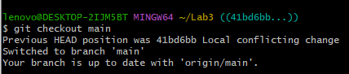

**Task 6 – Resetting Commits (Soft vs Hard Reset) (With Verification Steps)**

Step A — Add a new line and commit it

1. Edit any file (e.g., README.md) and add a new line:

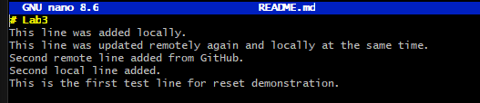

1. Stage and commit:

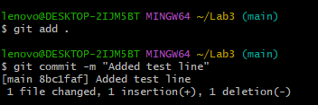

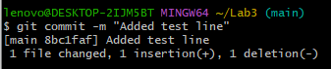

Step B — Add another change and commit again

1. Edit the file again, add another line:

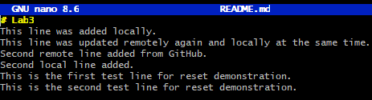

1. Stage and commit:



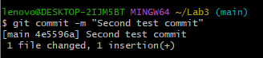

Step C — View commit history before reset

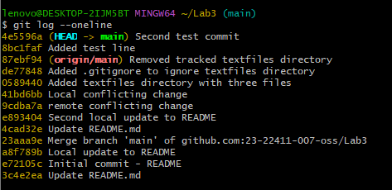

Step D — Verify file contents before reset

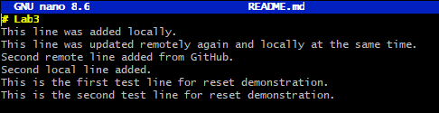

Step E — Perform a soft reset



Step F — Check commit history after soft reset

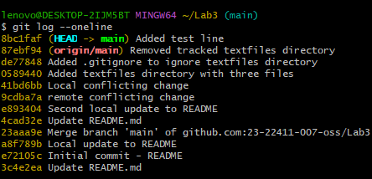

Step G — Verify changes in file after soft reset

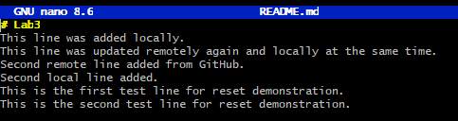

Step H — Check git status

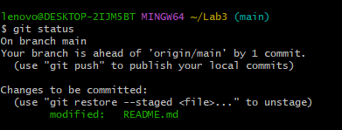

Step I — Recommit the second change

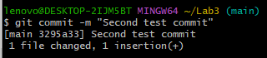

Step J — Perform a hard reset

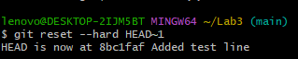

Step K — Check commit history after hard reset

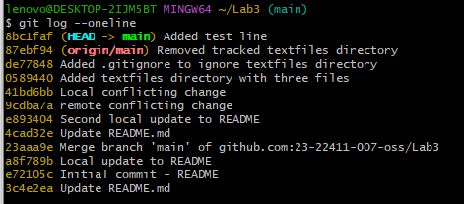

Step L — Verify file contents after hard reset

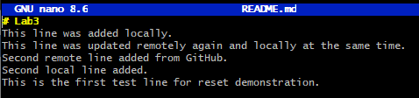

Step M — Check git status

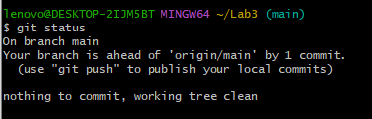

**Task 7: Amending the Last Commit**

Step A — Make a small change and commit

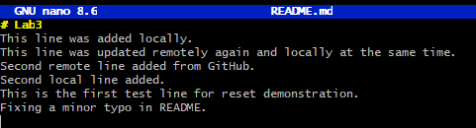

Step B: Stage and commit it:

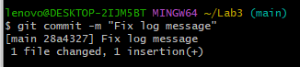

Step C — Make another change to amend

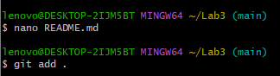

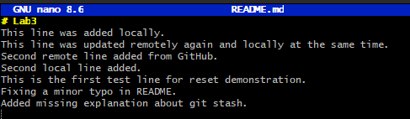

Step D— Amend the last commit

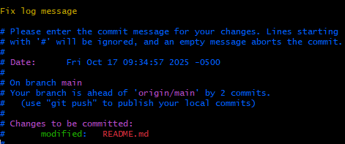

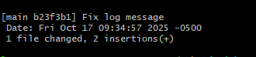

**Task 8 – Reverting a Commit (Safe Undo on Remote Branch)**

**Step A — Make a change and commit it**.

1. Add a temporary file:



1. Stage and commit:

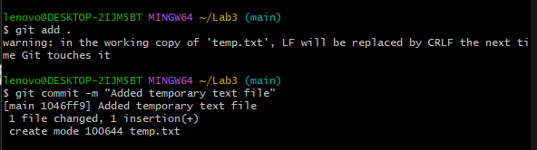

1. Push to GitHub:

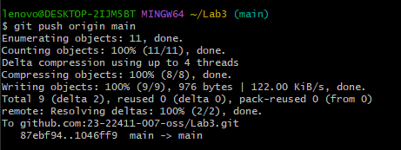

### Step B — Identify the commit to revert

1. View recent commits:

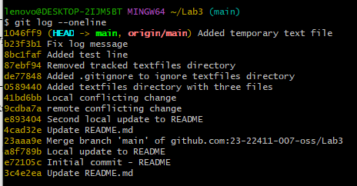

### Step C — Revert the commit

1. Run revert:

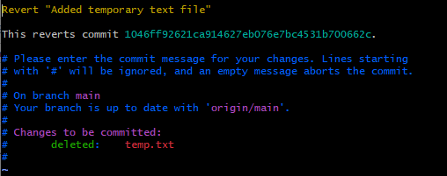

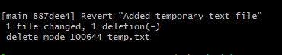

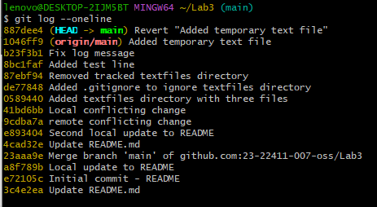

**Step D — Push the revert commit**

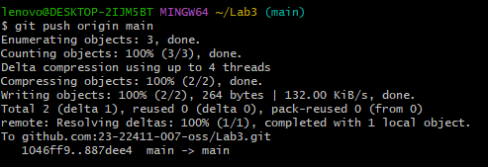

**Task 9 – Force Push (With Caution)**

Step A — Create a new branch



Step B — Make and commit a small change

1. Edit a file (e.g., README.md) and add:

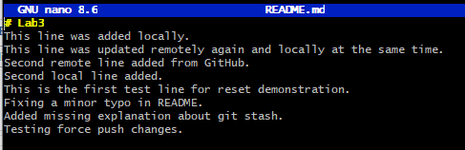

1. Stage and commit:





Step C — Push the new branch

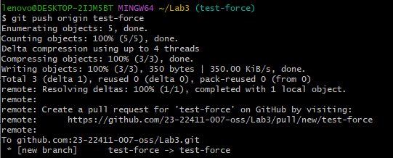

Step D — Perform a hard reset

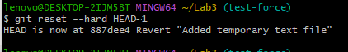

Step E — Try to push normally

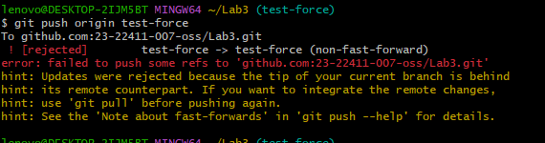

Step F — Force push (overwrites remote history)

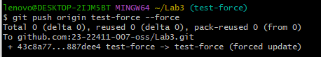

**Task 10 – Running Gitea in GitHub Codespaces via Docker Compose**

Step A — Fork the Gitea Repository  
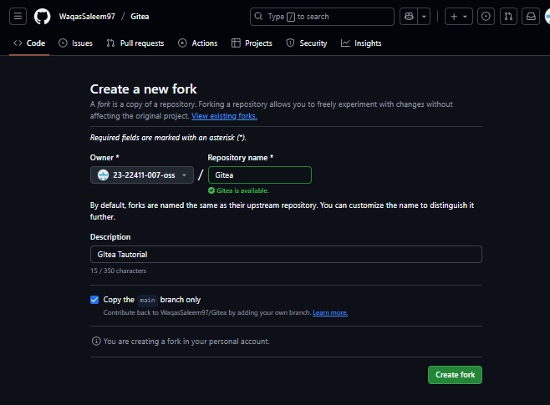

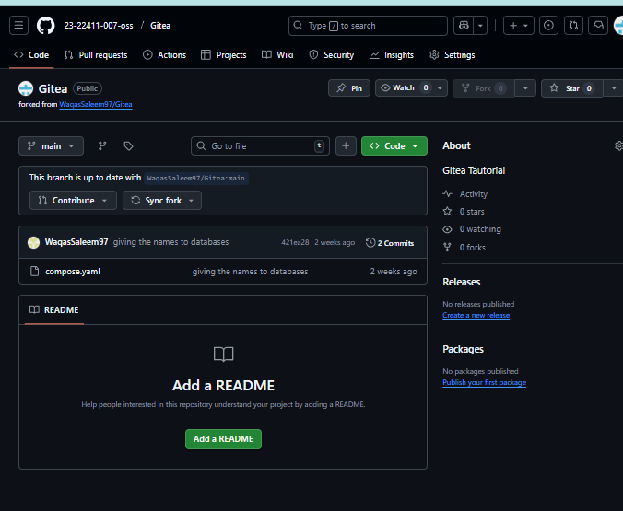

Step B — Open Forked Repo in Codespaces

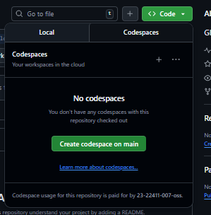

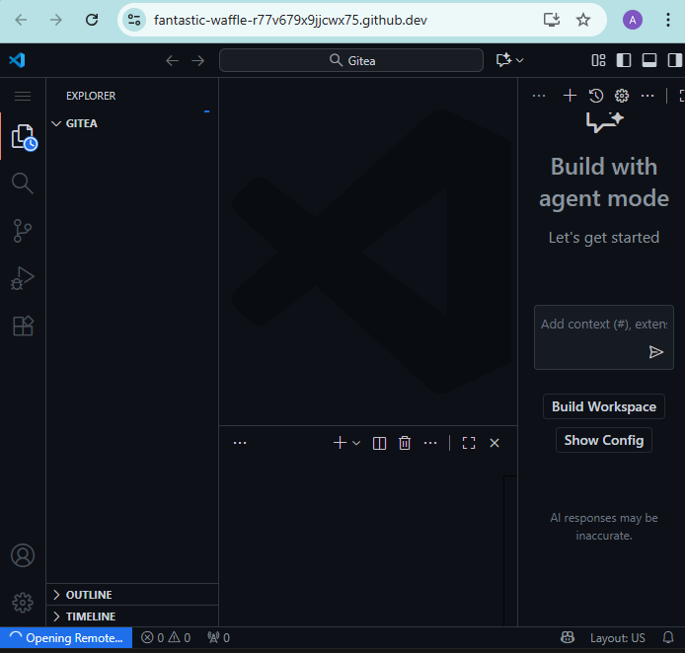

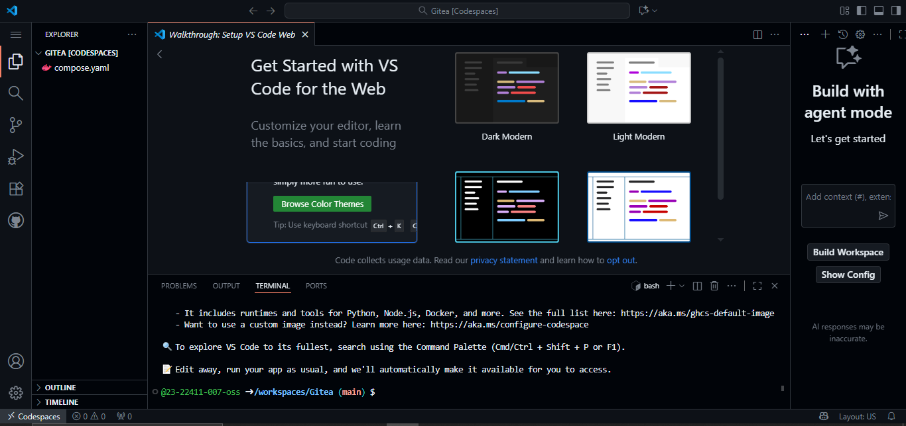

Step C — Start Gitea with Docker Compose

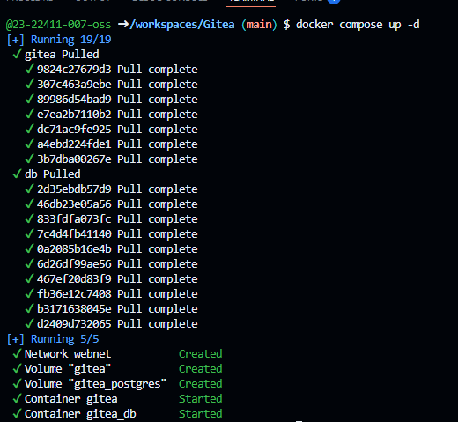

Step D — Access Gitea Web Interface

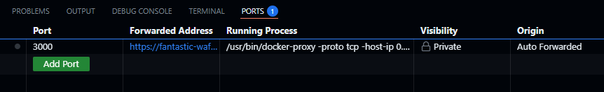

Step F — Log In to Gitea

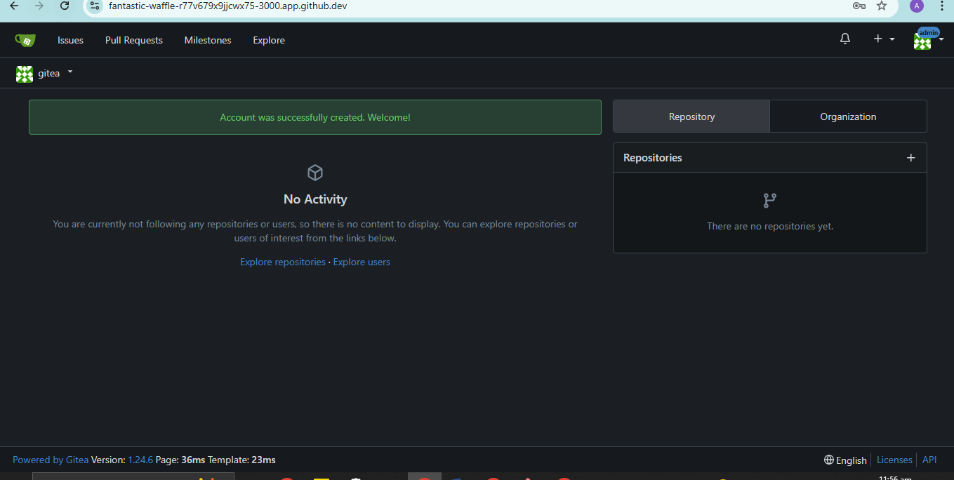

Step G — Create a New Repository in Gitea

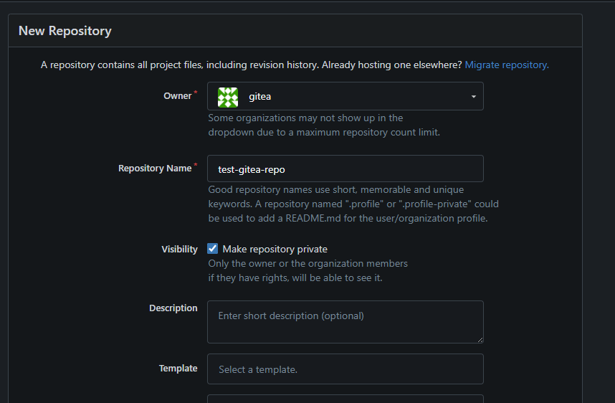

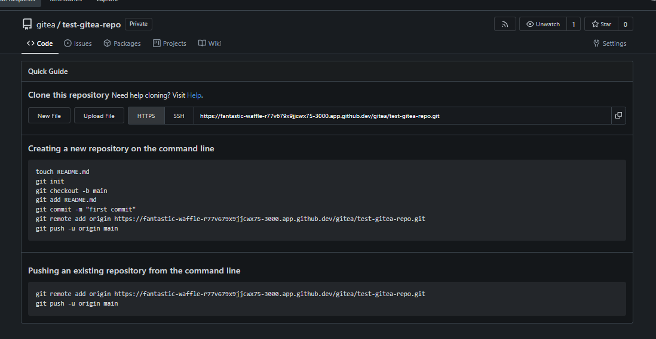

**Task 11 — Creating a GitHub Pages Portfolio Site**

Step A — Create GitHub Pages Repository

1. Go to GitHub → click **New Repository**.
2. Name it.

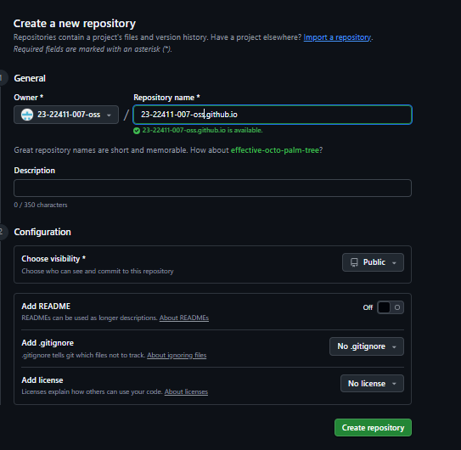

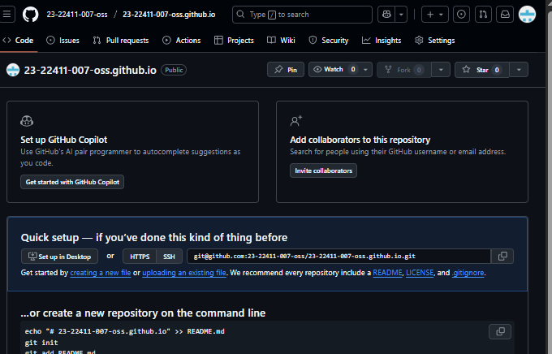

Step B — Add Static Website Code

## Create a project folder

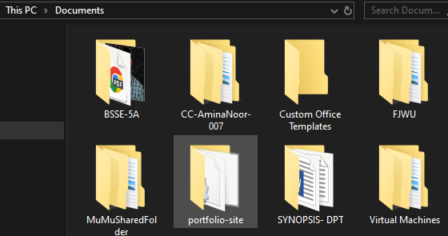

1. Create the HTML file (index.html)

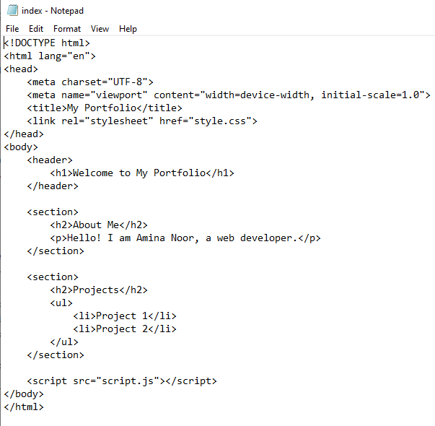

1. Create the CSS file (style.css)

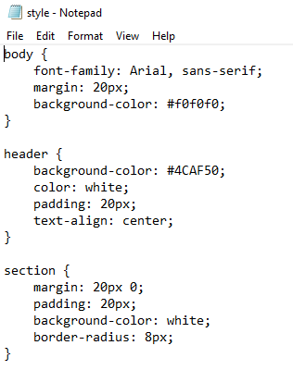

1. Create the JavaScript file (script.js)

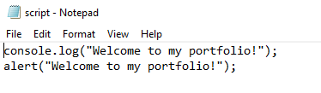

All the files are shown below,

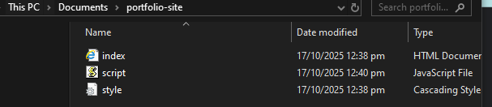

Step C — Push the Files to GitHub

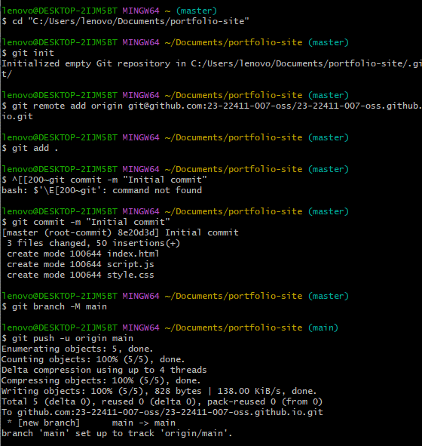

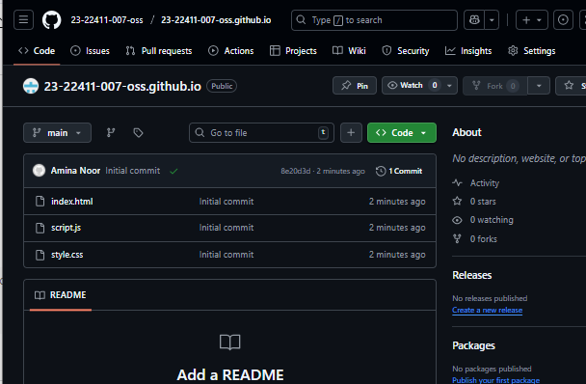

Step D — Check GitHub Pages Settings

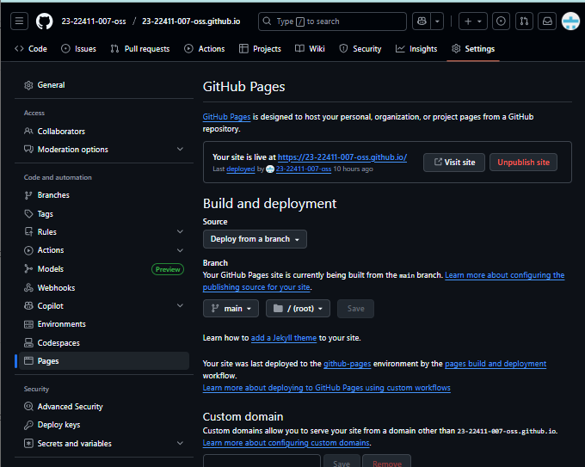

Step E — Visit Your Live Site



