CLOUD COMPUTING

LAB NO# 04



SUBMITTED TO:
Sir Shohaib

SUBMITTED BY:
Name: Amina Noor
Reg No. 2023-BSE-007
Semester: V-A
CLOUD COMPUTING
LAB NO# 04

Task No # 01: Verify VM Resources in VMware

To verify VM Resources, follow the steps given below:
- Open VMware Workstation on our Windows PC.
- In the left panel, click on our VM Ubuntu Server.
- Click Edit virtual machine settings.
- Check these values:
  - Memory (RAM)
  - Processors (CPUs)
  - Hard Disk
  - Network Adapter
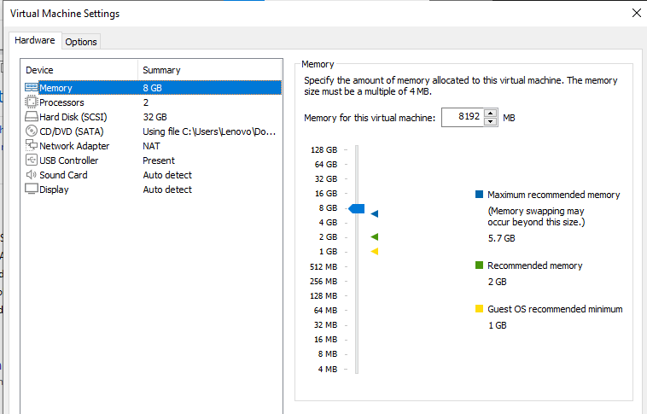

Task No # 02: Start VM and Login Using SSH

To start VM and Login using SSH, follow the steps given below:

2.1. Start the VM
- In VMware → select our VM → click Power On.
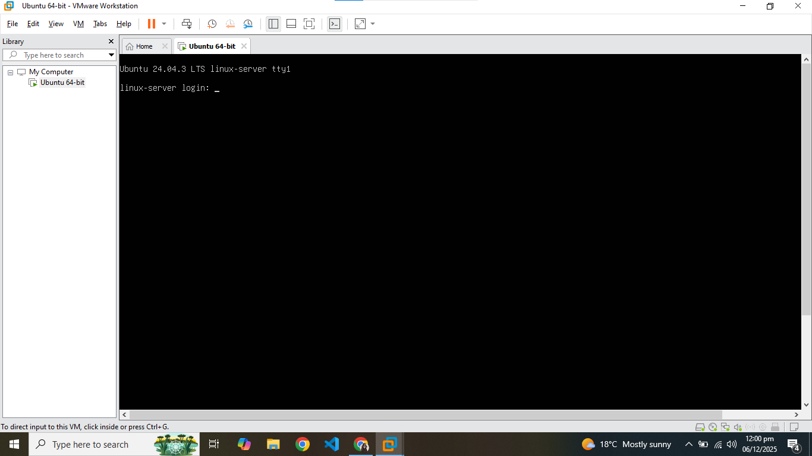

2.2. Find VM’s IP address
- Inside VM console:
ip a
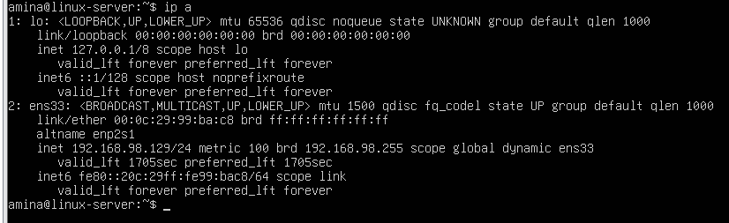IP = 192.168.98.129

2.3. Connect from host terminal
On Windows host → Open Command Prompt or PowerShell.
ssh amina@192.168.98.128>
If it asks "yes/no": type yes
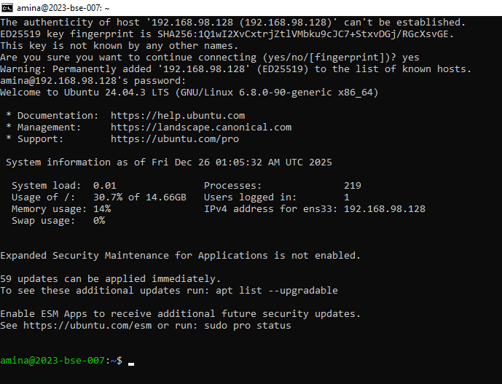

2.4. Run whoami and pwd
Inside SSH terminal:
whoami
pwd
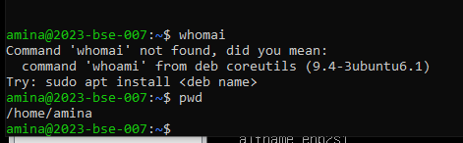
Task 3: Filesystem Exploration
PART A: Root filesystem listing
List root directory
Run:
ls -la /
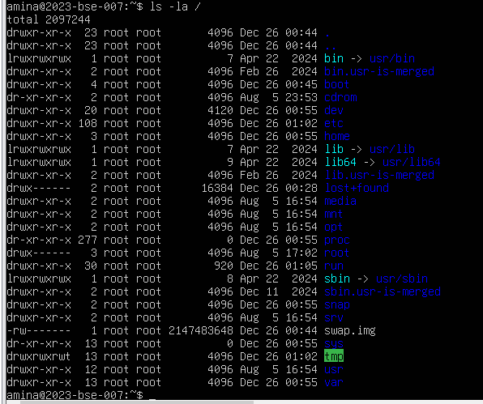
PART B: Inspect system directories
Run ONE command at a time, take a screenshot after each, then continue.
/bin
ls -la /bin
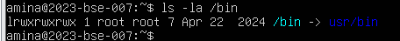
/sbin
ls -la /sbin
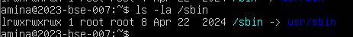
/usr
ls -la /usr
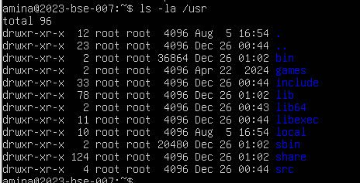
/opt
ls -la /opt
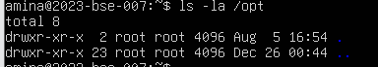
/etc
ls -la /etc
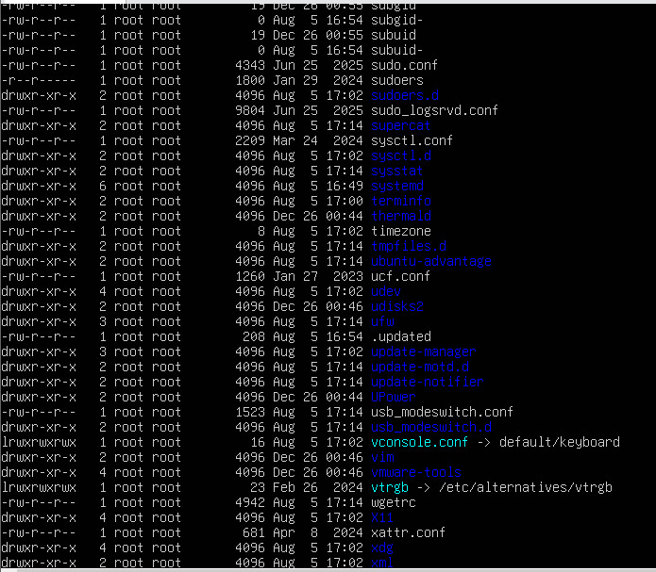
/dev
ls -la /dev
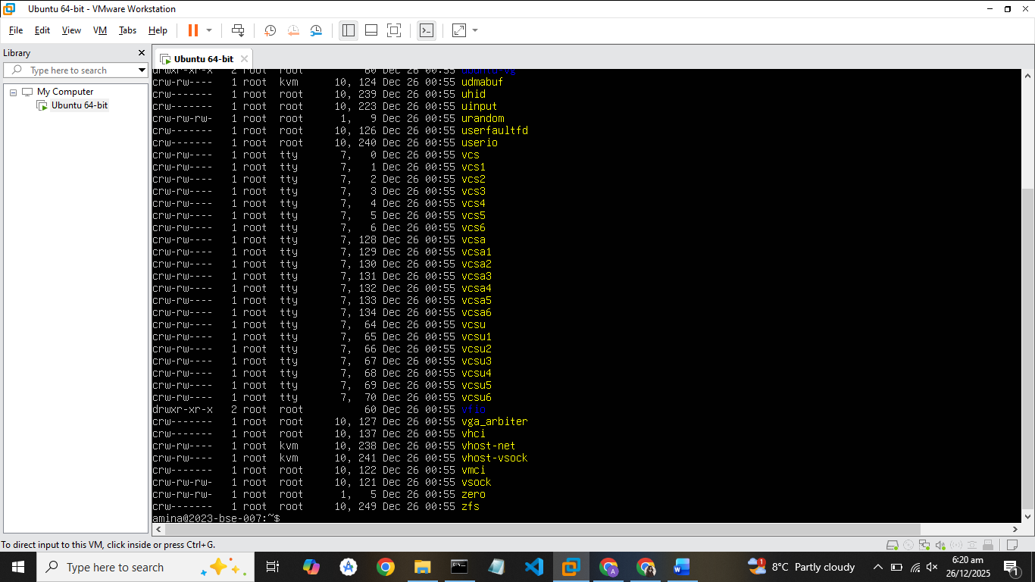
/var
ls -la /var
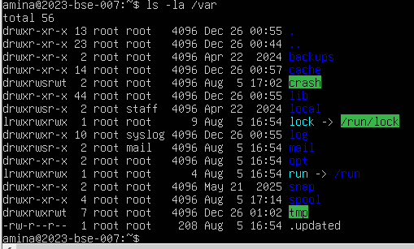
/tmp
ls -la /tmp
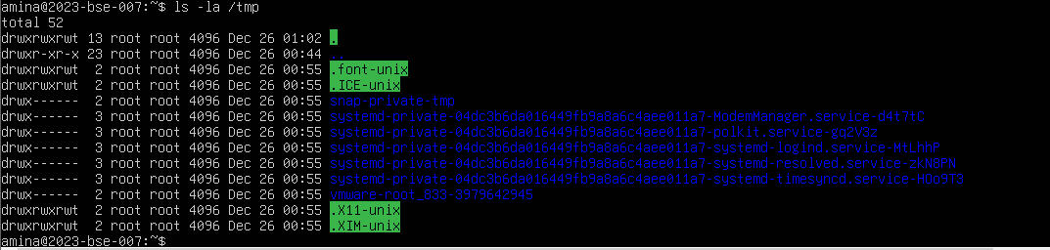
PART C: Home directory + hidden files
List home directory (with dotfiles)
Run:
ls -la ~
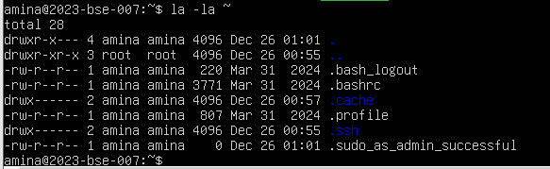
PART D: Written explanation
Open nano editor
Run:
nano ~/answer.md
Type THIS paragraph (3–5 sentences)
Type exactly this:
/bin contains essential command binaries needed for the system to boot and operate in single-user mode.
/usr/bin holds the majority of user commands and programs that are not required for basic system startup.
/usr/local/bin is used for locally installed software.
Programs in /usr/local/bin are added by the system admin.
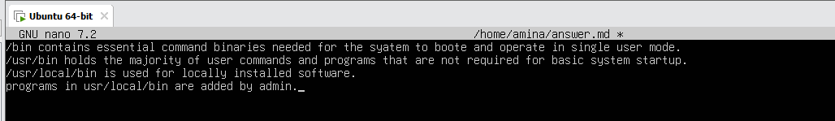
Save and exit nano
- Press CTRL + O → Enter (save)
- Press CTRL + X (exit)
Show the paragraph and screenshot
Run:
cat ~/answer.md
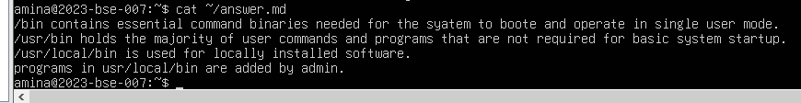
Task 4: Essential CLI Tasks
PART A: Create workspace and navigate
Create workspace directories
Run:
mkdir -p ~/lab4/workspace/python_project
Change directory
Run:
cd ~/lab4/workspace/python_project
Show current directory
Run:
pwd
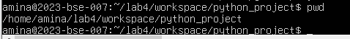
PART B: Create files using nano editor
Create README.md
Run:
nano README.md
Inside nano:
- Type:
- Lab 4 README
- Save: CTRL + O → Enter
- STOP (screen still showing nano content)
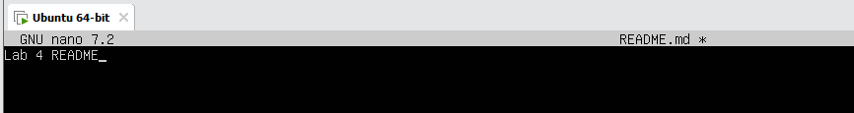
Exit nano:
- CTRL + X
Create main.py
Run:
nano main.py
Inside nano:
- Type:
- print("hello lab4")
- Save: CTRL + O → Enter
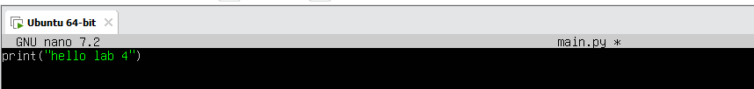
Exit:
- CTRL + X
Create .env file
Run:
nano .env
Inside nano:
- Type:
- ENV=lab4
- Save: CTRL + O → Enter
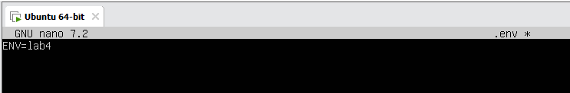
Exit:
- CTRL + X
PART C: List files
List workspace contents
Run:
ls -la
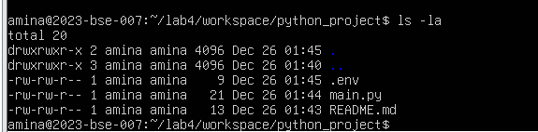
PART D: Copy, move, remove files
Copy README.md
Run:
cp README.md README.copy.md
Rename copied file
Run:
mv README.copy.md README.dev.md
Remove file
Run:
rm README.dev.md
PART E: Directory creation & recursive copy
Create java_app directory
Run:
mkdir -p ~/lab4/workspace/java_app
Recursive copy
Run:
cp -r ~/lab4/workspace/python_project ~/lab4/workspace/java_app_copy
Verify copy
Run:
ls -la ~/lab4/workspace
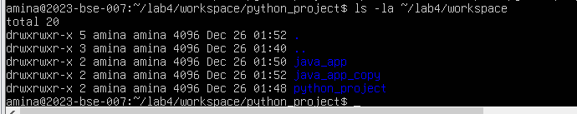
PART F: History and tab completion
Command history
Run:
history
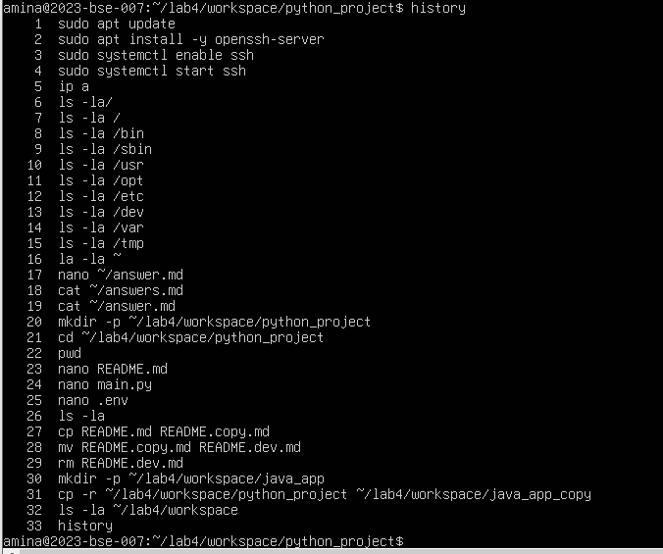
Tab completion demonstration
Do this slowly:
- Type:
- cd ~/lab4/workspace/py
- Press TAB
- Terminal auto-completes to python_project
Task 5: System Info, Resources & Processes
Kernel and OS information
Run:
uname -a
CPU information
Run:
cat /proc/cpuinfo
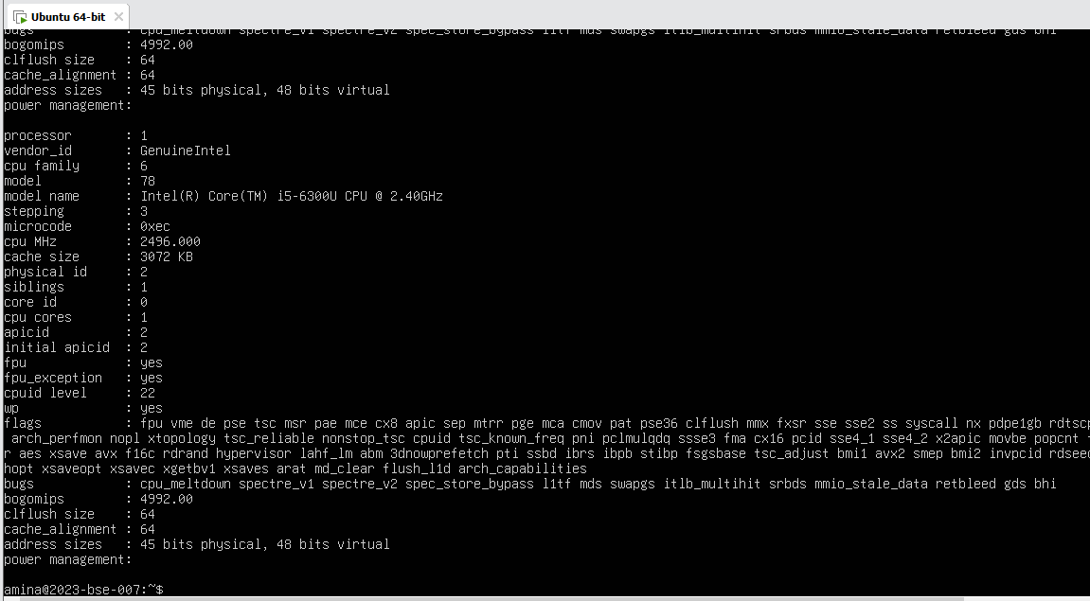
Memory usage
Run:
free -h
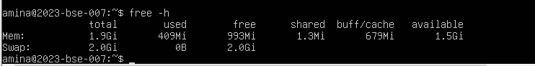
Disk usage
Run:
df -h
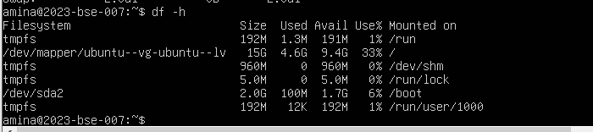
OS release information
Run:
cat /etc/os-release
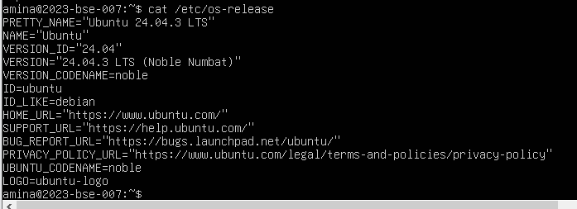
Running processes
Run:
ps aux
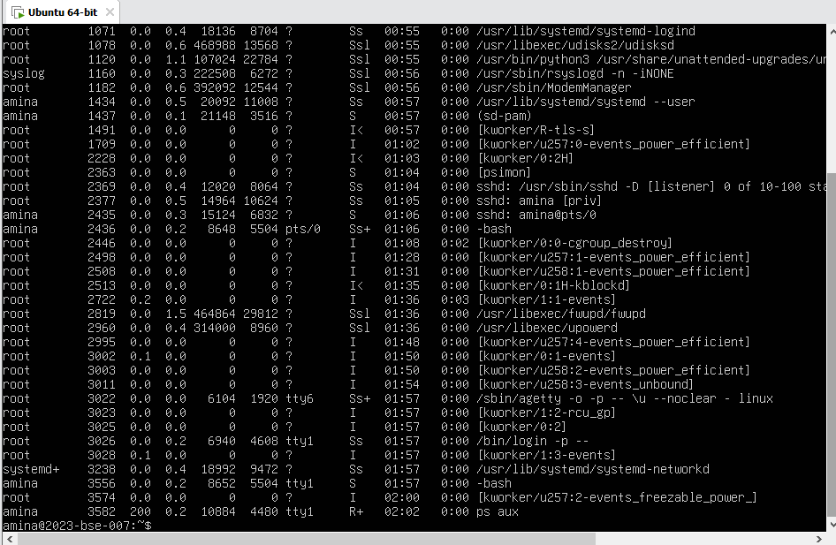
Task 6: Users and Account Verification
PART A: Create a new user
Create user lab4user
Run:
sudo adduser lab4user
During prompts:
- Enter a password (twice)
- WE can press Enter to skip Full Name, Room Number, etc.
- Type Y to confirm
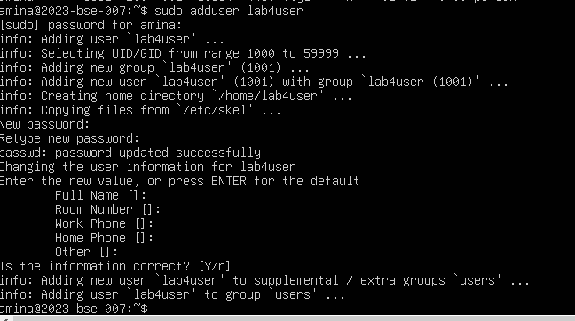
PART B: Verify user exists
Check /etc/passwd entry
Run:
getent passwd lab4user
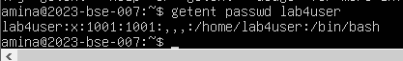
PART C: Switch to the new user
Switch user
Run:
su - lab4user
- Enter the lab4user password
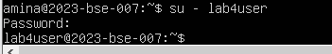
PART D: Show sudo is NOT allowed
Attempt sudo
Run:
sudo whoami
Expected result:
- Error like:
- lab4user is not in the sudoers file
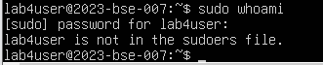
PART E: Return to original user
Exit back
Run:
exit
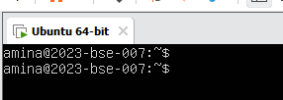
PART F: Remove the test user
Delete user
Run:
sudo deluser --remove-home lab4user
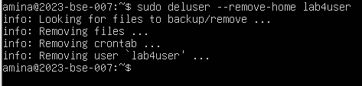
Bonus Task 7: Demo Script
PART A: Create the script
Open nano editor
Run:
nano ~/lab4/workspace/run-demo.sh
Type the script
Inside nano, type:
#!/bin/bash
echo "Lab 4 demo: current user is $(whoami)"
echo "Current time: $(date)"
uptime
free -h
Save and screenshot
- Press CTRL + O → Enter (save)
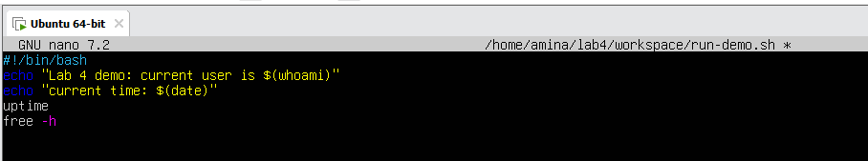
Now exit:
- CTRL + X
PART B: Make script executable
Change permissions
Run:
chmod +x ~/lab4/workspace/run-demo.sh
PART C: Run the script
Execute the script
Run:
~/lab4/workspace/run-demo.sh
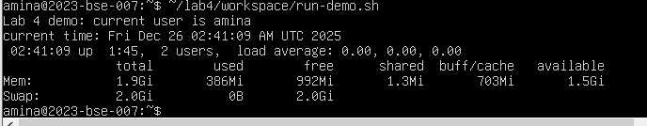
PART D: Run with sudo
Run script with sudo
Run:
sudo ~/lab4/workspace/run-demo.sh
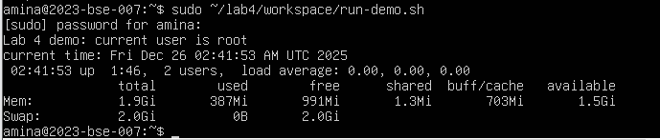
Exam Evaluation Questions
1. Remote Access Verification (Cyber Login Check)
Scenario:
You are part of a SOC (Security Operations Center) investigating unauthorized access to a Linux server hosted on VMware. Prove you can securely connect and verify your identity.
Steps:
- Connect to the Ubuntu VM remotely from your host terminal.

- Verify your current user and home directory path.

- Confirm you are connected to the correct host machine.
2. Filesystem Inspection for Forensic Evidence
Scenario:
The incident response team suspects malicious files in system directories. You must explore the filesystem to locate and document the system’s structure.
Steps:
- Display the contents of the root directory.
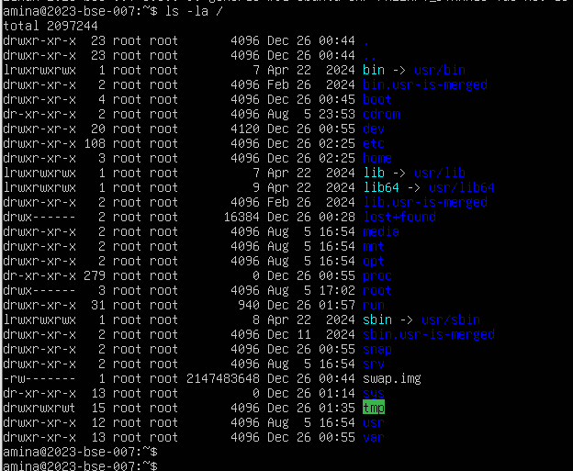
- Display the OS version and release information.
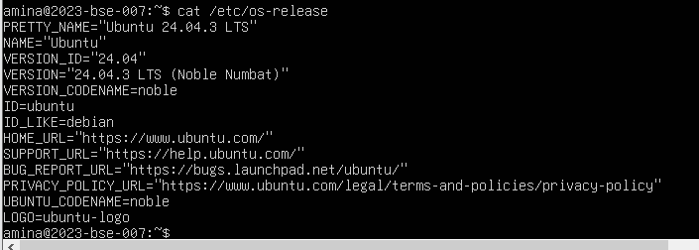
- Explore and record directory listings for /bin, /sbin, /usr, /opt, /etc, /dev, /var, and /tmp.
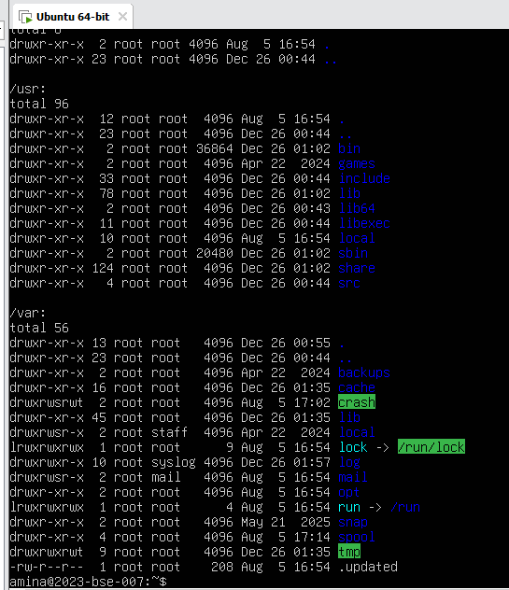
- Display all hidden files in your home directory.
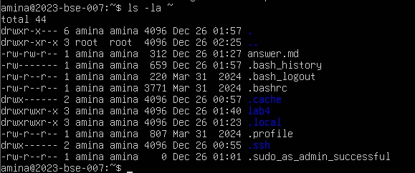
- Create a markdown file summarizing your findings on key binary directories.
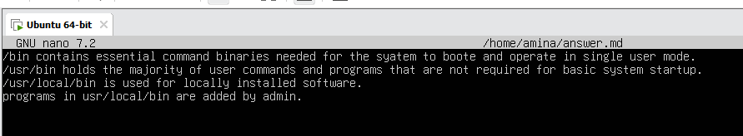
3. Evidence Handling & File Operations
Scenario:
You are creating a sandbox environment to safely analyse and handle suspicious files collected from a compromised system.
Steps:
- Create a structured folder hierarchy under your home directory for analysis.
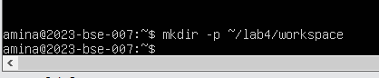
- Create three text files, including one hidden file, in your workspace.
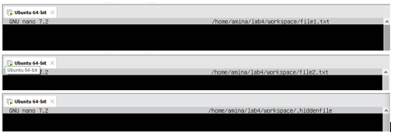
- Create a backup copy of one file, rename it, and then delete it after verification.
- Copy the entire workspace as an evidence backup folder.
- Display your command history to document all actions performed.
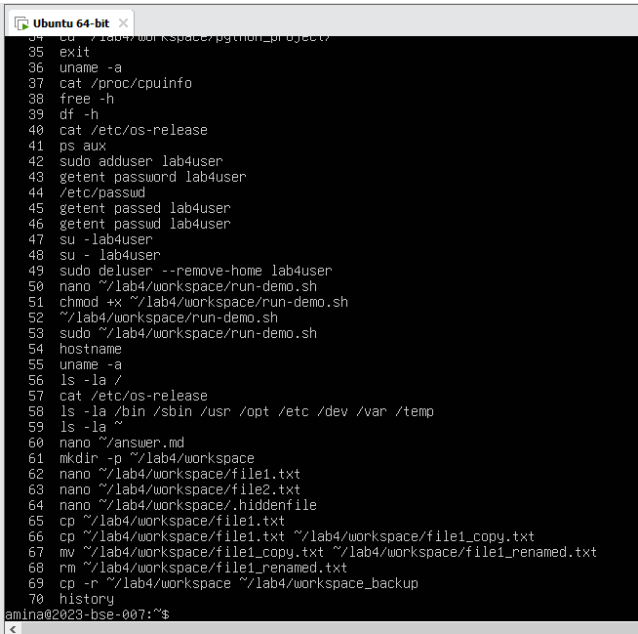
- Demonstrate Linux auto-completion by typing a partial command or filename.
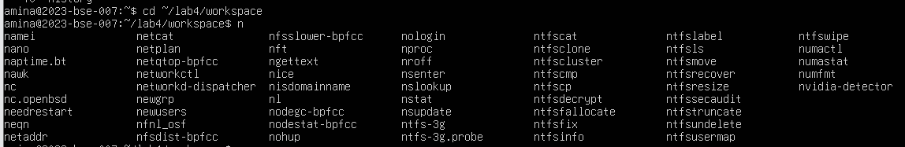
4. System Profiling and Process Monitoring
Scenario:
You are investigating a potential malware infection that is consuming excessive resources on the Linux VM.
Steps:
- Display the system’s OS and kernel version for the investigation report.
- Display CPU, memory, and disk usage information.
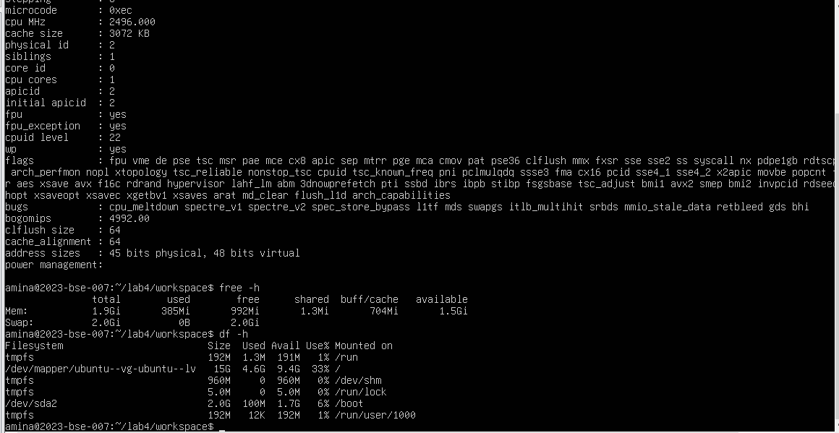
- Display all active running processes to identify suspicious activity.
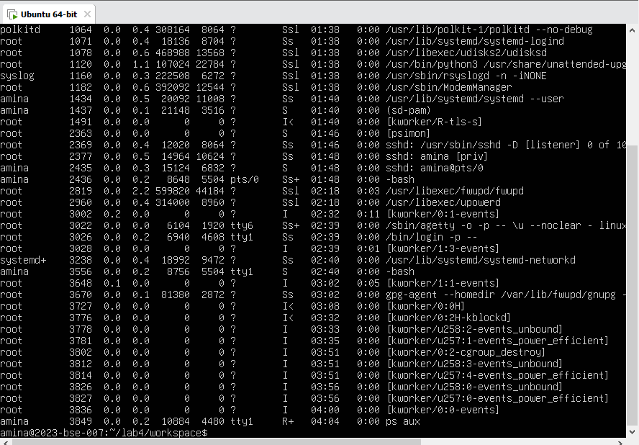
5. User Account Audit & Privilege Escalation Simulation
Scenario:
You are performing a user activity audit on a compromised Linux server.
The SOC suspects a newly created account (lab4user) may have been used for unauthorized access.
Your task is to simulate the account creation, perform privilege tests, and analyze authentication logs for forensic evidence.
Steps:
- Create a new test user named lab4user.
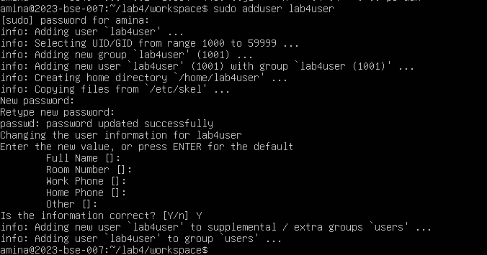
- Verify that the new user record exists in the system’s user database.
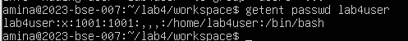
- Log in as lab4user and confirm successful login.
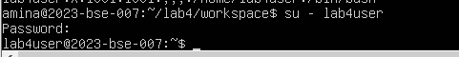
- Attempt to run an administrative command as lab4user (expect permission denied).
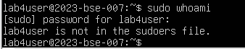
- Switch back to your main analyst account.

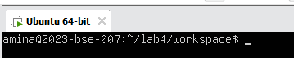
- Inspect the system authentication logs located at /var/log/auth.log to determine whether the lab4user account attempted any logins (successful or failed).
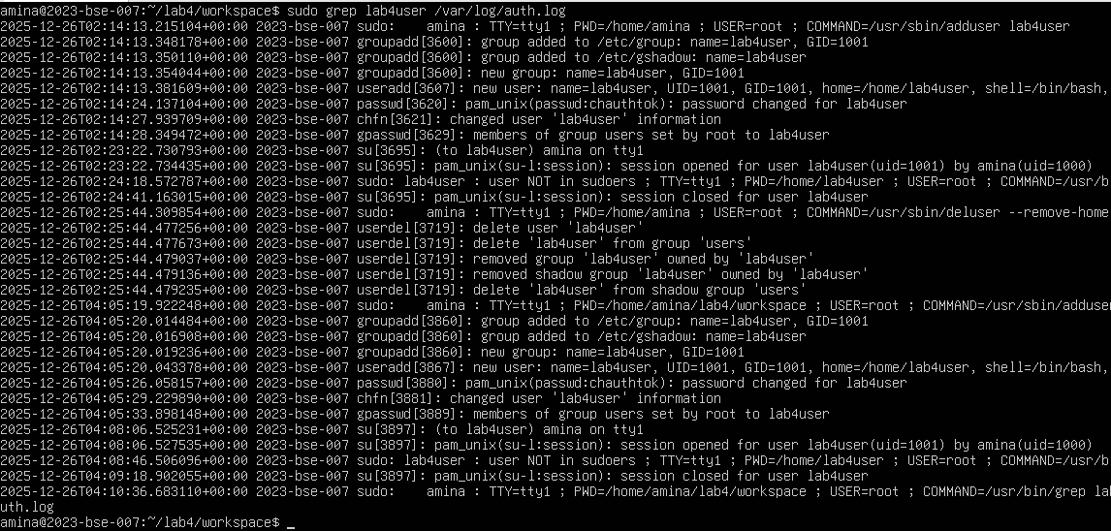
- Remove the lab4user account after the audit and verify deletion.
