Cloud Computing Lab
Name: Arooj Saleem
Roll # 2023-BSE-013
Submitted To: Engr. Muhammad Shoaib
Lab Title: Terraform IAM Management with AWS
Lab # 13
Task 0 Lab Setup (Codespace & GH CLI)
Create Codespace & connect:
# create or open codespace via GH CLI (example)
gh repo create CC_<YourName>_<YourRollNumber>/Lab13 --public
gh codespace create --repo <user_name>/Lab13
gh codespace list
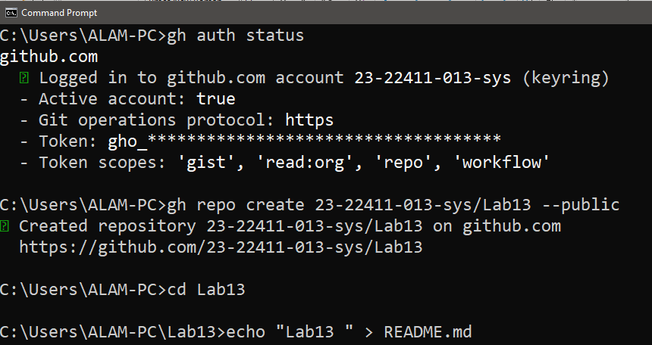

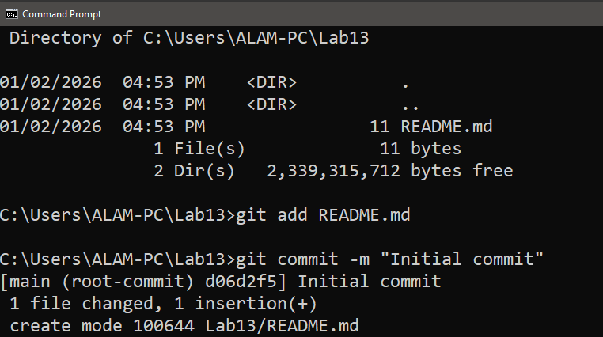
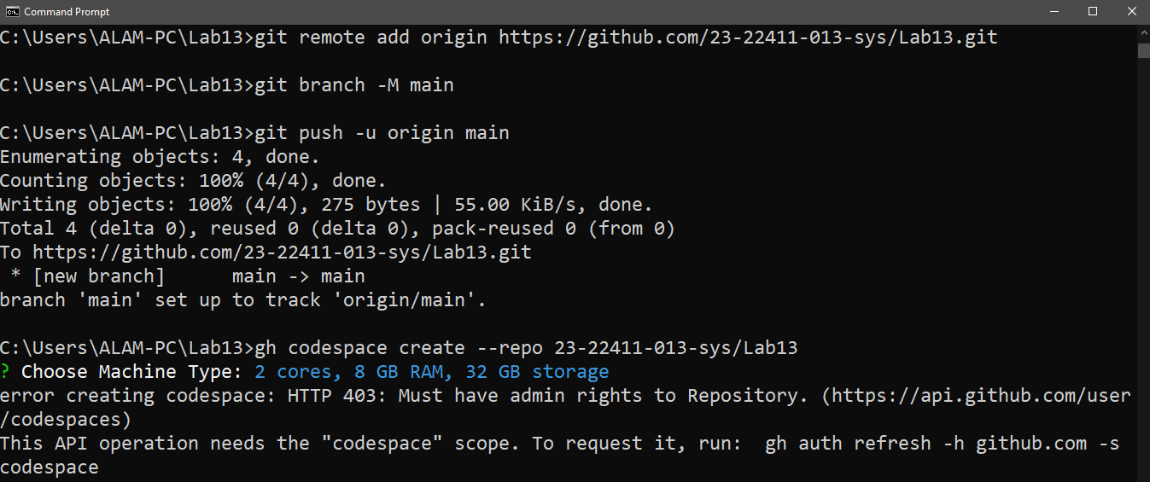
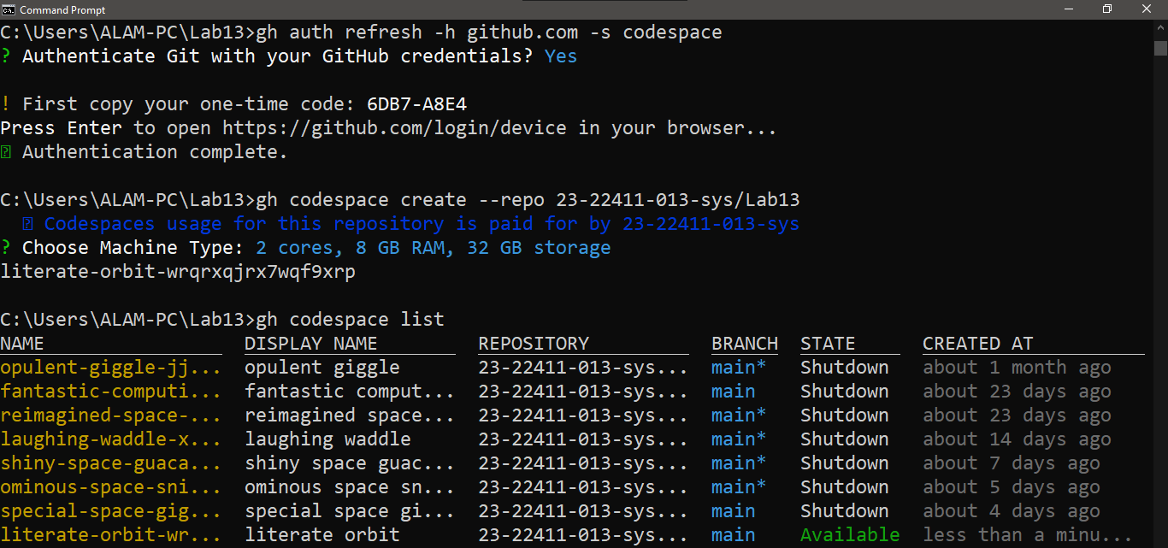
gh codespace ssh -c <your_codespace_name>
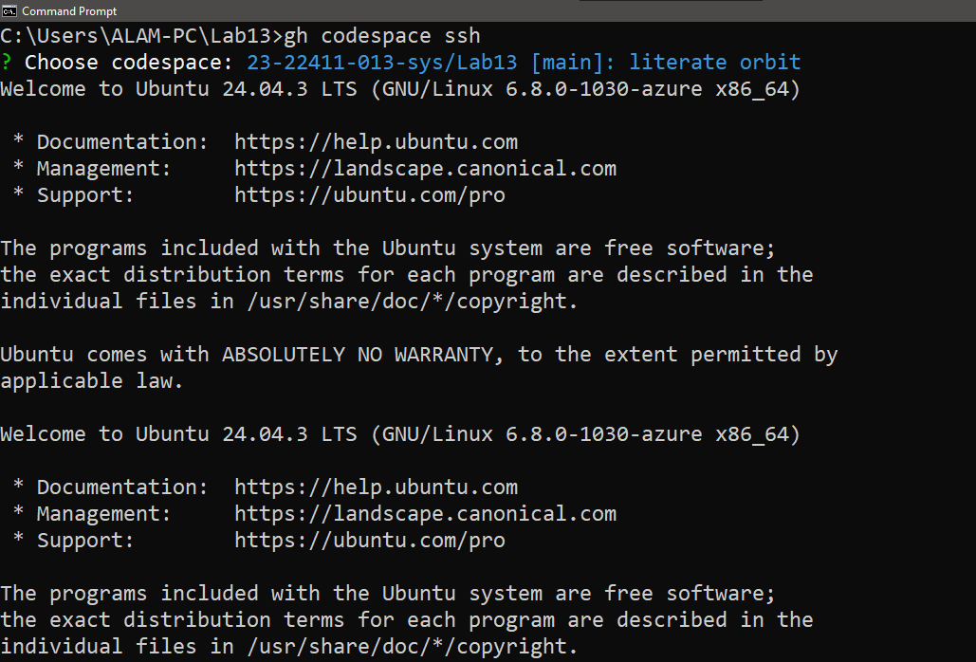

Task 1 — Create IAM Group and Output Details
Create the initial project structure:
mkdir -p ~/Lab13
cd ~/Lab13
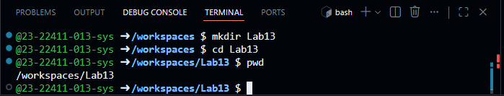
- Create the main Terraform file:
touch main.tf
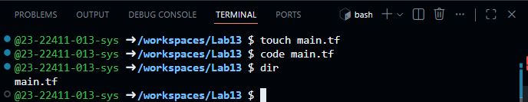
- Create main.tf with AWS provider configuration:
provider "aws" {
shared_config_files = ["~/.aws/config"]
shared_credentials_files = ["~/.aws/credentials"]
}
resource "aws_iam_group" "developers" {
name = "developers"
path = "/groups/"
}
output "group_details" {
value = {
group_name = aws_iam_group.developers.name
group_arn = aws_iam_group.developers.arn
unique_id = aws_iam_group.developers.unique_id
}
}
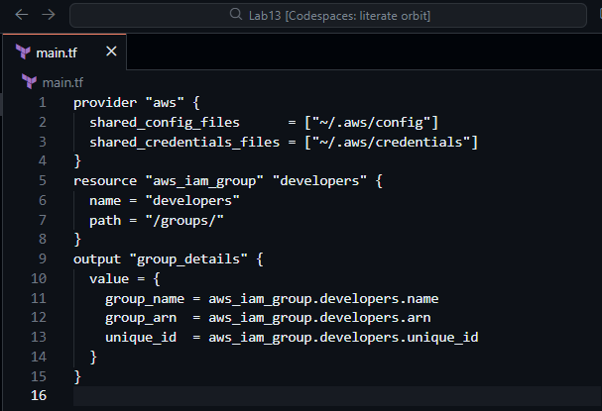
- Initialize Terraform:
terraform init
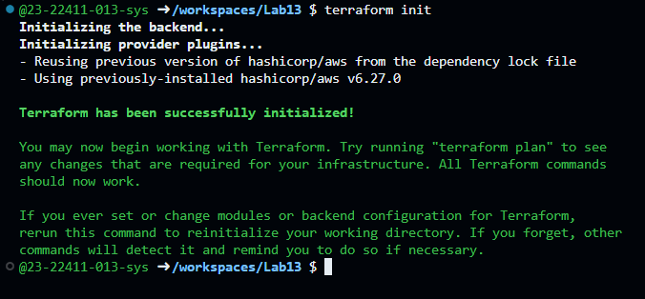
- Apply the configuration:
terraform apply -auto-approve
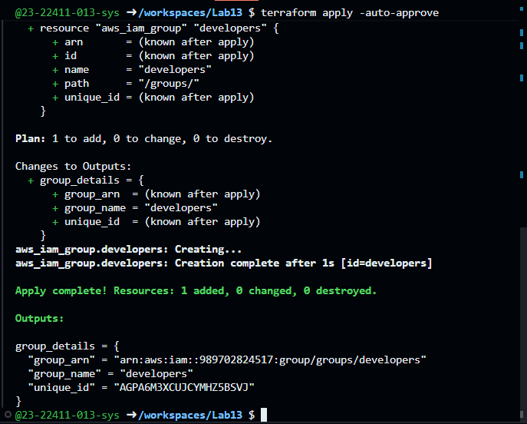
- Display the output:
terraform output
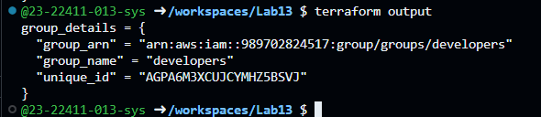
- Verify the group in AWS Console:
Navigate to IAM → Groups in AWS Console
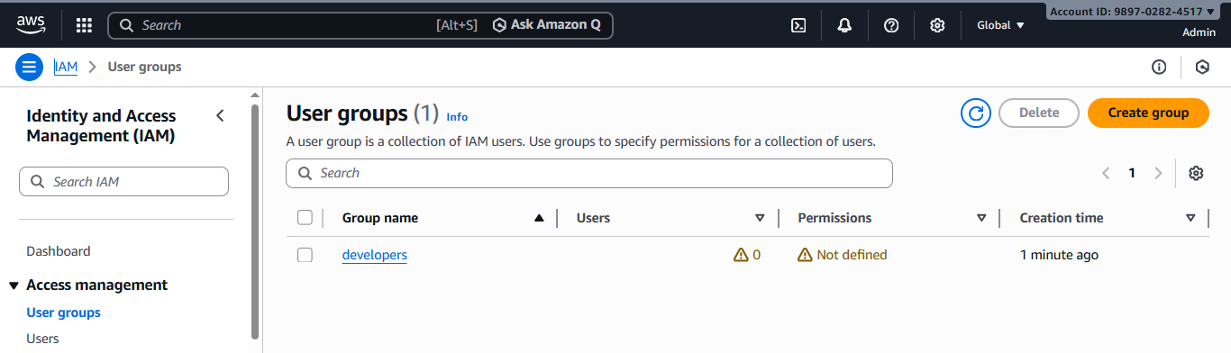

Task 2 — Create IAM User with Group Membership
In this task, you will create an IAM user named "loadbalancer" and add it to the developers group.
- Update main.tf to add the IAM user resource:
provider "aws" {
shared_config_files = ["~/.aws/config"]
shared_credentials_files = ["~/.aws/credentials"]
}
resource "aws_iam_group" "developers" {
name = "developers"
path = "/groups/"
}
output "group_details" {
value = {
group_name = aws_iam_group.developers. name
group_arn = aws_iam_group. developers.arn
unique_id = aws_iam_group.developers.unique_id
}
}
resource "aws_iam_user" "lb" {
name = "loadbalancer"
path = "/users/"
force_destroy = true
tags = {
DisplayName = "Load Balancer"
}
}
resource "aws_iam_user_group_membership" "lb_membership" {
user = aws_iam_user.lb.name
groups = [
aws_iam_group. developers.name
]
}
output "user_details" {
value = {
user_name = aws_iam_user.lb.name
user_arn = aws_iam_user.lb.arn
unique_id = aws_iam_user.lb.unique_id
}
}
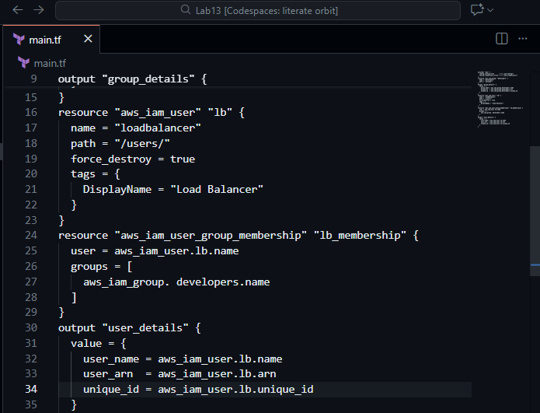
- Apply the configuration:
terraform apply -auto-approve
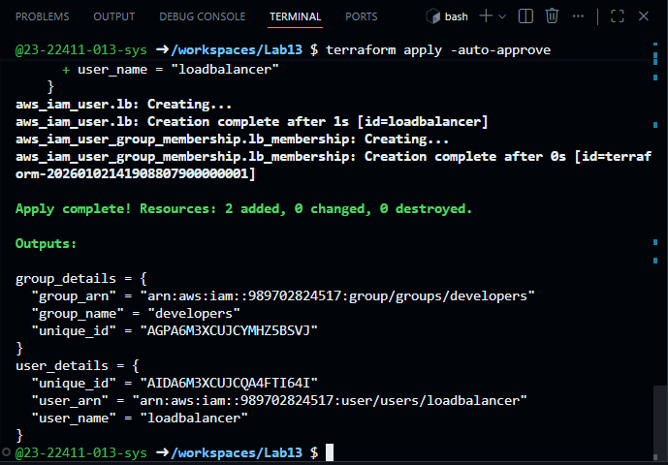
- Display the outputs:
terraform output
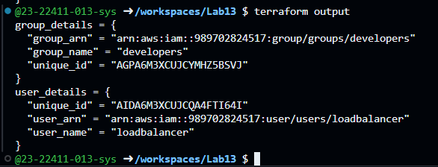
- Verify the user in AWS Console:
Navigate to IAM → Users in AWS Console
Click on "loadbalancer" user
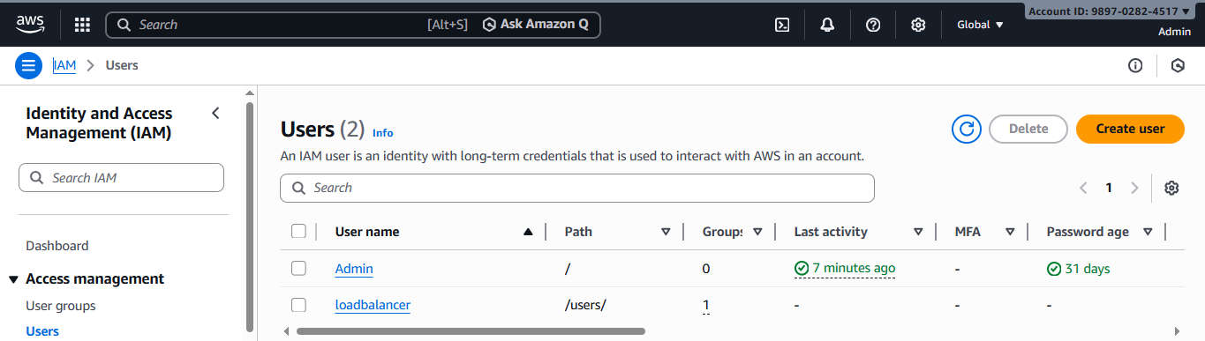
Check the "Groups" tab
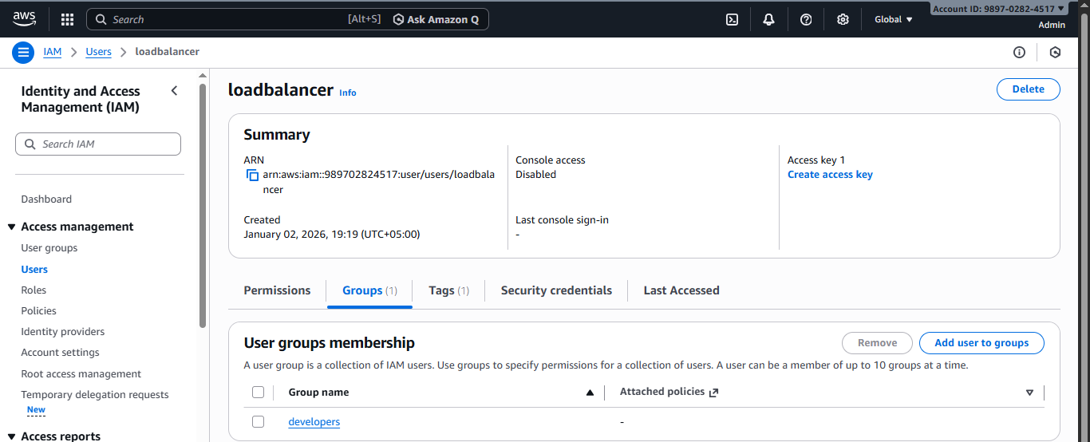

Task 3 — Attach Policies to IAM Group
In this task, you will attach AWS managed policies (AmazonEC2FullAccess and IAMUserChangePassword) to the developers group.
- Update main.tf to add policy attachments:
provider "aws" {
shared_config_files = ["~/.aws/config"]
shared_credentials_files = ["~/.aws/credentials"]
}
resource "aws_iam_group" "developers" {
name = "developers"
path = "/groups/"
}
output "group_details" {
value = {
group_name = aws_iam_group.developers.name
group_arn = aws_iam_group.developers.arn
unique_id = aws_iam_group.developers.unique_id
}
}
resource "aws_iam_user" "lb" {
name = "loadbalancer"
path = "/users/"
force_destroy = true
tags = {
DisplayName = "Load Balancer"
}
}
resource "aws_iam_user_group_membership" "lb_membership" {
user = aws_iam_user.lb.name
groups = [
aws_iam_group.developers.name
]
}
output "user_details" {
value = {
user_name = aws_iam_user.lb.name
user_arn = aws_iam_user.lb.arn
unique_id = aws_iam_user.lb.unique_id
}
}
resource "aws_iam_group_policy_attachment" "developer_ec2_fullaccess" {
group = aws_iam_group.developers.name
policy_arn = "arn:aws:iam::aws:policy/AmazonEC2FullAccess"
}
resource "aws_iam_group_policy_attachment" "change_password" {
group = aws_iam_group.developers.name
policy_arn = "arn:aws:iam::aws:policy/IAMUserChangePassword"
}
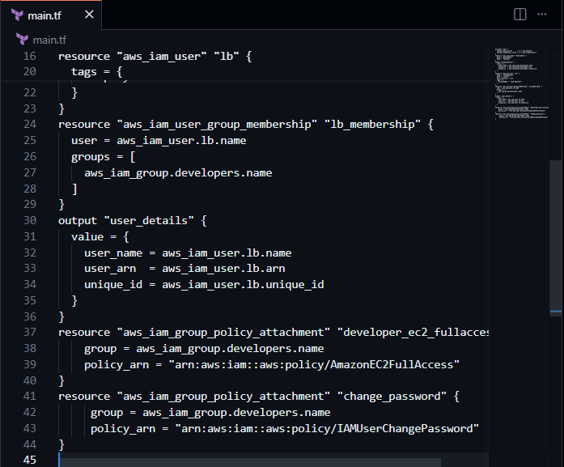
- Apply the configuration:
terraform apply -auto-approve
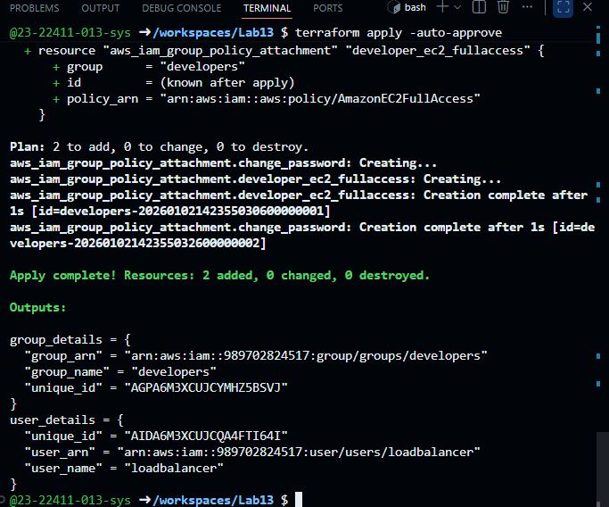
- Verify policies in AWS Console:
Navigate to IAM → Groups → developers
Click on "Permissions" tab
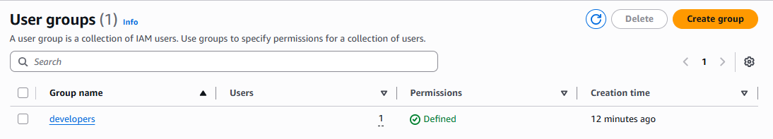

Task 4 — Create Login Profile for IAM User
In this task, you will create a login profile for the loadbalancer user using a bash script and null_resource provisioner.
- Create variables.tf file:
variable "iam_password" {
description = "Temporary password for the IAM user"
type = string
sensitive = true
default = "1dontKnow"
}
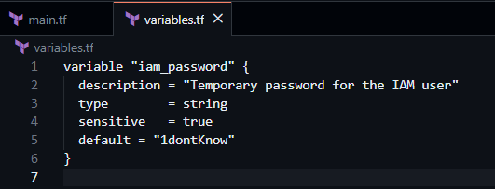
- Create the bash script create-login-profile.sh:
#!/usr/bin/env bash
set -euo pipefail
USERNAME="$1"
PASSWORD="$2"
# Check if login profile already exists
if aws iam get-login-profile --user-name "$USERNAME" >/dev/null 2>&1; then
echo "Login profile already exists for $USERNAME. Skipping."
else
echo "Creating login profile for $USERNAME"
aws iam create-login-profile \
--user-name "$USERNAME" \
--password "$PASSWORD" \
--password-reset-required
Fi
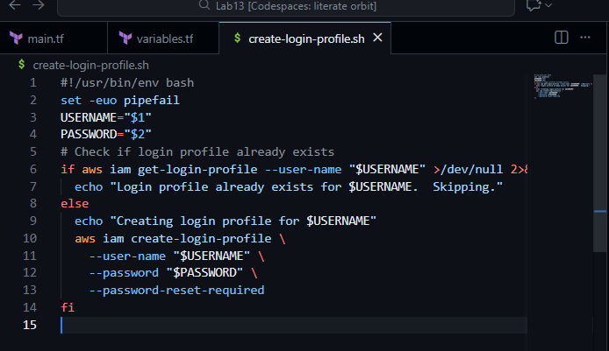
- Make the script executable:
chmod +x create-login-profile.sh
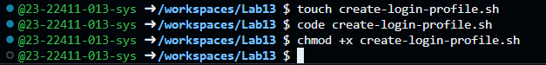
- Update main.tf to add the null_resource provisioner:
Add this resource after the user creation:
resource "null_resource" "create_login_profile" {
triggers = {
password_hash = sha256(var.iam_password)
user = aws_iam_user.lb.name
}
depends_on = [aws_iam_user. lb]
provisioner "local-exec" {
command = "${path.module}/create-login-profile.sh ${aws_iam_user.lb.name} '${var.iam_password}'"
}
}
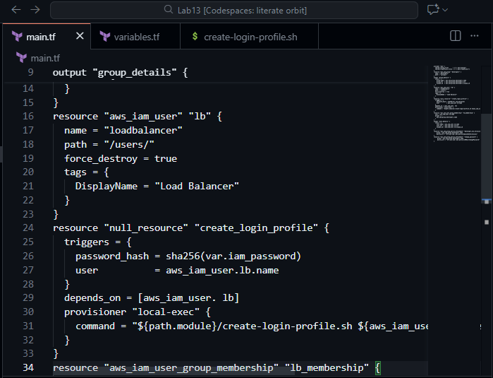
- Apply the configuration with a custom password:
terraform apply -auto-approve -var="iam_password=MySecurePass123!"
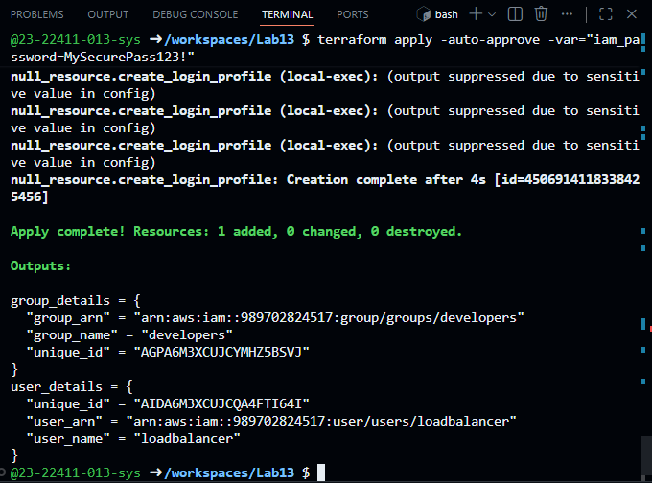
- Verify login profile creation:
aws iam get-login-profile --user-name loadbalancer
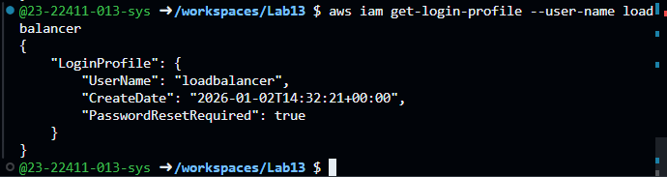
- Test login in AWS Console:
Open AWS Console login page
Sign in as IAM user with username "loadbalancer" and the password you set
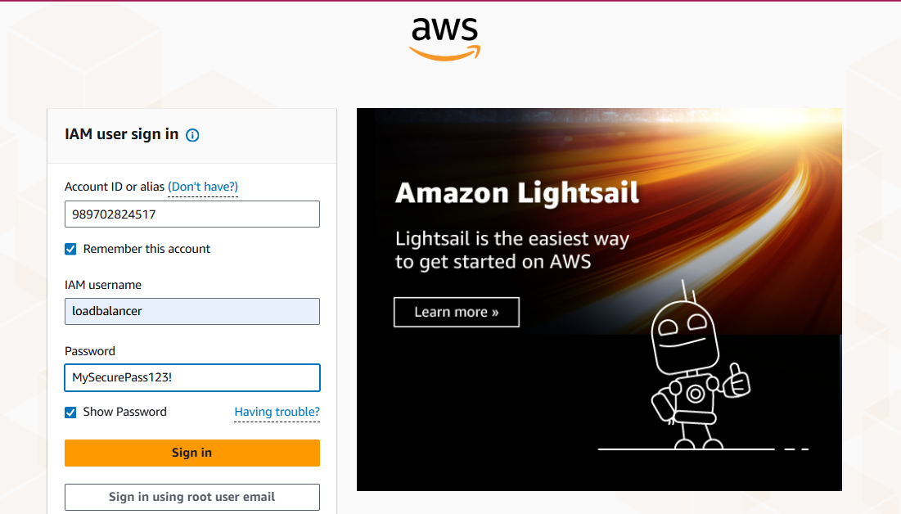
You should be prompted to change password
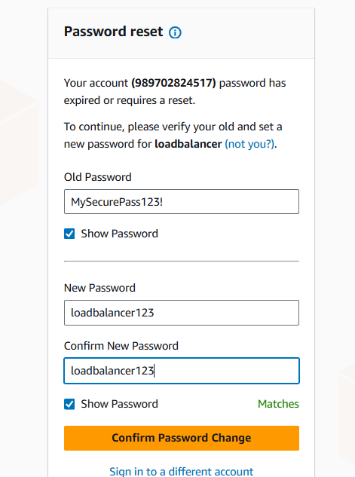

Task 5 — Generate Access Keys for IAM User
In this task, you will create access keys for the loadbalancer user and view them in terraform state.
- Update main.tf to add access key resource and outputs:
Add these resources:
resource "aws_iam_access_key" "lb_access_key" {
user = aws_iam_user.lb.name
}
output "access_key_id" {
value = aws_iam_access_key.lb_access_key.id
}
output "access_key_secret" {
value = aws_iam_access_key.lb_access_key. secret
sensitive = true
}
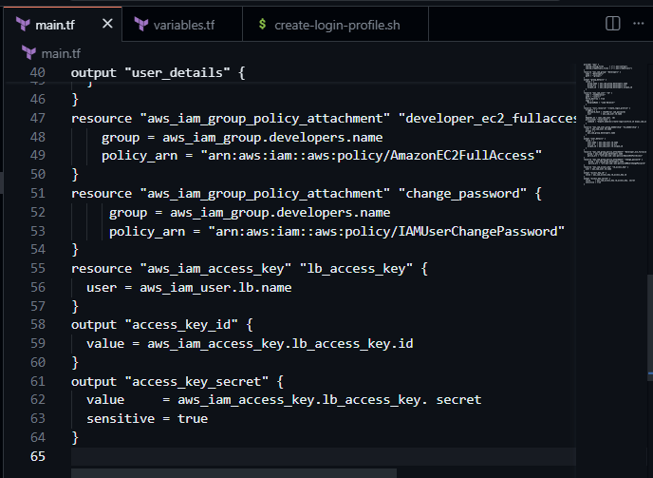
- Apply the configuration:
terraform apply -auto-approve -var="iam_password=MySecurePass123!"
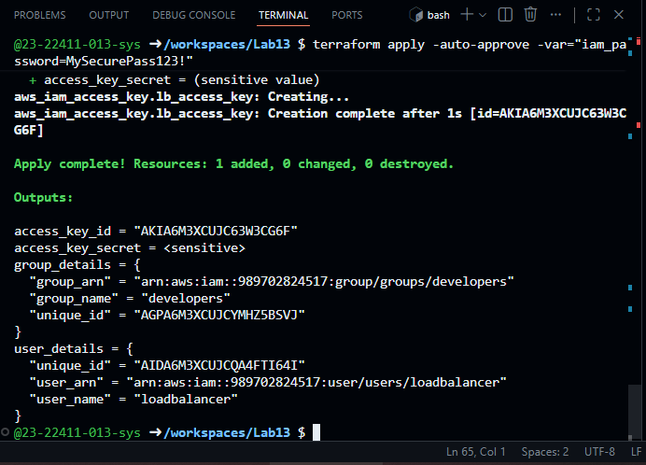
- Display outputs:
terraform output
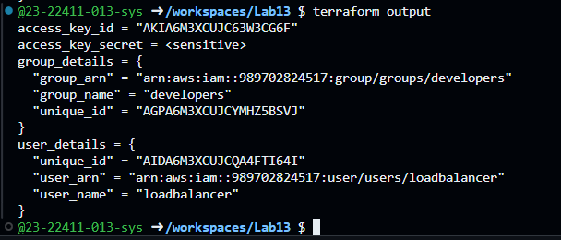
- View the secret in terraform state:
cat terraform.tfstate | grep -A 10 "access_key_secret"
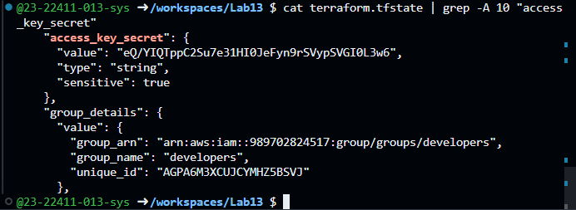
- Verify access key in AWS Console:
Navigate to IAM → Users → loadbalancer → Security credentials
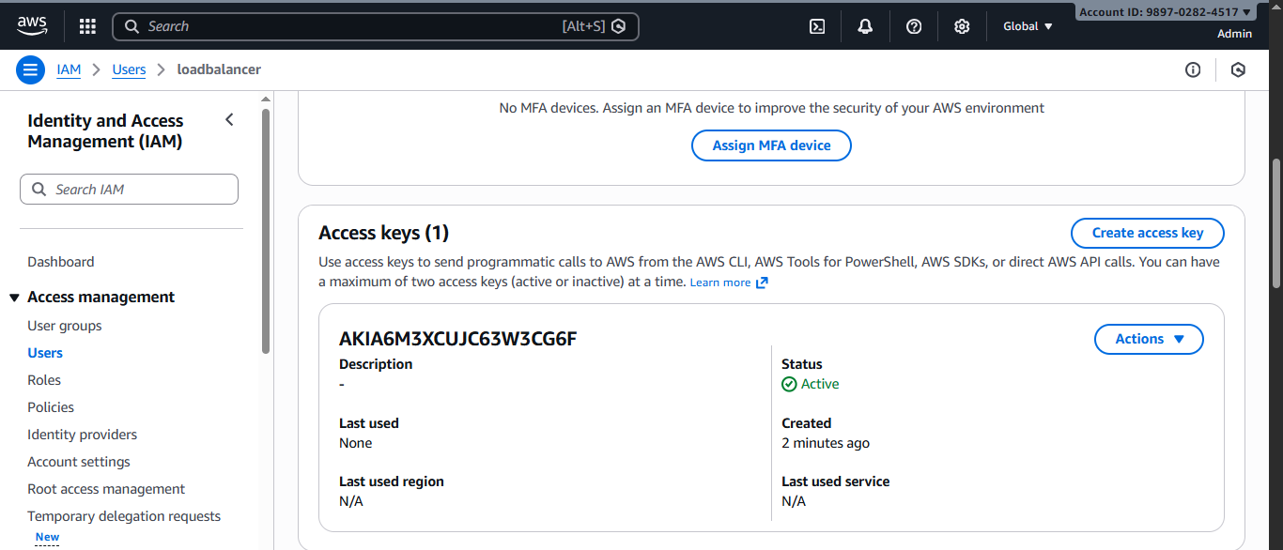

Task 6 — Implement Terraform Remote State with S3
In this task, you will configure Terraform to use S3 backend for remote state storage.
- Create S3 bucket in AWS Console:
Navigate to S3 in AWS Console
Click "Create bucket"
Bucket name: myapp-s3-bucket-demo (use a unique name if this is taken)
Enable versioning
Keep other settings as default
[Click "Create bucket"
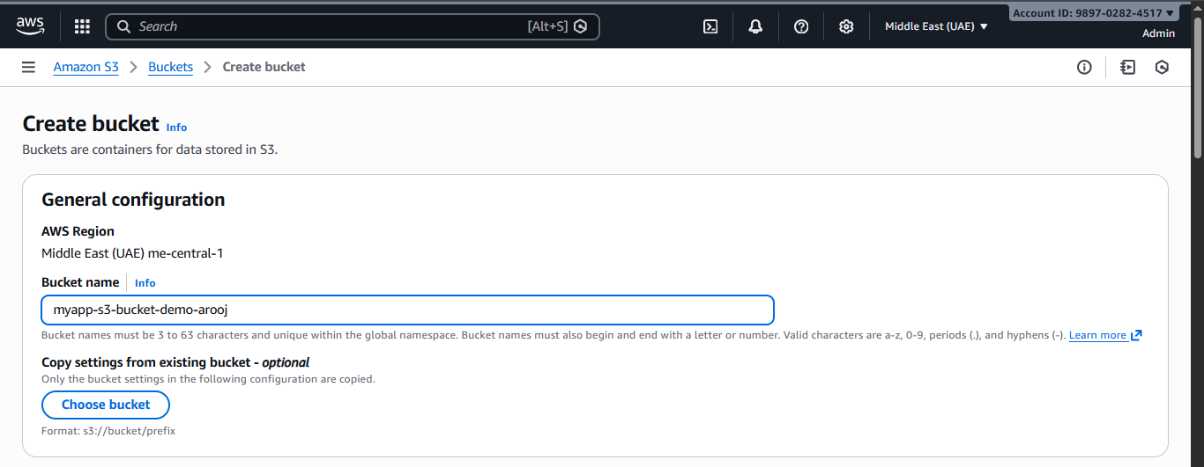
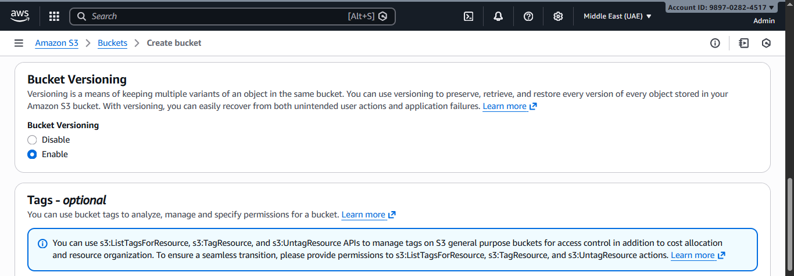
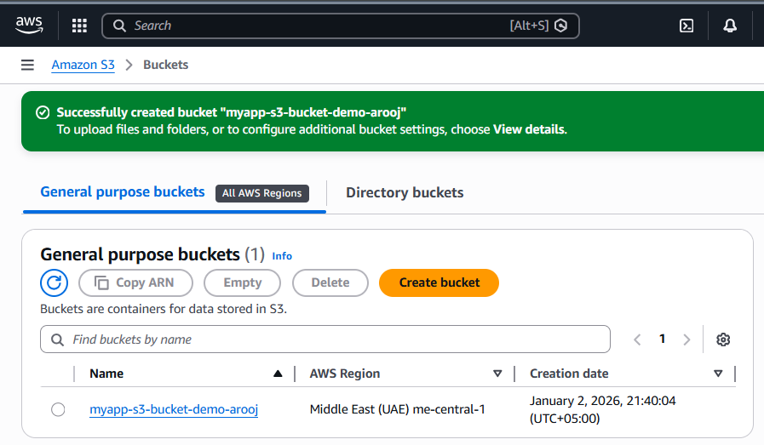
- Update main.tf to add S3 backend configuration:
Add this at the beginning of main.tf (before the provider block):
terraform {
backend "s3" {
bucket = "myapp-s3-bucket-demo"
key = "myapp/terraform.tfstate"
region = "me-central-1"
encrypt = true
use_lockfile = true
}
}
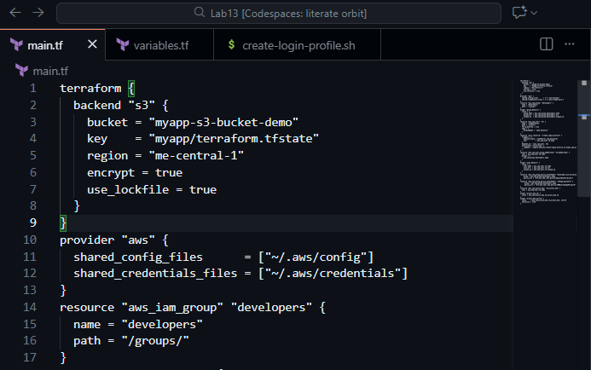
- Save screenshot as: task6_main_tf_backend. png — main.tf showing backend configuration.
- Reinitialize Terraform with the backend:
terraform init -migrate-state
- Type yes when prompted to migrate state
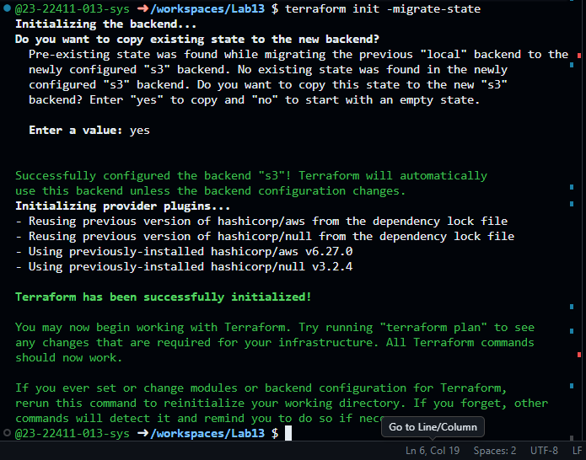
- Save screenshot as: task6_terraform_init_migrate.png — terraform init output showing state migration.
- Apply the configuration:
terraform apply -auto-approve -var="iam_password=MySecurePass123!"
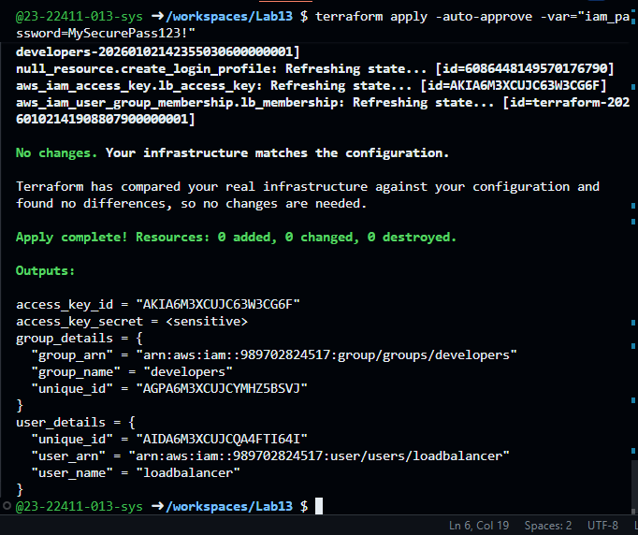
- Verify state file in S3:
Navigate to S3 → myapp-s3-bucket-demo → myapp/
You should see terraform.tfstate file
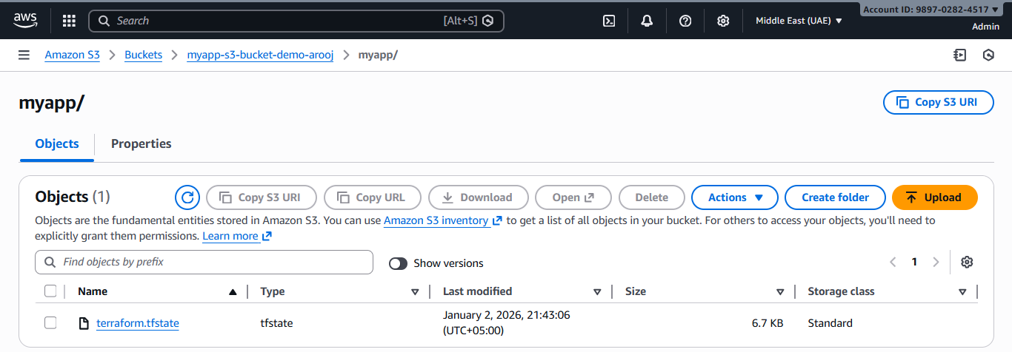
- Check local state file:
ls -la terraform.tfstate*
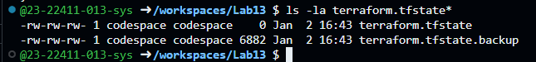
- Destroy resources and verify state change:
terraform destroy -auto-approve
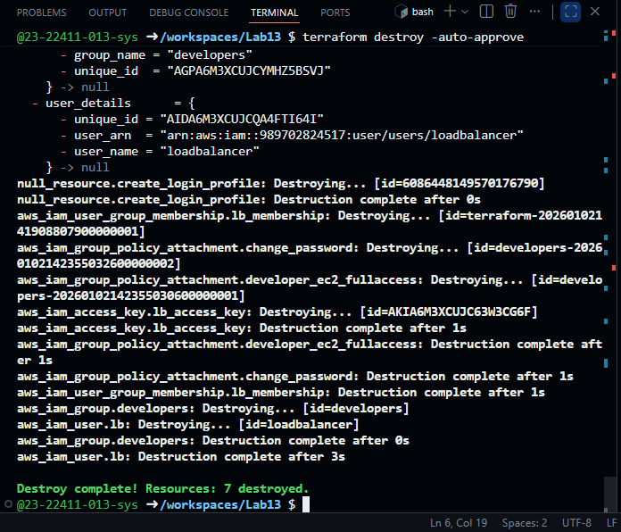
- Verify updated state in S3:
Refresh S3 bucket view
Check the terraform.tfstate file (it should show empty resources)
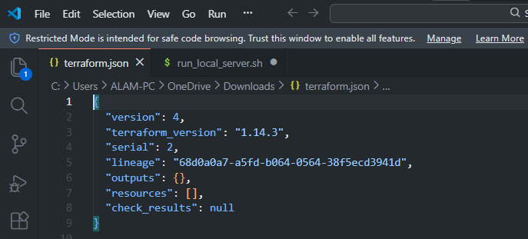

Task 7 — Create Multiple Users from CSV File
In this task, you will create multiple IAM users dynamically from a CSV file.
- Create locals.tf file:
locals {
users = csvdecode(file("users.csv"))
}
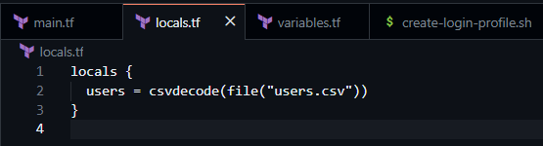
- Create users.csv file:
user_name
Michael
Dwight
Jim
Pam
Ryan
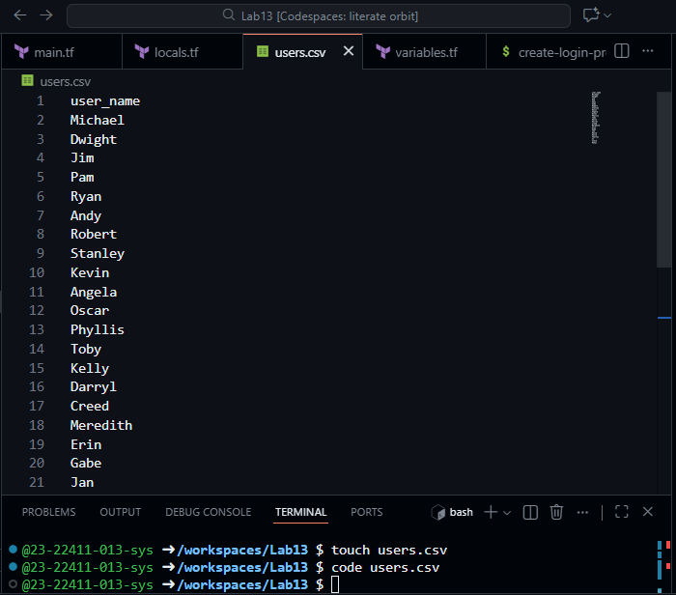
Andy
Robert
Stanley
Kevin
Angela
Oscar
Phyllis
Toby
Kelly
Darryl
Creed
Meredith
Erin
Gabe
Jan
David
Holly
Charles
Jo
Clark
Peter
- Update main.tf to create multiple users:
Replace the single user resources with:
# Create multiple IAM users from CSV
resource "aws_iam_user" "users" {
for_each = { for user in local.users : user.user_name => user }
name = each.value.user_name
path = "/users/"
force_destroy = true
tags = {
DisplayName = each.value.user_name
CreatedBy = "Terraform" }}
# Add all users to developers group
resource "aws_iam_user_group_membership" "users_membership" {
for_each = aws_iam_user.users
user = each.value.name
groups = [
aws_iam_group.developers.name
]}
# Create login profiles for all users
resource "null_resource" "create_login_profiles" {
for_each = aws_iam_user.users
triggers = {
password_hash = sha256(var. iam_password)
user = each.value.name
}
depends_on = [aws_iam_user. users]
provisioner "local-exec" {
command = "${path. module}/create-login-profile. sh ${each.value.name} '${var.iam_password}'"
}}
# Create access keys for all users
resource "aws_iam_access_key" "users_access_keys" {
for_each = aws_iam_user. users
user = each.value.name}
# Output all user details
output "all_users_details" {
value = {
for user_name, user in aws_iam_user.users : user_name => {
user_arn = user.arn
user_unique_id = user.unique_id
access_key_id = aws_iam_access_key.users_access_keys[user_name].id
} }}
# Output all access key secrets (sensitive)
output "all_access_key_secrets" {
value = {
for user_name, key in aws_iam_access_key.users_access_keys : user_name => key.secret }
sensitive = true}
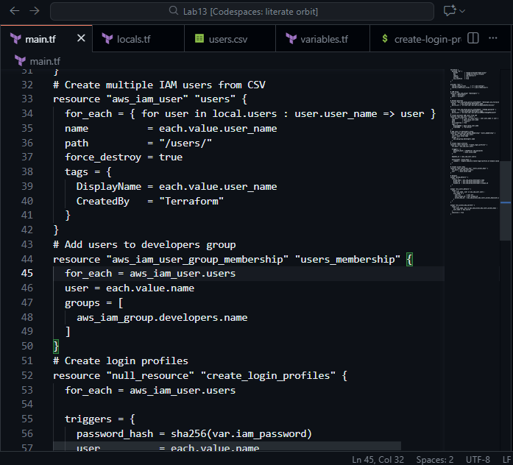
- Save screenshot as: task7_main_tf_multiple_users.png — main.tf showing multiple user resources.
- Reinitialize Terraform (since we changed the configuration significantly):
terraform init
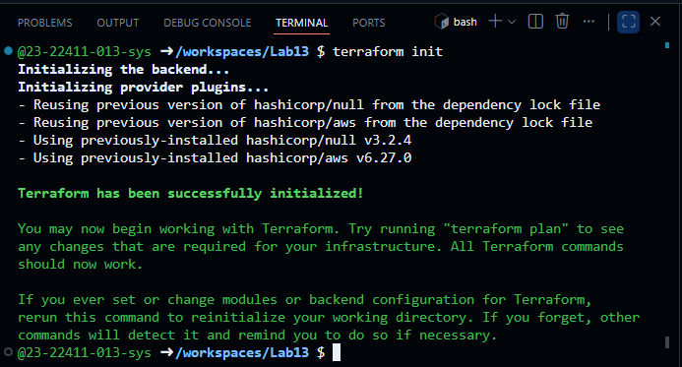
- Save screenshot as: task7_terraform_init.png — terraform init output.
- Apply the configuration to create all users:
terraform apply -auto-approve -var="iam_password=MySecurePass123!"
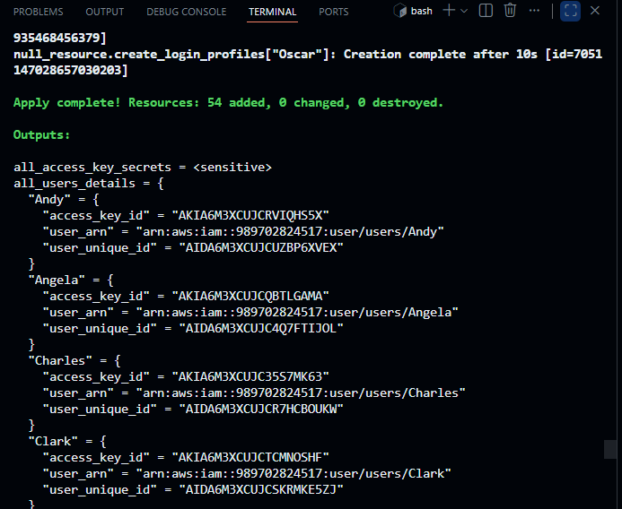
- Display the outputs:
terraform output
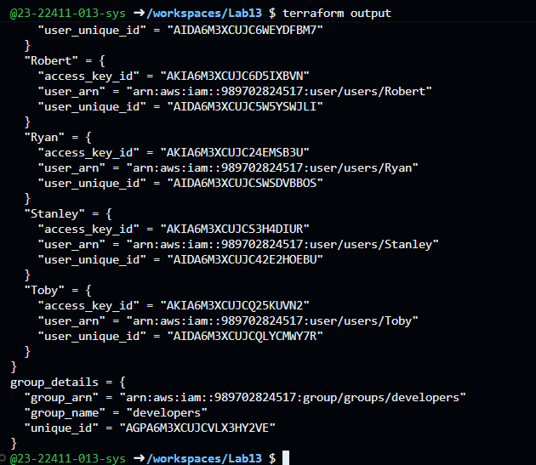
- View secrets in terraform. tfstate:
cat terraform.tfstate | grep -A 5 "all_access_key_secrets"
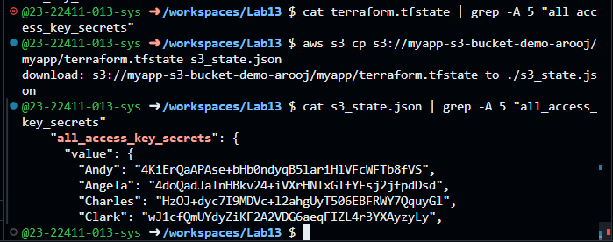
The local terraform.tfstate file did not display the all_access_key_secrets output because Terraform was configured to use a remote S3 backend. Therefore, the state file was downloaded directly from the S3 bucket using the AWS CLI and saved locally as s3_state.json. This allowed successful verification of the all_access_key_secrets output stored in the remote Terraform state.
- Verify all users in AWS Console:
Navigate to IAM → Users
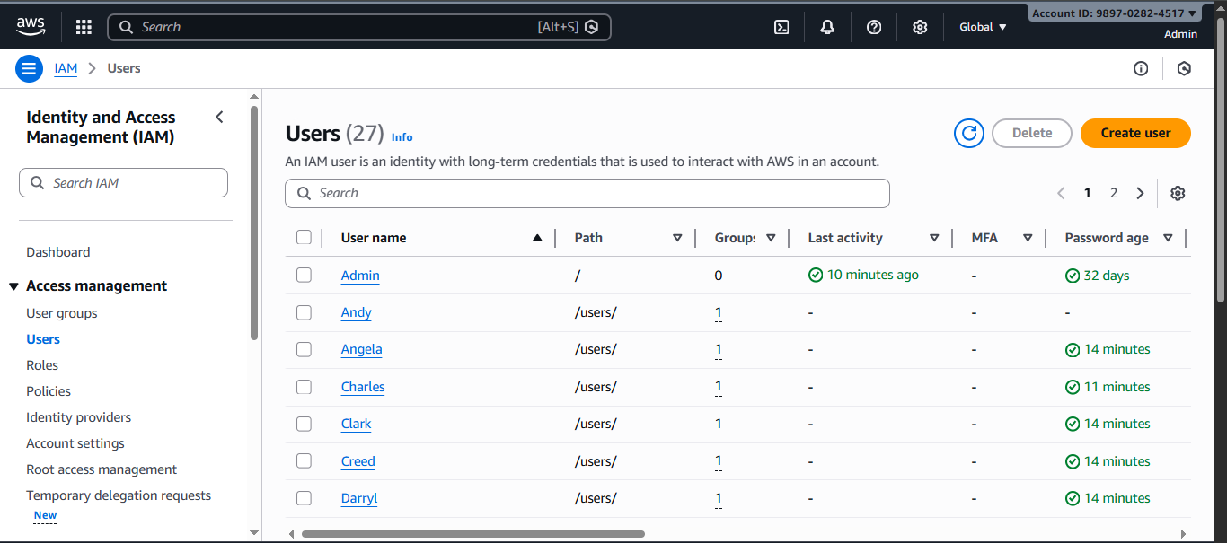
- Save screenshot as: task7_aws_console_all_users.png — AWS Console showing all created users.
- Verify group membership:
Navigate to IAM → Groups → developers → Users tab
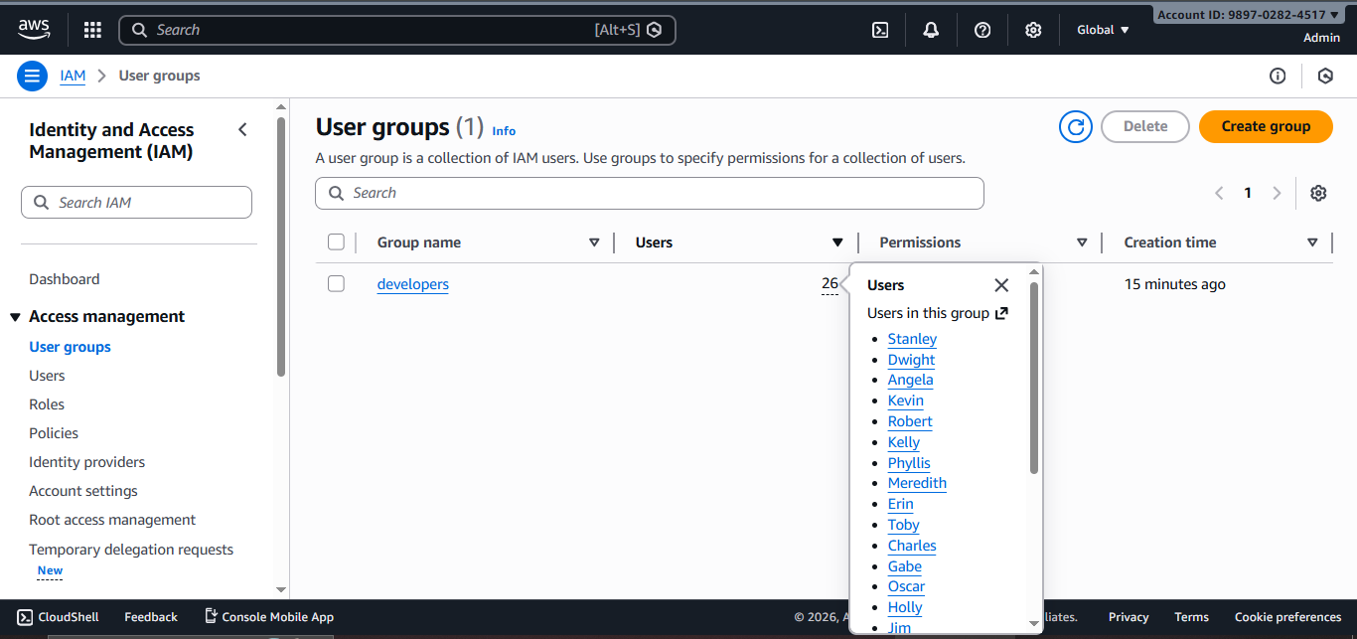
- Verify one user's access keys:
Click on any user (e.g., "Michael")
Go to Security credentials tab
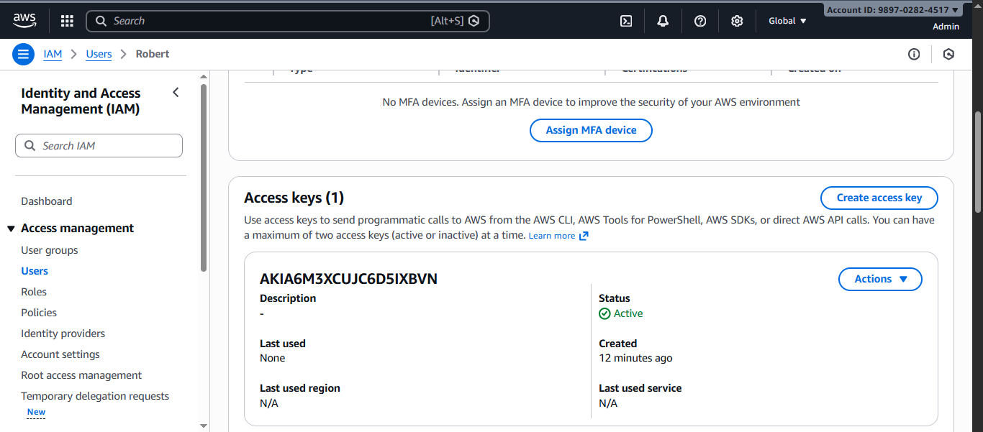
- Check terraform state in S3:
Navigate to S3 bucket and view the state file
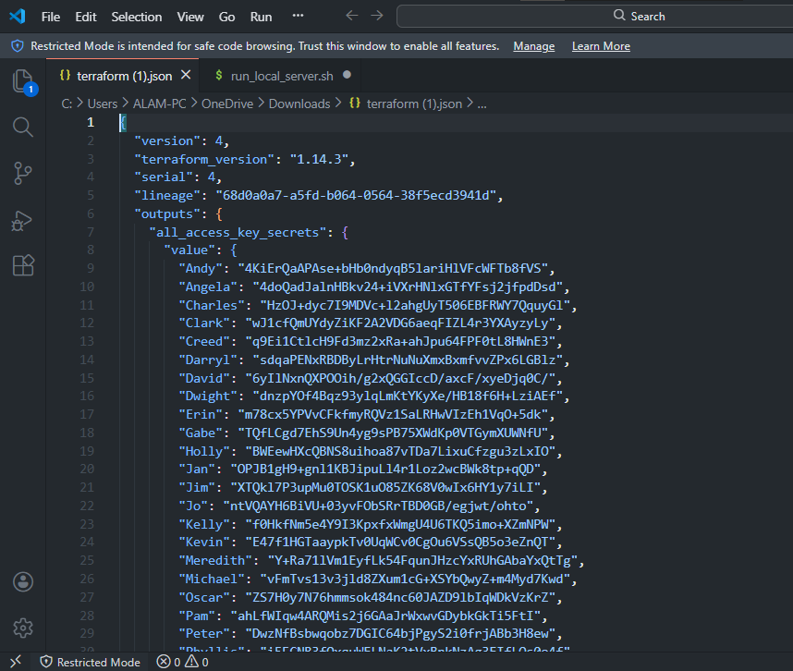

Cleanup
- Destroy all resources:
terraform destroy -auto-approve
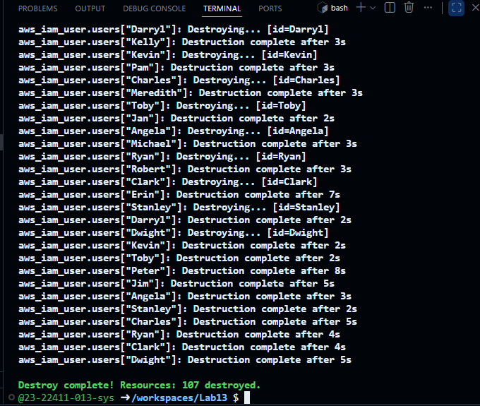
- Verify users deleted in AWS Console:
Navigate to IAM → Users
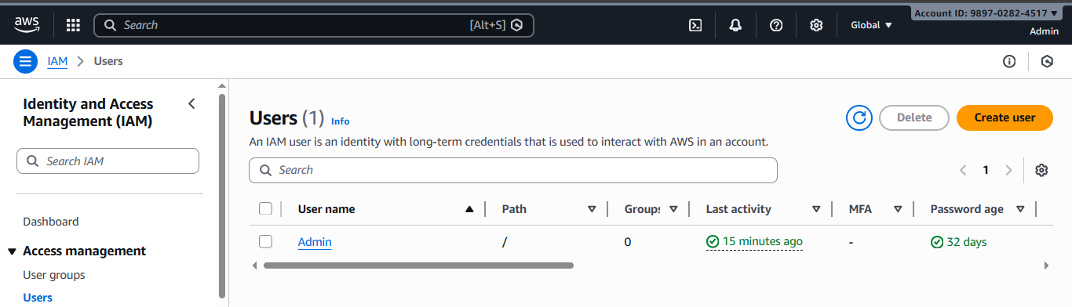
- Verify group deleted in AWS Console:
Navigate to IAM → Groups
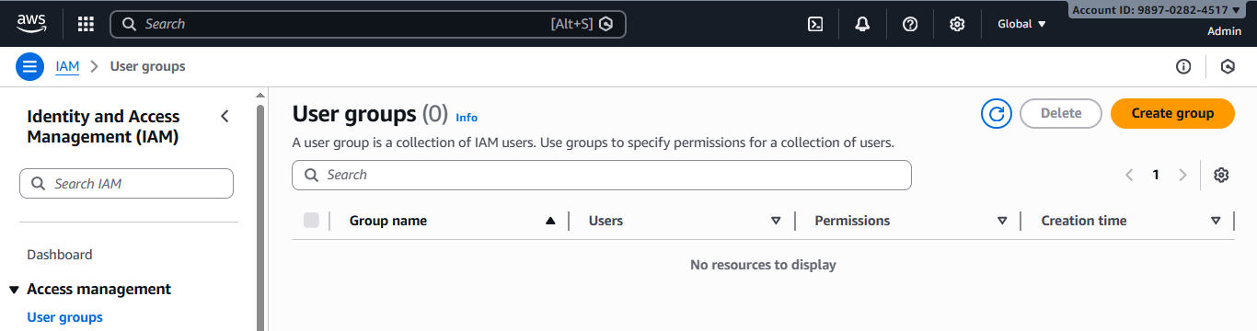
- Check S3 state file:
Navigate to S3 bucket
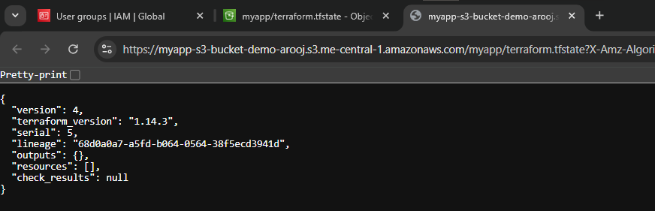
- List all project files:
ls -la
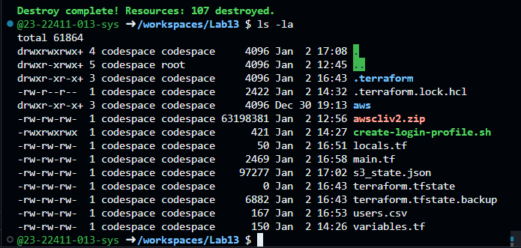
- Delete S3 bucket:
- If you want to clean up completely, delete the S3 bucket from AWS Console
