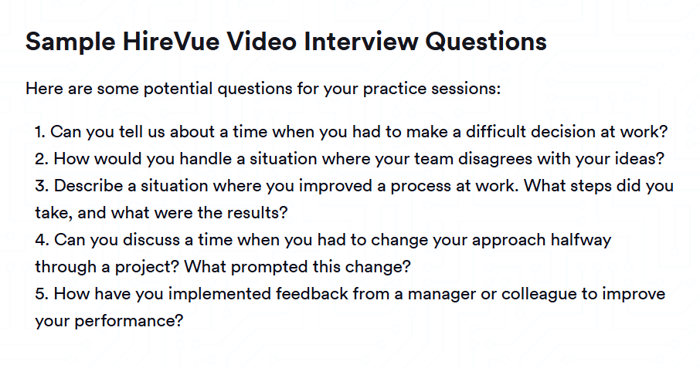

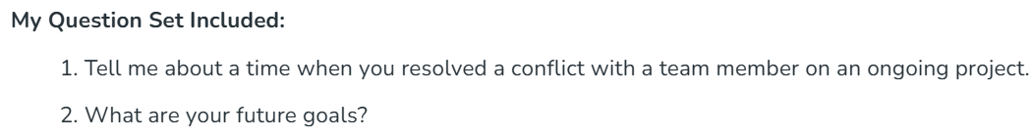

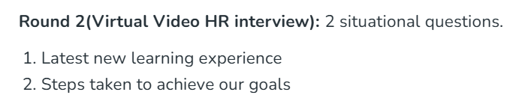

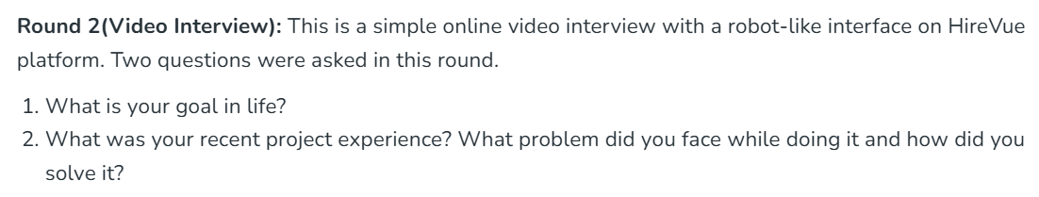

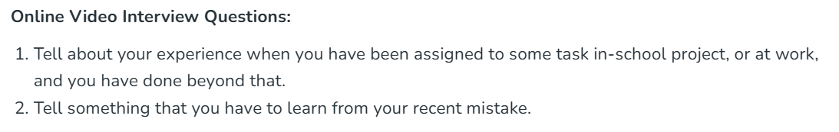

**Question:** *Can you tell us about a time when you had to make a difficult decision at work?*

*🡪 Certainly. While working on a* ***social media platform****, I was responsible for integrating a* ***ReactJS frontend with a Spring Boot backend****. During development, we encountered a critical challenge—****the database design was not optimized for handling real-time user interactions****, leading to performance bottlenecks, especially with features like live comments and notifications.*

*I had two options:* ***implement temporary caching solutions*** *to meet deadlines or* ***redesign the database schema*** *to ensure long-term scalability, which could delay the launch. After analyzing the trade-offs, I collaborated with* ***backend engineers and database architects*** *to evaluate our approach. We decided to* ***refactor the schema****, introducing* ***asynchronous message queues and optimized indexing*** *to enhance data consistency and system performance.*

*To stay on track, I proposed a* ***parallel development approach****, allowing the frontend and backend teams to work independently while database restructuring was in progress. This ensured that development continued smoothly without affecting our release schedule.*

*Ultimately, we* ***successfully deployed a high-performing, scalable social media platform*** *that could handle increased user activity seamlessly. This experience strengthened my ability to* ***make strategic decisions under pressure, balance technical trade-offs, and collaborate effectively****—skills that are highly valuable in a* ***dynamic, innovation-driven environment like J.P. Morgan Chase****.*

***Question:*** *How would you handle a situation where your team disagrees with your ideas?*

*🡪 Collaboration and open communication are key to successful problem-solving. If my team disagrees with my idea, I would first* ***actively listen*** *to their concerns to understand their perspectives. Instead of pushing my viewpoint, I would encourage a* ***constructive discussion****, ensuring that every team member feels heard.*

*Next, I would* ***present data-driven reasoning*** *behind my approach, using technical insights or past experiences to support my proposal. However, I remain open to feedback, as the best solutions often emerge through collective input. If a better alternative arises, I would be* ***flexible in adapting*** *my approach to align with the team's expertise and project goals.*

*In one instance, while developing a* ***React-based social media platform****, I proposed using* ***WebSockets*** *for real-time updates. Some team members preferred* ***polling*** *due to concerns about scalability. Instead of insisting, I facilitated a* ***pros and cons analysis****, conducted a* ***small-scale test****, and ultimately, we combined both methods for an optimized solution.*

*By fostering* ***collaboration, data-driven decision-making, and adaptability****, I ensure that disagreements become opportunities for innovation—an approach that aligns well with J.P. Morgan Chase’s culture of teamwork and problem-solving.*

***Question: Describe a situation where you improved a process at work. What steps did you take, and what were the results?***

***🡪*** *Certainly. While working on a* ***Food Waste Management System****, we faced an issue where* ***data processing was slow****, causing delays in tracking surplus food donations. The system processed large amounts of data from multiple sources, but* ***the inefficient database structure*** *led to performance bottlenecks.*

*To improve this, I took the following steps:*

*1️⃣* ***Analyzed Performance Issues*** *– Used* ***SQL query profiling*** *and* ***monitoring tools*** *to identify slow queries.  
2️⃣* ***Optimized Database Structure*** *– Implemented* ***proper indexing and normalization*** *to enhance query execution speed.  
3️⃣* ***Introduced Caching*** *– Used* ***Redis*** *to store frequently accessed data, reducing redundant database calls.  
4️⃣* ***Parallelized Data Processing*** *– Integrated* ***asynchronous processing*** *with* ***message queues (Kafka)*** *for handling high-volume transactions efficiently.*

*As a result,* ***data retrieval time improved by 50%****, allowing NGOs and food distribution centers to access surplus food records in real time. This not only enhanced system performance but also helped in* ***reducing food waste efficiently****.*

*This experience strengthened my ability to* ***analyze system inefficiencies, implement scalable solutions, and drive impact—key skills in a data-driven environment like J.P. Morgan Chase.***

***Question: Describe a situation where you improved a process at work. What steps did you take, and what were the results?***

***🡪*** *Certainly. While working on a* ***Food Waste Management System****, we noticed inefficiencies in how food donation requests were processed. Initially, the system relied on* ***manual matching****, where NGOs had to* ***manually request food from suppliers****, leading to delays and missed opportunities for redistribution.*

*To improve this, I took the following steps:*

*1️⃣* ***Identified the Bottleneck*** *– Analyzed the system logs and found that* ***manual intervention slowed down matching food donors with NGOs****.  
2️⃣* ***Automated the Matching Process*** *– Developed an* ***AI-based recommendation engine*** *that automatically matched food donations with nearby NGOs based on* ***location, food type, and urgency****.  
3️⃣* ***Implemented Real-Time Notifications*** *– Integrated* ***push notifications and SMS alerts*** *to notify NGOs instantly when a matching donation was available.  
4️⃣* ***Optimized UI for Better Engagement*** *– Redesigned the dashboard to provide a* ***clear, real-time view of available food resources****.*

*As a result,* ***food distribution efficiency increased by 65%****, reducing food wastage and ensuring surplus food reached those in need* ***faster****. Additionally, NGOs reported* ***30% fewer delays****, improving overall system adoption.*

*This experience reinforced my ability to* ***identify inefficiencies, implement automation, and drive impactful solutions—key skills in a data-driven and fast-paced environment like J.P. Morgan Chase.***