实验三Windows应用程序开发

**一、实验目的**

1.掌握窗口控件的使用方法；

2.掌握Windows的编程基础。

**二、实验要求**

根据要求，编写C#程序，并将程序代码和运行结果写入实验报告。

**三、实验内容**

1．编写一个计算器，练习在窗体上添加控件、调整控件的布局，设置或修改控件属性，编写事件处理程序的方法。

1.1在计算器中，增加四个功能键：x2，sqrt，log,ln四个键，分别计算求平方，开方，log，ln值，将增加的代码写入实验报告。

**源代码：**

using System;

using System.Collections.Generic;

using System.ComponentModel;

using System.Data;

using System.Drawing;

using System.Linq;

using System.Text;

using System.Threading.Tasks;

using System.Windows.Forms;

namespace 实训3._1

{

public partial class Form1 : Form

{

double a = 0;

double b = 0;

bool c = false;

string d;

public Form1()

{

InitializeComponent();

}

private void button1_Click(object sender, EventArgs e)

{

if (c == true)

{

textBox1.Text = "";

c = false;

}

textBox1.Text += "7";

}

private void Form1_Load(object sender, EventArgs e)

{

}

private void button9_Click(object sender, EventArgs e)

{

if (c == true)

{

textBox1.Text = "";

c = false;

}

textBox1.Text += "1";

}

private void button10_Click(object sender, EventArgs e)

{

if (c == true)

{

textBox1.Text = "";

c = false;

}

textBox1.Text += "2";

}

private void button11_Click(object sender, EventArgs e)

{

if (c == true)

{

textBox1.Text = "";

c = false;

}

textBox1.Text += "3";

}

private void button8_Click(object sender, EventArgs e)

{

if (c == true)

{

textBox1.Text = "";

c = false;

}

textBox1.Text += "4";

}

private void button7_Click(object sender, EventArgs e)

{

if (c == true)

{

textBox1.Text = "";

c = false;

}

textBox1.Text += "5";

}

private void button5_Click(object sender, EventArgs e)

{

if (c == true)

{

textBox1.Text = "";

c = false;

}

textBox1.Text += "6";

}

private void button2_Click(object sender, EventArgs e)

{

if (c == true)

{

textBox1.Text = "";

c = false;

}

textBox1.Text += "8";

}

private void button3_Click(object sender, EventArgs e)

{

if (c == true)

{

textBox1.Text = "";

c = false;

}

textBox1.Text += "9";

}

private void button13_Click(object sender, EventArgs e)

{

if (c == true)

{

textBox1.Text = "";

c = false;

}

textBox1.Text += "0";

if (d == "/")

{

textBox1.Clear();

MessageBox.Show("除数不能为零", "错误提示", MessageBoxButtons.OK,

MessageBoxIcon.Warning);

}

}

private void button15_Click(object sender, EventArgs e)

{

c = true;

b = double.Parse(textBox1.Text);

d = "+";

}

private void button4_Click(object sender, EventArgs e)

{

c = true;

b = double.Parse(textBox1.Text);

d = "/";

}

private void button6_Click(object sender, EventArgs e)

{

c = true;

b = double.Parse(textBox1.Text);

d = "*";

}

private void button12_Click(object sender, EventArgs e)

{

c = true;

b = double.Parse(textBox1.Text);

d = "-";

}

private void button16_Click(object sender, EventArgs e)

{

switch (d)

{

case "+": a = b + double.Parse(textBox1.Text); break;

case "-": a = b - double.Parse(textBox1.Text); break;

case "*": a = b * double.Parse(textBox1.Text); break;

case "/": a = b / double.Parse(textBox1.Text); break;

}

textBox1.Text = a + "";

c = true;

}

private void button14_Click(object sender, EventArgs e)

{

textBox1.Text = "";

}

private void button17_Click(object sender, EventArgs e)

{

b = double.Parse(textBox1.Text);

a = b * b;

textBox1.Text = a + "";

c = true;

}

private void button18_Click(object sender, EventArgs e)

{

if (double.Parse(textBox1.Text) < 0)

{

MessageBox.Show("除数不能为0", "错误提示", MessageBoxButtons.OK, MessageBoxIcon.Warning);

}

b = double.Parse(textBox1.Text);

a = Math.Sqrt(b); //Math.Sqrt（double a）函数用于求开方运算

textBox1.Text = a + "";

c = true;

}

private void button19_Click(object sender, EventArgs e)

{

if (double.Parse(textBox1.Text) < 0)

{

MessageBox.Show("指数不能为0", "错误提示", MessageBoxButtons.OK, MessageBoxIcon.Warning);

}

b = double.Parse(textBox1.Text);

a = Math.Log(b); //Math.Log(double b)函数用于求ln运算，以e为底

textBox1.Text = a + "";

c = true;

}

private void button20_Click(object sender, EventArgs e)

{

if (double.Parse(textBox1.Text) < 0)

{

MessageBox.Show("指数不能为0", "错误提示", MessageBoxButtons.OK, MessageBoxIcon.Warning);

}

b = double.Parse(textBox1.Text);

a = Math.Log10(b); //Math.Log10(double b)函数用于求log运算，以10为底

textBox1.Text = a + "";

c = true;

}

}

}

**结果截图：**

加法：

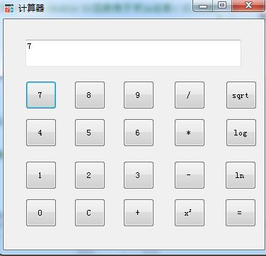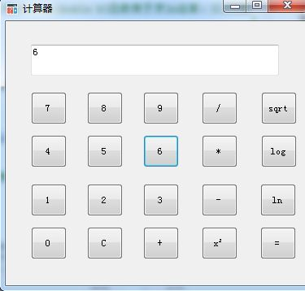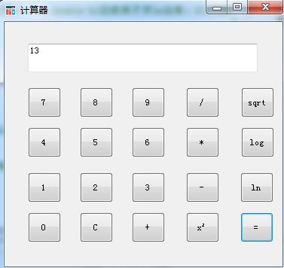

平方：

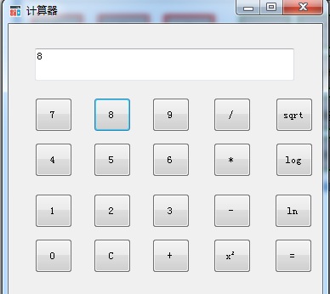

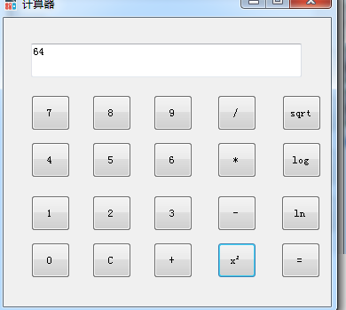

2．自己设计并编写一个Windows应用程序，要求至少用到TextBox、GroupBox、RadioButton、CheckBox、ComboBox、ListBox控件。将程序功能、界面布局和运行结果的截图与事件代码写在实验报告中。

**程序功能：**

学生网注册功能。

截图：

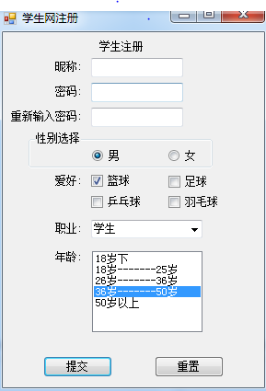

**四、实验总结**

通过这次的实验，学会了很多插件的使用和插件的属性，对于今后

制作Windows form有很大的帮助。比如：获取TextBox框的值，TextBox.text就可以，button，radio等都可以通过text属性获取值，其实就是控件的一些属性值。