B/S结构用户界面设计

【实验编号】
10003809548j Web界面设计
【实验学时】
8学时
【实验环境】
- 所需硬件环境为微机；
- 所需软件环境为dreamweaver
【实验内容】
按照一个框网页来仿制一个网页

【关键步骤】
<!DOCTYPE html PUBLIC "-//W3C//DTD XHTML 1.0 Transitional//EN" "http://www.w3.org/TR/xhtml1/DTD/xhtml1-transitional.dtd">
<html style="overflow-x: hidden; overflow-y: scroll;" xmlns="http://www.w3.org/1999/xhtml">
<head>
<meta http-equiv="Content-Type" content="text/html; charset=UTF-8"/>
<meta name="description" content="淘宝，京东，天猫，亚马逊，国美，苏宁...你去这些网站，95%都是先搜索，为什么不找个地方把入口汇总呢？所以，有了一个框。"/>
<meta name="keywords" content="网购 入口 搜索 京东 淘宝 天猫 亚马逊 国美 苏宁"/>
<meta http-equiv="Pragma" content="no-cache"/>
<meta http-equiv="Cache-Control" content="no-cache"/>
<meta http-equiv="Expires" content="0"/>
<meta property="wb:webmaster" content="9404f82f9a6b0829" />
<link rel="icon" type="image/ico" href="./favicon.ico?v=1409151118"/>
<script src="js/wb.js" type="text/javascript" charset="utf-8"></script>
<script>
var _hmt = _hmt || [];
</script>
<html xmlns:wb="http://open.weibo.com/wb">
<link rel="stylesheet" href="css/jquery-ui.min.css" />
<link media="all" rel="stylesheet" type="text/css" href="css/style_201409111838.css" />
<title>一个框 | 网购最快入口</title>
</head>
<body>
<div id="wrapper">
<div id="main">
<div class="head">
<a href="/"><img class="headimg" src="picture/ygkhead.png"></a>
</div>
<div class="superarea">
<div class="searchbox">
<div class="searchboxtitlebk" id="searchboxtitlebk">
<div class="searchboxtitle"></div>
</div>
<div class="searchfielddiv" id="searchfielddiv">
<input class="searchfield" id="searchfield">
</div>
<div class="searchbutton" id="searchbutton"></div>
</div>
<div class="clear"></div>
<div class="searchoption">
<div class="eachmall" mallid=1>
<div class="mallitem jditeminactive" id="jditem"></div>
</div>
<div class="eachmall" mallid=2>
<div class="mallitem taobaoiteminactive" id="taobaoitem"></div>
</div>
<div class="eachmall" mallid=3>
<div class="mallitem tmalliteminactive" id="tmallitem"></div>
</div>
<div class="eachmall" mallid=4>
<div class="mallitem ziteminactive" id="zitem"></div>
</div>
<div class="eachmall" mallid=5>
<div class="mallitem suningiteminactive" id="suningitem"></div>
</div>
<div class="eachmall" mallid=6>
<div class="mallitem yhditeminactive" id="yhditem"></div>
</div>
<div class="eachmall" mallid=7>
<div class="mallitem gditeminactive" id="gditem"></div>
</div>
</div>
<div class="clear"></div>
<div class="tip" id="tip" style="display:block">
<div class="tiparrow"></div>
<div class="tiparea" id="tiparea"></div>
</div>
</div>
<div class="clear"></div>
<div class="navarea" style="">

<!--最常用商城-->
<div class="navparagraph hotmalls">
<div class="navhead twoline hothead">
常用商城导航
</div>
<div class="navitems">
<a class="navhotitem" href="http://www.jd.com/" target="_blank">
<span class="navmallname"><span class="navmallfavicon jdfavicon"></span>京东商城</span>
</a>
<a class="navhotitem" href="http://www.amazon.cn/" target="_blank">
<span class="navmallname"><span class="navmallfavicon zfavicon"></span>亚马逊中国</span>
</a>
<a class="navhotitem" href="http://www.suning.com/" target="_blank">
<span class="navmallname"><span class="navmallfavicon snfavicon"></span>苏宁易购</span>
</a>
<a class="navhotitem" href="http://www.yhd.com/" target="_blank">
<span class="navmallname"><span class="navmallfavicon yhdfavicon"></span>1号店</span>
</a>
<a class="navhotitem" href="http://www.yixun.com/" target="_blank">
<span class="navmallname"><span class="navmallfavicon yxfavicon"></span>易迅网</span>
</a>
</div>
<div class="navitems">
<a class="navhotitem" href="http://www.tmall.com/" target="_blank">
<span class="navmallname"><span class="navmallfavicon tmfavicon"></span>天猫</span>
</a>
<a class="navhotitem" href="http://www.taobao.com/" target="_blank">
<span class="navmallname"><span class="navmallfavicon tbfavicon"></span>淘宝</span>
</a>
<a class="navhotitem" href="http://www.gome.com.cn/" target="_blank">
<span class="navmallname"><span class="navmallfavicon gmfavicon"></span>国美在线</span>
</a>
<a class="navhotitem" href="http://www.sfbest.com/" target="_blank">
<span class="navmallname"><span class="navmallfavicon sffavicon"></span>顺丰优选</span>
</a>
<a class="navhotitem" href="http://zhi.fyigou.com" target="_blank">
<span class="navmallname"><span class="navmallfavicon gdfavicon"></span>好值得</span>
</a>
</div>
</div>

<!--家居日用-->
<div class="navparagraph">
<div class="navhead twoline">
家居日用
</div>
<div class="navitems">
<a class="navitem" href="http://www.feifei.com/" target="_blank">
<span class="navmallname">飞飞商城</span>
</a>
<a class="navitem" href="http://www.muji.com.cn/cn/store/" target="_blank">
<span class="navmallname">MUJI无印良品</span>
</a>
<a class="navitem" href="http://www.j1.com/" target="_blank">
<span class="navmallname">健一网</span>
</a>
<a class="navitem" href="http://www.meilele.com/" target="_blank">
<span class="navmallname">美乐乐家具</span>
</a>
<a class="navitem" href="http://www.a-life.cn/" target="_blank">
<span class="navmallname">a-life最生活</span>
</a>
</div>
<div class="navitems">
<a class="navitem" href="http://www.dapu.com/" target="_blank">
<span class="navmallname">大朴网</span>
</a>
<a class="navitem" href="http://www.purcotton.com/" target="_blank">
<span class="navmallname">全棉时代</span>
</a>
<a class="navitem" href="http://www.beyond.cn/" target="_blank">
<span class="navmallname">博洋家纺</span>
</a>
<a class="navitem" href="http://www.chunshuitang.com/" target="_blank">
<span class="navmallname">春水堂</span>
</a>
<a class="navitem" href="http://www.x.com.cn/" target="_blank">
<span class="navmallname">桔色商城</span>
</a>
</div>
</div>

<!--食品母婴-->
<div class="navparagraph">
<div class="navhead twoline">
食品母婴
</div>
<div class="navitems">
<a class="navitem" href="http://www.yhd.com/" target="_blank">
<span class="navmallname">1号店</span>
</a>
<a class="navitem" href="http://www.sfbest.com/" target="_blank">
<span class="navmallname">顺丰优选</span>
</a>
<a class="navitem" href="http://www.tootoo.cn/" target="_blank">
<span class="navmallname">沱沱工社</span>
</a>
<a class="navitem" href="http://www.benlai.com/" target="_blank">
<span class="navmallname">本来生活</span>
</a>
<a class="navitem" href="http://miao.tmall.com/" target="_blank">
<span class="navmallname">喵鲜生</span>
</a>
</div>
<div class="navitems">
<a class="navitem" href="http://www.womai.com/" target="_blank">
<span class="navmallname">我买网</span>
</a>
<a class="navitem" href="http://www.yesmywine.com/" target="_blank">
<span class="navmallname">也买酒</span>
</a>
<a class="navitem" href="http://www.gdcct.com/" target="_blank">
<span class="navmallname">村村通</span>
</a>
<a class="navitem" href="http://www.muyingzhijia.com/" target="_blank">
<span class="navmallname">母婴之家</span>
</a>
<a class="navitem" href="http://redbaby.suning.com/" target="_blank">
<span class="navmallname">红孩子</span>
</a>
</div>
</div>

<!--数码家电-->
<div class="navparagraph">
<div class="navhead oneline">
数码家电
</div>
<div class="navitems">
<a class="navitem" href="http://www.jd.com/" target="_blank">
<span class="navmallname">京东商城</span>
</a>
<a class="navitem" href="http://www.amazon.cn/" target="_blank">
<span class="navmallname">亚马逊中国</span>
</a>
<a class="navitem" href="http://www.newegg.cn/" target="_blank">
<span class="navmallname">新蛋中国</span>
</a>
<a class="navitem" href="http://www.vmall.com/" target="_blank">
<span class="navmallname">华为商城</span>
</a>
<a class="navitem" href="http://www.mi.com/" target="_blank">
<span class="navmallname">小米商城</span>
</a>
</div>
</div>

<!--服装鞋帽-->
<div class="navparagraph">
<div class="navhead twoline">
服装鞋帽
</div>
<div class="navitems">
<a class="navitem" href="http://www.vip.com/" target="_blank">
<span class="navmallname">唯品会</span>
</a>
<a class="navitem" href="http://www.gap.cn/" target="_blank">
<span class="navmallname">Gap中国官网</span>
</a>
<a class="navitem" href="http://www.uniqlo.cn/" target="_blank">
<span class="navmallname">优衣库</span>
</a>
<a class="navitem" href="http://www.handu.com/" target="_blank">
<span class="navmallname">韩都衣舍</span>
</a>
<a class="navitem" href="http://www.vancl.com/" target="_blank">
<span class="navmallname">凡客</span>
</a>
</div>
<div class="navitems">
<a class="navitem" href="http://www.aimer.com.cn/" target="_blank">
<span class="navmallname">爱慕</span>
</a>
<a class="navitem" href="http://www.vjia.com/" target="_blank">
<span class="navmallname">V+商城</span>
</a>
<a class="navitem" href="http://www.taoxie.com/" target="_blank">
<span class="navmallname">淘鞋网</span>
</a>
<a class="navitem" href="http://www.forever21.cn/" target="_blank">
<span class="navmallname">Forever21</span>
</a>
<a class="navitem" href="http://www.mbaobao.com/" target="_blank">
<span class="navmallname">麦包包</span>
</a>
</div>
</div>

<!--美妆配饰-->
<div class="navparagraph">
<div class="navhead oneline">
美妆配饰
</div>
<div class="navitems">
<a class="navitem" href="http://www.jumei.com" target="_blank">
<span class="navmallname">聚美优品</span>
</a>
<a class="navitem" href="http://www.lefeng.com/" target="_blank">
<span class="navmallname">乐蜂网</span>
</a>
<a class="navitem" href="http://www.zhiwo.com/" target="_blank">
<span class="navmallname">知我药妆</span>
</a>
<a class="navitem" href="http://cn.strawberrynet.com/main.aspx" target="_blank">
<span class="navmallname">草莓网</span>
</a>
<a class="navitem" href="http://web1.sasa.com/SasaWeb/cn/sasa/home.jsp" target="_blank">
<span class="navmallname">Sasa</span>
</a>
</div>
</div>

<!--图书音像-->
<div class="navparagraph">
<div class="navhead oneline">
图书音像
</div>
<div class="navitems">
<a class="navitem" href="http://www.amazon.cn/" target="_blank">
<span class="navmallname">亚马逊中国</span>
</a>
<a class="navitem" href="http://www.china-pub.com/" target="_blank">
<span class="navmallname">China-pub</span>
</a>
<a class="navitem" href="http://www.bookuu.com" target="_blank">
<span class="navmallname">博库网</span>
</a>
<a class="navitem" href="http://www.winxuan.com/" target="_blank">
<span class="navmallname">文轩网</span>
</a>
<a class="navitem" href="http://www.wl.cn/" target="_blank">
<span class="navmallname">蔚蓝网</span>
</a>
</div>
</div>

<!--团购-->
<div class="navparagraph">
<div class="navhead oneline">
团购
</div>
<div class="navitems">
<a class="navitem" href="http://www.meituan.com" target="_blank">
<span class="navmallname">美团网</span>
</a>
<a class="navitem" href="http://t.dianping.com" target="_blank">
<span class="navmallname">大众点评团</span>
</a>
<a class="navitem" href="http://www.nuomi.com" target="_blank">
<span class="navmallname">糯米网</span>
</a>
<a class="navitem" href="http://www.55tuan.com" target="_blank">
<span class="navmallname">窝窝团</span>
</a>
<a class="navitem" href="http://www.lashou.com" target="_blank">
<span class="navmallname">拉手网</span>
</a>
</div>
</div>

<!--海淘网站-->
<div class="navparagraph">
<div class="navhead twoline">
海淘网站
</div>
<div class="navitems">
<a class="navitem" href="http://www.amazon.com/" target="_blank">
<span class="navmallname">美国亚马逊</span>
</a>
<a class="navitem" href="http://www.amazon.co.jp/" target="_blank">
<span class="navmallname">日本亚马逊</span>
</a>
<a class="navitem" href="http://www.ebay.com/" target="_blank">
<span class="navmallname">eBay</span>
</a>
<a class="navitem" href="http://www.6pm.com/" target="_blank">
<span class="navmallname">6pm</span>
</a>
<a class="navitem" href="http://www.sierratradingpost.com/" target="_blank">
<span class="navmallname">STP</span>
</a>
</div>
<div class="navitems">
<a class="navitem" href="http://www.drugstore.com/" target="_blank">
<span class="navmallname">drugstore</span>
</a>
<a class="navitem" href="http://www.woot.com/" target="_blank">
<span class="navmallname">woot</span>
</a>
<a class="navitem" href="http://www.gnc.com/home/index.jsp" target="_blank">
<span class="navmallname">GNC美国官网</span>
</a>
<a class="navitem" href="http://www.ashford.com/us/home" target="_blank">
<span class="navmallname">Ashford</span>
</a>
<a class="navitem" href="http://www.iherb.com/" target="_blank">
<span class="navmallname">iherb</span>
</a>
</div>
</div>

<!--导购好站-->
<div class="navparagraph">
<div class="navhead twoline">
导购好站
</div>
<div class="navitems">
<a class="navitem" href="http://zhi.fyigou.com" target="_blank">
<span class="navmallname">好值得买</span>
</a>
<a class="navitem" href="http://www.smzdm.com/" target="_blank">
<span class="navmallname">什么值得买</span>
</a>
<a class="navitem" href="http://www.mgpyh.com/" target="_blank">
<span class="navmallname">买个便宜货</span>
</a>
<a class="navitem" href="http://www.huihui.cn" target="_blank">
<span class="navmallname">惠惠网</span>
</a>
<a class="navitem" href="http://www.yifen.com/" target="_blank">
<span class="navmallname">一分网</span>
</a>
</div>
<div class="navitems">
<a class="navitem" href="http://www.zhe800.com/" target="_blank">
<span class="navmallname">折800</span>
</a>
<a class="navitem" href="http://www.55haitao.com/" target="_blank">
<span class="navmallname">55海淘</span>
</a>
<a class="navitem" href="http://www.tsdxb.com/" target="_blank">
<span class="navmallname">天上掉馅饼</span>
</a>
<a class="navitem" href="http://best.pconline.com.cn/" target="_blank">
<span class="navmallname">今日聚超值</span>
</a>
<a class="navitem" href="http://www.zhizhizhi.com/" target="_blank">
<span class="navmallname">值值值</span>
</a>
</div>
</div>
</div>
<div class="clear"></div>
<div class="footer">
<b>Ctrl+D</b>&nbsp;将本站添加到收藏夹&nbsp;|&nbsp;&copy;2016 <a href="http://www.fyigou.com/" style="color:#c8c8c8;text-decoration:underline" target="_blank">制作：</a>李国帅（精仿一个框）</div>
</div>
</div>
<script src="js/jquery-1.9.1.min.js"></script>
<script src="js/jquery-ui.min.js"></script>
<script type='text/javascript'>
var tipclick=0;
var timeStr=new Date().getTime();
if(tipclick==0)
{
$.get("setcookie.php?name=tipclick&value=1");
}
else if(tipclick==1)
{
$.get("setcookie.php?v="+timeStr+"&name=tipclick&value=2");
}
</script>

<script type='text/javascript'>
var _jjl = new Date().toDateString().replace(/\s/g, '') + new Date().toTimeString().replace(/:\d{2}:\d{2}\sUTC[+]\d{4}$/g, '');
document.write(unescape("%3Cscript src='http://p.yiqifa.com/js/juejinlian.js' type='text/javascript'%3E%3C/script%3E"));
document.write(unescape("%3Cscript src='http://p.yiqifa.com/jj?_jjl.js' type='text/javascript'%3E%3C/script%3E"));
document.write(unescape("%3Cscript src='http://p.yiqifa.com/js/md.js' type='text/javascript'%3E%3C/script%3E"));
</script>
<script type='text/javascript'>
try{
var siteId = 319382;
document.write(unescape("%3Cscript src='http://p.yiqifa.com/jj?sid=" + siteId + "&_jjl.js' type='text/javascript'%3E%3C/script%3E"));
var jjl = JueJinLian._init();
jjl._addWid(siteId);
jjl._addE("");
jjl._addScope(0);
jjl._run();
}catch(e){}
</script>
<script src="js/buyindex_201409111838.js"></script>
</body>
</html>

【程序运行截图】
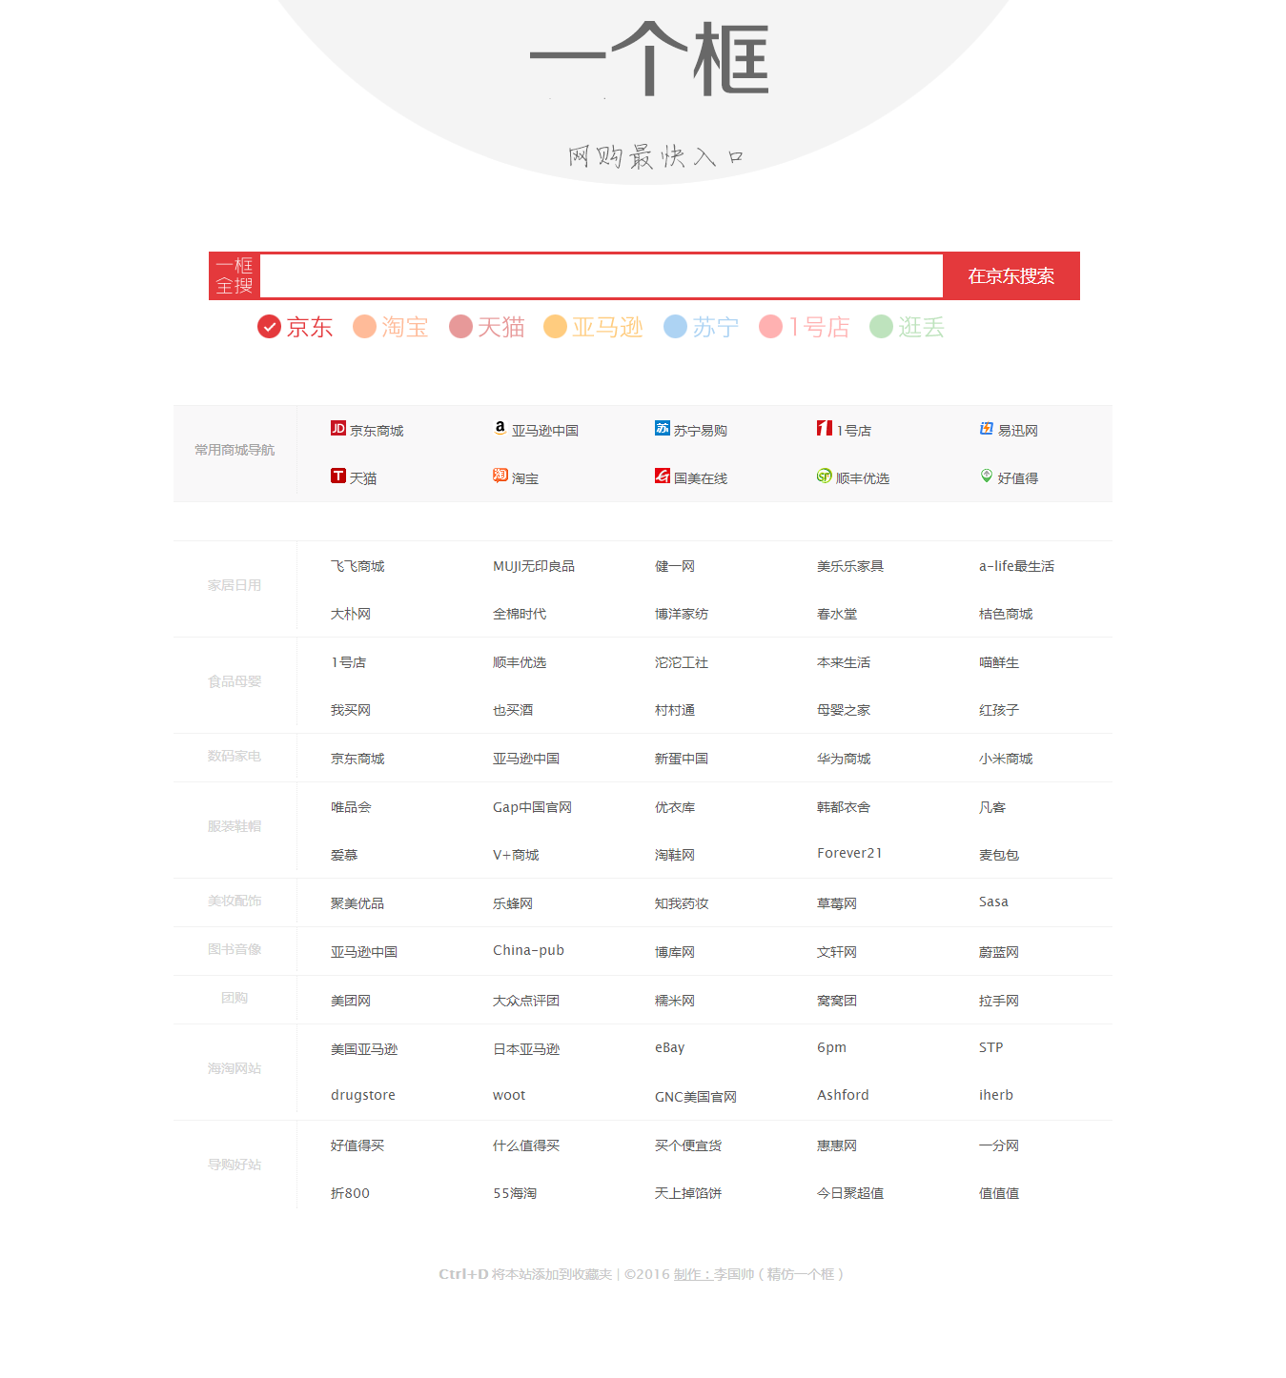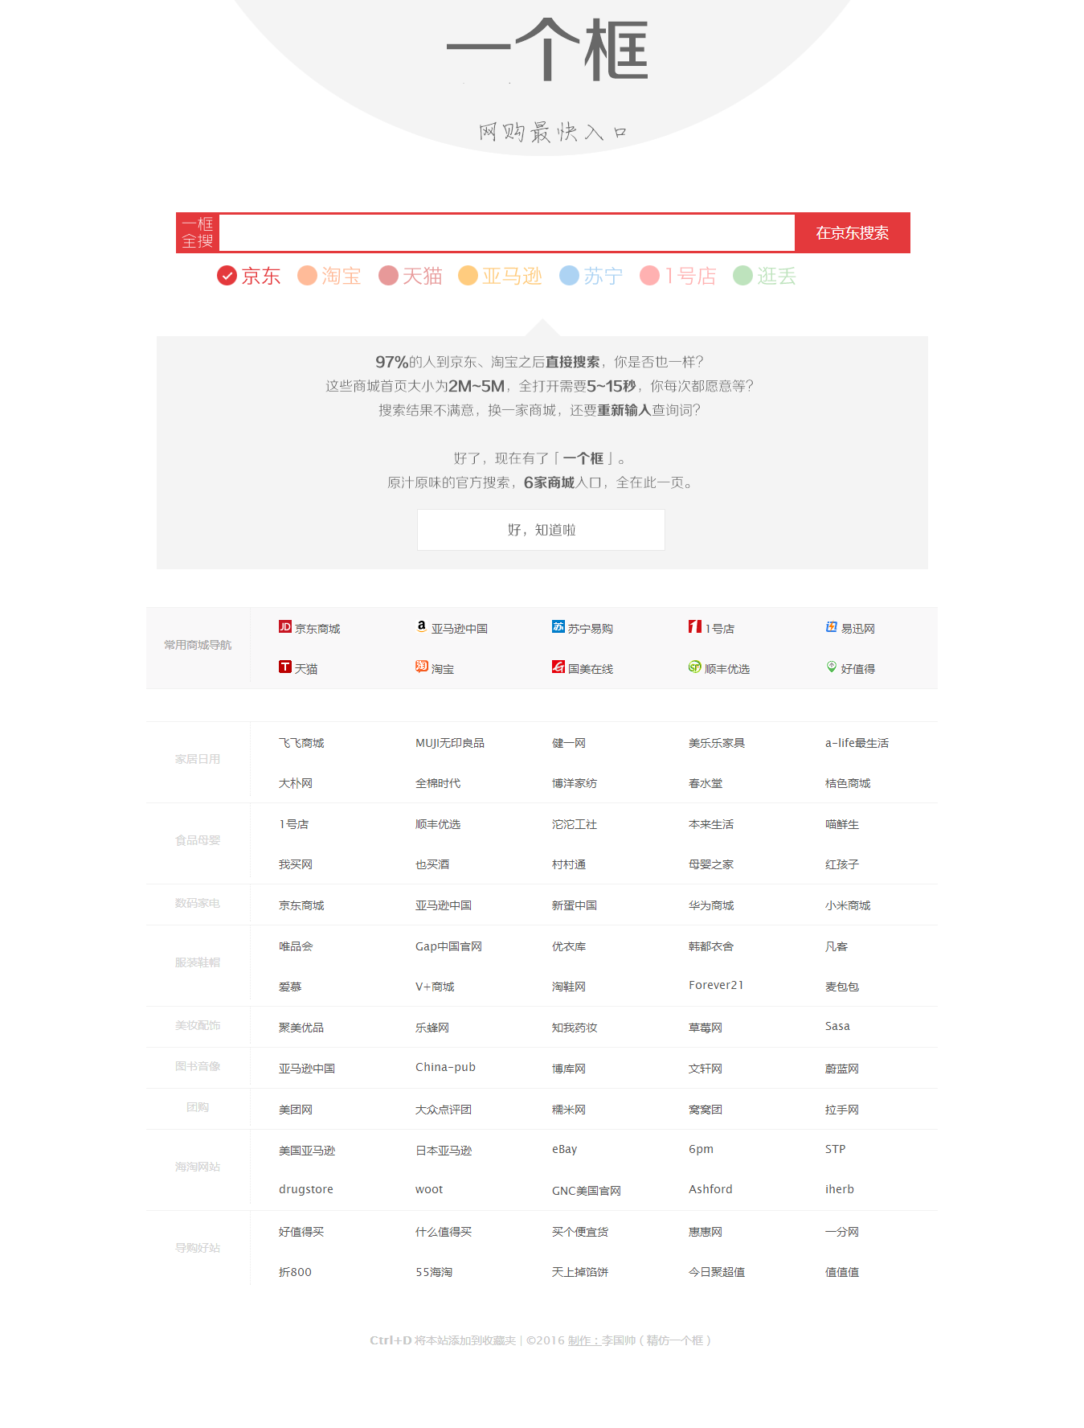

【实验体会】
经过这次的实验，学会了怎样在页面上布局，也就是怎样来设计页面的布局，怎样布局能够使得页面更加的美观，简洁，不会让人眼花缭乱，运用dreamweaver来设计页面，在把生成的代码复制到eclipse中运行。这次的实验让我更加了解了页面的布局和怎样来布局，把老师上课时讲的那些人机交互的内容，实践到自己的网页上，让我初步的掌握了布局的设计，这对我以后学习与工作有很大的帮助。说道为什么要做这样的网页，主要是平时买东西的时候要到各个网购网站去搜索，太麻烦。在看到一个框网站的时候，突然被他吸引了，这个网站很方便，在一个页面上就可以在不同的网购网站上搜索自己想要的东西。基于这一点我便按照一个框仿制了一个网页。

