课程设计报告书

数据库系统开发综合训练
--- XXX系统

班 级： 信1405-2班
学 号： 20142998
姓 名： 李国帅
指导教师： 杨子光

石家庄铁道大学信息学院
2016年9月10日
- 功能概述
爱阅读小说网是建立在信息技术的基础上，以系统化的管理，为网民提供了最新小说来源平台，其核心思想是提供小说的类型，书号，书名和其作者，方便读者了解小说的信息。它整合了用户登录、管理员登录、添加小说、删除小说、修改小说信息、查找小说信息、注册等七个功能模块。
登录
登录这一模块，主要功能有：用户输入账号与密码，并对账号与密码的输入情况进行处理，新用户注册以及对注册内容的审核，提交和重置。其中除了重置的其余各个部分都与数据库进行了连接与相应的增、查、匹配工作。
- 用户注册
这一模块，主要是采集新用户的信息，包括账号，密码。同时，系统自动将其存入SQL数据库，便于以后查看与使用。
- 添加小说
这一模块，主要是收集小说的信息，包括类别、书号、书名、作者的等。点击添加按钮，系统将其存入SQL数据库中，并显示在首页上。
- 删除小说
这一模块，主要是删除不需要的小说，包括删除小说的类别、书号、书名、作者等。
- 修改小说信息
这一模块，主要是应对小说信息错误或者小说信息更新所产生的与数据库中原信息不符的情况，修改小说信息并更新数据库中的小说信息。
- 查询小说
这一模块，主要是用来查找小说是否在数据库中并查找出小说的信息，让用户更加方便的来了解小说的信息。

二、数据库设计
1.yonghu(用户的相关信息)
zhanghu | Char(10) | Primary key
mima | Char(10)
shengfen | Char(2)
2.shu(小说的相关信息)
leibie | Char(2)
shuhao | Char(10) | Primary key
shuming | Char(10)
zuozhe | Char(10)

三、界面设计
1．登录界面
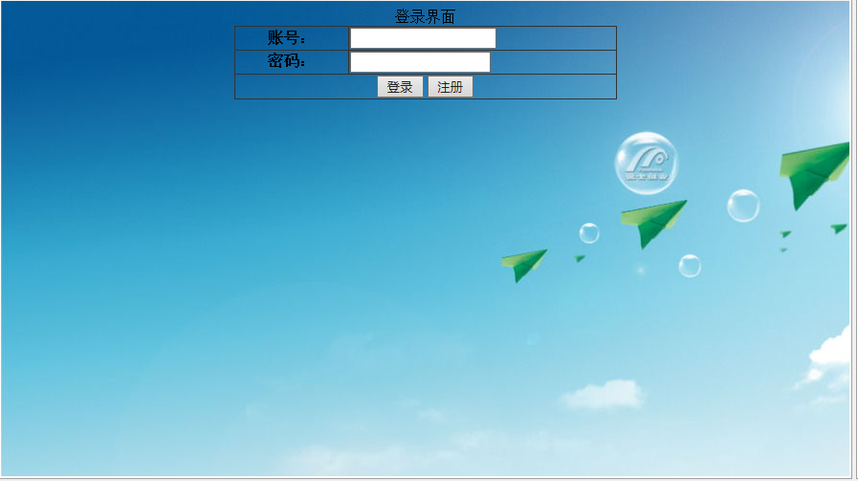

2.员工注册界面
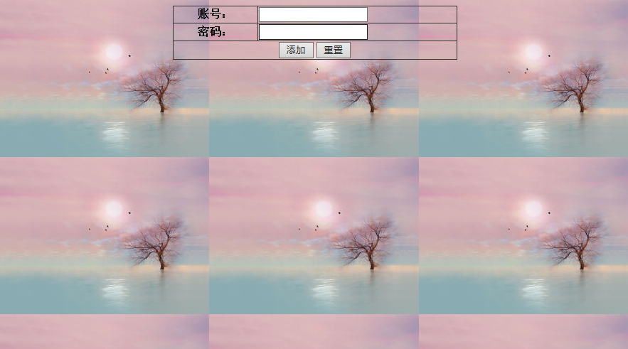

3.主界面
(1)
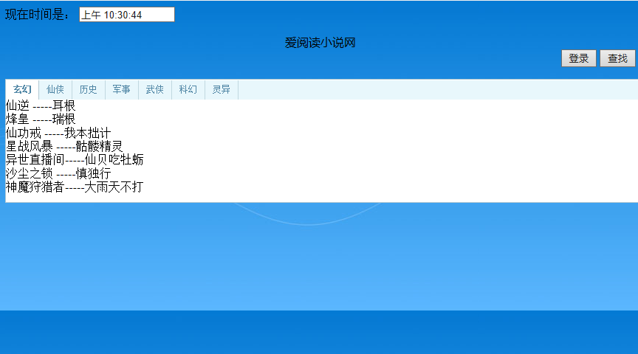
（2）用户登录界面
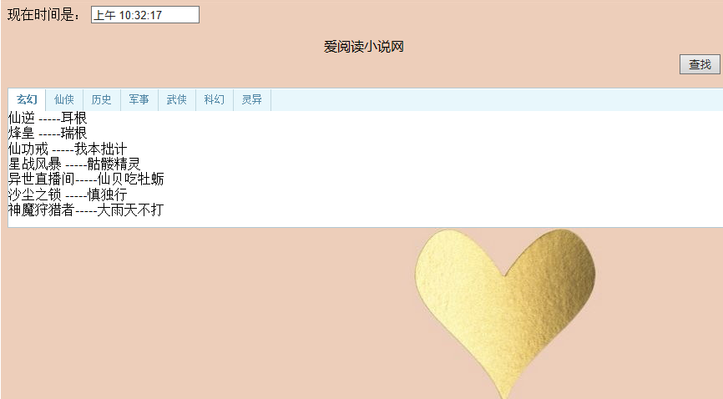
（3）管理员登录界面
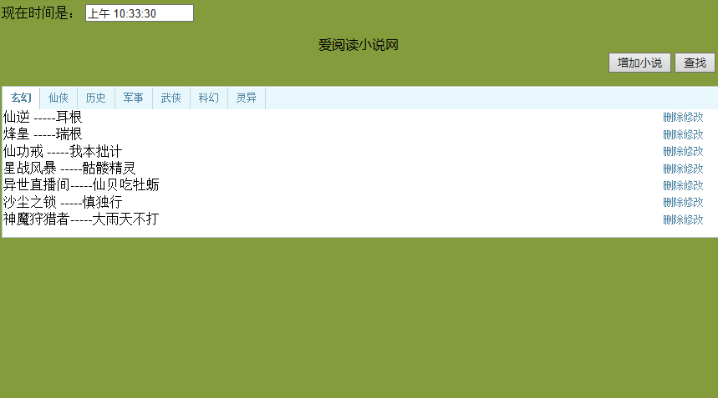

4.添加小说界面

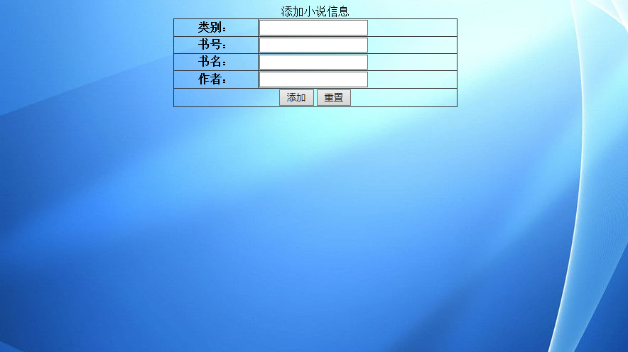
5.查找小说界面


- 关键代码
- 数据库的链接
- package bean;

- import java.sql.*;

- public class DBBean {
- private String driverStr = "com.microsoft.sqlserver.jdbc.SQLServerDriver";
- private String connStr = "jdbc:sqlserver://localhost:1433;DatabaseName=xiaoshuo";
- private String dbusername = "sa";
- private String dbpassword = "123";
- private Connection conn = null;
- private Statement stmt = null;

- public DBBean() {
- try {
- Class.forName(driverStr);
- conn = DriverManager.getConnection(connStr, dbusername, dbpassword);
- stmt = conn.createStatement();

- } catch (Exception ex) {
- System.out.println("无法同数据库建立连接！");
- }
- }

- public int executeUpdate(String s) {
- int result = 0;
- try {
- result = stmt.executeUpdate(s);
- } catch (Exception ex) {
- System.out.println("执行查询错误！");
- }
- return result;
- }

- public ResultSet executeQuery(String s) {
- ResultSet rs = null;
- try {
- rs = stmt.executeQuery(s);
- } catch (Exception ex) {
- System.out.println("执行更新错误！");
- }
- return rs;
- }

- public void close() {
- try {
- stmt.close();
- conn.close();
- } catch (Exception e) {
- }
- }
- }

- /*public class DBBean {
- public static void main(String [] args)
- {
- String driverName="com.microsoft.sqlserver.jdbc.SQLServerDriver";
- String dbURL="jdbc:sqlserver://localhost:1433;DatabaseName=xiaoshuo";
- String userName="sa";
- String userPwd="123";
- try
- {
- Class.forName(driverName);
- System.out.println("加载驱动成功！");
- }catch(Exception e){
- e.printStackTrace();
- System.out.println("加载驱动失败！");
- }
- try{
- Connection dbConn=DriverManager.getConnection(dbURL,userName,userPwd);
- System.out.println("连接数据库成功！");
- }catch(Exception e)
- {
- e.printStackTrace();
- System.out.print("数据库连接失败！");
- }
- }

- }*/

2. 登陆界面 denglu.jsp
<%@ page import="java.sql.*" import ="java.util.*" language="java" contentType="text/html; charset=utf-8"
pageEncoding="utf-8"%>
<!DOCTYPE html PUBLIC "-//W3C//DTD HTML 4.01 Transitional//EN" "http://www.w3.org/TR/html4/loose.dtd">
<html>
<head>
<meta http-equiv="Content-Type" content="text/html; charset=utf-8">
<title>用户登录</title>
<style type="text/css">
table {
border-collapse: collapse;
border: none;
margin: 0px auto;
width: 400px;
}
th, td {
border: solid #333 1px;
height: 20px;
}
div {
text-align: center;
}
</style>
</head>
<body background="lop.jpg">
<form action="denglu.jsp" method="post">
<table>
<caption>登录界面</caption>
<tr>
<th width="30%">账号：</th>
<td width="70%"><input name="zhanghao" type="text" onkeydown="checkUsername()"><span id="usernameMsg"></span></td>
</tr>
<tr>
<th>密码：</th>
<td><input type="password" name="mima" type="text"></td>
</tr>

<tr>
<th colspan="2"><input type="submit" name="submit" value="登录">
<input type="button" name="jump" value= "注册" onclick="location.href='zhuce.jsp'"/>
</th>
</tr>
</table>

</form>
<jsp:useBean id="db" class="bean.DBBean" scope="page" />
<%
request.setCharacterEncoding("UTF-8");
String submit = request.getParameter("submit");
boolean accounttf=false;
boolean passtf=false;
String shengfen=null;
try{
if (submit != null && !submit.equals("")) {
String zhanghao = request.getParameter("zhanghao");
String mima = request.getParameter("mima");
if (zhanghao.equals("1") && mima.equals("123"))
response.setHeader("refresh", "1;url=shouye2.jsp");
else {
String sql = "select * from yonghu where zhanghao='" + zhanghao + "' and mima='" + mima
+ "'";
ResultSet rs = db.executeQuery(sql);
int flag = 0;

while (rs.next()) {
flag = 1;
response.setHeader("refresh", "3;url=shouye1.jsp");
}
if (flag == 0) {
out.println("<script language='javaScript'> alert('登录失败,请重新登录!');</script>");
response.setHeader("refresh", "1;url=denglu.jsp");
}
}
}}
catch(Exception e)
{
System.out.println("数据库操作错误");
}
%>

</body>
</html>

3.首页shouye.jsp
<%@ page contentType="text/html; charset=UTF-8" import="java.sql.*"%>
<!DOCTYPE HTML PUBLIC "-//W3C//DTD HTML 4.01 Transitional//EN">
<html>
<head>
<title>爱阅读小说网</title>
<style type="text/css">
/*设置超链接样式*/
table
{
border-collapse: collapse;
border-spacing: 0;
}
a
{
color: #5086a5;
text-decoration: none;
font-size: 12px;
}
a:hover
{
color: #5086a5;
text-decoration: underline;
font-size: 12px;
}
a:visited
{
color: #5086a5;
font-size: 12px;
}
/*整个tab层居中，宽度为600px*/
#tabDiv
{
width:600px;
margin:1em auto;
padding-bottom: 10px;
border-right: #b2c9d3 1px solid;
border-top: #b2c9d3 1px solid;
border-left: #b2c9d3 1px solid;
border-bottom: #b2c9d3 1px solid;
background: #ffffff;
}
/*tab头的样式*/
#tabsHead
{
padding-left: 0px;
height: 26px;
background-color: #e8f7fc;
font-size: 1em;
margin: 1px 0px 0px;
color: #5086a5;
line-height: 26px;
}
/*已选tab头（超链接）的样式*/
.curtab
{
padding-top: 0px;
padding-right: 10px;
padding-bottom: 0px;
padding-left: 10px;
border-right: #b2c9d3 1px solid;
font-weight: bold;
float: left;
cursor: pointer;
background: #ffffff;
}
/*未选tab头（超链接）的样式*/
.tabs
{
border-right: #c1d8e0 1px solid;
padding-top: 0px;
padding-right: 10px;
padding-bottom: 0px;
r padding-left: 10px;
font-weight: normal;
float: left;
cursor: pointer;
}
p
{
font-size:9pt;
margin-left:20pt;
}
</style>

<script type="text/jscript">
//显示tab（tabHeadId：tab头中当前的超链接；tabContentId要显示的层ID）
function showTab(tabHeadId,tabContentId)
{
//tab层
var tabDiv = document.getElementById("tabDiv");
//将tab层中所有的内容层设为不可见
//遍历tab层下的所有子节点
var taContents = tabDiv.childNodes;
for(i=0; i<taContents.length; i++)
{
//将所有内容层都设为不可见
if(taContents[i].id!=null && taContents[i].id != 'tabsHead')
{
taContents[i].style.display = 'none';
}
}
//将要显示的层设为可见
document.getElementById(tabContentId).style.display = 'block';
//遍历tab头中所有的超链接
var tabHeads = document.getElementById('tabsHead').getElementsByTagName('a');
for(i=0; i<tabHeads.length; i++)
{
//将超链接的样式设为未选的tab头样式
tabHeads[i].className='tabs';
}
//将当前超链接的样式设为已选tab头样式
document.getElementById(tabHeadId).className='curtab';
document.getElementById(tabHeadId).blur();
}
</script>
<meta http-equiv="keywords" content="keyword1,keyword2,keyword3">
<meta http-equiv="description" content="this is my page">
<meta http-equiv="content-type" content="text/html; charset=UTF-8">

<title>首页</title>
</head>

<body background="beijing.jpg">
<center>
<jsp:useBean id="db" class="bean.DBBean" scope="page"></jsp:useBean>
<%
request.setCharacterEncoding("UTF-8");
String name = request.getParameter("name");
String pwd = request.getParameter("pwd");
%>

</center>
<%
int num;
if(application.getAttribute("num")==null)
{
application.setAttribute("num","1");
}
else
{
num=Integer.parseInt((String)application.getAttribute("num"));
num++;
application.setAttribute("num",Integer.toString(num));
}

%>
<SCRIPT LANGUAGE="javascript">
function gettime()
{ var t = new Date();
var hours = t.getHours();
var minutes = t.getMinutes();
var seconds = t.getSeconds();
var show_str ="";
show_str +=(hours > 12) ? "下午 ": "上午 ";
show_str += ((hours > 12) ? hours-12 : hours);
show_str += ((minutes <10) ? ":0" : ":") + minutes;
show_str += ((seconds <10) ? ":0" : ":") + seconds;
document.show_time.name1.value = show_str;
timerID = setTimeout("gettime()",1000);
}
</SCRIPT>
<FORM NAME="show_time" onSubmit="0">
现在时间是：
<INPUT TYPE="text" NAME="name1" SIZE=16 VALUE="">
</FORM>
<BODY onLoad="gettime()">
<div style="width: 100%; font-family: 微软雅黑; text-align: center">
爱阅读小说网</div>
<div style = "text-align:right;">
<input type="button" name="jump" value="登录" onclick="location.href='denglu.jsp'">
<input type="button" name="jump" value="查找" onclick="location.href='chazhao.jsp'">
</div>
<div id="tabDiv" style="width: 1000px">

<div id="tabsHead">
<a id="tabs1" class="curtab" href="javascript:showTab('tabs1','tabContent1')">玄幻</a>
<a id="tabs2" class="tabs" href="javascript:showTab('tabs2','tabContent2')">仙侠</a>
<a id="tabs3" class="tabs" href="javascript:showTab('tabs3','tabContent3')">历史</a>
<a id="tabs4" class="tabs" href="javascript:showTab('tabs4','tabContent4')">军事</a>
<a id="tabs5" class="tabs" href="javascript:showTab('tabs5','tabContent5')">武侠</a>
<a id="tabs6" class="tabs" href="javascript:showTab('tabs6','tabContent6')">科幻</a>
<a id="tabs7" class="tabs" href="javascript:showTab('tabs7','tabContent7')">灵异</a>
</div>

<div id="tabContent1" style="display: block">
<table style="border-width: 0; width: 100%">
<%
String sql1="select shuming,zuozhe from shu where leibie='1'";
String shuchu1;
ResultSet rs1=db.executeQuery(sql1);
while(rs1.next()){
shuchu1=rs1.getString(1)+rs1.getString(2);
out.println(rs1.getString(1)+"-----"+rs1.getString(2)+"<br/>");
}
%>
</table>
</div>

<div id="tabContent2" style="display: none">
<table style="border-width: 0; width: 100%">
<%
String sql2="select shuming,zuozhe from shu where leibie='2'";
String shuchu2;
ResultSet rs2=db.executeQuery(sql2);
while(rs2.next()){
shuchu2=rs2.getString(1)+"-----"+rs2.getString(2)+"<br/>";
out.println(shuchu2);
}
%>
</table>
</div>

<div id="tabContent3" style="display: none">
<table style="border-width: 0; width: 100%">
<%
String sql3="select shuming,zuozhe from shu where leibie='3'";
String shuchu3;
ResultSet rs3=db.executeQuery(sql3);
while(rs3.next()){
shuchu3=rs3.getString(1)+"-----"+rs3.getString(2)+"<br/>";
out.println(shuchu3);
}
%>
</table>
</div>

<div id="tabContent4" style="display: none">
<table style="border-width: 0; width: 100%">
<%
String sql4="select shuming,zuozhe from shu where leibie='4'";
String shuchu4;
ResultSet rs4=db.executeQuery(sql4);
while(rs4.next()){
shuchu4=rs4.getString(1)+"-----"+rs4.getString(2)+"<br/>";
out.println(shuchu4);
}
%>
</table>
</div>
<div id="tabContent5" style="display: none">
<table style="border-width: 0; width: 100%">
<%
String sql5="select shuming,zuozhe from shu where leibie='5'";
String shuchu5;
ResultSet rs5=db.executeQuery(sql5);
while(rs5.next()){
shuchu5=rs5.getString(1)+"-----"+rs5.getString(2)+"<br/>";
out.println(shuchu5);
}
%>
</table>
</div>
<div id="tabContent6" style="display: none">
<table style="border-width: 0; width: 100%">
<%
String sql6="select shuming,zuozhe from shu where leibie='6'";
String shuchu6;
ResultSet rs6=db.executeQuery(sql6);
while(rs6.next()){
shuchu6=rs6.getString(1)+"-----"+rs6.getString(2)+"<br/>";
out.println(shuchu6);
}
%>
</table>
</div>
<div id="tabContent7" style="display: none">
<table style="border-width: 0; width: 100%">
<%
String sql7="select shuming,zuozhe from shu where leibie='7'";
String shuchu7;
ResultSet rs7=db.executeQuery(sql7);
while(rs7.next()){
shuchu7=rs7.getString(1)+"-----"+rs7.getString(2)+"<br/>";
out.println(shuchu7);
}
%>
</table>
</div>
</div>

</body>
</html>

shouye1.jsp
<%@ page import="java.sql.*" import="java.util.*" language="java" contentType="text/html; charset=utf-8"
pageEncoding="utf-8"%>
<!DOCTYPE HTML PUBLIC "-//W3C//DTD HTML 4.01 Transitional//EN">
<html>
<head>
<title>爱阅读小说网</title>
<style type="text/css">
/*设置超链接样式*/
table
{
border-collapse: collapse;
border-spacing: 0;
}
a
{
color: #5086a5;
text-decoration: none;
font-size: 12px;
}
a:hover
{
color: #5086a5;
text-decoration: underline;
font-size: 12px;
}
a:visited
{
color: #5086a5;
font-size: 12px;
}
/*整个tab层居中，宽度为600px*/
#tabDiv
{
width:600px;
margin:1em auto;
padding-bottom: 10px;
border-right: #b2c9d3 1px solid;
border-top: #b2c9d3 1px solid;
border-left: #b2c9d3 1px solid;
border-bottom: #b2c9d3 1px solid;
background: #ffffff;
}
/*tab头的样式*/
#tabsHead
{
padding-left: 0px;
height: 26px;
background-color: #e8f7fc;
font-size: 1em;
margin: 1px 0px 0px;
color: #5086a5;
line-height: 26px;
}
/*已选tab头（超链接）的样式*/
.curtab
{
padding-top: 0px;
padding-right: 10px;
padding-bottom: 0px;
padding-left: 10px;
border-right: #b2c9d3 1px solid;
font-weight: bold;
float: left;
cursor: pointer;
background: #ffffff;
}
/*未选tab头（超链接）的样式*/
.tabs
{
border-right: #c1d8e0 1px solid;
padding-top: 0px;
padding-right: 10px;
padding-bottom: 0px;
padding-left: 10px;
font-weight: normal;
float: left;
cursor: pointer;
}
p
{
font-size:9pt;
margin-left:20pt;
}
</style>

<script type="text/jscript">
//显示tab（tabHeadId：tab头中当前的超链接；tabContentId要显示的层ID）
function showTab(tabHeadId,tabContentId)
{
//tab层
var tabDiv = document.getElementById("tabDiv");
//将tab层中所有的内容层设为不可见
//遍历tab层下的所有子节点
var taContents = tabDiv.childNodes;
for(i=0; i<taContents.length; i++)
{
//将所有内容层都设为不可见
if(taContents[i].id!=null && taContents[i].id != 'tabsHead')
{
taContents[i].style.display = 'none';
}
}
//将要显示的层设为可见
document.getElementById(tabContentId).style.display = 'block';
//遍历tab头中所有的超链接
var tabHeads = document.getElementById('tabsHead').getElementsByTagName('a');
for(i=0; i<tabHeads.length; i++)
{
//将超链接的样式设为未选的tab头样式
tabHeads[i].className='tabs';
}
//将当前超链接的样式设为已选tab头样式
document.getElementById(tabHeadId).className='curtab';
document.getElementById(tabHeadId).blur();
}
</script>
<meta http-equiv="keywords" content="keyword1,keyword2,keyword3">
<meta http-equiv="description" content="this is my page">
<meta http-equiv="content-type" content="text/html; charset=UTF-8">

<title>首页</title>
</head>

<body background="lp.jpg">
<center>
<jsp:useBean id="db" class="bean.DBBean" scope="page"></jsp:useBean>
<%
request.setCharacterEncoding("UTF-8");
String name = request.getParameter("name");
String pwd = request.getParameter("pwd");
%>

</center>
<%
int num;
if(application.getAttribute("num")==null)
{
application.setAttribute("num","1");
}
else
{
num=Integer.parseInt((String)application.getAttribute("num"));
num++;
application.setAttribute("num",Integer.toString(num));
}

%>
<SCRIPT LANGUAGE="javascript">
function gettime()
{ var t = new Date();
var hours = t.getHours();
var minutes = t.getMinutes();
var seconds = t.getSeconds();
var show_str ="";
show_str +=(hours > 12) ? "下午 ": "上午 ";
show_str += ((hours > 12) ? hours-12 : hours);
show_str += ((minutes <10) ? ":0" : ":") + minutes;
show_str += ((seconds <10) ? ":0" : ":") + seconds;
document.show_time.name1.value = show_str;
timerID = setTimeout("gettime()",1000);
}
</SCRIPT>
<FORM NAME="show_time" onSubmit="0">
现在时间是：
<INPUT TYPE="text" NAME="name1" SIZE=16 VALUE="">
</FORM>
<BODY onLoad="gettime()">
<div style="width: 100%; font-family: 微软雅黑; text-align: center">
爱阅读小说网</div>
<div>

</div>
<div style = "text-align:right;">
<input type="button" name="jump" value="查找" onclick="location.href='chazhao.jsp'">
</div>
<div id="tabDiv" style="width: 1000px">

<div id="tabsHead">
<a id="tabs1" class="curtab" href="javascript:showTab('tabs1','tabContent1')">玄幻</a>
<a id="tabs2" class="tabs" href="javascript:showTab('tabs2','tabContent2')">仙侠</a>
<a id="tabs3" class="tabs" href="javascript:showTab('tabs3','tabContent3')">历史</a>
<a id="tabs4" class="tabs" href="javascript:showTab('tabs4','tabContent4')">军事</a>
<a id="tabs5" class="tabs" href="javascript:showTab('tabs5','tabContent5')">武侠</a>
<a id="tabs6" class="tabs" href="javascript:showTab('tabs6','tabContent6')">科幻</a>
<a id="tabs7" class="tabs" href="javascript:showTab('tabs7','tabContent7')">灵异</a>
</div>

<div id="tabContent1" style="display: block">
<table style="border-width: 0; width: 100%">
<%
String sql1="select shuming,zuozhe from shu where leibie='1'";
String shuchu1;
ResultSet rs1=db.executeQuery(sql1);
while(rs1.next()){
shuchu1=rs1.getString(1)+rs1.getString(2);
out.println(rs1.getString(1)+"-----"+rs1.getString(2)+"<br/>");
}
%>
</table>
</div>

<div id="tabContent2" style="display: none">
<table style="border-width: 0; width: 100%">
<%
String sql2="select shuming,zuozhe from shu where leibie='2'";
String shuchu2;
ResultSet rs2=db.executeQuery(sql2);
while(rs2.next()){
shuchu2=rs2.getString(1)+"-----"+rs2.getString(2)+"<br/>";
out.println(shuchu2);
}
%>
</table>
</div>

<div id="tabContent3" style="display: none">
<table style="border-width: 0; width: 100%">
<%
String sql3="select shuming,zuozhe from shu where leibie='3'";
String shuchu3;
ResultSet rs3=db.executeQuery(sql3);
while(rs3.next()){
shuchu3=rs3.getString(1)+"-----"+rs3.getString(2)+"<br/>";
out.println(shuchu3);
}
%>
</table>
</div>

<div id="tabContent4" style="display: none">
<table style="border-width: 0; width: 100%">
<%
String sql4="select shuming,zuozhe from shu where leibie='4'";
String shuchu4;
ResultSet rs4=db.executeQuery(sql4);
while(rs4.next()){
shuchu4=rs4.getString(1)+"-----"+rs4.getString(2)+"<br/>";
out.println(shuchu4);
}
%>
</table>
</div>
<div id="tabContent5" style="display: none">
<table style="border-width: 0; width: 100%">
<%
String sql5="select shuming,zuozhe from shu where leibie='5'";
String shuchu5;
ResultSet rs5=db.executeQuery(sql5);
while(rs5.next()){
shuchu5=rs5.getString(1)+"-----"+rs5.getString(2)+"<br/>";
out.println(shuchu5);
}
%>
</table>
</div>
<div id="tabContent6" style="display: none">
<table style="border-width: 0; width: 100%">
<%
String sql6="select shuming,zuozhe from shu where leibie='6'";
String shuchu6;
ResultSet rs6=db.executeQuery(sql6);
while(rs6.next()){
shuchu6=rs6.getString(1)+"-----"+rs6.getString(2)+"<br/>";
out.println(shuchu6);
}
%>
</table>
</div>
<div id="tabContent7" style="display: none">
<table style="border-width: 0; width: 100%">
<%
String sql7="select shuming,zuozhe from shu where leibie='7'";
String shuchu7;
ResultSet rs7=db.executeQuery(sql7);
while(rs7.next()){
shuchu7=rs7.getString(1)+"-----"+rs7.getString(2)+"<br/>";
out.println(shuchu7);
}
%>
</table>
</div>
</div>

</body>
</html>

shouye2.jsp
<%@ page contentType="text/html; charset=UTF-8" import="java.sql.*"%>
<!DOCTYPE HTML PUBLIC "-//W3C//DTD HTML 4.01 Transitional//EN">
<html>
<head>
<title>爱阅读小说网</title>
<style type="text/css">
/*设置超链接样式*/
table
{
border-collapse: collapse;
border-spacing: 0;
}
a
{
color: #5086a5;
text-decoration: none;
font-size: 12px;
}
a:hover
{
color: #5086a5;
text-decoration: underline;
font-size: 12px;
}
a:visited
{
color: #5086a5;
font-size: 12px;
}
/*整个tab层居中，宽度为600px*/
#tabDiv
{
width:600px;
margin:1em auto;
padding-bottom: 10px;
border-right: #b2c9d3 1px solid;
border-top: #b2c9d3 1px solid;
border-left: #b2c9d3 1px solid;
border-bottom: #b2c9d3 1px solid;
background: #ffffff;
}
/*tab头的样式*/
#tabsHead
{
padding-left: 0px;
height: 26px;
background-color: #e8f7fc;
font-size: 1em;
margin: 1px 0px 0px;
color: #5086a5;
line-height: 26px;
}
/*已选tab头（超链接）的样式*/
.curtab
{
padding-top: 0px;
padding-right: 10px;
padding-bottom: 0px;
padding-left: 10px;
border-right: #b2c9d3 1px solid;
font-weight: bold;
float: left;
cursor: pointer;
background: #ffffff;
}
/*未选tab头（超链接）的样式*/
.tabs
{
border-right: #c1d8e0 1px solid;
padding-top: 0px;
padding-right: 10px;
padding-bottom: 0px;
padding-left: 10px;
font-weight: normal;
float: left;
cursor: pointer;
}
p
{
font-size:9pt;
margin-left:20pt;
}
</style>

<script type="text/jscript">
//显示tab（tabHeadId：tab头中当前的超链接；tabContentId要显示的层ID）
function showTab(tabHeadId,tabContentId)
{
//tab层
var tabDiv = document.getElementById("tabDiv");
//将tab层中所有的内容层设为不可见
//遍历tab层下的所有子节点
var taContents = tabDiv.childNodes;
for(i=0; i<taContents.length; i++)
{
//将所有内容层都设为不可见
if(taContents[i].id!=null && taContents[i].id != 'tabsHead')
{
taContents[i].style.display = 'none';
}
}
//将要显示的层设为可见
document.getElementById(tabContentId).style.display = 'block';
//遍历tab头中所有的超链接
var tabHeads = document.getElementById('tabsHead').getElementsByTagName('a');
for(i=0; i<tabHeads.length; i++)
{
//将超链接的样式设为未选的tab头样式
tabHeads[i].className='tabs';
}
//将当前超链接的样式设为已选tab头样式
document.getElementById(tabHeadId).className='curtab';
document.getElementById(tabHeadId).blur();
}
</script>
<meta http-equiv="keywords" content="keyword1,keyword2,keyword3">
<meta http-equiv="description" content="this is my page">
<meta http-equiv="content-type" content="text/html; charset=UTF-8">

<title>首页</title>
</head>

<body background="uu.jpg">
<center>
<jsp:useBean id="db" class="bean.DBBean" scope="page"></jsp:useBean>
<%
request.setCharacterEncoding("UTF-8");
String name = request.getParameter("name");
String pwd = request.getParameter("pwd");
%>

</center>
<%
int num;
if(application.getAttribute("num")==null)
{
application.setAttribute("num","1");
}
else
{
num=Integer.parseInt((String)application.getAttribute("num"));
num++;
application.setAttribute("num",Integer.toString(num));
}

%>
<SCRIPT LANGUAGE="javascript">
function gettime()
{ var t = new Date();
var hours = t.getHours();
var minutes = t.getMinutes();
var seconds = t.getSeconds();
var show_str ="";
show_str +=(hours > 12) ? "下午 ": "上午 ";
show_str += ((hours > 12) ? hours-12 : hours);
show_str += ((minutes <10) ? ":0" : ":") + minutes;
show_str += ((seconds <10) ? ":0" : ":") + seconds;
document.show_time.name1.value = show_str;
timerID = setTimeout("gettime()",1000);
}
</SCRIPT>
<FORM NAME="show_time" onSubmit="0">
现在时间是：
<INPUT TYPE="text" NAME="name1" SIZE=16 VALUE="">
</FORM>
<BODY onLoad="gettime()">
<div style="width: 100%; font-family: 微软雅黑; text-align: center">
爱阅读小说网</div>
<div style = "text-align:right;">
<input type="button" name="jump" value="增加小说" onclick="location.href='tianjia.jsp'">
<input type="button" name="jump" value="查找" onclick="location.href='chazhao.jsp'">
</div>
<div id="tabDiv" style="width: 1000px">

<div id="tabsHead">
<a id="tabs1" class="curtab" href="javascript:showTab('tabs1','tabContent1')">玄幻</a>
<a id="tabs2" class="tabs" href="javascript:showTab('tabs2','tabContent2')">仙侠</a>
<a id="tabs3" class="tabs" href="javascript:showTab('tabs3','tabContent3')">历史</a>
<a id="tabs4" class="tabs" href="javascript:showTab('tabs4','tabContent4')">军事</a>
<a id="tabs5" class="tabs" href="javascript:showTab('tabs5','tabContent5')">武侠</a>
<a id="tabs6" class="tabs" href="javascript:showTab('tabs6','tabContent6')">科幻</a>
<a id="tabs7" class="tabs" href="javascript:showTab('tabs7','tabContent7')">灵异</a>
</div>

<div id="tabContent1" style="display: block">
<table style="border-width: 0; width: 100%">
<%
String sql1="select shuming,zuozhe from shu where leibie='1'";
String shuchu1;
ResultSet rs1=db.executeQuery(sql1);
while(rs1.next()){
shuchu1=rs1.getString(1)+rs1.getString(2);
out.println("<td>"+rs1.getString(1)+"-----"+rs1.getString(2)+"</td>");
out.println("<td><a href='shanchu.jsp?shuming="+rs1.getString(1)+"'>删除</a><a href='xiugai.jsp?shuming="+rs1.getString(1)+"'>修改</a></td>");
out.println("<tr>");
}
%>
</table>
</div>

<div id="tabContent2" style="display: none">
<table style="border-width: 0; width: 100%">
<%
String sql2="select shuming,zuozhe from shu where leibie='2'";
String shuchu2;
ResultSet rs2=db.executeQuery(sql2);
while(rs2.next()){
shuchu2=rs2.getString(1)+rs2.getString(2)+"<br/>";
out.println("<td>"+rs2.getString(1)+"-----"+rs2.getString(2)+"</td>");
out.println("<td><a href='shanchu.jsp?shuming="+rs2.getString(1)+"'>删除</a><a href='xiugai.jsp?shuming="+rs2.getString(1)+"'>修改</a></td>");
out.println("<tr>");
}
%>
</table>
</div>

<div id="tabContent3" style="display: none">
<table style="border-width: 0; width: 100%">
<%
String sql3="select shuming,zuozhe from shu where leibie='3'";
String shuchu3;
ResultSet rs3=db.executeQuery(sql3);
while(rs3.next()){
shuchu3=rs3.getString(1)+rs3.getString(2)+"<br/>";
out.println("<td>"+rs3.getString(1)+"-----"+rs3.getString(2)+"</td>");
out.println("<td><a href='shanchu.jsp?shuming="+rs3.getString(1)+"'>删除</a><a href='xiugai.jsp?shuming="+rs3.getString(1)+"'>修改</a></td>");
out.println("<tr>");
}
%>
</table>
</div>

<div id="tabContent4" style="display: none">
<table style="border-width: 0; width: 100%">
<%
String sql4="select shuming,zuozhe from shu where leibie='4'";
String shuchu4;
ResultSet rs4=db.executeQuery(sql4);
while(rs4.next()){
shuchu4=rs4.getString(1)+rs4.getString(2)+"<br/>";
out.println("<td>"+rs4.getString(1)+"-----"+rs4.getString(2)+"</td>");
out.println("<td><a href='shanchu.jsp?shuming="+rs4.getString(1)+"'>删除</a><a href='xiugai.jsp?shuming="+rs4.getString(1)+"'>修改</a></td>");
out.println("<tr>");
}
%>
</table>
</div>
<div id="tabContent5" style="display: none">
<table style="border-width: 0; width: 100%">
<%
String sql5="select shuming,zuozhe from shu where leibie='5'";
String shuchu5;
ResultSet rs5=db.executeQuery(sql5);
while(rs5.next()){
shuchu5=rs5.getString(1)+rs5.getString(2)+"<br/>";
out.println("<td>"+rs5.getString(1)+"-----"+rs5.getString(2)+"</td>");
out.println("<td><a href='shanchu.jsp?shuming="+rs5.getString(1)+"'>删除</a><a href='xiugai.jsp?shuming="+rs5.getString(1)+"'>修改</a></td>");
out.println("<tr>");
}
%>
</table>
</div>
<div id="tabContent6" style="display: none">
<table style="border-width: 0; width: 100%">
<%
String sql6="select shuming,zuozhe from shu where leibie='6'";
String shuchu6;
ResultSet rs6=db.executeQuery(sql6);
while(rs6.next()){
shuchu6=rs6.getString(1)+rs6.getString(2)+"<br/>";
out.println("<td>"+rs6.getString(1)+"-----"+rs6.getString(2)+"</td>");
out.println("<td><a href='shanchu.jsp?shuming="+rs6.getString(1)+"'>删除</a><a href='xiugai.jsp?shuming="+rs6.getString(1)+"'>修改</a></td>");
out.println("<tr>");
}
%>
</table>
</div>
<div id="tabContent7" style="display: none">
<table style="border-width: 0; width: 100%">
<%
String sql7="select shuming,zuozhe from shu where leibie='7'";
String shuchu7;
ResultSet rs7=db.executeQuery(sql7);
while(rs7.next()){
shuchu7=rs7.getString(1)+rs7.getString(2)+"<br/>";
out.println("<td>"+rs7.getString(1)+"-----"+rs7.getString(2)+"</td>");
out.println("<td><a href='shanchu.jsp?shuming="+rs7.getString(1)+"'>删除</a><a href='xiugai.jsp?shuming="+rs7.getString(1)+"'>修改</a></td>");
out.println("<tr>");
}
%>
</table>
</div>
</div>

</body>
</html>

4.添加小说页面tianjia.jsp
<%@ page import ="java.sql.*" contentType="text/html; charset=UTF-8" language="java"
import="java.sql.*" %>
<html>
<head>
<title>小说管理</title>
<style type="text/css">
table {
border-collapse: collapse;
border: none;
margin: 0px auto;
width: 400px;
}
th, td {
border: solid #333 1px;
height: 20px;
}
div {
text-align: center;
}
</style>
</head>
<body background="lk.jpg">
<form action="tianjia.jsp" method="post">
<table>
<caption>添加小说信息</caption>
<tr>
<th width="30%">类别：</th>
<td width="70%"><input name="leibie" type="text"></td>
</tr>
<tr>
<th width="30%">书号：</th>
<td width="70%"><input name="shuhao" type="text"></td>
</tr>
<tr>
<th>书名：</th>
<td><input name="shuming" type="text"></td>
</tr>
<tr>
<th>作者：</th>
<td><input name="zuozhe" type="text"></td>
</tr>

<tr>
<th colspan="2"><input type="submit" name="submit" value="添加">
<input type="reset" value="重置"></th>
</tr>
</table>
</form>
<jsp:useBean id="db" class="bean.DBBean" scope="page" />
<%
request.setCharacterEncoding("UTF-8");
String submit = request.getParameter("submit");
if (submit != null && !submit.equals("")) {
String shuhao = request.getParameter("shuhao");
String shuming = request.getParameter("shuming");
String zuozhe = request.getParameter("zuozhe");
String leibie = request.getParameter("leibie");
String sql = "insert into shu(leibie,shuhao,shuming,zuozhe) values('" + leibie + "','" + shuhao + "','" + shuming + "','" + zuozhe + "')";
System.out.println(sql);
int i = db.executeUpdate(sql);
if (i == 1) {
out.println("<script language='javaScript'> alert('添加成功,点击确定跳转到主页!');</script>");
response.setHeader("refresh", "1;url=shouye2.jsp");
} else {
out.println("<script language='javaScript'> alert('添加失败，点击确定返回添加页面！');</script>");
response.setHeader("refresh", "1;url=shouye2.jsp");
}
db.close();
}
%>
</body>
</html>

5.chazhao.jsp
<%@ page import="java.sql.*" language="java" contentType="text/html; charset=utf-8"
pageEncoding="utf-8"%>
<!DOCTYPE html PUBLIC "-//W3C//DTD HTML 4.01 Transitional//EN" "http://www.w3.org/TR/html4/loose.dtd">
<html>
<head>
<meta http-equiv="Content-Type" content="text/html; charset=utf-8">
<title>小说查找</title>
<style type="text/css">
table {
border-collapse: collapse;
border: none;
margin: 0px auto;
width: 400px;
}
th, td {
border: solid #333 1px;
height: 20px;
}
div {
text-align: center;
}
</style>
</head>
<body background="kk.jpg">
<form action="chazhao.jsp" method="post">
<table>
<caption>查找界面</caption>
<tr>
<th>书名：</th>
<td><input name="shuming" type="text"></td>
</tr>

<tr>
<th colspan="2"><input type="submit" name="submit" value="查找">
</th>
</tr>
</table>

</form>
<jsp:useBean id="db" class="bean.DBBean" scope="page"/>

<%
request.setCharacterEncoding("UTF-8");
String submit = request.getParameter("submit");
try{
if (submit != null && !submit.equals("")) {
String shuming = request.getParameter("shuming");
String sql = "select * from shu where shuming='" + shuming + "'";
ResultSet rs = db.executeQuery(sql);
int flag = 0;

while (rs.next()) {
flag = 1;
out.println("<tr>");
out.println("类型：");
out.println("<td>"+rs.getString(1)+"</td>");
out.println("</br>");
out.println("书号：");
out.println("<td>"+rs.getString(2)+"</td>");
out.println("</br>");
out.println("书名：");
out.println("<td>"+rs.getString(3)+"</td>");
out.println("</br>");
out.println("作者：");
out.println("<td>"+rs.getString(4)+"</td>");
}
if (flag == 0) {
out.println("<script language='javaScript'> alert('未收录这本书!');</script>");
response.setHeader("refresh", "1;url=chazhao.jsp");
}
}
}
catch(Exception e)
{
System.out.println("数据库操作错误");
}

%>

</body>
</html>

五、小结
通过这次小学期，我认识到了在数据库学习方面还有很多的不足，以往的数据库知识大多都忘记了。在编程过程中不得不去重新翻阅课本。而对于网页的编写更是一头雾水，只有在老师给的参考代码修改下才做出网页，还不能做到独立编写网页，只能看懂一些代码，还做不到独立写代码，认识到了和其他同学的差距，在接下来的学期要好好的学习网页的编程和数据库的设计，做到知识常常温习。

