WEEK 1: MANDATORY HANDS-ON

DESIGN PRINCIPLES AND PATTERNS:

Exercise 1: Implementing the Singleton Pattern
Scenario:
You need to ensure that a logging utility class in your application has only one instance throughout the application lifecycle to ensure consistent logging.

CODE IMPLEMENTATION:
class Test{
public static void main(String args[]){
Logger l1=Logger.getInstance();
Logger l2=Logger.getInstance();
System.out.println(l1==l2);
l1.log("Hello World!");
}
}
class Logger{
private Logger(){
}
private static Logger instance;
public static Logger getInstance(){
if(instance==null){
instance=new Logger();
}
return instance;
}
public void log(String message){
System.out.print("Logging:"+message);
}
}
OUTPUT:
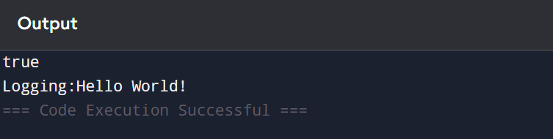

Exercise 2: Implementing the Factory Method Pattern
Scenario:
You are developing a document management system that needs to create different types of documents (e.g., Word, PDF, Excel). Use the Factory Method Pattern to achieve this.

CODE IMPLEMENTATION:
class Test{
public static void main(String args[]){
Document doc1=DocumentFactory.createDocumentFactory("WORD");
Document doc2=DocumentFactory.createDocumentFactory("PDF");
Document doc3=DocumentFactory.createDocumentFactory("EXCEL");
doc1.createDocument();
doc2.createDocument();
doc3.createDocument();
}
}

interface Document{
void createDocument();
}

class WordDocument implements Document{
public void createDocument(){
System.out.println("Word Document is created");
}
}

class PdfDocument implements Document{
public void createDocument(){
System.out.println("Pdf Document is created");
}
}

class ExcelDocument implements Document{
public void createDocument(){
System.out.println("Excel Document is created");
}
}

public class DocumentFactory{
public static Document createDocumentFactory(String type){
if(type.equalsIgnoreCase("WORD")){
return new WordDocument();
}
if(type.equalsIgnoreCase("PDF")){
return new PdfDocument();
}
if(type.equalsIgnoreCase("EXCEL")){
return new ExcelDocument();
}else{
return null;
}
}
}

OUTPUT:
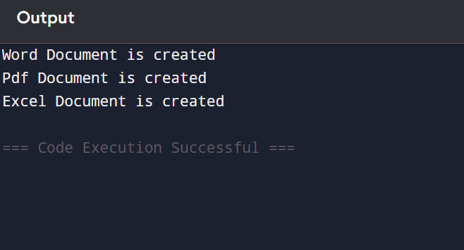

DATA STRUCTURES AND ALGORITHM:

Exercise 2: E-commerce Platform Search Function
Scenario:
You are working on the search functionality of an e-commerce platform. The search needs to be optimized for fast performance.

CODE IMPLEMENTATION:
import java.util.*;

class Product{
int productId;
String productName;
String category;

Product(int productId,String productName,String category){
this.productId=productId;
this.productName=productName;
this.category=category;
}
void display(){
System.out.println(productId+" "+productName+" "+category);
}
}
class search_Operations{
public static void display_products(Product products[]){
System.out.println("Products List:");
for(Product product:products){
product.display();
}
}
public static void linear_search_by_id(Product products[],int id){
boolean found=false;
for(Product product:products){
if(product.productId==id){
product.display();
found=true;
break;
}
}
if(found==false){
System.out.println("Product is not found");
}
}

public static void binary_search_by_id(Product products[],int id){
int low=0;
int high=products.length-1;
while(low<=high){
int mid=(low+high)/2;
if(products[mid].productId==id){
products[mid].display();
return;
}else if(products[mid].productId<id){
low=mid+1;
}else{
high=mid-1;
}
}
}
public static void main(String args[]){
Product[] products=new Product[5];
products[0]=new Product(101,"Wooden Chair","Furniture");
products[1]=new Product(102,"Smart Phone","Electronics");
products[2]=new Product(103,"Shoes","Footwear");
products[3]=new Product(104,"Smart Watch","Accessories");
products[4]=new Product(105,"Bag","Fashion");
display_products(products);
System.out.println("Linear Search:");
linear_search_by_id(products,101);
System.out.println("Time Complexity: O(1)");
linear_search_by_id(products,103);
System.out.println("Time Complexity: O(n)");
linear_search_by_id(products,105);
System.out.println("Time Complexity: O(n)");

Arrays.sort(products,Comparator.comparingInt(p->p.productId));
System.out.println("Binary Search:");
binary_search_by_id(products,101);
System.out.println("Time Complexity: O(1)");
binary_search_by_id(products,103);
System.out.println("Time Complexity: O(log n)");
linear_search_by_id(products,105);
System.out.println("Time Complexity: O(1)");

}

}
OUTPUT:
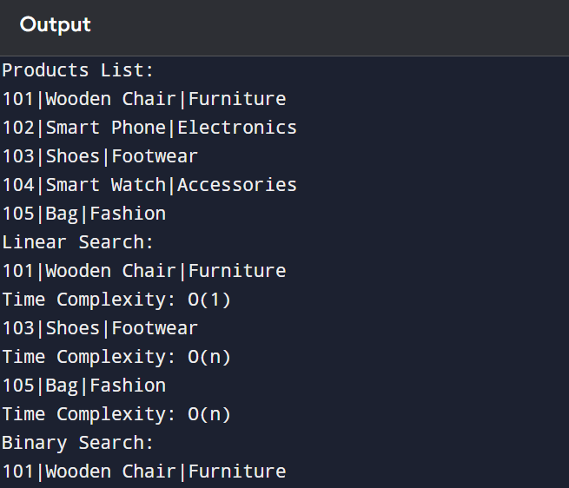
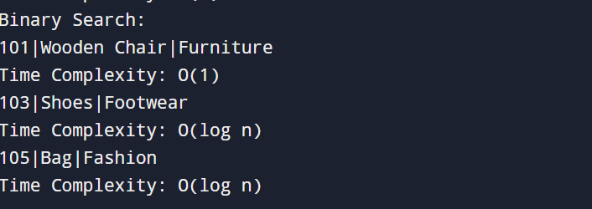

Exercise 7: Financial Forecasting
Scenario:
You are developing a financial forecasting tool that predicts future values based on past data.
CODE IMPLEMENTATION:
import java.util.*;
class Financial_Forecasting{
public static double forecastValue(double initialValue,double growthRate,int year){
if(year==0){
return initialValue;
}

return forecastValue(initialValue,growthRate,year-1)*(1+growthRate);

}
public static void main(String args[]){
double initialValue=10000.0;
double growthRate=0.10;
int year=5;
double futureValue = forecastValue(initialValue, growthRate, year);

System.out.println("Initial Value: " + initialValue);
System.out.println("Growth Rate: " + (growthRate * 100) + "%");
System.out.println("Years: " + year);
System.out.println("Predicted Future Value: " + futureValue);
}

}

OUTPUT:
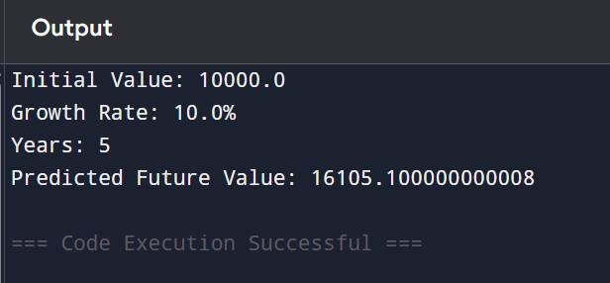

PL/SQL PROGRAMMING:

Exercise 1: Control Structures

Scenario 1: The bank wants to apply a discount to loan interest rates for customers above 60 years old.
  - Question: Write a PL/SQL block that loops through all customers, checks their age, and if they are above 60, apply a 1% discount to their current loan interest rates.

CODE IMPLEMENTATION:
BEGIN
FOR cust_rec IN(
SELECT c.CustomerID,c.DOB,l.loanID,l.InterestRate
FROM Customers c
JOIN Loans l ON c.CustomerID=l.CustomerID)
LOOP
IF MONTHS_BETWEEN(SYSDATE,cust_rec.DOB)/12>60 THEN
UPDATE Loans
SET InterestRate=InterestRate-1
WHERE LoanID=cust_rec.LoanID;
END IF;
END LOOP;

COMMIT;
END;
/

Scenario 2: A customer can be promoted to VIP status based on their balance.
- Question: Write a PL/SQL block that iterates through all customers and sets a flag IsVIP to TRUE for those with a balance over $10,000.

CODE IMPLEMENTATION:

BEGIN
FOR cust_rec IN(
SELECT CustomerID,Balance FROM Customers)
LOOP
IF cust_rec.Balance>10000 then
update Customers
Set IsVIP='True'
where CustomerID=cust_rec.CustomerID;
END IF;
END LOOP;

COMMIT;
END;
/

Scenario 3: The bank wants to send reminders to customers whose loans are due within the next 30 days.
Question: Write a PL/SQL block that fetches all loans due in the next 30 days and prints a reminder message for each customer.
CODE IMPLEMENTATION:

BEGIN
FOR loan_rec IN(
select l.LoanID,l.CustomerID,l.EndDate,c.Name
FROM Loans l
JOIN Customers c on l.CustomerID=c.CustomerID
WHERE l.EndDate between SYSDATE and SYSDATE+30)
LOOP
DBMS_OUTPUT.PUT_LINE(
' Reminder:Loan ID ' || loan_rec.LoanID ||
' for customer ' || loan_rec.Name ||
' is due on ' || TO_CHAR(loan_rec.EndDate,'DD-MON-YYYY'));
END LOOP;
END;
/

Exercise 3: Stored Procedures

Scenario 1: The bank needs to process monthly interest for all savings accounts.
- Question: Write a stored procedure ProcessMonthlyInterest that calculates and updates the balance of all savings accounts by applying an interest rate of 1% to the current balance.

CODE IMPLEMENTATION:

CREATE OR REPLACE PROCEDURE PROCESSMONTHLYINTEREST AS
BEGIN
UPDATE Accounts
SET Balance=Balance+(Balance*0.01)
where AccountType='Savings';

COMMIT;
END;
/

Scenario 2: The bank wants to implement a bonus scheme for employees based on their performance.
- Question: Write a stored procedure UpdateEmployeeBonus that updates the salary of employees in a given department by adding a bonus percentage passed as a parameter.

CODE IMPLEMENTATION:

create or replace procedure UpdateEmployeeBonus(
p_department IN VARCHAR2,
p_bonus_pct IN NUMBER
)as
begin
update Employees
set salary=salary+(salary*p_bonus_pct/100)
where Department=p_department;

commit;
end;
/

BEGIN
UpdateEmployeeBonus('HR', 10);
END;
/

Scenario 3: Customers should be able to transfer funds between their accounts.
- Question: Write a stored procedure TransferFunds that transfers a specified amount from one account to another, checking that the source account has sufficient balance before making the transfer.

CODE IMPLEMENTATION:

create or replace procedure TransferFunds(
p_from_account in number,
p_to_account in number,
p_amount in number
) as
v_balance number;
begin
select Balance into v_balance
from Accounts
where AccountID=p_from_account;

if v_balance>=p_amount then
update Accounts
set Balance=Balance-p_amount
where AccountID=p_from_account;

update Accounts
set Balance=Balance+p_amount
where AccountID=p_to_amount;

commit;
else
DBMS_OUTPUT.PUT_LINE('Insufficient balance in source account.');
end if;
end;
/

BEGIN
TransferFunds(101, 102, 5000);
END;
/

JUNIT TESTING EXERCISES:

Exercise 1: Setting Up JUnit Scenario: You need to set up JUnit in your Java project to start writing unit tests.

OUTPUT:

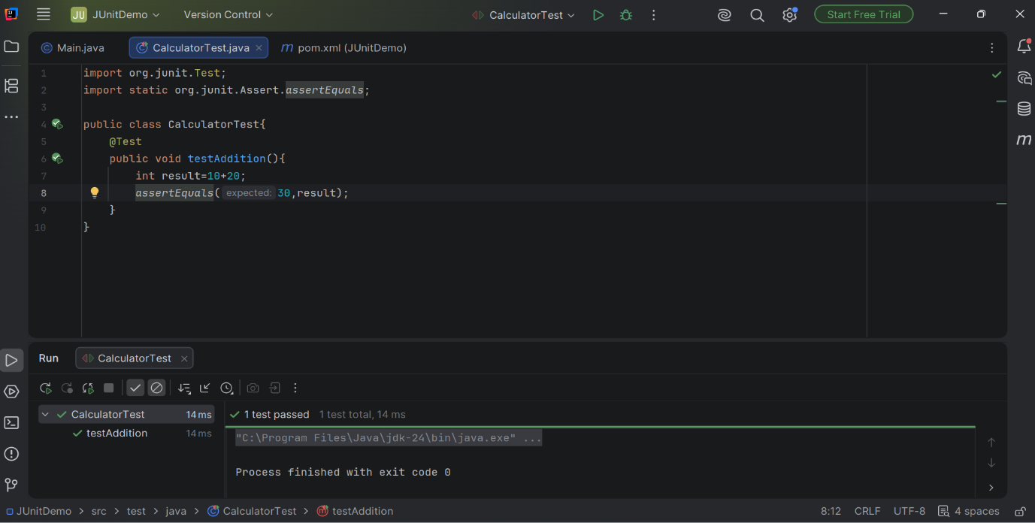

Exercise 3: Assertions in JUnit Scenario: You need to use different assertions in JUnit to validate your test results

OUTPUT:

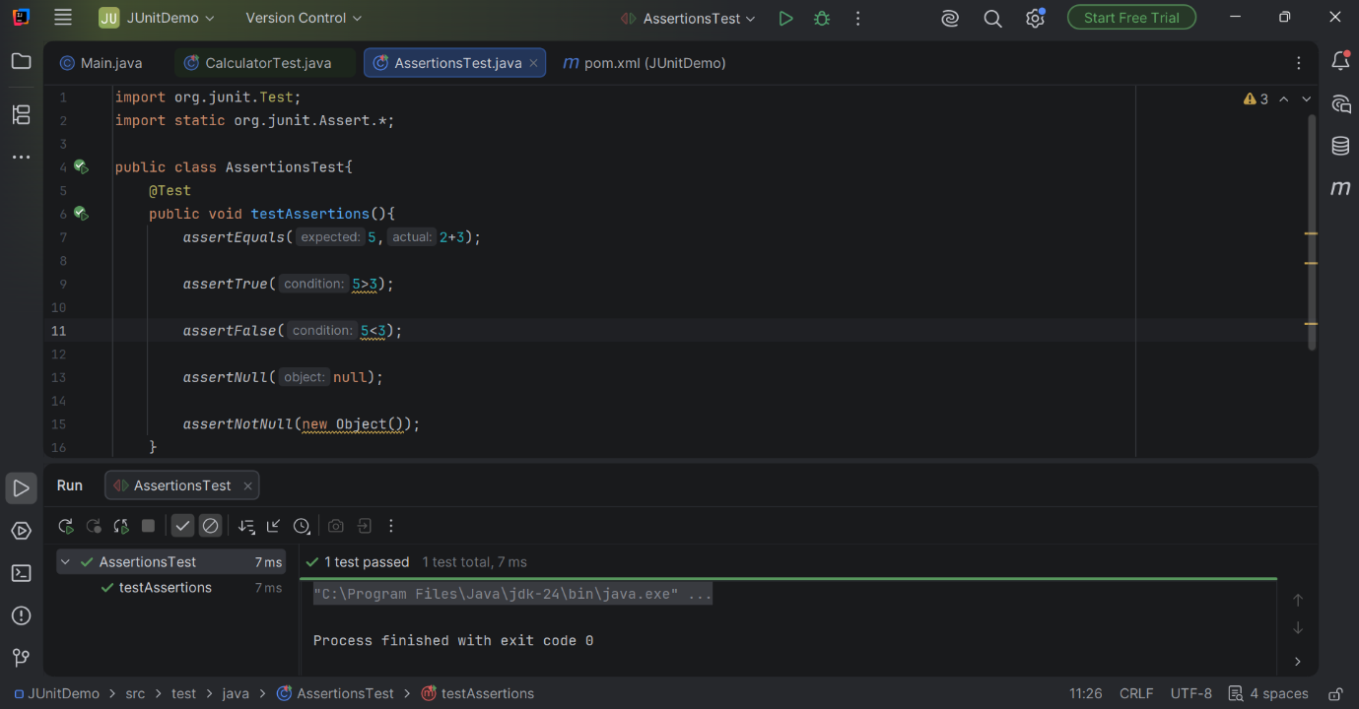

Exercise 4: Arrange-Act-Assert (AAA) Pattern, Test Fixtures, Setup and Teardown Methods in JUnit Scenario: You need to organize your tests using the Arrange-Act-Assert (AAA) pattern and use setup and teardown methods.

OUTPUT:

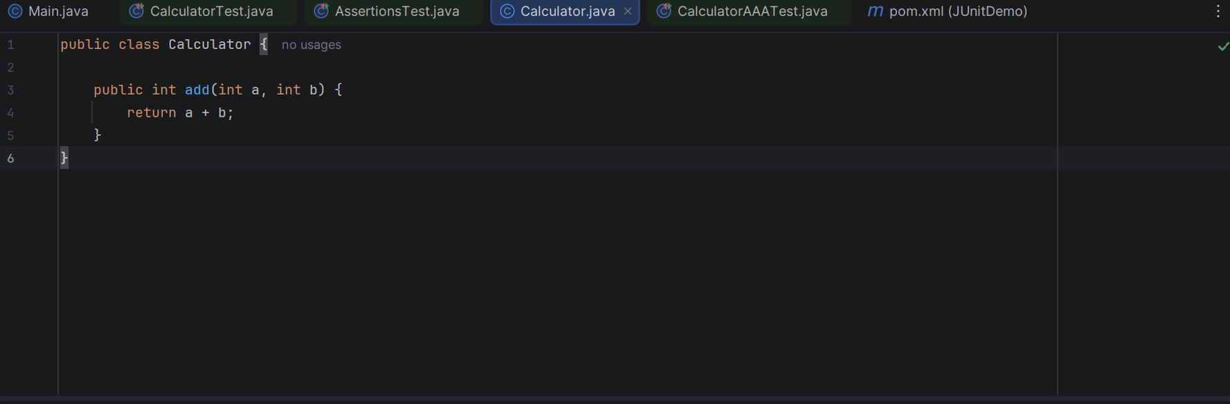

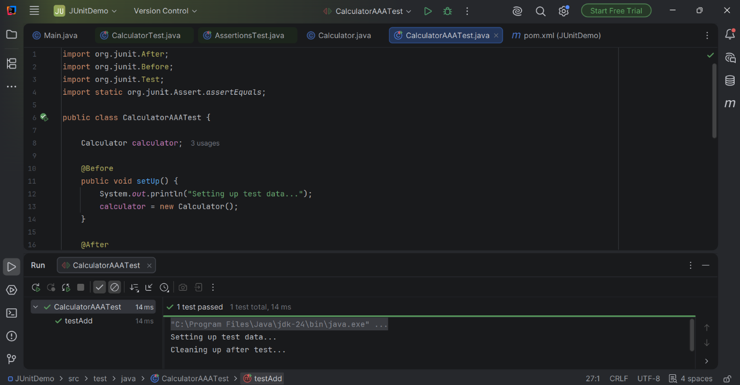

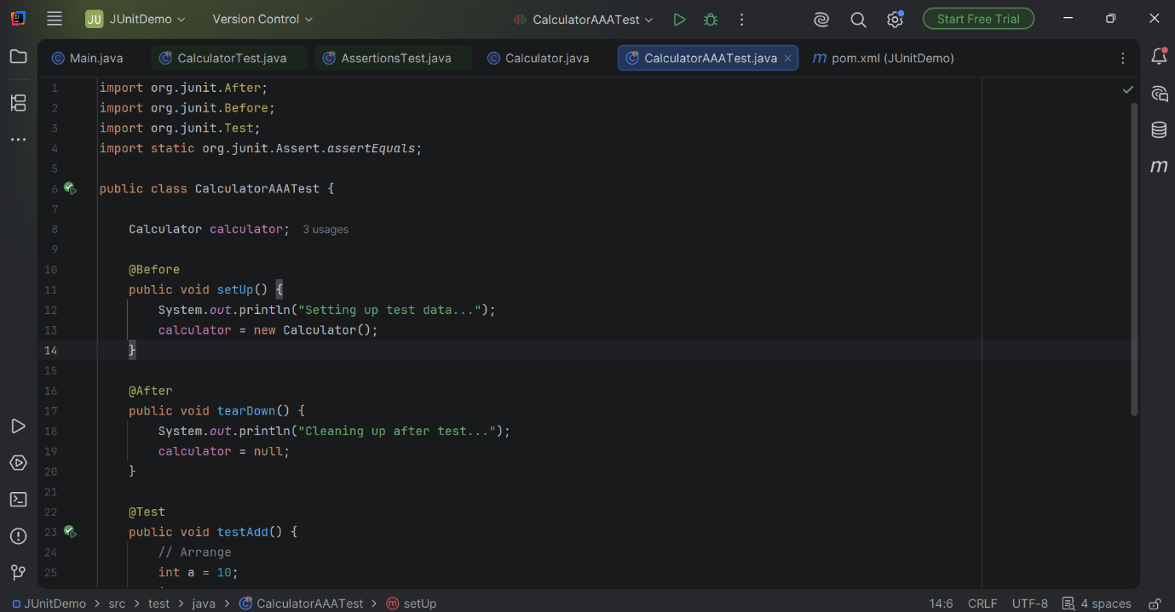



MOCKITO HANDS ON EXERCISES:

Exercise 1: Mocking and Stubbing Scenario: You need to test a service that depends on an external API. Use Mockito to mock the external API and stub its methods.

OUTPUT:
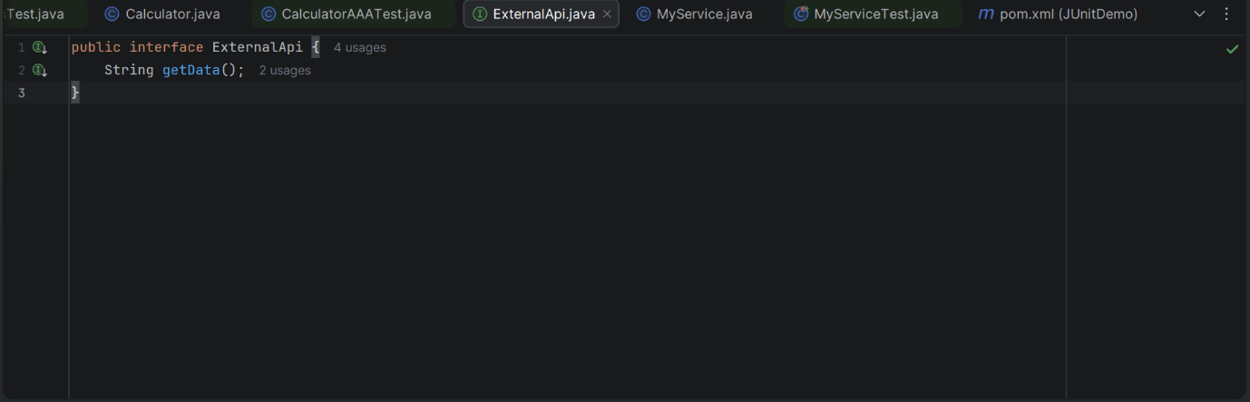

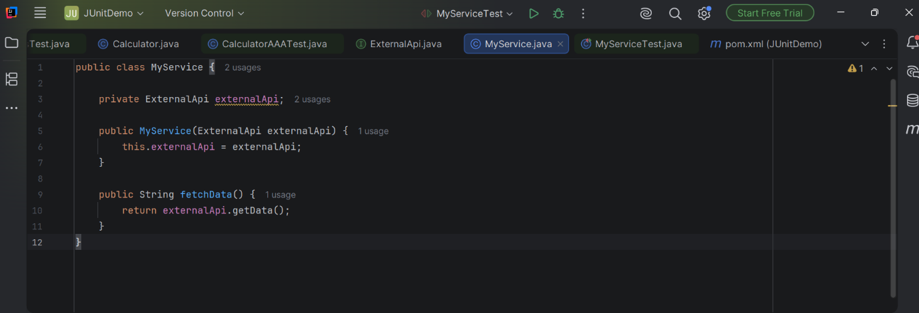
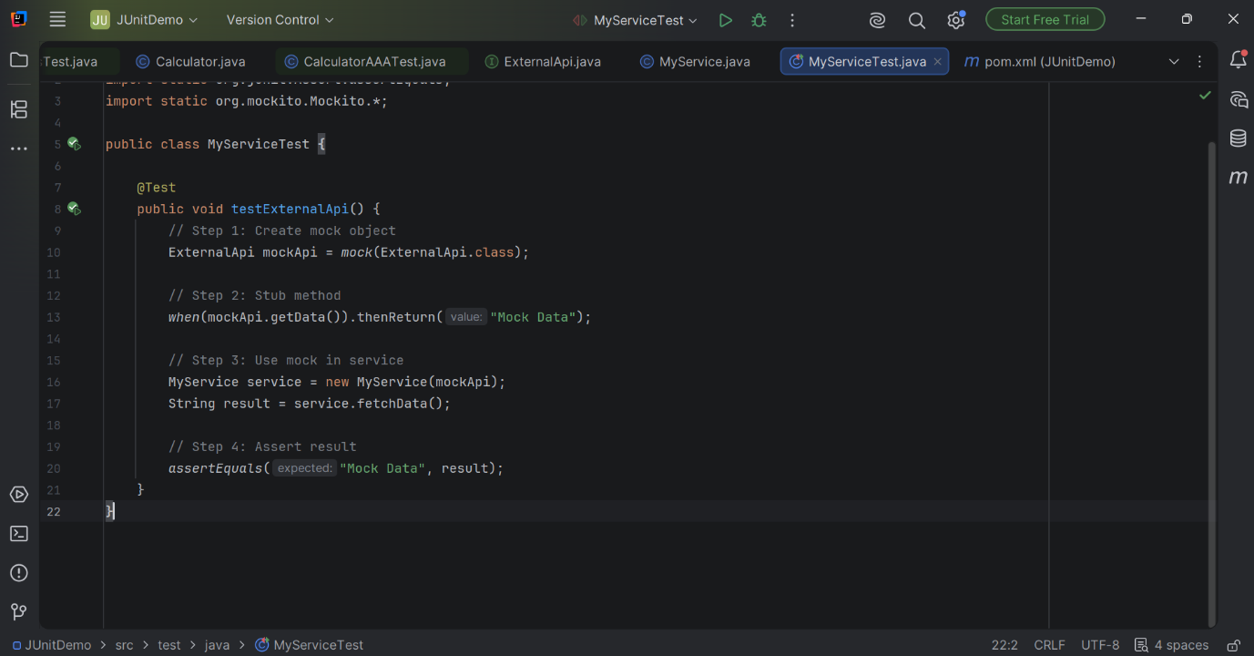

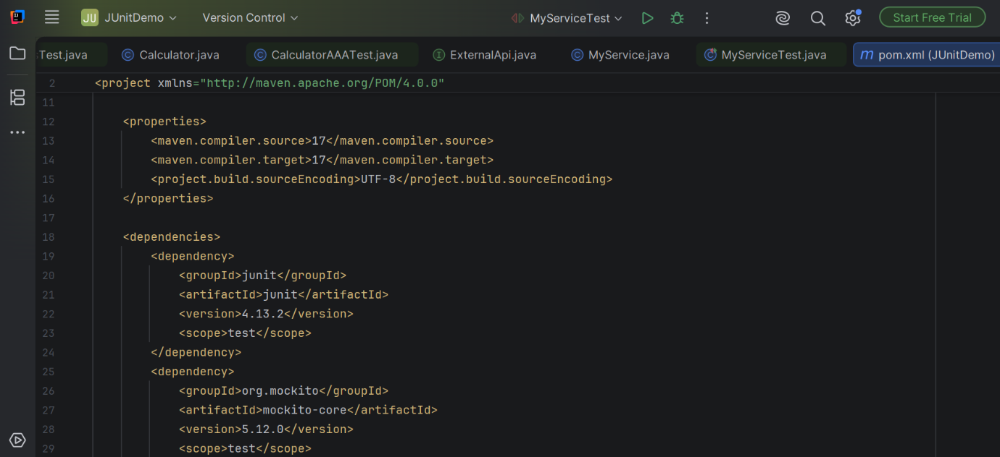

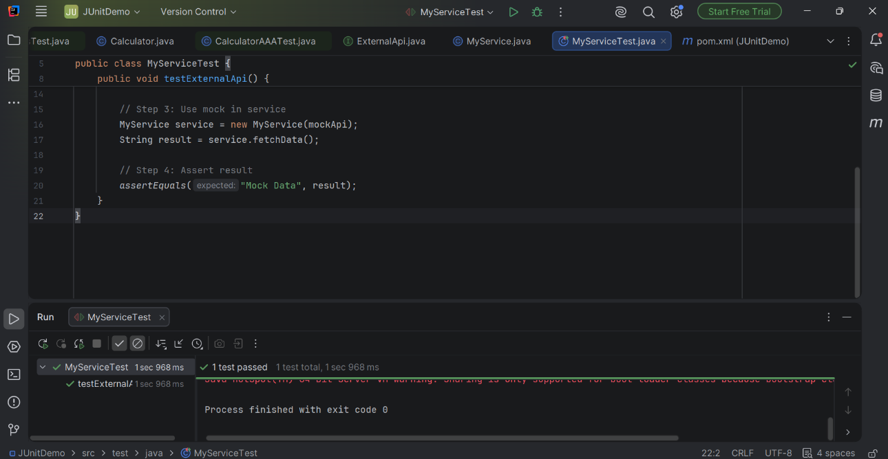
Exercise 2: Verifying Interactions Scenario: You need to ensure that a method is called with specific arguments.

OUTPUT:

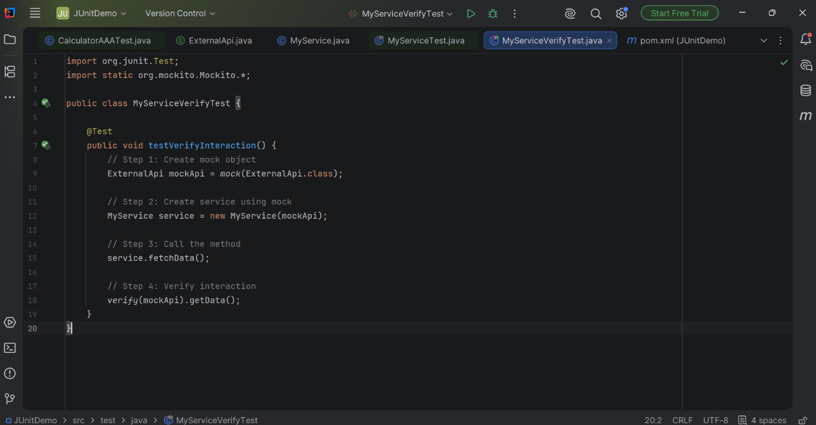

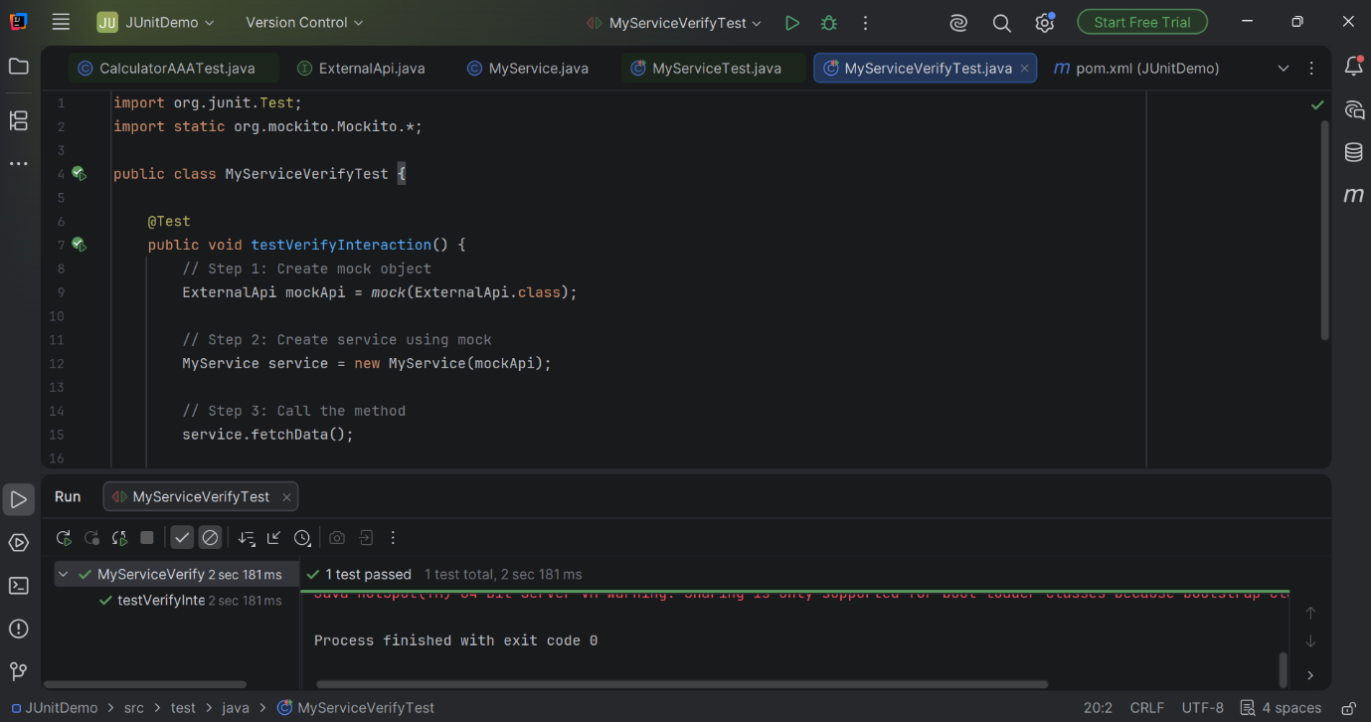

LOGGING USING SLF4J:

Exercise 1: Logging Error Messages and Warning Levels Task: Write a Java application that demonstrates logging error messages and warning levels using SLF4J.

OUTPUT:s

