WEEK-2 MANDATORY HANDS-ON EXERCISES

1.SPRING CORE AND MAVEN:

Exercise 1: Configuring a Basic Spring Application
Scenario:
Your company is developing a web application for managing a library. You need to use the Spring Framework to handle the backend operations.

OUTPUT:

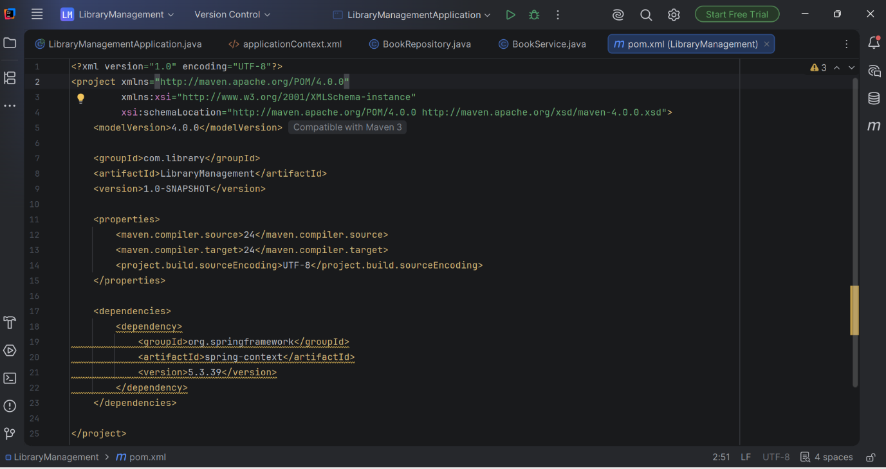

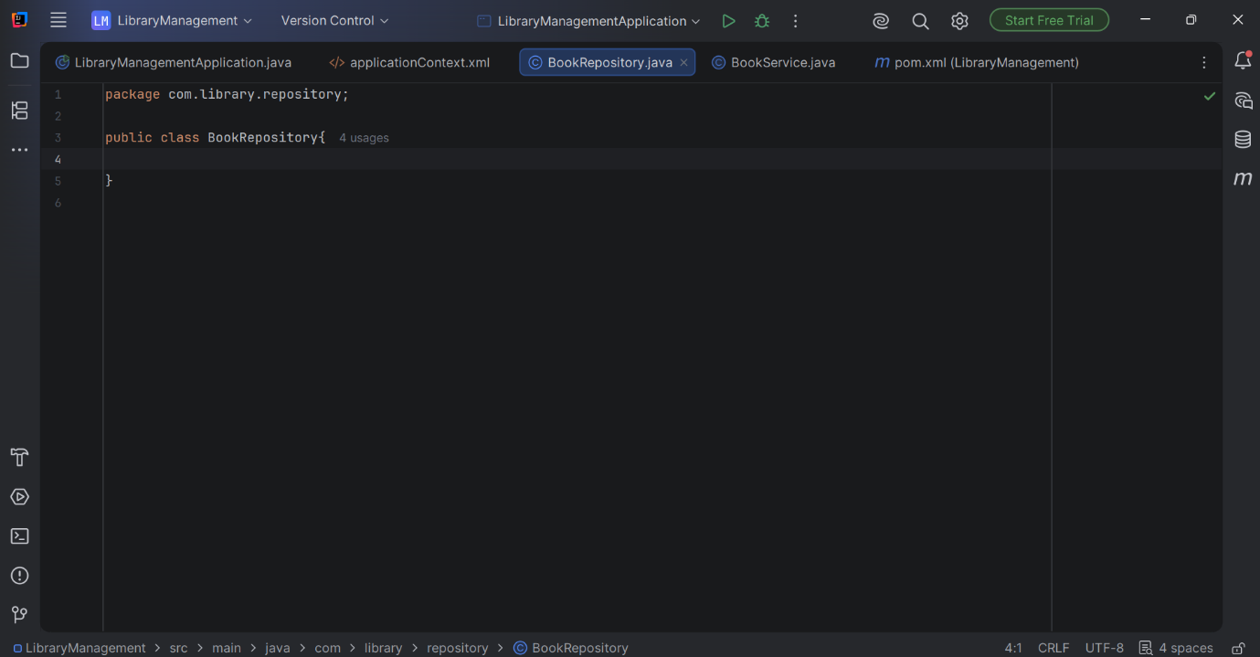

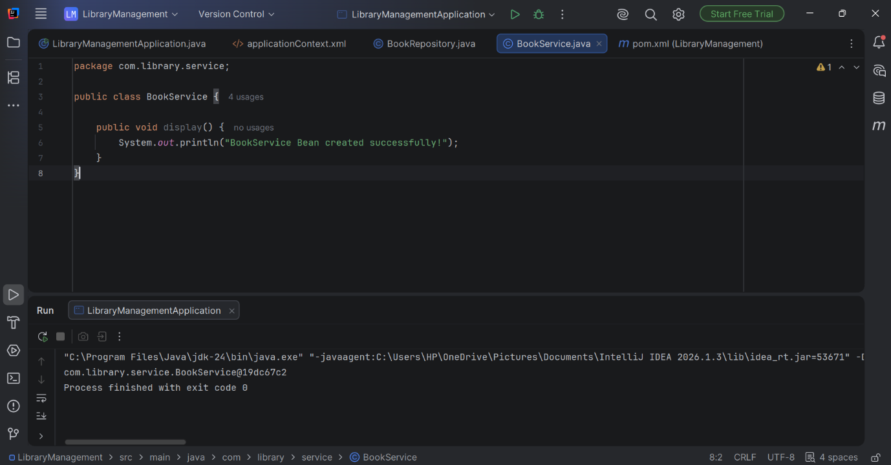

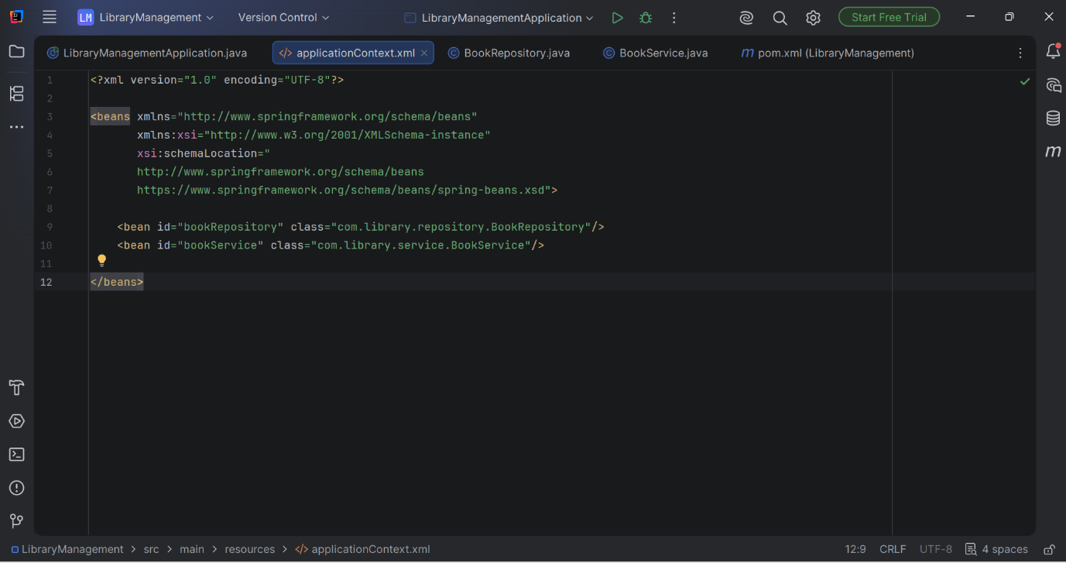

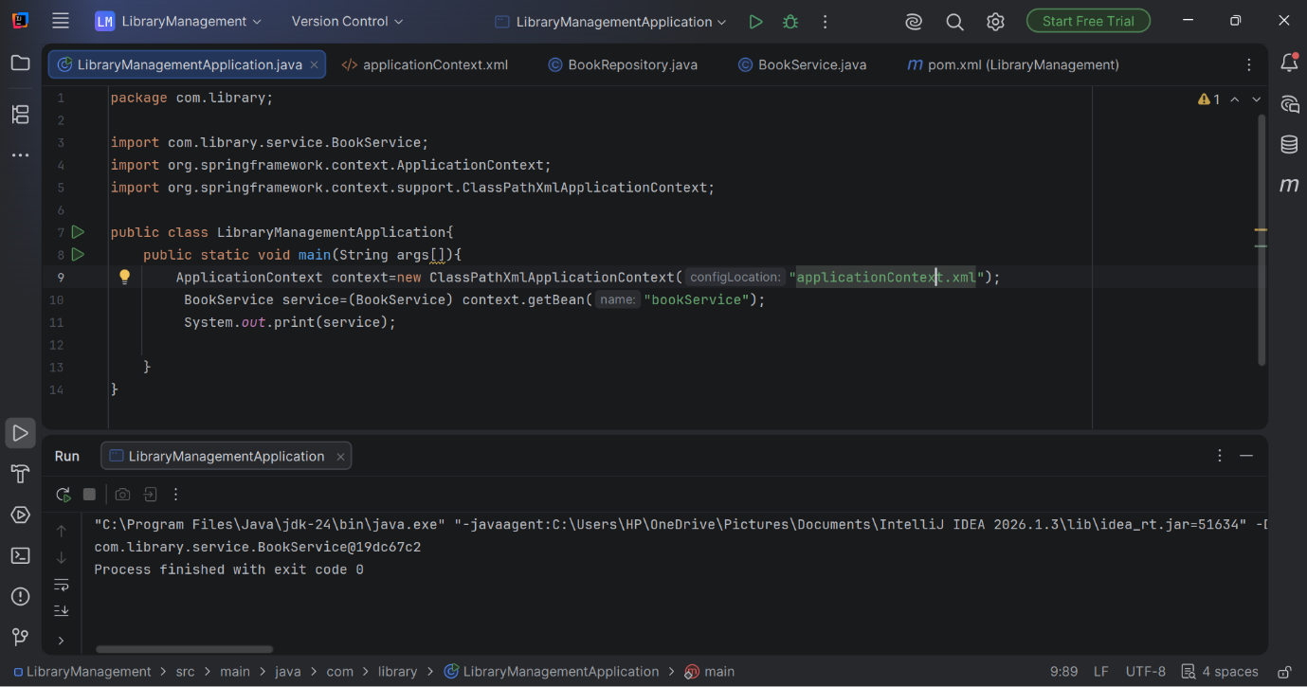

Exercise 2: Implementing Dependency Injection
Scenario:
In the library management application, you need to manage the dependencies between the BookService and BookRepository classes using Spring's IoC and DI.

OUTPUT:
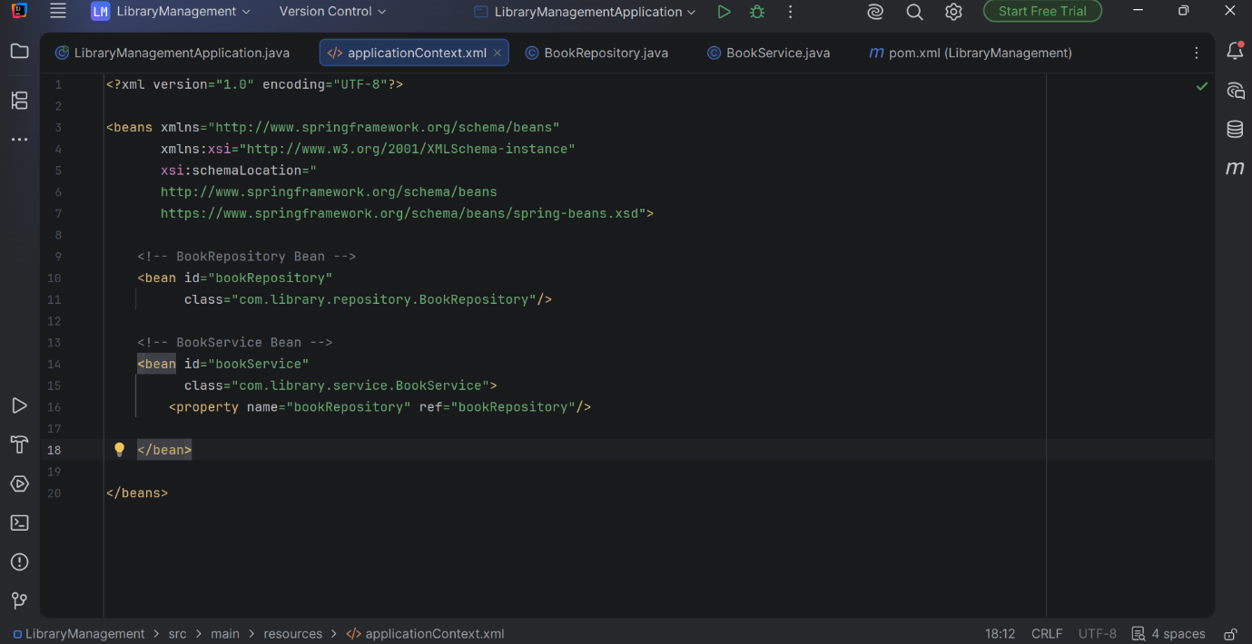

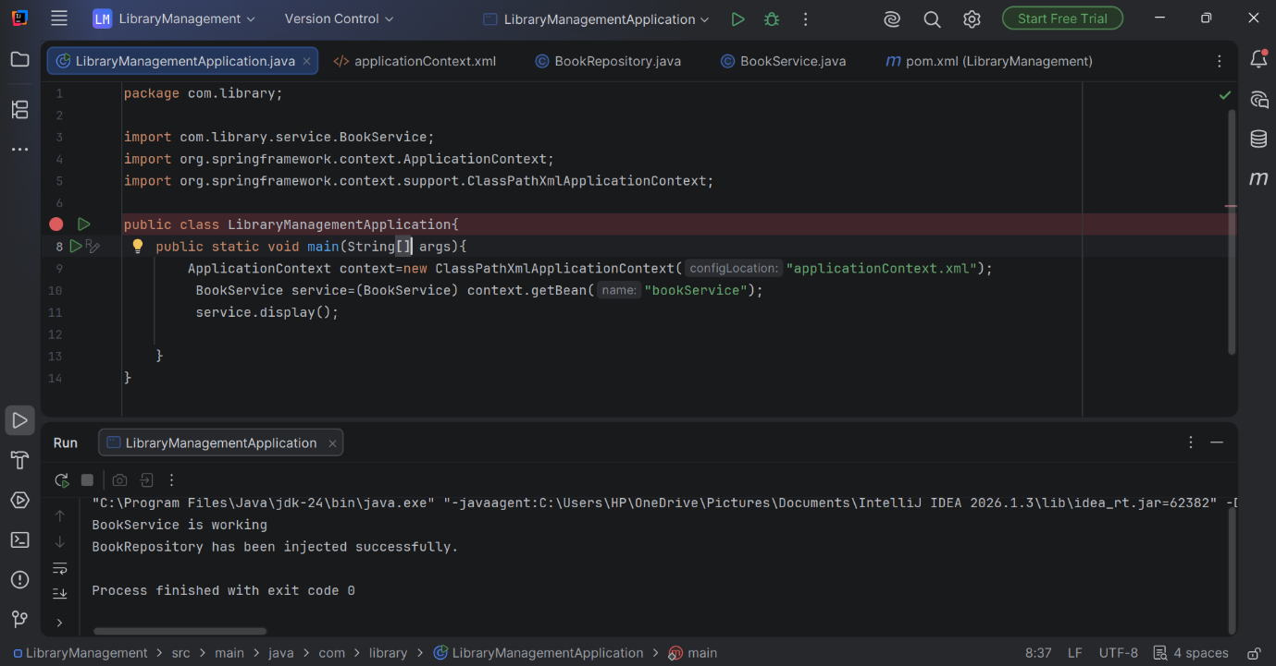

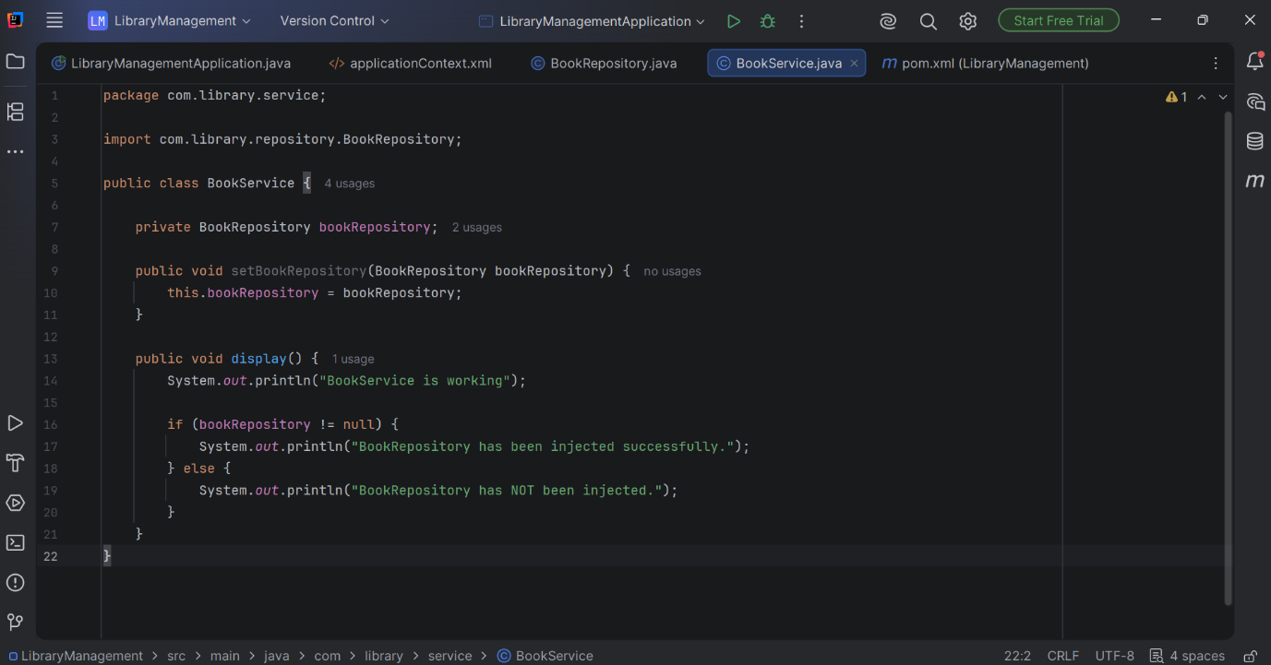

Exercise 4: Creating and Configuring a Maven Project
Scenario:
You need to set up a new Maven project for the library management application and add Spring dependencies.
OUTPUT:
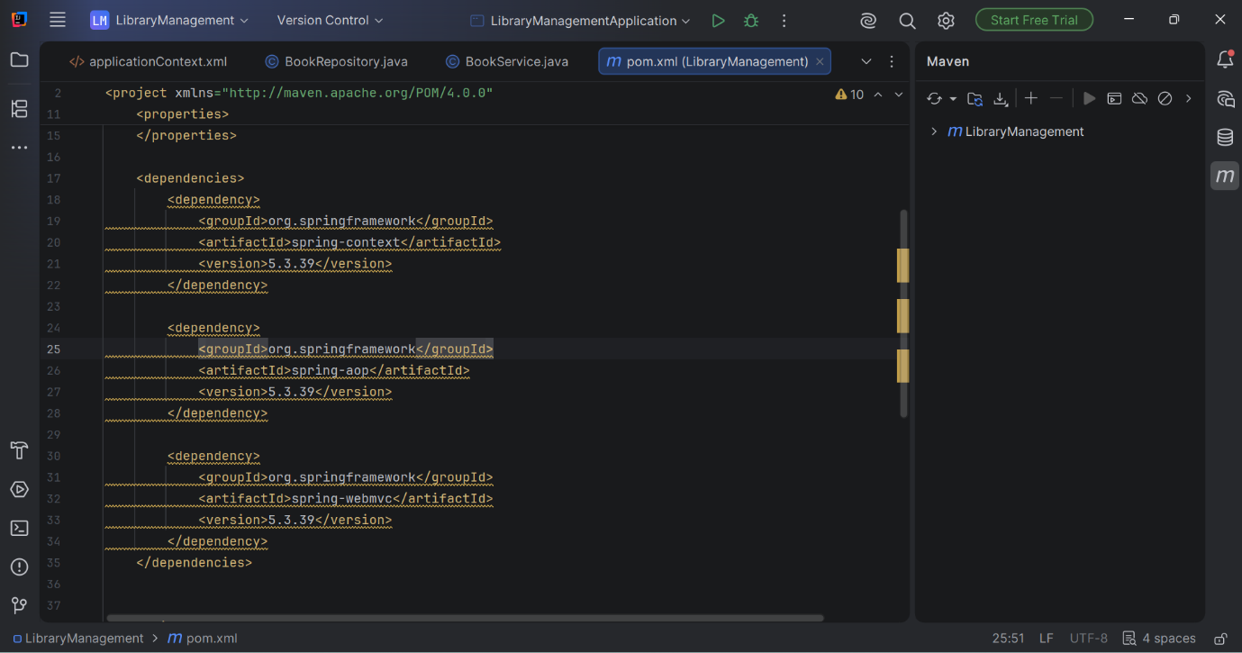

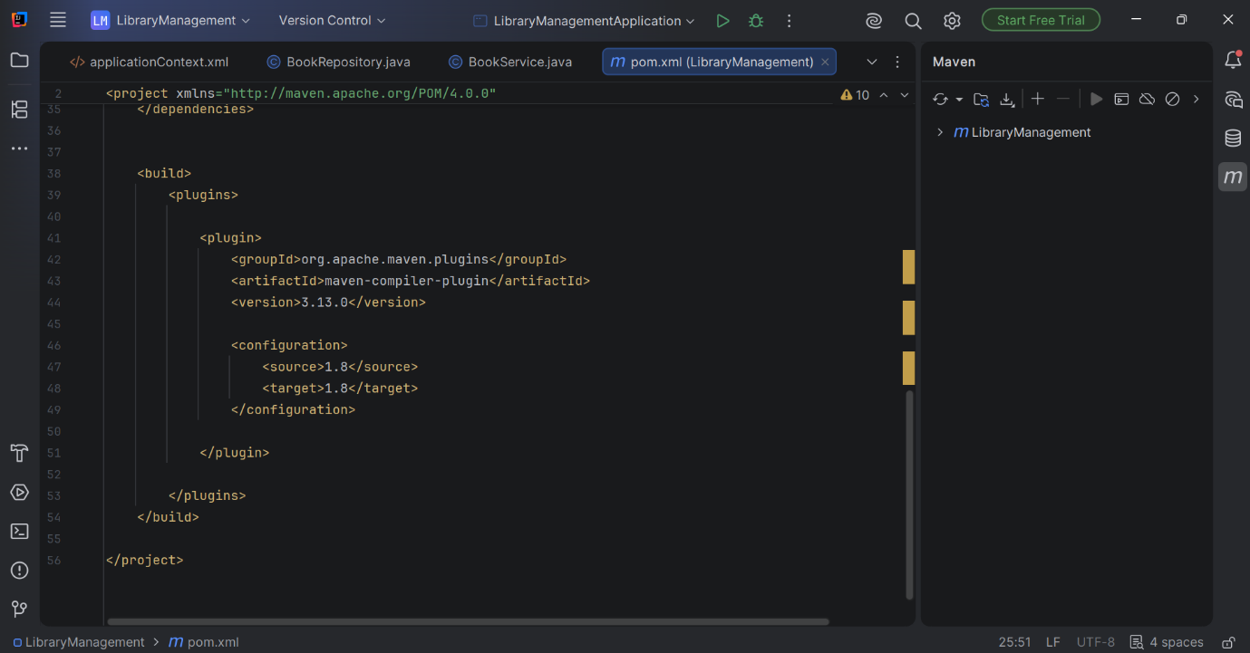

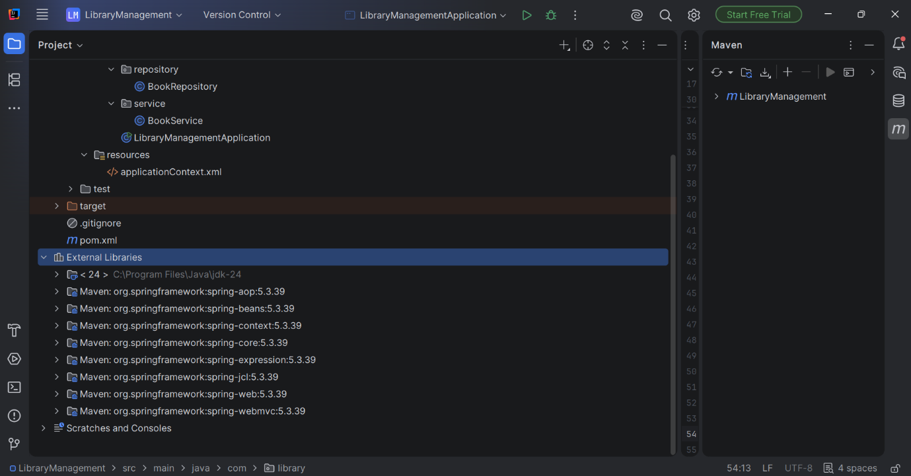

Spring Data JPA with Spring Boot and Hibernate:
MANDATORY HANDSON EXERCISES:

HANDS ON 4

Difference between JPA, Hibernate and Spring Data JPA

Java Persistence API (JPA)
- JPA (Java Persistence API) is a Java specification (JSR 338) for persisting, reading, updating, and deleting data from Java objects.
- It defines a standard set of rules for Object Relational Mapping (ORM).
- JPA does not provide an implementation; it only defines the APIs.
- Frameworks like Hibernate, EclipseLink, and OpenJPA implement the JPA specification.
Example:
JPA defines methods such as persist(), merge(), find(), and remove(), but it does not provide the code to execute these operations.

Hibernate
- Hibernate is an ORM (Object Relational Mapping) framework that implements the JPA specification.
- It maps Java objects to database tables and automatically converts Java operations into SQL queries.
- Hibernate reduces the need to write SQL manually and manages database interactions.

Example (Hibernate)
Session session = sessionFactory.openSession();
Transaction transaction = session.beginTransaction();
Country country = new Country();
country.setCode("IN");
country.setName("India");
session.save(country);
transaction.commit();
session.close();
In this example, Hibernate converts session.save(country) into an SQL INSERT statement.

Spring Data JPA
- Spring Data JPA is a Spring module built on top of JPA.
- It does not implement JPA itself; instead, it works with JPA providers such as Hibernate.
- It reduces boilerplate code by providing ready-made repository methods.
- It also integrates transaction management with Spring.

Example (Spring Data JPA)
CountryRepository.java
public interface CountryRepository extends JpaRepository<Country, String> {
}
CountryService.java
@Service
public class CountryService {
@Autowired
private CountryRepository countryRepository;
@Transactional
public void addCountry(Country country) {
countryRepository.save(country);
}
}
Here, calling
countryRepository.save(country);
automatically saves the country into the database. There is no need to write Hibernate session management or SQL statements.
Hands on 1
Spring Data JPA - Quick Example
OUTPUT:

"C:\Program Files\Java\jdk-24\bin\java.exe" -XX:TieredStopAtLevel=1 -Dspring.output.ansi.enabled=always "-javaagent:C:\Users\HP\OneDrive\Pictures\Documents\IntelliJ IDEA 2026.1.3\lib\idea_rt.jar=54450" -Dfile.encoding=UTF-8 -Dsun.stdout.encoding=UTF-8 -Dsun.stderr.encoding=UTF-8 -classpath C:\Users\HP\Downloads\orm-learn\orm-learn\target\classes;C:\Users\HP\.m2\repository\org\springframework\boot\spring-boot-starter\3.5.16\spring-boot-starter-3.5.16.jar;C:\Users\HP\.m2\repository\org\springframework\boot\spring-boot\3.5.16\spring-boot-3.5.16.jar;C:\Users\HP\.m2\repository\org\springframework\spring-context\6.2.19\spring-context-6.2.19.jar;C:\Users\HP\.m2\repository\org\springframework\spring-expression\6.2.19\spring-expression-6.2.19.jar;C:\Users\HP\.m2\repository\io\micrometer\micrometer-observation\1.15.12\micrometer-observation-1.15.12.jar;C:\Users\HP\.m2\repository\io\micrometer\micrometer-commons\1.15.12\micrometer-commons-1.15.12.jar;C:\Users\HP\.m2\repository\org\springframework\boot\spring-boot-autoconfigure\3.5.16\spring-boot-autoconfigure-3.5.16.jar;C:\Users\HP\.m2\repository\org\springframework\boot\spring-boot-starter-logging\3.5.16\spring-boot-starter-logging-3.5.16.jar;C:\Users\HP\.m2\repository\ch\qos\logback\logback-classic\1.5.34\logback-classic-1.5.34.jar;C:\Users\HP\.m2\repository\ch\qos\logback\logback-core\1.5.34\logback-core-1.5.34.jar;C:\Users\HP\.m2\repository\org\apache\logging\log4j\log4j-to-slf4j\2.24.3\log4j-to-slf4j-2.24.3.jar;C:\Users\HP\.m2\repository\org\apache\logging\log4j\log4j-api\2.24.3\log4j-api-2.24.3.jar;C:\Users\HP\.m2\repository\org\slf4j\jul-to-slf4j\2.0.18\jul-to-slf4j-2.0.18.jar;C:\Users\HP\.m2\repository\jakarta\annotation\jakarta.annotation-api\2.1.1\jakarta.annotation-api-2.1.1.jar;C:\Users\HP\.m2\repository\org\springframework\spring-core\6.2.19\spring-core-6.2.19.jar;C:\Users\HP\.m2\repository\org\springframework\spring-jcl\6.2.19\spring-jcl-6.2.19.jar;C:\Users\HP\.m2\repository\org\yaml\snakeyaml\2.4\snakeyaml-2.4.jar;C:\Users\HP\.m2\repository\org\slf4j\slf4j-api\2.0.18\slf4j-api-2.0.18.jar;C:\Users\HP\.m2\repository\jakarta\xml\bind\jakarta.xml.bind-api\4.0.5\jakarta.xml.bind-api-4.0.5.jar;C:\Users\HP\.m2\repository\jakarta\activation\jakarta.activation-api\2.1.4\jakarta.activation-api-2.1.4.jar;C:\Users\HP\.m2\repository\net\bytebuddy\byte-buddy\1.17.8\byte-buddy-1.17.8.jar;C:\Users\HP\.m2\repository\org\springframework\boot\spring-boot-starter-data-jpa\3.5.16\spring-boot-starter-data-jpa-3.5.16.jar;C:\Users\HP\.m2\repository\org\springframework\boot\spring-boot-starter-jdbc\3.5.16\spring-boot-starter-jdbc-3.5.16.jar;C:\Users\HP\.m2\repository\com\zaxxer\HikariCP\6.3.3\HikariCP-6.3.3.jar;C:\Users\HP\.m2\repository\org\springframework\spring-jdbc\6.2.19\spring-jdbc-6.2.19.jar;C:\Users\HP\.m2\repository\org\hibernate\orm\hibernate-core\6.6.53.Final\hibernate-core-6.6.53.Final.jar;C:\Users\HP\.m2\repository\jakarta\persistence\jakarta.persistence-api\3.1.0\jakarta.persistence-api-3.1.0.jar;C:\Users\HP\.m2\repository\jakarta\transaction\jakarta.transaction-api\2.0.1\jakarta.transaction-api-2.0.1.jar;C:\Users\HP\.m2\repository\org\jboss\logging\jboss-logging\3.6.3.Final\jboss-logging-3.6.3.Final.jar;C:\Users\HP\.m2\repository\org\hibernate\common\hibernate-commons-annotations\7.0.3.Final\hibernate-commons-annotations-7.0.3.Final.jar;C:\Users\HP\.m2\repository\io\smallrye\jandex\3.2.0\jandex-3.2.0.jar;C:\Users\HP\.m2\repository\com\fasterxml\classmate\1.7.3\classmate-1.7.3.jar;C:\Users\HP\.m2\repository\org\glassfish\jaxb\jaxb-runtime\4.0.9\jaxb-runtime-4.0.9.jar;C:\Users\HP\.m2\repository\org\glassfish\jaxb\jaxb-core\4.0.9\jaxb-core-4.0.9.jar;C:\Users\HP\.m2\repository\org\eclipse\angus\angus-activation\2.0.3\angus-activation-2.0.3.jar;C:\Users\HP\.m2\repository\org\glassfish\jaxb\txw2\4.0.9\txw2-4.0.9.jar;C:\Users\HP\.m2\repository\com\sun\istack\istack-commons-runtime\4.1.2\istack-commons-runtime-4.1.2.jar;C:\Users\HP\.m2\repository\jakarta\inject\jakarta.inject-api\2.0.1\jakarta.inject-api-2.0.1.jar;C:\Users\HP\.m2\repository\org\antlr\antlr4-runtime\4.13.2\antlr4-runtime-4.13.2.jar;C:\Users\HP\.m2\repository\org\springframework\data\spring-data-jpa\3.5.13\spring-data-jpa-3.5.13.jar;C:\Users\HP\.m2\repository\org\springframework\data\spring-data-commons\3.5.13\spring-data-commons-3.5.13.jar;C:\Users\HP\.m2\repository\org\springframework\spring-orm\6.2.19\spring-orm-6.2.19.jar;C:\Users\HP\.m2\repository\org\springframework\spring-aop\6.2.19\spring-aop-6.2.19.jar;C:\Users\HP\.m2\repository\org\springframework\spring-tx\6.2.19\spring-tx-6.2.19.jar;C:\Users\HP\.m2\repository\org\springframework\spring-beans\6.2.19\spring-beans-6.2.19.jar;C:\Users\HP\.m2\repository\org\springframework\spring-aspects\6.2.19\spring-aspects-6.2.19.jar;C:\Users\HP\.m2\repository\org\aspectj\aspectjweaver\1.9.25.1\aspectjweaver-1.9.25.1.jar;C:\Users\HP\.m2\repository\com\mysql\mysql-connector-j\9.7.0\mysql-connector-j-9.7.0.jar com.cognizant.ormlearn.OrmLearnApplication

. ____ _ __ _ _
/\\ / ___'_ __ _ _(_)_ __ __ _ \ \ \ \
( ( )\___ | '_ | '_| | '_ \/ _` | \ \ \ \
\\/ ___)| |_)| | | | | || (_| | ) ) ) )
' |____| .__|_| |_|_| |_\__, | / / / /
=========|_|==============|___/=/_/_/_/

:: Spring Boot :: (v3.5.16)

2026-07-01T22:50:02.662+05:30 INFO 4864 --- [ main] c.c.ormlearn.OrmLearnApplication : Starting OrmLearnApplication using Java 24.0.2 with PID 4864 (C:\Users\HP\Downloads\orm-learn\orm-learn\target\classes started by HP in C:\Users\HP\Downloads\orm-learn)
2026-07-01T22:50:02.664+05:30 DEBUG 4864 --- [ main] c.c.ormlearn.OrmLearnApplication : Running with Spring Boot v3.5.16, Spring v6.2.19
2026-07-01T22:50:02.665+05:30 INFO 4864 --- [ main] c.c.ormlearn.OrmLearnApplication : No active profile set, falling back to 1 default profile: "default"
2026-07-01T22:50:03.288+05:30 INFO 4864 --- [ main] .s.d.r.c.RepositoryConfigurationDelegate : Bootstrapping Spring Data JPA repositories in DEFAULT mode.
2026-07-01T22:50:03.355+05:30 INFO 4864 --- [ main] .s.d.r.c.RepositoryConfigurationDelegate : Finished Spring Data repository scanning in 57 ms. Found 1 JPA repository interface.
2026-07-01T22:50:03.800+05:30 INFO 4864 --- [ main] o.hibernate.jpa.internal.util.LogHelper : HHH000204: Processing PersistenceUnitInfo [name: default]
2026-07-01T22:50:03.862+05:30 INFO 4864 --- [ main] org.hibernate.Version : HHH000412: Hibernate ORM core version 6.6.53.Final
2026-07-01T22:50:03.922+05:30 INFO 4864 --- [ main] o.h.c.internal.RegionFactoryInitiator : HHH000026: Second-level cache disabled
2026-07-01T22:50:04.283+05:30 INFO 4864 --- [ main] o.s.o.j.p.SpringPersistenceUnitInfo : No LoadTimeWeaver setup: ignoring JPA class transformer
2026-07-01T22:50:04.338+05:30 INFO 4864 --- [ main] com.zaxxer.hikari.HikariDataSource : HikariPool-1 - Starting...
2026-07-01T22:50:05.026+05:30 INFO 4864 --- [ main] com.zaxxer.hikari.pool.HikariPool : HikariPool-1 - Added connection com.mysql.cj.jdbc.ConnectionImpl@27976390
2026-07-01T22:50:05.028+05:30 INFO 4864 --- [ main] com.zaxxer.hikari.HikariDataSource : HikariPool-1 - Start completed.
2026-07-01T22:50:05.118+05:30 WARN 4864 --- [ main] org.hibernate.orm.deprecation : HHH90000025: MySQLDialect does not need to be specified explicitly using 'hibernate.dialect' (remove the property setting and it will be selected by default)
2026-07-01T22:50:05.151+05:30 INFO 4864 --- [ main] org.hibernate.orm.connections.pooling : HHH10001005: Database info:
Database JDBC URL [Connecting through datasource 'HikariDataSource (HikariPool-1)']
Database driver: undefined/unknown
Database version: 8.0.43
Autocommit mode: undefined/unknown
Isolation level: undefined/unknown
Minimum pool size: undefined/unknown
Maximum pool size: undefined/unknown
2026-07-01T22:50:06.138+05:30 INFO 4864 --- [ main] o.h.e.t.j.p.i.JtaPlatformInitiator : HHH000489: No JTA platform available (set 'hibernate.transaction.jta.platform' to enable JTA platform integration)
2026-07-01T22:50:06.236+05:30 INFO 4864 --- [ main] j.LocalContainerEntityManagerFactoryBean : Initialized JPA EntityManagerFactory for persistence unit 'default'
2026-07-01T22:50:06.728+05:30 INFO 4864 --- [ main] c.c.ormlearn.OrmLearnApplication : Started OrmLearnApplication in 4.63 seconds (process running for 5.185)
2026-07-01T22:50:06.732+05:30 INFO 4864 --- [ main] c.c.ormlearn.OrmLearnApplication : Start
2026-07-01T22:50:06.918+05:30 DEBUG 4864 --- [ main] org.hibernate.SQL : select c1_0.code,c1_0.name from country c1_0
2026-07-01T22:50:06.969+05:30 INFO 4864 --- [ main] c.c.ormlearn.OrmLearnApplication : Countries = [Country{code='IN', name='India'}, Country{code='US', name='United States of America'}]
2026-07-01T22:50:06.969+05:30 INFO 4864 --- [ main] c.c.ormlearn.OrmLearnApplication : End
2026-07-01T22:50:06.969+05:30 INFO 4864 --- [ main] c.c.ormlearn.OrmLearnApplication : Inside main
2026-07-01T22:50:06.971+05:30 INFO 4864 --- [ionShutdownHook] j.LocalContainerEntityManagerFactoryBean : Closing JPA EntityManagerFactory for persistence unit 'default'
2026-07-01T22:50:06.974+05:30 INFO 4864 --- [ionShutdownHook] com.zaxxer.hikari.HikariDataSource : HikariPool-1 - Shutdown initiated...
2026-07-01T22:50:06.997+05:30 INFO 4864 --- [ionShutdownHook] com.zaxxer.hikari.HikariDataSource : HikariPool-1 - Shutdown completed.

Process finished with exit code 0

