WEEK 3 MANDATORY HANDSON EXERCISES:

Spring REST using Spring Boot 3:

1.Spring-rest-handson:

Hands on 1
Create a Spring Web Project using Maven :

CODE IMPLEMENTATION:
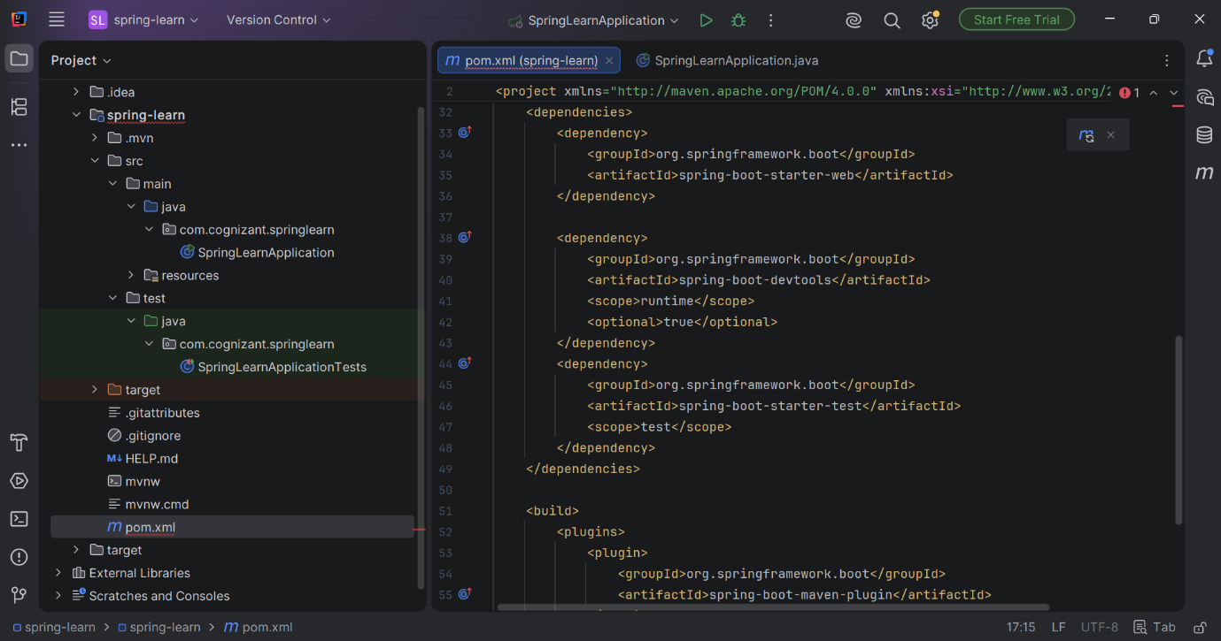

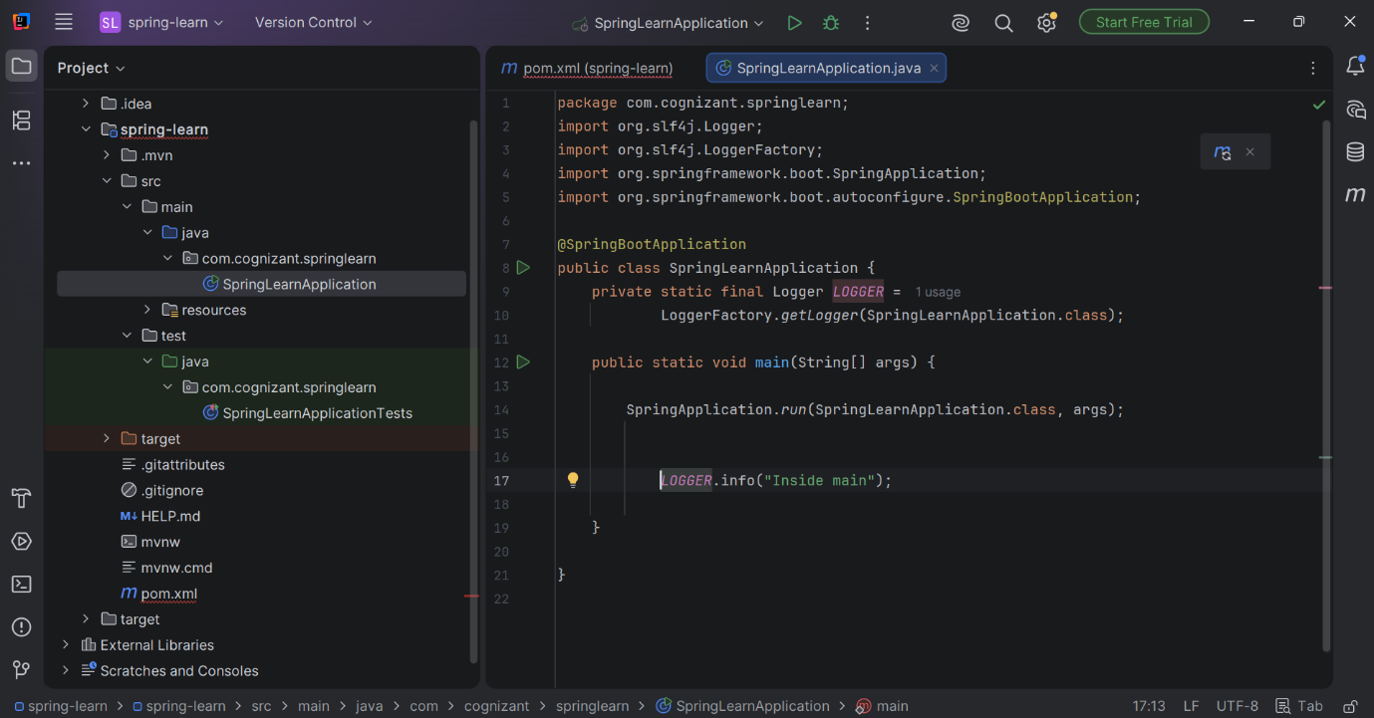

OUTPUT:
"C:\Program Files\Java\jdk-24\bin\java.exe" -XX:TieredStopAtLevel=1 -Dspring.output.ansi.enabled=always "-javaagent:C:\Users\HP\OneDrive\Pictures\Documents\IntelliJ IDEA 2026.1.3\lib\idea_rt.jar=54234" -Dfile.encoding=UTF-8 -Dsun.stdout.encoding=UTF-8 -Dsun.stderr.encoding=UTF-8 -classpath C:\Users\HP\Downloads\spring-learn\spring-learn\target\classes;C:\Users\HP\.m2\repository\org\springframework\boot\spring-boot-starter-web\3.5.16\spring-boot-starter-web-3.5.16.jar;C:\Users\HP\.m2\repository\org\springframework\boot\spring-boot-starter\3.5.16\spring-boot-starter-3.5.16.jar;C:\Users\HP\.m2\repository\org\springframework\boot\spring-boot-starter-logging\3.5.16\spring-boot-starter-logging-3.5.16.jar;C:\Users\HP\.m2\repository\ch\qos\logback\logback-classic\1.5.34\logback-classic-1.5.34.jar;C:\Users\HP\.m2\repository\ch\qos\logback\logback-core\1.5.34\logback-core-1.5.34.jar;C:\Users\HP\.m2\repository\org\apache\logging\log4j\log4j-to-slf4j\2.24.3\log4j-to-slf4j-2.24.3.jar;C:\Users\HP\.m2\repository\org\apache\logging\log4j\log4j-api\2.24.3\log4j-api-2.24.3.jar;C:\Users\HP\.m2\repository\org\slf4j\jul-to-slf4j\2.0.18\jul-to-slf4j-2.0.18.jar;C:\Users\HP\.m2\repository\jakarta\annotation\jakarta.annotation-api\2.1.1\jakarta.annotation-api-2.1.1.jar;C:\Users\HP\.m2\repository\org\yaml\snakeyaml\2.4\snakeyaml-2.4.jar;C:\Users\HP\.m2\repository\org\springframework\boot\spring-boot-starter-json\3.5.16\spring-boot-starter-json-3.5.16.jar;C:\Users\HP\.m2\repository\com\fasterxml\jackson\core\jackson-databind\2.21.4\jackson-databind-2.21.4.jar;C:\Users\HP\.m2\repository\com\fasterxml\jackson\core\jackson-annotations\2.21\jackson-annotations-2.21.jar;C:\Users\HP\.m2\repository\com\fasterxml\jackson\core\jackson-core\2.21.4\jackson-core-2.21.4.jar;C:\Users\HP\.m2\repository\com\fasterxml\jackson\datatype\jackson-datatype-jdk8\2.21.4\jackson-datatype-jdk8-2.21.4.jar;C:\Users\HP\.m2\repository\com\fasterxml\jackson\datatype\jackson-datatype-jsr310\2.21.4\jackson-datatype-jsr310-2.21.4.jar;C:\Users\HP\.m2\repository\com\fasterxml\jackson\module\jackson-module-parameter-names\2.21.4\jackson-module-parameter-names-2.21.4.jar;C:\Users\HP\.m2\repository\org\springframework\boot\spring-boot-starter-tomcat\3.5.16\spring-boot-starter-tomcat-3.5.16.jar;C:\Users\HP\.m2\repository\org\apache\tomcat\embed\tomcat-embed-core\10.1.55\tomcat-embed-core-10.1.55.jar;C:\Users\HP\.m2\repository\org\apache\tomcat\embed\tomcat-embed-el\10.1.55\tomcat-embed-el-10.1.55.jar;C:\Users\HP\.m2\repository\org\apache\tomcat\embed\tomcat-embed-websocket\10.1.55\tomcat-embed-websocket-10.1.55.jar;C:\Users\HP\.m2\repository\org\springframework\spring-web\6.2.19\spring-web-6.2.19.jar;C:\Users\HP\.m2\repository\org\springframework\spring-beans\6.2.19\spring-beans-6.2.19.jar;C:\Users\HP\.m2\repository\io\micrometer\micrometer-observation\1.15.12\micrometer-observation-1.15.12.jar;C:\Users\HP\.m2\repository\io\micrometer\micrometer-commons\1.15.12\micrometer-commons-1.15.12.jar;C:\Users\HP\.m2\repository\org\springframework\spring-webmvc\6.2.19\spring-webmvc-6.2.19.jar;C:\Users\HP\.m2\repository\org\springframework\spring-aop\6.2.19\spring-aop-6.2.19.jar;C:\Users\HP\.m2\repository\org\springframework\spring-context\6.2.19\spring-context-6.2.19.jar;C:\Users\HP\.m2\repository\org\springframework\spring-expression\6.2.19\spring-expression-6.2.19.jar;C:\Users\HP\.m2\repository\org\springframework\boot\spring-boot-devtools\3.5.16\spring-boot-devtools-3.5.16.jar;C:\Users\HP\.m2\repository\org\springframework\boot\spring-boot\3.5.16\spring-boot-3.5.16.jar;C:\Users\HP\.m2\repository\org\springframework\boot\spring-boot-autoconfigure\3.5.16\spring-boot-autoconfigure-3.5.16.jar;C:\Users\HP\.m2\repository\org\slf4j\slf4j-api\2.0.18\slf4j-api-2.0.18.jar;C:\Users\HP\.m2\repository\org\springframework\spring-core\6.2.19\spring-core-6.2.19.jar;C:\Users\HP\.m2\repository\org\springframework\spring-jcl\6.2.19\spring-jcl-6.2.19.jar com.cognizant.springlearn.SpringLearnApplication

. ____ _ __ _ _
/\\ / ___'_ __ _ _(_)_ __ __ _ \ \ \ \
( ( )\___ | '_ | '_| | '_ \/ _` | \ \ \ \
\\/ ___)| |_)| | | | | || (_| | ) ) ) )
' |____| .__|_| |_|_| |_\__, | / / / /
=========|_|==============|___/=/_/_/_/

:: Spring Boot :: (v3.5.16)

2026-07-04T22:03:22.298+05:30 INFO 6620 --- [spring-learn] [ restartedMain] c.c.springlearn.SpringLearnApplication : Starting SpringLearnApplication using Java 24.0.2 with PID 6620 (C:\Users\HP\Downloads\spring-learn\spring-learn\target\classes started by HP in C:\Users\HP\Downloads\spring-learn)
2026-07-04T22:03:22.310+05:30 INFO 6620 --- [spring-learn] [ restartedMain] c.c.springlearn.SpringLearnApplication : No active profile set, falling back to 1 default profile: "default"
2026-07-04T22:03:22.385+05:30 INFO 6620 --- [spring-learn] [ restartedMain] .e.DevToolsPropertyDefaultsPostProcessor : Devtools property defaults active! Set 'spring.devtools.add-properties' to 'false' to disable
2026-07-04T22:03:22.385+05:30 INFO 6620 --- [spring-learn] [ restartedMain] .e.DevToolsPropertyDefaultsPostProcessor : For additional web related logging consider setting the 'logging.level.web' property to 'DEBUG'
2026-07-04T22:03:23.471+05:30 INFO 6620 --- [spring-learn] [ restartedMain] o.s.b.w.embedded.tomcat.TomcatWebServer : Tomcat initialized with port 8080 (http)
2026-07-04T22:03:23.489+05:30 INFO 6620 --- [spring-learn] [ restartedMain] o.apache.catalina.core.StandardService : Starting service [Tomcat]
2026-07-04T22:03:23.489+05:30 INFO 6620 --- [spring-learn] [ restartedMain] o.apache.catalina.core.StandardEngine : Starting Servlet engine: [Apache Tomcat/10.1.55]
2026-07-04T22:03:23.571+05:30 INFO 6620 --- [spring-learn] [ restartedMain] o.a.c.c.C.[Tomcat].[localhost].[/] : Initializing Spring embedded WebApplicationContext
2026-07-04T22:03:23.572+05:30 INFO 6620 --- [spring-learn] [ restartedMain] w.s.c.ServletWebServerApplicationContext : Root WebApplicationContext: initialization completed in 1186 ms
2026-07-04T22:03:24.057+05:30 INFO 6620 --- [spring-learn] [ restartedMain] o.s.b.d.a.OptionalLiveReloadServer : LiveReload server is running on port 35729
2026-07-04T22:03:24.109+05:30 INFO 6620 --- [spring-learn] [ restartedMain] o.s.b.w.embedded.tomcat.TomcatWebServer : Tomcat started on port 8080 (http) with context path '/'
2026-07-04T22:03:24.118+05:30 INFO 6620 --- [spring-learn] [ restartedMain] c.c.springlearn.SpringLearnApplication : Started SpringLearnApplication in 2.464 seconds (process running for 3.096)
2026-07-04T22:03:24.121+05:30 INFO 6620 --- [spring-learn] [ restartedMain] c.c.springlearn.SpringLearnApplication : Inside main

Hands on 4
Spring Core – Load Country from Spring Configuration XML

CODE IMPLEMENTATION:

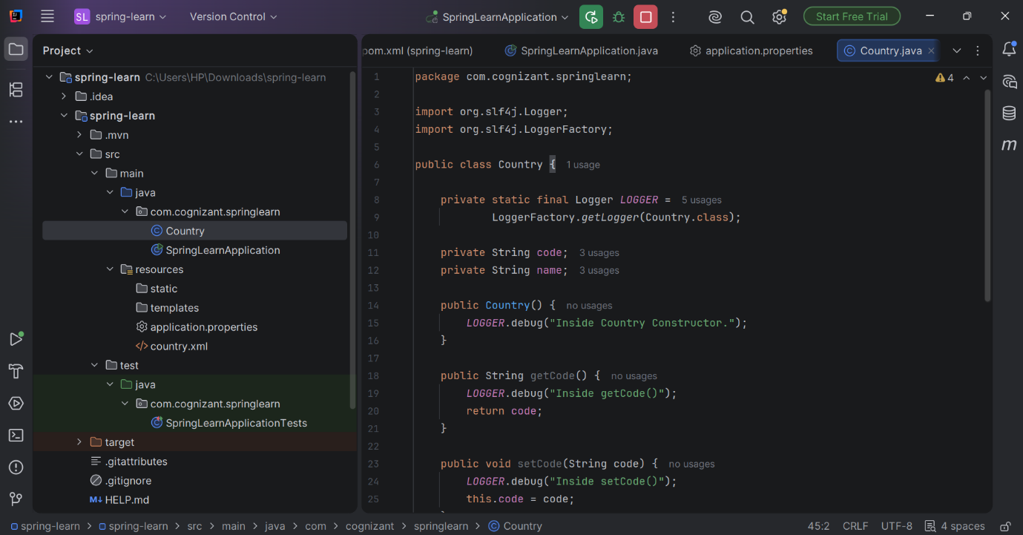

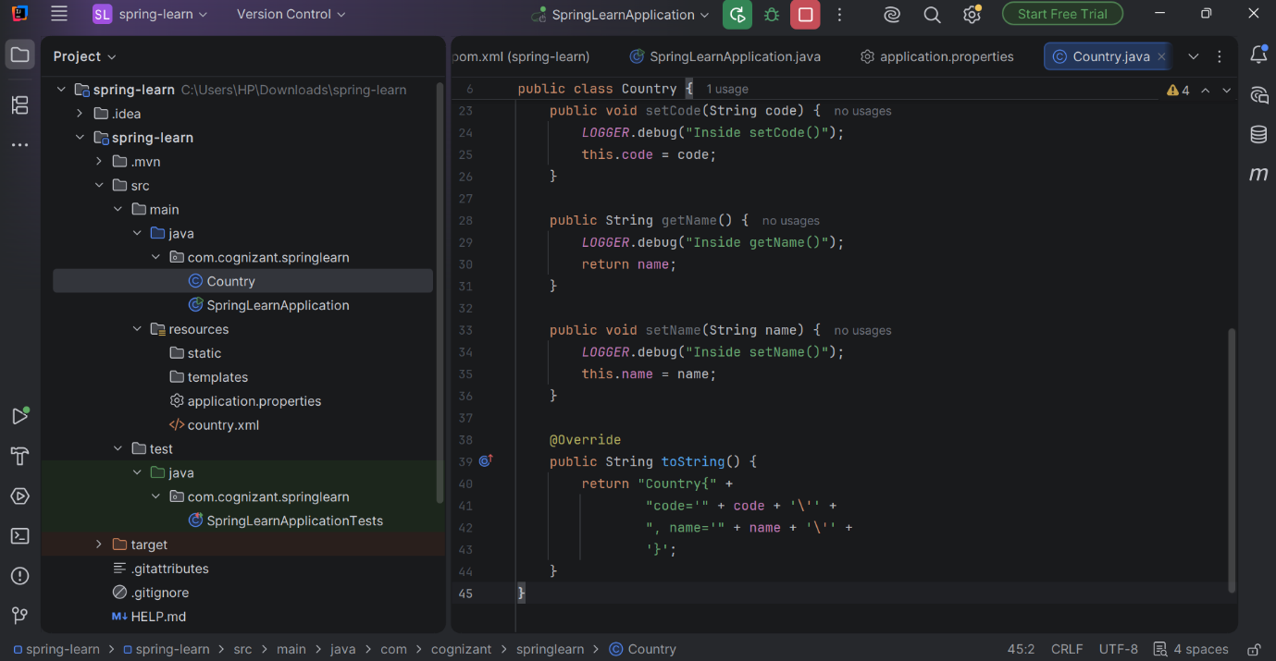

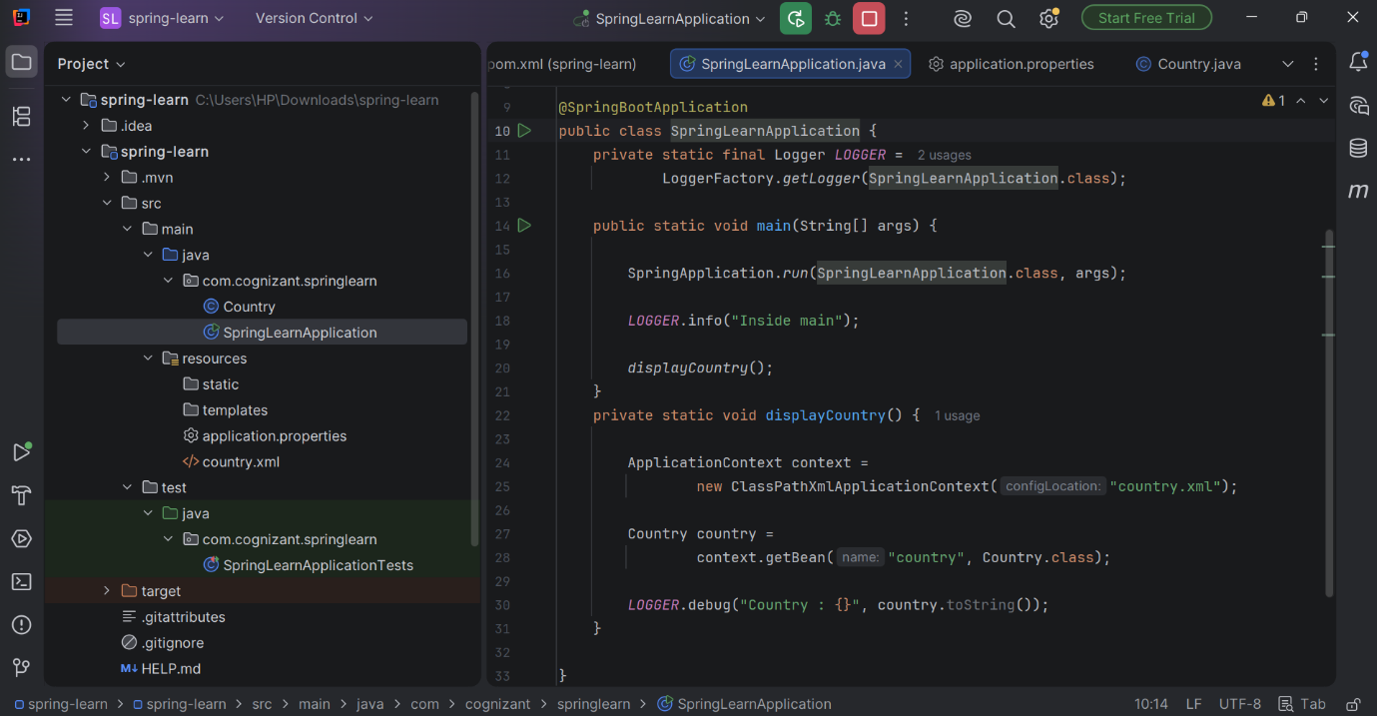

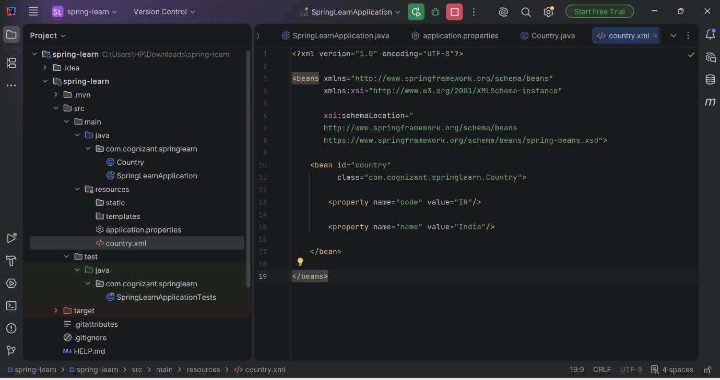

OUTPUT:
"C:\Program Files\Java\jdk-24\bin\java.exe" -XX:TieredStopAtLevel=1 -Dspring.output.ansi.enabled=always "-javaagent:C:\Users\HP\OneDrive\Pictures\Documents\IntelliJ IDEA 2026.1.3\lib\idea_rt.jar=54205" -Dfile.encoding=UTF-8 -Dsun.stdout.encoding=UTF-8 -Dsun.stderr.encoding=UTF-8 -classpath C:\Users\HP\Downloads\spring-learn\spring-learn\target\classes;C:\Users\HP\.m2\repository\org\springframework\boot\spring-boot-starter-web\3.5.16\spring-boot-starter-web-3.5.16.jar;C:\Users\HP\.m2\repository\org\springframework\boot\spring-boot-starter\3.5.16\spring-boot-starter-3.5.16.jar;C:\Users\HP\.m2\repository\org\springframework\boot\spring-boot-starter-logging\3.5.16\spring-boot-starter-logging-3.5.16.jar;C:\Users\HP\.m2\repository\ch\qos\logback\logback-classic\1.5.34\logback-classic-1.5.34.jar;C:\Users\HP\.m2\repository\ch\qos\logback\logback-core\1.5.34\logback-core-1.5.34.jar;C:\Users\HP\.m2\repository\org\apache\logging\log4j\log4j-to-slf4j\2.24.3\log4j-to-slf4j-2.24.3.jar;C:\Users\HP\.m2\repository\org\apache\logging\log4j\log4j-api\2.24.3\log4j-api-2.24.3.jar;C:\Users\HP\.m2\repository\org\slf4j\jul-to-slf4j\2.0.18\jul-to-slf4j-2.0.18.jar;C:\Users\HP\.m2\repository\jakarta\annotation\jakarta.annotation-api\2.1.1\jakarta.annotation-api-2.1.1.jar;C:\Users\HP\.m2\repository\org\yaml\snakeyaml\2.4\snakeyaml-2.4.jar;C:\Users\HP\.m2\repository\org\springframework\boot\spring-boot-starter-json\3.5.16\spring-boot-starter-json-3.5.16.jar;C:\Users\HP\.m2\repository\com\fasterxml\jackson\core\jackson-databind\2.21.4\jackson-databind-2.21.4.jar;C:\Users\HP\.m2\repository\com\fasterxml\jackson\core\jackson-annotations\2.21\jackson-annotations-2.21.jar;C:\Users\HP\.m2\repository\com\fasterxml\jackson\core\jackson-core\2.21.4\jackson-core-2.21.4.jar;C:\Users\HP\.m2\repository\com\fasterxml\jackson\datatype\jackson-datatype-jdk8\2.21.4\jackson-datatype-jdk8-2.21.4.jar;C:\Users\HP\.m2\repository\com\fasterxml\jackson\datatype\jackson-datatype-jsr310\2.21.4\jackson-datatype-jsr310-2.21.4.jar;C:\Users\HP\.m2\repository\com\fasterxml\jackson\module\jackson-module-parameter-names\2.21.4\jackson-module-parameter-names-2.21.4.jar;C:\Users\HP\.m2\repository\org\springframework\boot\spring-boot-starter-tomcat\3.5.16\spring-boot-starter-tomcat-3.5.16.jar;C:\Users\HP\.m2\repository\org\apache\tomcat\embed\tomcat-embed-core\10.1.55\tomcat-embed-core-10.1.55.jar;C:\Users\HP\.m2\repository\org\apache\tomcat\embed\tomcat-embed-el\10.1.55\tomcat-embed-el-10.1.55.jar;C:\Users\HP\.m2\repository\org\apache\tomcat\embed\tomcat-embed-websocket\10.1.55\tomcat-embed-websocket-10.1.55.jar;C:\Users\HP\.m2\repository\org\springframework\spring-web\6.2.19\spring-web-6.2.19.jar;C:\Users\HP\.m2\repository\org\springframework\spring-beans\6.2.19\spring-beans-6.2.19.jar;C:\Users\HP\.m2\repository\io\micrometer\micrometer-observation\1.15.12\micrometer-observation-1.15.12.jar;C:\Users\HP\.m2\repository\io\micrometer\micrometer-commons\1.15.12\micrometer-commons-1.15.12.jar;C:\Users\HP\.m2\repository\org\springframework\spring-webmvc\6.2.19\spring-webmvc-6.2.19.jar;C:\Users\HP\.m2\repository\org\springframework\spring-aop\6.2.19\spring-aop-6.2.19.jar;C:\Users\HP\.m2\repository\org\springframework\spring-context\6.2.19\spring-context-6.2.19.jar;C:\Users\HP\.m2\repository\org\springframework\spring-expression\6.2.19\spring-expression-6.2.19.jar;C:\Users\HP\.m2\repository\org\springframework\boot\spring-boot-devtools\3.5.16\spring-boot-devtools-3.5.16.jar;C:\Users\HP\.m2\repository\org\springframework\boot\spring-boot\3.5.16\spring-boot-3.5.16.jar;C:\Users\HP\.m2\repository\org\springframework\boot\spring-boot-autoconfigure\3.5.16\spring-boot-autoconfigure-3.5.16.jar;C:\Users\HP\.m2\repository\org\slf4j\slf4j-api\2.0.18\slf4j-api-2.0.18.jar;C:\Users\HP\.m2\repository\org\springframework\spring-core\6.2.19\spring-core-6.2.19.jar;C:\Users\HP\.m2\repository\org\springframework\spring-jcl\6.2.19\spring-jcl-6.2.19.jar com.cognizant.springlearn.SpringLearnApplication

. ____ _ __ _ _
/\\ / ___'_ __ _ _(_)_ __ __ _ \ \ \ \
( ( )\___ | '_ | '_| | '_ \/ _` | \ \ \ \
\\/ ___)| |_)| | | | | || (_| | ) ) ) )
' |____| .__|_| |_|_| |_\__, | / / / /
=========|_|==============|___/=/_/_/_/

:: Spring Boot :: (v3.5.16)

2026-07-04T22:27:36.487+05:30 INFO 5136 --- [spring-learn] [ restartedMain] c.c.springlearn.SpringLearnApplication : Starting SpringLearnApplication using Java 24.0.2 with PID 5136 (C:\Users\HP\Downloads\spring-learn\spring-learn\target\classes started by HP in C:\Users\HP\Downloads\spring-learn)
2026-07-04T22:27:36.494+05:30 DEBUG 5136 --- [spring-learn] [ restartedMain] c.c.springlearn.SpringLearnApplication : Running with Spring Boot v3.5.16, Spring v6.2.19
2026-07-04T22:27:36.495+05:30 INFO 5136 --- [spring-learn] [ restartedMain] c.c.springlearn.SpringLearnApplication : No active profile set, falling back to 1 default profile: "default"
2026-07-04T22:27:36.606+05:30 INFO 5136 --- [spring-learn] [ restartedMain] .e.DevToolsPropertyDefaultsPostProcessor : Devtools property defaults active! Set 'spring.devtools.add-properties' to 'false' to disable
2026-07-04T22:27:36.606+05:30 INFO 5136 --- [spring-learn] [ restartedMain] .e.DevToolsPropertyDefaultsPostProcessor : For additional web related logging consider setting the 'logging.level.web' property to 'DEBUG'
2026-07-04T22:27:38.502+05:30 INFO 5136 --- [spring-learn] [ restartedMain] o.s.b.w.embedded.tomcat.TomcatWebServer : Tomcat initialized with port 8080 (http)
2026-07-04T22:27:38.539+05:30 INFO 5136 --- [spring-learn] [ restartedMain] o.apache.catalina.core.StandardService : Starting service [Tomcat]
2026-07-04T22:27:38.540+05:30 INFO 5136 --- [spring-learn] [ restartedMain] o.apache.catalina.core.StandardEngine : Starting Servlet engine: [Apache Tomcat/10.1.55]
2026-07-04T22:27:38.642+05:30 INFO 5136 --- [spring-learn] [ restartedMain] o.a.c.c.C.[Tomcat].[localhost].[/] : Initializing Spring embedded WebApplicationContext
2026-07-04T22:27:38.644+05:30 INFO 5136 --- [spring-learn] [ restartedMain] w.s.c.ServletWebServerApplicationContext : Root WebApplicationContext: initialization completed in 2035 ms
2026-07-04T22:27:39.752+05:30 INFO 5136 --- [spring-learn] [ restartedMain] o.s.b.d.a.OptionalLiveReloadServer : LiveReload server is running on port 35729
2026-07-04T22:27:39.840+05:30 INFO 5136 --- [spring-learn] [ restartedMain] o.s.b.w.embedded.tomcat.TomcatWebServer : Tomcat started on port 8080 (http) with context path '/'
2026-07-04T22:27:39.855+05:30 INFO 5136 --- [spring-learn] [ restartedMain] c.c.springlearn.SpringLearnApplication : Started SpringLearnApplication in 4.337 seconds (process running for 5.087)
2026-07-04T22:27:39.859+05:30 INFO 5136 --- [spring-learn] [ restartedMain] c.c.springlearn.SpringLearnApplication : Inside main
2026-07-04T22:27:40.062+05:30 DEBUG 5136 --- [spring-learn] [ restartedMain] com.cognizant.springlearn.Country : Inside Country Constructor.
2026-07-04T22:27:40.064+05:30 DEBUG 5136 --- [spring-learn] [ restartedMain] com.cognizant.springlearn.Country : Inside setCode()
2026-07-04T22:27:40.064+05:30 DEBUG 5136 --- [spring-learn] [ restartedMain] com.cognizant.springlearn.Country : Inside setName()
2026-07-04T22:27:40.065+05:30 DEBUG 5136 --- [spring-learn] [ restartedMain] c.c.springlearn.SpringLearnApplication : Country : Country{code='IN', name='India'}

2.Spring-rest-handson:
Hello World RESTful Web Service
Write a REST service in the spring learn application created earlier, that returns the text "Hello World!!" using Spring Web Framework. Refer details below:

CODE IMPLEMENTATION:
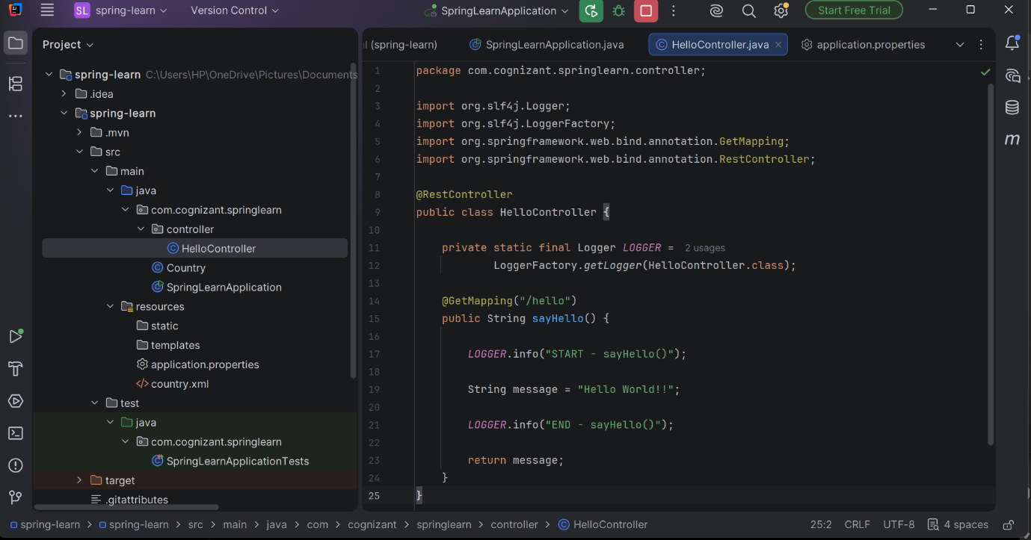

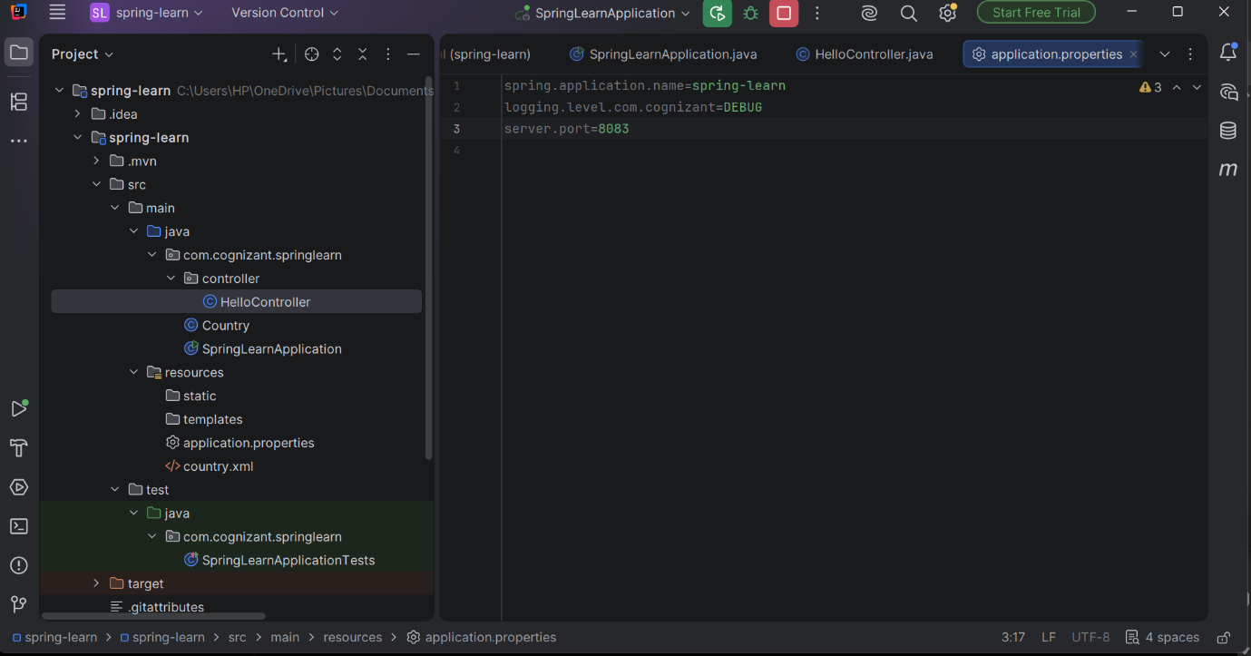

OUTPUT:

"C:\Program Files\Java\jdk-24\bin\java.exe" -XX:TieredStopAtLevel=1 -Dspring.output.ansi.enabled=always "-javaagent:C:\Users\HP\OneDrive\Pictures\Documents\IntelliJ IDEA 2026.1.3\lib\idea_rt.jar=52502" -Dfile.encoding=UTF-8 -Dsun.stdout.encoding=UTF-8 -Dsun.stderr.encoding=UTF-8 -classpath C:\Users\HP\OneDrive\Pictures\Documents\cognizant_java_exercises\spring-learn\spring-learn\target\classes;C:\Users\HP\.m2\repository\org\springframework\boot\spring-boot-starter-web\3.5.16\spring-boot-starter-web-3.5.16.jar;C:\Users\HP\.m2\repository\org\springframework\boot\spring-boot-starter\3.5.16\spring-boot-starter-3.5.16.jar;C:\Users\HP\.m2\repository\org\springframework\boot\spring-boot-starter-logging\3.5.16\spring-boot-starter-logging-3.5.16.jar;C:\Users\HP\.m2\repository\ch\qos\logback\logback-classic\1.5.34\logback-classic-1.5.34.jar;C:\Users\HP\.m2\repository\ch\qos\logback\logback-core\1.5.34\logback-core-1.5.34.jar;C:\Users\HP\.m2\repository\org\apache\logging\log4j\log4j-to-slf4j\2.24.3\log4j-to-slf4j-2.24.3.jar;C:\Users\HP\.m2\repository\org\apache\logging\log4j\log4j-api\2.24.3\log4j-api-2.24.3.jar;C:\Users\HP\.m2\repository\org\slf4j\jul-to-slf4j\2.0.18\jul-to-slf4j-2.0.18.jar;C:\Users\HP\.m2\repository\jakarta\annotation\jakarta.annotation-api\2.1.1\jakarta.annotation-api-2.1.1.jar;C:\Users\HP\.m2\repository\org\yaml\snakeyaml\2.4\snakeyaml-2.4.jar;C:\Users\HP\.m2\repository\org\springframework\boot\spring-boot-starter-json\3.5.16\spring-boot-starter-json-3.5.16.jar;C:\Users\HP\.m2\repository\com\fasterxml\jackson\core\jackson-databind\2.21.4\jackson-databind-2.21.4.jar;C:\Users\HP\.m2\repository\com\fasterxml\jackson\core\jackson-annotations\2.21\jackson-annotations-2.21.jar;C:\Users\HP\.m2\repository\com\fasterxml\jackson\core\jackson-core\2.21.4\jackson-core-2.21.4.jar;C:\Users\HP\.m2\repository\com\fasterxml\jackson\datatype\jackson-datatype-jdk8\2.21.4\jackson-datatype-jdk8-2.21.4.jar;C:\Users\HP\.m2\repository\com\fasterxml\jackson\datatype\jackson-datatype-jsr310\2.21.4\jackson-datatype-jsr310-2.21.4.jar;C:\Users\HP\.m2\repository\com\fasterxml\jackson\module\jackson-module-parameter-names\2.21.4\jackson-module-parameter-names-2.21.4.jar;C:\Users\HP\.m2\repository\org\springframework\boot\spring-boot-starter-tomcat\3.5.16\spring-boot-starter-tomcat-3.5.16.jar;C:\Users\HP\.m2\repository\org\apache\tomcat\embed\tomcat-embed-core\10.1.55\tomcat-embed-core-10.1.55.jar;C:\Users\HP\.m2\repository\org\apache\tomcat\embed\tomcat-embed-el\10.1.55\tomcat-embed-el-10.1.55.jar;C:\Users\HP\.m2\repository\org\apache\tomcat\embed\tomcat-embed-websocket\10.1.55\tomcat-embed-websocket-10.1.55.jar;C:\Users\HP\.m2\repository\org\springframework\spring-web\6.2.19\spring-web-6.2.19.jar;C:\Users\HP\.m2\repository\org\springframework\spring-beans\6.2.19\spring-beans-6.2.19.jar;C:\Users\HP\.m2\repository\io\micrometer\micrometer-observation\1.15.12\micrometer-observation-1.15.12.jar;C:\Users\HP\.m2\repository\io\micrometer\micrometer-commons\1.15.12\micrometer-commons-1.15.12.jar;C:\Users\HP\.m2\repository\org\springframework\spring-webmvc\6.2.19\spring-webmvc-6.2.19.jar;C:\Users\HP\.m2\repository\org\springframework\spring-aop\6.2.19\spring-aop-6.2.19.jar;C:\Users\HP\.m2\repository\org\springframework\spring-context\6.2.19\spring-context-6.2.19.jar;C:\Users\HP\.m2\repository\org\springframework\spring-expression\6.2.19\spring-expression-6.2.19.jar;C:\Users\HP\.m2\repository\org\springframework\boot\spring-boot-devtools\3.5.16\spring-boot-devtools-3.5.16.jar;C:\Users\HP\.m2\repository\org\springframework\boot\spring-boot\3.5.16\spring-boot-3.5.16.jar;C:\Users\HP\.m2\repository\org\springframework\boot\spring-boot-autoconfigure\3.5.16\spring-boot-autoconfigure-3.5.16.jar;C:\Users\HP\.m2\repository\org\slf4j\slf4j-api\2.0.18\slf4j-api-2.0.18.jar;C:\Users\HP\.m2\repository\org\springframework\spring-core\6.2.19\spring-core-6.2.19.jar;C:\Users\HP\.m2\repository\org\springframework\spring-jcl\6.2.19\spring-jcl-6.2.19.jar com.cognizant.springlearn.SpringLearnApplication

. ____ _ __ _ _
/\\ / ___'_ __ _ _(_)_ __ __ _ \ \ \ \
( ( )\___ | '_ | '_| | '_ \/ _` | \ \ \ \
\\/ ___)| |_)| | | | | || (_| | ) ) ) )
' |____| .__|_| |_|_| |_\__, | / / / /
=========|_|==============|___/=/_/_/_/

:: Spring Boot :: (v3.5.16)

2026-07-05T12:41:38.485+05:30 INFO 16968 --- [spring-learn] [ restartedMain] c.c.springlearn.SpringLearnApplication : Starting SpringLearnApplication using Java 24.0.2 with PID 16968 (C:\Users\HP\OneDrive\Pictures\Documents\cognizant_java_exercises\spring-learn\spring-learn\target\classes started by HP in C:\Users\HP\OneDrive\Pictures\Documents\cognizant_java_exercises\spring-learn)
2026-07-05T12:41:38.490+05:30 DEBUG 16968 --- [spring-learn] [ restartedMain] c.c.springlearn.SpringLearnApplication : Running with Spring Boot v3.5.16, Spring v6.2.19
2026-07-05T12:41:38.491+05:30 INFO 16968 --- [spring-learn] [ restartedMain] c.c.springlearn.SpringLearnApplication : No active profile set, falling back to 1 default profile: "default"
2026-07-05T12:41:38.613+05:30 INFO 16968 --- [spring-learn] [ restartedMain] .e.DevToolsPropertyDefaultsPostProcessor : Devtools property defaults active! Set 'spring.devtools.add-properties' to 'false' to disable
2026-07-05T12:41:38.613+05:30 INFO 16968 --- [spring-learn] [ restartedMain] .e.DevToolsPropertyDefaultsPostProcessor : For additional web related logging consider setting the 'logging.level.web' property to 'DEBUG'
2026-07-05T12:41:40.163+05:30 INFO 16968 --- [spring-learn] [ restartedMain] o.s.b.w.embedded.tomcat.TomcatWebServer : Tomcat initialized with port 8083 (http)
2026-07-05T12:41:40.191+05:30 INFO 16968 --- [spring-learn] [ restartedMain] o.apache.catalina.core.StandardService : Starting service [Tomcat]
2026-07-05T12:41:40.191+05:30 INFO 16968 --- [spring-learn] [ restartedMain] o.apache.catalina.core.StandardEngine : Starting Servlet engine: [Apache Tomcat/10.1.55]
2026-07-05T12:41:40.247+05:30 INFO 16968 --- [spring-learn] [ restartedMain] o.a.c.c.C.[Tomcat].[localhost].[/] : Initializing Spring embedded WebApplicationContext
2026-07-05T12:41:40.247+05:30 INFO 16968 --- [spring-learn] [ restartedMain] w.s.c.ServletWebServerApplicationContext : Root WebApplicationContext: initialization completed in 1632 ms
2026-07-05T12:41:40.701+05:30 INFO 16968 --- [spring-learn] [ restartedMain] o.s.b.d.a.OptionalLiveReloadServer : LiveReload server is running on port 35729
2026-07-05T12:41:40.742+05:30 INFO 16968 --- [spring-learn] [ restartedMain] o.s.b.w.embedded.tomcat.TomcatWebServer : Tomcat started on port 8083 (http) with context path '/'
2026-07-05T12:41:40.750+05:30 INFO 16968 --- [spring-learn] [ restartedMain] c.c.springlearn.SpringLearnApplication : Started SpringLearnApplication in 3.058 seconds (process running for 4.036)
2026-07-05T12:41:40.752+05:30 INFO 16968 --- [spring-learn] [ restartedMain] c.c.springlearn.SpringLearnApplication : Inside main
2026-07-05T12:41:40.971+05:30 DEBUG 16968 --- [spring-learn] [ restartedMain] com.cognizant.springlearn.Country : Inside Country Constructor.
2026-07-05T12:41:40.972+05:30 DEBUG 16968 --- [spring-learn] [ restartedMain] com.cognizant.springlearn.Country : Inside setCode()
2026-07-05T12:41:40.973+05:30 DEBUG 16968 --- [spring-learn] [ restartedMain] com.cognizant.springlearn.Country : Inside setName()
2026-07-05T12:41:40.974+05:30 DEBUG 16968 --- [spring-learn] [ restartedMain] c.c.springlearn.SpringLearnApplication : Country : Country{code='IN', name='India'}
2026-07-05T12:43:06.805+05:30 INFO 16968 --- [spring-learn] [nio-8083-exec-1] o.a.c.c.C.[Tomcat].[localhost].[/] : Initializing Spring DispatcherServlet 'dispatcherServlet'
2026-07-05T12:43:06.806+05:30 INFO 16968 --- [spring-learn] [nio-8083-exec-1] o.s.web.servlet.DispatcherServlet : Initializing Servlet 'dispatcherServlet'
2026-07-05T12:43:06.807+05:30 INFO 16968 --- [spring-learn] [nio-8083-exec-1] o.s.web.servlet.DispatcherServlet : Completed initialization in 1 ms
2026-07-05T12:43:06.845+05:30 INFO 16968 --- [spring-learn] [nio-8083-exec-1] c.c.s.controller.HelloController : START - sayHello()
2026-07-05T12:43:06.846+05:30 INFO 16968 --- [spring-learn] [nio-8083-exec-1] c.c.s.controller.HelloController : END - sayHell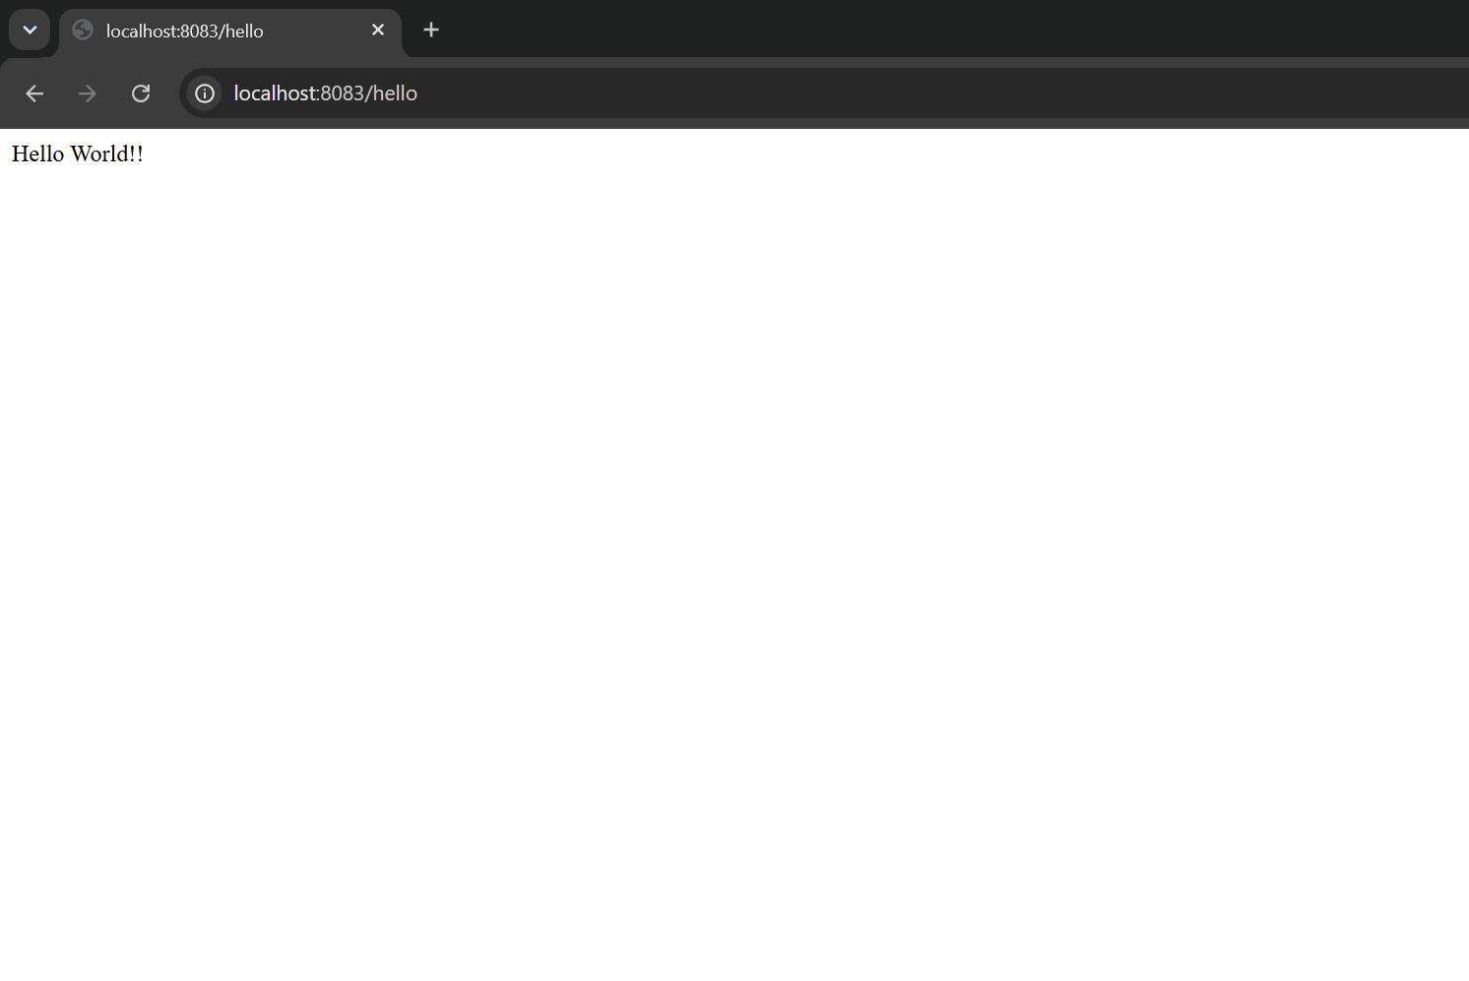
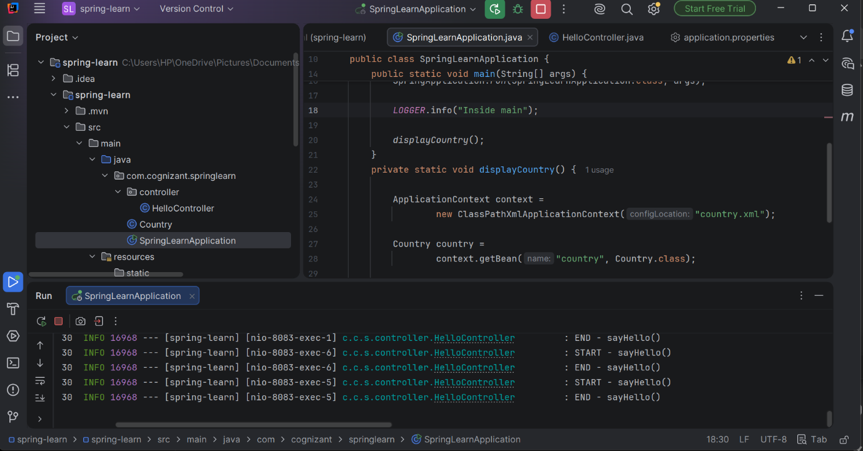

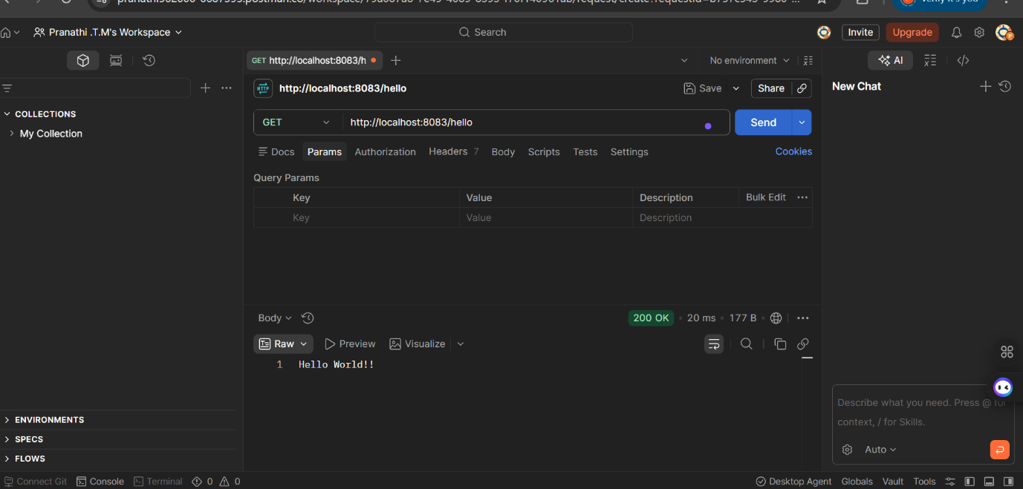

REST - Country Web Service
Write a REST service that returns India country details in the earlier created spring learn application.

CODE IMPLEMENTATION:

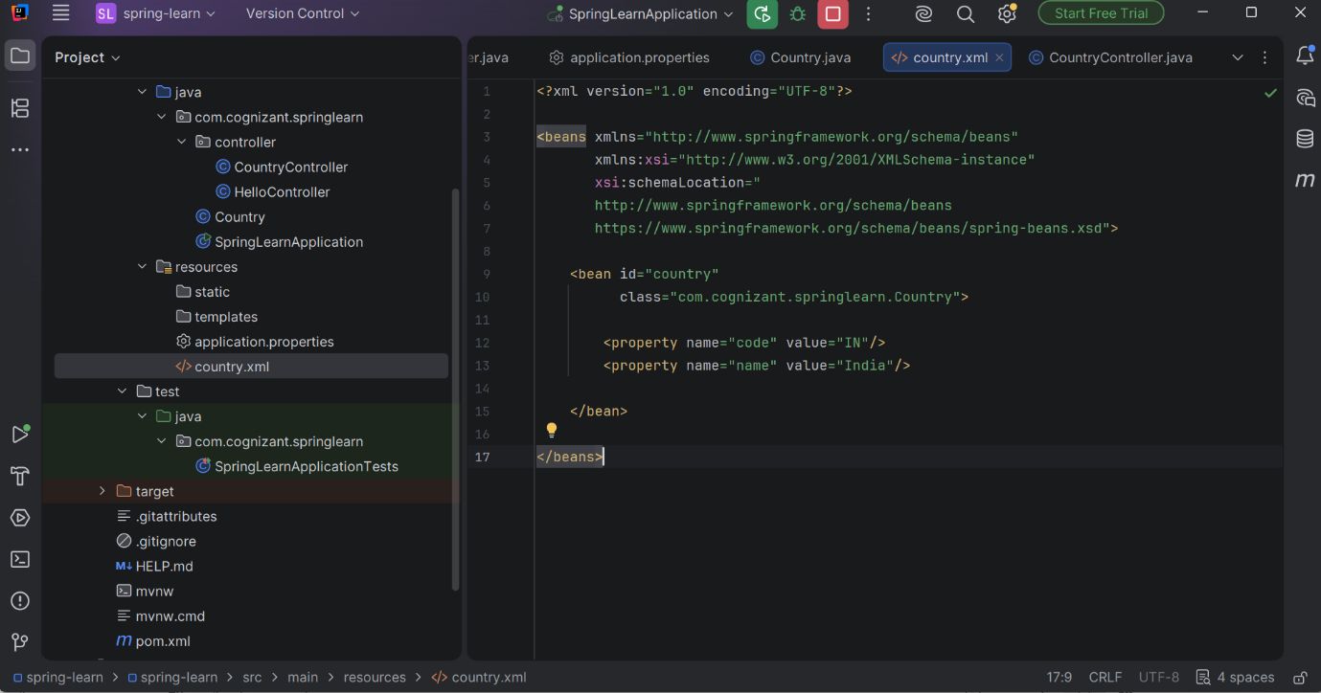

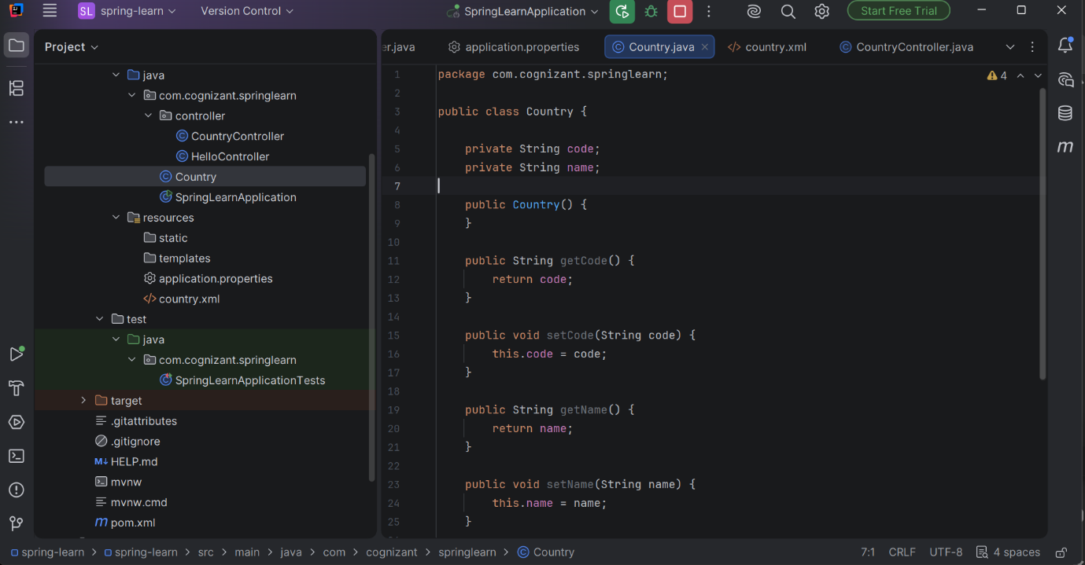
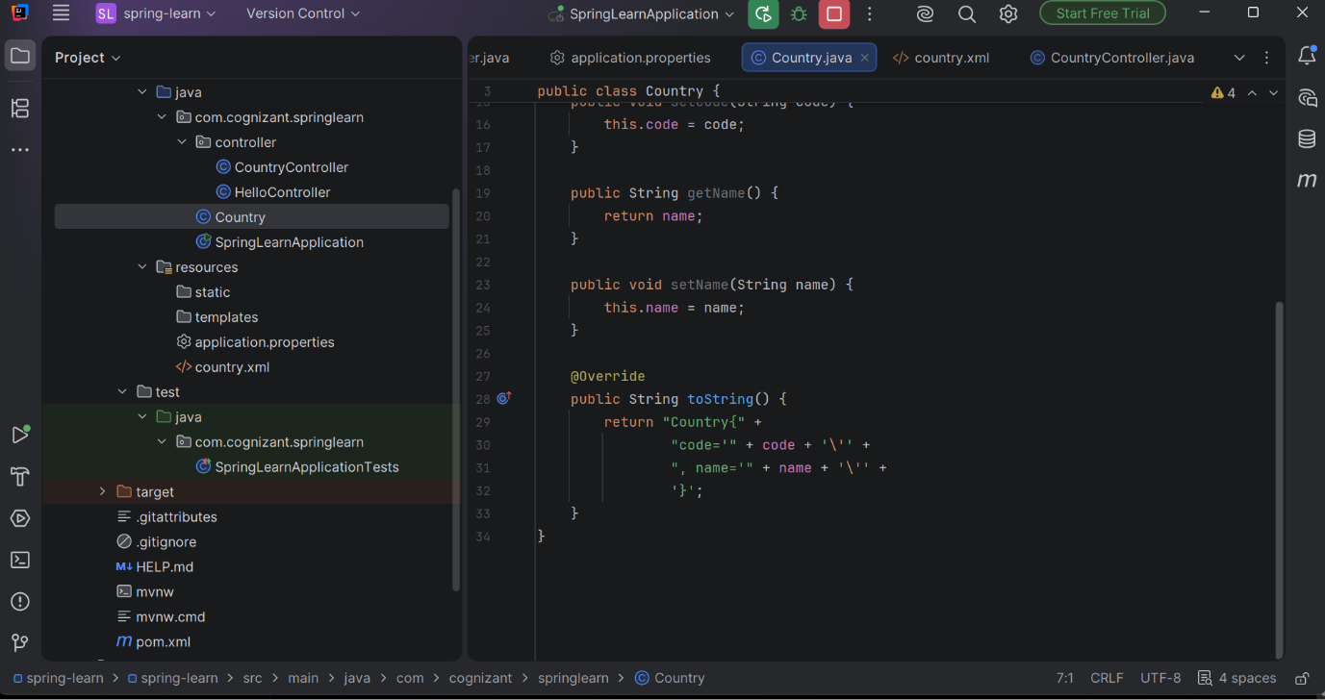

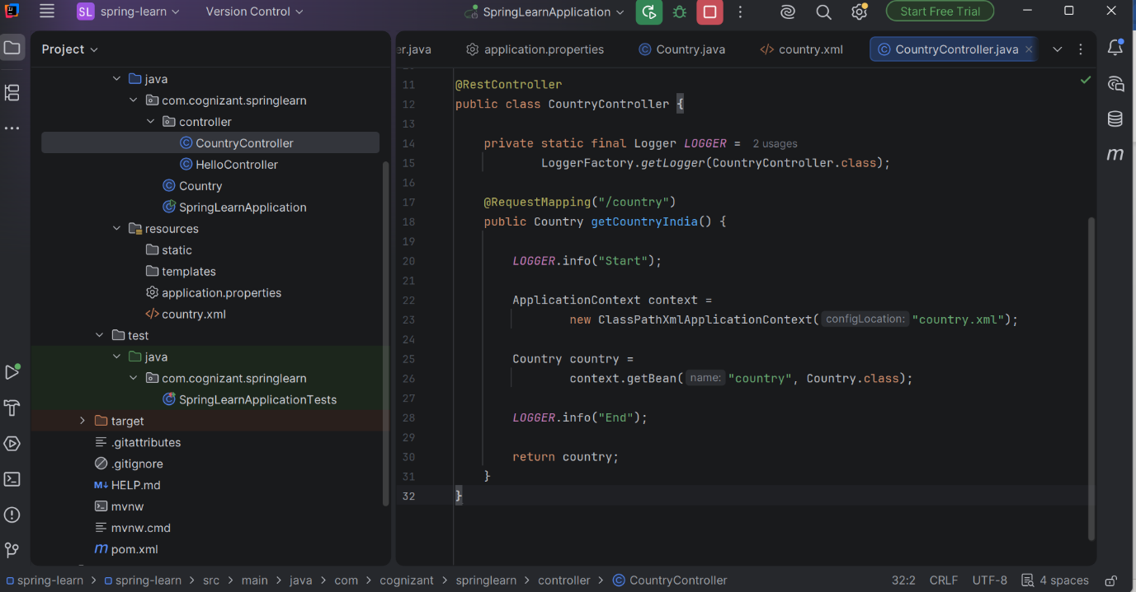

OUTPUT:
"C:\Program Files\Java\jdk-24\bin\java.exe" -XX:TieredStopAtLevel=1 -Dspring.output.ansi.enabled=always "-javaagent:C:\Users\HP\OneDrive\Pictures\Documents\IntelliJ IDEA 2026.1.3\lib\idea_rt.jar=61106" -Dfile.encoding=UTF-8 -Dsun.stdout.encoding=UTF-8 -Dsun.stderr.encoding=UTF-8 -classpath C:\Users\HP\OneDrive\Pictures\Documents\cognizant_java_exercises\spring-learn\spring-learn\target\classes;C:\Users\HP\.m2\repository\org\springframework\boot\spring-boot-starter-web\3.5.16\spring-boot-starter-web-3.5.16.jar;C:\Users\HP\.m2\repository\org\springframework\boot\spring-boot-starter\3.5.16\spring-boot-starter-3.5.16.jar;C:\Users\HP\.m2\repository\org\springframework\boot\spring-boot-starter-logging\3.5.16\spring-boot-starter-logging-3.5.16.jar;C:\Users\HP\.m2\repository\ch\qos\logback\logback-classic\1.5.34\logback-classic-1.5.34.jar;C:\Users\HP\.m2\repository\ch\qos\logback\logback-core\1.5.34\logback-core-1.5.34.jar;C:\Users\HP\.m2\repository\org\apache\logging\log4j\log4j-to-slf4j\2.24.3\log4j-to-slf4j-2.24.3.jar;C:\Users\HP\.m2\repository\org\apache\logging\log4j\log4j-api\2.24.3\log4j-api-2.24.3.jar;C:\Users\HP\.m2\repository\org\slf4j\jul-to-slf4j\2.0.18\jul-to-slf4j-2.0.18.jar;C:\Users\HP\.m2\repository\jakarta\annotation\jakarta.annotation-api\2.1.1\jakarta.annotation-api-2.1.1.jar;C:\Users\HP\.m2\repository\org\yaml\snakeyaml\2.4\snakeyaml-2.4.jar;C:\Users\HP\.m2\repository\org\springframework\boot\spring-boot-starter-json\3.5.16\spring-boot-starter-json-3.5.16.jar;C:\Users\HP\.m2\repository\com\fasterxml\jackson\core\jackson-databind\2.21.4\jackson-databind-2.21.4.jar;C:\Users\HP\.m2\repository\com\fasterxml\jackson\core\jackson-annotations\2.21\jackson-annotations-2.21.jar;C:\Users\HP\.m2\repository\com\fasterxml\jackson\core\jackson-core\2.21.4\jackson-core-2.21.4.jar;C:\Users\HP\.m2\repository\com\fasterxml\jackson\datatype\jackson-datatype-jdk8\2.21.4\jackson-datatype-jdk8-2.21.4.jar;C:\Users\HP\.m2\repository\com\fasterxml\jackson\datatype\jackson-datatype-jsr310\2.21.4\jackson-datatype-jsr310-2.21.4.jar;C:\Users\HP\.m2\repository\com\fasterxml\jackson\module\jackson-module-parameter-names\2.21.4\jackson-module-parameter-names-2.21.4.jar;C:\Users\HP\.m2\repository\org\springframework\boot\spring-boot-starter-tomcat\3.5.16\spring-boot-starter-tomcat-3.5.16.jar;C:\Users\HP\.m2\repository\org\apache\tomcat\embed\tomcat-embed-core\10.1.55\tomcat-embed-core-10.1.55.jar;C:\Users\HP\.m2\repository\org\apache\tomcat\embed\tomcat-embed-el\10.1.55\tomcat-embed-el-10.1.55.jar;C:\Users\HP\.m2\repository\org\apache\tomcat\embed\tomcat-embed-websocket\10.1.55\tomcat-embed-websocket-10.1.55.jar;C:\Users\HP\.m2\repository\org\springframework\spring-web\6.2.19\spring-web-6.2.19.jar;C:\Users\HP\.m2\repository\org\springframework\spring-beans\6.2.19\spring-beans-6.2.19.jar;C:\Users\HP\.m2\repository\io\micrometer\micrometer-observation\1.15.12\micrometer-observation-1.15.12.jar;C:\Users\HP\.m2\repository\io\micrometer\micrometer-commons\1.15.12\micrometer-commons-1.15.12.jar;C:\Users\HP\.m2\repository\org\springframework\spring-webmvc\6.2.19\spring-webmvc-6.2.19.jar;C:\Users\HP\.m2\repository\org\springframework\spring-aop\6.2.19\spring-aop-6.2.19.jar;C:\Users\HP\.m2\repository\org\springframework\spring-context\6.2.19\spring-context-6.2.19.jar;C:\Users\HP\.m2\repository\org\springframework\spring-expression\6.2.19\spring-expression-6.2.19.jar;C:\Users\HP\.m2\repository\org\springframework\boot\spring-boot-devtools\3.5.16\spring-boot-devtools-3.5.16.jar;C:\Users\HP\.m2\repository\org\springframework\boot\spring-boot\3.5.16\spring-boot-3.5.16.jar;C:\Users\HP\.m2\repository\org\springframework\boot\spring-boot-autoconfigure\3.5.16\spring-boot-autoconfigure-3.5.16.jar;C:\Users\HP\.m2\repository\org\slf4j\slf4j-api\2.0.18\slf4j-api-2.0.18.jar;C:\Users\HP\.m2\repository\org\springframework\spring-core\6.2.19\spring-core-6.2.19.jar;C:\Users\HP\.m2\repository\org\springframework\spring-jcl\6.2.19\spring-jcl-6.2.19.jar com.cognizant.springlearn.SpringLearnApplication

. ____ _ __ _ _
/\\ / ___'_ __ _ _(_)_ __ __ _ \ \ \ \
( ( )\___ | '_ | '_| | '_ \/ _` | \ \ \ \
\\/ ___)| |_)| | | | | || (_| | ) ) ) )
' |____| .__|_| |_|_| |_\__, | / / / /
=========|_|==============|___/=/_/_/_/

:: Spring Boot :: (v3.5.16)

2026-07-05T14:14:52.483+05:30 INFO 16016 --- [spring-learn] [ restartedMain] c.c.springlearn.SpringLearnApplication : Starting SpringLearnApplication using Java 24.0.2 with PID 16016 (C:\Users\HP\OneDrive\Pictures\Documents\cognizant_java_exercises\spring-learn\spring-learn\target\classes started by HP in C:\Users\HP\OneDrive\Pictures\Documents\cognizant_java_exercises\spring-learn)
2026-07-05T14:14:52.490+05:30 DEBUG 16016 --- [spring-learn] [ restartedMain] c.c.springlearn.SpringLearnApplication : Running with Spring Boot v3.5.16, Spring v6.2.19
2026-07-05T14:14:52.497+05:30 INFO 16016 --- [spring-learn] [ restartedMain] c.c.springlearn.SpringLearnApplication : No active profile set, falling back to 1 default profile: "default"
2026-07-05T14:14:52.584+05:30 INFO 16016 --- [spring-learn] [ restartedMain] .e.DevToolsPropertyDefaultsPostProcessor : Devtools property defaults active! Set 'spring.devtools.add-properties' to 'false' to disable
2026-07-05T14:14:52.585+05:30 INFO 16016 --- [spring-learn] [ restartedMain] .e.DevToolsPropertyDefaultsPostProcessor : For additional web related logging consider setting the 'logging.level.web' property to 'DEBUG'
2026-07-05T14:14:53.859+05:30 INFO 16016 --- [spring-learn] [ restartedMain] o.s.b.w.embedded.tomcat.TomcatWebServer : Tomcat initialized with port 8083 (http)
2026-07-05T14:14:53.878+05:30 INFO 16016 --- [spring-learn] [ restartedMain] o.apache.catalina.core.StandardService : Starting service [Tomcat]
2026-07-05T14:14:53.878+05:30 INFO 16016 --- [spring-learn] [ restartedMain] o.apache.catalina.core.StandardEngine : Starting Servlet engine: [Apache Tomcat/10.1.55]
2026-07-05T14:14:53.926+05:30 INFO 16016 --- [spring-learn] [ restartedMain] o.a.c.c.C.[Tomcat].[localhost].[/] : Initializing Spring embedded WebApplicationContext
2026-07-05T14:14:53.927+05:30 INFO 16016 --- [spring-learn] [ restartedMain] w.s.c.ServletWebServerApplicationContext : Root WebApplicationContext: initialization completed in 1342 ms
2026-07-05T14:14:54.399+05:30 INFO 16016 --- [spring-learn] [ restartedMain] o.s.b.d.a.OptionalLiveReloadServer : LiveReload server is running on port 35729
2026-07-05T14:14:54.443+05:30 INFO 16016 --- [spring-learn] [ restartedMain] o.s.b.w.embedded.tomcat.TomcatWebServer : Tomcat started on port 8083 (http) with context path '/'
2026-07-05T14:14:54.452+05:30 INFO 16016 --- [spring-learn] [ restartedMain] c.c.springlearn.SpringLearnApplication : Started SpringLearnApplication in 2.706 seconds (process running for 3.492)
2026-07-05T14:14:54.455+05:30 INFO 16016 --- [spring-learn] [ restartedMain] c.c.springlearn.SpringLearnApplication : Inside main
2026-07-05T14:14:54.581+05:30 DEBUG 16016 --- [spring-learn] [ restartedMain] c.c.springlearn.SpringLearnApplication : Country : Country{code='IN', name='India'}
2026-07-05T14:15:19.311+05:30 INFO 16016 --- [spring-learn] [nio-8083-exec-1] o.a.c.c.C.[Tomcat].[localhost].[/] : Initializing Spring DispatcherServlet 'dispatcherServlet'
2026-07-05T14:15:19.312+05:30 INFO 16016 --- [spring-learn] [nio-8083-exec-1] o.s.web.servlet.DispatcherServlet : Initializing Servlet 'dispatcherServlet'
2026-07-05T14:15:19.314+05:30 INFO 16016 --- [spring-learn] [nio-8083-exec-1] o.s.web.servlet.DispatcherServlet : Completed initialization in 2 ms
2026-07-05T14:15:19.376+05:30 INFO 16016 --- [spring-learn] [nio-8083-exec-1] c.c.s.controller.CountryController : Start
2026-07-05T14:15:19.431+05:30 INFO 16016 --- [spring-learn] [nio-8083-exec-1] c.c.s.controller.CountryController : End

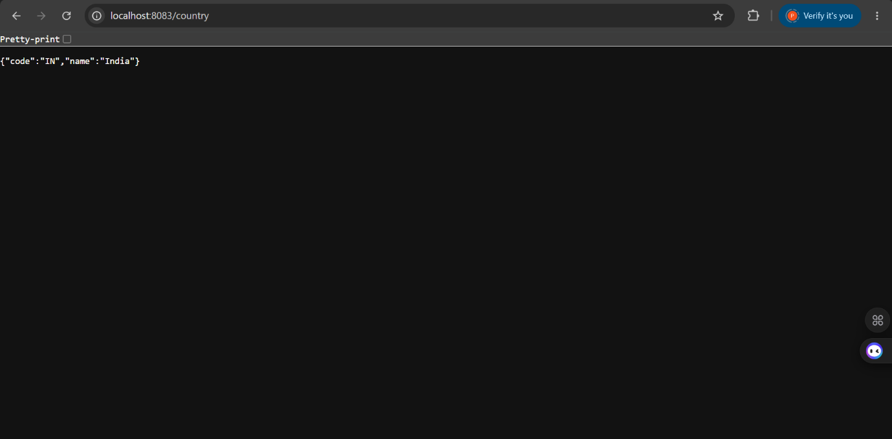

REST - Get country based on country code
Write a REST service that returns a specific country based on country code. The country code should be case insensitive.

CODE IMPLEMENTATION:
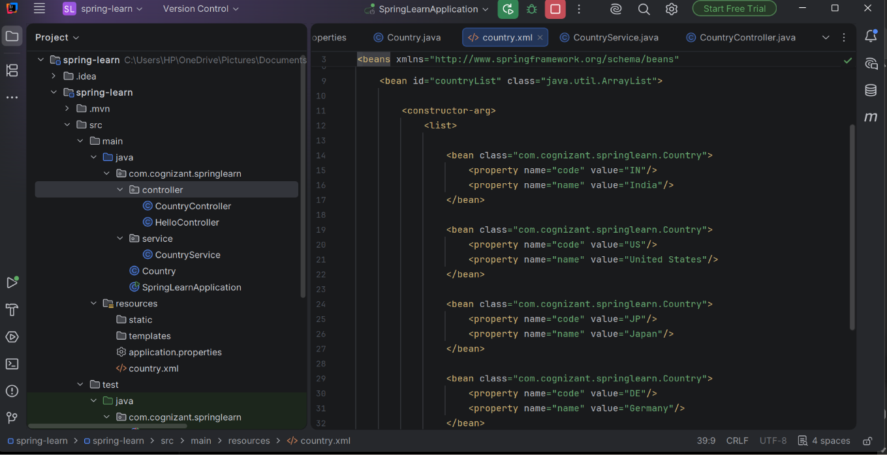
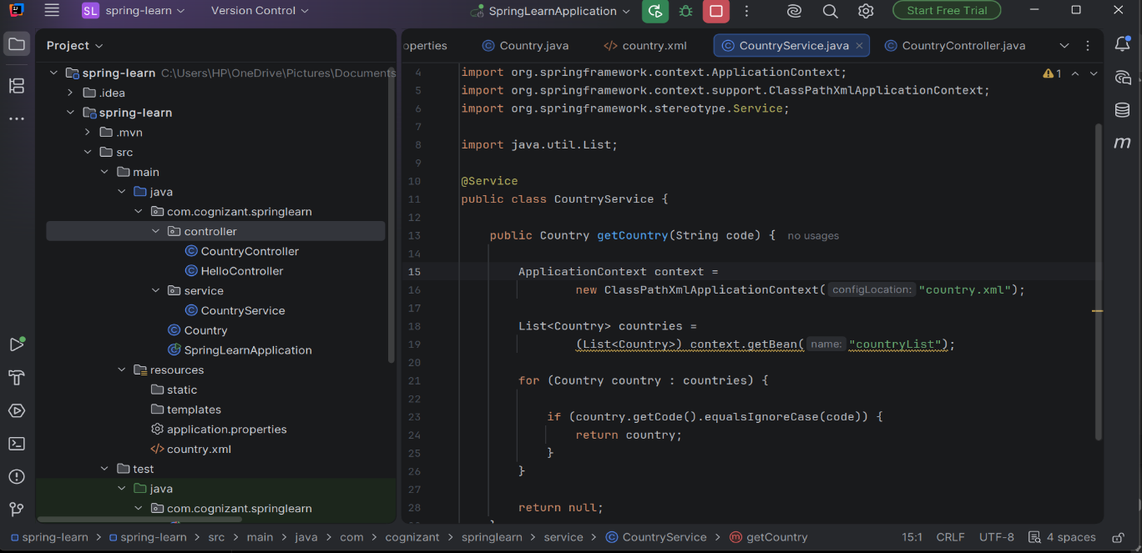
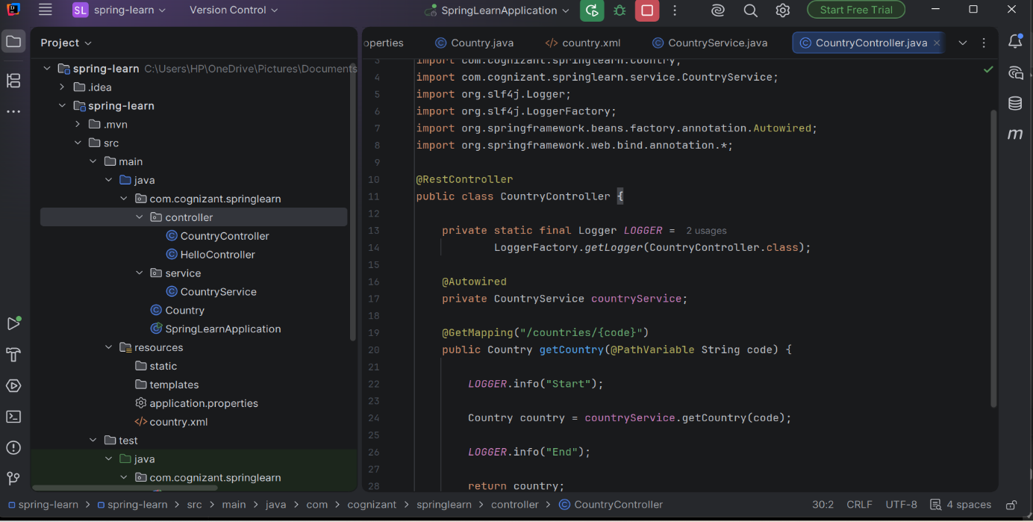
OUTPUT:
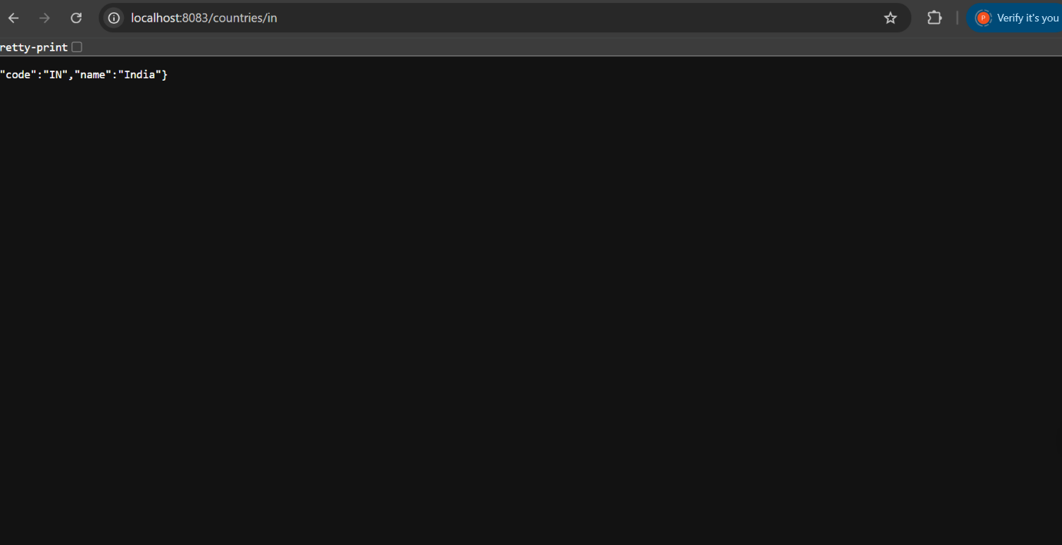

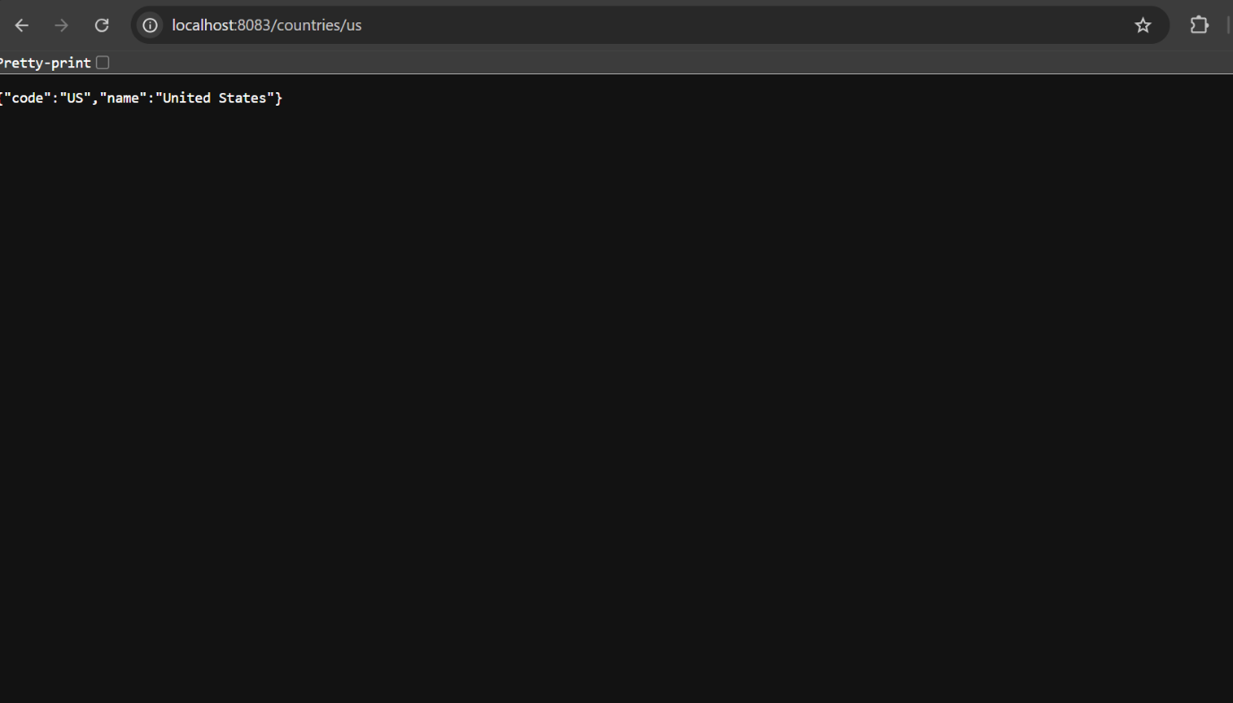

5.JWT-handson:
Create authentication service that returns JWT

CODE IMPLEMENTATION:

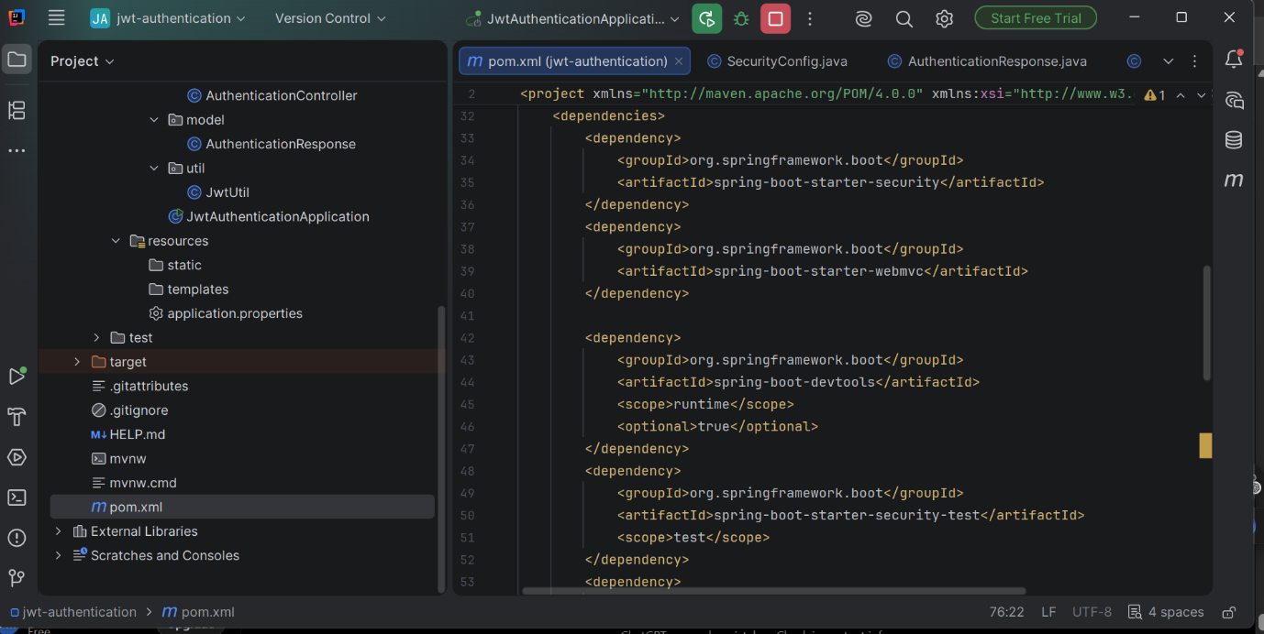

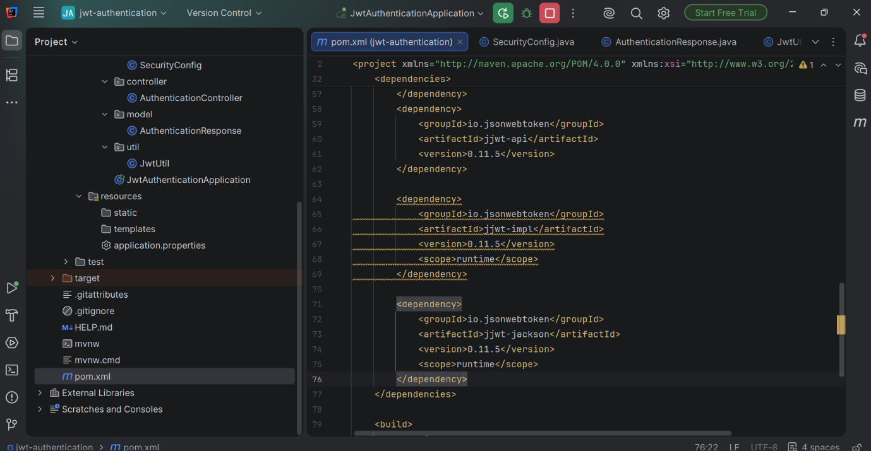
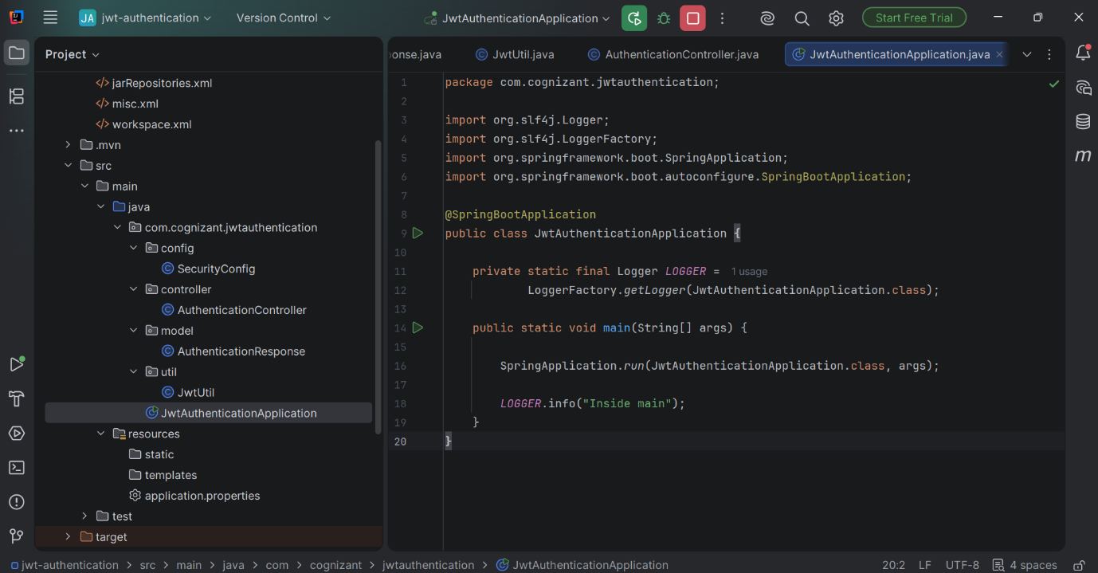

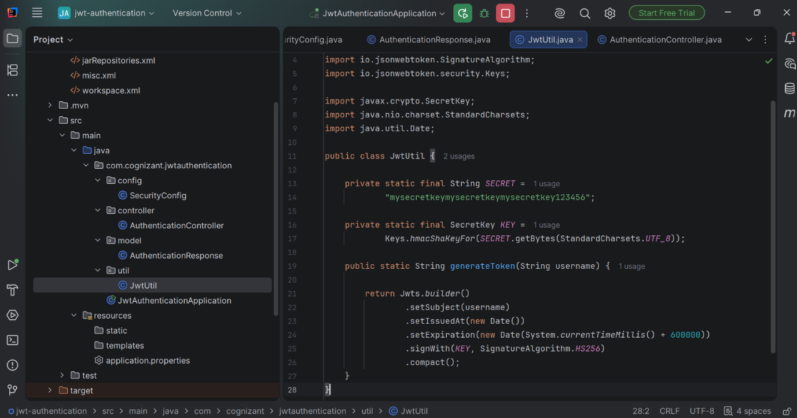

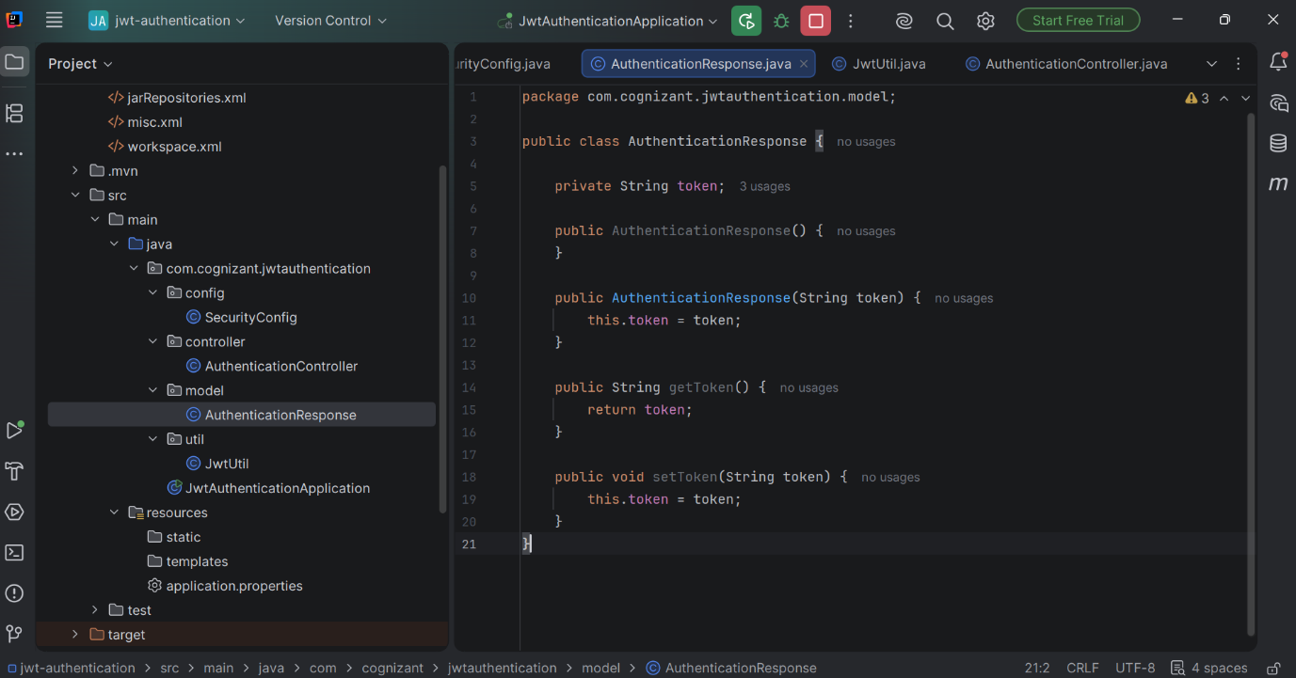

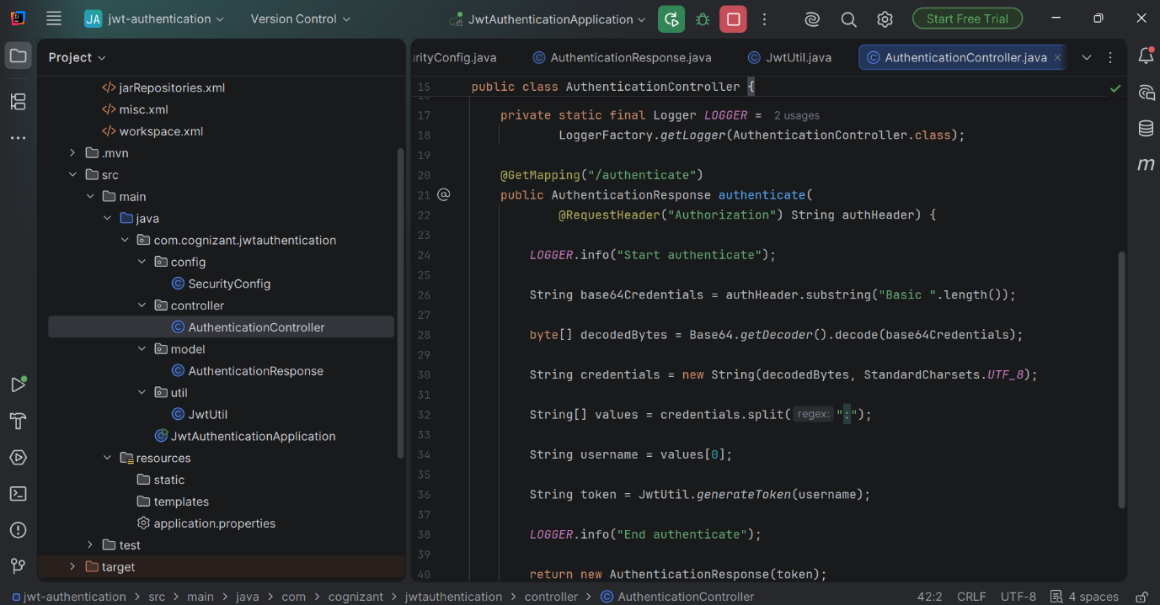

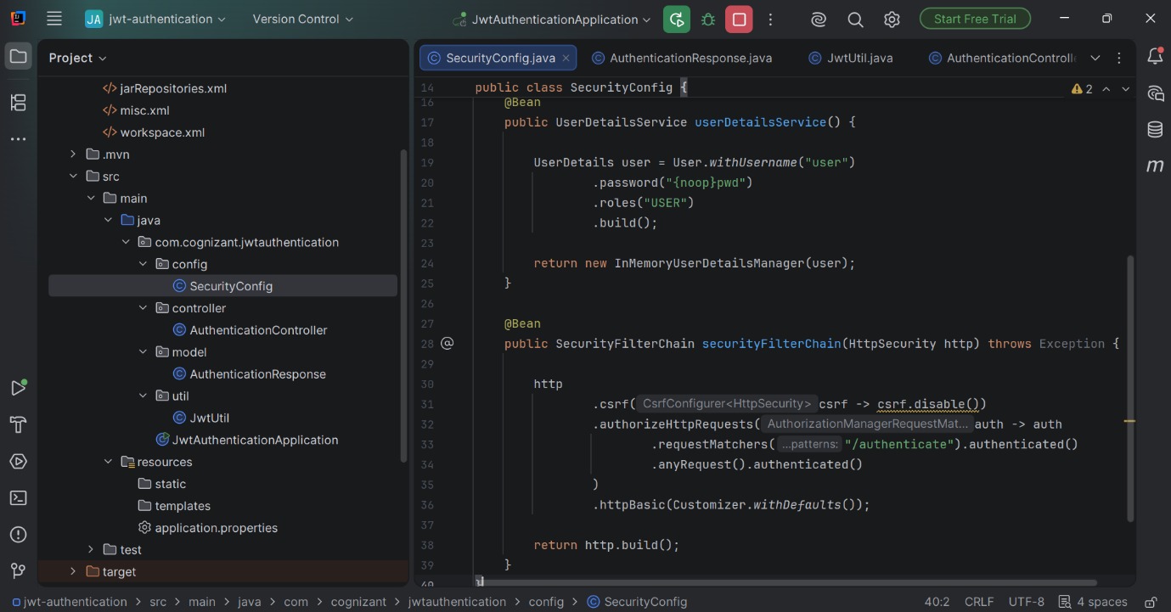

OUTPUT:
