WEEK 5 MANDATORY HANDS-ON:
ANGULAR

HANDS-ON 1 [Beginner] Environment Setup, Project Structure & First Component
Task 1: Scaffold and Explore the Angular Project
Task 2: Create and Organise Components

CODE IMPLEMENTATION:

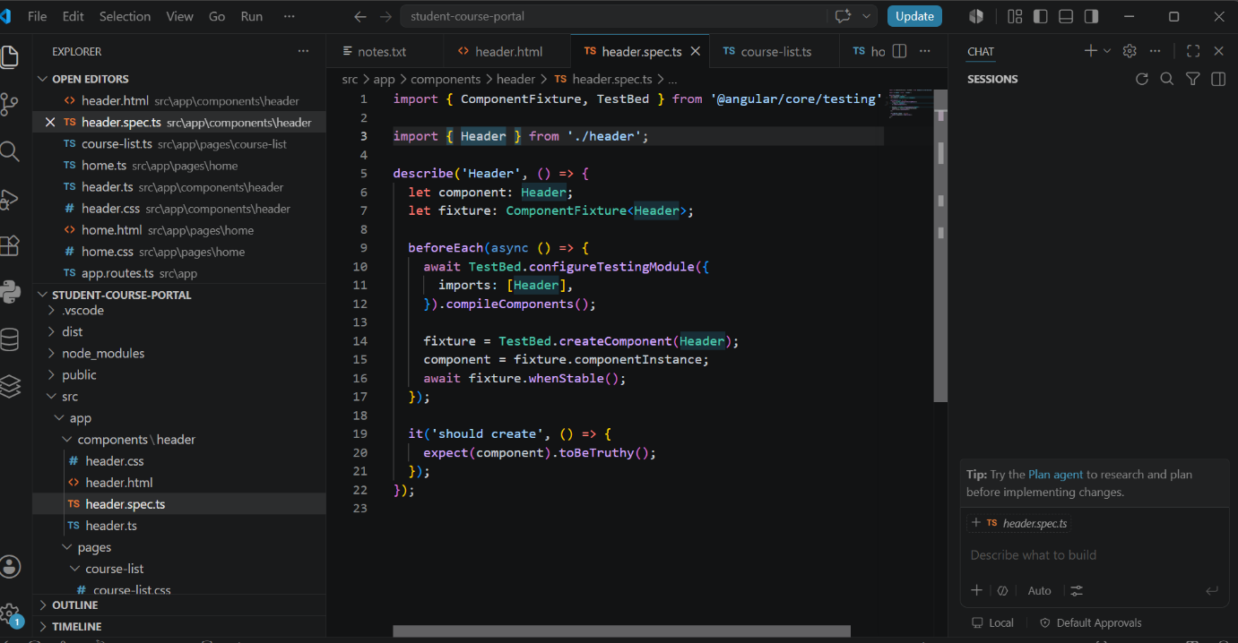

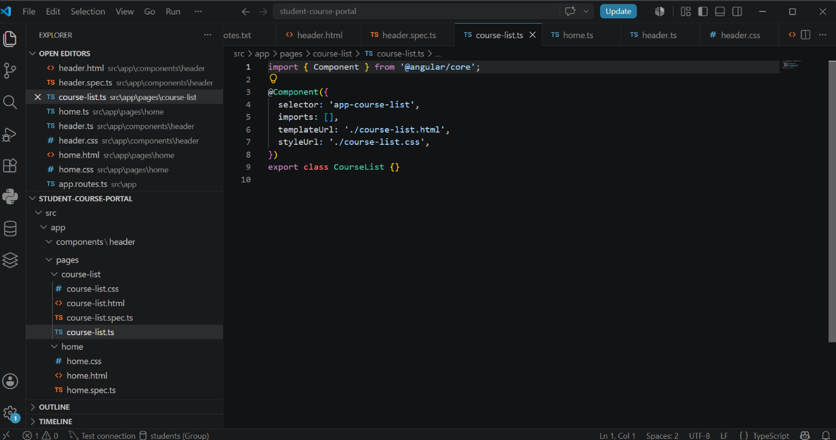

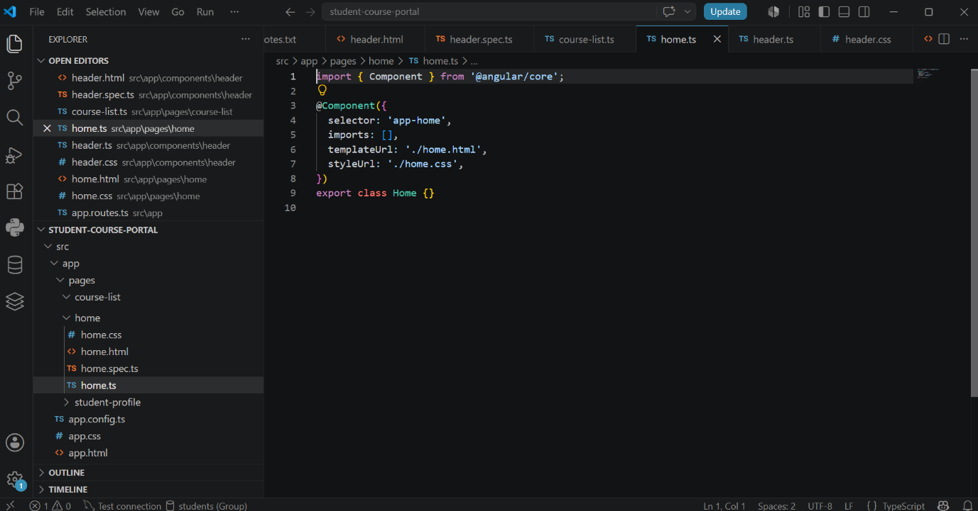

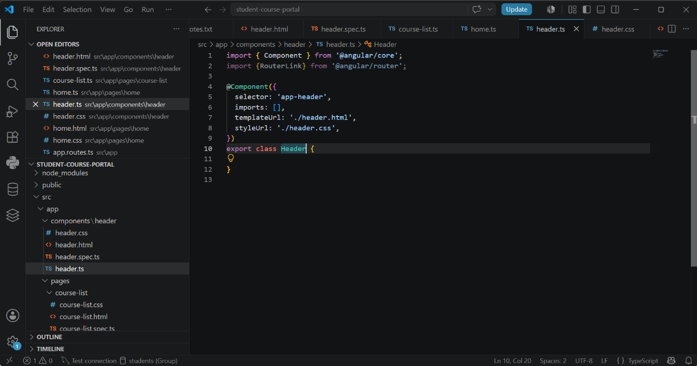

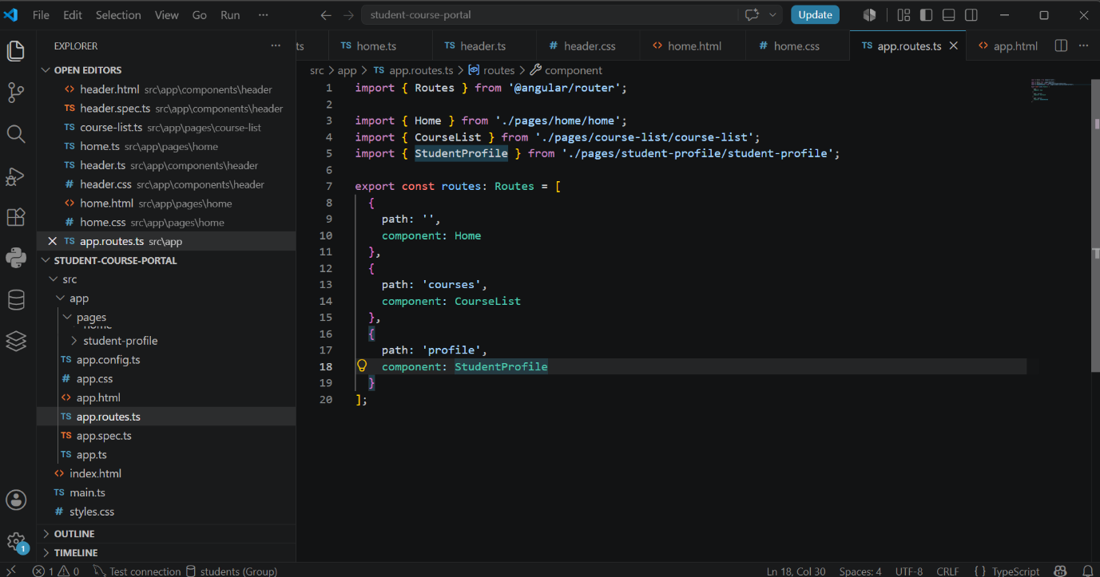

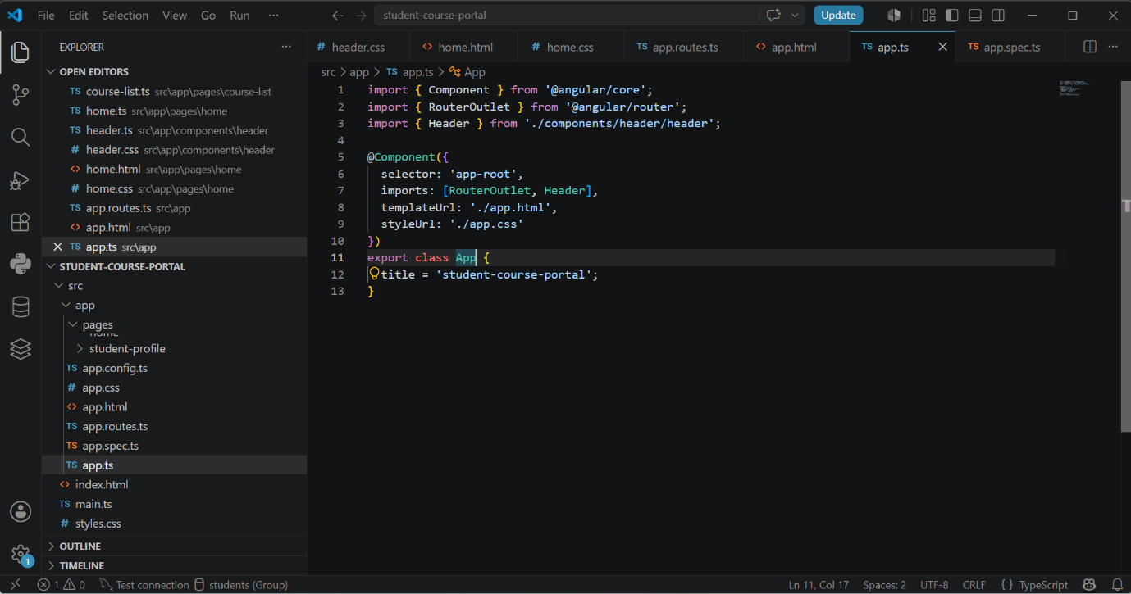

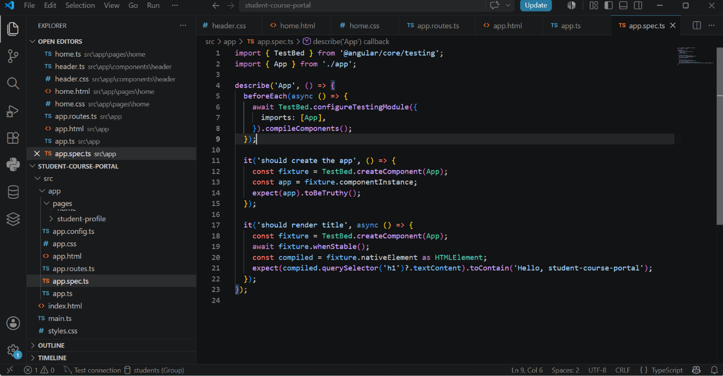

OUTPUT:
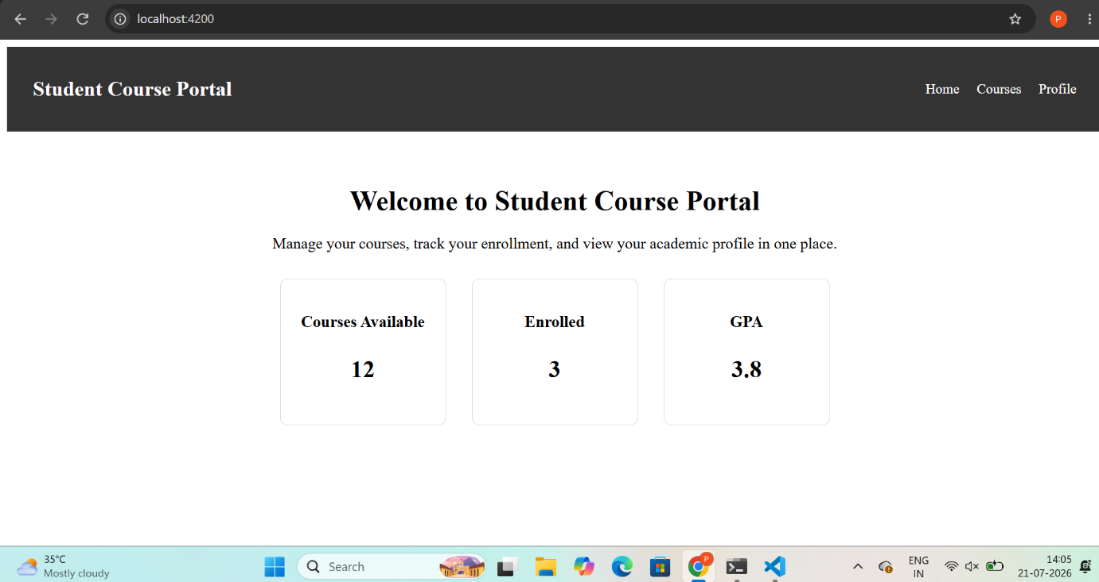

HANDS-ON 2 [Beginner] Data Binding, Lifecycle Hooks & Component Communication

CODE IMPLEMENTATION:
Course-card.ts:
import {
Component,
Input,
Output,
EventEmitter,
OnChanges,
SimpleChanges
} from '@angular/core';

@Component({
selector: 'app-course-card',
imports: [],
templateUrl: './course-card.html',
styleUrl: './course-card.css'
})
export class CourseCard implements OnChanges {

@Input() course: {
id: number;
name: string;
code: string;
credits: number;
} = {
id: 0,
name: '',
code: '',
credits: 0
};

@Output() enrollRequested = new EventEmitter<number>();

ngOnChanges(changes: SimpleChanges): void {

if (changes['course']) {
console.log(
'Course changed:',
'Previous value:',
changes['course'].previousValue,
'Current value:',
changes['course'].currentValue
);
}

}

}

Course-list.ts:
import { Component } from '@angular/core';
import { CourseCard } from '../../components/course-card/course-card';

@Component({
selector: 'app-course-list',
imports: [CourseCard],
templateUrl: './course-list.html',
styleUrl: './course-list.css'
})
export class CourseList {

courses = [
{
id: 1,
name: 'Java Programming',
code: 'JAVA101',
credits: 4
},
{
id: 2,
name: 'Web Development',
code: 'WEB102',
credits: 3
},
{
id: 3,
name: 'Database Management',
code: 'DB103',
credits: 4
},
{
id: 4,
name: 'Cloud Computing',
code: 'CLOUD104',
credits: 3
},
{
id: 5,
name: 'Data Structures',
code: 'DS105',
credits: 4
}
];

selectedCourseId: number | null = null;

onEnroll(courseId: number): void {

console.log('Enrolling in course: ' + courseId);

this.selectedCourseId = courseId;

}

}

Course-list.html:
<h2>Available Courses</h2>

@for (c of courses; track c.id) {

<app-course-card
[course]="c"
(enrollRequested)="onEnroll($event)">
</app-course-card>

}

@if (selectedCourseId) {

<p>
Selected course ID: {{ selectedCourseId }}
</p>

}

Course-card.html:
<div class="course-card">

<h3>{{ course.name }}</h3>

<p>Course ID: {{ course.id }}</p>

<p>Course Code: {{ course.code }}</p>

<p>Credits: {{ course.credits }}</p>

<button (click)="enrollRequested.emit(course.id)">
Enroll
</button>

</div>

home.ts:
import { Component } from '@angular/core';
import { FormsModule } from '@angular/forms';
import { CourseList } from '../course-list/course-list';
import { NgIf } from '@angular/common';

@Component({
selector: 'app-home',
imports: [
FormsModule,
CourseList,
NgIf

],
templateUrl: './home.html',
styleUrl: './home.css'
})
export class Home {

portalName = 'Student Course Portal';

isPortalActive = true;

message = '';

searchTerm = '';

availableCourses = 5;

onEnrollClick(): void {
this.message = 'Enrollment opened!';
}

}

hearder.ts:
import { Component } from '@angular/core';
import {RouterLink} from '@angular/router';

@Component({
selector: 'app-header',
imports: [],
templateUrl: './header.html',
styleUrl: './header.css',
})
export class Header {

}

header.html:
<nav class="navbar">
<h2>Student Course Portal</h2>

<div class="nav-links">
<a routerLink="/">Home</a>
<a routerLink="/courses">Courses</a>
<a routerLink="/profile">Profile</a>
</div>
</nav>

course-card.spec.ts:
import { ComponentFixture, TestBed } from '@angular/core/testing';

import { CourseCard } from './course-card';

describe('CourseCard', () => {
let component: CourseCard;
let fixture: ComponentFixture<CourseCard>;

beforeEach(async () => {
await TestBed.configureTestingModule({
imports: [CourseCard],
}).compileComponents();

fixture = TestBed.createComponent(CourseCard);
component = fixture.componentInstance;
await fixture.whenStable();
});

it('should create', () => {
expect(component).toBeTruthy();
});
});

course-list.spec.ts:
import { ComponentFixture, TestBed } from '@angular/core/testing';

import { CourseList } from './course-list';

describe('CourseList', () => {
let component: CourseList;
let fixture: ComponentFixture<CourseList>;

beforeEach(async () => {
await TestBed.configureTestingModule({
imports: [CourseList],
}).compileComponents();

fixture = TestBed.createComponent(CourseList);
component = fixture.componentInstance;
await fixture.whenStable();
});

it('should create', () => {
expect(component).toBeTruthy();
});
});

app.route.ts:
import { Routes } from '@angular/router';
import { Home } from './pages/home/home';
import { CourseList } from './pages/course-list/course-list';
import { StudentProfile } from './pages/student-profile/student-profile';

export const routes: Routes = [
{
path: '',
component: Home
},
{
path: 'home',
component: Home
},
{
path: 'courses',
component: CourseList
},
{
path: 'profile',
component: StudentProfile
}
];

app.config.ts:
import { ApplicationConfig } from '@angular/core';
import { provideRouter } from '@angular/router';

import { routes } from './app.routes';

export const appConfig: ApplicationConfig = {
providers: [
provideRouter(routes)
]
};

app.spec.ts:
import { TestBed } from '@angular/core/testing';
import { App } from './app';

describe('App', () => {
beforeEach(async () => {
await TestBed.configureTestingModule({
imports: [App],
}).compileComponents();
});

it('should create the app', () => {
const fixture = TestBed.createComponent(App);
const app = fixture.componentInstance;
expect(app).toBeTruthy();
});

it('should render title', async () => {
const fixture = TestBed.createComponent(App);
await fixture.whenStable();
const compiled = fixture.nativeElement as HTMLElement;
expect(compiled.querySelector('h1')?.textContent).toContain('Hello, student-course-portal');
});
});

Task 1: All Four Binding Types
OUTPUT:
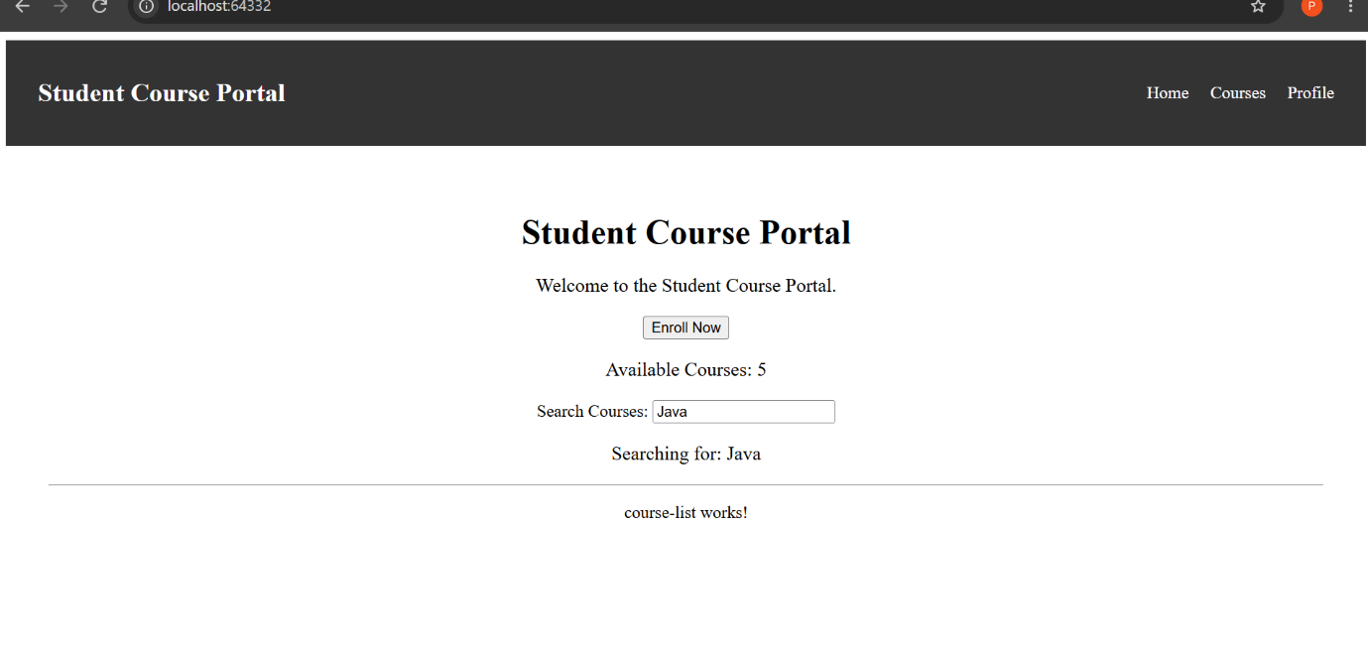

Task 2: Lifecycle Hooks
OUTPUT:
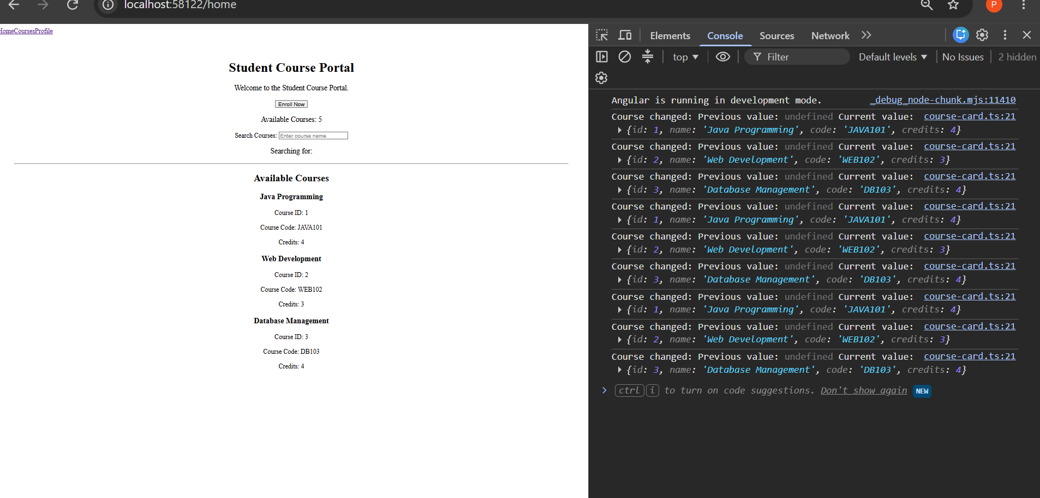

Task 3: @Input and @Output — Parent-Child Communication
OUTPUT:
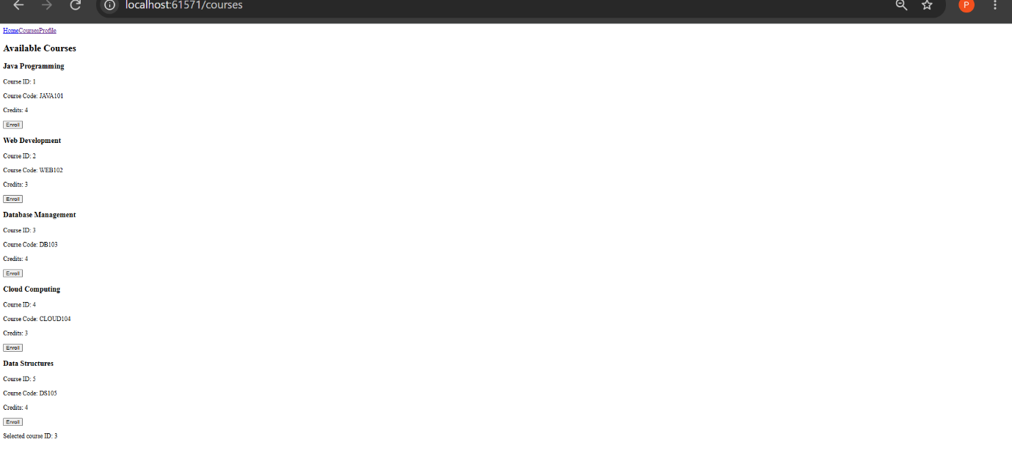

HANDS-ON 3 [Beginner] Directives & Pipes — Built-in and Custom

Task 1: Structural Directives

CODE IMPLEMENTATION:
course-list.ts:
import { Component } from '@angular/core';
import { CommonModule } from '@angular/common';
import { CourseCard } from '../../components/course-card/course-card';

@Component({
selector: 'app-course-list',
standalone: true,
imports: [CommonModule, CourseCard],
templateUrl: './course-list.html',
styleUrl: './course-list.css'
})
export class CourseList {

courses = [
{
id: 1,
title: 'Angular Fundamentals',
instructor: 'John Doe',
credits: 3,
enrolled: true,
gradeStatus: 'passed'
},
{
id: 2,
title: 'Java Programming',
instructor: 'Jane Smith',
credits: 4,
enrolled: false,
gradeStatus: 'failed'
},
{
id: 3,
title: 'Database Management',
instructor: 'Robert Brown',
credits: 2,
enrolled: true,
gradeStatus: 'pending'
}
];

// trackBy improves performance by allowing Angular
// to identify each course using its unique ID.
trackByCourseId(index: number, course: any) {
return course.id;
}
}

course-list.html:
<h2>Available Courses</h2>

<!-- Display courses when the courses array is not empty -->
<div *ngIf="courses.length > 0; else noCourses">

<div class="course-grid">

<!-- *ngFor displays each course -->
<app-course-card
*ngFor="let course of courses; trackBy: trackByCourseId"
[course]="course">
</app-course-card>

</div>

</div>

<!-- Display this message when there are no courses -->
<ng-template #noCourses>
<p>No courses available.</p>
</ng-template>

Course-list.css:
.course-grid {
display: grid;
grid-template-columns: repeat(auto-fit, minmax(280px, 1fr));
gap: 20px;
margin-top: 20px;
}

course-card.ts:
import { Component, Input } from '@angular/core';
import { CommonModule } from '@angular/common';

@Component({
selector: 'app-course-card',
standalone: true,
imports: [CommonModule],
templateUrl: './course-card.html',
styleUrl: './course-card.css'
})
export class CourseCard {

@Input() course: any;

}

course-card.html:
<div class="course-card">

<h3>{{ course.title }}</h3>

<p>
<strong>Instructor:</strong>
{{ course.instructor }}
</p>

<p>
<strong>Credits:</strong>
{{ course.credits }}
</p>

<p>
<strong>Enrollment:</strong>
{{ course.enrolled ? 'Enrolled' : 'Not Enrolled' }}
</p>

<!-- *ngSwitch displays the grade status -->
<div [ngSwitch]="course.gradeStatus">

<span *ngSwitchCase="'passed'" class="badge badge--passed">
Passed
</span>

<span *ngSwitchCase="'failed'" class="badge badge--failed">
Failed
</span>

<span *ngSwitchCase="'pending'" class="badge badge--pending">
Pending
</span>

</div>

</div>

course-card.css:
.course-card {
padding: 20px;
border: 1px solid #ddd;
border-radius: 10px;
background-color: white;
box-shadow: 0 2px 8px rgba(0, 0, 0, 0.1);
}

.course-card h3 {
margin-top: 0;
}

.course-card p {
margin: 8px 0;
}

.badge {
display: inline-block;
margin-top: 10px;
padding: 5px 12px;
border-radius: 5px;
font-weight: bold;
}

.badge--passed {
background-color: green;
color: white;
}

.badge--failed {
background-color: red;
color: white;
}

.badge--pending {
background-color: grey;
color: white;
}

OUTPUT:
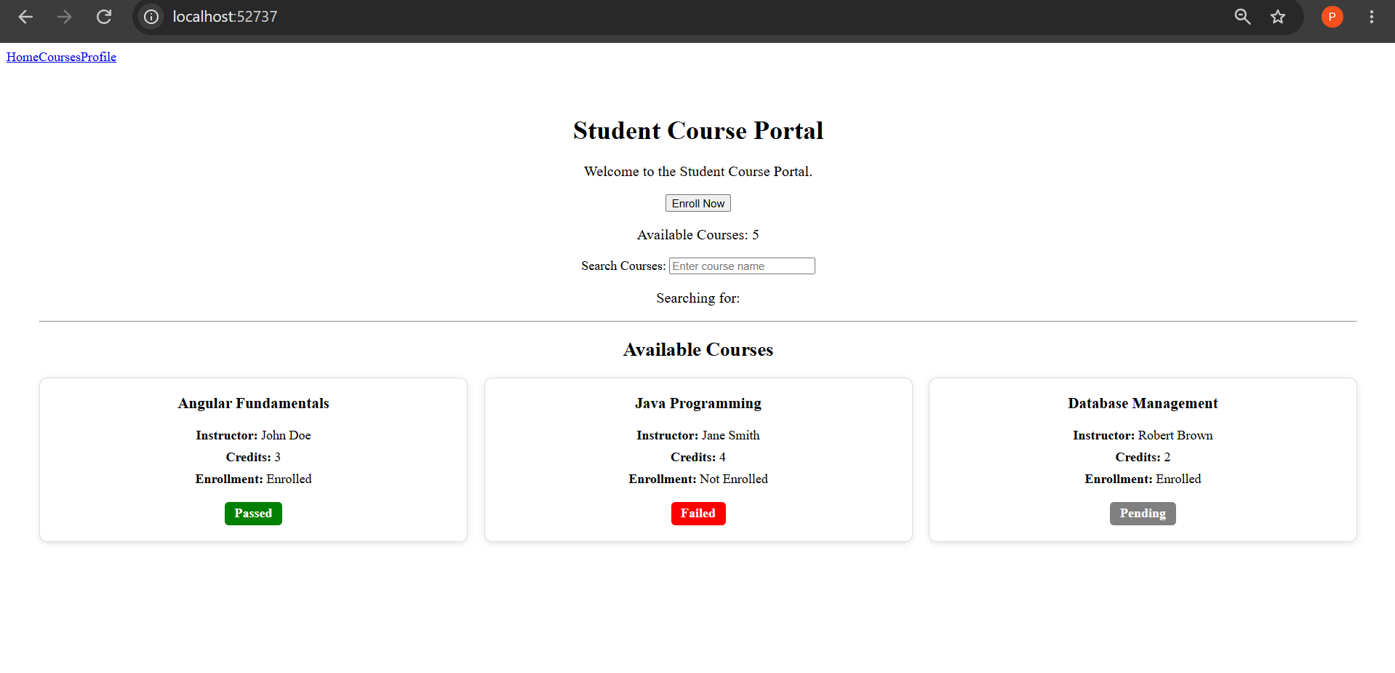

Task 2: Attribute Directives — ngClass and ngStyle

CODE IMPLEMENTATION:
course-card.ts
import { Component, Input } from '@angular/core';
import { CommonModule } from '@angular/common';

@Component({
selector: 'app-course-card',
standalone: true,
imports: [CommonModule],
templateUrl: './course-card.html',
styleUrl: './course-card.css'
})
export class CourseCard {

@Input() course: any;

// Controls whether additional course details are visible
isExpanded = false;

// Getter keeps the template clean by keeping
// conditional class logic inside the component.
get cardClasses() {
return {
'card--enrolled': this.course.enrolled,
'card--full': this.course.credits >= 4,
'expanded': this.isExpanded
};
}

// Toggles the expanded state of the course card
toggleDetails(): void {
this.isExpanded = !this.isExpanded;
}

}

course-card.html:
<div
class="course-card"
[ngClass]="cardClasses"
[ngStyle]="{
'border-left-color':
course.gradeStatus === 'passed' ? 'green' :
course.gradeStatus === 'failed' ? 'red' :
'grey'
}">

<h3>{{ course.title }}</h3>

<p>
<strong>Instructor:</strong>
{{ course.instructor }}
</p>

<p>
<strong>Credits:</strong>
{{ course.credits }}
</p>

<p>
<strong>Enrollment:</strong>
{{ course.enrolled ? 'Enrolled' : 'Not Enrolled' }}
</p>

<!-- Grade status using ngSwitch -->
<div [ngSwitch]="course.gradeStatus">

<span
*ngSwitchCase="'passed'"
class="badge badge--passed">
Passed
</span>

<span
*ngSwitchCase="'failed'"
class="badge badge--failed">
Failed
</span>

<span
*ngSwitchCase="'pending'"
class="badge badge--pending">
Pending
</span>

</div>

<!-- Additional details appear when expanded -->
<div *ngIf="isExpanded" class="course-details">

<p>
<strong>Course ID:</strong>
{{ course.id }}
</p>

<p>
<strong>Course Status:</strong>
{{ course.gradeStatus }}
</p>

</div>

<!-- Toggle button -->
<button (click)="toggleDetails()">

{{ isExpanded ? 'Hide Details' : 'Show Details' }}

</button>

</div>

course-card.css:
.course-card {
padding: 20px;
border: 1px solid #ddd;
border-left: 5px solid grey;
border-radius: 10px;
background-color: white;
box-shadow: 0 2px 8px rgba(0, 0, 0, 0.1);

/* Smooth height transition */
transition: all 0.3s ease;
}

/* Applied when the student is enrolled */
.card--enrolled {
background-color: #f0fff0;
}

/* Applied when credits are 4 or more */
.card--full {
font-weight: 500;
}

/* Applied when Show Details is clicked */
.course-card.expanded {
min-height: 300px;
}

.course-card h3 {
margin-top: 0;
}

.course-card p {
margin: 8px 0;
}

.badge {
display: inline-block;
margin-top: 10px;
padding: 5px 12px;
border-radius: 5px;
font-weight: bold;
}

.badge--passed {
background-color: green;
color: white;
}

.badge--failed {
background-color: red;
color: white;
}

.badge--pending {
background-color: grey;
color: white;
}

.course-details {
margin-top: 15px;
padding: 10px;
border-top: 1px solid #ddd;
}

button {
margin-top: 15px;
padding: 8px 15px;
border: none;
border-radius: 5px;
cursor: pointer;
}

OUTPUT:
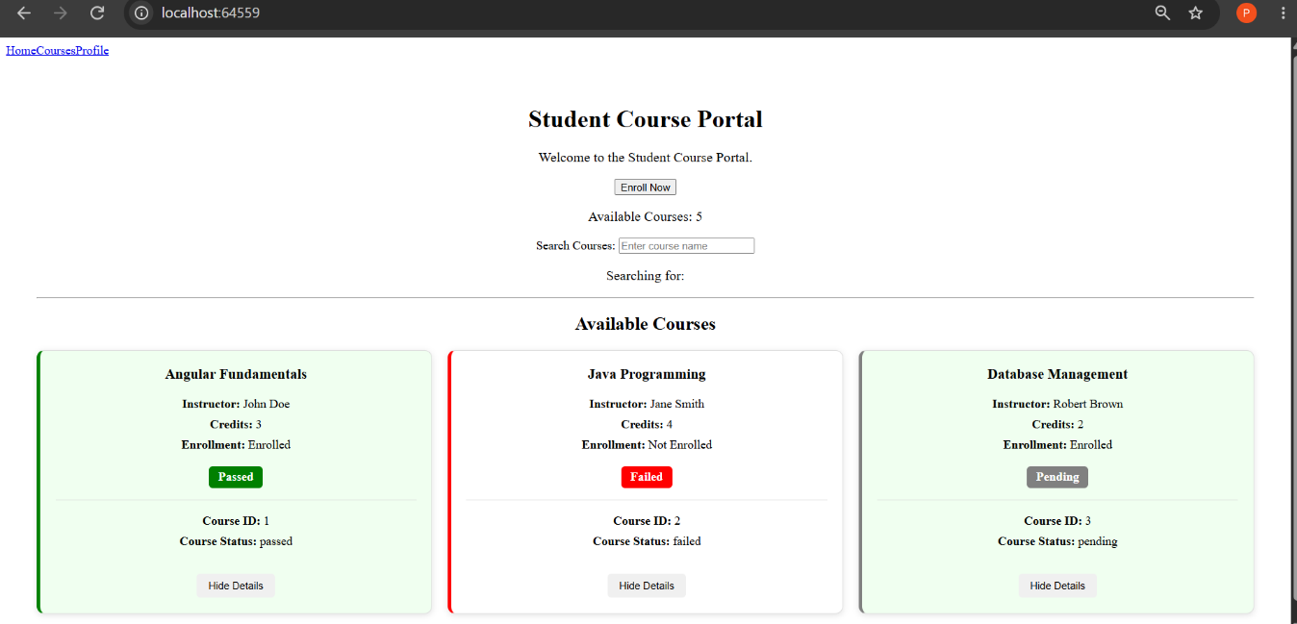

Task 3: Custom Directive and Custom Pipe
CODE IMPLEMENTATION:
course-list.ts:
import { Component } from '@angular/core';
import { CommonModule } from '@angular/common';
import { CourseCard } from '../../components/course-card/course-card';

@Component({
selector: 'app-course-list',
standalone: true,
imports: [CommonModule, CourseCard],
templateUrl: './course-list.html',
styleUrl: './course-list.css'
})
export class CourseList {

courses = [
{
id: 1,
title: 'Angular Fundamentals',
instructor: 'John Doe',
credits: 3,
enrolled: true,
gradeStatus: 'passed'
},
{
id: 2,
title: 'Java Programming',
instructor: 'Jane Smith',
credits: 4,
enrolled: false,
gradeStatus: 'failed'
},
{
id: 3,
title: 'Database Management',
instructor: 'Robert Brown',
credits: 2,
enrolled: true,
gradeStatus: 'pending'
}
];

// trackBy improves performance by allowing Angular
// to identify each course using its unique ID.
trackByCourseId(index: number, course: any) {
return course.id;
}
}

course-list.html:
<h2>Available Courses</h2>

<!-- Display courses when the courses array is not empty -->
<div *ngIf="courses.length > 0; else noCourses">

<div class="course-grid">

<!-- *ngFor displays each course -->
<app-course-card
*ngFor="let course of courses; trackBy: trackByCourseId"
[course]="course">
</app-course-card>

</div>

</div>

<!-- Display this message when there are no courses -->
<ng-template #noCourses>
<p>No courses available.</p>
</ng-template>

course-list.css:
.course-grid {
display: grid;
grid-template-columns: repeat(auto-fit, minmax(280px, 1fr));
gap: 20px;
margin-top: 20px;
}

course-card.ts:
import { Component, Input } from '@angular/core';
import { CommonModule } from '@angular/common';
import { HighlightDirective } from '../../directives/highlight';
import { CreditLabelPipe } from '../../pipes/credit-label-pipe';

@Component({
selector: 'app-course-card',
standalone: true,
imports: [
CommonModule,
HighlightDirective,
CreditLabelPipe
],
templateUrl: './course-card.html',
styleUrl: './course-card.css'
})
export class CourseCard {

@Input() course: any;

// Controls whether course details are expanded
isExpanded = false;

// Getter keeps conditional class logic clean
get cardClasses() {
return {
'card--enrolled': this.course.enrolled,
'card--full': this.course.credits >= 4,
'expanded': this.isExpanded
};
}

// Toggle course details
toggleDetails(): void {
this.isExpanded = !this.isExpanded;
}

}

course-card.html:
<div
class="course-card"
appHighlight="lightblue"
[ngClass]="cardClasses"
[ngStyle]="{
'border-left-color':
course.gradeStatus === 'passed' ? 'green' :
course.gradeStatus === 'failed' ? 'red' :
'grey'
}">

<h3>{{ course.title }}</h3>

<p>
<strong>Instructor:</strong>
{{ course.instructor }}
</p>

<p>
<strong>Credits:</strong>
{{ course.credits | creditLabel }}
</p>

<p>
<strong>Enrollment:</strong>
{{ course.enrolled ? 'Enrolled' : 'Not Enrolled' }}
</p>

<!-- Display grade status using ngSwitch -->
<div [ngSwitch]="course.gradeStatus">

<span
*ngSwitchCase="'passed'"
class="badge badge--passed">
Passed
</span>

<span
*ngSwitchCase="'failed'"
class="badge badge--failed">
Failed
</span>

<span
*ngSwitchCase="'pending'"
class="badge badge--pending">
Pending
</span>

</div>

<!-- Additional course details -->
<div *ngIf="isExpanded" class="course-details">

<p>
<strong>Course ID:</strong>
{{ course.id }}
</p>

<p>
<strong>Grade Status:</strong>
{{ course.gradeStatus }}
</p>

</div>

<!-- Toggle details -->
<button (click)="toggleDetails()">
{{ isExpanded ? 'Hide Details' : 'Show Details' }}
</button>

</div>

course-card.css:
.course-card {
padding: 20px;
border: 1px solid #ddd;
border-left: 5px solid grey;
border-radius: 10px;
background-color: white;
box-shadow: 0 2px 8px rgba(0, 0, 0, 0.1);
transition: all 0.3s ease;
}

.card--enrolled {
background-color: #f0fff0;
}

.card--full {
font-weight: 500;
}

.course-card.expanded {
min-height: 300px;
}

.course-card h3 {
margin-top: 0;
}

.course-card p {
margin: 8px 0;
}

.badge {
display: inline-block;
margin-top: 10px;
padding: 5px 12px;
border-radius: 5px;
font-weight: bold;
}

.badge--passed {
background-color: green;
color: white;
}

.badge--failed {
background-color: red;
color: white;
}

.badge--pending {
background-color: grey;
color: white;
}

.course-details {
margin-top: 15px;
padding: 10px;
border-top: 1px solid #ddd;
}

button {
margin-top: 15px;
padding: 8px 15px;
border: none;
border-radius: 5px;
cursor: pointer;
}

highlight.ts:
import { Directive, HostListener, Input, ElementRef } from '@angular/core';

@Directive({
selector: '[appHighlight]',
standalone: true
})
export class HighlightDirective {

// Default highlight color
@Input() appHighlight = 'yellow';

constructor(private elementRef: ElementRef) {}

// Add highlight when mouse enters the element
@HostListener('mouseenter')
onMouseEnter(): void {
this.elementRef.nativeElement.style.backgroundColor = this.appHighlight;
}

// Remove highlight when mouse leaves the element
@HostListener('mouseleave')
onMouseLeave(): void {
this.elementRef.nativeElement.style.backgroundColor = '';
}

}

credit-label-pipe.ts:
import { Pipe, PipeTransform } from '@angular/core';

@Pipe({
name: 'creditLabel',
standalone: true
})
export class CreditLabelPipe implements PipeTransform {

transform(credits: number | null | undefined): string {

// Handle null, undefined, or zero credits
if (!credits || credits === 0) {
return 'No Credits';
}

// Singular form
if (credits === 1) {
return '1 Credit';
}

// Plural form
return `${credits} Credits`;
}

}

OUTPUT:
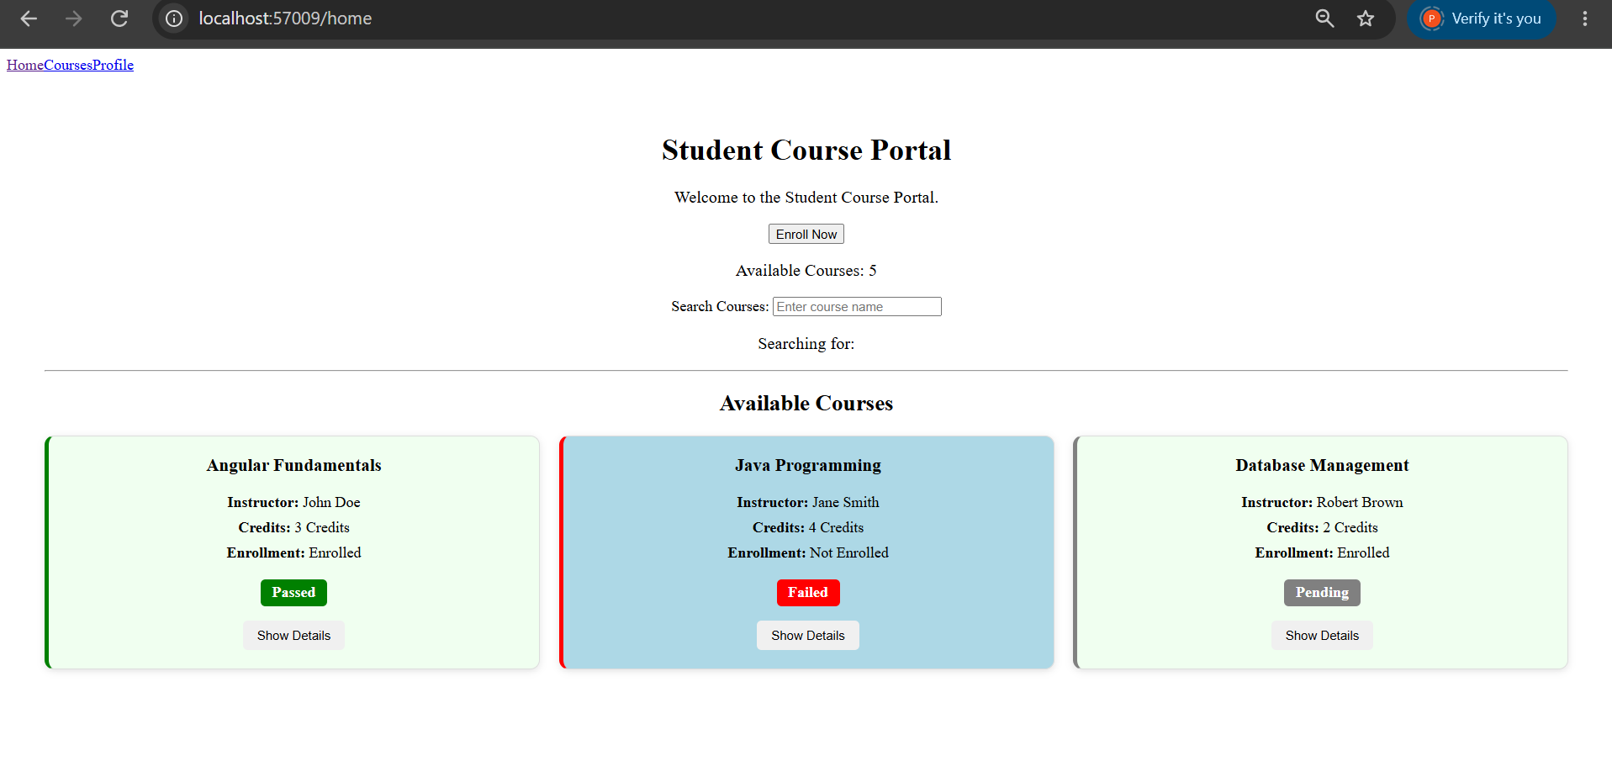
HANDS-ON 4 [Intermediate] Template-Driven Forms & Validation
Task 1: Build the Enrollment Request Form
CODE IMPLEMENTATION:
enrollment-form.ts:
import { Component } from '@angular/core';
import { FormsModule, NgForm } from '@angular/forms';

@Component({
selector: 'app-enrollment-form',
standalone: true,
imports: [FormsModule],
templateUrl: './enrollment-form.html',
styleUrl: './enrollment-form.css'
})
export class EnrollmentForm {

submitted = false;

studentName = '';
studentEmail = '';
courseId: number | null = null;
preferredSemester = '';
agreeToTerms = false;

onSubmit(form: NgForm): void {

console.log('Form Value:', form.value);
console.log('Form Valid:', form.valid);

this.submitted = true;
}

}

enrollment-form.html:
<h2>Student Enrollment Request</h2>

<form
#enrollForm="ngForm"
(ngSubmit)="onSubmit(enrollForm)"
>

<!-- Student Name -->
<div class="form-group">

<label for="studentName">
Student Name:
</label>

<input
type="text"
id="studentName"
name="studentName"
[(ngModel)]="studentName"
/>

</div>

<!-- Student Email -->
<div class="form-group">

<label for="studentEmail">
Student Email:
</label>

<input
type="email"
id="studentEmail"
name="studentEmail"
[(ngModel)]="studentEmail"
/>

</div>

<!-- Course ID -->
<div class="form-group">

<label for="courseId">
Course ID:
</label>

<input
type="number"
id="courseId"
name="courseId"
[(ngModel)]="courseId"
/>

</div>

<!-- Preferred Semester -->
<div class="form-group">

<label for="preferredSemester">
Preferred Semester:
</label>

<select
id="preferredSemester"
name="preferredSemester"
[(ngModel)]="preferredSemester"
>

<option value="">
Select Semester
</option>

<option value="Odd">
Odd
</option>

<option value="Even">
Even
</option>

</select>

</div>

<!-- Agree to Terms -->
<div class="form-group checkbox-group">

<input
type="checkbox"
id="agreeToTerms"
name="agreeToTerms"
[(ngModel)]="agreeToTerms"
/>

<label for="agreeToTerms">
I agree to the terms and conditions
</label>

</div>

<!-- Buttons -->
<div class="button-group">

<button
type="submit"
[disabled]="enrollForm.invalid"
>
Submit
</button>

</div>

</form>

enrollment-form.css:
h2 {
text-align: center;
margin-bottom: 25px;
}

form {
max-width: 500px;
margin: 0 auto;
padding: 25px;
border: 1px solid #ddd;
border-radius: 10px;
}

.form-group {
margin-bottom: 20px;
}

label {
display: block;
margin-bottom: 8px;
font-weight: bold;
}

input,
select {
width: 100%;
padding: 10px;
box-sizing: border-box;
}

.checkbox-group {
display: flex;
align-items: center;
gap: 8px;
}

.checkbox-group label {
margin-bottom: 0;
}

.checkbox-group input {
width: auto;
}

.button-group {
display: flex;
gap: 10px;
}

button {
padding: 10px 20px;
cursor: pointer;
}

button:disabled {
cursor: not-allowed;
opacity: 0.5;
}

app.routes.ts:
import { Routes } from '@angular/router';
import { Home } from './pages/home/home';
import { CourseList } from './pages/course-list/course-list';
import { StudentProfile } from './pages/student-profile/student-profile';

export const routes: Routes = [
{
path: '',
component: Home
},
{
path: 'home',
component: Home
},
{
path: 'courses',
component: CourseList
},
{
path: 'profile',
component: StudentProfile
},
{
path: 'enroll',
loadComponent: () =>
import('./pages/enrollment-form/enrollment-form')
.then(m => m.EnrollmentForm)
}
];

home.ts:
import { Component } from '@angular/core';
import { FormsModule } from '@angular/forms';
import { CourseList } from '../course-list/course-list';
import { NgIf } from '@angular/common';
import { Router } from '@angular/router';

@Component({
selector: 'app-home',
standalone: true,
imports: [
FormsModule,
CourseList,
NgIf
],
templateUrl: './home.html',
styleUrl: './home.css'
})
export class Home {

portalName = 'Student Course Portal';

isPortalActive = true;

message = '';

searchTerm = '';

availableCourses = 5;

constructor(private router: Router) {}

onEnrollClick(): void {
this.router.navigate(['/enroll']);
}

}

home.html:
<div class="home-container">

<!-- ========================================= -->
<!-- TASK 1: INTERPOLATION -->
<!-- ========================================= -->

<h1>{{ portalName }}</h1>

<p>Welcome to the Student Course Portal.</p>

<!-- ========================================= -->
<!-- TASK 1: PROPERTY BINDING + EVENT BINDING -->
<!-- ========================================= -->

<<button (click)="onEnrollClick()">
Enroll Now
</button>

<!-- Display message after clicking Enroll Now -->
<p *ngIf="message">
{{ message }}
</p>

<!-- ========================================= -->
<!-- DISPLAY AVAILABLE COURSES -->
<!-- ========================================= -->

<p>
Available Courses: {{ availableCourses }}
</p>

<!-- ========================================= -->
<!-- TASK 1: TWO-WAY BINDING -->
<!-- ========================================= -->

<div class="search-container">

<label for="search">
Search Courses:
</label>

<input
id="search"
type="text"
[(ngModel)]="searchTerm"
placeholder="Enter course name">

</div>

<!-- Display live search value -->
<p>
Searching for: {{ searchTerm }}
</p>

<!-- ========================================= -->
<!-- COURSE LIST -->
<!-- ========================================= -->

<hr>

<app-course-list></app-course-list>

</div>

OUTPUT:
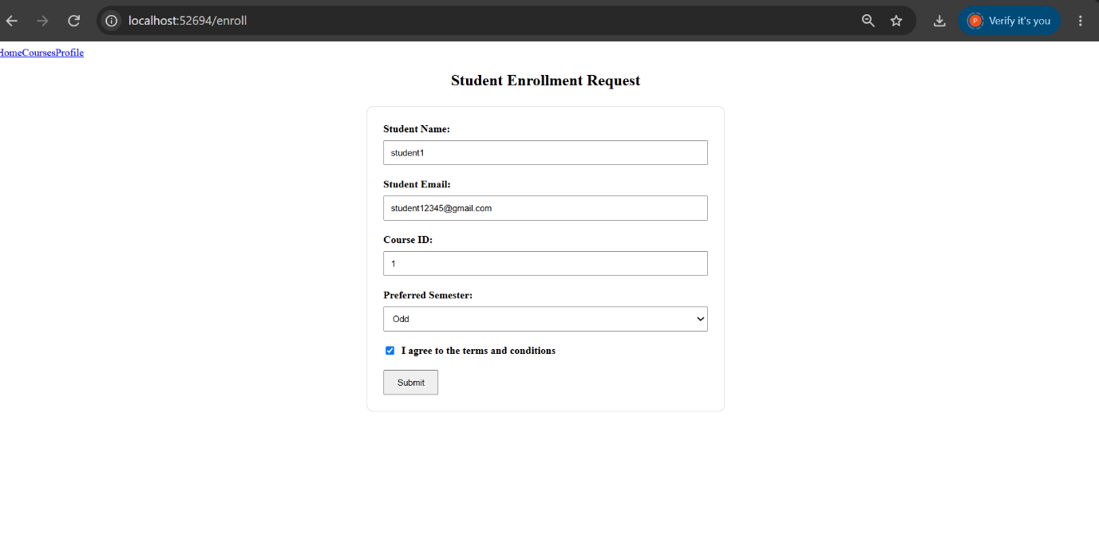

Task 2: Validation and Error Messages
CODE IMPLEMENTATION:
enrollment-form.ts:
import { Component } from '@angular/core';
import { NgIf } from '@angular/common';
import { FormsModule, NgForm } from '@angular/forms';

@Component({
selector: 'app-enrollment-form',
standalone: true,
imports: [
FormsModule,
NgIf
],
templateUrl: './enrollment-form.html',
styleUrl: './enrollment-form.css'
})
export class EnrollmentForm {

submitted = false;

studentName = '';
studentEmail = '';
courseId: number | null = null;
preferredSemester = '';
agreeToTerms = false;

onSubmit(form: NgForm): void {

console.log('Form Value:', form.value);
console.log('Form Valid:', form.valid);

if (form.valid) {
this.submitted = true;
}
}

}

enrollment-form.html:
<h2>Student Enrollment Request</h2>

<form
#enrollForm="ngForm"
(ngSubmit)="onSubmit(enrollForm)"
>

<!-- Student Name -->
<div class="form-group">

<label for="studentName">
Student Name:
</label>

<input
type="text"
id="studentName"
name="studentName"
[(ngModel)]="studentName"
required
minlength="3"
#nameCtrl="ngModel"
>

<!-- Required error -->
<span
class="error"
*ngIf="nameCtrl.touched && nameCtrl.errors?.['required']"
>
Name is required
</span>

<!-- Minimum length error -->
<span
class="error"
*ngIf="nameCtrl.touched && nameCtrl.errors?.['minlength']"
>
Name must be at least 3 characters
</span>

</div>

<!-- Student Email -->
<div class="form-group">

<label for="studentEmail">
Student Email:
</label>

<input
type="email"
id="studentEmail"
name="studentEmail"
[(ngModel)]="studentEmail"
required
email
#emailCtrl="ngModel"
>

<!-- Email required error -->
<span
class="error"
*ngIf="emailCtrl.touched && emailCtrl.errors?.['required']"
>
Email is required
</span>

<!-- Invalid email error -->
<span
class="error"
*ngIf="emailCtrl.touched && emailCtrl.errors?.['email']"
>
Please enter a valid email address
</span>

</div>

<!-- Course ID -->
<div class="form-group">

<label for="courseId">
Course ID:
</label>

<input
type="number"
id="courseId"
name="courseId"
[(ngModel)]="courseId"
required
#courseCtrl="ngModel"
>

<!-- Course ID error -->
<span
class="error"
*ngIf="courseCtrl.touched && courseCtrl.errors?.['required']"
>
Course ID is required
</span>

</div>

<!-- Preferred Semester -->
<div class="form-group">

<label for="preferredSemester">
Preferred Semester:
</label>

<select
id="preferredSemester"
name="preferredSemester"
[(ngModel)]="preferredSemester"
required
#semesterCtrl="ngModel"
>

<option value="">
Select Semester
</option>

<option value="Odd">
Odd
</option>

<option value="Even">
Even
</option>

</select>

<span
class="error"
*ngIf="semesterCtrl.touched && semesterCtrl.errors?.['required']"
>
Please select a semester
</span>

</div>

<!-- Agree to Terms -->
<div class="form-group checkbox-group">

<input
type="checkbox"
id="agreeToTerms"
name="agreeToTerms"
[(ngModel)]="agreeToTerms"
required
#termsCtrl="ngModel"
>

<label for="agreeToTerms">
I agree to the terms and conditions
</label>

<span
class="error"
*ngIf="termsCtrl.touched && termsCtrl.errors?.['required']"
>
You must agree to the terms
</span>

</div>

<!-- Buttons -->
<div class="button-group">

<button
type="submit"
[disabled]="enrollForm.invalid"
>
Submit
</button>

<button
type="button"
(click)="enrollForm.resetForm(); submitted = false"
>
Reset
</button>

</div>

<!-- Success Message -->
<div
class="success-message"
*ngIf="submitted"
>
Enrollment request submitted successfully!
</div>

</form>

enrollment-form.css:
h2 {
text-align: center;
margin-bottom: 25px;
}

form {
max-width: 500px;
margin: 0 auto;
padding: 25px;
border: 1px solid #ddd;
border-radius: 10px;
}

.form-group {
margin-bottom: 20px;
}

label {
display: block;
margin-bottom: 8px;
font-weight: bold;
}

input,
select {
width: 100%;
padding: 10px;
box-sizing: border-box;
}

/* Invalid field after user interacts with it */
input.ng-invalid.ng-touched,
select.ng-invalid.ng-touched {
border: 2px solid red;
}

/* Valid field after user interacts with it */
input.ng-valid.ng-touched,
select.ng-valid.ng-touched {
border: 2px solid green;
}

.checkbox-group {
display: flex;
align-items: center;
gap: 8px;
flex-wrap: wrap;
}

.checkbox-group label {
margin-bottom: 0;
}

.checkbox-group input {
width: auto;
}

.error {
display: block;
color: red;
font-size: 14px;
margin-top: 5px;
}

.success-message {
margin-top: 20px;
padding: 10px;
color: green;
background-color: #e8f5e9;
border: 1px solid green;
border-radius: 5px;
}

.button-group {
display: flex;
gap: 10px;
}

button {
padding: 10px 20px;
cursor: pointer;
}

button:disabled {
cursor: not-allowed;
opacity: 0.5;
}

OUTPUT:
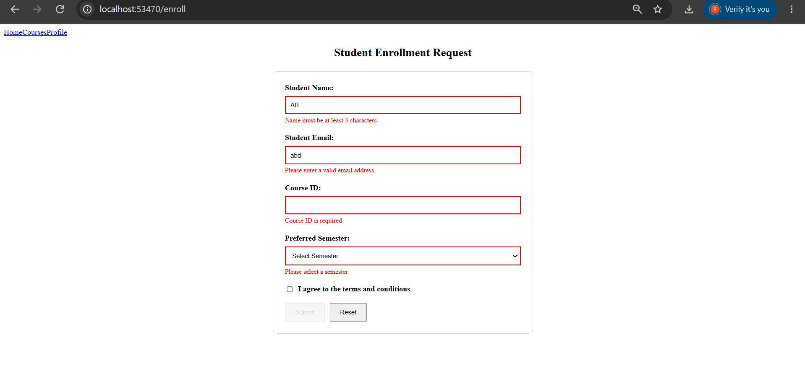
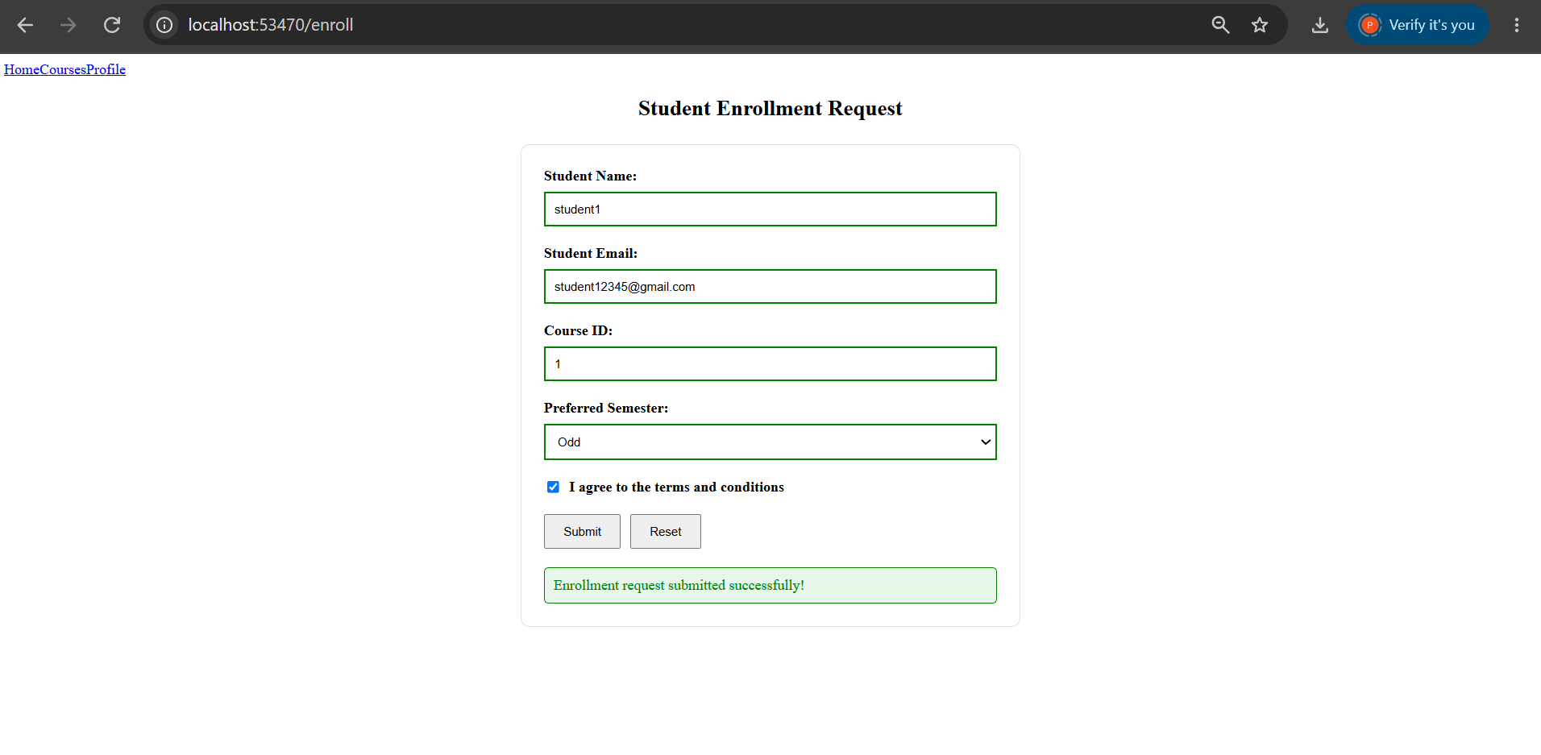

HANDS-ON 5 [Intermediate] Reactive Forms — FormBuilder, FormGroup, FormArray & Custom Validators
Task 1: Build a Reactive Form with FormBuilder
CODE IMPLEMENTATION:
Reactive-enrollment-form.ts:
import { Component, OnInit } from '@angular/core';
import {
FormBuilder,
FormGroup,
ReactiveFormsModule,
Validators
} from '@angular/forms';

@Component({
selector: 'app-reactive-enrollment-form',
standalone: true,
imports: [ReactiveFormsModule],
templateUrl: './reactive-enrollment-form.html',
styleUrl: './reactive-enrollment-form.css'
})
export class ReactiveEnrollmentForm implements OnInit {

enrollForm!: FormGroup;

constructor(private fb: FormBuilder) {}

ngOnInit(): void {

this.enrollForm = this.fb.group({

studentName: [
'',
[
Validators.required,
Validators.minLength(3)
]
],

studentEmail: [
'',
[
Validators.required,
Validators.email
]
],

courseId: [
null,
Validators.required
],

preferredSemester: [
'Odd',
Validators.required
],

agreeToTerms: [
false,
Validators.requiredTrue
]

});

}

onSubmit(): void {

console.log('Form Value:', this.enrollForm.value);

// enrollForm.value excludes disabled controls.
// enrollForm.getRawValue() includes all controls,
// including controls that are disabled.
console.log(
'Raw Form Value:',
this.enrollForm.getRawValue()
);

}

}

Reactive-enrollment-form.html:
<h2>Reactive Student Enrollment Form</h2>

<form
[formGroup]="enrollForm"
(ngSubmit)="onSubmit()"
>

<!-- Student Name -->
<div class="form-group">

<label for="studentName">
Student Name:
</label>

<input
id="studentName"
type="text"
formControlName="studentName"
>

<div
class="error"
*ngIf="
enrollForm.get('studentName')?.touched &&
enrollForm.get('studentName')?.errors?.['required']
"
>
Name is required
</div>

<div
class="error"
*ngIf="
enrollForm.get('studentName')?.touched &&
enrollForm.get('studentName')?.errors?.['minlength']
"
>
Name must be at least 3 characters
</div>

</div>

<!-- Student Email -->
<div class="form-group">

<label for="studentEmail">
Student Email:
</label>

<input
id="studentEmail"
type="email"
formControlName="studentEmail"
>

<div
class="error"
*ngIf="
enrollForm.get('studentEmail')?.touched &&
enrollForm.get('studentEmail')?.errors?.['required']
"
>
Email is required
</div>

<div
class="error"
*ngIf="
enrollForm.get('studentEmail')?.touched &&
enrollForm.get('studentEmail')?.errors?.['email']
"
>
Please enter a valid email address
</div>

</div>

<!-- Course ID -->
<div class="form-group">

<label for="courseId">
Course ID:
</label>

<input
id="courseId"
type="text"
formControlName="courseId"
>

</div>

<!-- Preferred Semester -->
<div class="form-group">

<label for="preferredSemester">
Preferred Semester:
</label>

<select
id="preferredSemester"
formControlName="preferredSemester"
>

<option value="Odd">
Odd
</option>

<option value="Even">
Even
</option>

</select>

</div>

<!-- Agree to Terms -->
<div class="checkbox-group">

<input
id="agreeToTerms"
type="checkbox"
formControlName="agreeToTerms"
>

<label for="agreeToTerms">
I agree to the terms and conditions
</label>

</div>

<br>

<!-- Submit Button -->
<button
type="submit"
[disabled]="enrollForm.invalid"
>
Submit
</button>

</form>

Reactive-enrollment-form.css:
h2 {
text-align: center;
margin-bottom: 25px;
}

form {
max-width: 500px;
margin: 0 auto;
padding: 25px;
border: 1px solid #ddd;
border-radius: 10px;
}

.form-group {
margin-bottom: 20px;
}

label {
display: block;
margin-bottom: 8px;
font-weight: bold;
}

input,
select {
width: 100%;
padding: 10px;
box-sizing: border-box;
}

.checkbox-group {
display: flex;
align-items: center;
gap: 8px;
}

.checkbox-group input {
width: auto;
}

.checkbox-group label {
margin-bottom: 0;
}

.error {
color: red;
font-size: 14px;
margin-top: 5px;
}

button {
padding: 10px 20px;
cursor: pointer;
}

button:disabled {
cursor: not-allowed;
opacity: 0.5;
}
App.routes.ts:
import { Routes } from '@angular/router';
import { Home } from './pages/home/home';
import { CourseList } from './pages/course-list/course-list';
import { StudentProfile } from './pages/student-profile/student-profile';

export const routes: Routes = [
{
path: '',
component: Home
},
{
path: 'home',
component: Home
},
{
path: 'courses',
component: CourseList
},
{
path: 'profile',
component: StudentProfile
},
{
path: 'enroll',
loadComponent: () =>
import('./pages/enrollment-form/enrollment-form')
.then(m => m.EnrollmentForm)
}
];

OUTPUT:
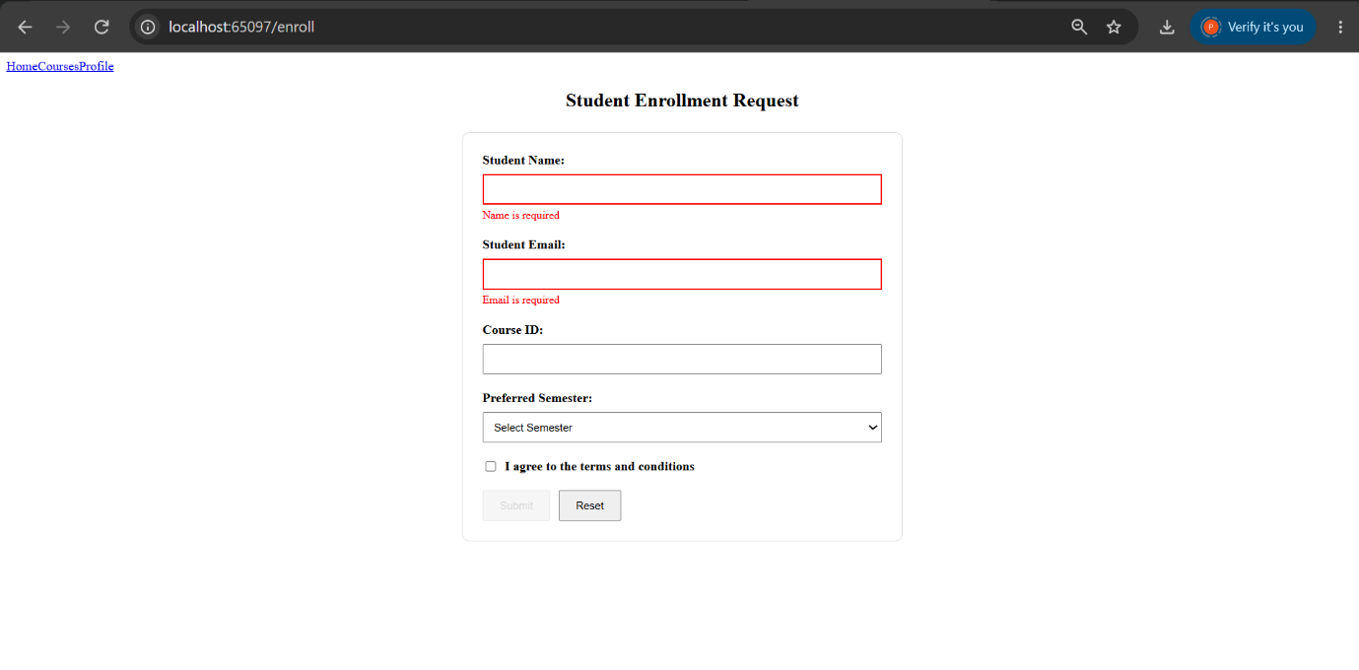
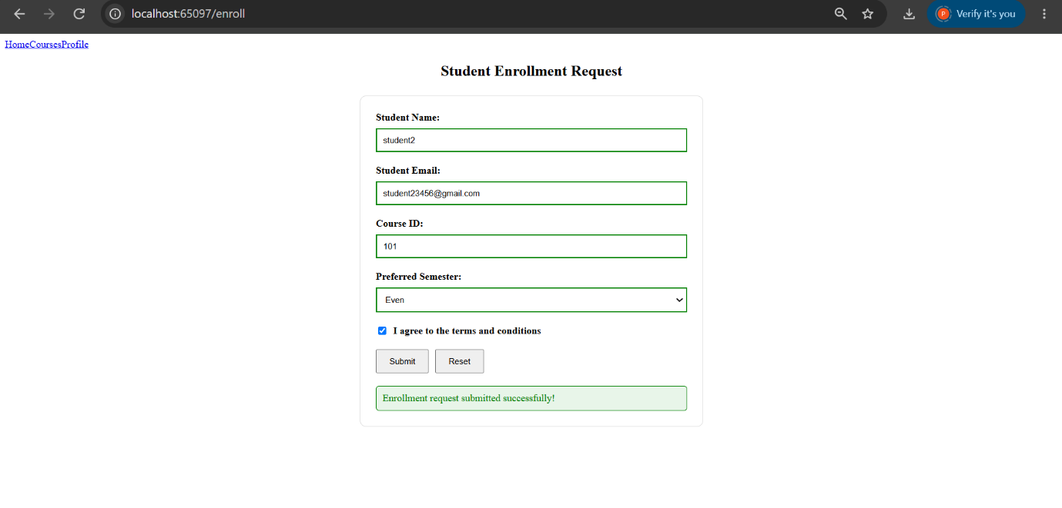

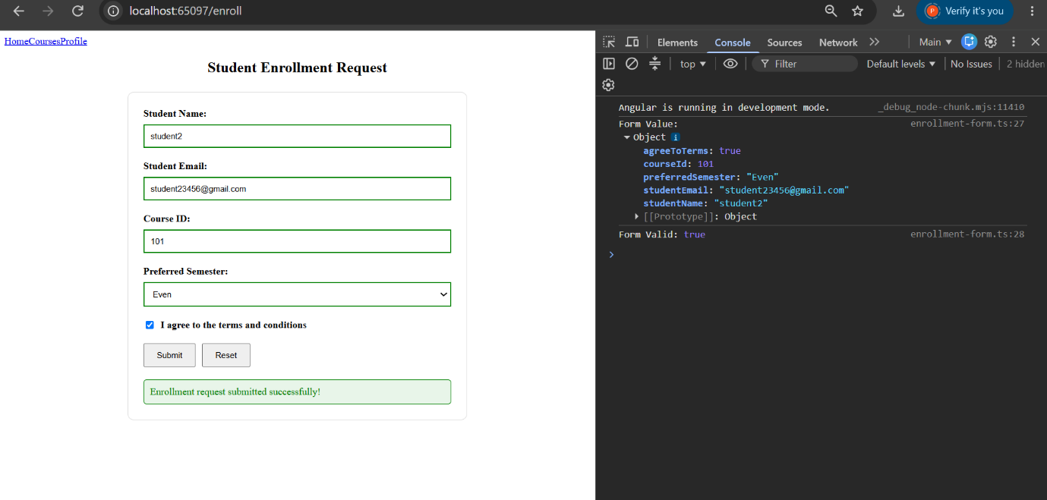

Task 2: Custom Validators and FormArray for Dynamic Controls
CODE IMPLEMENTATION:
reactive-enrollment-form.ts:
import { Component, OnInit } from '@angular/core';
import { CommonModule } from '@angular/common';
import {
AbstractControl,
FormArray,
FormBuilder,
FormControl,
FormGroup,
ReactiveFormsModule,
ValidationErrors,
Validators
} from '@angular/forms';

// Custom synchronous validator
// Returns an error if the course code starts with "XX"
function noCourseCode(
control: AbstractControl
): ValidationErrors | null {

const value = control.value;

if (value && value.toString().startsWith('XX')) {
return {
noCourseCode: true
};
}

return null;
}

// Custom asynchronous validator
// Simulates checking whether an email is already registered
function simulateEmailCheck(
control: AbstractControl
): Promise<ValidationErrors | null> {

return new Promise((resolve) => {

setTimeout(() => {

const email = control.value;

if (email && email.includes('test@')) {
resolve({
emailTaken: true
});
} else {
resolve(null);
}

}, 800);

});

}

@Component({
selector: 'app-reactive-enrollment-form',
standalone: true,
imports: [
CommonModule,
ReactiveFormsModule
],
templateUrl: './reactive-enrollment-form.html',
styleUrl: './reactive-enrollment-form.css'
})
export class ReactiveEnrollmentForm implements OnInit {

enrollForm!: FormGroup;

constructor(
private fb: FormBuilder
) {}

ngOnInit(): void {

this.enrollForm = this.fb.group({

studentName: [
'',
[
Validators.required,
Validators.minLength(3)
]
],

studentEmail: [
'',
[
Validators.required,
Validators.email
],
[
simulateEmailCheck
]
],

courseId: [
null,
[
Validators.required,
noCourseCode
]
],

preferredSemester: [
'Odd',
Validators.required
],

agreeToTerms: [
false,
Validators.requiredTrue
],

// FormArray for dynamically added courses
additionalCourses:
this.fb.array<FormControl<string>>([])

});

}

// Typed getter for FormArray
get additionalCourses(): FormArray<FormControl<string>> {

return this.enrollForm.get(
'additionalCourses'
) as FormArray<FormControl<string>>;

}

// Add a new course
addCourse(): void {

const courseControl =
new FormControl<string>(
'',
{
nonNullable: true,
validators: Validators.required
}
);

this.additionalCourses.push(
courseControl
);

}

// Remove course
removeCourse(index: number): void {

this.additionalCourses.removeAt(index);

}

// Submit form
onSubmit(): void {

console.log(
'Form Value:',
this.enrollForm.value
);

// value excludes disabled controls.
console.log(
'Raw Form Value:',
this.enrollForm.getRawValue()
);

}

}

reactive-enrollment-form.html:
<div class="form-container">

<h1>Hands-On 5</h1>

<h2>Reactive Student Enrollment Form</h2>

<p class="description">
This form demonstrates Reactive Forms,
custom validators, async validators,
and dynamic FormArray controls.
</p>

<form
[formGroup]="enrollForm"
(ngSubmit)="onSubmit()"
>

<!-- Student Name -->

<div class="form-group">

<label for="studentName">
Student Name:
</label>

<input
id="studentName"
type="text"
formControlName="studentName"
>

<div
class="error"
*ngIf="
enrollForm.get('studentName')?.touched &&
enrollForm.get('studentName')?.errors?.['required']
"
>
Name is required
</div>

<div
class="error"
*ngIf="
enrollForm.get('studentName')?.touched &&
enrollForm.get('studentName')?.errors?.['minlength']
"
>
Name must be at least 3 characters
</div>

</div>

<!-- Student Email -->

<div class="form-group">

<label for="studentEmail">
Student Email:
</label>

<input
id="studentEmail"
type="email"
formControlName="studentEmail"
>

<div
class="error"
*ngIf="
enrollForm.get('studentEmail')?.touched &&
enrollForm.get('studentEmail')?.errors?.['required']
"
>
Email is required
</div>

<div
class="error"
*ngIf="
enrollForm.get('studentEmail')?.touched &&
enrollForm.get('studentEmail')?.errors?.['email']
"
>
Please enter a valid email address
</div>

<div
class="checking"
*ngIf="
enrollForm.get('studentEmail')?.pending
"
>
Checking email...
</div>

<div
class="error"
*ngIf="
enrollForm.get('studentEmail')?.errors?.['emailTaken']
"
>
Email taken
</div>

</div>

<!-- Course ID -->

<div class="form-group">

<label for="courseId">
Course ID:
</label>

<input
id="courseId"
type="text"
formControlName="courseId"
>

<div
class="error"
*ngIf="
enrollForm.get('courseId')?.touched &&
enrollForm.get('courseId')?.errors?.['required']
"
>
Course ID is required
</div>

<!-- Custom Validator -->

<div
class="error"
*ngIf="
enrollForm.get('courseId')?.errors?.['noCourseCode']
"
>
Course code starting with XX is not allowed.
</div>

</div>

<!-- Preferred Semester -->

<div class="form-group">

<label for="preferredSemester">
Preferred Semester:
</label>

<select
id="preferredSemester"
formControlName="preferredSemester"
>

<option value="Odd">
Odd
</option>

<option value="Even">
Even
</option>

</select>

</div>

<!-- Agree to Terms -->

<div class="checkbox-group">

<input
id="agreeToTerms"
type="checkbox"
formControlName="agreeToTerms"
>

<label for="agreeToTerms">
I agree to the terms and conditions
</label>

</div>

<!-- Additional Courses -->

<div class="additional-courses">

<h3>Additional Courses</h3>

<p>
Add additional courses using FormArray.
</p>

<div
*ngFor="
let ctrl of additionalCourses.controls;
let i = index
"
class="additional-course"
>

<input
type="text"
[formControl]="ctrl"
placeholder="Enter additional course"
>

<button
type="button"
(click)="removeCourse(i)"
>
Remove
</button>

<div
class="error"
*ngIf="
ctrl.touched &&
ctrl.errors?.['required']
"
>
Course is required
</div>

</div>

<button
type="button"
class="add-button"
(click)="addCourse()"
>
Add Another Course
</button>

</div>

<!-- Submit -->

<button
type="submit"
class="submit-button"
[disabled]="
enrollForm.invalid ||
enrollForm.pending
"
>
Submit
</button>

</form>

</div>

reactive-enrollment-form.css:
.form-container {
max-width: 600px;
margin: 30px auto;
padding: 30px;
border: 1px solid #ddd;
border-radius: 10px;
background-color: #f9f9f9;
}

h1 {
text-align: center;
margin-bottom: 5px;
}

h2 {
text-align: center;
margin-bottom: 10px;
}

.description {
text-align: center;
margin-bottom: 25px;
}

form {
background-color: white;
padding: 25px;
border-radius: 8px;
}

.form-group {
margin-bottom: 20px;
}

label {
display: block;
font-weight: bold;
margin-bottom: 8px;
}

input,
select {
width: 100%;
padding: 10px;
box-sizing: border-box;
border: 1px solid #ccc;
border-radius: 5px;
}

.checkbox-group {
display: flex;
align-items: center;
gap: 8px;
margin-bottom: 20px;
}

.checkbox-group input {
width: auto;
}

.checkbox-group label {
margin-bottom: 0;
}

.error {
color: red;
font-size: 14px;
margin-top: 5px;
}

.checking {
color: blue;
font-size: 14px;
margin-top: 5px;
}

.additional-courses {
margin-top: 25px;
padding: 20px;
border: 1px solid #ddd;
border-radius: 8px;
}

.additional-course {
margin-bottom: 15px;
}

.additional-course input {
width: 65%;
margin-right: 10px;
}

button {
padding: 10px 18px;
border: none;
border-radius: 5px;
cursor: pointer;
}

.add-button {
margin-top: 10px;
}

.submit-button {
margin-top: 25px;
}

button:disabled {
cursor: not-allowed;
opacity: 0.5;
}

app.routes.ts:
import { Routes } from '@angular/router';

import { Home } from './pages/home/home';
import { CourseList } from './pages/course-list/course-list';
import { StudentProfile } from './pages/student-profile/student-profile';

export const routes: Routes = [

{
path: '',
component: Home
},

{
path: 'home',
component: Home
},

{
path: 'courses',
component: CourseList
},

{
path: 'profile',
component: StudentProfile
},

// Hands-On 4
{
path: 'enroll',
loadComponent: () =>
import('./pages/enrollment-form/enrollment-form')
.then(m => m.EnrollmentForm)
},

// Hands-On 5
{
path: 'enroll-reactive',
loadComponent: () =>
import('./pages/reactive-enrollment-form/reactive-enrollment-form')
.then(m => m.ReactiveEnrollmentForm)
}

];

OUTPUT:
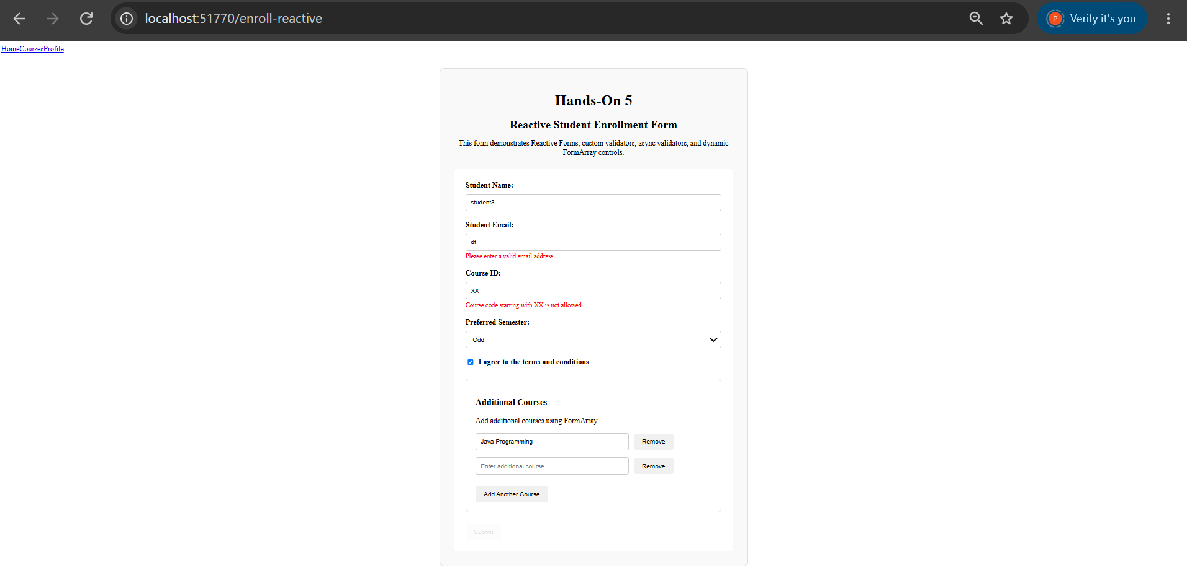

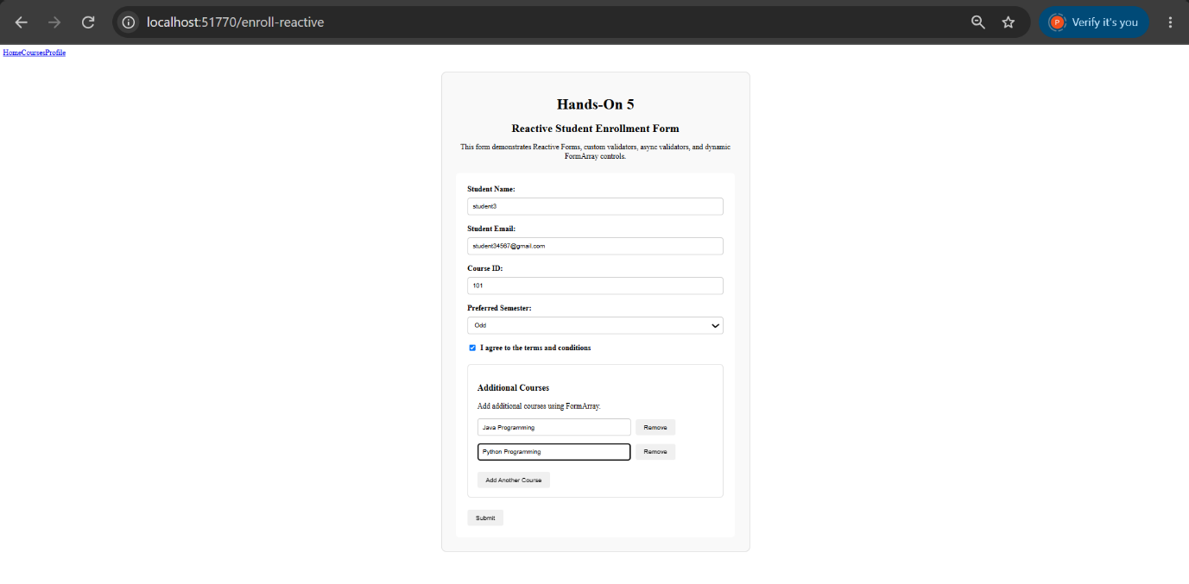
HANDS-ON 6 [Intermediate] Services & Dependency Injection
Task 1: Create and Use a Course Service
CODE IMPLEMENTATION:
Course.ts:
export interface Course {
id: number;
name: string;
code: string;
credits: number;
gradeStatus: 'passed' | 'failed' | 'pending';
}

Course-summary-widget.ts:
import { Component, OnInit } from '@angular/core';
import { CourseService } from '../../services/course';

@Component({
selector: 'app-course-summary-widget',
standalone: true,
imports: [],
templateUrl: './course-summary-widget.html',
styleUrl: './course-summary-widget.css'
})
export class CourseSummaryWidget implements OnInit {

courseCount = 0;

constructor(
private courseService: CourseService
) {}

ngOnInit(): void {

// Get the number of courses from the shared CourseService
this.courseCount = this.courseService.getCourses().length;

}

}

Course-summary-widget.html:
<div class="summary-widget">

<h3>Course Summary</h3>

<p>
Total Available Courses: {{ courseCount }}
</p>

</div>

Course-summary-widget.css:
.summary-widget {
border: 1px solid #ccc;
border-radius: 8px;
padding: 20px;
margin: 20px 0;
width: 300px;
}

.summary-widget h3 {
margin-top: 0;
}
Home.ts:
import { Component, OnInit } from '@angular/core';
import { FormsModule } from '@angular/forms';
import { NgIf } from '@angular/common';

import { CourseService } from '../../services/course';
import { CourseSummaryWidget } from '../../components/course-summary-widget/course-summary-widget';

@Component({
selector: 'app-home',
standalone: true,
imports: [
FormsModule,
NgIf,
CourseSummaryWidget
],
templateUrl: './home.html',
styleUrl: './home.css'
})
export class Home implements OnInit {

portalName = 'Student Course Portal';

isPortalActive = true;

message = '';

searchTerm = '';

availableCourses = 0;

constructor(
private courseService: CourseService
) {}

ngOnInit(): void {

// Get the live course count from CourseService
this.availableCourses =
this.courseService.getCourses().length;

}

onEnrollClick(): void {

this.message = 'Enrollment opened!';

}

}

Home.html:
<div class="home-container">

<!-- Portal Title -->
<h1>{{ portalName }}</h1>

<!-- Welcome Message -->
<p>
Welcome to the Student Course Portal.
</p>

<!-- Portal Status -->
<p *ngIf="isPortalActive">
Portal is currently active.
</p>

<!-- Enroll Button -->
<button (click)="onEnrollClick()">
Enroll Now
</button>

<!-- Enrollment Message -->
<p *ngIf="message">
{{ message }}
</p>

<!-- Course Statistics -->
<div class="stats">

<h3>Portal Statistics</h3>

<p>
Available Courses: {{ availableCourses }}
</p>

</div>

<!-- Course Search -->
<div class="search-section">

<label for="search">
Search Courses:
</label>

<input
id="search"
type="text"
[(ngModel)]="searchTerm"
placeholder="Enter course name"
>

<p>
Searching for: {{ searchTerm }}
</p>

</div>

<!-- Course Summary Widget -->
<app-course-summary-widget></app-course-summary-widget>

</div>

OUTPUT:
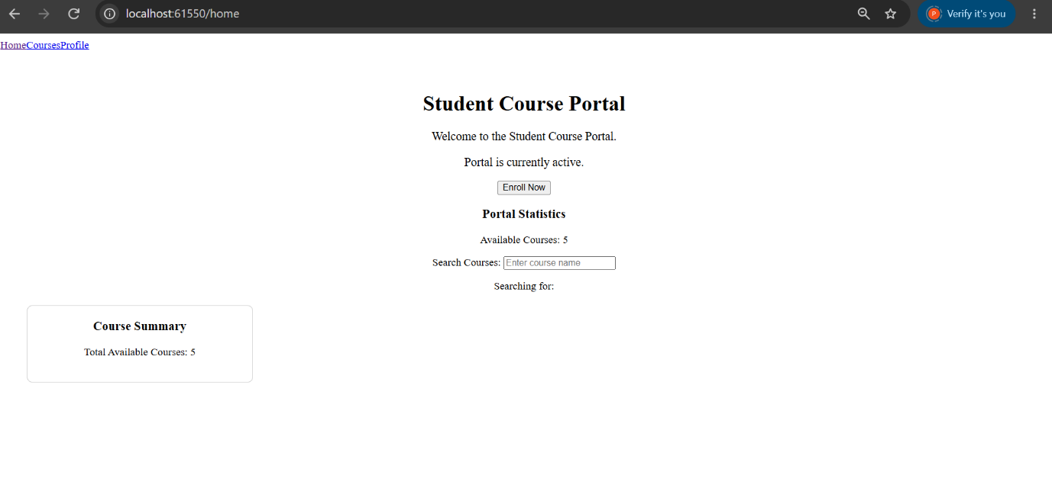

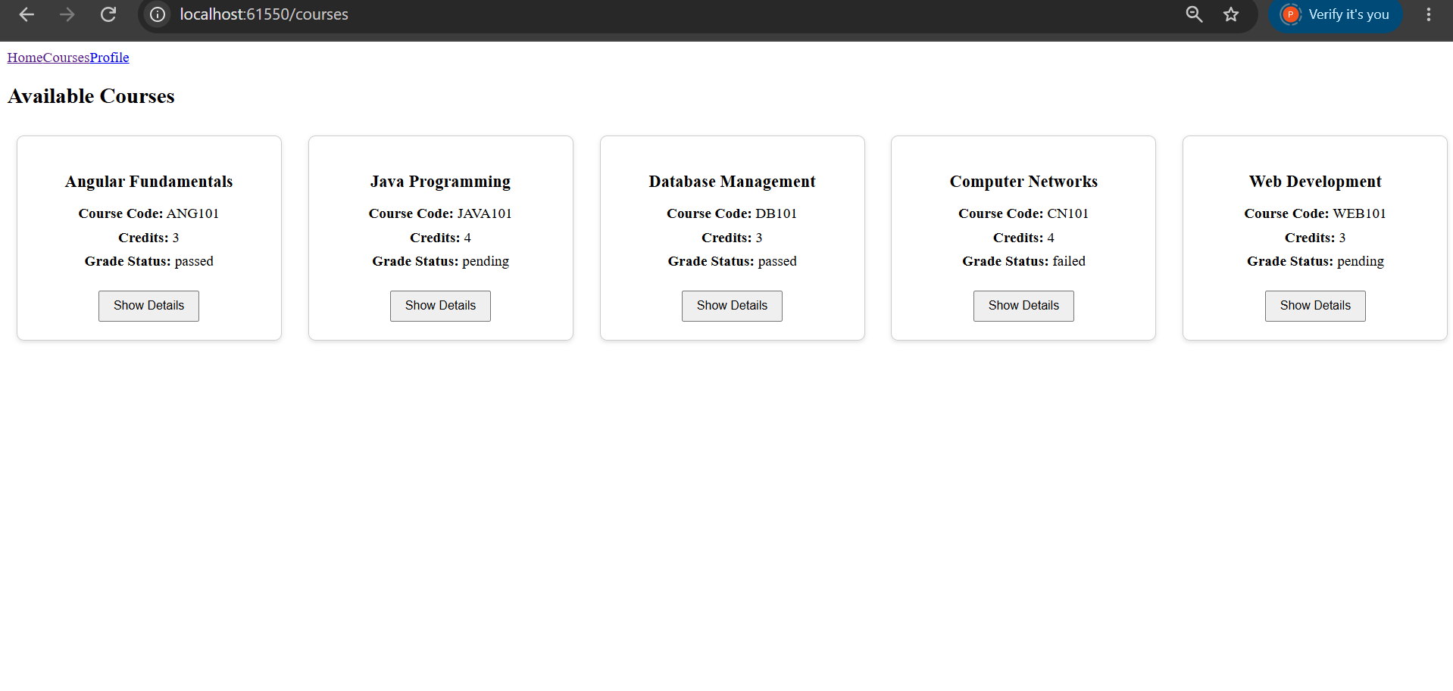
Task 2: Enrollment Service and Hierarchical DI
CODE IMPLEMENTATION:
enrollment.ts:
import { Injectable } from '@angular/core';
import { CourseService } from './course';

@Injectable({
providedIn: 'root'
})
export class EnrollmentService {

// Stores the IDs of courses that the student has enrolled in
private enrolledCourseIds: number[] = [];

constructor(
private courseService: CourseService
) {}

// Enroll in a course
enroll(courseId: number): void {

// Add the course ID only if it is not already enrolled
if (!this.enrolledCourseIds.includes(courseId)) {
this.enrolledCourseIds.push(courseId);
}

}

// Unenroll from a course
unenroll(courseId: number): void {

this.enrolledCourseIds =
this.enrolledCourseIds.filter(id => id !== courseId);

}

// Check whether a course is already enrolled
isEnrolled(courseId: number): boolean {

return this.enrolledCourseIds.includes(courseId);

}

// Return complete course objects for enrolled courses
getEnrolledCourses() {

return this.enrolledCourseIds
.map(id => this.courseService.getCourseById(id))
.filter(course => course !== undefined);

}

}

course-card.ts:
import { Component, Input } from '@angular/core';
import { CommonModule } from '@angular/common';
import { EnrollmentService } from '../../services/enrollment';

@Component({
selector: 'app-course-card',
standalone: true,
imports: [CommonModule],
templateUrl: './course-card.html',
styleUrl: './course-card.css'
})
export class CourseCard {

@Input() course: any;

constructor(
private enrollmentService: EnrollmentService
) {}

isEnrolled(): boolean {
return this.enrollmentService.isEnrolled(this.course.id);
}

toggleEnrollment(): void {

if (this.isEnrolled()) {
this.enrollmentService.unenroll(this.course.id);
} else {
this.enrollmentService.enroll(this.course.id);
}

}

}

student-profile.ts:
import { Component, OnInit } from '@angular/core';
import { CommonModule } from '@angular/common';

import { EnrollmentService } from '../../services/enrollment';

@Component({
selector: 'app-student-profile',
standalone: true,
imports: [
CommonModule
],
templateUrl: './student-profile.html',
styleUrl: './student-profile.css'
})
export class StudentProfile implements OnInit {

enrolledCourses: any[] = [];

constructor(
private enrollmentService: EnrollmentService
) {}

ngOnInit(): void {

// Get all courses currently enrolled by the student
this.enrolledCourses =
this.enrollmentService.getEnrolledCourses();

}

}

student-profile.html:
<div class="profile-container">

<h1>Student Profile</h1>

<h2>Enrolled Courses</h2>

<!-- Display enrolled courses -->
<div *ngIf="enrolledCourses.length > 0; else noCourses">

<div
class="enrolled-course"
*ngFor="let course of enrolledCourses"
>

<h3>
{{ course.name }}
</h3>

<p>
<strong>Course Code:</strong>
{{ course.code }}
</p>

<p>
<strong>Credits:</strong>
{{ course.credits }}
</p>

<p>
<strong>Grade Status:</strong>
{{ course.gradeStatus }}
</p>

</div>

</div>

<!-- Display when no courses are enrolled -->
<ng-template #noCourses>

<p>
You have not enrolled in any courses yet.
</p>

</ng-template>

</div>

course-card.html:
<div class="course-card">

<h3>
{{ course.name }}
</h3>

<p>
<strong>Course Code:</strong>
{{ course.code }}
</p>

<p>
<strong>Credits:</strong>
{{ course.credits }}
</p>

<p>
<strong>Grade Status:</strong>
{{ course.gradeStatus }}
</p>

<button (click)="toggleEnrollment()">

{{ isEnrolled() ? 'Unenroll' : 'Enroll' }}

</button>

</div>

OUTPUT:
