# TASKS TO MAKE GIT REPOSITORY

OPEN GITHUB AFTER SING IN THEN CLICK CREATE REPOSITORY

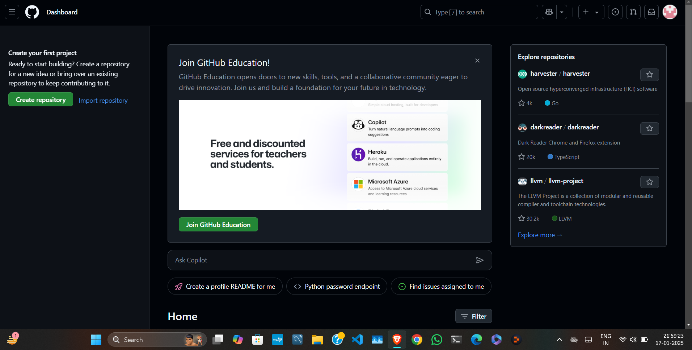

ENTER ENROLLMENT NO. AS REPOSITORY NAME

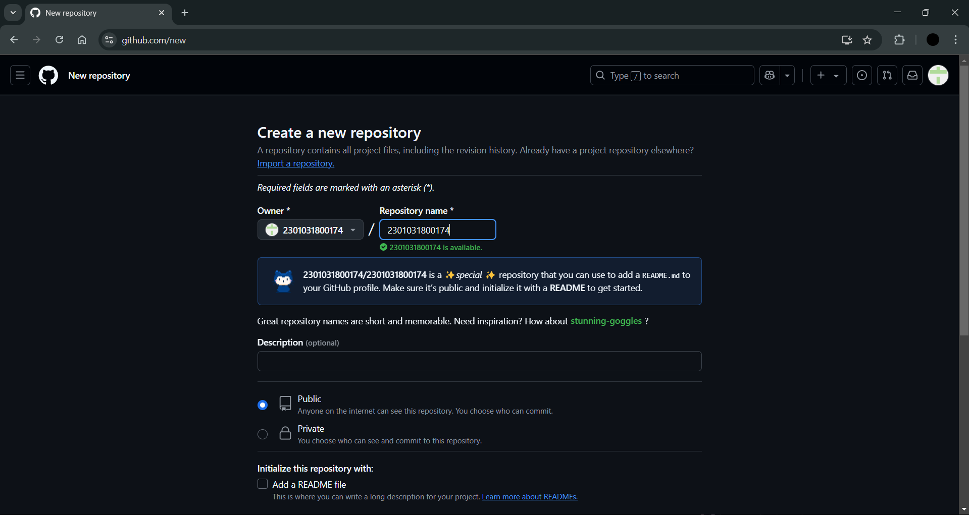

AFTER CREATING REPOSITORY CREATE 2 FILES AS ASSIGNMEN_1 AND ASSIGNMENT_2 RESPECTIVELY

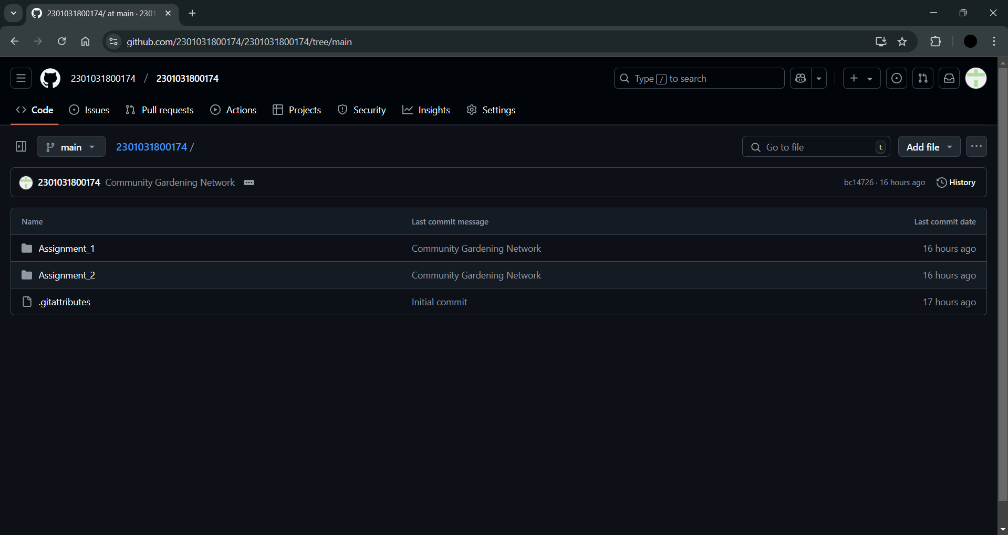

ASSSIGNMENT_1 CREATED

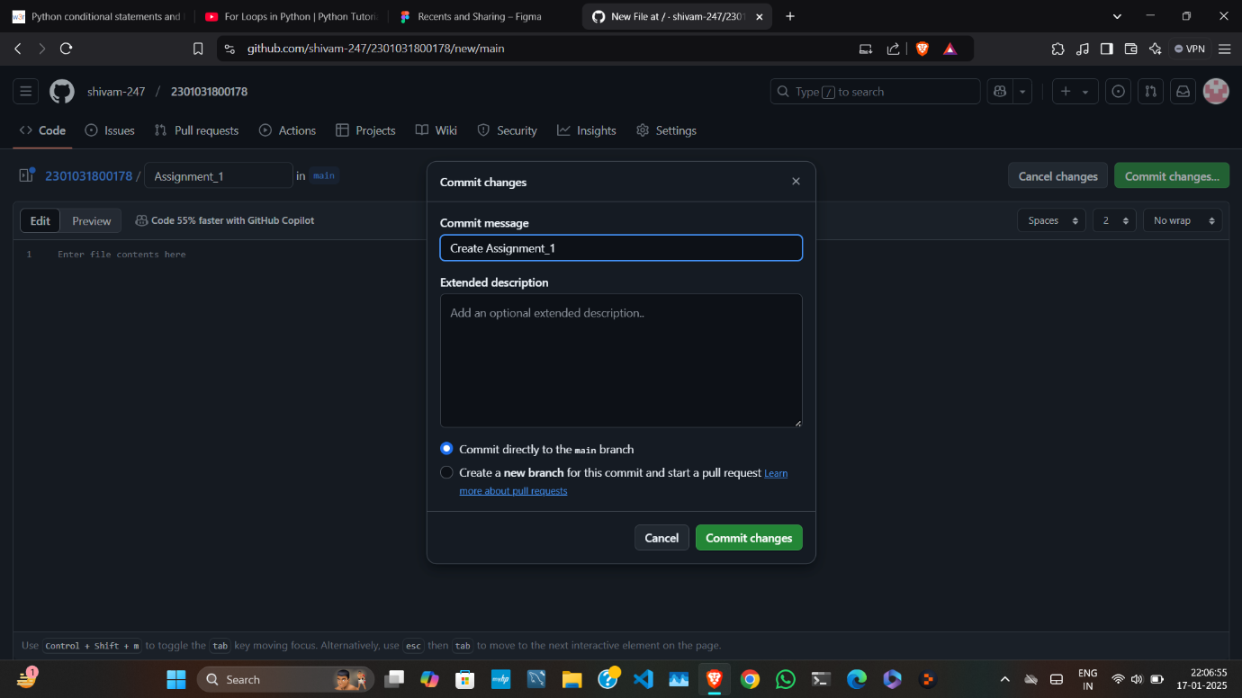

SAME AS ASSIGNMENT_1 WAS CREATED DO IT FOR ASSIGNMENT_2

