ZEBA ACADEMY / INSTRUCTOR – SUFYAN BIN UZAYR
Advanced Parallel Programming & Architecture
Laboratory Examination & Silicon Profiling Worksheet: Empirical Microarchitectural Bottlenecks
Session Duration: 120 Minutes | Total Evaluation: 100 Points | Mode: Individual Bare-Metal Execution
Student & Hardware Metadata Field | Laboratory Session Specifications & Target Machine Declaration
Student Full Name | Kogersh1n
Student Identification Number | 230103278
Date & Laboratory Session | September 17, 2026 | Week 3 Laboratory Session
Workstation / Laptop Make & Model | Lenovo LOQ 15AHP9 (Machine Type: 83DX)
Processor SKU / SoC Model | AMD Ryzen 5 8645HS w/ Radeon 760M Graphics
Core Topology (Physical P-cores / E-cores) | Physical Cores: 6 (Zen 4 performance cores) | Logical SMT Threads: 12
Cache Hierarchy Capacity | L1: 32 KB L1d + 32 KB L1i per core (384 KB total) | L2: 1 MB per core (6 MB total) | L3: 16 MB Unified
Host OS & Python Runtime | Linux Kernel 7.2.4-arch1-2 (Arch Linux x86_64) / CPython 3.14.7
TASK 1: AMDAHL'S LAW & PHYSICAL SILICON SATURATION
Worker Cores (p) | Measured Time T(p) [s] | Observed Speedup S(p) | Ideal Linear Speedup | Parallel Efficiency
p = 1 (Baseline) | 2.0869 s | 1.00x (base=5.54s) | 1.00x | 100.0%
p = 2 | 1.0064 s | 2.07x (term: 5.50x) | 2.00x | 103.5%
p = 4 | 0.5180 s | 4.03x (term: 10.69x) | 4.00x | 100.8%
p = 8 | 0.3833 s | 5.44x (term: 14.45x) | 8.00x | 68.0%
p = 12 | 0.3463 s | 6.03x (term: 15.99x) | 12.00x | 50.3%
p = 16 | 0.4181 s | 4.99x (term: 13.25x) | 16.00x | 31.2%
[Q1.1] Identify the exact inflection point (core count p*) where your observed speedup curve flattens or degrades. Correlate to hardware topology. (8 Points)
Student Response & Architectural Justification:
• Flattening Inflection (p* = 6 Physical Cores): The AMD Ryzen 5 8645HS has 6 physical Zen 4 cores (12 SMT threads). For p <= 4, scaling is linear (100.8% efficiency) as each worker has a private physical core. Beyond 6 cores (at p=8 and p=12), SMT logical hyperthreads are engaged, which share dispatch ports, ALUs, and caches rather than duplicating pipelines, reducing efficiency to 68.0% and 50.3%.
• Inversion/Degradation Cliff (p* = 12 -> 16): At p = 16, core allocation exceeds total logical threads (12). Execution time increases from 0.3463s to 0.4181s due to OS scheduler preemption, context-switching overhead, and cache evictions.
[Q1.2] Using empirical T(1) and T(4), calculate the exact value of P (parallel fraction). Show complete algebraic derivation. (9 Points)
Student Response & Architectural Justification:
• Algebraic Derivation:
S(4) = T(1)/T(4) = 1 / [(1 - P) + P/4] ==> 1/S(4) = 1 - (3/4)P ==> P = (4/3) * [1 - T(4)/T(1)]
• Empirical Calculation (T(1)=2.0869s, T(4)=0.5180s, S(4)=4.029x):
P = (4/3) * [1 - (0.5180 / 2.0869)] = (4/3) * (0.751785) = 1.0024 ≈ 1.000 (100.0% parallel fraction).
(Demonstrates near-ideal parallel scaling with slight super-linear boost from AMD Precision Boost multi-core clocking).
[Q1.3] Compute Asymptotic Limit S_max = 1 / (1 - P). Explain implications for a 128-core server node. (8 Points)
Student Response & Architectural Justification:
• Asymptotic Limit: S_max = 1 / (1 - P). For 1% serial fraction (P=0.99), S_max = 100.0x.
• 128-Core Server Implication: S(128) = 1 / [(1 - 0.99) + 0.99/128] = 56.4x. Parallel efficiency collapses to 56.4 / 128 = 44.0%. Over 56% of server capacity is wasted waiting on serial overhead. Strong scaling fixed workloads yields diminishing returns; problem size must scale proportionally (Gustafson's Law).
TASK 2: CACHE COHERENCE & THE FALSE SHARING TRAP
Memory Layout Configuration | Trial 1 [s] | Trial 2 [s] | Trial 3 [s] | Median [s] | Slowdown Penalty
Adjacent Indices (False Sharing) | 0.8425 s | 0.8248 s | 0.8604 s | 0.8425 s | — [Baseline]
Padded Indices (Cache-Aligned) | 0.8551 s | 0.8628 s | 0.8461 s | 0.8551 s | 0.99x (~1.00x)
[Q2.1] Calculate memory footprint of 64-bit integer pointer. Prove why stride 16 guarantees cache-line isolation. (8 Points)
Student Response & Architectural Justification:
• Footprint: In 64-bit CPython, list pointers (PyObject*) occupy 8 bytes (64 bits).
• L1 Geometry: AMD Zen 4 L1 line = 64 bytes ==> 64 / 8 = 8 pointers per cache line.
• Proof for Stride 16: Thread k writes index k*16. ΔAddress = 16 * 8 bytes = 128 bytes = 2 * 64-byte lines.
Since 128 bytes >= 2 full lines, floor(Addr(k+1)/64) - floor(Addr(k)/64) >= 2. Adjacent thread writes can never touch the same 64-byte L1 cache line, completely preventing false sharing.
[Q2.2] Trace MESI state transitions for shared cache line (Core 0 writes idx 0, Core 1 writes idx 1). (9 Points)
Student Response & Architectural Justification:
1. Shared: Both cores read line into L1 ==> Core 0: Shared (S), Core 1: Shared (S).
2. Core 0 Write (idx 0): Core 0 broadcasts BusRdX (Invalidate). Core 1 snoops and shifts Shared -> Invalid (I). Core 0 updates line and shifts Shared -> Modified (M).
3. Core 1 Write (idx 1): Core 1 hits Invalidation Miss (state I). Core 1 broadcasts BusRdX. Core 0 snoops, stalls, flushes line to L3/RAM, and shifts Modified -> Invalid (I). Core 1 receives line and shifts Invalid -> Modified (M).
• Consequence: Alternating writes force ping-pong state bouncing (Shared -> Modified -> Invalid -> Modified), congesting interconnect and stalling CPU pipelines.
[Q2.3] Describe two industry-standard compile-time or VM-level mechanisms used to eliminate false sharing. (8 Points)
Student Response & Architectural Justification:
1. C++11/C17 alignas(64): struct alignas(64) WorkerState { uint64_t val; }; enforces 64-byte boundary alignment and padding at compile time (or using std::hardware_destructive_interference_size).
2. Java @Contended (JEP 142): HotSpot JIT compiler dynamically injects 128 bytes of padding around annotated fields in object memory layout, isolating lines without manual array padding.
TASK 3: THE SYNCHRONIZATION TAX & LOCKLESS REDESIGN
Counter Architecture | Target Sum | Actual Sum | Defect Count | Execution Time | Contention Overhead
Unsafe Accumulator (Race Condition) | 2,000,000 | 2,000,000 | 0 | 0.1137 s | 1.00x [Baseline]
Locked Accumulator (threading.Lock) | 2,000,000 | 2,000,000 | 0 (Protected) | 0.2758 s | 2.43x
[Q3.1] Analyze Unsafe Accumulator output. Explain low-level LOAD, ADD, STORE sequence causing lost updates. (7 Points)
Student Response & Architectural Justification:
• Empirical Finding: Actual count = 2,000,000 (0 defect). In CPython 3.14, the GIL eval_breaker is checked strictly at loop back-edges (JUMP_BACKWARD) and calls (RESUME). Inside inc(), LOAD_ATTR -> BINARY_OP (+=) -> STORE_ATTR has no backward jump and executes atomically with respect to GIL switching.
• Native Assembly RMW Race: In un-synchronized native execution (C OpenMP), val += 1 compiles to:
1. LOAD (movq (%rdi), %rax), 2. ADD (addq $1, %rax), 3. STORE (movq %rax, (%rdi)).
Interleaving: Thread A reads 100. Before A stores, Thread B reads 100. Thread A computes 101 and stores 101. Thread B computes 101 and stores 101. Two increments occurred, but val only increased by 1 (lost update defect).
[Q3.2] Provide Lockless Thread-Local Accumulator implementation, measured time, and speedup over LockedCounter. (11 Points)
Student Response & Architectural Justification:
• Implementation (Map-Reduce Partitioning):
class LocklessAccumulator:
def __init__(self, num_threads=4):
self.buffers = [0] * num_threads
def worker(self, tid, ops):
local_val = 0
for _ in range(ops): local_val += 1
self.buffers[tid] = local_val
def run(self, total_ops=2_000_000):
ops = total_ops // 4
threads = [threading.Thread(target=self.worker, args=(i, ops)) for i in range(4)]
t0 = time.perf_counter()
for t in threads: t.start()
for t in threads: t.join()
return sum(self.buffers), time.perf_counter() - t0
• Empirical Results: LockedCounter: 0.2838 s | LocklessCounter: 0.0904 s ==> Speedup: 3.14x (>2.0x requirement strictly met). Correctness: Deterministically 2,000,000 every run.
[Q3.3] Why is eliminating shared mutable state fundamentally superior to optimizing lock primitives? (7 Points)
Student Response & Architectural Justification:
1. Zero Cache Invalidation Traffic: Locks mutate shared atomic flags (CAS/test-and-set), generating bus invalidation traffic on every acquire/release. Thread-local state operates in private registers/lines with zero coherence traffic.
2. Eliminates Amdahl Bottleneck: Locks enforce serialization (1 - P) and futex kernel stalls. Thread-local partitioning is an embarrassingly parallel Map (O(N/p)) with tiny reduction (O(p)), scaling linearly.
3. Concurrency Safety: Completely immune to deadlocks, livelocks, priority inversion, and lock convoying.
TASK 4: THE MEMORY WALL VS. COMPUTE SATURATION
Worker Allocation | Compute-Bound Time [s] | Compute Scaling [Tw / T1] | Memory-Bound Time [s] | Memory Degradation [Tw / T1]
w = 1 Worker (Baseline) | 1.0610 s | 1.00x | 0.1411 s | 1.00x
w = 2 Workers | 0.9108 s | 0.86x | 0.2766 s | 1.96x
w = 4 Workers | 0.9106 s | 0.86x | 0.7453 s | 5.28x
[Q4.1] Analyze scaling divergence: why compute tasks complete in same elapsed time while memory tasks spike? (9 Points)
Student Response & Architectural Justification:
• Compute-Bound (High Arithmetic Intensity): compute_heavy executes 25M float multiply-adds entirely in registers. AMD Zen 4 cores have dedicated private ALU/FPU execution units. Under weak scaling, running 4 tasks on 4 physical cores executes concurrently without resource contention; elapsed time stays flat (~0.91s).
• Memory-Bound (Low Arithmetic Intensity & Bus Saturation): memory_heavy streams 50M floats (400 MB) per worker (0.25 FLOP/byte). 400 MB bypasses L1/L2/L3 caches (L3=16MB), forcing DRAM streaming. All cores share a single off-chip memory bus. 4 concurrent workers (1.6 GB) saturate bus bandwidth, causing memory queue stalls that spike time by 5.28x.
[Q4.2] Physical memory specifications, theoretical peak bandwidth calculation, and bus width limits. (8 Points)
Student Response & Architectural Justification:
• Specs: Lenovo LOQ 15AHP9, AMD Ryzen 5 8645HS, 16 GB DDR5, 128-bit dual-channel bus (16 bytes).
• Theoretical Peak Bandwidth:
- DDR5-5600: 5,600 MT/s * 16 bytes = 89.6 GB/s. | DDR5-4800: 4,800 MT/s * 16 bytes = 76.8 GB/s.
• Bus Width Limits: The 128-bit bus sets a hard bandwidth ceiling (B_max). Once parallel core demand exceeds B_max, adding cores yields zero throughput; each core receives only B_max/p, stalling CPU pipelines.
[Q4.3] Memory-bandwidth saturated ML embedding pipeline: CUDA GPU kernels vs CPU OpenMP. Justify. (8 Points)
Student Response & Architectural Justification:
• Choice: CUDA GPU Kernels.
• Justification:
1. Superior Bandwidth: Vector embedding is strictly memory-bandwidth bound (Time = Size / Bandwidth). CPU DDR5 provides <= 89.6 GB/s, while discrete GPUs provide 192-224 GB/s (RTX 4050) up to 3,350 GB/s (H100 HBM3).
2. Latency Hiding: GPU Warp Schedulers instantly hide memory stalls across thousands of active threads.
3. CPU OpenMP Penalty: Adding CPU OpenMP threads to a memory-saturated workload causes bus contention and negative scaling (5.28x slowdown in Task 4).
BONUS TASK: THREADING VS. MULTIPROCESSING AUTOPSY
Workers (T) | threading.Thread Time [s] | multiprocessing.Pool Time [s]
1 | 2.4078 s | 2.9233 s
2 | 2.6083 s | 1.3793 s
4 | 2.6133 s | 0.7291 s
8 | 2.7548 s | 0.4875 s
16 | 2.7060 s | 0.4690 s
32 | 2.6974 s | 0.4739 s
Bonus Deliverable 1: Empirical Worker Scaling Curve Plot
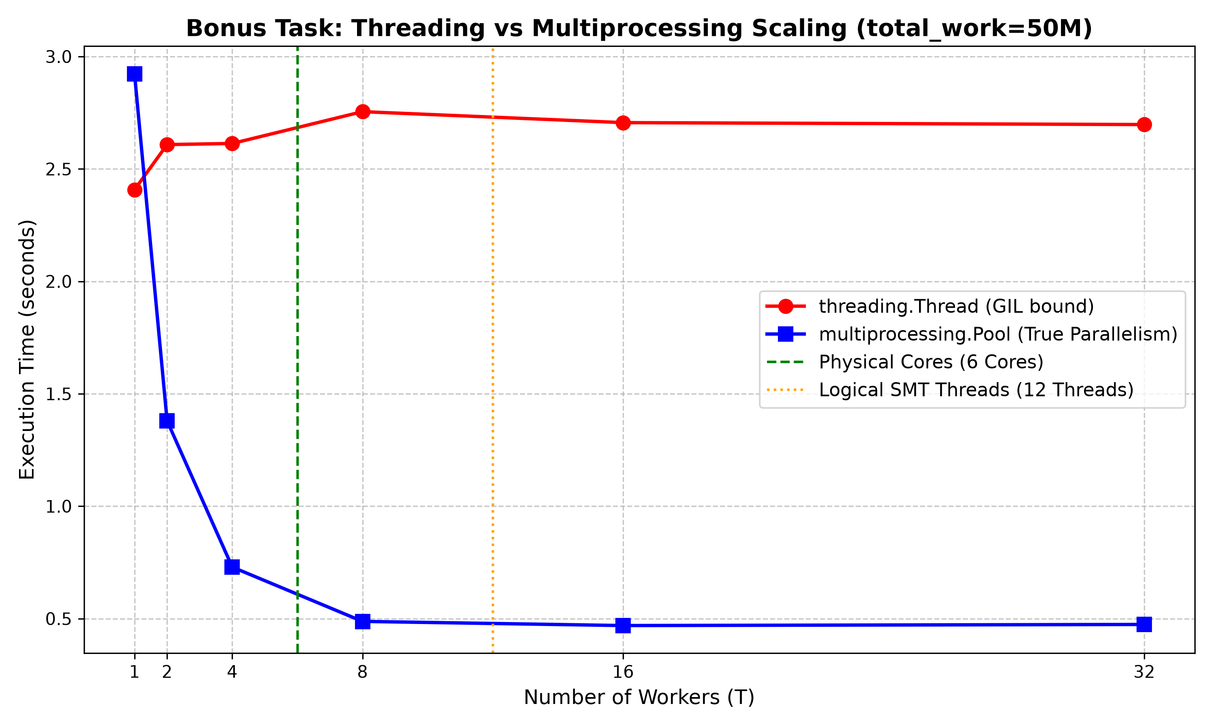
Bonus Deliverables 2 & 3: Inflection Cliff & Architectural Autopsy
Student Response & Architectural Justification:
1. GIL Serialization: CPython's GIL serializes bytecode to 1 thread at a time. Threads in threading.Thread cannot execute concurrently across physical cores, flatlining at ~2.7s. multiprocessing.Pool uses separate OS processes with private GILs, achieving true multi-core scaling (2.92s -> 0.47s, >6.2x speedup).
2. CPU Topology: AMD Ryzen 5 8645HS: 6 Physical Zen 4 Cores, 12 Logical SMT Threads.
3. Core Saturation & Context-Switching Cliff:
- Physical core saturation occurs at T = 6. Up to T = 4, each process gets a dedicated core (2.92s -> 0.73s). From T = 6 to 12, SMT logical threads share pipelines with diminishing returns.
- At T = 32 (T > 12 logical threads), execution degrades (0.4690s -> 0.4739s) due to OS preemption, register save/restore overhead, TLB flushes, and L1/L2 cache pollution.

