Lab 4
4.1: Decomposition by Business Capability
Goal: Identify independent microservices based on distinct business functions to ensure scalability and loose coupling.
Business Capability | Proposed Microservice | Owned Data (Entities)
Menu & Catalog Management | Catalog Service | Menu Items, Categories, Ingredients, Item Status (In/Out of Stock).
Order Processing & Management | Order Service | Orders, Order Items, Table IDs, Order Status (Pending, Preparing, Served).
Payment & Billing Processing | Payment Service | Transactions, Payment Status, Invoices, Payment Gateway Logs.
4.2: Defining Service Contracts
Goal: Define the public interfaces (API Endpoints) that the microservices will expose to the front-end applications or to each other.
Endpoint | HTTP Method | Description | Return Data (Response)
/api/catalog/menu | GET | Retrieves the full list of available menu items for the customer. | Array of MenuItem objects.
/api/orders | POST | Submits a new customer order to the kitchen. | The created Order object including order ID and total amount.
/api/orders/{id}/status | PATCH | Updates the status of an existing order (e.g., staff marks it as 'Served'). | The updated Order object with the new status timestamp.
/api/payments/checkout | POST | Initiates a payment request via a 3rd-party provider (MoMo/VNPay). | Transaction Result, Payment URL, and Transaction ID.
4.3: C4 Model – Level 1: System Context
Goal: Create a high-level map showing the system boundary and its interactions with external users and systems.
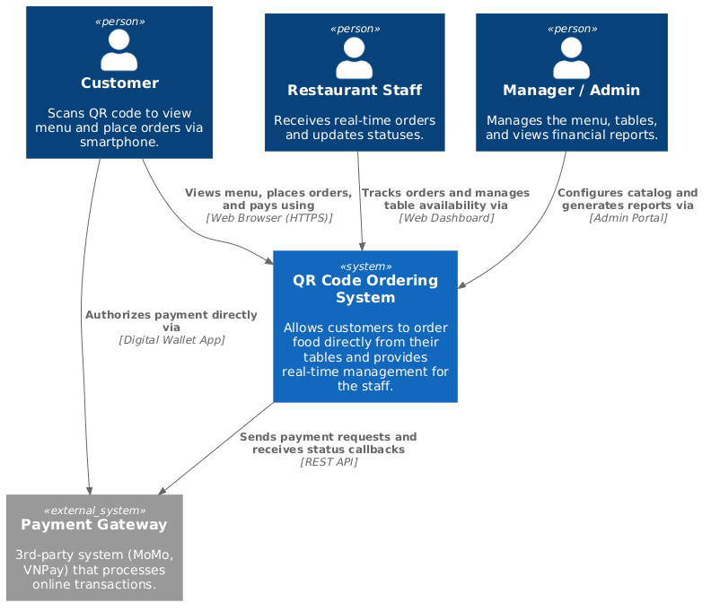
Communication Strategy
Goal: Define how different components and services interact with each other, ensuring the system remains responsive and reliable.
Service/Component Interaction | Communication Type | Reason
Customer UI $\rightarrow$ API Gateway | Synchronous (REST / HTTP) | The customer needs immediate feedback when loading the menu or submitting an order. A standard request-response cycle is required here.
Order Service $\rightarrow$ Payment Service | Asynchronous (Message Queue / Event Bus) | Order creation should not be blocked by payment processing delays. The Order Service publishes an "OrderCreated" event, which the Payment Service listens to, decoupling the two systems.
API Gateway $\rightarrow$ Staff Dashboard | Real-time Push (WebSockets / SSE) | Staff must receive instant notifications of new orders without manually refreshing the web browser. WebSockets keep an open connection for instant two-way data delivery.

