Lab 8: Deployment View & Quality Attribute Analysis (ATAM)
1. Introduction
This lab focuses on architectural documentation and evaluation instead of coding.
Based on the microservices system designed and implemented in Labs 5, 6, and 7, this lab presents:
- A Deployment View using a UML Deployment Diagram
- A simplified Architecture Trade-off Analysis Method (ATAM)
- A comparison between Monolithic (Layered) Architecture and Microservices Architecture
The analysis concentrates on two critical Non-Functional Requirements (NFRs):
Scalability and Availability.
2. Deployment View (UML Deployment Diagram)
2.1 Identified Deployment Nodes
The system is deployed using a typical cloud-based microservices architecture with the following physical nodes:
- Client Device
  - Web browser or mobile application
  - Sends HTTP/HTTPS requests
- Load Balancer (Nginx / Cloud Load Balancer)
  - Distributes incoming client requests
  - Improves availability and traffic handling
- Application Cluster (Docker / Kubernetes / VM Cluster)
  - Hosts all backend services as independent deployable units
2.2 Deployed Artifacts (Services)
Inside the Application Cluster, the following artifacts are deployed:
- API Gateway
  - Single entry point for all client requests
  - Performs routing and security checks (Lab 6)
- Product Service
  - Manages course/product catalog (Lab 5)
- Order Service
  - Handles order creation and business transactions
- Notification Service
  - Sends confirmation notifications asynchronously (Lab 7)
- Message Broker (RabbitMQ)
  - Enables event-driven communication between services
Each microservice owns its own database, ensuring loose coupling and data isolation.
2.3 Communication Paths
- Client → Load Balancer (HTTP/HTTPS)
- Load Balancer → API Gateway (HTTP)
- API Gateway → Product Service / Order Service (REST)
- Order Service → Message Broker (AMQP)
- Message Broker → Notification Service (AMQP)
This deployment supports horizontal scaling, fault isolation, and independent service evolution.
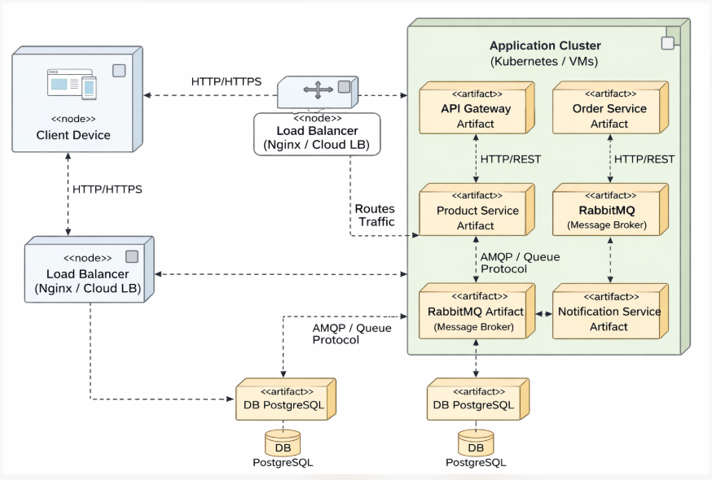

3. Quality Attribute Analysis (Simplified ATAM)
3.1 Defined Scenarios
Scalability Scenario (SS1)
During a 5-minute promotion, the system must handle a 10x increase in concurrent users viewing products and placing orders.
Availability Scenario (AS1)
The Notification Service is unavailable for 1 hour. The system must still successfully accept and process new orders.
3.2 Architecture Evaluation
Quality Attribute | Scenario | Monolithic Architecture | Microservices Architecture
Scalability | SS1 | Entire application must be scaled, even if only product browsing requires more resources. Inefficient and costly. | Only Product Service or Order Service can be scaled independently. Efficient resource usage.
Availability | AS1 | Failure in notification logic may block or slow down the whole system. | Order Service continues working. Events are stored in RabbitMQ until Notification Service recovers.

4. Architectural Trade-offs
The microservices architecture provides superior scalability and availability through:
- Independent deployment
- Event-driven communication
- Fault isolation
However, these benefits come with increased operational complexity, including:
- Service orchestration (Docker/Kubernetes)
- API Gateway management
- Message broker maintenance
- Monitoring and observability requirements
In contrast, the monolithic architecture is simpler to deploy but lacks flexibility and resilience.
5. Conclusion
Lab 8 demonstrates that the chosen microservices architecture successfully satisfies critical Non-Functional Requirements.
By combining an API Gateway, independent services, and an event-driven approach, the system achieves:
- High scalability
- High availability
- Strong fault isolation
This completes the architectural evolution from a layered monolithic system to a modern, cloud-ready microservices architecture.

