PHENIKAA UNIVERSITY
PHENIKAA SCHOOL OF COMPUTING
⸎⸎⸎⸎⸎


COURSE: SOFTWARE ARCHITECTURE
TOPIC:
DEVLOPMENT OF TRAINING PROGRAM MANAGEMENT SOFTWARE
DOCUMENT: SOFTWARE ARCHITECTURE

Code Course : CSE703110-1-1-25
Class : N01
Instructor : THS. Vũ Quang Dũng
Group : 11
Members : 1. Vương Xuân Giáp
2. Đặng Minh Quang
3. Nguyễn Đào Tuấn Cường
4. Vũ Hồng Phúc

Hanoi, November 2025
Lab1
1)Practice 1
a)Actor
Actor | Role
Admin | Add/edit/delete training program structure, knowledge blocks, courses, subjects, tuition fees,…  Compare training program versions
Student | Look up published curriculum/learning path and view/pay tuition

b) Functional Requirements (FRs)
ID | Functional Requirements
FR-01 | The system shall support organization structure management (e.g., faculties, majors): create/update, search, and deactivate instead of hard-delete when constrained
FR-02 | The system shall support lecturer/user management: create, update, deactivate/remove, search; validate unique code/email and optionally create accounts with roles
FR-03 | The system shall support a shared course catalog: create/edit/remove, search; validate constraints (code, credits, owner unit) and support bulk import
FR-04 | The system shall support curriculum building & management: knowledge blocks, curriculum structures and frameworks; compare and copy curricula, keep copy history, and manage display configuration
FR-05 | The system shall allow publishing and read-only lookup of published curricula for students/advisors to view learning paths and structures
FR-06 | The system shall support term-based tuition calculation & tracking, including overview/detail and the online payment flow (open payment → select items & compute total → …

c) Non-Functional Requirements
ID | Non-Functional Requirements
NFR-01  (Availability/Backup) | Availability ≥ 99% (7am–10pm); outage detection/alerting + restore ≤ 2h; daily backups, keep ≥ 7 versions
NFR-02  (Performance/Scalability) | Page/search ≤3s/≤5s; import/export ≥1000 records/min; ≥100 concurrent users; use index/cache and horizontal scaling
NFR-03  (Security) | SSO auth; role-based access; SSL/TLS; 15-min inactivity timeout; immutable audit logs; permission checks before actions

d) Architecturally Significant Requirements + Impact
ID | Feature | Description | Impact
ASR-01 | Versioning + Traceability + No hard delete + Audit | Curriculum data must be versioned & traceable, no hard-delete for linked entities; critical actions must be logged | Requires soft delete, a versioning model, immutable audit logs, and DB constraints/history retention
ASR-02 | Performance + scalability + high volume tasks | Meet SLA 3s/5s, 1000 records/min, 100 concurrent, with index/cache and horizontal scaling | Calls for caching/indexing, pagination; bulk I/O should run as background jobs/queues
ASR-03 | Reliable payment flow + transaction status + security | Online payments must create pending transactions, redirect/QR, handle callback/recheck, update SUCCESS/FAILED/CANCELLED, reconcile balances with audit trail; comply with SSO/TLS/RBAC | Needs a transaction state machine, idempotent callbacks, strong logging/auditing, clear gateway integration boundaries + session security

- Use case
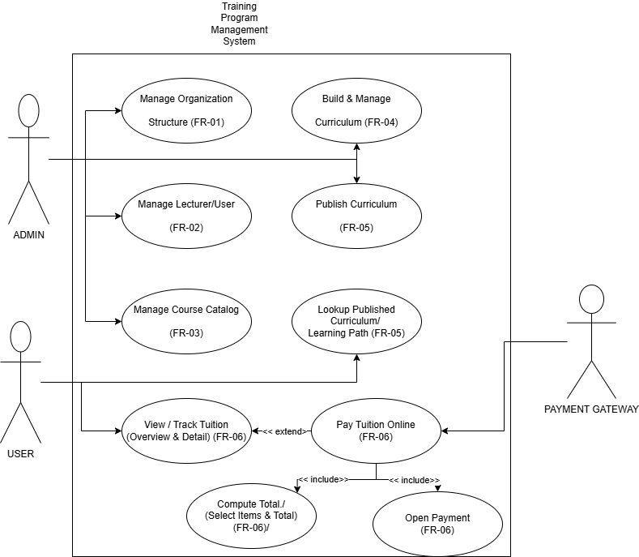
Use Case Diagram – Description
System boundary: Training Program Management System.
Actors: Admin (manage organization structure, lecturer/user, course catalog, build/manage curriculum, publish curriculum) and Student (lookup published curriculum/learning path; view/track tuition; pay tuition online).
Payment flow (FR-06): Pay Tuition Online <<extend>> View/Track Tuition; and <<include>> Compute Total (Select Items & Total), <<include>> Open Payment.

