Lab 4: Microservices Decomposition & Communication
Activity Practice 1: Decomposition by Business Capability
1. Identify Core Business Capabilities
The business domains are grouped as follows:
- Organization structure management (Faculty/Department): FR-01
- Lecturer/user management: FR-02
- Shared course/subject catalog (Course catalog): FR-03
- Build & manage curricula/frameworks/knowledge blocks + version/compare/copy: FR-04
- Publish & look up published curricula (read-only): FR-05
- Calculate tuition by term, track outstanding balances & online payment: FR-06
Actor/Role: Admin and Student.
2. Define Microservices
Business Capability | Proposed Microservice | Data Owned (Entities)
FR-01: Organization structure management | Organization Service | faculty, major (CRUD already exists in frontend/khoa.php, frontend/nganh.php)
FR-02: Lecturer/user management | User/Lecturer Service | lecturer (CRUD in frontend/giangvien.php)
FR-03: Shared course catalog (create/edit/remove/search + bulk import) | Course Catalog Service | course, course_relationship (CRUD + relationships in frontend/monhoc.php)
FR-04: Curriculum building & management (knowledge blocks, structures/frameworks, compare/copy/versioning) | Curriculum Service | knowledge_block, curriculum (CRUD for knowledge blocks + curriculum/framework)
FR-05: Publish & read-only lookup | Publishing/Lookup Service | Published curriculum data for read-only lookup
FR-06: Tuition calculation & tracking + online payment flow | Tuition & Payment Service | Flow for “calculate/track tuition by term + online payment” (FR-06) and payment business tables
3. Define External Dependencies
- Payment Gateway / Payment Processor – supports the online payment flow for FR-06
- SSO Identity Provider – because NFR-03 requires SSO auth + RBAC + SSL/TLS
- Backup/Monitoring/Alerting system – because NFR-01 requires outage detection/alerting + daily backups
- Activity Practice 2: Defining Service Contracts
- Producer: Course Catalog Service (manages courses/subjects – FR-03)
- Consumer: Curriculum Service (builds curricula/frameworks/knowledge blocks – FR-04)
2.1. Define the Producer API
Endpoint | HTTP Method | Description | Data Returned
/api/courses/{id} | GET | Retrieve full details of a single course/subject | Course object (courseCode, courseName, credits, unit_id, description, …) — based on the same CRUD fields used when INSERTing a course
/api/courses | GET | Search / list courses by criteria | List of Course (summary view)
/api/courses | POST | Add a new course (Admin function) | Course object

2.2. Define the Consumer Interaction
- Action: courseName and credits
- Requirement: Curriculum Service must not access the Course Catalog Service database directly (violates the service boundary); instead it must call the defined endpoint: GET /api/courses/{id}.
Activity – Practice 3:
C4 Model (Level 1: System Context)

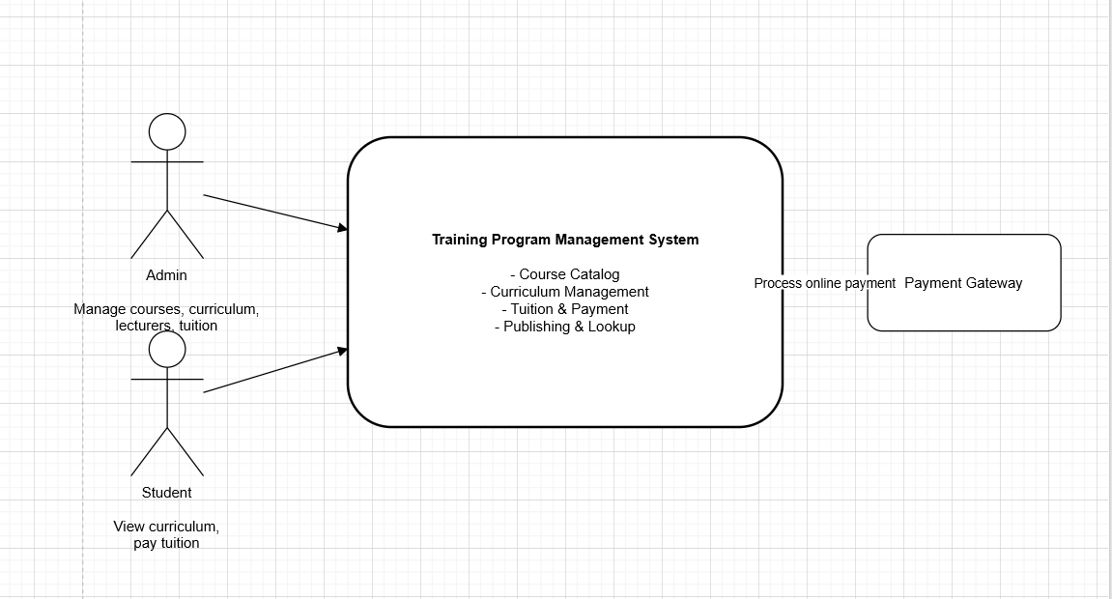
C4 Model (Level 2: Container View)
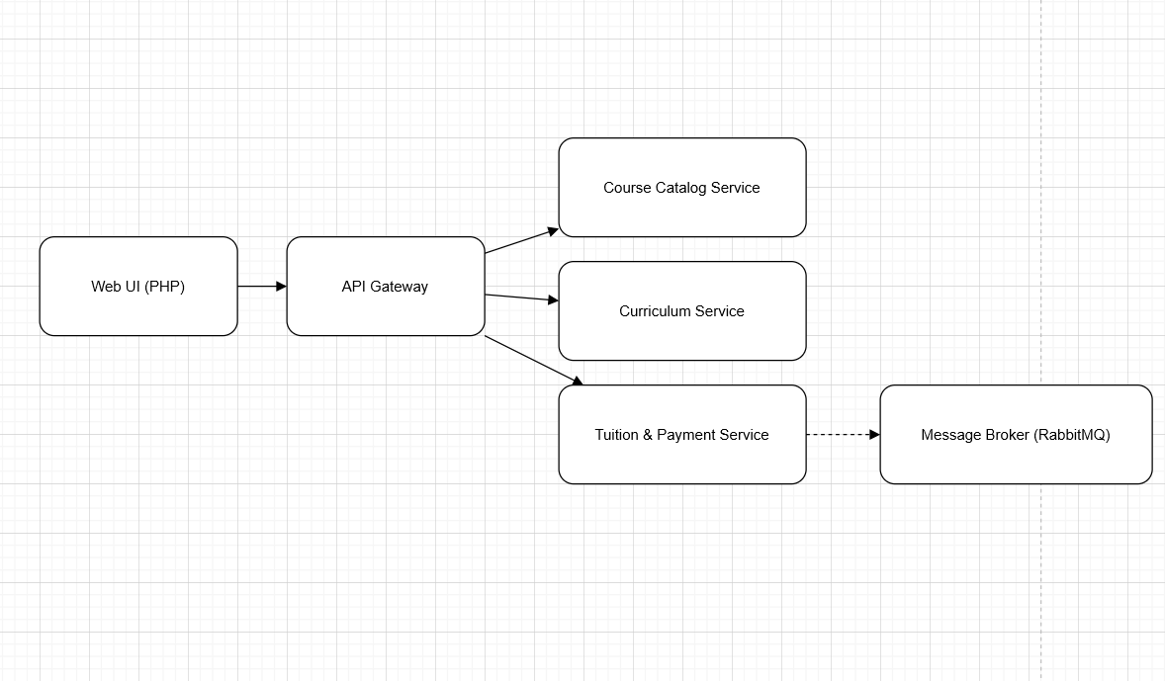
C4 Model (Level 3: Component)

