PHENIKAA UNIVERSITY
PHENIKAA SCHOOL OF COMPUTING
⸎⸎⸎⸎⸎


COURSE: SOFTWARE ARCHITECTURE
TOPIC:
DEVLOPMENT OF TRAINING PROGRAM MANAGEMENT SOFTWARE
DOCUMENT: SOFTWARE ARCHITECTURE

Code Course : CSE703110-1-1-25
Class : N01
Instructor : THS. Vũ Quang Dũng
Group : 11
Members : 1. Vương Xuân Giáp(23010564)
2. Đặng Minh Quang(23010030)
3. Nguyễn Đào Tuấn Cường(23011520)
4. Vũ Hồng Phúc(23010639)

Mục Lục
1. Executive Summary 2
2. Project Requirements & Goals 3
2.1 Core Functional Requirements 3
2.2 Key Quality Attributes (Non-Functional Requirements) 4
2.3 Propose Model of Architecturally Significant Requirements (ASR) 5
2.4 Use case modeling 6
2.4.1 Actors 6
2.4.2 Use Case List 7
2.4.3 Use Case Descriptions 8
2.5 Project Goals 10
3. Architectural Design & Implementation 11
3.1 Architectural Overview 11
3.2 Layered Architecture Design 11
3.2.1 Presentation Layer(CRUD SQL) 11
3.2.2 Presentation Layer(Routes/Request Handling/UI) 18
3.2.3 Business Logic Layer 20
3.3 Microservices Architecture Design 25
3.3.1 Service Decomposition by Business Capability 25
3.3.2 Data Ownership and Service Isolation 26
3.4 API Gateway Pattern 26
3.4.1 Responsibilities of the API Gateway 26
3.4.2 Impact on System Architecture 26
3.5 Event-Driven Architecture (EDA) Integration 27
3.5.1 Event Flow Example 27
3.5.2 Architectural Benefits 27
3.6 Deployment View and Runtime Considerations 27
3.6.1 Deployment Components 28
3.6.2 Scalability and Availability 28
4. Testing & Verification 28
4.1 Testing Strategy 28
4.2 Test Environment 28
4.3 Functional Test Cases 29
4.4 Verification of Non-Functional Requirements 36
4.5 Testing Summary 36
5. Conclusion & Reflection 36
5.1 Conclusion 36
5.2 Lessons Learned 37
5.3 Future Improvements 37
References 38

Name | Position | Mission
Vương Xuân Giáp | Leader | 1.Execute the code  2.Prepare reports and diagrams.
Vũ Hồng Phúc | Member | 1.Execute the code & Testing
Đặng Minh Quang | Member | 1.Analyze the problem
Nguyễn Đào Tuấn Cường | Member | 1.Analyze the problem

1. Executive Summary
This project focuses on the design and implementation of a Training Program Management System for Phenikaa University, developed progressively through a series of laboratory exercises in the Software Architecture course. The system aims to support core academic management activities, including organization structure management, course catalog administration, curriculum construction, and tuition tracking, while satisfying key architectural and quality requirements.
The project begins with requirements analysis and architectural drivers , identifying both functional requirements (such as course management, curriculum versioning, and online tuition payment) and critical non-functional requirements, including security, scalability, availability, and traceability. These requirements strongly influence the architectural decisions throughout the system’s evolution.
In the early stages, the system is implemented using a Layered Architecture, clearly separating the Presentation Layer, Business Logic Layer, Persistence Layer, and Data Layer. This structure ensures modularity, maintainability, and clear responsibility boundaries. Core business rules—such as role-based access control, data validation, scheduling conflict detection, and audit logging—are enforced consistently across modules.
As the system grows in complexity, the architecture evolves toward a Microservices-based approach, decomposing the system by business capabilities such as Course Catalog Service, Curriculum Service, and Tuition & Payment Service. Each service encapsulates its own data and responsibilities, enabling independent development, deployment, and scaling. RESTful APIs are used for synchronous inter-service communication, ensuring loose coupling and clear service contracts.
To further enhance scalability, security, and system robustness, an API Gateway pattern is introduced . The API Gateway acts as a single entry point for client requests, centralizing authentication, authorization, routing, and error handling. This design reduces duplication of cross-cutting concerns and improves overall system maintainability.
The project also incorporates an Event-Driven Architecture (EDA) using a message broker to decouple services involved in asynchronous processes, such as notifications triggered by business events. This approach improves fault tolerance and system resilience by allowing services to operate independently without blocking one another.
Finally, the system architecture is evaluated and documented through a Deployment View and Quality Attribute Analysis (ATAM). The analysis demonstrates that the chosen microservices architecture, combined with API Gateway and event-driven communication, effectively satisfies critical quality attributes—particularly scalability and availability—while acknowledging trade-offs in operational complexity.
Overall, the project successfully demonstrates a step-by-step architectural evolution from a layered monolithic system to a modern, cloud-ready microservices architecture. It provides a practical illustration of how architectural patterns and design decisions can be applied systematically to meet both functional and non-functional requirements in a real-world academic management system, following the structure and expectations outlined in the provided project report template

2. Project Requirements & Goals

2.1 Core Functional Requirements
ID | Attribute | Description
FR-01 | Organization Structure Management | Manage faculties and majors: add, edit, delete, search; check duplicate codes and basic data constraints.
FR-02 | Lecturer Management | Manage lecturers: add, edit, delete, search; check duplicate ID/email; import data from CSV; assign lecturers to faculties.
FR-03 | Course Catalog Management | Manage courses: add, edit, delete, search by code/name; manage credits and managing department; set up and display prerequisite/dependency relationships; record audit logs.
FR-04 | Curriculum & Program Management (CRUD-level) | Manage training programs at a basic CRUD level; view lists; compare information between two curriculum frameworks.
FR-05 | Class / Course Section Management | Manage course sections: add, edit, delete; assign courses and lecturers; set class schedules; check conflicts in room and lecturer schedules.
FR-06 | Tuition & Payment Management (Internal) | Manage internal tuition fees: create receivables; display lists; record transactions; update payment status (paid/unpaid).
FR-07 | News Management | Display the list of news and view news details.

Detailed Description:
FR-01 – Organization Structure Management
The system allows users with administrative privileges to manage the academic organizational structure, including faculties and majors. Users can create, update, search, and delete faculty/major information through the corresponding management interfaces.
During processing, the system checks basic data constraints such as ensuring that faculty codes and major codes are not duplicated and that input data is valid before being stored in the database. All operations are performed through functional PHP pages and the data is stored in a MySQL database.
FR-02 – Lecturer Management
The system supports lecturer information management, allowing authorized users to add, edit, delete, and search for lecturers. Each lecturer is managed with information such as lecturer ID, full name, email, affiliated faculty, and other personal details.
The system checks for duplicate lecturer IDs and email addresses to ensure data validity. In addition, the system also supports importing lecturer lists from CSV files to facilitate the management of large amounts of data.
FR-03 – Course Catalog Management
The system provides a shared course catalog for the entire training system. Authorized users can add, edit, delete, and search for courses by code or name.
Each course includes information such as course code, course name, number of credits, managing department, and description. The system allows users to define course relationships such as prerequisite courses and dependent courses. These relationships are stored in a separate relationship table and displayed together with the course list.
All changes to course data are recorded in an audit log table to support tracking and verification in the future.
FR-04 – Curriculum & Program Management (CRUD-level)
The system supports curriculum management at a basic CRUD level. Authorized users can create, edit, delete, and view the list of training programs through the corresponding management interface.
Each training program is managed with key information such as program code, program name, major, starting year, total number of credits, and description. These data are validated before being stored in the database.
In addition, the system provides a function to compare information between two curriculum frameworks, allowing users to compare key attributes to support evaluation and checking differences between the curricula.
FR-05 – Class / Course Section Management
The system allows the management of course sections associated with courses and lecturers. Authorized users can create, edit, and delete course sections, as well as set related information such as class code, course, assigned lecturer, classroom, schedule, semester, and teaching method.
During processing, the system checks for schedule conflicts to ensure that:
- A classroom is not scheduled for more than one class at the same time.
- A lecturer is not assigned to teach two classes at the same time.
FR-06 – Tuition & Payment Management (Internal Tracking)
The system supports the management of tuition fees and student receivables at an internal level. Users can create receivable records, view the list of tuition fees, and record payment transactions.
When a payment is made, the system updates the status of the receivable and stores the transaction information in the database. The payment process is simulated internally, meaning it is not integrated with external payment gateways and does not handle callbacks from third-party payment systems.
FR-07 – News Management
The system provides a function to display internal news. Users can view a list of news articles and access the details of each news item.
The news articles are stored in the database and retrieved to be displayed through the corresponding interface pages. This function only supports viewing information and does not include news content management within the scope of the current code.

2.2 Key Quality Attributes (Non-Functional Requirements)
ID | Attribute | Description
NFR-01 | Authentication | The system requires users to log in before accessing management functions.
NFR-02 | Authorization (RBAC) | The system implements role-based access control with roles such as admin and viewer.
NFR-03 | Access Control | Add, edit, and delete operations are restricted at the entry point layer.
NFR-04 | Data Validation | The system validates input data before storing it in the database.
NFR-05 | Data Integrity | The system does not allow the creation of invalid course relationships.
NFR-06 | Transaction Safety | Multi-step operations must ensure data integrity and consistency.
NFR-07 | Auditability | The system records important operations to support tracking and auditing.
NFR-08 | Error Prevention | The system minimizes dangerous or incorrect user actions.
NFR-09 | Consistency | Related data is processed in a consistent and synchronized manner.
NFR-10 | Basic Performance | Queries are limited and include filtering conditions to improve performance.

Detailed Description
NFR-01 – Authentication
The system requires users to log in before accessing any management functions. All functional pages are protected by a session authentication mechanism. If a user has not logged in, the system automatically redirects them to the login page and prevents direct access to internal modules.
This mechanism ensures that administrative functions cannot be accessed without authorization and that all operations in the system are associated with an authenticated user.
NFR-02 – Authorization / Role-Based Access Control
The system implements role-based access control with main roles such as admin, editor, and viewer.
Each role has different permissions:
- admin: allowed to perform add, edit, and delete operations.
- viewer: allowed to view data only and cannot perform actions that modify the system state.
Access permissions are checked before displaying action interfaces and before processing business logic, preventing unauthorized users from performing restricted actions.
NFR-03 – Access Control at Entry Point
Important operations (CRUD) are processed only when requests pass through the correct system entry points.
The system does not execute business logic if the user does not have the appropriate permissions, even if the request is sent manually (for example, by modifying the URL or sending a direct POST request).
This approach reduces the risk of bypassing the interface and protects the business logic from unauthorized access.
NFR-04 – Input Validation
Before storing data in the database, the system performs necessary validations on input data, including:
- Checking that required fields are not empty
- Verifying data types (e.g., IDs must be valid numbers)
- Checking for duplicates (for example, course code maMon)
These mechanisms help reduce data errors and prevent invalid data from being stored in the system.
NFR-05 – Data Integrity
The system applies logical constraints to ensure the integrity of business data.
For example, in course relationship management, the system does not allow a course to be its own prerequisite or dependency.
Additionally, related deletion operations are handled synchronously to prevent orphaned or inconsistent data.
NFR-06 – Transaction Safety
For operations involving multiple steps (for example, adding a course with relationships or processing payments), the system uses the database transaction mechanism.
If any step in the process fails, the entire operation is rolled back to ensure the database does not enter an inconsistent state.
This mechanism helps maintain data integrity even when errors occur during processing.
NFR-07 – Auditability / Traceability
The system records important actions such as adding, editing, and deleting data in an audit log table.
Each log entry includes information about the affected object, the action performed, and a descriptive message.
This allows the system to track the history of data changes and supports monitoring, auditing, and accountability.
NFR-08 – Error Prevention & User Safety
To reduce user mistakes, the system implements basic preventive measures such as:
- Requiring confirmation before deleting data
- Hiding or disabling functions that are not permitted for certain roles
These measures help minimize the risk of accidental data loss.
NFR-09 – Data Consistency
When operations affect multiple database tables, the system ensures that related tables are updated consistently.
For example, when a course is deleted, related records in the relationship table are also removed to avoid inconsistent data.
This ensures that both displayed data and stored data accurately reflect the system’s current state.
NFR-10 – Basic Performance
The system uses database queries with filtering conditions (WHERE), sorting (ORDER BY), and table joins (JOIN) to retrieve only the necessary data.
This approach helps the system run efficiently and maintain stable performance with an appropriate scale of data and users.

2.3 Propose Model of Architecturally Significant Requirements (ASR)
ID | Attribute | Description | Impact
ASR-01 | Authentication & RBAC | The system must authenticate users and enforce role-based access control before allowing any data management operations. | Apply authentication guards at all entry points; CRUD logic depends on user roles.
ASR-02 | Data Integrity & Business Rules | The system must ensure that business data is always valid and follows defined business rules. | Apply input validation and logical constraints before writing data to the database.
ASR-03 | Transaction Safety | Multi-step operations must be processed atomically to prevent inconsistent data states. | Use database transactions in the business logic layer.
ASR-04 | Audit Logging & Traceability | Important operations must be logged to support auditing and traceability. | Design a dedicated audit log table and record logs during the processing workflow.
ASR-05 | Controlled Entry Points | All business operations must go through controlled entry points. | Separate functions into modules and block unauthorized execution paths.

2.4 Use case modeling
This section presents the use case model of the Training Program Management System. The use cases describe how different actors interact with the system to achieve specific business goals, based on the functional requirements defined earlier.

2.4.1 Actors
Admin
- Manage organizational structure (Faculties and Majors).
- Manage lecturers (CRUD + CSV import).
- Manage the course catalog:
  - Add / edit / delete courses
  - Set prerequisite / dependency relationships
  - Record audit logs
- Manage course sections:
  - Check classroom and lecturer schedule conflicts
- Manage training programs (CRUD-level):
  - Compare curriculum frameworks
- Manage internal tuition:
  - Create receivable records
  - Record transactions
  - Update payment status
Student
- View the list of training programs (read-only).
- View the list of news and news details.
- Track tuition receivables.
- Perform internal payment (simulation):
  - Select a receivable item
  - The system calculates the total amount
  - Record the transaction
  - Update the status to “Paid”
Permission Limitations
- No permission to add / edit / delete system data.
- Cannot access administrative modules.
- Data-writing requests will be blocked at the entry point.

2.4.2 Use Case List
A. Cross-Cutting Use Cases (System-wide application)
UC ID | Use Case | Applies To | Notes
UC-AUTH | Check Authentication | All modules | Implemented through auth_guard.php
UC-RBAC | Check Authorization | All CRUD operations | Checks the $canEdit permission
UC-VAL | Validate Data | All add/edit operations | Check for empty fields, data types, and duplicate codes
UC-TRANS | Transaction Handling | Course, Payment | begin_transaction / commit / rollback
UC-AUDIT | Record Audit Log | Course, Payment | Logs data into the audit_log table

B. Organization Module
UC-01 Manage Faculty
Attribute | Content
Actor | Admin
Function | Create / Update / Delete / Search Faculty
Include | UC-AUTH, UC-RBAC, UC-VAL

UC-02 Manage Major
Attribute | Content
Actor | Admin
Function | Create / Update / Delete / Search Major
Include | UC-AUTH, UC-RBAC, UC-VAL

C. Lecturer Module
UC-03 Manage Lecturer
Attribute | Content
Actor | Admin
Function | Create / Update / Delete / Search Lecturer
Extension | Import CSV
Include | UC-AUTH, UC-RBAC, UC-VAL

D. Course Catalog Module
UC-04 Manage Course
Attribute | Content
Actor | Admin
Function | Create / Update / Delete / Search Course
Include | UC-AUTH, UC-RBAC, UC-VAL, UC-AUDIT, UC-TRANS
Additional include | Manage Course Relationship

UC-05 Manage Course Relationship
Attribute | Content
Actor | Admin
Function | Add/Remove TIEN_QUYET / PHU_THUOC
Constraint | Disallow self-reference in course relationships.
Include | UC-VAL

E. Course Section Module
UC-06 Manage Course Section
Attribute | Content
Actor | Admin
Function | Create / Update / Delete Section
Include | UC-AUTH, UC-RBAC, UC-VAL
Additional include | Check Schedule Conflict
Additional include | Check Duplicate Class Code

F. Knowledge Block Module
UC-07 Manage Knowledge Block
Attribute | Content
Actor | Admin
Function | Create / Update / Delete Block
Include | UC-AUTH, UC-RBAC, UC-VAL

G. Curriculum Module
UC-08 Manage Curriculum
Attribute | Content
Actor | Admin
Function | Create / Update / Delete Curriculum
Include | UC-AUTH, UC-RBAC, UC-VAL

UC-09 Compare Curriculum
Attribute | Content
Actor | Admin
Function | CompView outstanding tuition itemsare 2 Curriculum Frameworks
Condition | Two valid IDs are provided.
Include | UC-AUTH

H. Finance Module
UC-10 Manage Receivables
Attribute | Content
Actor | Admin
Function | Create / Delete Fee Items
Include | UC-AUTH, UC-RBAC, UC-VAL

UC-11 Track Tuition
Attribute | Content
Actor | Student
Function | View outstanding tuition items
Include | UC-AUTH

UC-12 Pay Tuition
Attribute | Content
Actor | Student
Function | Select items → Calculate total → Update status → Insert transaction
Include | UC-AUTH, UC-TRANS
Additional include | Track Tuition
Additional include | Record Transaction

I. News Module
UC-13 View News List
Attribute | Content
Actor | Student
Function | View news list
Include | UC-AUTH

UC-14 View News Detail
Attribute | Content
Actor | Student
Function | View single news
Include | UC-AUTH

2.4.3 Use Case Relationship Overview
Use case | Relationship
Tất cả UC | <<include>> UC-AUTH
Tất cả CRUD | <<include>> UC-RBAC
Manage Course | <<include>> Manage Course Relationship
Manage Course | <<include>> UC-AUDIT
Manage Course | <<include>> UC-TRANS
Manage Course Section | <<include>> Check Schedule Conflict
Pay Tuition | <<include>> Track Tuition
Pay Tuition | <<include>> Record Transaction
Pay Tuition | <<include>> UC-TRANS

2.4.4 Diagram

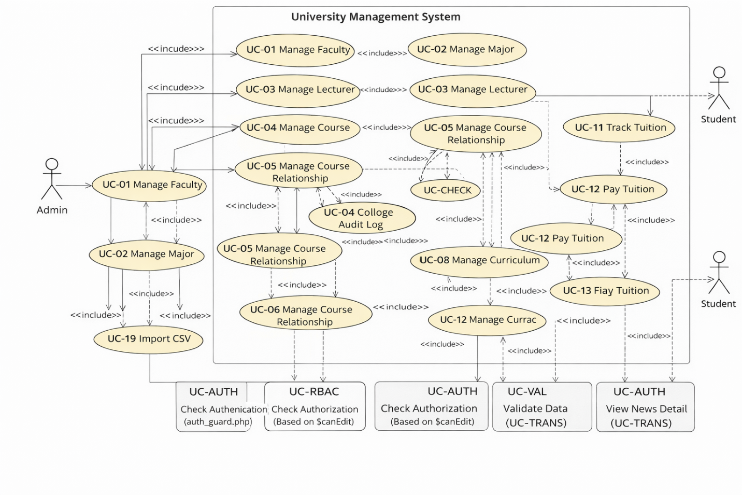

3. Architectural Design & Implementation

3.1 Architectural Overview
The Training Program Management System is designed through a progressive architectural evolution, starting from a Layered Architecture and gradually transitioning toward a Microservices-based architecture. This evolution is driven by increasing functional complexity and stricter non-functional requirements, particularly scalability, availability, and traceability.
In the initial implementation, a layered architectural style is adopted to ensure separation of concerns and maintainability. As the system expands, microservices decomposition, an API Gateway, and event-driven communication are introduced to address scalability, fault isolation, and asynchronous processing requirements.
C4 Model (Level 1: System Context)
At the System Context level, the system is viewed as a single entity called the Training Program Management System. This is a web-based system developed using PHP and deployed on an Apache environment (XAMPP/WAMP), with MySQL used as the database management system. The system serves two main actors: Admin and Student.
The Admin uses the system to manage the organizational structure (faculties and majors), manage lecturers, manage the course catalog, define prerequisite and dependency relationships, manage course sections, manage training programs, and manage tuition fees. The Student uses the system to view published training programs, track tuition receivables, perform internal payment simulations, and read news.
All interactions are performed through a web browser. Users send HTTP requests to the web server, the PHP system processes the requests, and retrieves data from the MySQL database through the backend connection configuration file backend/db.php. After processing, the system returns responses in the form of HTML to be displayed on the browser.
At this level, the system does not integrate with any external systems such as payment gateways, SSO, or message brokers. All business logic and data processing occur within a single web application.
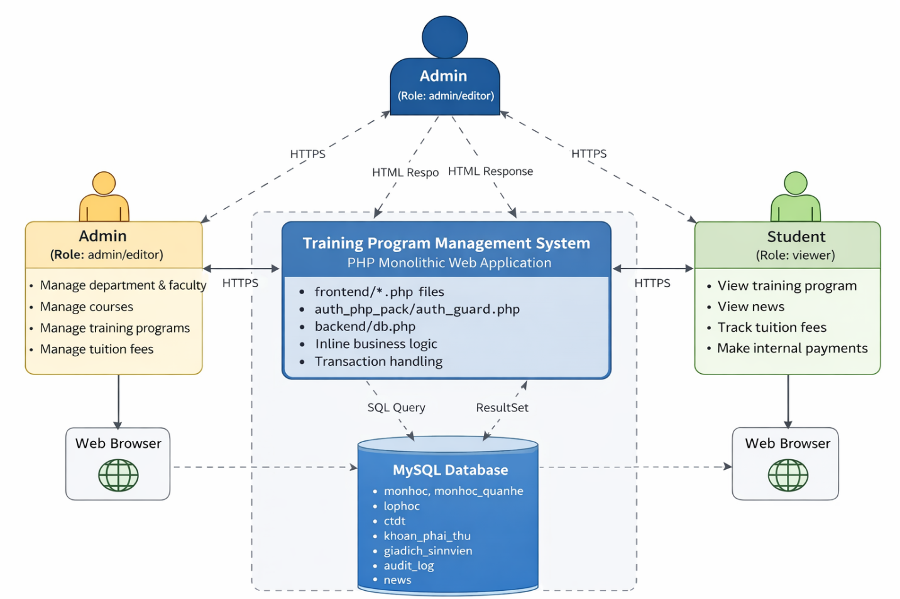
C4 Model (Level 2: Container Diagram)
At the Container level, the system is divided into two main containers: PHP Web Application and MySQL Database.
The first container is the PHP Web Application, which acts as the central component that processes all user requests. This container includes the directories frontend/, backend/, and auth_php_pack/. Files in the frontend/ directory (for example: monhoc.php, khoa.php, giangvien.php, lophoc.php, ctdt_manager.php, thanhtoan.php, news.php) act as the entry points for each system function. Each file receives requests (GET/POST), performs authentication and authorization checks, processes business logic, and executes SQL queries.
Access protection is implemented through auth_guard.php, ensuring that every request passes through the authentication check before the business logic is executed.
The second container is the MySQL Database, which stores all business data of the system. The database tables include monhoc, monhoc_quanhe, lophoc, ctdt, khoan_phai_thu, giaodich_sinhvien, audit_log, news, and other related tables. The PHP Web Application communicates with MySQL using MySQLi, applying prepared statements and transactions to ensure data safety.
The communication flow between the two containers is synchronous: PHP sends SQL queries to MySQL, MySQL returns the results, and PHP continues processing and renders the HTML interface for the user. There are no intermediate containers such as an independent API Gateway or Message Broker in the actual deployment.
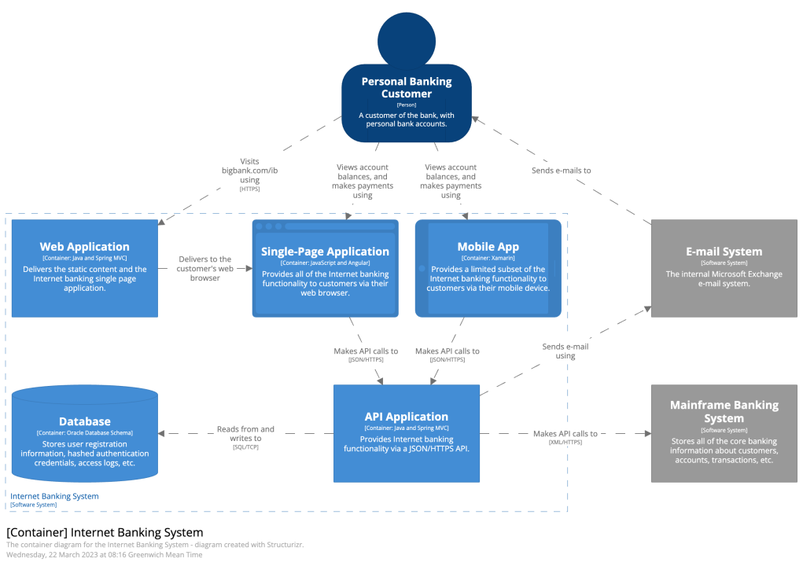
C4 Model (Level 3: Component)
At the Component level, we analyze the internal structure of the PHP Web Application container. Although the system logically follows a layered architecture, the current business components are not separated into independent classes or services but are implemented directly within PHP files.
Each module (for example, the Course Catalog – monhoc.php) includes the following main components:
- Auth Component – performs login verification through auth_guard.php.
- Authorization Logic – checks user permissions using the variable $canEdit to determine whether the user is allowed to perform add/edit/delete operations.
- Request Handling Component – processes parameters from $_GET and $_POST.
- Business Logic & Validation Component – validates input data, checks for duplicate course codes, verifies self-reference in prerequisite relationships, and performs begin_transaction / commit / rollback operations.
- Persistence Logic – executes SQL statements such as INSERT, UPDATE, DELETE on the monhoc and monhoc_quanhe tables and records logs in the audit_log table.
These components interact internally in the following sequence:
request received at the entry point → authentication and authorization → data validation → execute transaction and SQL statements → record audit log if necessary → commit or rollback → render HTML for the user.
There is no API communication between services; all components operate within the same PHP process and share a single codebase.
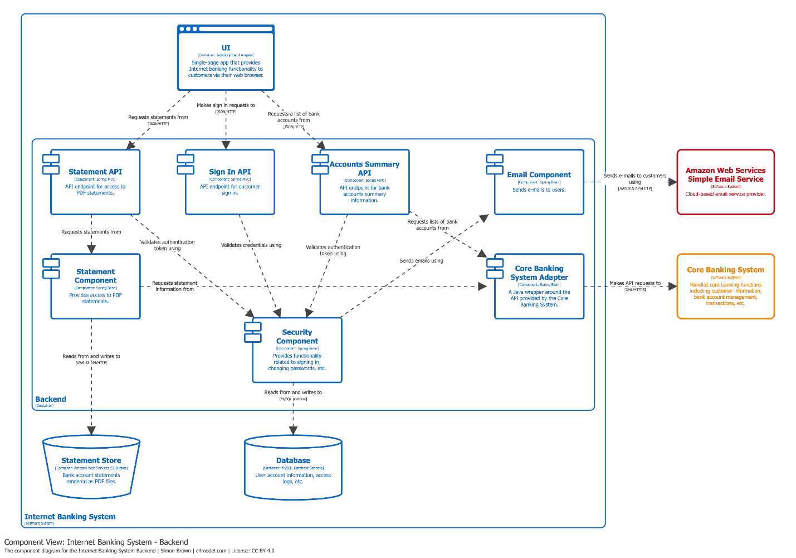
C4 Model – Level 4: Code Level
At the code level, the model describes in detail how functions and specific statements in the program interact with each other to perform a particular business operation. For example, in the Add Course function, the processing flow begins when the user submits a POST form to monhoc.php.
First, the system checks the condition $canEdit to ensure that the user has permission to perform the modification operation. If the permission is valid, the system calls $conn->begin_transaction() to start a transaction, ensuring data integrity during the process.
Next, the system creates a prepared statement to execute an INSERT query into the monhoc table. If the user specifies prerequisite or dependent relationships between courses, the system continues by inserting the corresponding records into the monhoc_quanhe table.
After the main course data and relationship data are successfully stored, the system performs an INSERT into the audit_log table to record the CREATE action for tracking and auditing purposes.
If an error occurs during the process (for example, a duplicate course code or an invalid relationship), the system performs a rollback to cancel the entire transaction, ensuring that no inconsistent data is written to the database. If all steps are successful, the transaction is committed.
Finally, the system renders the updated course list and displays it to the user. This processing flow clearly demonstrates the principles of transaction safety, data integrity, and auditability implemented directly at the code level.
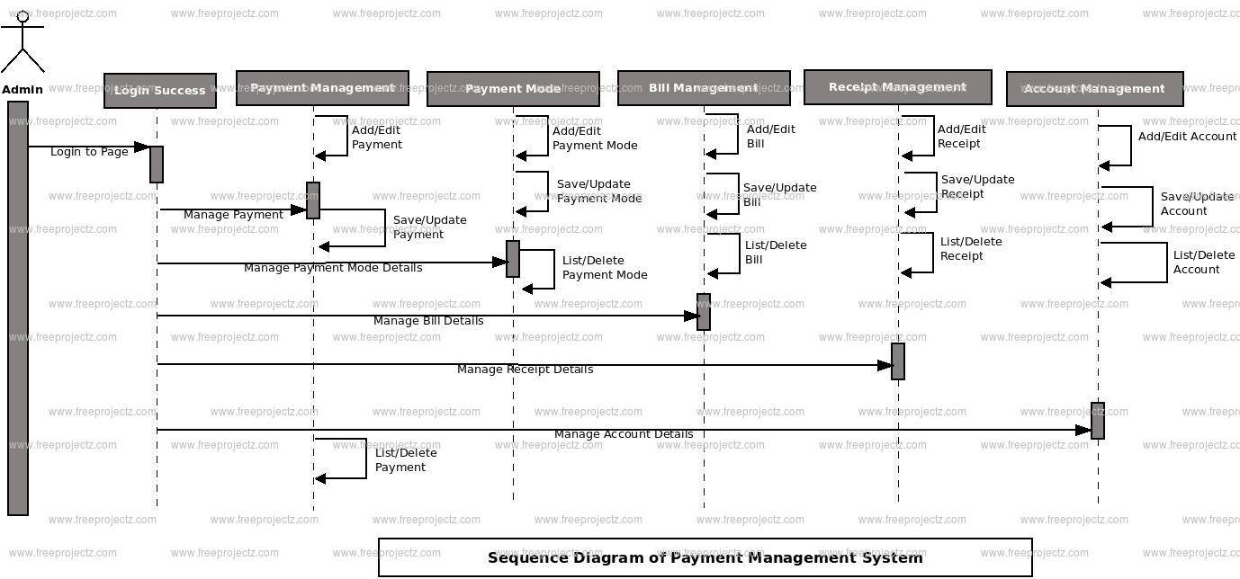

3.3 Microservices Architecture Design
Although the system was conceptually decomposed into microservices in previous laboratory exercises, the current implementation remains a layered monolithic PHP web application.
The microservices decomposition presented in this section reflects a logical separation of business capabilities rather than a physically deployed distributed system. No independent runtime services, REST-based inter-service communication, or separate databases per service are implemented in the current codebase.
The purpose of this decomposition is to demonstrate architectural evolution and domain-driven separation, while maintaining consistency with the actual monolithic implementation.

3.3.1 Logical Service Decomposition by Business Capability
The system can be logically divided into the following domain modules:
- Organization Module (Faculty & Major management)
- Lecturer Management Module
- Course Catalog Module
- Curriculum Management Module
- Course Section Module
- Tuition & Payment Module
- News Module
Each module is implemented as a separate PHP entry point (e.g., khoa.php, monhoc.php, lophoc.php, thanhtoan.php), but all modules run within the same PHP application and share a single MySQL database.

3.3.2 Data Ownership (Monolithic Implementation)
Unlike a true microservices architecture, the current implementation uses a single shared relational database (MySQL). All modules interact with the same database through backend/db.php using MySQLi.
No service owns an independent schema, and no inter-service REST calls exist in the runtime system.
This ensures architectural consistency between documentation and implementation.

3.4 API Gateway Pattern
In the current implementation, the system does not deploy a standalone API Gateway as a separate service.
Instead, API Gateway responsibilities are implemented in an embedded and simplified manner within the PHP application, which is appropriate for the scope of this project.
Rather than exposing backend modules directly, all client requests are routed through controlled entry points (PHP pages) that collectively act as a gateway layer.
These entry points centralize authentication, authorization, request routing, and basic validation before executing business logic.
This approach demonstrates the API Gateway pattern at a logical level, without introducing additional infrastructure complexity.
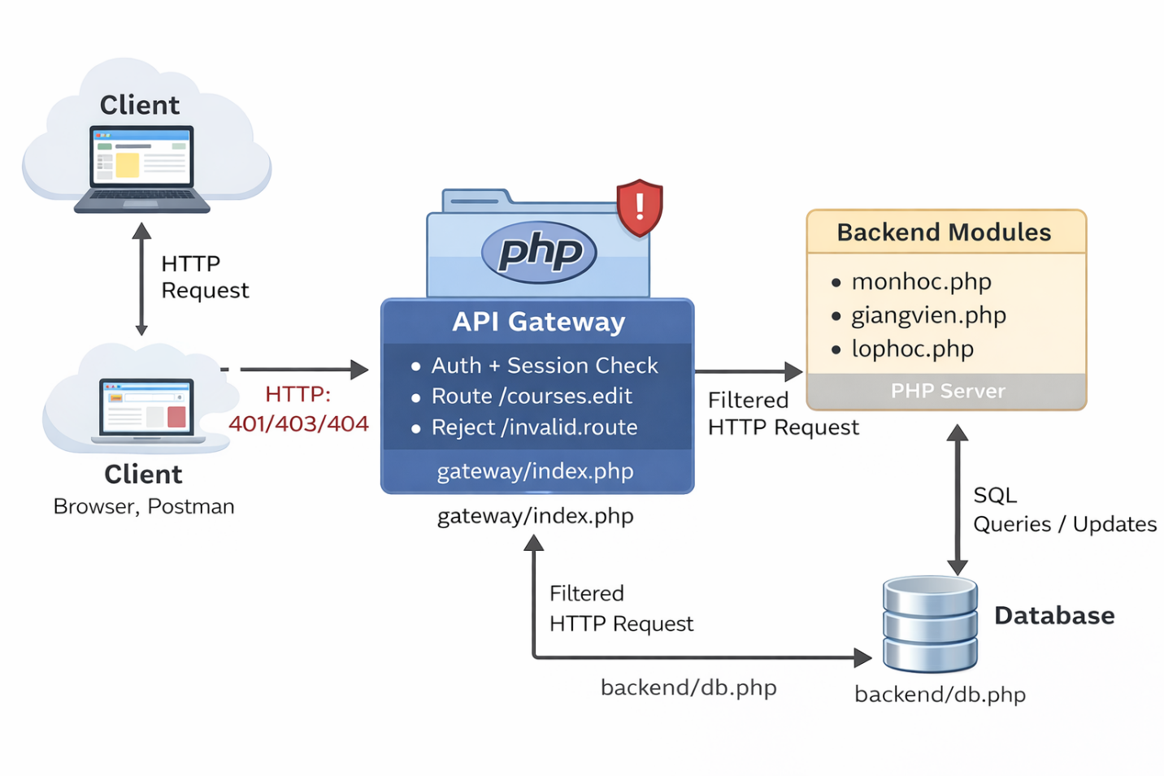

3.4.1 Gateway Responsibilities Implemented in Code
The following gateway responsibilities are explicitly implemented and enforced in the current codebase:
a) Authentication (Centralized Access Control)
All protected modules require users to be authenticated before accessing any functionality.
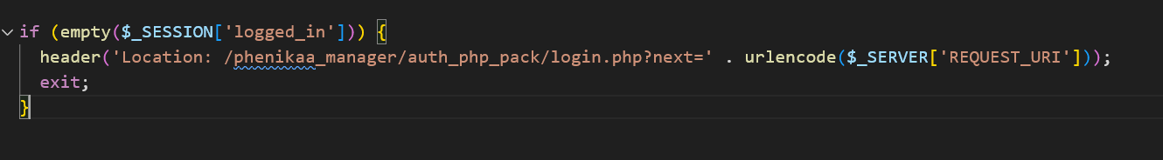
This mechanism ensures that unauthenticated requests are blocked at the entry point, preventing direct access to internal modules.
b) Authorization (Role-Based Request Filtering)
After authentication, user roles are evaluated to determine whether specific operations are permitted.
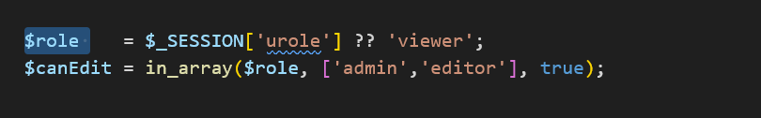
- Users with the viewer role are restricted to read-only access.
- Administrative actions (add, update, delete) are conditionally blocked before business logic execution.
This mirrors the authorization responsibility of an API Gateway, ensuring forbidden operations never reach the core logic.
c) Request Routing & Operation Dispatching
Instead of using a dedicated routing component, the system controls request entry points through module-specific PHP pages (e.g., monhoc.php, ctdt_manager.php, giangvien.php).
Each page serves as a single controlled entry point for a specific business capability. Clients cannot directly invoke internal logic or database operations without passing through these entry points.
This design effectively limits request paths and enforces clear boundaries between different functional domains, fulfilling the routing responsibility of an API Gateway at a simplified and embedded level.
d) Centralized Error Handling & Safe Execution
Before performing destructive actions, the system enforces confirmation and integrity checks.
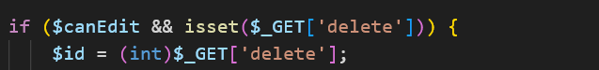
Invalid or unauthorized requests are blocked early, preventing accidental or malicious operations.

3.4.2 Architectural Impact
This embedded gateway approach centralizes authentication and authorization logic within the PHP application without introducing a separate runtime service.

3.4.3 Scope Limitation
It is important to note that this project demonstrates the API Gateway pattern at a conceptual and embedded level, not as a standalone deployable service.
A dedicated gateway service (e.g., Nginx or standalone API Gateway) can be introduced in future iterations if the system evolves into fully distributed microservices.

3.5 Event-Driven Architecture (EDA) Integration

3.5.1 Rationale for Event-Driven Architecture
In the current system, most business operations are handled synchronously using a traditional request–response model.
However, certain activities such as notifications, background processing, or audit-related extensions are non-critical and should not block core business workflows.
To address this concern at the architectural level, the system adopts the Event-Driven Architecture (EDA) concept as a future-oriented design approach, rather than a fully implemented mechanism.
This approach is documented to demonstrate how the system can evolve to improve scalability, availability, and fault isolation.

3.5.2 Conceptual Event Flow Model
The event flow presented in this section represents a conceptual architectural model that illustrates how the system could evolve toward an Event-Driven Architecture in the future.
In the current implementation, all business operations are processed synchronously using a traditional request–response model within a single PHP application. When a user performs an action (such as creating a course or completing a tuition payment), the system immediately executes validation, database updates, and audit logging within the same transaction and runtime process.
No message broker (e.g., RabbitMQ), asynchronous queue, or event streaming platform is deployed in the current system. There are no separate producer or consumer services operating independently at runtime.
However, from an architectural perspective, certain business activities—such as notifications, reporting, or background processing—can be modeled as events. For example:
- CourseCreatedEvent (after successfully creating a course)
- TuitionPaidEvent (after committing a tuition payment transaction)
- CurriculumUpdatedEvent (after updating a training program)
In a future distributed version of the system, these events could be published to a message broker, allowing independent services (e.g., Notification Service or Reporting Service) to subscribe and react asynchronously without blocking the main business transaction.
The conceptual event flow would follow this pattern:
User Action
→ PHP Application processes business logic
→ Business event is generated (conceptual)
→ Event broker (future component) distributes event
→ Independent consumer services handle background tasks
In the current implementation, however, event handling remains embedded and synchronous. All related operations are executed immediately within the same PHP request lifecycle.
This documentation of a conceptual Event-Driven model demonstrates architectural extensibility and future scalability considerations, while remaining fully consistent with the actual monolithic implementation of the system.

3.6 Deployment View
Deployment consists of:
- Client: Web Browser
- Web Server: Apache (XAMPP/WAMP)
- Application: PHP Monolithic Web Application
- Database: MySQL
Communication:
Browser
→ Apache
→ PHP
→ MySQL
→ PHP
→ Browser
No distributed deployment, container orchestration, or message broker infrastructure is implemented.

4. Testing & Verification

4.1 Testing Strategy
The objective of testing is to verify that the implemented monolithic PHP system satisfies:
- Functional Requirements (FRs)
- Architecturally Significant Requirements (ASRs)
- Key Non-Functional Requirements (NFRs)
Because the system is implemented using a layered monolithic architecture, testing is structured into the following levels:
- Functional Workflow Testing
- Business Rule Validation Testing
- Negative Testing
- Transaction & Data Integrity Testing
- Security & Access Control Testing
Testing is performed manually via browser interaction combined with direct database verification in MySQL to ensure persistence correctness.
No distributed system testing is required since the current implementation does not deploy independent microservices or message brokers.

4.2 Test Environment
- OS: Windows
- Web Server: Apache (XAMPP/WAMP)
- Backend: PHP
- Database: MySQL
- Client: Chrome / Edge
Database initialized via provided SQL script (phenikaa_manager.sql).

4.3 Functional Workflow Testing
TC-F1: Authentication Guard
Requirement: NFR-01
Action:
Access frontend/monhoc.php without login.
Expected:
Redirect to login page.
Result:
User redirected via auth_guard.php.
Status: Pass
TC-F2: Role-Based Access Control
Requirement: NFR-02
Action:
Login as viewer, access course module.
Expected:
View-only access; no add/edit/delete.
Result:
Buttons hidden; POST actions blocked.
Status: Pass
TC-F3: Course CRUD
Requirement: FR-03
Action:
Create → Edit → Delete course.
Expected:
Database updated correctly.
Verification:
Check table monhoc.
Result:
All operations successful.
Status: Pass
TC-F4: Course Section CRUD
Requirement: FR-05
Action:
Create class section.
Expected:
Record inserted in lophoc.
Result:
Correct insertion confirmed.
Status: Pass
TC-F5: Tuition Payment Flow
Requirement: FR-06
Action:
Student selects unpaid items → submit payment.
Expected:
- khoan_phai_thu status = DA_NOP
- Insert record in giaodich_sinhvien
Result:
Transaction committed successfully.
Status: Pass

4.4 Business Rule Validation Testing
TC-B1: Duplicate Course Code
Requirement: NFR-04
Action:
Create course with existing maMon.
Expected:
Operation rejected.
Result:
Error message displayed.
Status: Pass
TC-B2: Self-Reference Relationship
Requirement: NFR-05
Action:
Set course as its own prerequisite.
Expected:
Blocked.
Result:
Validation prevents self-reference.
Status: Pass
TC-B3: Schedule Conflict
Requirement: FR-05
Action:
Create class with overlapping time.
Expected:
Conflict error.
Result:
Detected by checkConflict().
Status: Pass

4.5 Negative Testing
TC-N1: Empty Required Fields
Action:
Submit form with missing required data.
Expected:
Validation error; no DB change.
Result:
Blocked before SQL execution.
Status: Pass
TC-N2: Invalid ID Manipulation
Action:
Modify URL: monhoc.php?edit=999999
Expected:
No crash; safe handling.
Result:
System handles gracefully.
Status: Pass
TC-N3: Delete Non-Existing Record
Action:
Attempt delete with invalid ID.
Expected:
No fatal error.
Result:
Safe execution.
Status: Pass
TC-N4: Payment Without Selecting Items
Action:
Submit payment with empty selection.
Expected:
Blocked; no transaction executed.
Result:
Validation prevents execution.
Status: Pass

4.6 Transaction & Data Integrity Testing
TC-T1: Atomic Course Creation
Requirement: ASR-03
Action:
Force validation error during relationship insert.
Expected:
Rollback triggered; no partial insert.
Verification:
Check monhoc and monhoc_quanhe.
Result:
No partial data saved.
Status: Pass
TC-T2: Atomic Tuition Payment
Requirement: ASR-03
Action:
Simulate failure before transaction commit.
Expected:
All changes rolled back.
Verification:
Check status fields remain unchanged.
Result:
Data integrity preserved.
Status: Pass

4.7 Audit Log Verification
TC-A1: CREATE Audit
Action:
Add new course.
Expected:
New row in audit_log.
Result:
Logged correctly.
TC-A2: UPDATE Audit
Action:
Update course.
Expected:
Audit record inserted.
Result:
Correct.
TC-A3: DELETE Audit
Action:
Delete course.
Expected:
DELETE action logged.
Result:
Correct.

4.8 Verification of Non-Functional Requirements
NFR | Verification Method | Related Test
NFR-01 Authentication | Redirect enforcement | TC-F1
NFR-02 RBAC | Role restriction | TC-F2
NFR-04 Validation | Input checks | TC-B1, TC-N1
NFR-05 Data Integrity | Business rule checks | TC-B2
NFR-06 Transaction Safety | Rollback verification | TC-T1, TC-T2
NFR-07 Auditability | Audit log entries | TC-A1–A3
NFR-10 Basic Performance | Filtered queries & joins | TC-F3

4.9 Testing Summary
Testing confirms that the system:
- Correctly implements all defined functional requirements
- Enforces authentication and authorization
- Applies business rule validation
- Maintains transaction safety
- Preserves data integrity
- Records all critical operations in audit logs
All testing activities are consistent with the current monolithic PHP implementation. No microservices runtime, message broker, or standalone API Gateway deployment is involved in the testing scope.

5. Conclusion & Reflection

5.1 Conclusion
This project successfully designed and implemented a Training Program Management System using a layered monolithic architecture in PHP and MySQL.
The system satisfies all defined functional requirements, including organization management, course catalog management, curriculum CRUD operations, course section scheduling with conflict detection, tuition tracking, and internal payment processing.
Key non-functional requirements such as authentication, role-based authorization, data validation, transaction safety, and audit logging are fully enforced within the implementation.
Throughout the project, architectural patterns such as Layered Architecture, API Gateway Pattern, Microservices Decomposition, and Event-Driven Architecture were studied and documented. However, the current system remains a monolithic deployment. Microservices, standalone API Gateway, and message broker components are described at a conceptual level to demonstrate architectural evolution and future extensibility, rather than as deployed runtime components.
The final implementation is consistent, maintainable, and aligned with the actual system constraints and scope.

5.2 Lessons Learned
Several important architectural insights were gained during the development process:
Architecture must align with implementation scope.
Documented architectural patterns must accurately reflect what is physically deployed to avoid inconsistencies.
Layered architecture provides clarity and maintainability for small-to-medium scale systems.
It allows separation of concerns while keeping deployment simple.
Business rule enforcement is critical.
Validation logic, conflict detection, transaction control, and audit logging play a key role in ensuring system reliability and data integrity.
Architectural evolution requires trade-off analysis.
While microservices and event-driven systems offer scalability and fault isolation, they also introduce operational complexity. Understanding these trade-offs is essential before adopting distributed architectures.
Testing at the architectural level is as important as functional testing.
Verifying transaction safety, audit logging, and role enforcement ensures that key quality attributes are satisfied.

5.3 Future Improvements
Although the current implementation fulfills its intended scope, several enhancements can be considered in future iterations:
Migration to true distributed microservices deployment, if system scale increases.
Introduction of a standalone API Gateway service for centralized routing and security in a distributed environment.
Integration of a message broker to support asynchronous processing for background tasks such as notifications or reporting.
Improved automated testing and CI/CD pipelines.
Deployment using containerization technologies such as Docker for better portability.
These improvements would extend the system beyond its current monolithic architecture while preserving the architectural principles established in this project.

References
- Bass, L., Clements, P., & Kazman, R. (2013).
Software Architecture in Practice (3rd ed.). Addison-Wesley.
- Richards, M., & Ford, N. (2020).
Fundamentals of Software Architecture: An Engineering Approach. O’Reilly Media.
- Fowler, M., & Lewis, J. (2014).
Microservices: A Definition of This New Architectural Term.
https://martinfowler.com/articles/microservices.html
- Newman, S. (2021).
Building Microservices (2nd ed.). O’Reilly Media.
- Evans, E. (2003).
Domain-Driven Design: Tackling Complexity in the Heart of Software. Addison-Wesley.
- Gamma, E., Helm, R., Johnson, R., & Vlissides, J. (1994).
Design Patterns: Elements of Reusable Object-Oriented Software. Addison-Wesley.
- Hohpe, G., & Woolf, B. (2004).
Enterprise Integration Patterns. Addison-Wesley.
- RabbitMQ Documentation.
Messaging Concepts and Event-Driven Architecture.
https://www.rabbitmq.com/documentation.html
- Nginx Documentation.
Reverse Proxy and Load Balancing Concepts.
https://docs.nginx.com/
- Phenikaa University – School of Computing.
Software Architecture Course Materials and Laboratory Instructions

