LABORATORY EXPERIMENTAL PROTOCOL
Applied Massive Parallelism: CUDA Python, Thread Geometries, and Hardware Latency Pitfalls
Student Name: Bekbolatuly Yernar
Student ID: 230109011
Session / Date: 08.10.2026
Assigned GPU ID: GPU 0 — Tesla T4 (Bus-Id 00000000:00:04.0)

SECTION 1: Hardware Telemetry (Task 1.1)
Field | Recorded value
NVIDIA Driver Version (from nvidia-smi table) | 580.82.07
CUDA Version Supported by Driver | 13.0
Allocated GPU Name | Tesla T4
Total Available VRAM | 15360 MiB (nvidia-smi); 14913 MiB reported by Numba
Compute Capability Major.Minor | 7.5
Max Threads Per Block (hardware limit) | 1024

SECTION 2: The Crossover Experiment
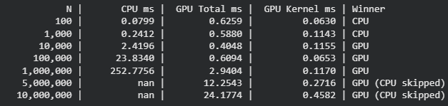
Q1. Empirical Crossover Point N*:
N* = 10,000. At N = 1,000 the CPU was still faster (0.2412 ms vs 0.5880 ms GPU Total). At N = 10,000 the GPU Total time (0.4048 ms) became lower than the CPU time (2.4196 ms), and the gap kept growing for larger N.
Q2. Why is GPU Total slower than CPU at N = 100?
At N = 100 the GPU Total time was 0.6259 ms, while the GPU Kernel Only time was just 0.0630 ms. About 89.9% of the elapsed time ((0.6259 − 0.0630) / 0.6259) was overhead rather than computation: allocating device memory, launching the kernel, and copying data host-to-device and device-to-host over the high-latency PCIe bus. The data is so small that this fixed cost dwarfs the actual computation, so the CPU (0.0799 ms) wins.

SECTION 3: Thread Geometry & Boundary Corruption

Task 3.1: Observed behavior / Console output from defective kernel
Launching defective kernel with 1024 threads on 1000-element array...
Execution finished (or did it crash?). Checking host copy...
Elements processed: 1000. Last element: 999.0
Only a NumbaPerformanceWarning (grid size 4, low occupancy) was shown. No Python IndexError and no CUDA_ERROR_ILLEGAL_ADDRESS appeared: threads 1000–1023 wrote outside the 1000-element array silently, because GPU memory is raw VRAM with no bounds checking. The corruption of adjacent memory went undetected, which is the danger of a missing 'if idx < n' guard.

Task 3.2: Mandatory calculation (N = 37, Block Size = 8)
Quantity | Value
Total Blocks Allocated | 5
Total Hardware Threads Launched | 40
Number of Active Working Threads | 37
Number of Idle Guarded Threads | 3
Block 4 boundary: global IDs 32–36 were ACTIVE; global IDs 37, 38, 39 (thread IDs 5, 6, 7) were IDLE (GUARDED).

SECTION 4: Race Condition (Parallel Reduction)
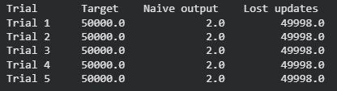
Atomic Sum Output: 50000.0 — equals exactly 50,000.0? YES
Naive Kernel Time: 0.0941 ms
Atomic Kernel Time: 0.2633 ms
Why do atomic operations incur a performance penalty?
Atomic operations force the hardware to serialize updates to the same memory address: each thread must wait for the previous read-modify-write on d_total[0] to complete, so thousands of threads queue up instead of running in parallel. The naive kernel is faster (0.0941 ms vs 0.2633 ms, about 2.8x) but wrong, because simultaneous read-modify-write sequences overwrite each other and almost all updates are lost (result 2.0 instead of 50,000.0).

SECTION 5: 2D Grid Processing (1024 × 1024)
Quantity | Value
Blocks in X | 64
Blocks in Y | 64
Total Blocks | 4096
Verified pixel value at center (512, 512) | 1.0000
Verified pixel value at outer corner (0, 0) | 0.0000

SECTION 6: Final Verification Token
TOKEN: F71E22F5C3F8FBF8

