Adaptive adjustable performance function based direct prescribed performance control for spacecraft flying around mission

**Kun Wang1, Tao Meng1, *and Jiakun Lei1**

1. School of Aeronautics and Astronautics, Zhejiang University, Hangzhou, 310027, China

* Corresponding author’s e-mail: [mengtao@zju.edu.cn](mailto:mengtao@zju.edu.cn)

**Abstract.** The control for spacecraft flying around mission is investigated in this paper based on the prescribed performance control (PPC). Considering the challenges in the traditional PPC framework, we design an adaptive adjustable performance function, which can self-adjust the performance requirement according to the saturation of the control input. Besides, a combined switching controller is designed and the controller behaves as a PPC in the convergence stage, and gradually switches to a nonlinear controller after entering a steady state, which can avoid the over-control problem caused by high-gain PPC after entering the steady state. Finally, the numerical simulations illustrate the effectiveness of the proposed control method.

Presenting author: Kun Wang; E-mail: [wang_kun@zju.edu.cn](mailto:wang_kun@zju.edu.cn), Affiliation: Zhejiang University; Country: People's Republic of China.

Preferred Mode of presentation: Poster.

1. Introduction

The problem of spacecraft proximity operation control has been investigated for a long time and has sufficient research results. Many nonlinear control methods have been used to achieve spacecraft proximity operation control robustly and precisely, such as sliding mode control, backstepping control, model predictive control and so on. Besides, as a method that can quantitatively characterize the transient and steady-state performance of the system, prescribed performance control (PPC) has been widely used in spacecraft relative orbit and attitude control, such as in [1] ~ [3].

However, there are some challenges in the PPC framework, which are desired further research [4]. The rationality of the prescribed performance function (PPF) is key problem in traditional PPC framework. The PPF is a user defined function that describes the performance of system, however, the actuator saturation is not considered during the design of PPF, which will lead to the performance violation because of the limited control ability. Besides, in origin PPC frame work, multiple PPFs should be designed one by one and the number of PPFs often depends on the dimensionality of the system. However, the design of multiple PPFs is not only a tedious task, but also often not intuitive for practical control systems. In practical systems, control performance is often described by absolute distance or angle. Thus, it is not necessary to design a PPF for each state.

In this paper, we proposed an adaptive adjustable performance function based direct prescribed performance controller and try to solve the problems mentioned above. The control error is summarized as the distance between the current state and the desired state and only two adaptive PPFs is designed to characterize the control accuracy for position and attitude control. The adaptive PPF is a self-adjust function according to the saturation of the control input. Besides, another robust nonlinear controller is designed and the switch of the nonlinear controller and distance based PPC is achieved by using a smooth step function. Stability analysis shows the feasibility of switching between the two controllers. Finally, numerical simulation illustrates the effectiveness of the proposed controller.

1. Preliminaries and Problem Statement

In this section, we give spacecraft relative position dynamics and attitude dynamics first, then the problem investigated in this paper is formulated. The coordinate system used in this paper is given as follows: the Earth-centred inertial (ECI) frame , the body frame of the chaser spacecraft  and the vehicle-velocity-local-horizontal (VVLH) frame. The origin of frame  locates at the centre of the target spacecraft. The following notations are used in this paper: to represent the norm of a vector, ,  is the skew symmetric matrix form of vector,  denotes the  zero matrix, denotes the  identity matrix, denotes the minimum eigenvalue of a matrix.

**Lemma 1** For any  and, the following formula will be satisfied:



* 1. Relative Position Dynamics

The relative position dynamics between the chaser spacecraft and the target spacecraft can be written as:



where  and  denote the relative position and velocity vector between the chaser and the target, is the orbit control force expressed in frame,  is the mass of the chaser spacecraft, denotes the external disturbance force and unmodeled dynamics. Besides, the detailed expressions of matrices  and  can be found in [5]. We denote  as the desired flying around trajectory, which is second order continuous differentiable, i.e., exist. Then the position error can be expressed as.

* 1. Attitude Dynamics

We suppose that the relative navigation devices are installed on the  side of the chaser spacecraft, i.e. the current point direction vector of the navigation device expressed in frame  is. The unit direction vector of the target spacecraft expressed in frame  is denoted as, then the attitude error quaternion  can be expressed as [6]:



then the attitude error kinematics can be written as [5]



and the attitude dynamics can be written as



where  denotes the angular velocity of the chaser, is the inertia matrix of the chaser, denotes the control torque and  denotes the external disturbance torque and unmodeled dynamics. Let  denote the desired angular velocity and then , where the corresponding rotation matrix  can be given as .

* 1. Spacecraft 6-DOF dynamics model

We define the transformed errors as  and. The transformed error vector can be defined as , then the dynamics of  can be written as



where, , . We define ,  and , where  is the virtual control to be designed. Then the spacecraft 6-DOF dynamics model can be written as



where, ,  and .

* 1. Problem Formulation

**Assumption 1**: The uncertainty term  is a bounded term, i.e..

The control objective of this paper is to design a controller that can guarantee the position and attitude control error to satisfy  and  under input saturation, where  and  are continuous functions.

1. Main Results
   1. Adaptive Adjustable Performance Function Design

The control force and torque generated by controllers are denoted as  and , and,  are the practically applied force and torque, where  is the saturation function. The adaptive adjustable performance functions are designed as



where,  are the initial values related to the initial position and attitude control error and satisfy, , ,  are the tuneable constants and,  represent the steady performance requirements. Besides, and  are the modification signals to origin performance function and generated by the following system:





where, , , , ,  and,  are tuneable positive constants.

* 1. Direct Prescribed Performance Controller Design

The definition of the transformed errors means that  and  when the performance constraints are satisfied.

Then the controller can be designed as



The virtual control is designed as



and the PPC term and nonlinear controller term are designed as



where,. The diagonal matrix  is defined as



where  and  are two variables that related to the position and attitude control performance and can be defined as



where, ,  are user defined parameters. From Eq., we can indicate that the variables  and the control input will be switched between the PPC controller and the nonlinear controller.

Then we can give the following theorem:

**Theorem 1**: Considering the spacecraft 6-DOF dynamics model Eq., the controller is designed as Eq. and the performance functions are designed as Eq., then the transformed error will be maintained in the interval  and the control objective can be achieved.

***Proof*:**

The candidate Lyapunov function can be designed as



Taking the time derivative of  yields



Considering the following inequality



and substituting Eq. into Eq. yields



Then define the following Lyapunov function



Taking the time derivative of  and substituting Eq. yields



Then substituting Eq. into Eq. yields



Here we discuss the following two cases:

1) case 1: when  and, , then Eq. can be deduced as



selecting proper  to make sure that  and, then we can have



where,.

2) case 2: when  and, then Eq. can be deduced as



Considering that function  is a positive monotonically increasing function, then we have  and. Selecting proper  and  to make sure that  and , considering that, we have



Let, then we have



where,.

The results of other cases are same as the above two cases. Then it can be deduced that the following inequality always holds in different cases



where  and. Then it can be concluded that the transformed error will be maintained in the desired interval and the control objective can be achieved.

1. Numerical Simulations

In this section, we conduct the numerical simulations to illustrate the effectiveness of the proposed control method. The simulations are conducted as nominal part and practical part and the control frequency is set as 1s.

* 1. Simulation Settings

The mass of the chaser spacecraft is 20kg, and the initial orbit elements of the target spacecraft are listed in Table 1, the inertia of the chaser is .

**Table 1**. Initial Orbit Elements of the Target Spacecraft

|  |  |  |
| --- | --- | --- |
| Parameters | Value | Unit |
| Semimajor axis | 42139 | km |
| Eccentricity | 0.002 | - |
| Inclination | 5.3707 | deg |
| RAAN | 51.2091 | deg |
| Argument of perigee | 236.3791 | deg |
| Mean anomaly | 59.4097 | deg |

The desired trajectory is generated as the trajectory in [5], where the radius of trajectory is set as 60m, the inclination of the trajectory is set as 45deg and the period of flying around is set as 3600s. The initial position of the chaser is set as m, the initial velocity is set as m/s, the initial attitude is set as , and the initial angular velocity is set as°/s.

Besides, the control parameters are selected as: , , , , , , , , , , , , , , , , . The maximum control force is set as 0.1N and the maximum control torque is set as 0.01Nm.

* 1. Nominal Simulation

Here we give the results of nominal simulation, from **Figure 1**~ **Figure 4**.

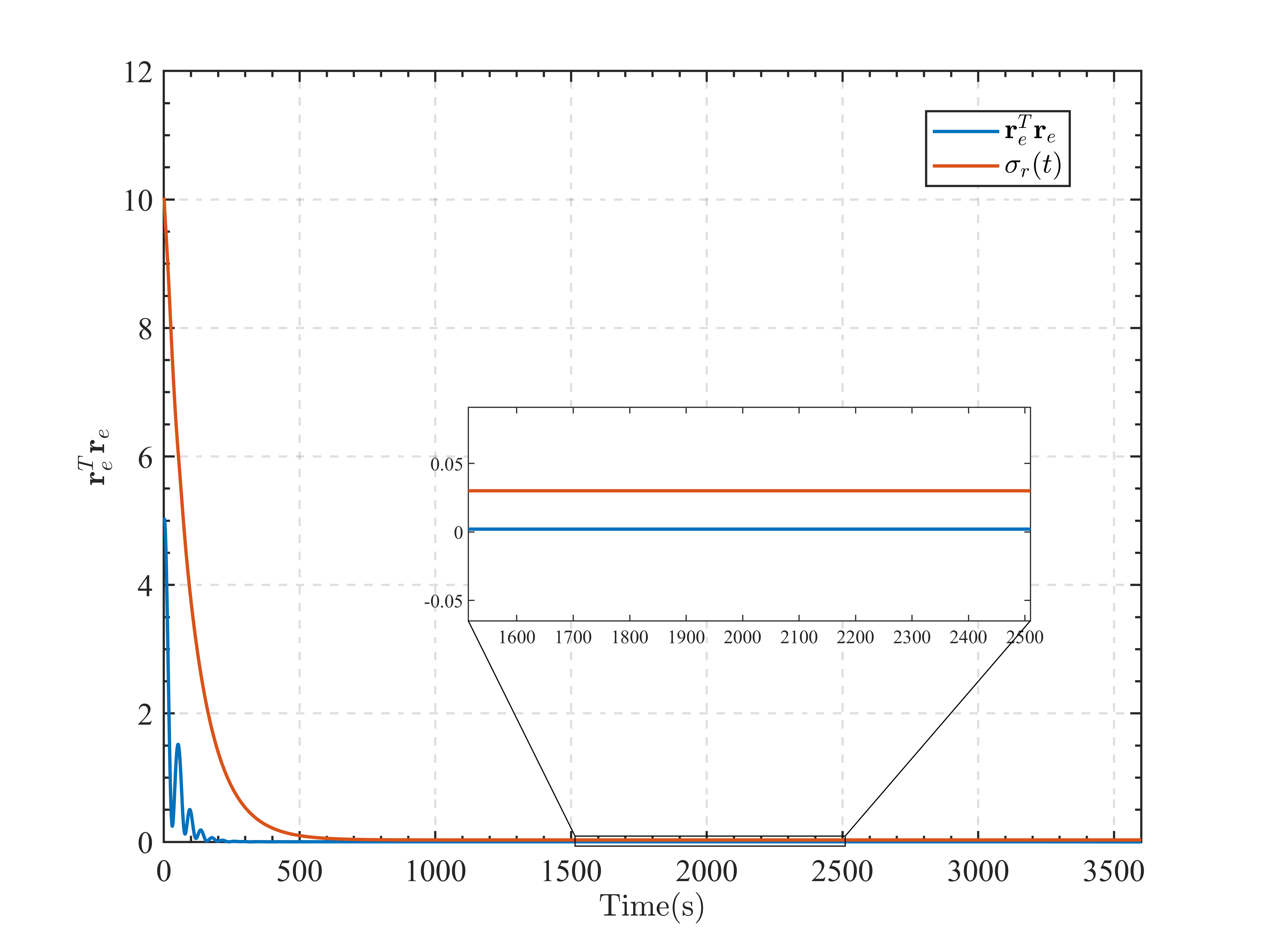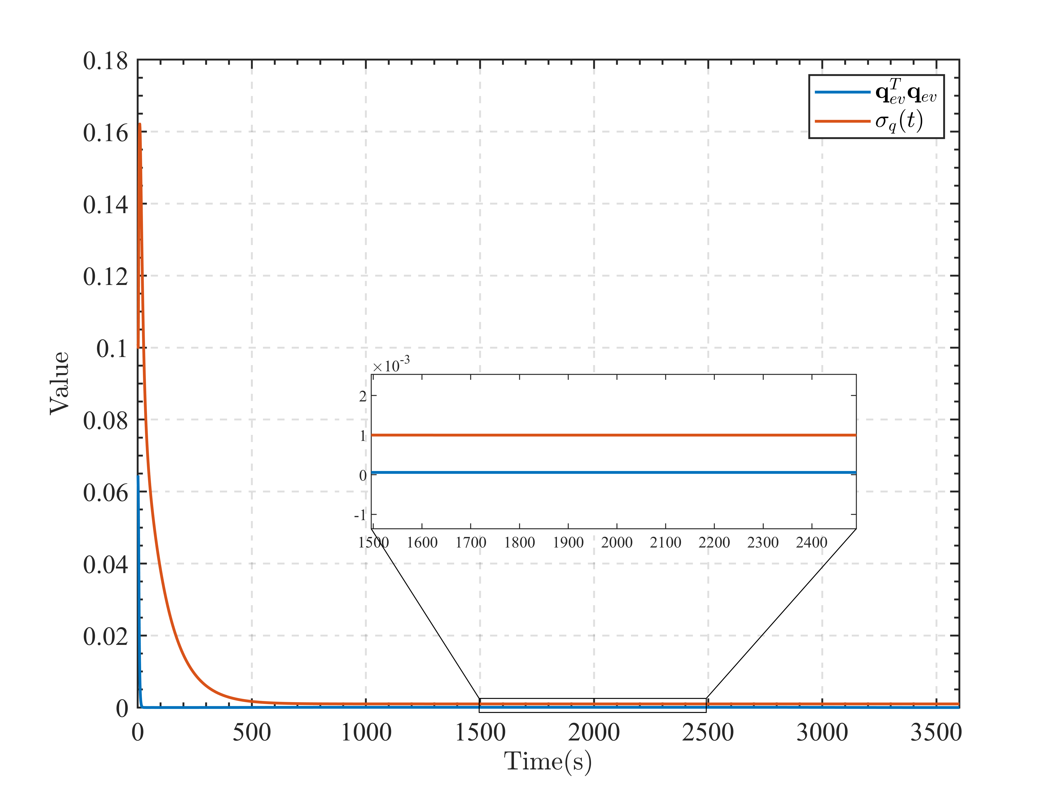

**Figure 1**. Time Response of Position and Attitude Control Error

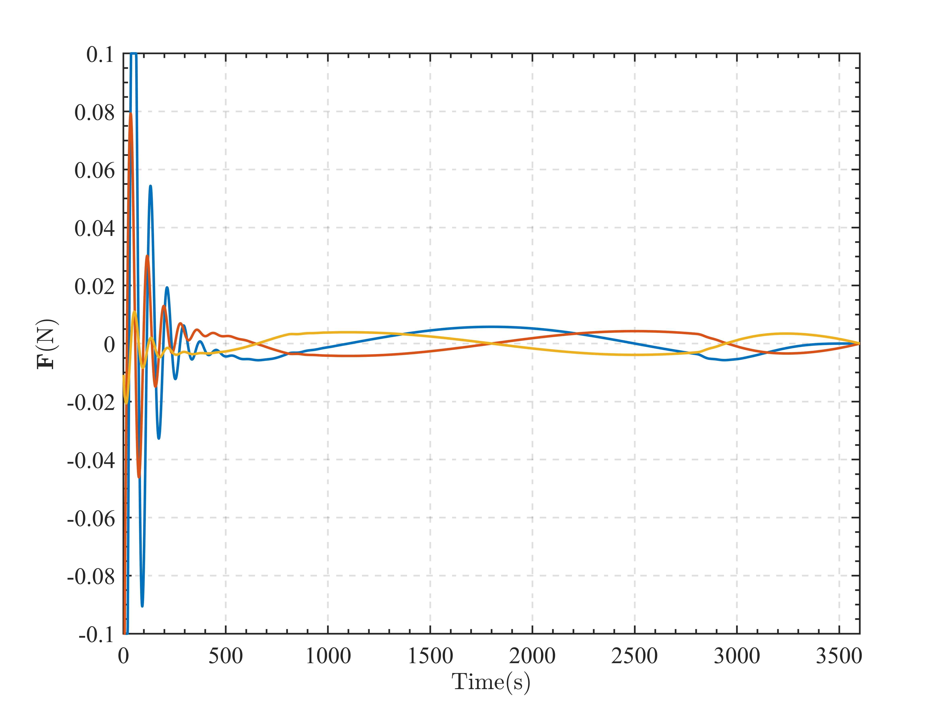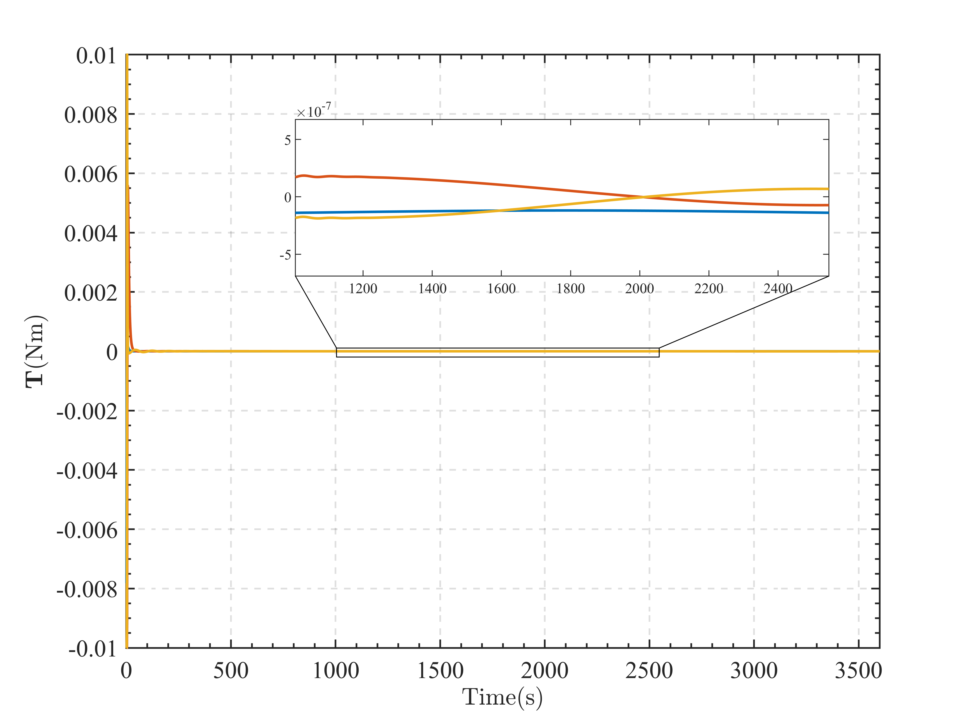

**Figure 2**. Time Response of Control Force and Torque

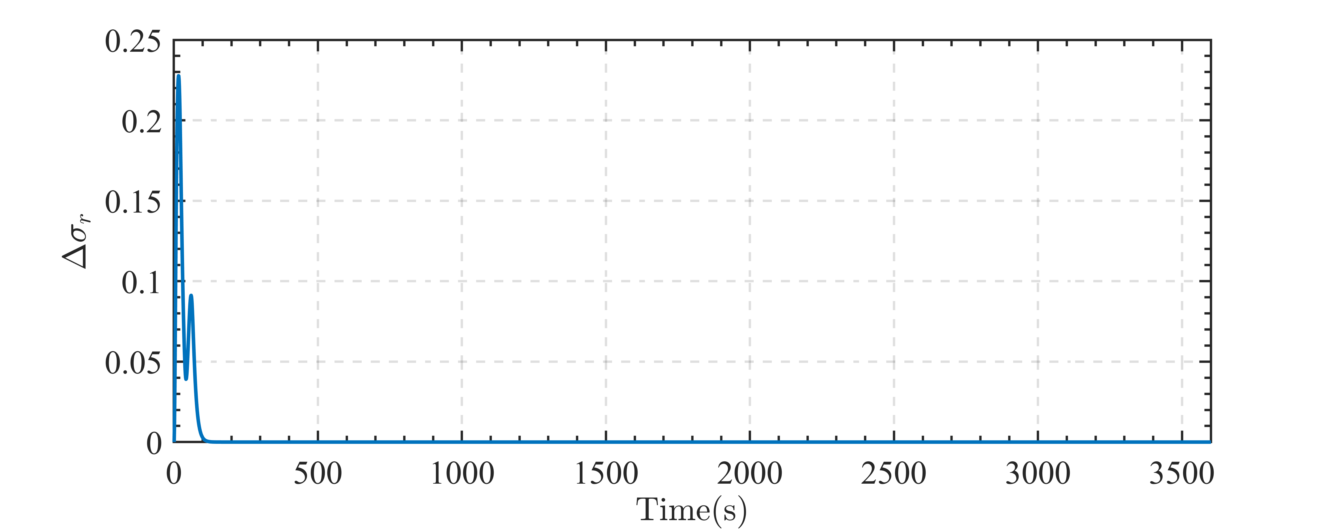

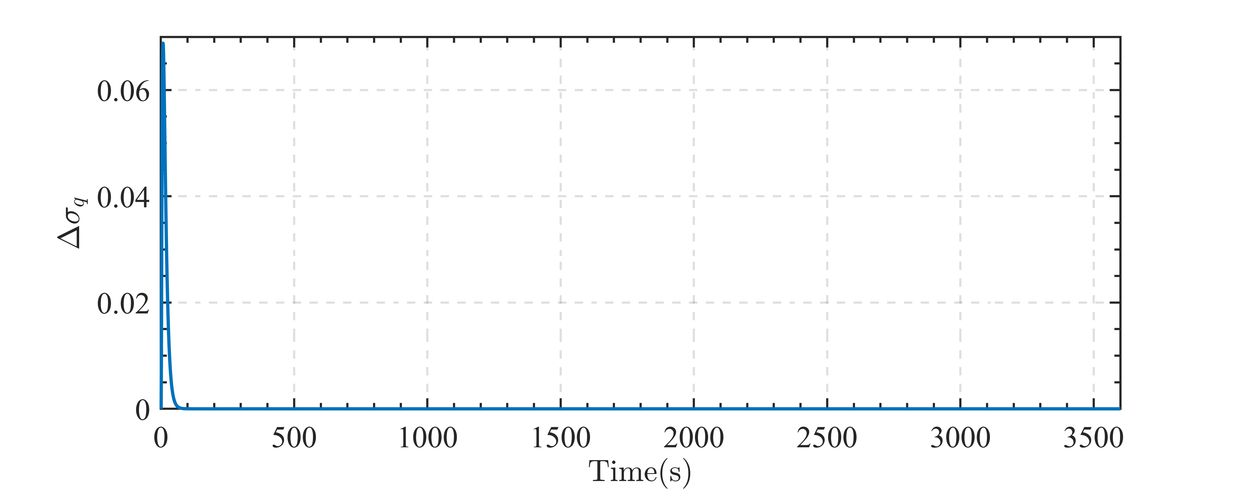

**Figure 3**. Time Response of the Modification Signal of Performance Function

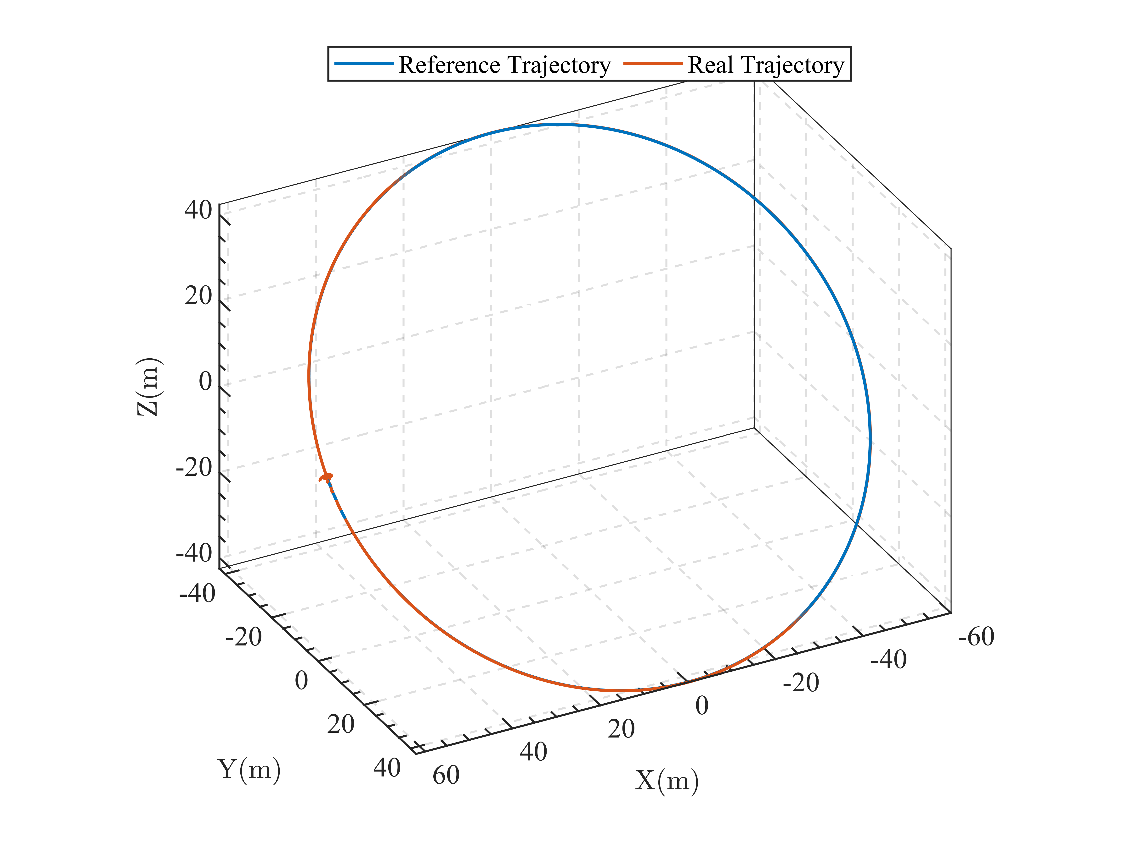

**Figure 4**. 3D Trajectory of the Flying Around Mission

**Figure 1** shows the control error curves and we can conclude that the control objective is totally achieved. It can be observed that the control force and torque are saturated and the performance functions are modified at the same time from **Figure 2** and **Figure 3**. Thus, the designed adaptive performance functions are effective.

* 1. Practical Simulation

In practical simulation, the external disturbances are added to the chaser and set as





The simulation results are shown from Figure 5 ~ Figure 6.

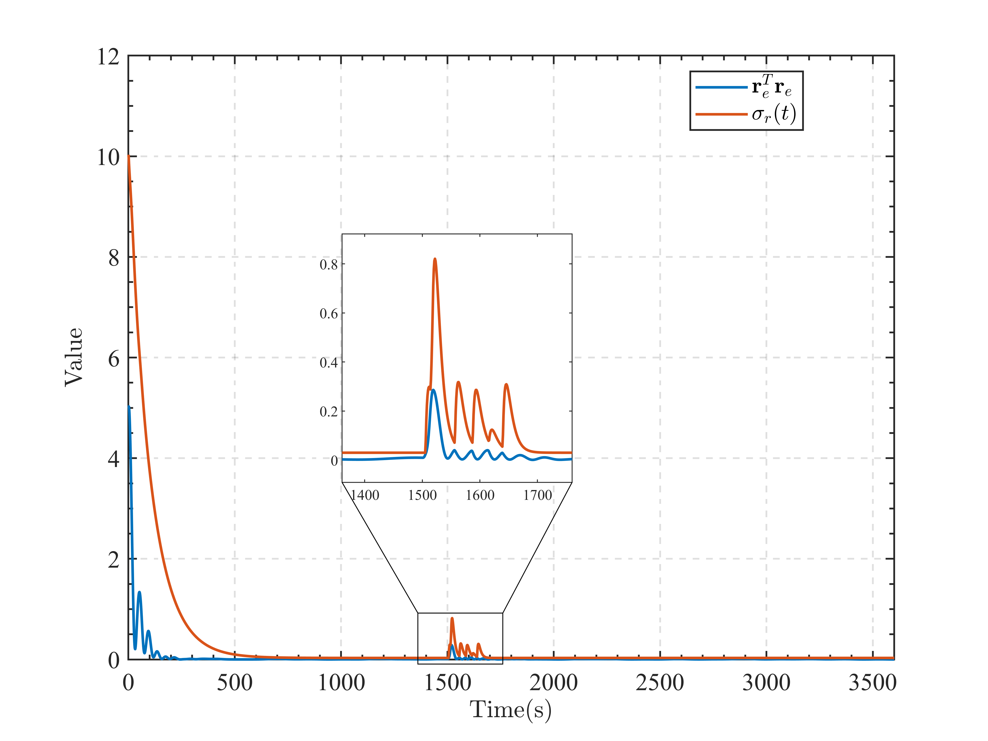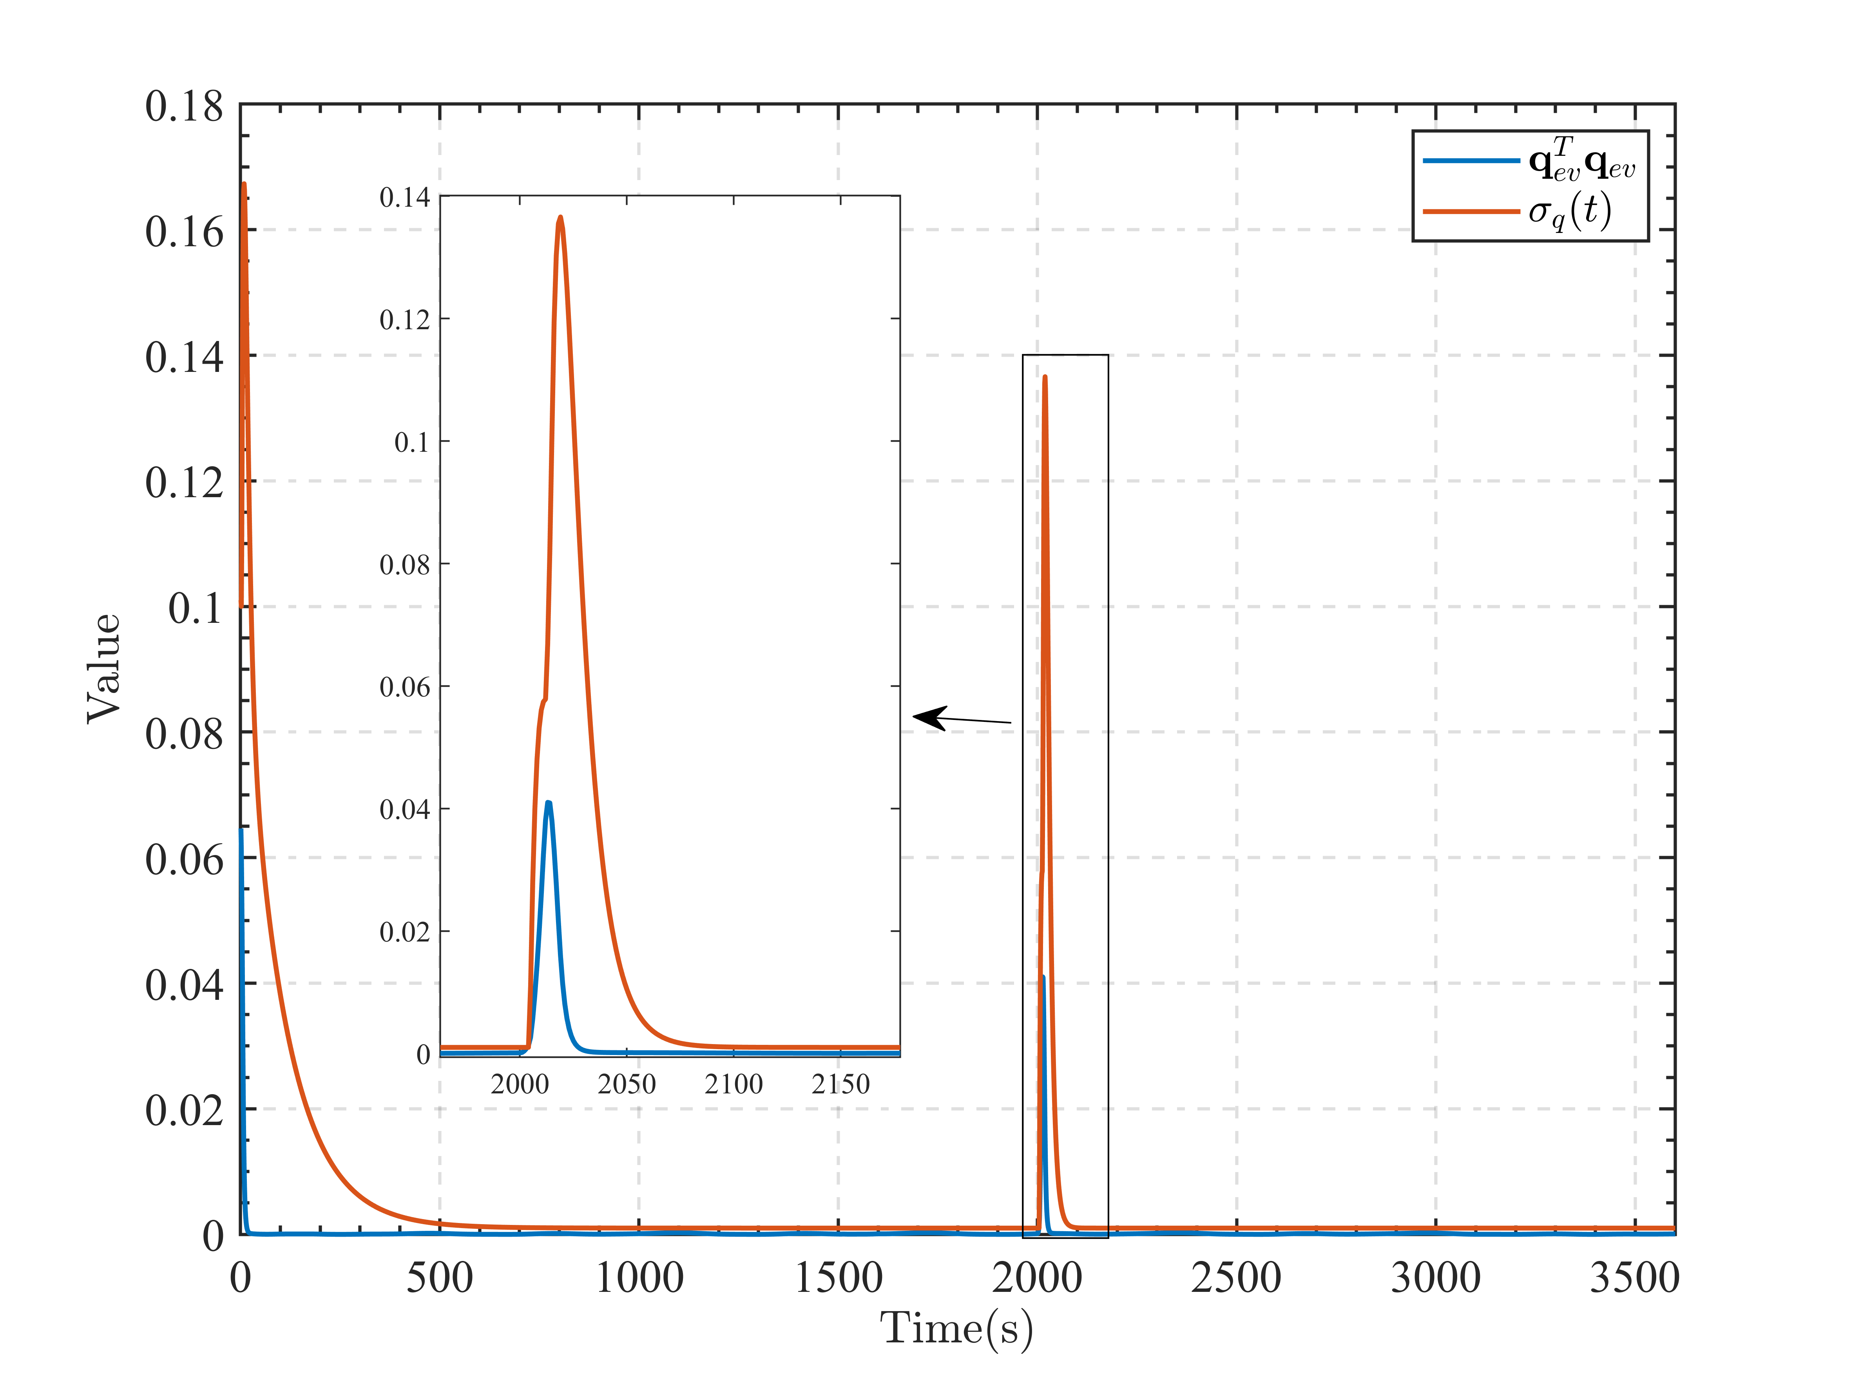

**Figure 5.** Time Response of Position and Attitude Control Error under External Disturbance

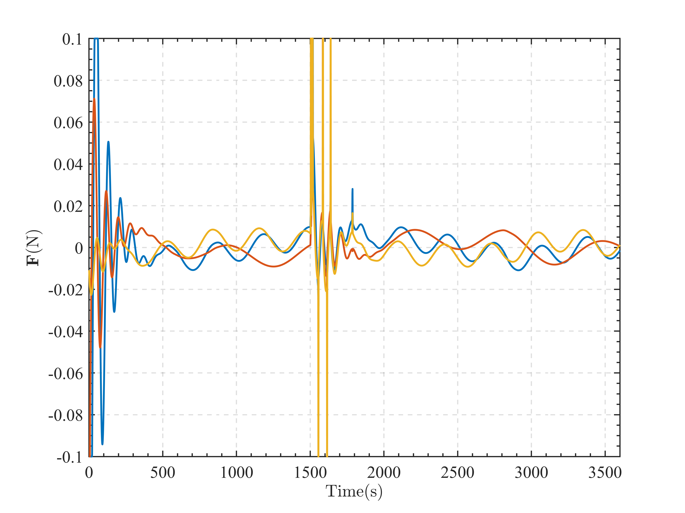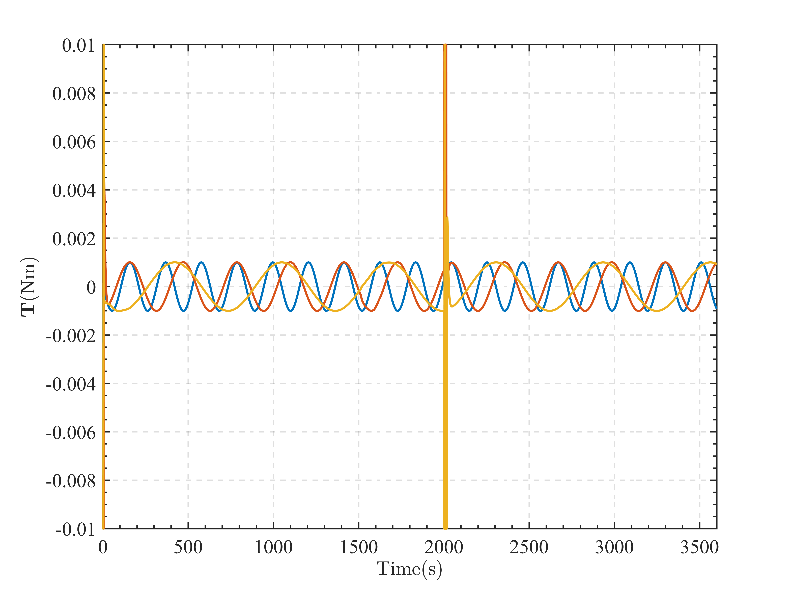

**Figure 6**. Time Response of Control Force and Torque under External Disturbance

In the practical simulation, we add some large external disturbance force and torque, which are equal to the maximum control output. From **Figure 5**, it can be observed that the performance function will adjust the performance requirements and then converge to the required performance when the saturation is eliminated. From **Figure 6**, we can observe that the controller can switch to the PPC mode when the large disturbances are added and then switch to the nonlinear control mode when the disturbances being small. These phenomena illustrate the effectiveness of the proposed method.

1. Conclusions

In this paper, the spacecraft flying around control is investigated. An adaptive adjustable performance function based direct prescribed performance controller is proposed, which can deal with the control input saturation and don’t need complicated performance function. The nominal simulation illustrates the effectiveness of the proposed controller and the practical simulation illustrates the effectiveness of the adaptive adjustable performance functions.

Reference

[1] Li, Q., Gao, D., Sun, C., Song, S., Niu, Z. and Yang, Y. 2023 Prescribed performance-based robust inverse optimal control for spacecraft proximity operations with safety concern. Aerosp. Sci. Technol. **136** 108229.

[2] Wu, X., Luo, S., Yang, S. and Wei, C. 2022 Adaptive appointed-time formation tracking control for multiple spacecraft with collision avoidance under a dynamic event-triggered mechanism. Adv. Space Res. **70(11)** 3552-3567.

[3] Zhang, Y. C., Wu, G. Q., Yuan, J., Yang, X. Y. and Song, S. M. 2023 Composite neural learning based appointed-time safe approach control under full-state constraints. Adv. Space Res (Preprint).

[4] Bu, X. 2023 Prescribed performance control approaches, applications and challenges: A comprehensive survey. Asian J. Control **25(1)** 241-261.

[5] Wang, K., Meng, T., Wang, W., Song, R. and Jin, Z. 2022 Finite-time extended state observer based prescribed performance fault tolerance control for spacecraft proximity operations. Adv. Space Res. **70(5)** 1270-1284.

[6] Roberts, A. and Tayebi, A. 2010 Adaptive position tracking of VTOL UAVs. IEEE Trans. Rob. **27(1)** 129-142.

Authors’ background

|  |  |  |  |
| --- | --- | --- | --- |
| Your Name | Title* | Research Field | Personal website |
| Kun Wang | Ph.D. Candidate | Spacecraft attitude and orbit control | https://scholar.google.com/citations?user=DEd9ppYAAAAJ&hl=zh-CN |
| Tao Meng | Full Professor | Spacecraft attitude and orbit control；Spacecraft formation control | https://person.zju.edu.cn/meng |
| Jiakun Lei | Ph.D. Candidate | Spacecraft attitude control |  |