BẾP NHỚ
SOFTWARE DESIGN DESCRIPTION (SDD)
Bếp Nhớ – Full Product Architecture & Detailed Design
Target design: production-ready architecture cho toàn bộ capability được định nghĩa trong BN-SRS v2.0
Document code | BN-SDD
Version | 2.0
Status | Full Product Baseline
Date | 06/10/2026
Product positioning: “Trợ lý nấu món Việt có trí nhớ khẩu vị – càng dùng càng hiểu bạn và gia đình.”

Kiểm soát tài liệu
Thuộc tính | Giá trị
Mã tài liệu | BN-SDD
Phiên bản | 2.0
Trạng thái | Full Product Baseline / Design Baseline
Chủ sở hữu | Product Owner / Engineering
Mục đích | Baseline chính thức cho phát triển, kiểm thử, vận hành và mở rộng sản phẩm.
Phạm vi | Sản phẩm hoàn chỉnh; không giới hạn ở MVP.

Lịch sử thay đổi
Version | Ngày | Thay đổi
1.0 | 06/10/2026 | Bản đầu tiên, tập trung định nghĩa MVP và lõi Taste DNA.
2.0 | 06/10/2026 | Mở rộng thành đặc tả full product: social, creator, pantry, meal planning, monetization, moderation, analytics, AI, native/mobile, production scale.

Mục lục tài liệu
- 1. Design goals & principles
- 2. Architecture overview
- 3. Technology & repository strategy
- 4. Client architecture
- 5. Backend domain design
- 6. Data model
- 7. Taste Engine
- 8. Recipe/versioning/cook engine
- 9. Household & Family Taste
- 10. Meal planner/pantry/shopping
- 11. Search/recommendation
- 12. Social/Taste Match/creator
- 13. AI Gateway & safety
- 14. API/event design
- 15. Media/notification/billing
- 16. Admin/moderation/support
- 17. Security/privacy
- 18. Scalability/reliability
- 19. Observability/analytics
- 20. CI/CD & environments
- 21. Testing
- 22. Backup/DR
- 23. Capacity/cost
- 24. Evolution strategy
- Appendices

1. Mục tiêu và nguyên tắc thiết kế
Nguyên tắc | Quyết định thiết kế
Domain-first | Recipe/Taste/Cook/Household là domain truth; AI không sở hữu dữ liệu lõi.
Progressive architecture | Khởi đầu modular monolith có boundary rõ; tách service khi scale/ownership yêu cầu.
Offline-aware | Cook Mode và timer không phụ thuộc mạng liên tục.
Event-driven where useful | Notification, analytics, search indexing, media, recompute chạy async.
Safety by construction | Allergy/restriction/range rule nằm ở deterministic layer trước AI.
Auditability | Recipe version, taste update, payment, moderation và admin action có lineage/audit.
Privacy default | Private cook history/note; social publish explicit; consent/versioned.
Cost-aware AI | Model routing, cache, quotas, async và fallback để kiểm soát unit economics.

2. Kiến trúc tổng thể
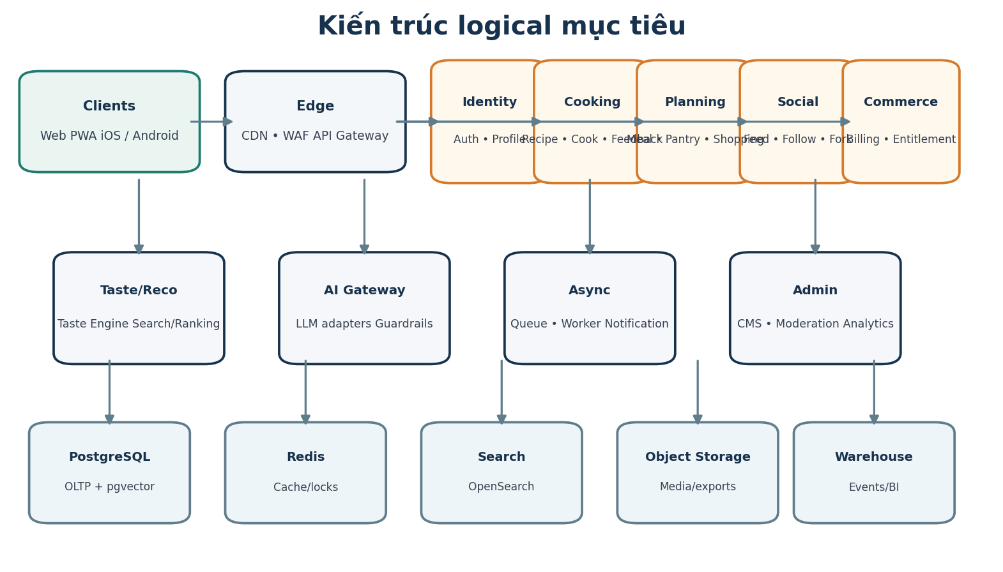
Hình 1 – Logical architecture mục tiêu

2.1 Architectural style
Khuyến nghị triển khai ban đầu theo modular monolith cho transactional domain chính, kết hợp worker/queue, search, object storage và AI gateway tách biệt. Boundary được thiết kế theo bounded context để có thể tách thành service độc lập mà không thay contract domain.
Bounded context | Ownership | Tách service khi
Identity/Profile | Account, device, consent, profile | Auth scale/security team riêng.
Recipe/Cooking | Recipe, version, cook session, feedback | Write/read load lớn hoặc content team riêng.
Taste/Recommendation | Taste vector, adjustment, ranking | ML iteration cadence/compute riêng.
Household/Planning | Household, meal plan, pantry, shopping | Complex shared state/optimizer cần scale riêng.
Social/Creator | Feed, follow, post, fork, creator | Social traffic/moderation tăng.
Commerce | Subscription, entitlement, ledger | Billing compliance/availability cần isolate.
Admin/Moderation | CMS, review, abuse case | RBAC/audit/security boundary riêng.

3. Technology stack và repository strategy
Layer | Khuyến nghị | Lý do
Web | Next.js + TypeScript + React Query | SEO/SSR cho recipe; PWA; shareable URL.
Mobile | React Native + Expo (eject/prebuild khi cần native) | Reuse TS/domain client, push/deep link, store billing.
Backend | NestJS/TypeScript hoặc Fastify-based modular service | Typed contract, module boundary, OpenAPI.
Database | PostgreSQL + pgvector | Transactional truth + vector similarity ban đầu.
Cache/lock | Redis | Session/rate limit/cache/idempotency/distributed lock.
Search | OpenSearch/Elasticsearch | Full-text, faceting, typo/ingredient filters.
Queue | SQS/RabbitMQ/Kafka tùy quy mô | Async event/worker; bắt đầu managed queue đơn giản.
Storage | S3-compatible + CDN | Image/video/export/backup artifacts.
Analytics | Event collector → warehouse (BigQuery/Snowflake/ClickHouse) | Product analytics/BI/experiments.
AI | Vendor-neutral AI Gateway | Model routing, prompt registry, guardrails, budget.
Infra | Container + managed DB/cache/search; IaC Terraform | Scale, reproducibility, DR.
Monorepo | pnpm/Nx/Turborepo | Shared schema/types/sdk giữa web/mobile/backend.

3.1 Repository layout
Path | Nội dung
apps/web | Next.js web/PWA
apps/mobile | React Native app
apps/api | HTTP API/BFF
apps/worker | Async jobs/consumers
packages/domain | Entities/value objects/business rules
packages/contracts | OpenAPI/Zod/protobuf/event schemas
packages/ui | Design system shared tokens/components
packages/ai | Prompt registry/provider adapters/guardrails
packages/observability | Logging/tracing/metrics helpers
infra/ | Terraform/Helm/deployment config

4. Client architecture

4.1 Web/PWA route map
Route | Chức năng
/ | Personalized home / discovery
/recipes/[slug] | Recipe detail + personalized diff
/cook/[sessionId] | Cook Mode
/plan | Day/week/month planner
/pantry | Inventory/expiry/leftover
/shopping | Shared shopping list
/taste | Taste DNA/history/control
/household | Members/preferences/shared settings
/social | Feed/Taste Match/discovery
/creator/[id] | Creator profile/collection
/studio | Creator Studio
/premium | Plan/paywall/subscription
/settings/privacy | Consent/export/delete
/admin/* | Separate privileged admin surface

4.2 State management
- Server state: React Query/TanStack Query với normalized query keys, stale policy theo domain.
- Local durable state: offline cook session/timer/cache qua SQLite/IndexedDB tùy platform.
- Sensitive auth token dùng secure storage/keychain trên mobile; web ưu tiên secure httpOnly cookie.
- Optimistic update chỉ cho low-risk action (reaction/list check); payment/pantry critical mutation xác nhận server.
- Realtime household list có thể dùng WebSocket/SSE; fallback polling nếu connection degraded.

4.3 Offline design
Artifact | Offline behavior | Conflict handling
Saved recipe | Cache read-only snapshot | Refresh khi online; version mismatch hiển thị banner.
Cook session | Local event log + timers | Upload ordered events; server idempotency.
Feedback | Queue local | Last-write with revision; server preserves audit.
Shopping list | Optional offline edits | Operation-based merge + item version.
Pantry | Read cache; write hạn chế | Reconcile server; explicit conflict UI khi quantity diverges.

5. Backend domain design
Module | Responsibility | Key domain events
Identity | Auth, devices, profile, consent | UserRegistered, ConsentChanged, AccountDeletionRequested
Recipe | Recipe, ingredient, version, provenance | RecipePublished, RecipeVersionCreated, RecipeDeprecated
Cooking | Cook session, timers, actuals, feedback | CookStarted, CookCompleted, FeedbackSubmitted
Taste | Taste state, adjustment, match | TasteSignalRecorded, TasteProfileUpdated
Household | Membership, role, meal participants | HouseholdMemberAdded, HouseholdChanged
Planning | Meal plan, pantry, leftover, shopping | MealPlanGenerated, PantryAdjusted, ShoppingListUpdated
Search/Reco | Indexing, candidate/rank/explain | RecommendationGenerated, SearchPerformed
Social | Post, comment, follow, reaction, fork graph | PostPublished, UserFollowed, RecipeForked
Commerce | Subscription, transaction, entitlement | PaymentReceived, EntitlementChanged
Notification | Preference, template, delivery | NotificationRequested, NotificationDelivered
Moderation | Report, case, decision, appeal | ContentReported, ModerationDecisionMade

6. Mô hình dữ liệu
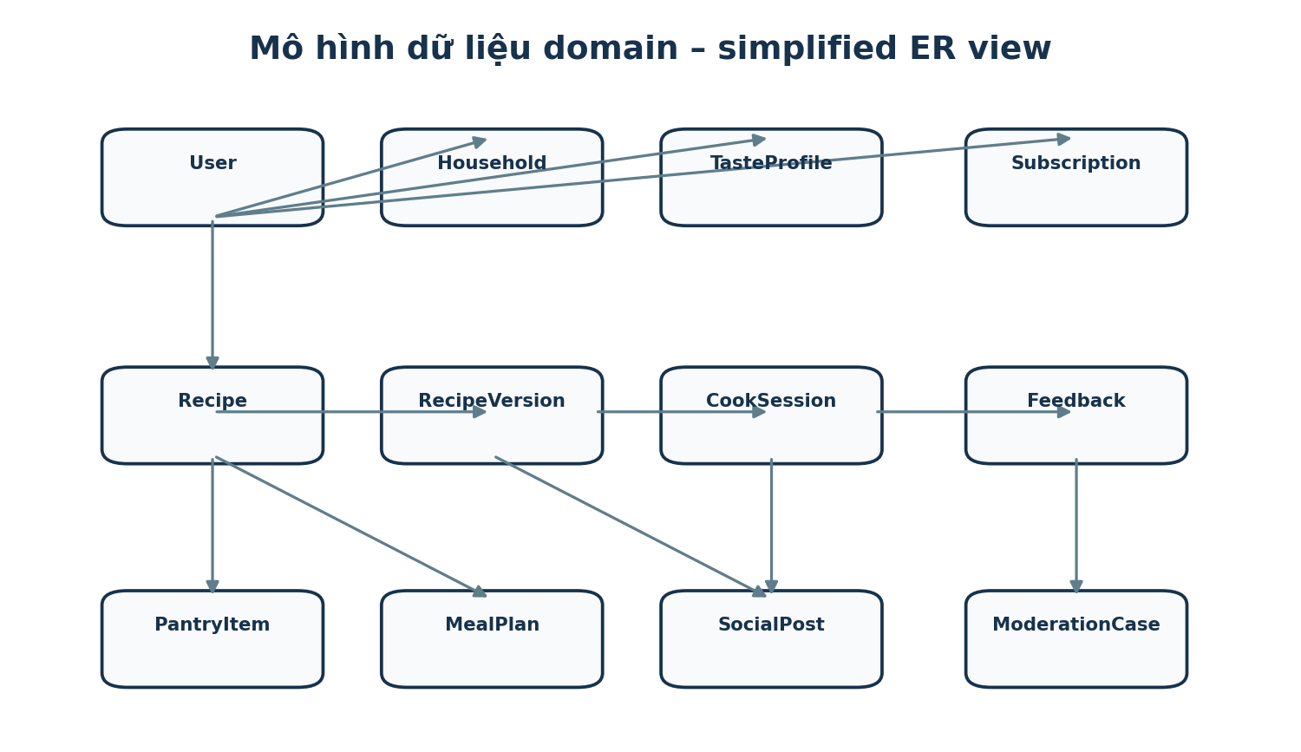
Hình 2 – Simplified ER view; schema thực tế được chuẩn hóa thêm theo module

6.1 Core entity schema
Entity | Key fields | Notes
users | id, status, locale, timezone, created_at | Identity root; PII tách bảng/profile khi cần.
user_profiles | user_id, skill, region, equipment, diet, allergies | Profile preferences.
consents | user_id, purpose, version, state, timestamp | Append/audit.
taste_profiles | owner_type/id, dimension_json, confidence_json, version | User hoặc household aggregate.
taste_signals | owner, dimension, value, source, context, weight | Event-like; supports re-compute.
ingredients | id, canonical_name, aliases, category, unit_rules, allergen_tags | Canonical ingredient graph.
recipes | id, slug, status, cuisine_region, provenance | Recipe identity.
recipe_versions | id, recipe_id, parent_id, author, structured_payload, checksum | Immutable after publish.
recipe_ingredients | version_id, ingredient_id, qty, unit, scaling_rule, prep | Structured quantities.
recipe_steps | version_id, order, duration, heat, text, dependencies | Step/timer aware.
cook_sessions | id, user/household, recipe_version, participants, actual_serving, state | Offline sync capable.
cook_actuals | session_id, ingredient/step, planned, actual, substitution | Learning context.
feedback | session_id, dimension ratings, overall, note, revision | Revisioned.
households | id, owner, name, settings | Shared boundary.
household_members | household_id, user/profile, role, active | Can include guest profile.
meal_plans | id, household/user, range, constraints, version | Plan root.
meal_items | plan_id, date, slot, recipe_version, participants, lock_state | Supports regenerate subset.
pantry_items | owner, ingredient, qty, unit, expiry, location, version | Optimistic locking.
leftovers | owner, source_cook, qty, storage, use_by | Separate from raw pantry.
shopping_lists/items | owner, source_plan, ingredient, qty, checked, assignee | Shared sync.
social_posts | author, visibility, media, recipe_ref, text, status | UGC.
follows/reactions/comments | actor, target, state | Social graph.
recipe_forks | source_version, target_recipe/version, author, attribution | Lineage edge.
subscriptions | user/household, provider, plan, status, period | Provider-neutral.
transactions | provider_event_id, amount, currency, state | Idempotent ledger.
entitlements | subject, feature, quota, valid_from/to | Server gate.
moderation_cases | reporter, target, reason, evidence, state, decision | Audit/appeal.
notifications | recipient, type, payload_ref, channel, status | Delivery lifecycle.

6.2 Data invariants
- Published recipe_version immutable; correction creates new version.
- Taste signal append-only; taste_profile is materialized state derived from signals + manual overrides.
- Payment provider event_id unique.
- Pantry row uses version/updated_at for optimistic concurrency.
- Social visibility enforced at query layer and authorization layer.
- Deletion uses tombstone/anonymization workflow where hard delete would break ledger/moderation integrity.

7. Taste Engine
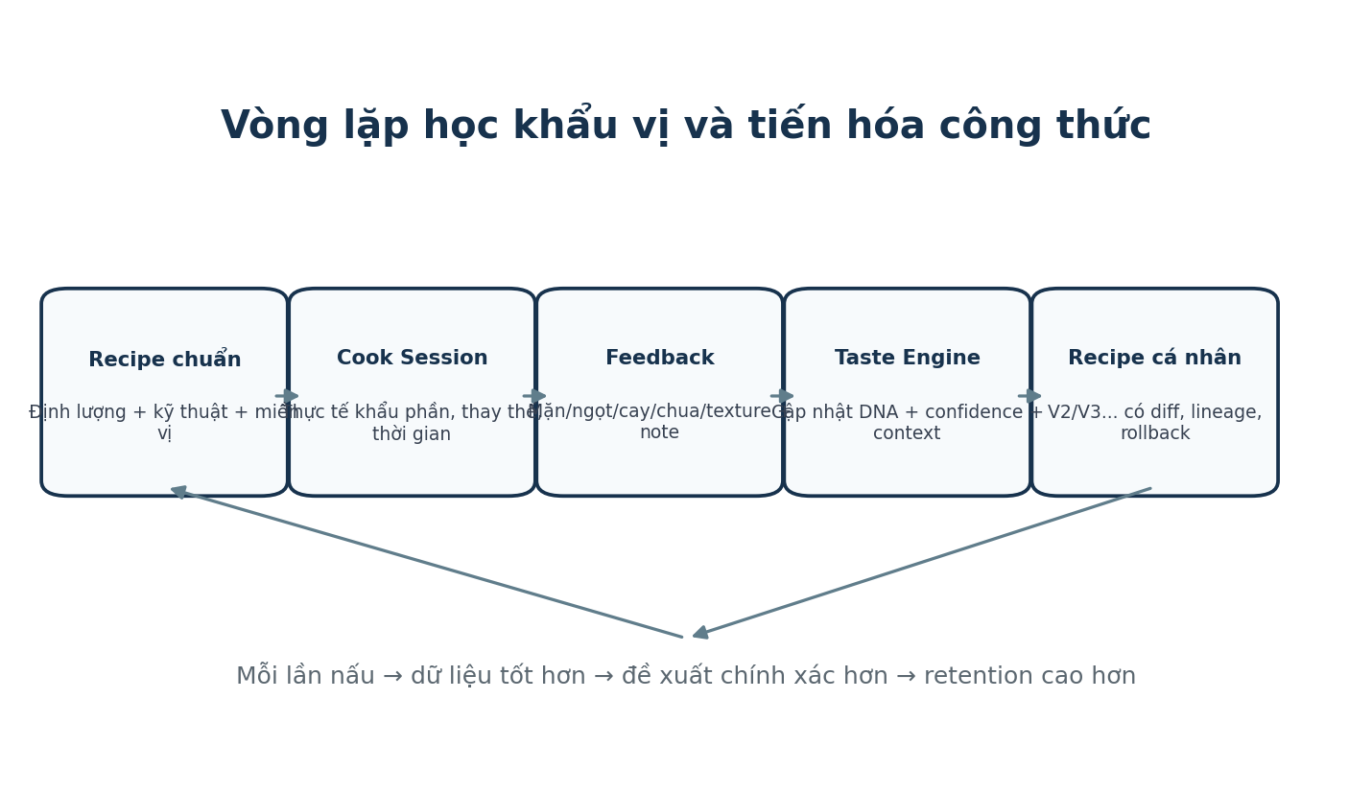
Hình 3 – Taste learning loop

7.1 Taste representation
Taste profile là vector theo dimension kèm confidence c∈[0,1], sample count n, recency và context. Giá trị chuẩn hóa về [-1,+1] hoặc thang nội bộ tương đương. Context có thể gồm dish_category, cooking_method, ingredient_group, meal_slot và household member set.
Signal | Weight gợi ý | Ví dụ
Explicit onboarding | 0.4 | “Tôi ăn cay nhiều”
Post-cook dimension feedback | 1.0 | “Món này hơi mặn”
Manual recipe adjustment accepted | 0.8 | Giảm nước mắm 15%
Repeated behavior | 0.3–0.6 | Luôn chọn recipe ít ngọt
Dislike/not interested | 0.2–0.5 | Không thích nhóm món quá béo
Household compromise | Không update trực tiếp cá nhân | Tránh học sai do nấu cho người khác

7.2 Update algorithm
Baseline deterministic update có thể dùng exponentially weighted evidence thay vì ML phức tạp sớm. Với dimension d: new_mean = clamp(old_mean + α * source_weight * confidence_factor * signed_feedback). α giảm khi sample count/confidence tăng. Context-specific profile được cập nhật song song nếu đủ sample.
- Confidence tăng theo số signal độc lập và consistency; giảm khi feedback mâu thuẫn hoặc manual reset.
- Outlier/rescue incident không cập nhật trực tiếp taste nếu nguyên nhân là thao tác sai.
- Recency decay nhẹ cho preference có thể thay đổi; allergy/restriction không decay.
- Model/algorithm version lưu cùng taste_profile để hỗ trợ re-compute/migration.

7.3 Recipe adjustment engine
Stage | Logic
1. Normalize | Scale serving, unit conversion, canonical ingredients.
2. Hard constraints | Allergy/diet/equipment/range/safety.
3. Taste delta | Map taste dimension → ingredient/technique coefficients theo recipe category.
4. Context cap | Giới hạn % thay đổi theo ingredient; không linear mù quáng.
5. Technique compensation | Ví dụ giảm nước mắm có thể cần điều chỉnh liquid/umami khác.
6. Explain | Sinh diff + lý do deterministic; AI chỉ diễn đạt.
7. Accept/Reject | User chọn áp dụng; quyết định trở thành signal.

8. Recipe, versioning và Cook Engine

8.1 Recipe state machine
DRAFT → IN_REVIEW → VERIFIED/PUBLISHED → DEPRECATED. Community recipe có thể PUBLISHED_UNVERIFIED và được gắn nhãn rõ. Verified state chỉ do workflow content review.

8.2 Version/fork lineage
- recipe = identity; recipe_version = immutable content snapshot.
- Personal version có owner=user và visibility private mặc định.
- Fork tạo recipe identity/branch mới hoặc personal branch, giữ source_version_id.
- Compare dựa structured payload diff: ingredient quantity, substitution, step duration/heat, note.
- “My Best Version” là pointer, không mutate historical version.

8.3 Cook session event model
Event | Payload chính | Purpose
CookStarted | recipe_version, servings, participants | Snapshot input.
StepStarted/Completed | step_id, timestamp | Actual timing.
IngredientActualUpdated | ingredient, actual_qty, substitution | Learning context.
TimerStarted/Paused/Ended | timer_id, duration | Offline-resumable timers.
RescueInvoked | issue, context, action | Avoid mis-learning taste.
CookCompleted | duration, result media refs | Completion.
FeedbackSubmitted | ratings, overall, note | Taste update trigger.

9. Household và Family Taste

9.1 Permission model
Role | Manage members | Edit shared plan/pantry | View personal Taste DNA | Billing
Owner | Yes | Yes | Chỉ khi member cho phép/child profile policy | Yes
Admin | Limited | Yes | No by default | No/optional
Member | No | Yes | Own only | No
Guest profile | No | Participant only | Profile-owned via guardian | No

9.2 Family Taste optimization
Bài toán là constrained optimization: trước hết lọc hard constraints cho tất cả participants; sau đó tối ưu aggregate dissatisfaction. Có thể dùng weighted median/robust mean cho taste dimensions, nhưng khi conflict lớn engine tạo split instruction thay vì compromise quá mức.
Case | Design
Một người không ăn cay | Base recipe không cay; sau khi tách phần, thêm chili oil/ớt cho người thích cay.
Một người dị ứng đậu phộng | Loại hoàn toàn candidate/ingredient; không split nếu cross-contamination risk.
Trẻ em ăn nhạt | Base seasoning thấp hơn; nước chấm/seasoning add-on cho người lớn.
Khẩu vị trái ngược mạnh | Đề xuất recipe khác hoặc component modular thay vì adjustment cực đoan.

10. Meal Planner, Pantry, Leftover và Shopping
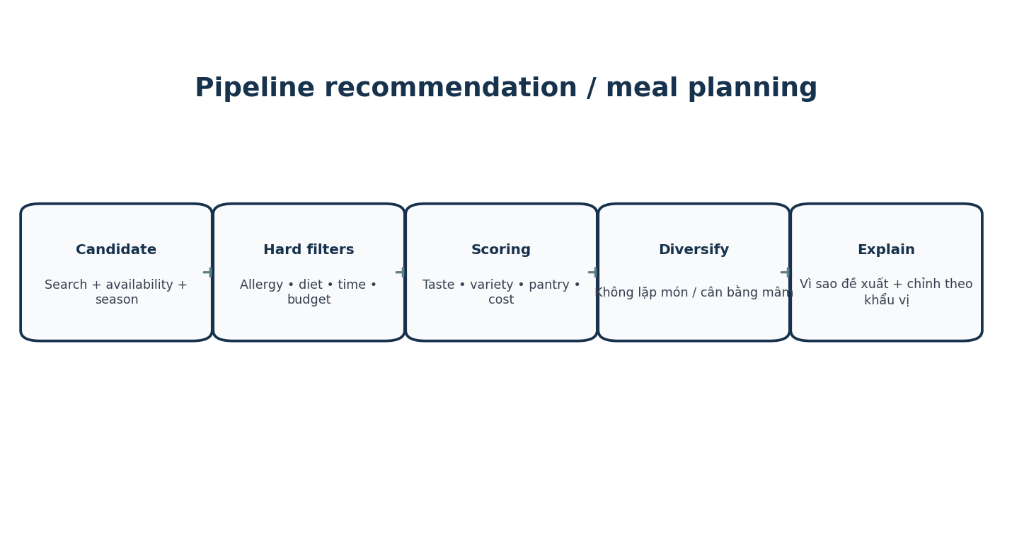
Hình 4 – Planning/recommendation pipeline

10.1 Planner scoring
Candidate score = w_taste*TasteFit + w_pantry*PantryUse + w_variety*Variety + w_budget*BudgetFit + w_time*TimeFit + w_season*Season + w_history*Novelty/Repeat + w_social*TrustedSignal. Hard filter chạy trước scoring.

10.2 Vietnamese meal composition
- Meal template hỗ trợ cơm + món mặn + rau + canh + side/nước chấm, nhưng không ép mọi bữa phải đủ component.
- Constraint tránh 2 món cùng quá nhiều dầu, quá mặn, cùng protein chính hoặc cùng kỹ thuật nếu không chủ đích.
- Optimizer ưu tiên dùng chung ingredient prep giữa các bữa để giảm waste và prep time.

10.3 Pantry transactions
Operation | Design
Add/Purchase | Create batch với quantity, unit, purchase/expiry date.
Reserve for plan | Soft reserve optional, không trừ stock.
Consume after cook | Generate proposed deductions từ recipe actuals; user confirm.
Adjust/Waste | Reason-coded inventory adjustment.
Expire | Mark unavailable; notification/analytics.
Undo | Compensating transaction, không xóa history.

10.4 Shopping list merge
Recipe demand được canonicalize về base unit → trừ usable pantry → merge theo ingredient/category → apply package/rounding rule → user manual override. Shared list item có version để merge optimistic updates.

11. Search và Recommendation

11.1 Search indexing
- Index recipe title, aliases, ingredients, region, technique, tags, creator, duration, budget band, pantry coverage fields.
- Use synonym dictionary tiếng Việt: bò/ thịt bò, hành lá/hành hoa...; accent-insensitive search.
- Search index async từ RecipePublished event; transactional DB vẫn là source of truth.

11.2 Recommendation stages
Stage | Implementation
Candidate generation | Taste-neighbor, content similarity, recent/trending, seasonal, pantry candidates, editorial.
Hard filtering | Allergy, diet, deprecated/unsafe, blocked creator, time/equipment.
Ranking | Feature-weighted model/rules; later learning-to-rank.
Diversity | MMR/category caps/novelty guard.
Exploration | Small controlled slot for new content to avoid filter bubble.
Explanation | Top 2–3 human-readable factors; no fake causal claim.
Feedback | Save/cook/dislike/skip feeds future ranking.

12. Social, Taste Match và Creator

12.1 Social graph
Follow graph, block/mute graph, creator/topic follow và recipe lineage graph được lưu tách để authorization/ranking rõ ràng. Feed fan-out có thể bắt đầu fan-out-on-read; chuyển hybrid/fan-out-on-write khi scale.

12.2 Taste Match
Taste Match không đơn giản cosine trên raw vector. Chỉ dùng dimensions đủ confidence, thêm context overlap và shrink score khi sample ít. Example: match = confidence_weighted_cosine × overlap_factor × maturity_factor. Kết quả public chỉ khi privacy policy cho phép.

12.3 Feed ranking
Feature group | Ví dụ
Affinity | Follow relationship, prior interactions, same household excluded/public policy.
Taste relevance | Taste Match, recipe TasteFit.
Content quality | Cook conversion, save rate, report rate, creator trust.
Freshness | Time decay.
Diversity | Creator/topic repetition caps.
Safety | Moderation state, unsafe/deprecated content hard filter.

12.4 Creator publishing workflow
Draft → structured validation → media validation → preview → publish unverified hoặc submit verified review → moderation/content review → publish. Analytics pipeline aggregates impressions/saves/cooks/forks without exposing individual cook identity.

13. AI Gateway và guardrails
Component | Thiết kế
Provider adapters | Chuẩn hóa chat/generation/embedding; retry/circuit breaker.
Prompt registry | Prompt ID/version, variables schema, owner, test cases.
Policy pre-check | PII redaction, consent, safety context, token/cost budget.
Structured output | JSON schema validation, reject/repair bounded retry.
Post-check | Range validation, ingredient/allergy rule, unsafe instruction detection.
Model routing | Cheap model cho rewrite/explanation; stronger model cho complex planning khi cần.
Cache | Semantic/exact cache cho explanation không chứa personal context nhạy cảm.
Observability | Latency, tokens, cost, error, safety block, acceptance rate.
Fallback | Template/rule response hoặc degraded UX; core cook vẫn chạy.

13.1 AI use cases
Use case | AI role | Deterministic guardrail
Recipe explanation | Natural language | Recipe data from DB only.
Rescue | Clarify/explain | Rule-based safety + validated action ranges.
Meal plan narrative | Explain planner output | Planner constraints/server output fixed.
Substitution explanation | Explain impact | Approved substitution graph.
Social moderation triage | Score/label | Human review for high-impact decision.
Image understanding | Ingredient suggestion optional | User confirmation before pantry mutation.
Voice assistant | Intent parsing | Command allowlist/state machine.

14. API và event design

14.1 API conventions
- REST JSON versioned `/v1`; OpenAPI generated SDK cho web/mobile.
- Bearer/session auth; scope/RBAC; `Idempotency-Key` cho critical POST.
- Cursor pagination cho feed/search result lớn; ETag/version cho shared resource.
- Errors chuẩn: code, message, correlation_id, retryable, field_errors.
- API không expose internal taste vector chi tiết nếu không cần UI.

14.2 Representative endpoints
Method | Endpoint | Purpose
POST | /v1/auth/* | Register/login/link/revoke device
GET | /v1/recipes/{id} | Recipe + personalized view
POST | /v1/cook-sessions | Start cook
POST | /v1/cook-sessions/{id}/events | Append offline-safe cook events
POST | /v1/cook-sessions/{id}/feedback | Submit/revise feedback
GET | /v1/taste/profile | Taste summary
POST | /v1/recipe-versions/{id}/personalize | Create proposed personal version
POST | /v1/households/{id}/plan:generate | Generate meal plan
PATCH | /v1/pantry/items/{id} | Adjust pantry with version
POST | /v1/rescue | Get rescue plan
GET | /v1/recommendations/home | Personalized home
GET | /v1/social/feed | Taste/social feed
POST | /v1/recipes/{version}/fork | Create fork
POST | /v1/billing/webhooks/{provider} | Provider webhook
POST | /v1/reports | Report content

14.3 Domain events
Events có envelope: event_id, type, schema_version, occurred_at, producer, subject_id, trace_id, payload. Consumer phải idempotent. Outbox pattern được dùng để tránh DB commit thành công nhưng event mất.

15. Media, notification và billing

15.1 Media pipeline
- Client request pre-signed upload → object storage quarantine → scan/transcode/metadata strip → moderation → publish CDN URL.
- Generate variants thumbnail/web/mobile; strip EXIF location theo privacy default.
- Video duration/size limits; lifecycle policy cho orphan upload.

15.2 Notification architecture
Domain event → Notification Orchestrator → preference/quiet-hours/dedup → template render → channel adapter (push/email/in-app) → delivery status. Social burst được digest; critical billing/security không bị digest.

15.3 Billing/entitlement
- Provider webhook là source event nhưng được verify signature + dedupe.
- Transaction ledger append-only; subscription materialized state; entitlement derived và cacheable.
- Grace period, refund, cancellation, restore purchase, cross-platform account mapping.
- Server authorization check entitlement cho premium endpoint; UI chỉ phản ánh state.

16. Admin, CMS, Moderation và Support
Surface | Capability
CMS | Recipe/ingredient/taxonomy/collection, workflow, preview, version compare.
Moderation | Queue, evidence, risk score, decision, action, appeal, audit.
Support | Masked user lookup, entitlement/device/sync diagnostic, safe admin actions.
Operations | Feature flags, kill switch, maintenance banner, job retry/replay.
Analytics | KPI dashboards, content quality, abuse, revenue aggregate.
Audit | Immutable privileged action log with actor/reason/correlation.

17. Security và Privacy Design

17.1 Threat controls
Threat | Controls
Account takeover | MFA option/user, admin mandatory MFA, rate limit, device/session revoke, anomaly alert.
API abuse | WAF, rate limits, bot detection, authorization at object level.
UGC abuse | Upload scan, moderation, block/report, content rate limit.
Prompt injection | No direct tool privilege from untrusted content; allowlist actions; structured context.
Payment spoof | Signed webhook verification, provider query reconciliation, idempotency.
PII leakage | Logging redaction, least privilege, encrypted storage, data access audit.
Broken household auth | Resource membership checks server-side for every shared resource.
Supply chain | Lockfiles, SBOM, dependency/container scanning, secret scanning.
Admin abuse | RBAC, JIT/least privilege where possible, audit + reason codes.

17.2 Privacy lifecycle
- Consent record versioned by purpose.
- Deletion: revoke sessions → deactivate → queue purge/anonymize → provider deletion where required → completion status.
- Export job async, signed time-limited download.
- Analytics pseudonymization và retention configurable.
- Location không cần thiết cho core cooking; không thu precise location mặc định.

18. Scalability và Reliability
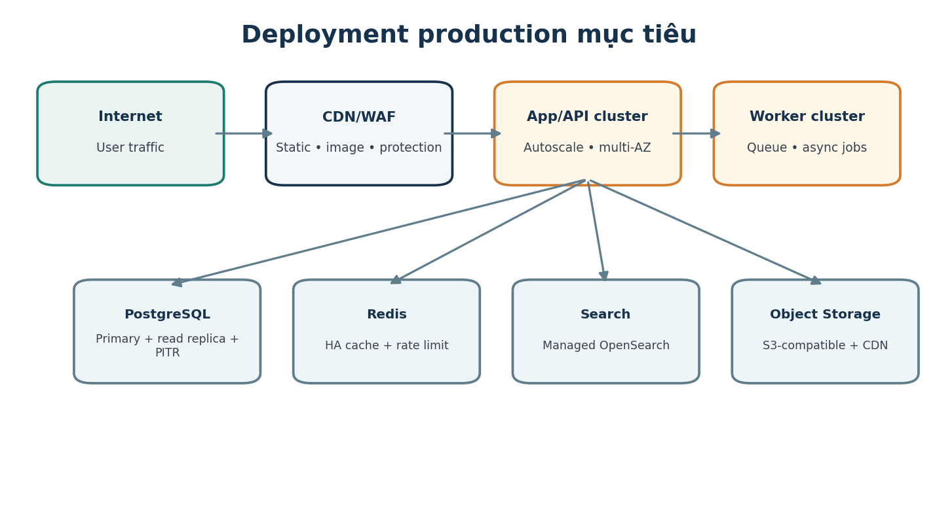
Hình 5 – Production deployment mục tiêu

18.1 Scaling strategy
Component | Scale strategy
Web/CDN | Edge cache/static assets; SSR cache where safe.
API | Stateless horizontal autoscale; connection pooler.
PostgreSQL | Managed HA, indexes, read replicas, partition large event tables, PITR.
Redis | HA managed cluster; cache TTL; avoid source-of-truth use.
Search | Shard/replica based on index size/query load.
Worker | Queue depth-based autoscaling; dead-letter queue.
Media | Direct client upload to object storage; CDN delivery.
Analytics | Async ingestion, decoupled warehouse.
AI | Concurrency quota, provider fallback, async jobs for non-interactive tasks.

18.2 Reliability patterns
- Outbox/inbox + idempotent consumers.
- Circuit breaker/timeouts/bounded retries với exponential backoff + jitter.
- DLQ + replay tooling.
- Graceful degradation: social/reco/AI down nhưng saved recipe/Cook Mode vẫn dùng được.
- Bulkhead cho billing, media, AI và social để không kéo sập core cooking.

19. Observability và Analytics
Signal | Thiết kế
Logs | Structured JSON, correlation/trace ID, PII redaction.
Metrics | RED/USE metrics, business counters, queue depth, cache hit, AI cost.
Tracing | Distributed trace API→DB/queue/external provider.
SLO | Availability/latency/error budget theo critical flow.
Audit | Separate tamper-resistant audit for admin/billing/moderation.
Product events | Versioned analytics schema, quality validation before warehouse.
Alerts | Symptom-based, actionable, linked runbook; avoid alert storm.

20. CI/CD và môi trường
Environment | Purpose | Data policy
Local | Developer | Synthetic/local only.
CI ephemeral | Unit/integration/e2e | Seed synthetic, destroyed after run.
Staging | Pre-release integration/load/UAT | Anonymized/synthetic; never raw production dump by default.
Production | Real users | Strict RBAC/audit.
DR/Restore test | Recovery validation | Encrypted copy/controlled access.

20.1 Pipeline
- Lint/typecheck/unit test.
- SAST/dependency/secret scan; build signed artifacts/SBOM.
- Integration tests với ephemeral DB/Redis/queue.
- Contract/API schema compatibility checks.
- Deploy staging; smoke/e2e/performance selected.
- Manual/automatic approval theo risk; progressive rollout/canary.
- Monitor SLO/error; auto/manual rollback qua immutable artifact.

21. Testing strategy
Test layer | Scope
Unit | Domain rules, unit conversion, taste update, scaling, scoring.
Property-based | Recipe scaling invariants, unit conversion, planner constraints.
Integration | DB/Redis/search/queue/payment sandbox/storage.
Contract | Web/mobile SDK ↔ API, event schema compatibility.
E2E | Onboarding→cook→feedback; plan→shopping→pantry; premium; report/moderation.
Offline/sync | Crash/reconnect/conflict/timer persistence.
Security | AuthZ, IDOR, rate limit, upload, webhook, admin.
AI regression | Prompt/model golden set, safety cases, schema failure, cost/latency.
Load/soak | Home/search/feed, cook events, notification fan-out.
Chaos/resilience | Provider timeout, queue lag, DB failover, search unavailable.
Accessibility | Screen reader, focus, text scale, contrast.
Migration | Schema/data migration rehearsal + rollback/forward-fix.

22. Backup và Disaster Recovery
Asset | Backup/Recovery design
PostgreSQL | Automated snapshots + WAL/PITR; encrypted; restore drill.
Object storage | Versioning/lifecycle/cross-region optional; media can be re-derived from original where retained.
Search | Rebuildable from DB/event log; snapshot optional for faster RTO.
Redis | Not source of truth; rebuildable.
Config/Infra | Git + IaC state protected/versioned.
Analytics warehouse | Provider backup/retention; product OLTP not dependent on warehouse.
Secrets | Managed secret store backup/recovery procedure; rotation after compromise.

23. Capacity, performance và cost controls
Area | Control
DB | Query budget, slow query dashboard, index review, connection pool limit.
Media | Client compression, CDN, variant sizes, lifecycle cleanup.
AI | Per-feature token budget, cheap/strong model routing, response cache, quota, daily spend alert.
Search | Index field discipline, pagination, cache popular queries.
Social feed | Cursor pagination, bounded fan-out, ranking cache.
Notification | Batch/digest, provider rate limit, retry caps.
Analytics | Sampling for high-volume low-value events; raw retention tiers.

24. Architecture evolution strategy
Stage | Architecture
Foundation | Modular API + PostgreSQL + Redis + object storage + queue; simple search/pg search nếu đủ.
Utility scale | Dedicated OpenSearch, worker autoscale, AI gateway, warehouse.
Social scale | Social bounded context/service, feed cache/ranking, moderation pipeline.
Commerce scale | Billing/entitlement isolation, reconciliation jobs, stronger audit.
Large scale | Selective service extraction, read replicas/partitioning, regional CDN, specialized ML serving.

Nguyên tắc — Không microservice hóa trước khi có bottleneck/ownership rõ. Boundary và event contract phải được thiết kế từ đầu để việc tách sau này là migration có kiểm soát, không rewrite.

Phụ lục A – Sequence: Feedback → Recipe V2
1. Client gửi FeedbackSubmitted với session revision/idempotency key.
2. Cooking module commit feedback + outbox event.
3. Taste consumer kiểm tra context/rescue flag → tạo taste signals.
4. Taste profile materializer cập nhật vector/confidence/version.
5. Personalization engine tính adjustment proposal với guardrails.
6. Tạo personal recipe_version DRAFT_PROPOSED, lưu diff/reason/model version.
7. Notification/UI hiển thị “Lần sau thử phiên bản V2”; user Accept/Reject.
8. Accept tạo pointer preferred version và signal; Reject giữ history nhưng không dùng mặc định.

Phụ lục B – Sequence: Generate weekly plan
1. Resolve household participants, diet/allergy, calendar locks, budget/time constraints.
2. Load pantry/leftover/expiry and recent meal history.
3. Generate candidate set per meal/component.
4. Apply hard constraints; score taste/pantry/cost/time/variety.
5. Run constraint solver/diversification across week.
6. Estimate shopping demand and pantry reuse; recalculate cost.
7. Persist versioned meal_plan; user locks/edits/regenerates subset.
8. Emit MealPlanGenerated for analytics/shopping recommendation.

Phụ lục C – Coding & data conventions
- Use UTC timestamps in storage; user timezone only at presentation/planning boundary.
- Use UUID/ULID opaque IDs; do not expose sequential internal IDs publicly.
- Money = integer minor unit + currency; quantity = decimal + canonical unit.
- No floating point equality for measurement/business-critical calculation.
- All external calls have timeout; all webhook handlers idempotent.
- Migrations backward-compatible across rolling deploy where possible.
- Domain event and API schema require versioning/deprecation policy.
- Logs never include password/token/raw payment credential or unrestricted personal note.

