­­­­­

|  |  |
| --- | --- |
|  |  |



Process Definition

Document

Getaway Gurus

Table of Contents

I. INTRODUCTION 4

1.1 Purpose 4

1.2 Objectives 4

1.3 Key Contacts 4

1.4 Minimum Pre-requisites for the Automation 4

II. AS IS Process description 5

2.1 Process Overview 5

2.2 Applications Used 6

2.3 AS IS Process Map 7

2.3.1 High Level Process Map 7

2.3.2 Detailed Level Process Map 7

2.4 Process Statistics 7

2.5 Detailed As Is Process Actions 8

2.6 Input Data Description 8

III. TO BE Process description 9

3.1. Detailed TO BE Process Map 9

3.2. Parallel Initiatives 9

3.3. In Scope For RPA 9

3.4. Out Of Scope for RPA 10

3.5. Exceptions Handling 10

3.5.1. Known Business Exceptions 10

3.5.2 Unknown Business Exceptions 10

3.6. Applications Errors & Exceptions Handling 11

3.6.1. Known Applications Errors and Exceptions 11

3.6.2. Unknown Applications Errors and Exceptions 11

3.7. Reporting 11

IV. Other 12

4.1. Additional sources of process documentation 12

# INTRODUCTION



## Purpose

Getaway Gurus is a trip planner application.

## Objectives

After taking in trip information Getaway Gurus can:

* Get weather for the destination for the length of the trip.
* Find hotels
* Find events
* Find restaurants
* Email information to customers

## Key Contacts

Table of stakeholders that need to be informed or to approve changes to the process:

|  |  |  |  |
| --- | --- | --- | --- |
| Role | Name | Contact Details (email, phone number) | Notes |
| RPA Developer | Catherine Schiber | catherine937@revature.net |  |
| RPA Developer | Chase Young | chase109@revature.net |  |
| RPA Developer | Trevor Bennett | Trevor568@revature.net |  |
| RPA Developer | Dylan Cummins | dylan139@revature.net |  |

## Minimum Pre-requisites for the Automation

1. Test data
2. API keys
3. Gmail authorization for accounts used in dispatcher/performer
4. UiPath Orchestrator Organization

# AS IS Process description

In this section the process is documented. This section will serve as the starting point for the re-engineering and automation effort.



## Process Overview

Section contains general information about the process before automation.

|  |  |
| --- | --- |
| Item | Description/Answer |
| Process Full Name | GetawayGurus |
| Process Area | N/A |
| Department | N/A |
| Short Description (operation, activity, outcome) | Given some information provides further information to help plan a trip |
| Process schedule and frequency | As needed |
| Input data description | SQL Server/Orchestrator Queue |
| Output Data description | Emails, excel workbooks. |

.

## Applications Used

The table includes a comprehensive list of all the applications that are used as part of the process to be automated to perform the given actions in the flow.

|  |  |  |  |  |  |
| --- | --- | --- | --- | --- | --- |
| Application Name | Version | Application Language | Thin/Thick Client | Environment/ Access method | Comments |
| UiPath Studio | 2023.4.0 | C# | Thick | Local |  |
| UiPath Orchestrator | Enterprise | English | Thin | Online |  |
| GitHub | Free | English | Thin | Online |  |
| Azure Data Studio | 1.42.0 | SQL Server | Thick | Local |  |
| MS Excel | 2302 | C++ | Thick | Local |  |
| Google Chrome | 110.0.5563.146 | C/C++ | Thin | Online |  |
| MS Edge | 109 | C++ | Thin | Online |  |
| Gmail | N/A | English | Thin | Online |  |

.

## AS IS Process Map

This section contains various process maps contributing to a better understanding of how the process is performed pre-automation.

### High Level Process Map

Start

Process Input Data

Gather Trip Planning Data

Compile Travel Reports and send out information to clients

### Detailed Level Process Map

This section describes the process at key-stroke level and is an essential part for the communication with the developers.

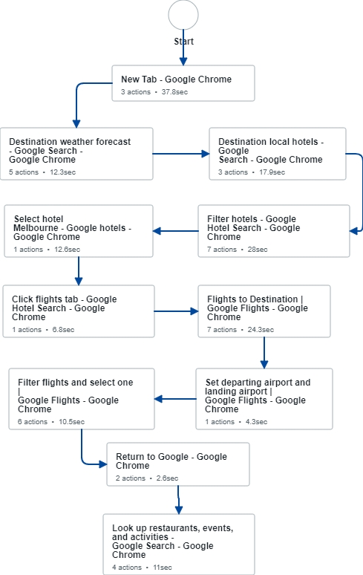

## Detailed As Is Process Actions

|  |  |  |
| --- | --- | --- |
| Process Step # | Input | Description |
| 1 | Mouse click | Open Google in a Chrome browser |
| 2 | Text | Search for weather forecast at the destination using google, gather data |
| 3 | Text | Search for hotels at destination using google. |
| 4 | Text/Click | Filter found hotels |
| 5 | Click | Select chosen hotel |
| 6 | Click | Click ‘flights’ tab |
| 7 | Text/Click | Navigate to flights |
| 8 | Text/Click | Set departing/arriving airports |
| 9 | Text/Click | Filter and select a flight |
| 10 | Text/Click | Return to Google |
| 11 | Text/Click | Search for restaurants/events and gather data |

# TO BE Process description

In this section the proposed improvements to the process, actions to the process will be outlined.

## Detailed TO BE Process Map

A detailed process map of the process as it will look like post-automation, all parts are slated to be automated except ‘start’.

## Exceptions Handling

Documented below are all the business exceptions identified in the automation process. Exceptions are of 2 types and both need to be addressed:

**Known exceptions** = previously encountered. A scenario is defined with clear actions and workarounds for each case.

**Unknown** = New situation that was not encountered before. It cannot be predicted and in case it happens it needs to be flagged and communicated to an authorized person for evaluation.

### Known Business Exceptions

Details regarding how the robot should handle the exceptions.

|  |  |
| --- | --- |
| Exception Name | Action to be taken |
| *All Business Exceptions* | *Current activity is skipped over after a set number of retries* |

### 3.5.2 Unknown Business Exceptions

All business exceptions, known or unknown, are treated the same way, in that the activity that throws the exception is retried a set number of times before being skipped over.

## Applications Errors & Exceptions Handling

A comprehensive list of all errors, warnings or notifications are consolidated here together with the action to be taken for each by the Robot. There are 2 types of exceptions/errors:

**Known** = Previously encountered and action plan or workaround available for it (e.g. SAP unresponsive during peak times)

**Unknown** = these are exceptions and errors that cannot be anticipated but for which the robot needs to have a rule so that the RPA solution is sustainable.

### Known Applications Errors and Exceptions

Details regarding how the robot should handle the exceptions.

|  |  |  |  |
| --- | --- | --- | --- |
| Error/Exception Name | Action | Parameters | Action to be taken |
| *API Key Runs Out* | *Takes away ability to make API calls* | *-* | *Request new API key* |

### Unknown Applications Errors and Exceptions

A set number of attempts is made to access the application, and if the robot still fails then the process is terminated.

## Reporting

In this section all the reporting requirements of the business are detailed so that when the RPA solution is moved to production the administrators can track the performance of the solution.

|  |  |  |  |
| --- | --- | --- | --- |
| Report Type | Update frequency | Details | Monitoring Tool to visualize the data |
| *Orchestrator Queue Logs* | *Each run* | *Orchestrator queue records whether each transaction item failed or succeeded* | *Only visible in the UiPath Cloud to those in the organization* |
| *UiPath Studio Logs* | *Each run* | *REFramework template used in the project has log messages and additional ones were added during development* | *UiPath Studio* |

# Other

## Additional sources of process documentation

Possible additional documentation for the next version.

|  |  |  |
| --- | --- | --- |
| Additional Process Documentation | | |
| Video Recording of the process (Optional) | N/A | N/A |
| Business Rules Library (Optional) | N/A | N/A |
| Other documentation (Optional) | N/A | N/A |
| Standard Operating Procedure(s) (Optional) | N/A | N/A |
| High Level Process Map (Optional) |  |  |
| Detailed level process map (Optional) |  |  |
| Work Instructions (Optional) |  |  |
| Input Files (Optional) |  |  |
| Output Files (Optional) |  |  |

