# **Building a Simple Calculator**

## Goal

By the end of this activity, you will create a basic calculator that can add, subtract, multiply, and divide numbers.

You will use:

- HTML → to design the structure  
- CSS → to style and arrange using flexbox  
- JavaScript → to add the logic

1. **Create the project folder**
   1. Make a new folder and name it: simple-calculator
2. **Inside it, create three files**
   1. Index.html
   2. style.css
   3. script.js
3. **Write the HTML code**
   1. Open you VS code and load your project folder
   2. Code the index.html
4. **Style your HTML code**
   1. Open style.css
   2. Code the css class
5. **Make it functional**
   1. Open script.js
   2. Code the js functions
6. **Run the calculator**
   1. Start the live serve
   2. Click “Go Live”
7. **Push to Github**
   1. Create a new repository in Github
   2. Switch to VS Code and open new terminal
   3. Enter the commands in github (skip the echo command)

index.html

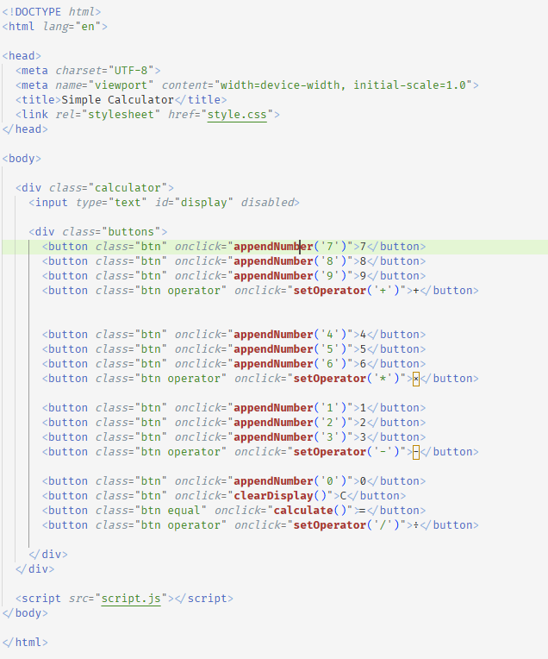

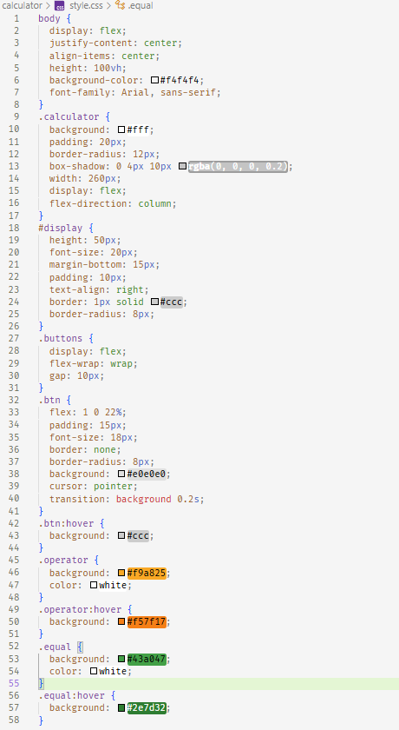style.css

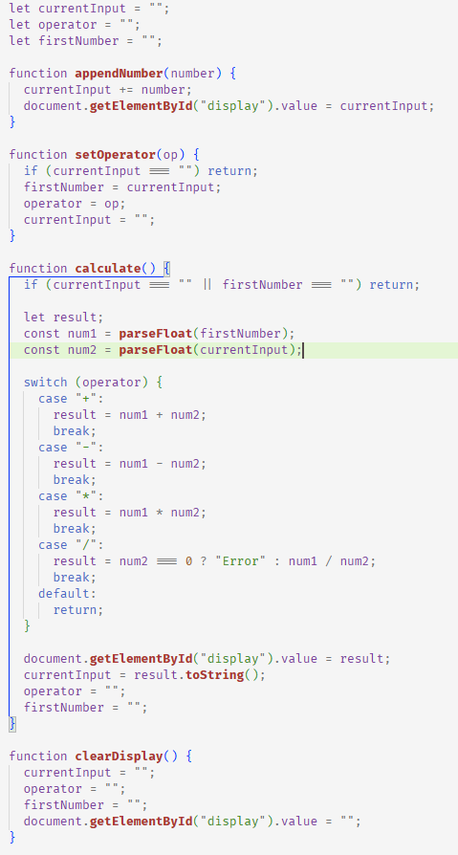script.js

Output:

