C369 Financial Technologies

AY2024 Semester 1 Graded Assignment Guide

**Important Timeline**

|  |  |  |
| --- | --- | --- |
| Start Date | : | 22 Apr 2024 |
| Interview Date | : | Week 13 |
| Milestone Deadline: |  | 4/8/23 |

|  |  |  |
| --- | --- | --- |
| **No.** | **Item** | **Deliverable Deadline**  **(by 2359 of)** |
|  | Problem Definition & Literature Review (LEO) | Week 5 |
|  | Website Design (LEO) | Week 7 |
|  | Responsive Website (LEO) | Week 11 |
|  | URL of Responsive Website (LEO) | Week 12 |
|  | All Finalised Items (SA) | 4 August 2024 |
|  |  |  |
|  |  |  |
|  |  |  |

Declaration of Compliance

|  |  |
| --- | --- |
| **Student ID** | 23023062 |
| **Student Name** | Glendys Mak Xin Rui |
| **Class** |  |



|  |  |  |  |  |
| --- | --- | --- | --- | --- |
| **Academic Integrity Compliance Statement** | | | | |
| I declare that:   * This submission is my original work – all sources have been properly referenced and acknowledged. * I have neither received nor rendered any assistance (either paid or unpaid) on work that requires individual effort. * I have fully complied with the RP rules and regulations for students pertaining to assessments and academic integrity outlined [here](https://myrp.sharepoint.com/sites/StudentHandbook/SitePages/assessment_rules_and_regulations.aspx) and     If found guilty of committing any act of academic dishonesty, I understand that I will be liable:   * for disciplinary action by the School * to the full extent of penalties, including immediate failure for this assessment and other disciplinary actions such as dismissal | | | | 🗸 |
| **Retention of Backup Copy**  I declare that I have a back-up electronic copy of this submission for immediate resubmission. | | | | 🗸 |
| **Signature** |  | **Date** | 4/8/23 | |
| **IMPORTANT**: Non-compliance to these clauses will result in unconditional rejection of your submission. | | | | |

# General Information for Candidates

1. This Graded Assignment (GA) is an individual assignment. The assignment must be completed and submitted by each student.
2. This GA forms 50% of this module’s final grade.
3. This GA comprises 2 components:
   1. **Deliverable:**
      1. 4 milestone items in accordance with the GA’s requirements; and
      2. Signed Declaration of Compliance
   2. **Interview:**
      1. The purpose of the interview is to verify your understanding and for you to explain the rationale for the decisions made in the GA.
      2. If you cannot explain your submission adequately, marks will be deducted.

# Submission Procedure

1. Create a folder with the following naming convention:

|  |
| --- |
| <<studentId>>-<<name>>-<<classcode>>-GA  e.g. **23000001-JayChan-Cxxx-1D-W65L-A-GA** |

1. Save all your milestone deliverable in the folder created above and zip the folder.
2. Upload the completed deliverable before the submission deadline via the SA2.0 link disseminated via email.
3. If you have difficulty in submitting any of the milestone deliverable (late or otherwise), email the lecturer.
4. Read and comply with RP’s Guidelines on Academic Dishonesty and Plagiarism. Sign the Declaration of Compliance document and upload the declaration to the same SA2.0 link.

# Summative Assessment Rules and Regulations:

1. Late submissions without leave of absence (LOA) will be subject to the following penalty:

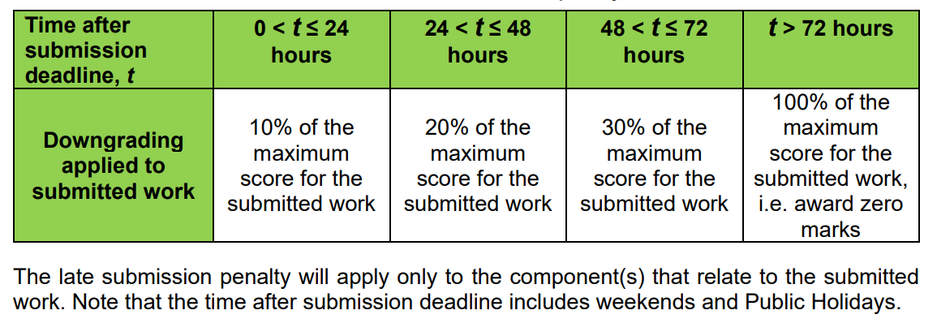

1. Plagiarism will be dealt with seriously. You are expected to:
   * **Submit authentic work for assessment** that represent your academic abilities
   * NOT submit any work produced, even only in part, by AI tool(s) as your own work

The unauthorised use of AI to create content that is submitted as the learner’s own work is considered plagiarism. Such an act constitutes academic dishonesty and is a violation of RP’s [Rules and Regulations pertaining to academic integrity](https://myrp.sharepoint.com/sites/StudentHandbook/SitePages/assessment_rules_and_regulations.aspx).

1. You must acknowledge the use of the AI tool(s) in your submitted work by:
   * Citing the AI tool(s) used (and the input prompt and response generated by the AI tool), and how and where you have used the generated response(s)
2. You will need to attend a Q&A session to:

* Verify the authenticity of the work submitted
* Demonstrate understanding of the response generated by the AI tool and
* Explain how that understanding influenced your submitted work.

# GA Assessment Rubrics

|  |  |
| --- | --- |
| **Grading Criteria** | **Weighting** |
| Methods and procedures | 30% |
| Interpretation and discussion | 30% |
| Deliverable | 40% |

# Recommendations

1. Submit your work progressively at any time before the submission deadline.
2. DO NOT wait till the last hour or minute to submit your work.
3. Make regular backups of your work.

**[ End of GA Guide ]**