ASSIGNMENT_13.1
HT.NO:2303A51909
Task Description #1 (Refactoring – Removing Code
Duplication)
- Task: Use AI to refactor a given Python script that contains multiple repeated code blocks.
- Instructions:
o Prompt AI to identify duplicate logic and replace it with functions or classes. o Ensure the refactored code maintains the same output. o Add docstrings to all functions.
- Sample Legacy Code:
# Legacy script with repeated logic print("Area of Rectangle:", 5 * 10) print("Perimeter of Rectangle:", 2 * (5 + 10)) print("Area of Rectangle:", 7 * 12) print("Perimeter of Rectangle:", 2 * (7 + 12)) print("Area of Rectangle:", 10 * 15) print("Perimeter of Rectangle:", 2 * (10 + 15))
- Expected Output:
o Refactored code with a reusable function and no duplication.

CODE:
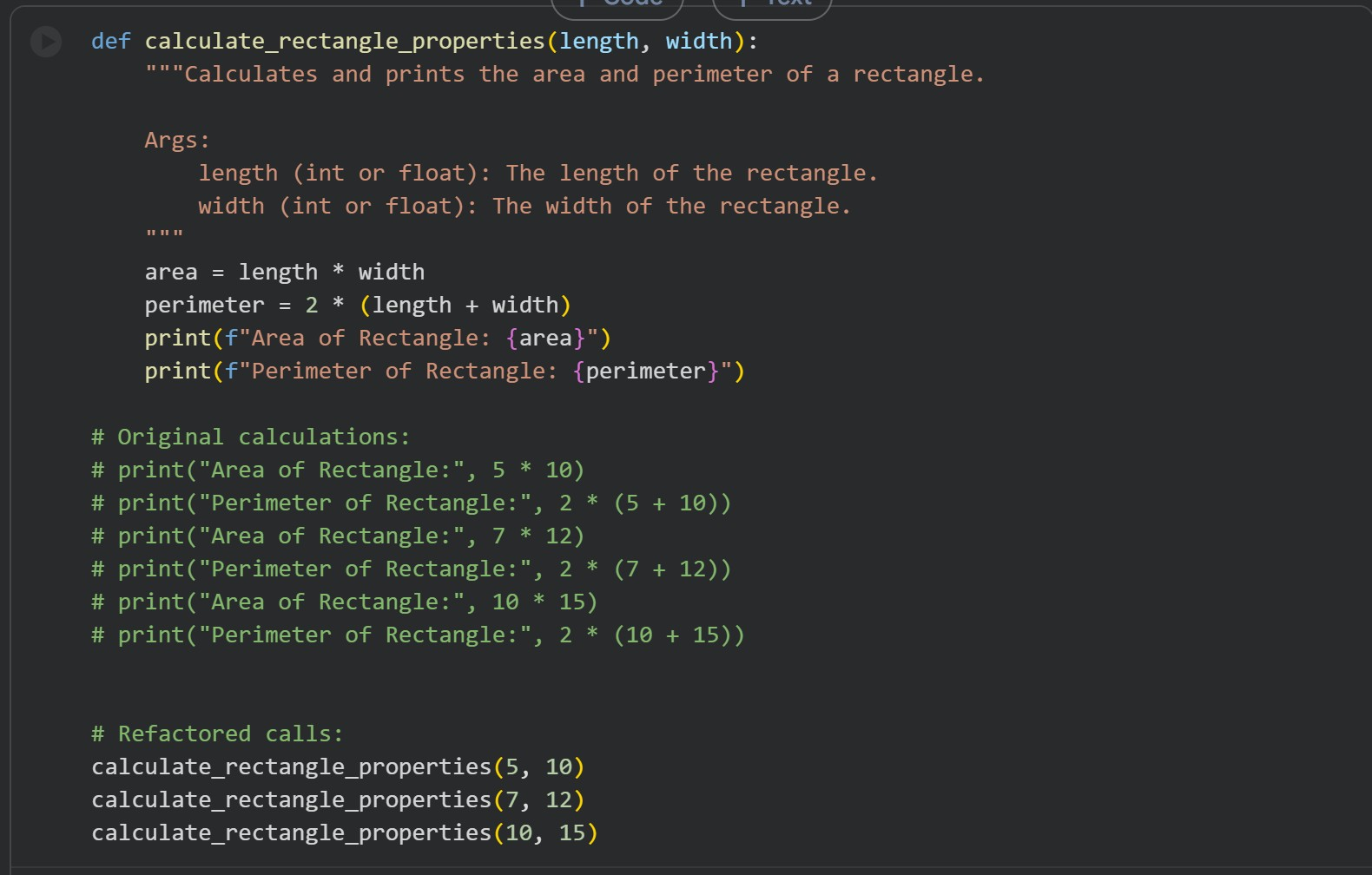
OUTPUT:
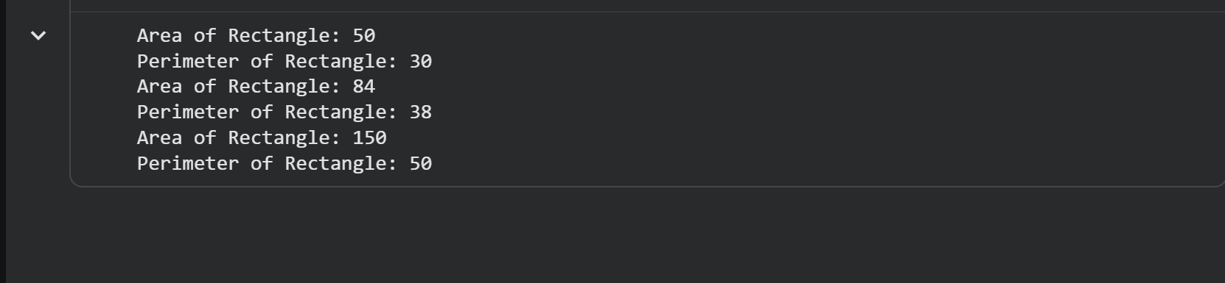
Task Description #2 (Refactoring – Optimizing Loops and
Conditionals)
- Task: Use AI to analyze a Python script with nested loops and complex conditionals.
- Instructions: o Ask AI to suggest algorithmic improvements (e.g., replace nested loops with set lookups or comprehensions). o Implement changes while keeping logic intact.
o Compare execution time before and after refactoring.
• Sample Legacy Code: # Legacy inefficient code
names = ["Alice", "Bob", "Charlie", "David"] search_names = ["Charlie", "Eve", "Bob"] for s in search_names:
found = False for n in names: if s == n: found = True if found:
print(f"{s} is in the list") else:
print(f"{s} is not in the list")
• Expected Output:
o Optimized code using set lookups with performance comparison table.
CODE:
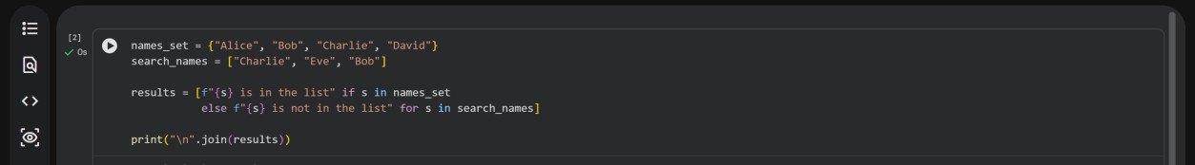
OUTPUT:
Task Description #3 (Refactoring – Extracting Reusable Functions)
- Task: Use AI to refactor a legacy script where multiple
calculations are embedded directly inside the main code block.
- Instructions:
- Identify repeated or related logic and extract it into reusable functions.
- Ensure the refactored code is modular, easy to read, and documented with docstrings.
- Sample Legacy Code:
# Legacy script with inline repeated logic price = 250 tax = price * 0.18 total = price + tax print("Total Price:", total) price = 500 tax = price * 0.18 total = price + tax print("Total Price:", total)
- Expected Output: o Code with a function calculate_total(price) that can be reused for multiple price inputs.
CODE:
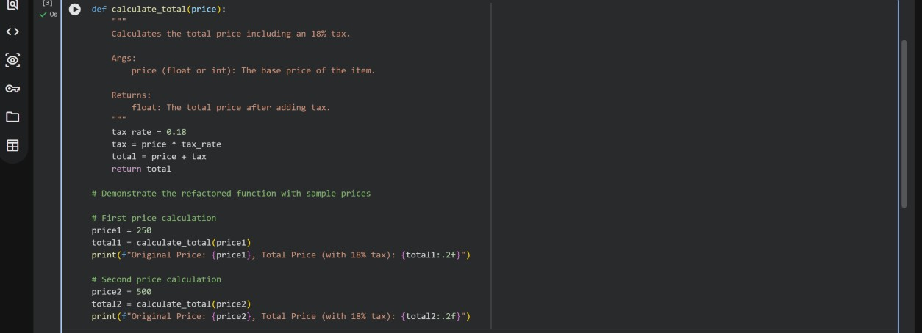
OUTPUT:
Task Description #4 (Refactoring – Replacing Hardcoded
Values with Constants)
- Task: Use AI to identify and replace all hardcoded “magic numbers” in the code with named constants.
- Instructions:
- Create constants at the top of the file.
- Replace all hardcoded occurrences in calculations with these constants.
- Ensure the code remains functional and is easier to maintain.
- Sample Legacy Code:
# Legacy script with hardcoded values print("Area of Circle:", 3.14159 * (7 ** 2)) print("Circumference of Circle:", 2 * 3.14159 * 7)
- Expected Output: o Code with constants like PI = 3.14159 and RADIUS
= 7 used in calculations CODE:
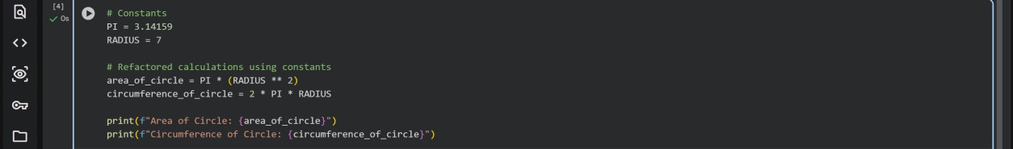

OUTPUT:
Task Description #5 (Refactoring – Improving Variable
Naming and Readability)
- Task: Use AI to improve readability by renaming unclear variables and adding inline comments.
- Instructions:
o Replace vague names with meaningful ones. o Add comments where logic is not obvious. o Keep functionality exactly the same.
- Sample Legacy Code:
# Legacy script with poor variable names a = 10 b = 20 c = a * b / 2 print(c)
- Expected Output: o Code with descriptive variable names like base, height, area_of_triangle, plus explanatory comments CODE:
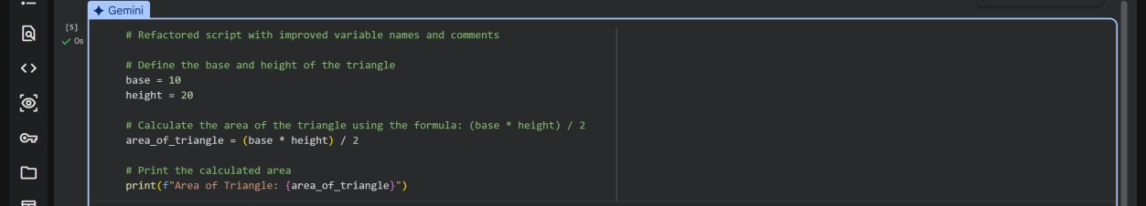
OUTPUT:
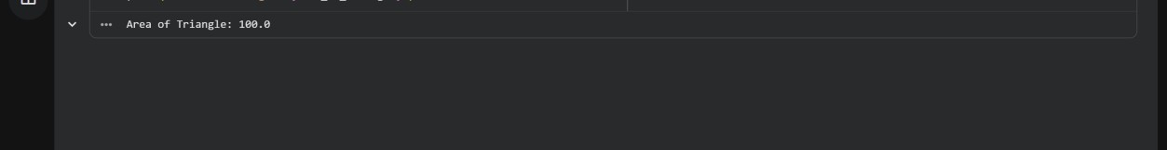
Task Description #6 (Refactoring – Removing Redundant Conditional
Logic)
- Task: Use AI to refactor a Python script that contains repeated if–else logic for grading students.
- Instructions:
o Ask AI to identify redundant conditional checks. o Replace them with a reusable function. o Ensure grading logic remains unchanged.
• Code: marks = 85 if marks >= 90: print("Grade A") elif marks >= 75: print("Grade B") else:
print("Grade C") marks = 72 if marks >= 90: print("Grade A") elif marks >= 75: print("Grade B") else:
print("Grade C") • Expected Output: o A reusable function like calculate_grade(marks) with clean logic and docstring. CODE:
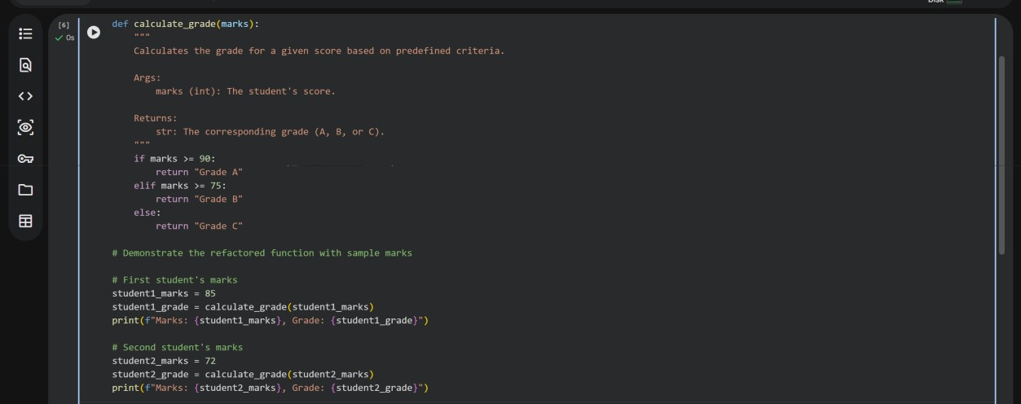
OUTPUT:
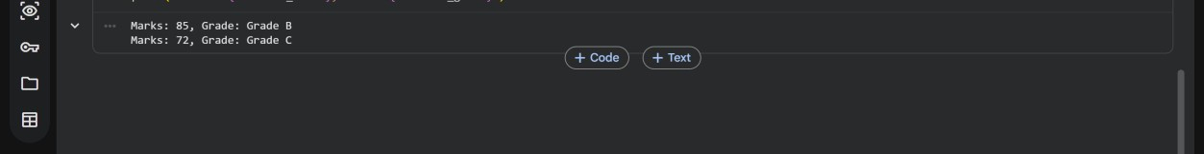
Task Description #7 (Refactoring – Converting Procedural Code to
Functions)
- Task: Use AI to refactor procedural input–processing logic into functions.
- Instructions:
- Identify input, processing, and output sections.
- Convert each into a separate function. o Improve code readability without changing behavior.
- Sample Legacy Code: num = int(input("Enter number: ")) square = num * num print("Square:", square)
- Expected Output:
o Modular code using functions like get_input(), calculate_square(), and display_result(). CODE:
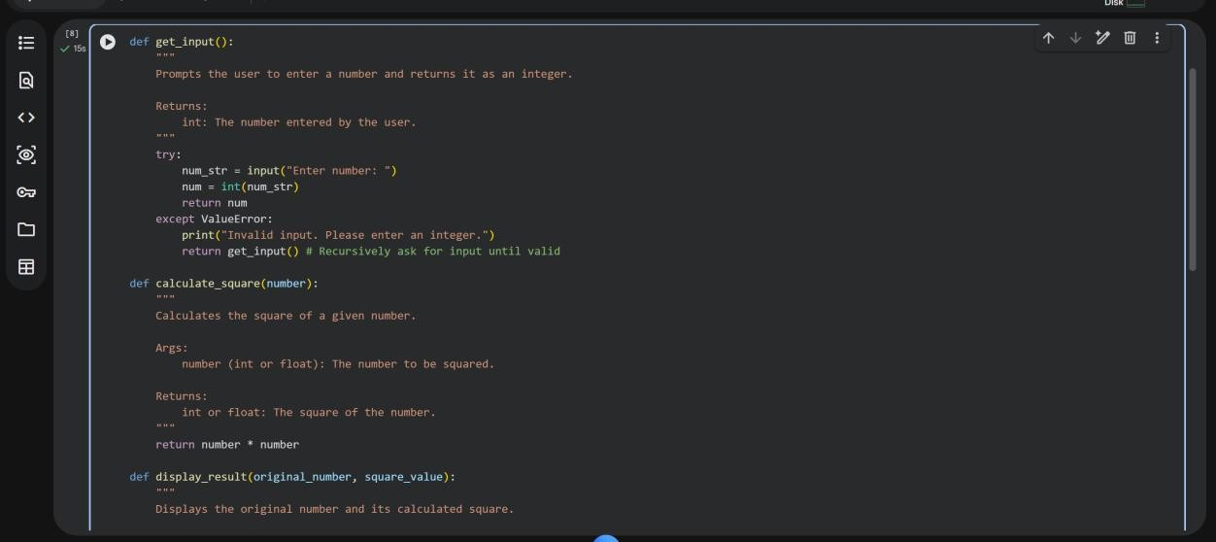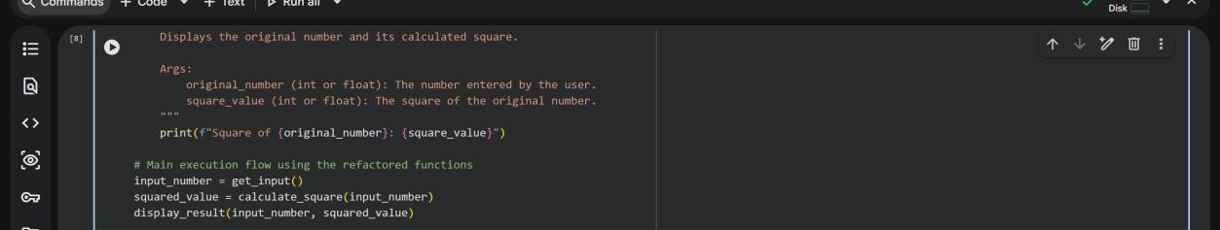
OUTPUT:
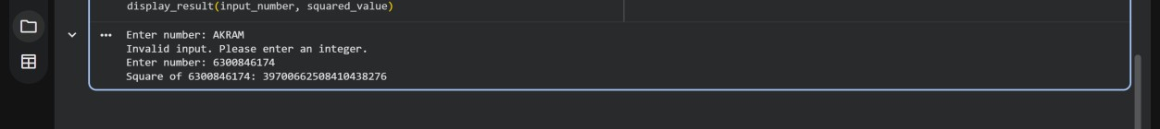
Task Description #8 (Refactoring – Optimizing List Processing)
- Task: Use AI to refactor inefficient list processing logic.
- Instructions:
o Ask AI to replace manual loops with list comprehensions or built-in
functions. o Ensure output remains identical.
• Sample Legacy Code: nums = [1, 2, 3, 4, 5] squares = [] for n in nums: squares.append(n * n) print(squares) • Expected Output:
o Optimized version using list comprehension with improved readability CODE:
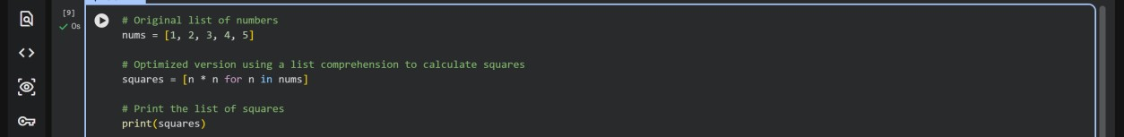

OUTPUT:
