AI ASSISTED CODING
LAB-11.1
p.v.gayathri
2303A51909Batch-12
Task Description #1 – Stack Implementation
Task: Use AI to generate a Stack class with push, pop, peek, and is_empty methods.
Sample Input Code: class Stack:
pass
Expected Output:
- A functional stack implementation with all required methods and docstrings PROMPT:
#Write a code to generate a stack class with push,pop,peek and isEmpty methods
CODE:
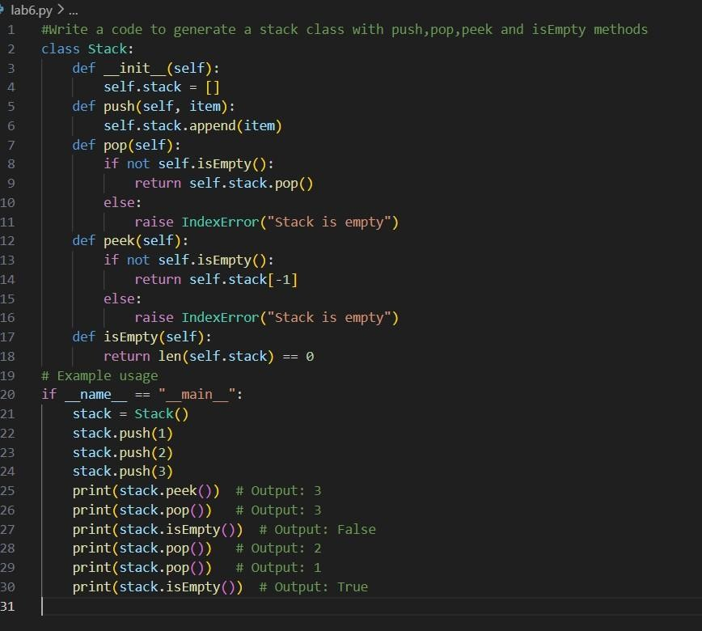

OUTPUT:

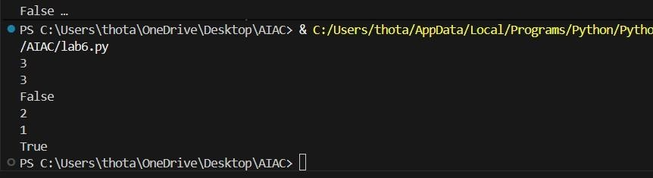

Task Description #2 – Queue Implementation Task: Use AI to implement a Queue using Python lists.
Sample Input Code: class Queue:
pass
Expected Output:
- FIFO-based queue class with enqueue, dequeue, peek, and size methods.
PROMPT:
#Write a code to generate a queue class with enqueue,dequeue,peek and size methods CODE:
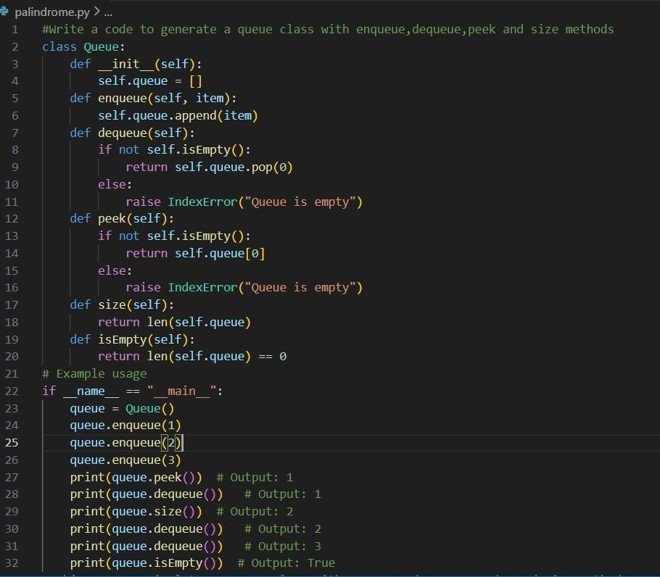

OUTPUT:
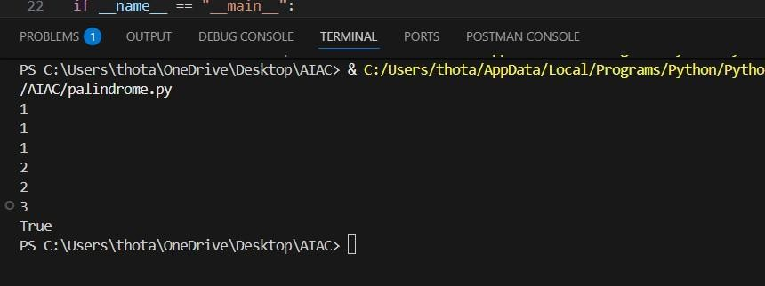

Task Description #3 – Linked List
Task: Use AI to generate a Singly Linked List with insert and display methods. Sample Input Code: class Node: pass class LinkedList:
pass
Expected Output:
- A working linked list implementation with clear method documentation PROMPT:
#Write a code to generate a singly linkedlist with insert and display methods
CODE AND OUTPUT:
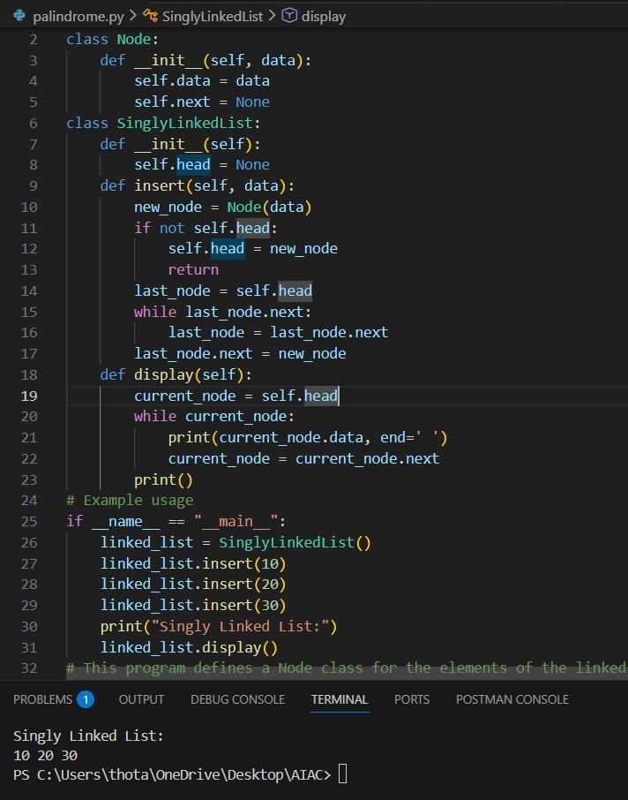

Task Description #4 – Binary Search Tree (BST)
Task: Use AI to create a BST with insert and in-order traversal methods.
Sample Input Code: class BST: pass
Expected Output:
- BST implementation with recursive insert and traversal methods.
PROMPT:
#Write a code to create a binary search tree and inorder traversal methods using recursive insert and travesal methods
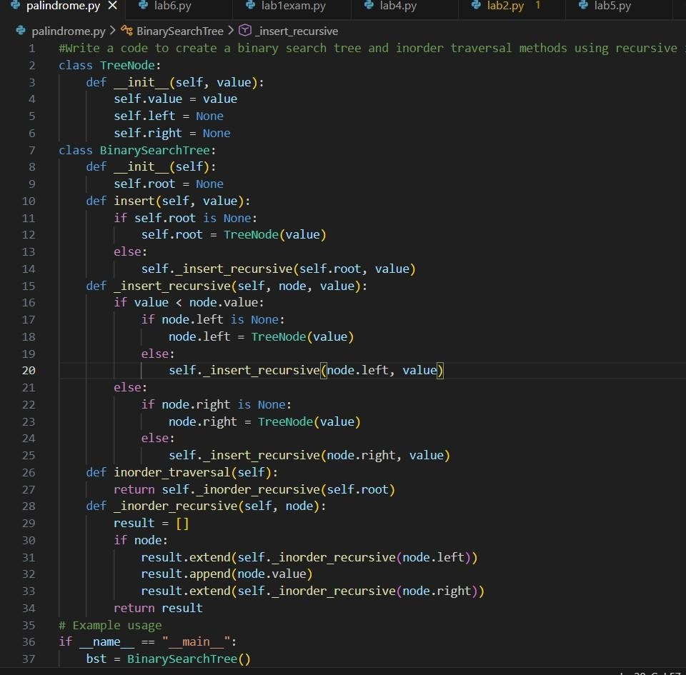
CODE AND OUTPUT:

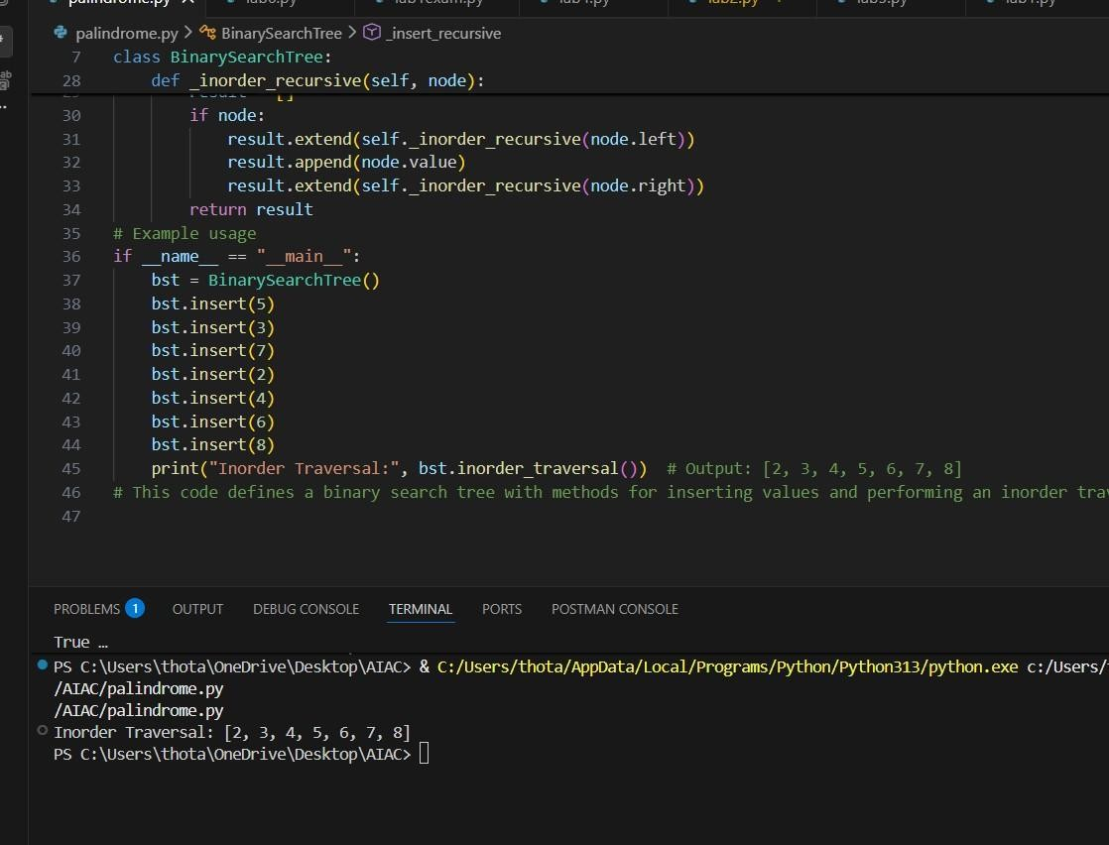

Task Description #5 – Hash Table
Task: Use AI to implement a hash table with basic insert, search, and delete methods. Sample Input Code: class HashTable:
pass
Expected Output:
- Collision handling using chaining, with wellcommented methods.
PROMPT:
#Write a code to implement a hash table with basic operations like insert, delete and search methods using chaining for collision handling with well commented methods
CODE AND OUTPUT:
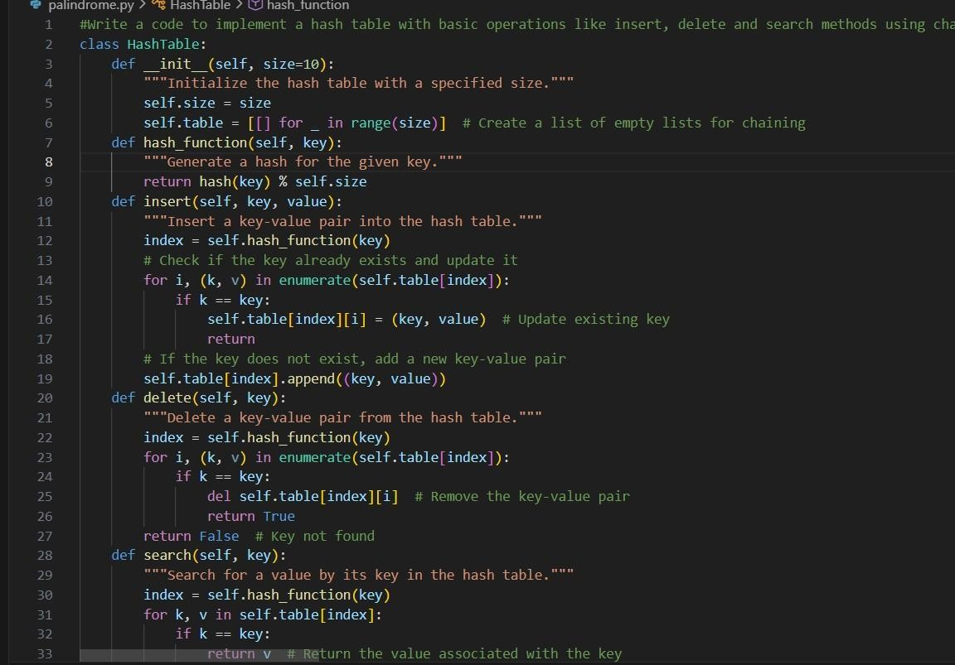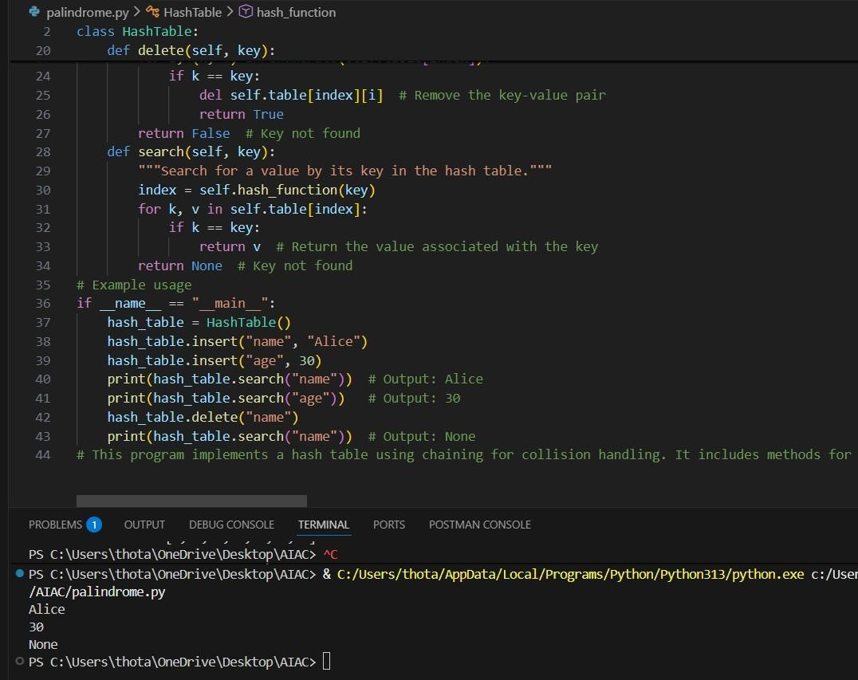

Task Description #6 – Graph Representation
Task: Use AI to implement a graph using an adjacency list.
Sample Input Code: class Graph:
pass
Expected Output:
- Graph with methods to add vertices, add edges, and display connections.
PROMPT:
#Write a code to implement a graph using an adjacency list and perform methods like add_vertices,add_edges and display connections CODE AND OUTPUT:
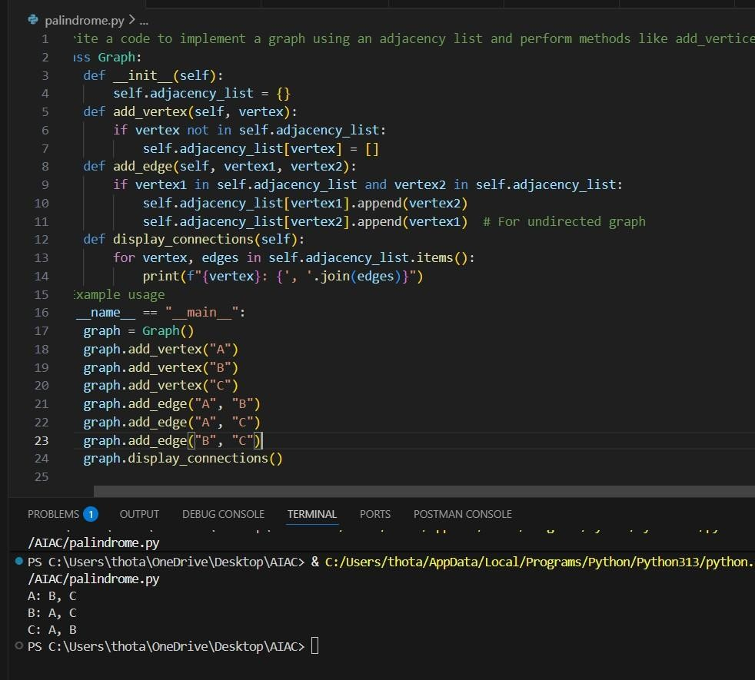

Task Description #7 – Priority Queue
Task: Use AI to implement a priority queue using Python’s heapq module.
Sample Input Code: class PriorityQueue:
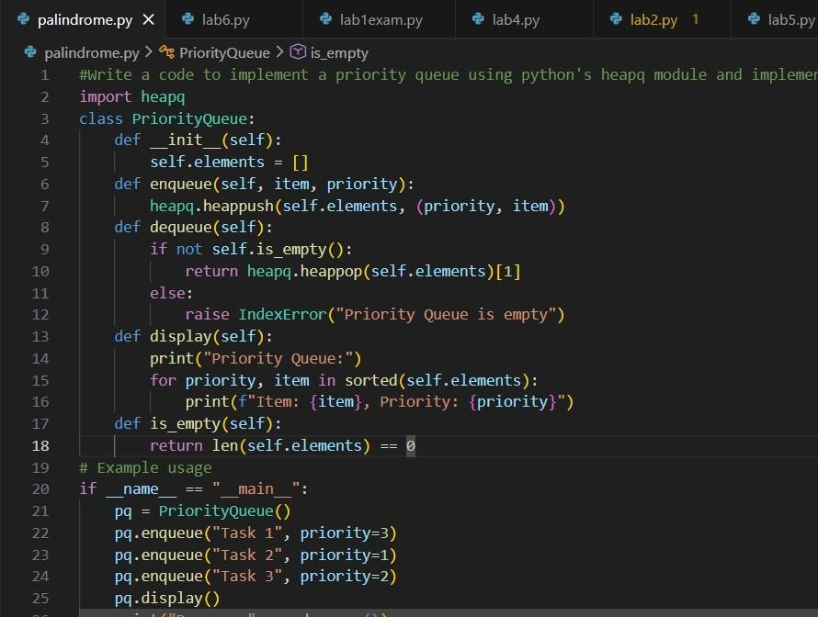

Task Description #8 – Deque
Task: Use AI to implement a double-ended queue using collections.deque. Sample Input Code: class DequeDS:
pass
Expected Output:
• Insert and remove from both ends with docstrings.
PROMPT:
#Write a code to implement a double ended queue using collections.dequeue using insert and remove from both ends with docstring
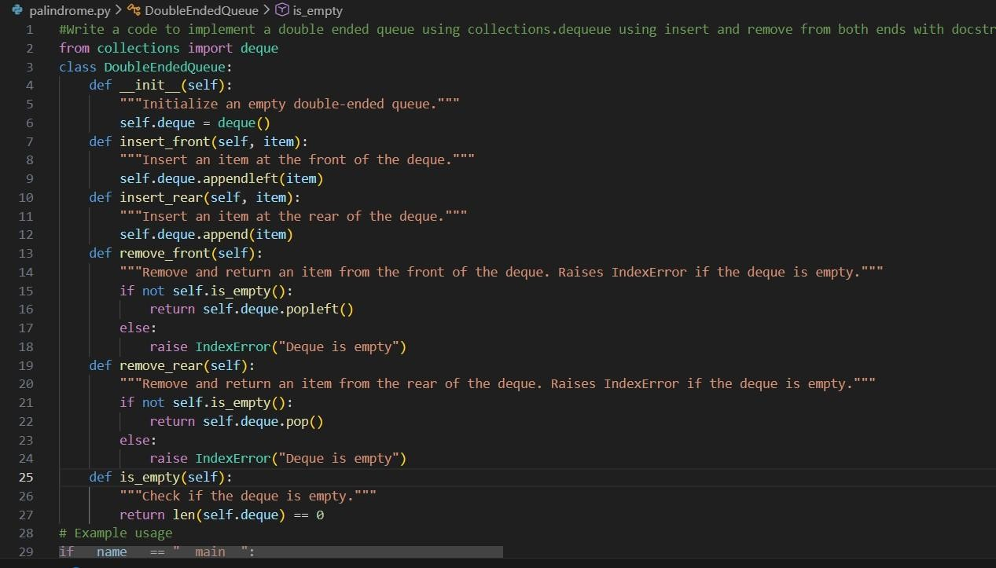
CODE AND OUTPUT:

