**C-DAC Hyderabad**

**Tripti Thakur**

**Assignment-2**

**Roll.no : 230350320123**

Write Java programs to:

1. Display prime numbers between 1 and 100 or 1 and n

Ans. import java.util.Scanner;

class Prime

{

public static void main(String arg[]) {

System.out.println("Enter a number ");

Scanner sc=new Scanner(System.in);

int n=sc.nextInt();

int count=0;

for(int i=1;i<=n;i++)

{

if(n%i==0)

{

count++;

}

}

if(count==2)

System.out.println("prime number ");

else

System.out.println("Not a prime number ");

} }

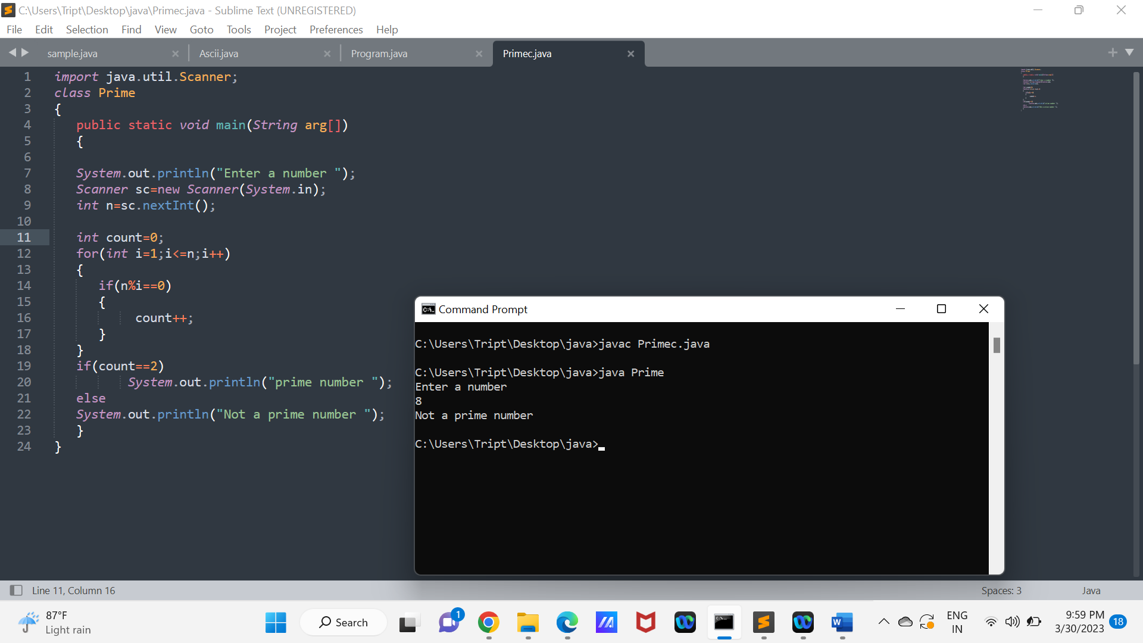

1. Find the factorial of a number.

Ans. import java.util.Scanner;

class Factorial

{

public static void main(String arg[]) {

System.out.println("Enter a number ");

Scanner sc=new Scanner(System.in);

int n=sc.nextInt();

int fact=1;

for(int i=1;i<=n;i++)

{

fact=fact*i;

}

System.out.println("Factorial of a number ="+fact);

}

}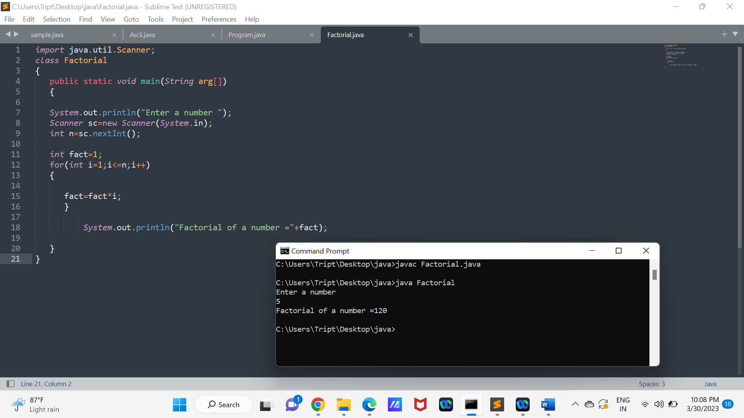

1. Check if a number is palindrome or not.

Ans. import java.util.*;

class Q3{

public static void main(String[] args) {

int n = 100+(int)(Math.random()*900);

System.out.println("Enter a number :"+n);

int r,sum=0;

int temp = n;

while(n>0){

r=n%10;

sum=(sum*10)+r;

n=n/10;

}

if(temp==sum)

System.out.println("palindrome number ");

else

System.out.println("not palindrome");

} }

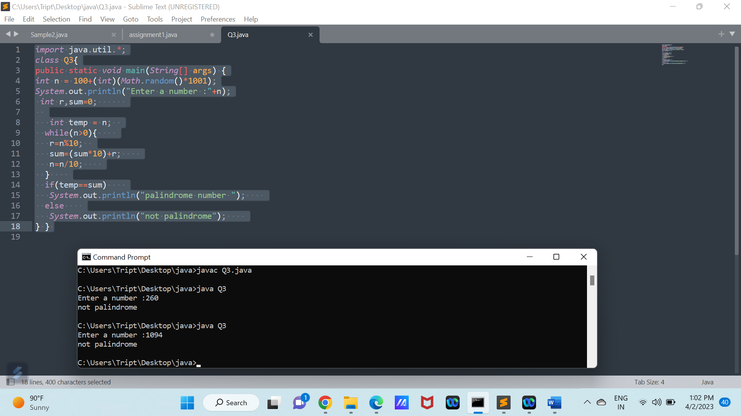

1. Add two integer variables in 5 different ways using methods and control statement.

Ans. class Q4{

static int add1(int x,int y){

return x+y;

}

static void add2(){

int x=10,y=20;

System.out.println("Addition method 2: "+(x+y));

}

static void add3(int x,int y){

int result=x+y;

System.out.println("Addition method 3: "+result);

}

static int add4(){

int x=10,y=20;

int result=x+y;

return result;

}

public static void main(String[] args) {

int a=30,b=20;

System.out.println("Addition method 1: "+add1(a,b));

add2();

add3(a,b);

System.out.println("Addition method 4: "+add4());

int count=0;

do{

int c=a+b;

System.out.println("Addition method 5: "+c);

count++;

if(count==1)

break;

}while(a>0);

}

}

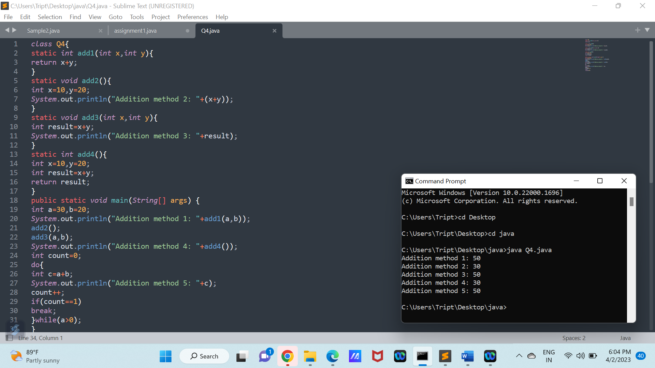

1. Find square root of a number without sqrt method.

Ans. class Q5{

public static void main(String[] args) {

// int a=25;

int a=Integer.parseInt(args[0]);

int sq=0;

for(int i=2;i<=a/2;i++){

if(a%(i*i)==0)

sq=i;

}

if(a==1)

System.out.print("Square root of "+a+" is "+a);

else if(a==(sq*sq))

System.out.print("Square root of "+a+" is "+sq);

else

System.out.print("Square root of "+a+" is not integer value.");

}

}

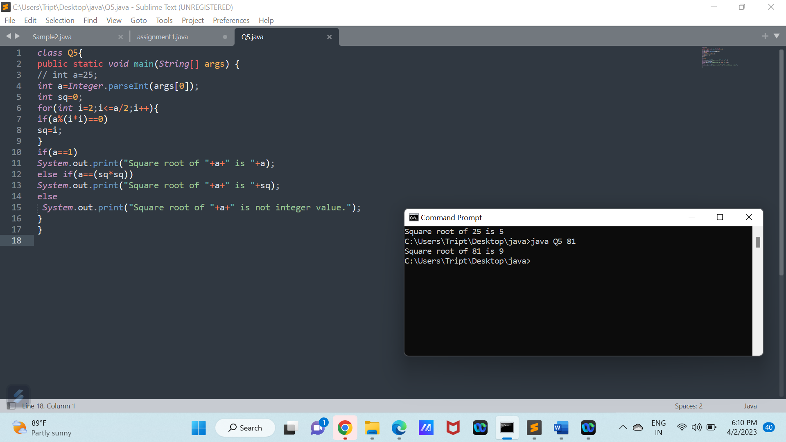

6. Program to Check Armstrong number.

Ans. import java.util.*;

class Q6{

public static void main(String[] args) {

Scanner sc=new Scanner(System.in);

System.out.print("Enter the number: ");

String amstrongNumber=sc.next();

int lengthNumber=amstrongNumber.length();

int sum=0;

int inputNumber=Integer.parseInt(amstrongNumber);

int inputNumber1=0+inputNumber;

// System.out.print(lengthNumber);

do{

for(int j=1;j<=lengthNumber;j++){

int numberDigit=inputNumber%10;

sum+=(int)(Math.pow(numberDigit,lengthNumber));

inputNumber=inputNumber/10;

}

}while(inputNumber>0);

if(sum==inputNumber1)

System.out.print("amstrong number");

else

System.out.print("Not a amstrong number");

}

}

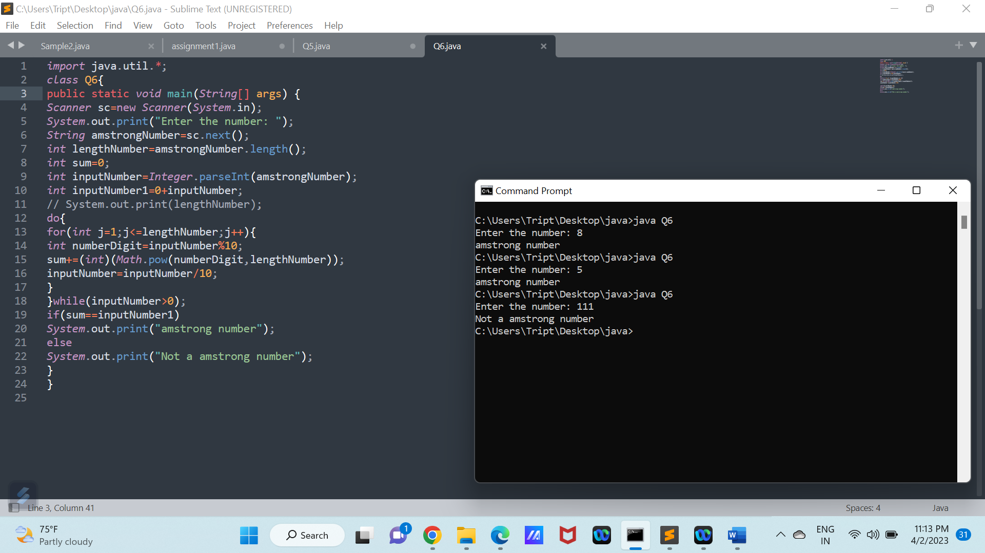

7. Calculate grades of students using their marks.

Ans. import java.util.*;

class StudentGrade{

public static void main(String[] args) {

Scanner sc=new Scanner(System.in);

int sum=0;

System.out.println("Enter the all three subject marks: ");

for(int i=1;i<=3;i++){

System.out.print("Subject "+i+" marks: ");

sum+=sc.nextInt();

}

int grade=sum/3;

if(grade>=90)

System.out.print("A+ grade");

else if(grade>=70 && grade<90)

System.out.print("A grade");

else if(grade>=50 && grade<70)

System.out.print("B grade");

else if(grade>=30 && grade<50)

System.out.print("C grade");

else if(grade<30)

System.out.print("Fail");

}

}

1. Use switch case, recursion, print patterns, etc.

Ans. import java.util.*;

class Recursion{

public static int factorial(int x) {

int total;

if(x==1)

total=1;

else

total=x*factorial(x-1);

return total;

}

public static void main(String[] args) {

Scanner sc=new Scanner(System.in);

System.out.print("Enter the factorial number: ");

int fact=sc.nextInt();

System.out.print("factorial of "+fact+" is "+factorial(fact));

}

}

class SwitchCase{

public static void main(String[] args) {

Scanner sc=new Scanner(System.in);

System.out.print("Enter the 1st number: ");

int a=sc.nextInt();

System.out.print("Enter the 2nd number: ");

int b=sc.nextInt();

System.out.print("choose the operator: + - * ");

char ch=sc.next().charAt(0);

switch(ch)

{

case '+':System.out.print("a+b= "+(a+b));

break;

case '-':System.out.print("a-b= "+(a-b));

break;

case '*':System.out.print("a*b= "+(a*b));

break;

default :System.out.print("not a valid input");

}

}

}

class Pattern{

public static void main(String[] args) {

Scanner sc=new Scanner(System.in);

System.out.print("Enter rows: ");

int rows=sc.nextInt();

System.out.print("Enter coloumns: ");

int col=sc.nextInt();

for(int i=0;i<rows;i++){

for(int j=0;j<col;j++){

System.out.print("* ");

}

System.out.println();

}

}

}

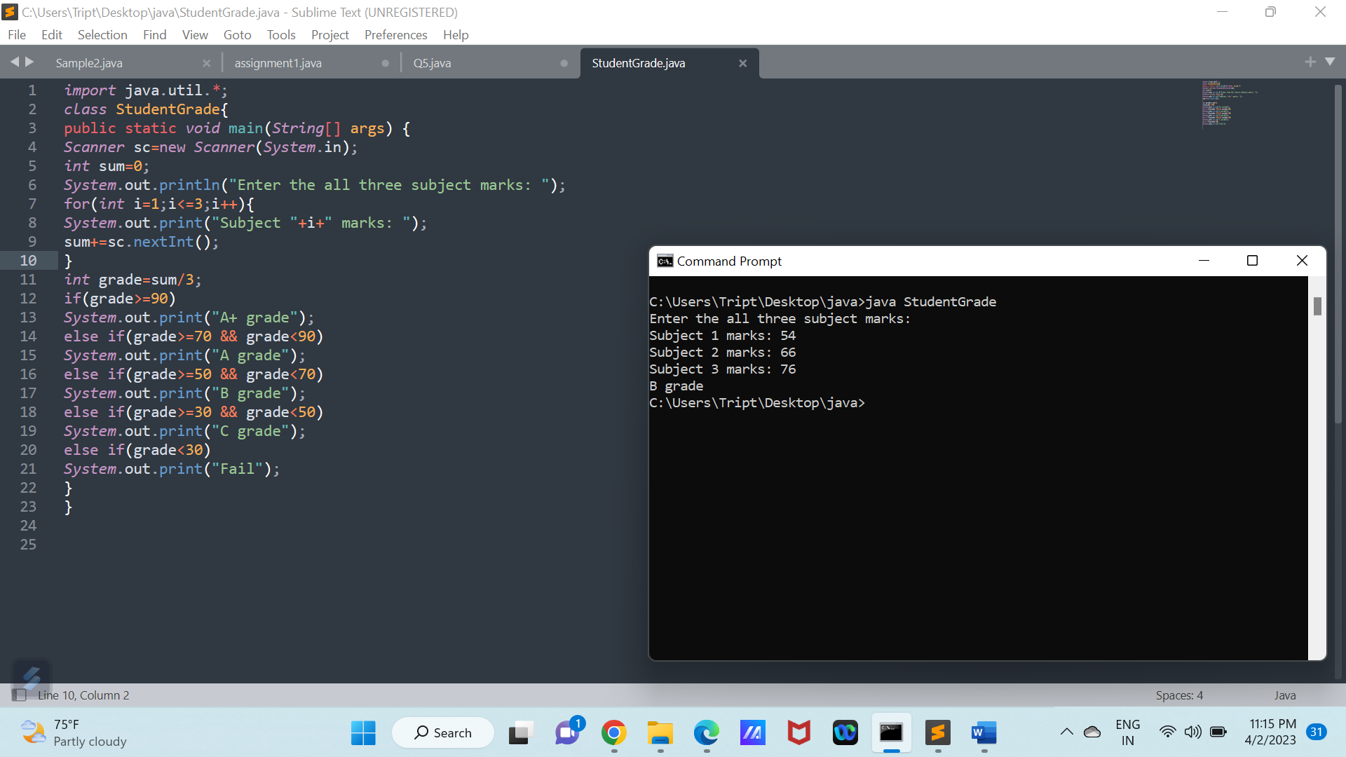

1. Print Fibonacci series till n.

Ans. class Q8{

public static void main(String[] args) {

int n=1+(int)(Math.random()*15);

int fib0=0;

int fib1=1;

System.out.println("The fibonacci series till "+n+" is :");

for(int i=1;i<=n;i++){

System.out.println(fib0);

int sum=fib0+fib1;

fib0=fib1;

fib1=sum;

}

}

}

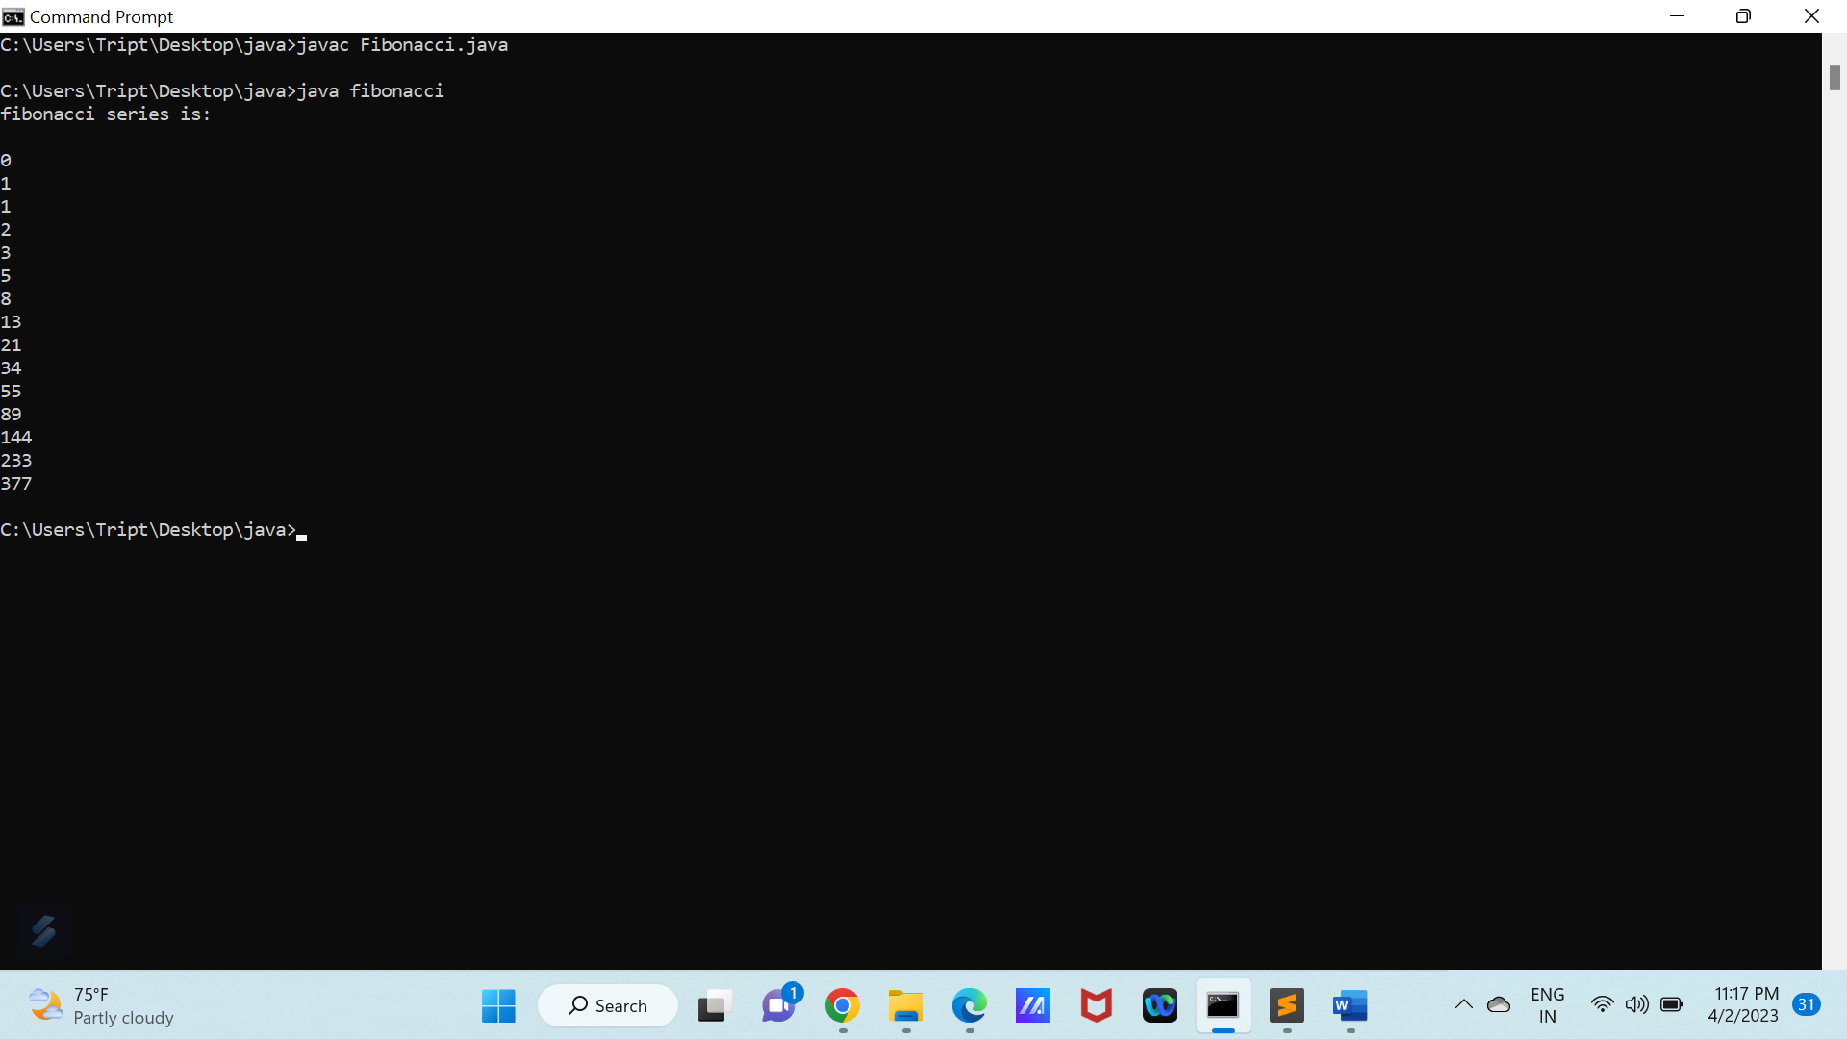

1. Program to find sum of digits of a number.

Ans. class Q9{

public static void main(String[] args) {

int a=11+(int)(Math.random()*1000);

int sum=0;

System.out.print("sum of digits of "+a+" is ");

while(a>0){

sum+=a%10;

a=a/10;

}

System.out.print(sum);

}

}

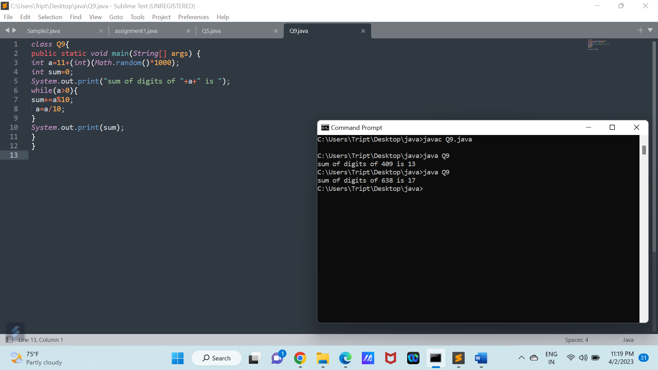

Q10. Program to print math tables in a given range (11 - 25 tables)

Ans. class Q10{

public static void main(String[] args) {

int a,b;

for(a=10;a<=25;a++){

System.out.println("Table of "+a+" is :");

for(int i=1;i<=10;i++){

System.out.println(a+"x"+i+"= "+(a*i));

}

System.out.println();

}

}

}

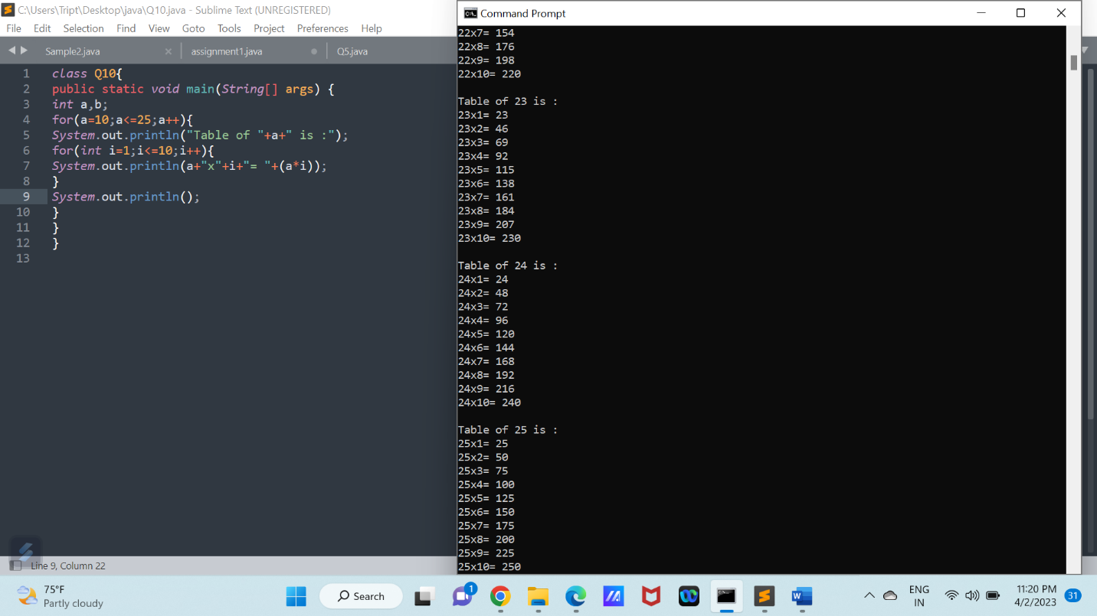

Q11.Write a program to give the examples of operators.

1) Increment and decrement operators.

2) Arithmetic operator.

3) Relational Operator.

4) Bitwise operator.

5) Conditional Operator.

Ans. class Q11{

public static void main(String[] args) {

//increment and decrement

int a=10;

int b=10;

int c=a++; //c=10, after this it will increment(post increment)

int d=++b; //d=11, pre increment

System.out.println("Examples of increment operator are:\na="+a+", b="+b+",

c=a++="+c+", d=++b="+d);

System.out.println();

a=10;

b=10;

c=a--; //c=10, after this it will decrement(post decrement)

d=--b; //d=9, pre decrement

System.out.println("Examples of decrement operator are:\na="+a+",

b="+b+", c=a--="+c+", d=--b="+d);

System.out.println();

//arithmetic operator

a=25;

b=10;

c=a+b; //add

d=a-b; //substract

int e=a*b; //multiply

int f=a/b; //divide

int g=a%b; //provides remainder

System.out.println("Examples of Arithmetic operator are:\na="+a+", b="+b+",

c=a+b="+c+", d=a-b="+d+", e=a*b="+e+", f=a/b="+f+", g=a%b="+g);

System.out.println();

//relational operator

a=25,b=10;

System.out.println("Examples of Relational operator are:");

System.out.println("a="+a+", b="+b+", a>b ="+(a>b)+", a<b ="+(a<b)+", a>=b

="+(a>=b)+", a<=b ="+(a<=b)+", a==b ="+(a==b)+", a!=b="+(a!=b));

System.out.println();

//bitwise operator

a=25;

b=10;

c=a&b;

d=a|b;

e=~a;

f=a^b;

g=a<<b;

int h=a>>b;

int l=a>>>b;

System.out.println("Examples of bitwise operator are:");

System.out.println("a="+a+", b="+b+", a&b ="+c+", a|b ="+d+", ~a ="+e+", a^b ="+f+",

a<<b ="+g+", a>>b="+h+", a>>>b="+l);

System.out.println();

//conditional operators=(condition)?expression 1(if true): expression 2(if false);

a=25;

b=10;

String s=(a>b)?"a is greater":"b is greater";

System.out.println("Examples of conditional operator are:\n(a>b)?\"a is greater\":\"b isgreater\"\nOutput: "+s);

System.out.println();

}

}

