**CDAC Hyderabad**

**PG-DAC March 2023**

**OOPs With Java**

**Assignment 3**

**Tripti Thakur**

**Roll.no : 230350320123**

1. Design a Java program to get a number from user and find the given number is

positive or negative. Display the message.

ANS. import java.util.Scanner;

class QQ1{

public static void main(String[] args) {

Scanner sc = new Scanner(System.in);

int n=sc.nextInt();

if(n>0){

System.out.println("Number is a positive number ="+n);

}else{

System.out.println("Number is a negative number ="+n);

}}}

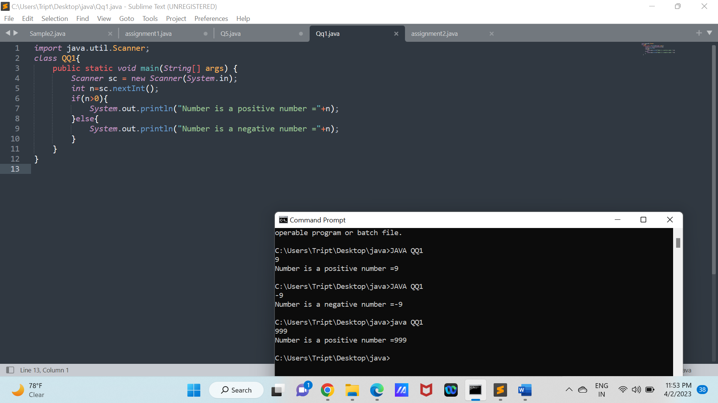

2. Write a Java program to get the age of a person and find the age group of that person as:

Age Category

0-3 Toddlers

4-8 Kids

9-12 Child

13-18 Teens

19-40 Adults

41-60 Matured

Adults

61-75 Seniors

>76 Super

Senios

ANS. import java.util.Scanner;

class QQ2{

public static void main(String[] args) {

int age=(int)(Math.random()*140);

System.out.println("Age of a person :"+age);

System.out.println("The age group of a person:");

if(age>=0 && age<=3)

System.out.println("Toddlers");

else if(age>=4 && age<=8)

System.out.println("Kids");

else if(age>=9 && age<=12)

System.out.println("Child");

else if(age>=13 && age<=18)

System.out.println("Teens");

else if(age>19 && age<=40)

System.out.println("Adult");

else if(age>=41 && age<=60)

System.out.println("Matured Adults");

else if(age>=61 && age<=75)

System.out.println("Seniors");

else

System.out.println("Super Senior");

}

}

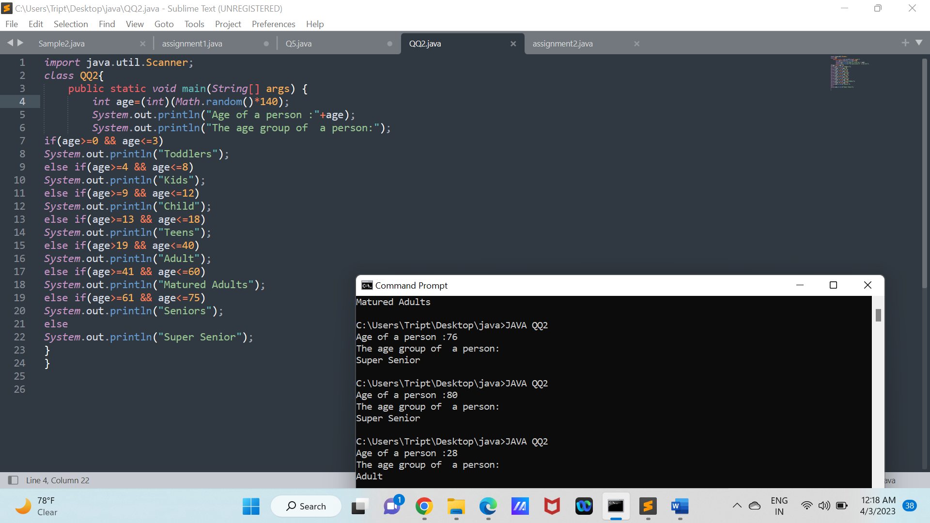

3. Write a program called CozaLozaWoza which prints the numbers 1 to 110, 11 numbers per line. The program shall print "Coza" in place of the numbers which are multiples of 3, "Loza" for multiples of 5, "Woza" for multiples of 7, "CozaLoza" for multiples of 3 and 5, and so on. The output shall look like:

1 2 Coza 4 Loza Coza Woza 8 Coza Loza 11

Coza 13 Woza CozaLoza 16 17 Coza 19 Loza CozaWoza 22

23 oza Loza 26 Coza Woza 29 CozaLoza 31 32 Coza

ANS. public class Coza{

public static void main(String[] args)

{

int i,j;

for(i=1;i<=110;i++){

if(i%11==0) {

if(i%3==0)

System.out.print(" Coza ");

else if(i%5==0)

System.out.print(" Loza ");

else if(i%7==0)

System.out.print(" Woza ");

else if(i%3==0 && i%5==0)

System.out.print(" CozaLoza ");

else

System.out.print(" "+i+" ");

System.out.println();

}

else {

if(i%3==0)

System.out.print(" Coza ");

else if(i%5==0)

System.out.print(" Loza ");

else if(i%7==0)

System.out.print(" Woza ");

else if(i%3==0 && i%5==0)

System.out.print(" CozaLoza ");

else

System.out.print(" "+i+" ");

}

}

}

}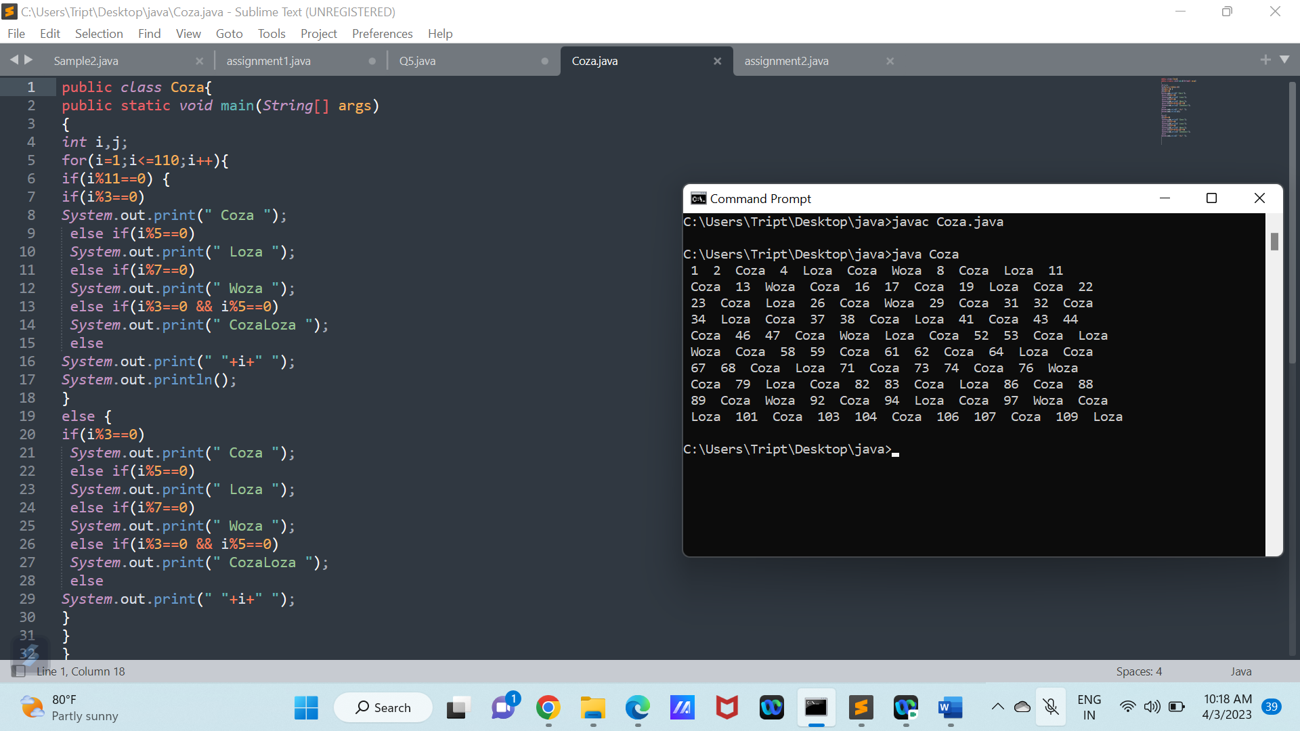

4. Write a Java code to get a number and find whether it is prime number or not.

(note : Prime number is the number divisible by 1 and itself only)

ANS. import java.util.Scanner;

class QQ3{

public static void main(String[] args) {

int i,count=0;

int n = 1+(int)(Math.random()*100);

System.out.println("enter a number :"+n);

for(i=1;i<=n;i++)

{

if(n%i==0)

{

count++;

}

}

if(count==2)

{

System.out.println(n+"is a prime number");

}else{

System.out.println(n+"is not a prime number");

}

}

}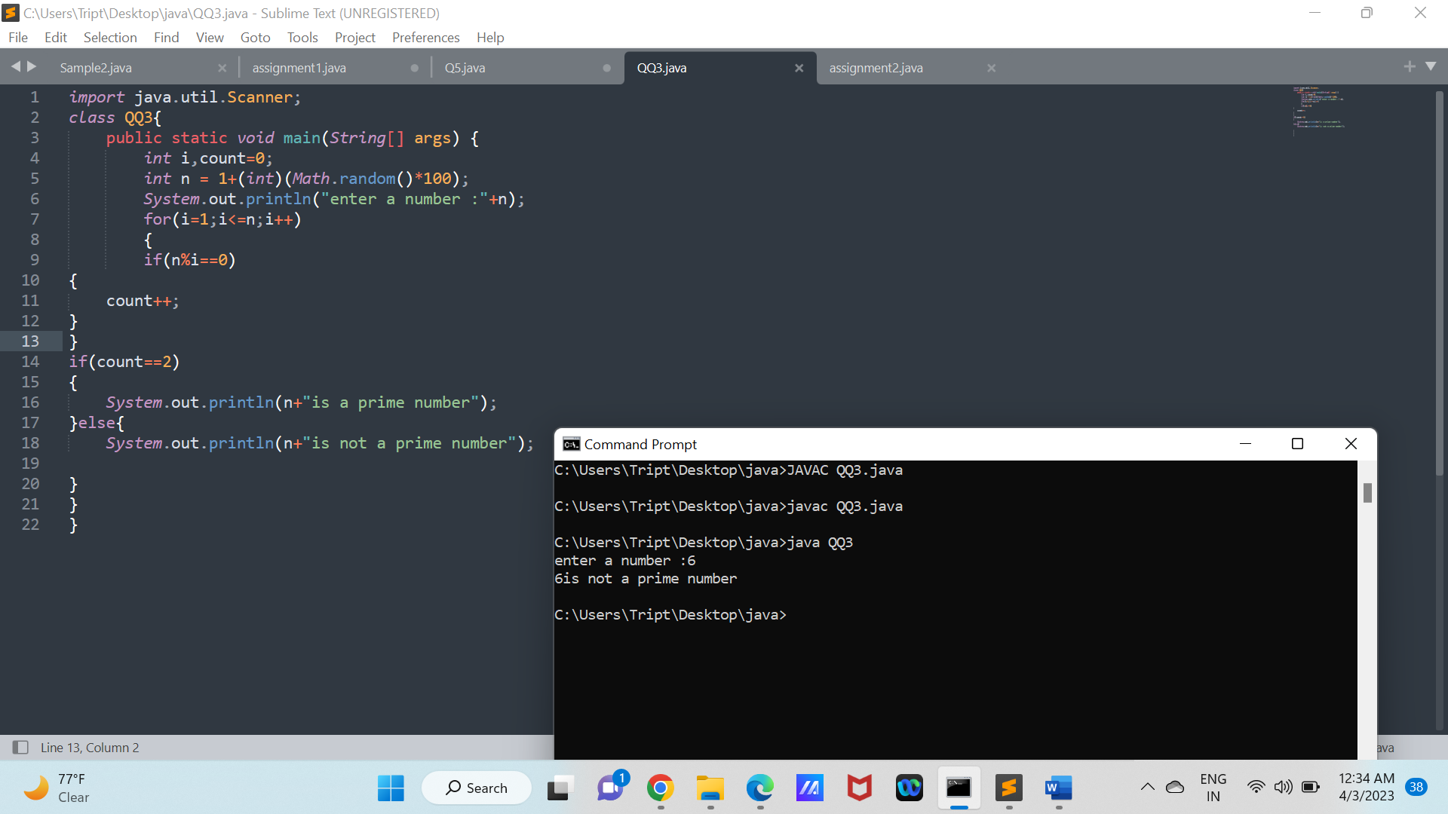

5. Design a Java program to print the following pattern for the positive value ‘n’. Sample Output: Enter any number = 5

*

* *

* * *

* * * *

* * * * *

Ans. import java.util.Scanner;

public class pyramid{

public static void main(String[] args) {

int i,j,k,num;

Scanner sc=new Scanner(System.in);

System.out.println("Enter any number:");

num=sc.nextInt();

for(k=1;k<=num;k++) {

for(i=1;i<=num-k;i++) {

System.out.print(" ");

}

for(j=1;j<=k;j++) {

System.out.print("* ");

}

System.out.println();

}

}

}

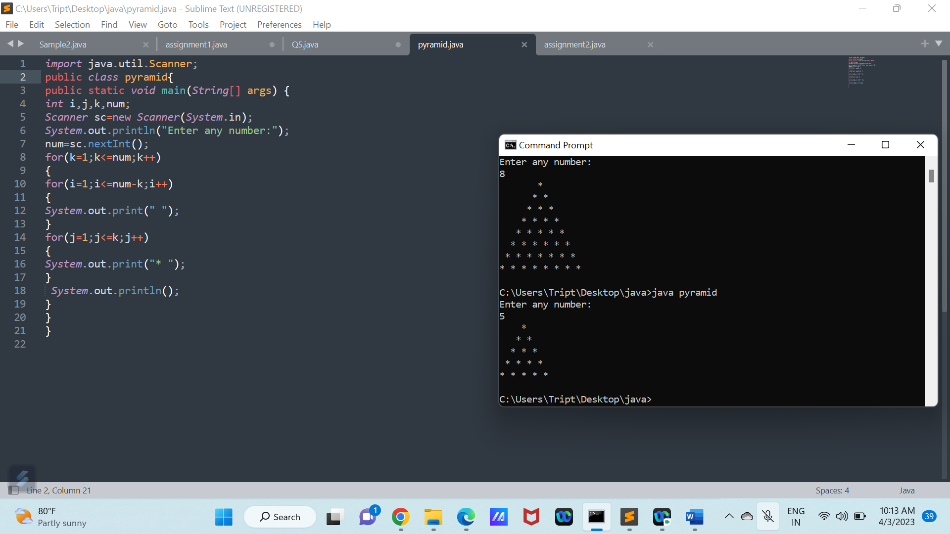

6. Write a Java program that will read in month and day (as numerical value). The

program will return the equivalent zodiac sign.

Sample Output:

Enter month: 6

Enter day: 25

Zodiac sign for June 25 is Cancer

Zodiac Sign Duration

Aquarius Jan 20-Feb 18

Pisces Feb 19-March 20

Aries March 21-April 19

Taurus April 20-May 20

Gemini May 21-June 20

Cancer June 21-July 22

Leo July 23-August 22

Virgo August 23-September 22

Libra September 23-October 22

Scorpio October 23-November 21

Sagittarius November 22-December 21

Capricorn December 22-January 19

Ans. import java.util.Scanner;

public class QQ6{

public static void main(String[] args) {

Scanner sc=new Scanner(System.in);

int n,month;

System.out.println("Enter Month:");

month=sc.nextInt();

System.out.println("Enter day:");

n=sc.nextInt();

switch(month) {

case 1:

if(n>=20 && n<=31)

System.out.println("Zodiac sign for January"+" "+n+" "+"is Aquarius");

else if(n>=1 && n<=19)

System.out.println("Zodiac sign for January"+" "+n+" "+"is Capricorn");

break;

case 2:

if(n>=1 && n<=18)

System.out.println("Zodiac sign for February"+" "+n+" "+"is Aquarius");

else if(n>=19 && n<=28)

System.out.println("Zodiac sign for February"+" "+n+" "+"is Pisces");

break;

case 3:

if(n>=1 && n<=20)

System.out.println("Zodiac sign for March"+" "+n+" "+"is Pisces");

else if(n>=21 && n<=31)

System.out.println("Zodiac sign for March"+" "+n+" "+"is Aries");

break;

case 4:

if(n>=1 && n<=19)

System.out.println("Zodiac sign for April"+" "+n+" "+"is Aries");

else if(n>=20 && n<=30)

System.out.println("Zodiac sign for April"+" "+n+" "+"is Taurus");

break;

case 5:

if(n>=1 && n<=20)

System.out.println("Zodiac sign for May"+" "+n+" "+"is Taurus ");

else if(n>=21 && n<=31)

System.out.println("Zodiac sign for May"+" "+n+" "+"is Gemini");

break;

case 6:

if(n>=1 && n<=20)

System.out.println("Zodiac sign for June"+" "+n+" "+"is Gemini ");

else if(n>=21 && n<=30)

System.out.println("Zodiac sign for June"+" "+n+" "+"is Cancer ");

break;

case 7:

if(n>=1 && n<=22)

System.out.println("Zodiac sign for July"+" "+n+" "+"is Cancer ");

else if(n>=23 && n<=31)

System.out.println("Zodiac sign for July"+" "+n+" "+"is Leo ");

break;

case 8:

if(n>=1 && n<=22)

System.out.println("Zodiac sign for August"+" "+n+" "+"is Leo ");

else if(n>=23 && n<=31)

System.out.println("Zodiac sign for August"+" "+n+" "+"is Virgo ");

break;

case 9:

if(n>=1 && n<=22)

System.out.println("Zodiac sign for September"+" "+n+" "+"is Virgo ");

else if(n>=23 && n<=30)

System.out.println("Zodiac sign for September"+" "+n+" "+"is Libra ");

break;

case 10:

if(n>=1 && n<=22)

System.out.println("Zodiac sign for October"+" "+n+" "+"is Libra ");

else if(n>=23 && n<=31)

System.out.println("Zodiac sign for October"+" "+n+" "+"is Scorpio ");

break;

case 11:

if(n>=1 && n<=21)

System.out.println("Zodiac sign for November"+" "+n+" "+"is Scorpio ");

else if(n>=22 && n<=30)

System.out.println("Zodiac sign for November"+" "+n+" "+"is Sagittarius ");

break;

case 12:

if(n>=1 && n<=21)

System.out.println("Zodiac sign for December"+" "+n+" "+"is Sagittarius ");

else if(n>=22 && n<=31)

System.out.println("Zodiac sign for December"+" "+n+" "+"is Capricorn ");

break;

}

}

}