**CDAC Hyderabad**

**PG-DAC March 2023**

**OOPs With Java**

**Assignment-1**

**Name: Tripti Thakur**

**Roll.no : 230350320123**

1. Write a Java Program to Print Hello World

Ans. class first

{

public static void main(String[] args)

{

System.out.println("Hello World");

}

}

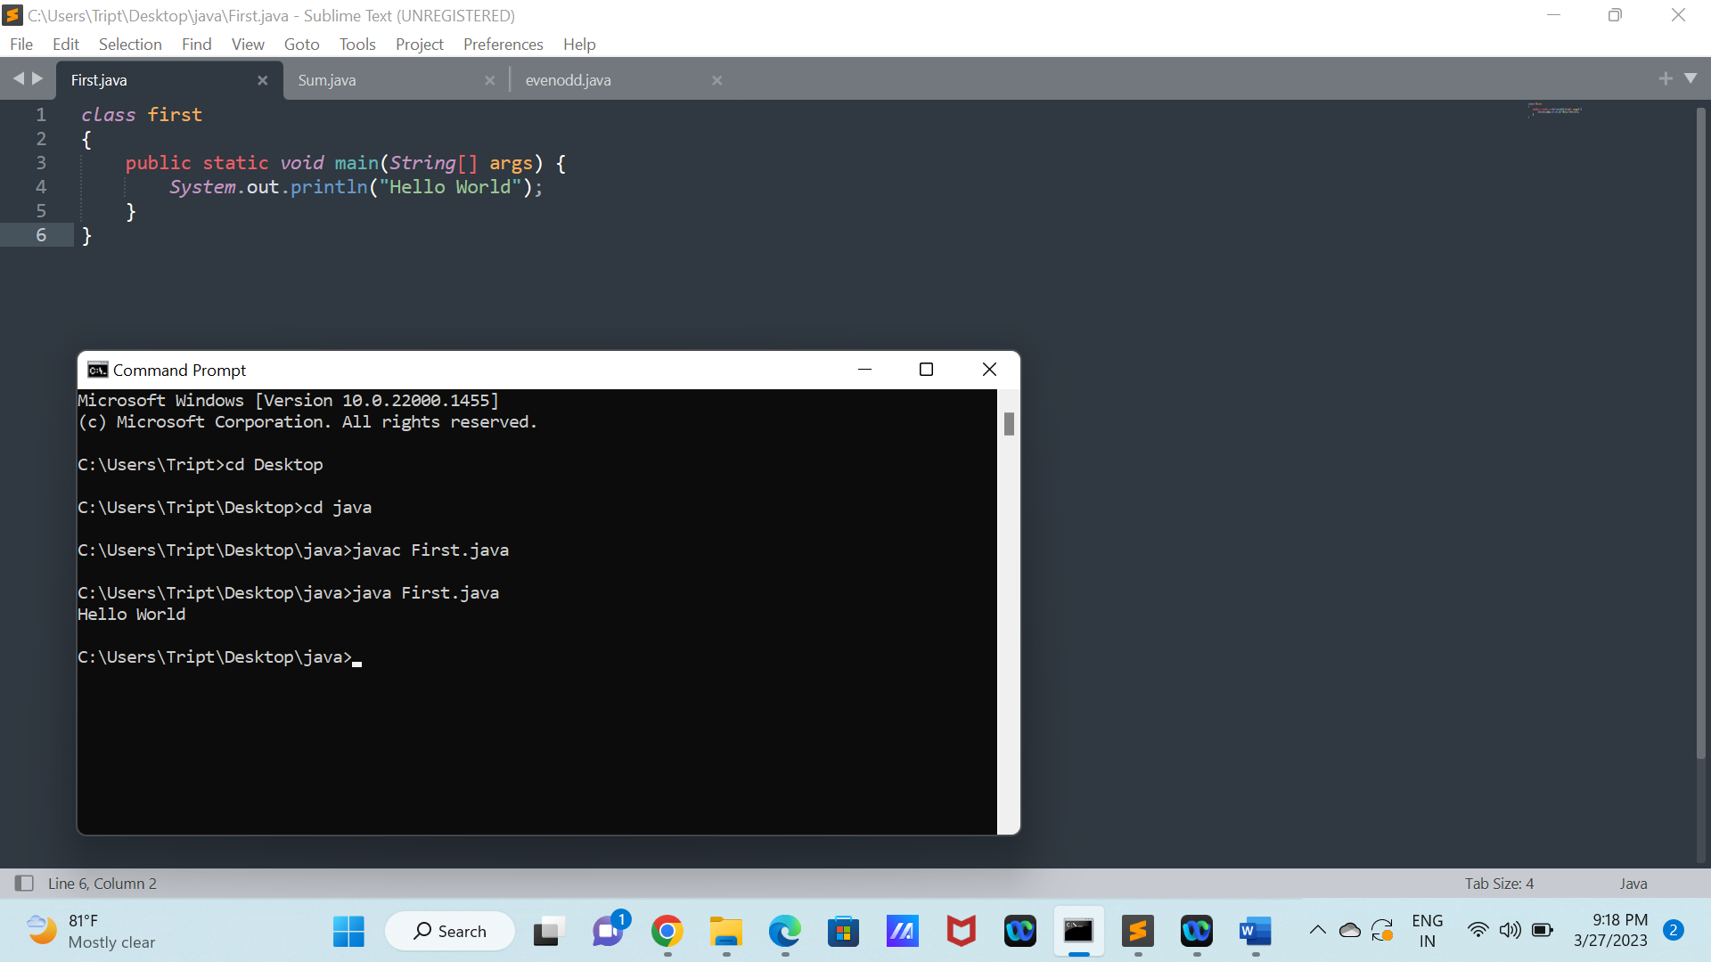

1. Write a Java Program to Add two numbers/binary numbers/characters.

Ans. class add{

public static void main(String[] args) {

int a= Integer.parseInt(args[0]);

int b= Integer.parseInt(args[1]);

System.out.println("Sum :"+(a+b));

}

}

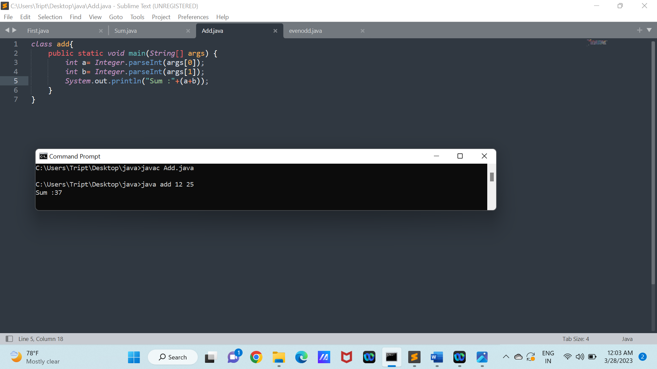

1. Write a Java Program to Calculate compound interest.

Ans.

public class CompoundInterest {

public static void main (String args[]){

double principle=2000, rate=4.5, time=2, compound_interest;

compound_interest = principle * (Math.pow((1 + rate / 100), time)) - principle;

System.out.println("The Compound Interest is : " + compound_interest);

}

}

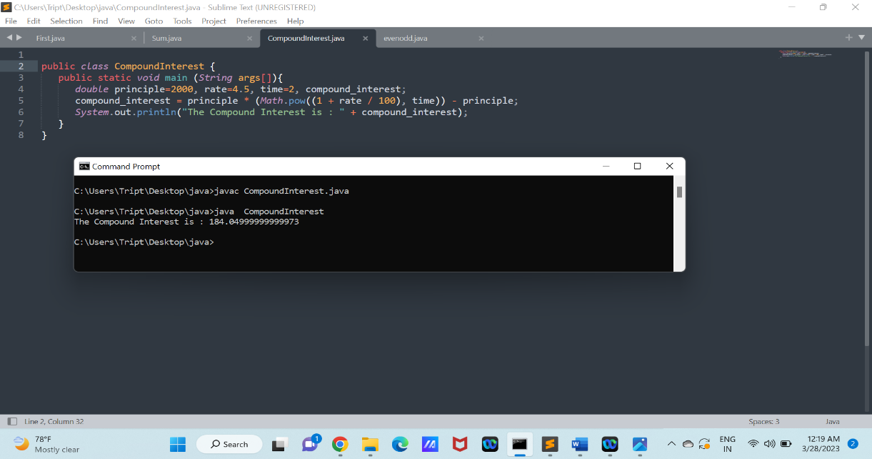

1. Write a Java Program to Calculate power of a number.

Ans. import java.util.Scanner;

class Power{

public static void main(String[] args) {

Scanner sc=new Scanner(System.in);

int a = sc.nextInt();

int b = sc.nextInt();

int power=1;

for(int i=0;i<b;i++)

power=power*a;

System.out.println("Power of a given number :"+power);

}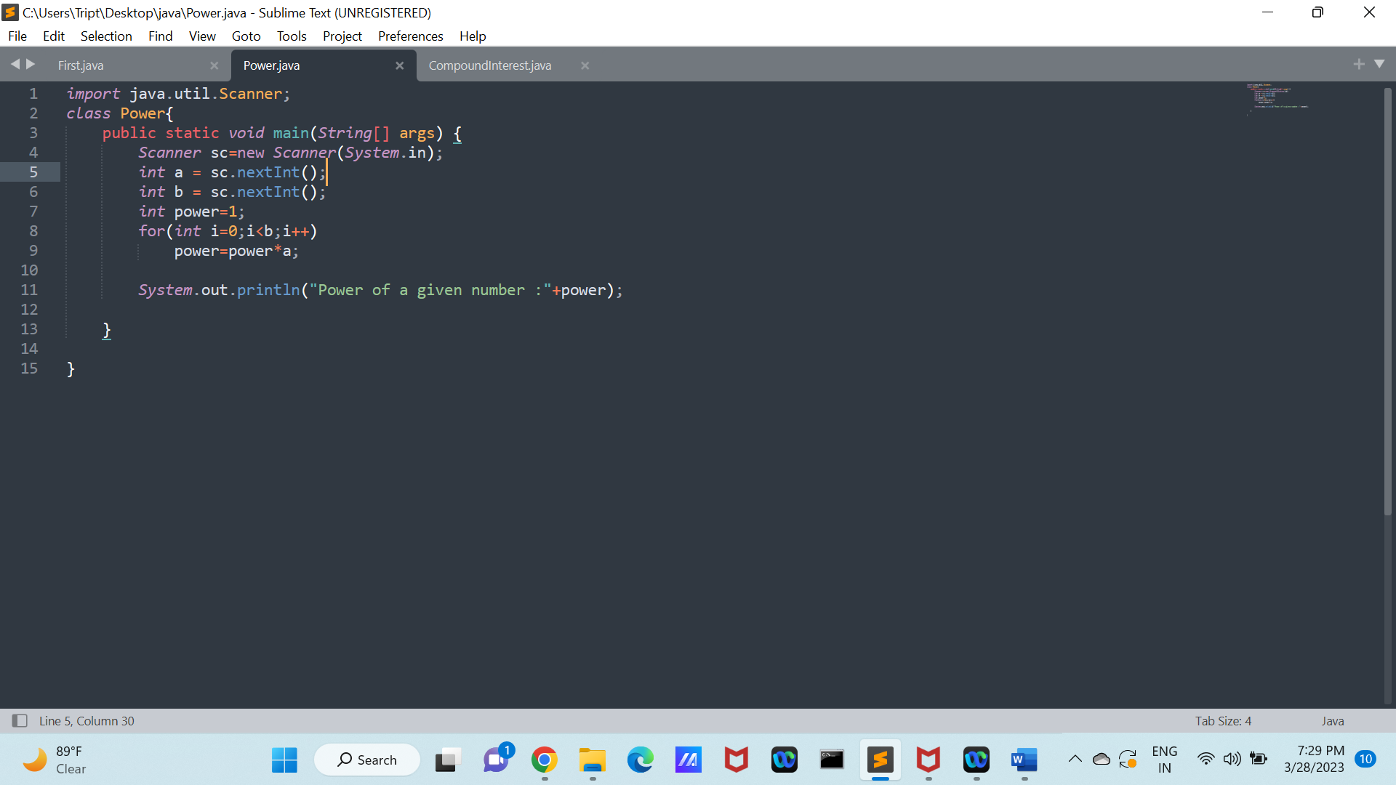

}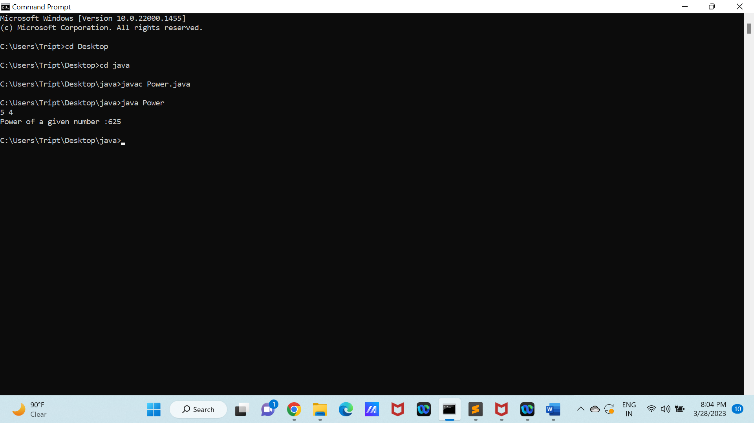

1. Write a Java Program to Swap two numbers.

Ans. import java.util.Scanner;

class Swap{

public static void main(String[] args) {

Scanner sc=new Scanner(System.in);

System.out.println("Enter the value of a and b:");

int a = sc.nextInt();

int b = sc.nextInt();

System.out.println("before swapping:"+a+" "+b);

int temp=0;

temp=a;

a=b;

b=temp;

System.out.println("After swapping number :"+a+" "+b);

}

}

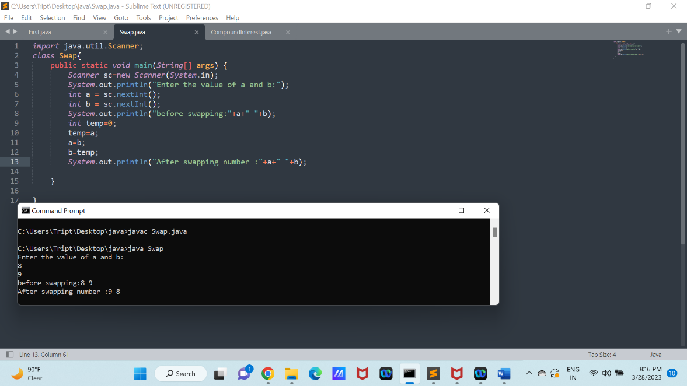

1. Write a Java Program to Calculate area of rectangle.

Ans. import java.util.Scanner;

class Rectangle{

public static void main(String[] args) {

Scanner sc=new Scanner(System.in);

System.out.println("Enter the value of length and breadth:");

float l = sc.nextFloat();

float b = sc.nextFloat();

float rect =l*b;

System.out.println("Area of a rectangle :"+rect+"square metre");

}

}

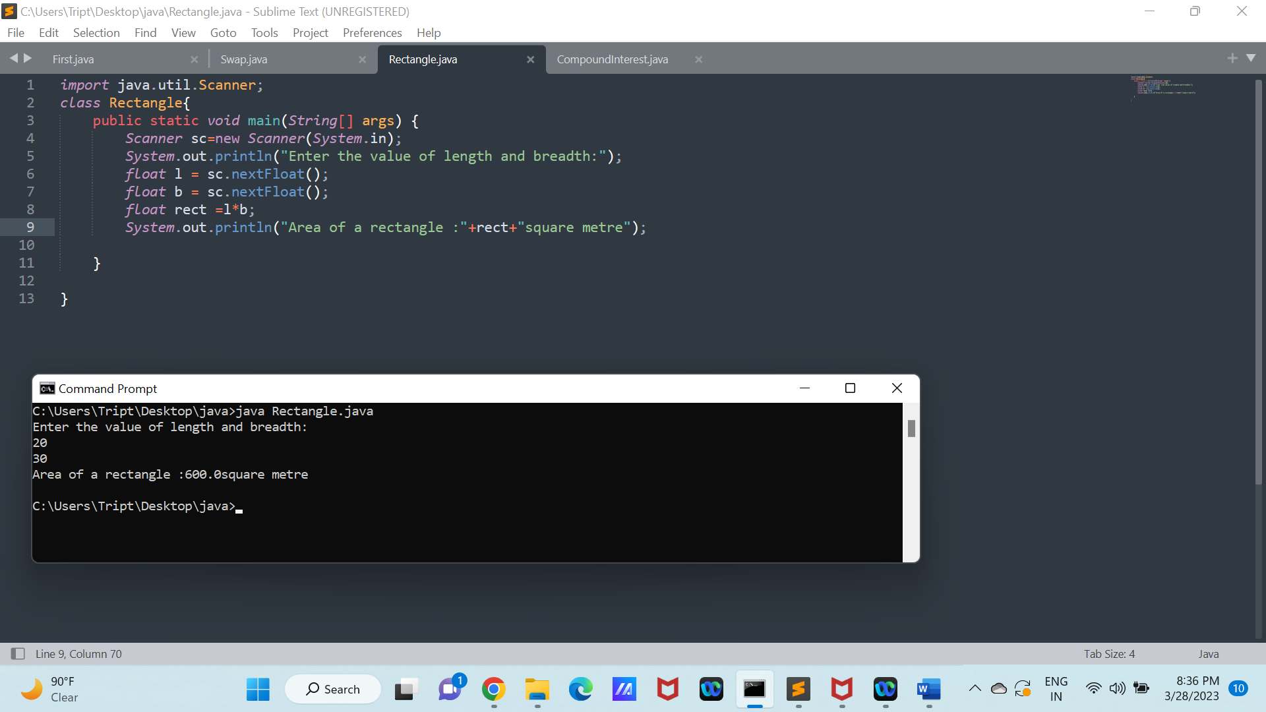

1. Write a Java Program to Calculate area and circumference of circle using multiple classes.

Ans. import java.util.Scanner;

public class circle{

public static void main(String[] args) {

Scanner sc= new Scanner(System.in);

System.out.println("Enter radius of a circle :");

float r=sc.nextFloat();

float circum=2*(float)Math.PI*r;

float area = (float)Math.PI*r*r;

System.out.println("circumference of a circle :"+circum);

System.out.println("Area of a circle :"+area);

}

)

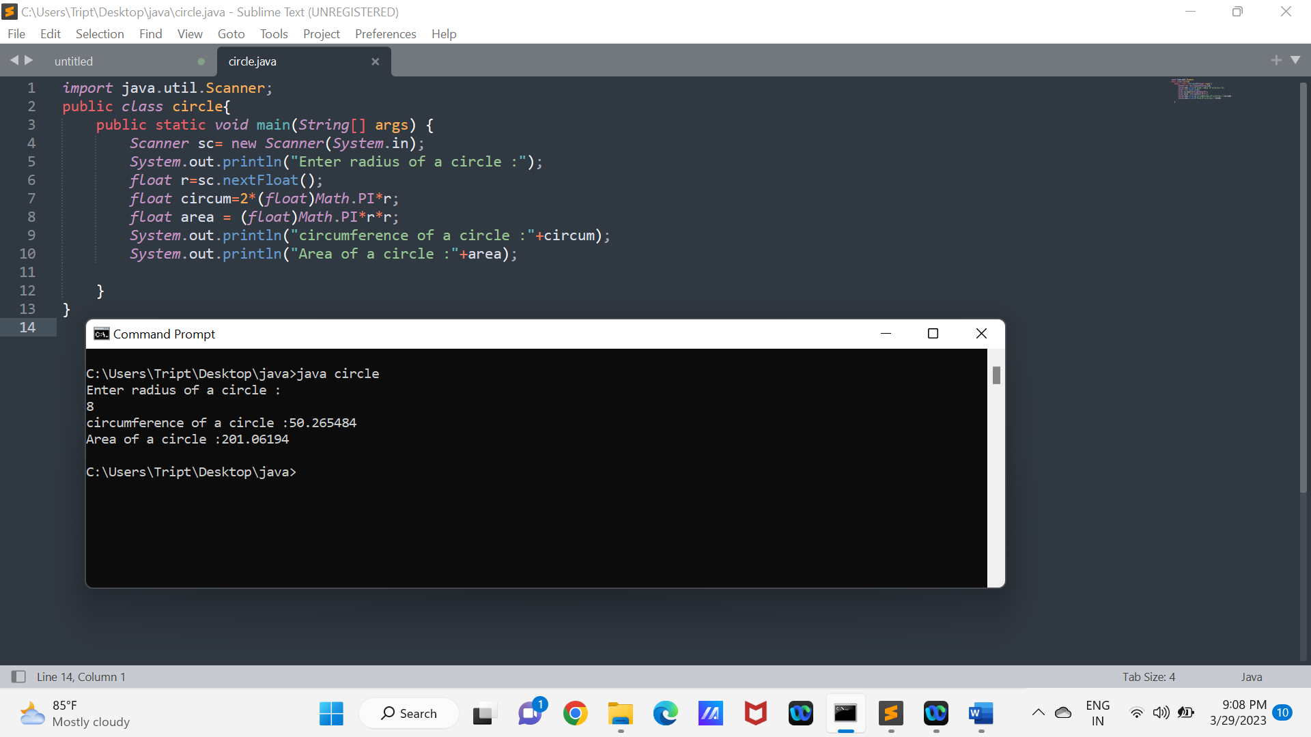

1. Write a Java Program to find ASCII value of a character.

Ans. import java.util.*;

public class Ascii{

public static void main(String[] args) {

Scanner sc=new Scanner(System.in);

System.out.println("Enter a character:");

char a=sc.next().charAt(0);

int b=a;

System.out.println("The Ascii value of a character:"+b);

}

}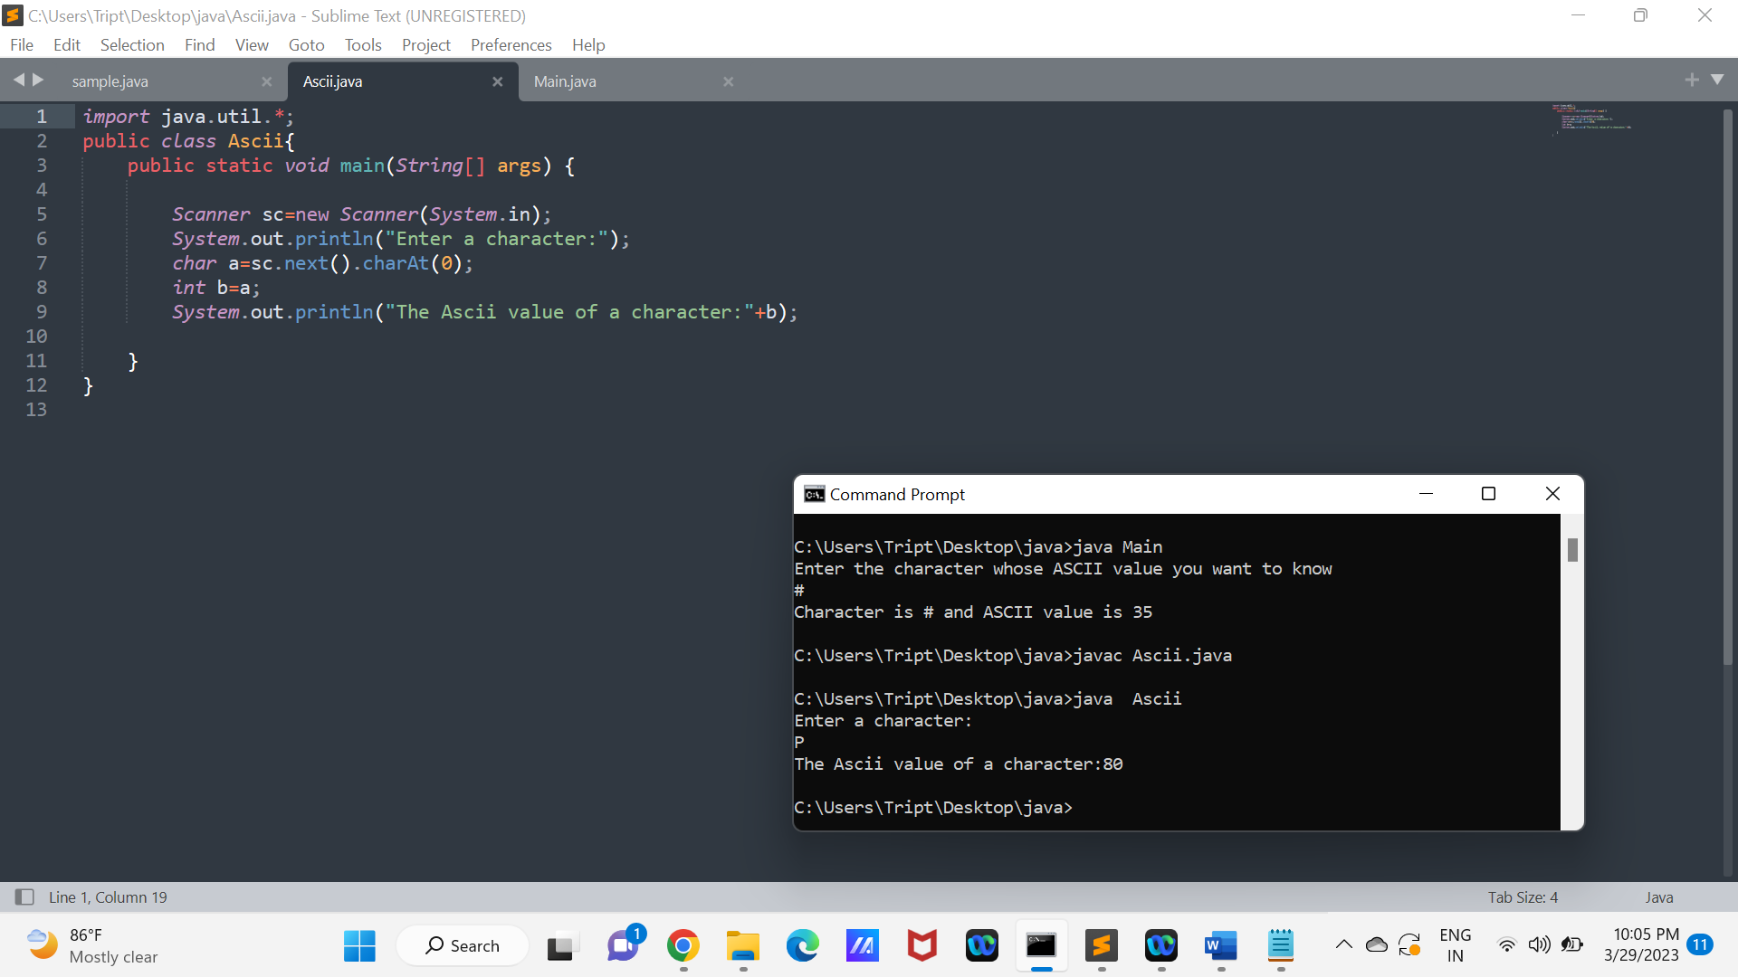

9. Write a Java Program to Print default values of primitive data type variables.

Ans. public class Primitive {

static boolean a;

static int b;

static long c;

static byte d;

static float e;

static double f;

static short g;

static char h;

public static void main(String[] args) {

System.out.println("Default value of boolean Type = " + a);

System.out.println("Default value of int Type = " + b);

System.out.println("Default value of long Type = " + c);

System.out.println("Default value of byte Type = " + d);

System.out.println("Default value of float Type = " + e);

System.out.println("Default value of double Type = " + f);

System.out.println("Default value of short Type = " + g);

System.out.println("Default value of char Type = " + h);

}

}

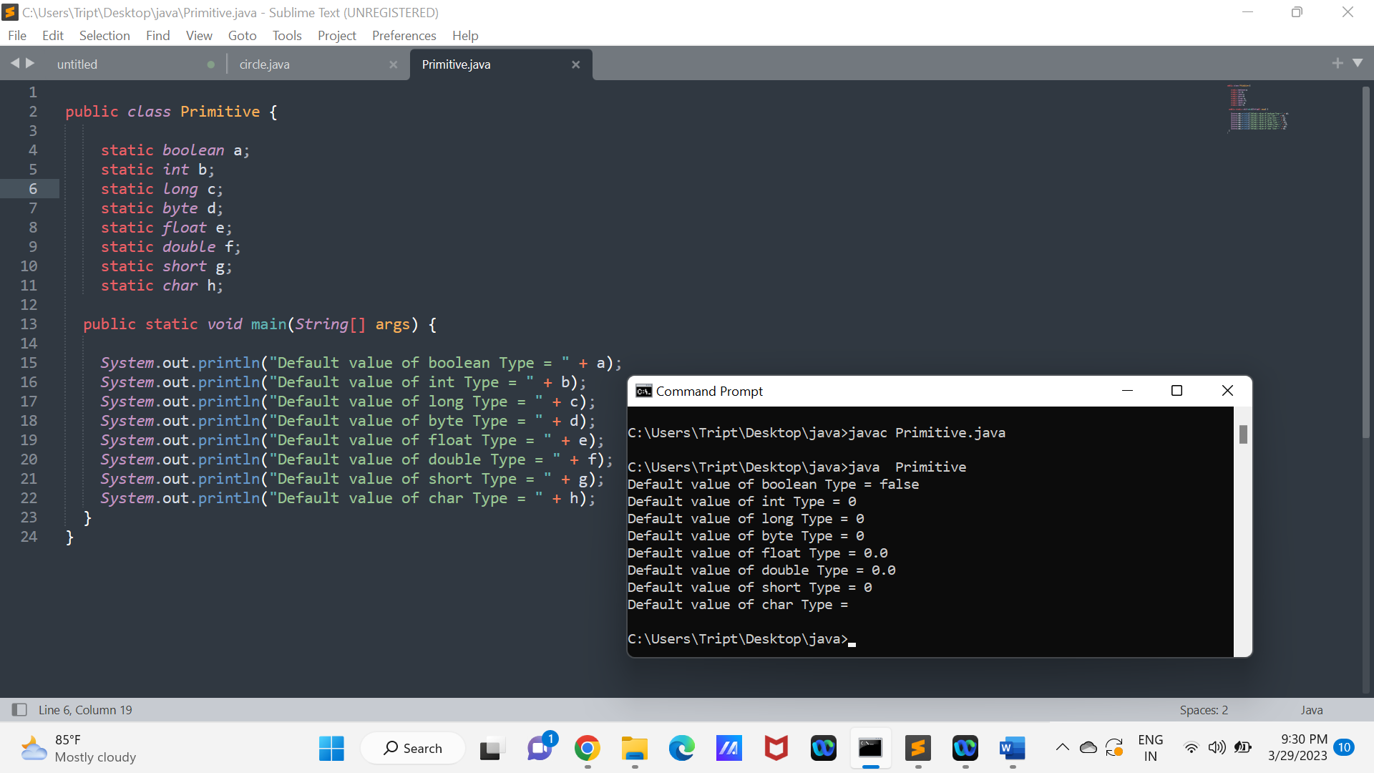

10. Write a Java Program to Swap two variables without using the third variable.

Ans. import java.util.Scanner;

class Swapping{

public static void main(String[] args) {

Scanner sc=new Scanner(System.in);

System.out.println("Enter the value of a and b:");

int a = sc.nextInt();

int b = sc.nextInt();

System.out.println("before swapping:"+a+" "+b);

a=a+b;

b=a-b;

a=a-b;

System.out.println("After swapping number :"+a+" "+b);

}}

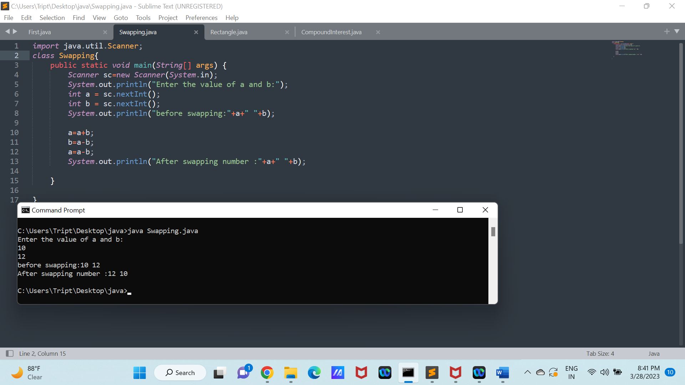

11. Write a Java Program to Print Fibonacci series till n times.

Ans. class fibonacci

{

public static void main(String[] args) {

int n=15;

int fib0 =0, fib1 =1;

System.out.println("fibonacci series is:\n");

for(int i=0;i<15;i++){

System.out.println(fib0);

int sum=fib0 + fib1;

fib0=fib1;

fib1=sum;

}

}

}

