AI ASSISTED CODING ASSIGNMENT – 8
D.Likhitha(2303A51009)
BATCH-01
Task 1: (Username Validator – Apply AI in Authentication Context)
Task: Use AI to generate at least 3 assert test cases for a
function is_valid_username(username) and then implement
the function using Test-Driven Development principles.
• Requirements:
o Username length must be between 5 and 15 characters.
o Must contain only alphabets and digits.
o Must not start with a digit.
o No spaces allowed
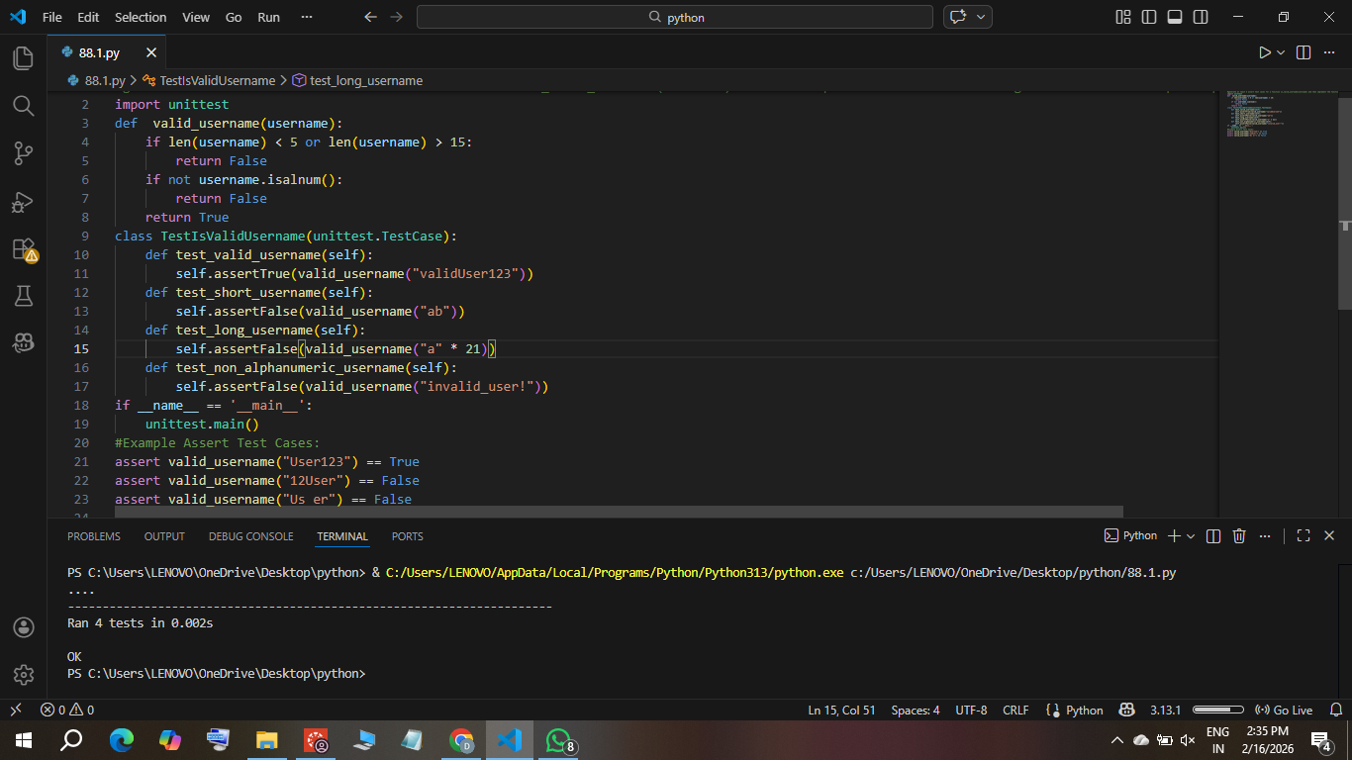
Expected Output :
• Username validation logic successfully passing all AI-
generated test cases.

Task:2 (Even–Odd & Type Classification – Apply AI for Robust Input Handling)
• Task: Use AI to generate at least 3 assert test cases for a
function classify_value(x) and implement it using conditional
logic and loops.
• Requirements:
o If input is an integer, classify as "Even" or "Odd".
o If input is 0, return "Zero".
o If input is non-numeric, return "Invalid Input".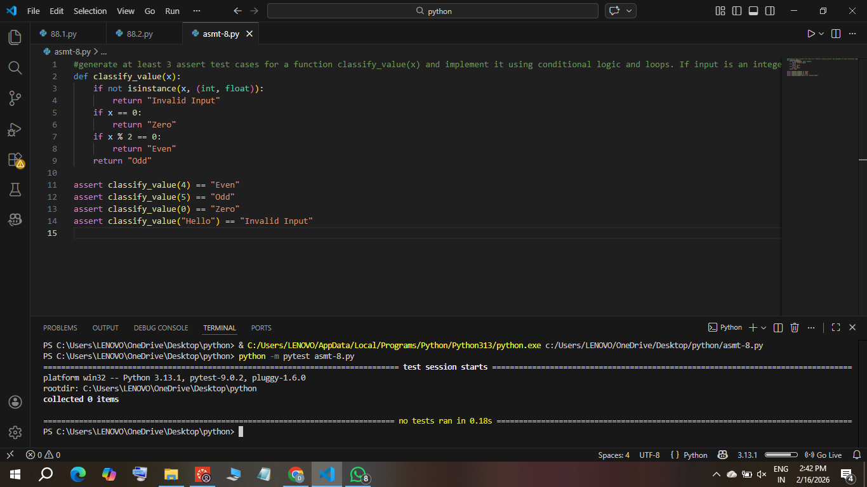
Expected Output #2:
• Function correctly classifying values and passing all test
cases.
Task3: (Palindrome Checker – Apply AI for String Normalization
Task: Use AI to generate at least 3 assert test cases for a
function is_palindrome(text) and implement the function.
• Requirements:
o Ignore case, spaces, and punctuation.
o Handle edge cases such as empty strings and single
characters.
Expected Output:
• Function correctly identifying palindromes and passing all AI-generated tests.
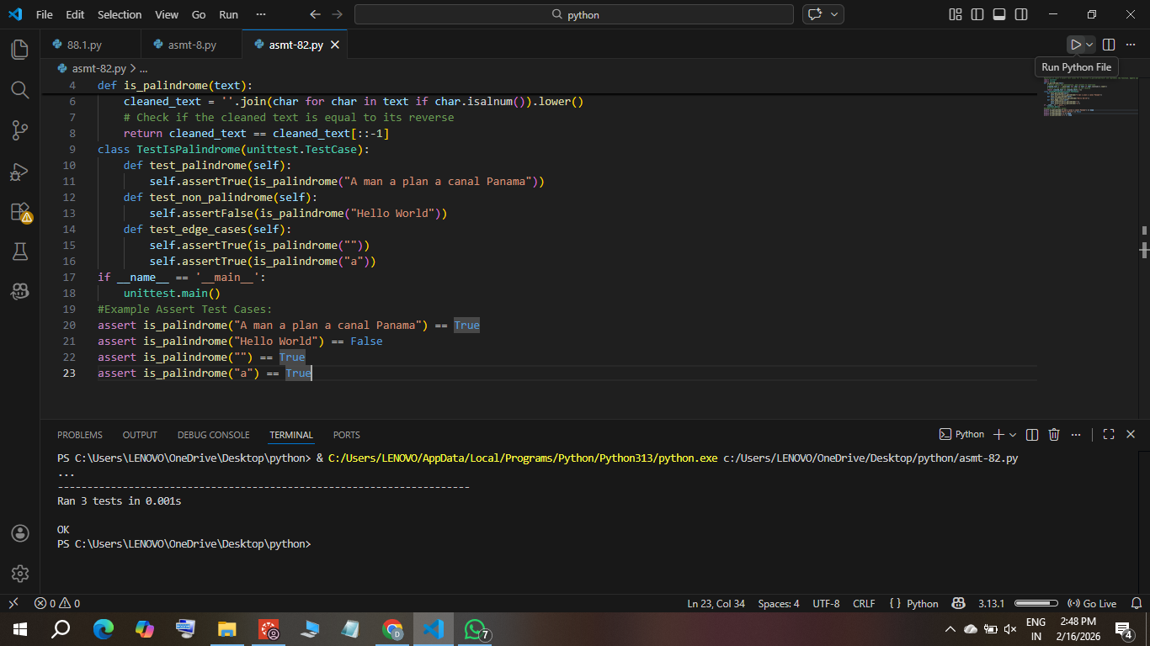

Task 4 (Email ID Validation – Apply AI for Data Validation)
Task: Use AI to generate at least 3 assert test cases for a function validate_email(email) and implement the function.
• Requirements:
Must contain @ and .
Must not start or end with special characters.
Should handle invalid formats gracefully
Expected Output : Email validation function passing all AI-generated test cases and handling edge cases correctly.
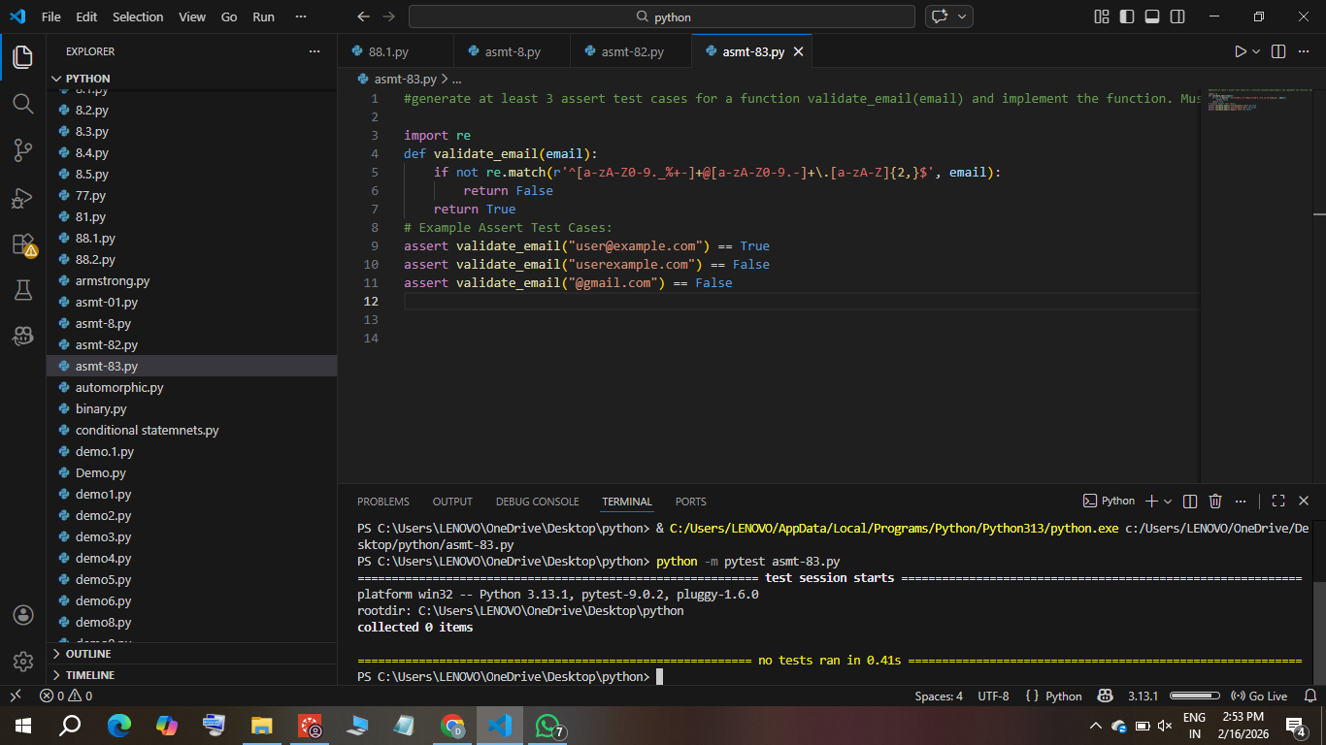

Task 5: (Perfect Number Checker – Test Case Design)
Task:
Check if a number is a perfect number (sum of divisors = number)..
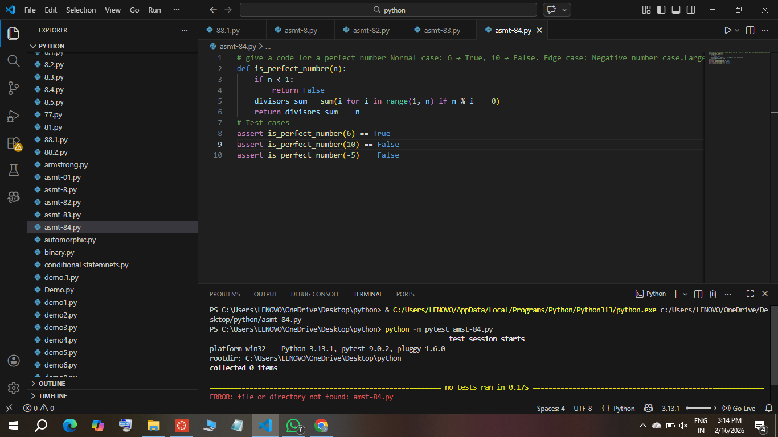

Task 6 (Abundant Number Checker – Test Case Design)
Task
Check if a number is abundant (sum of divisors >number)
Test Cases to Design:
o Normal case: 12 → True, 15 → False.
o Edge case: 1.
o Negative number case.
o Large case: 945.
Requirement: Validate correctness with unittest

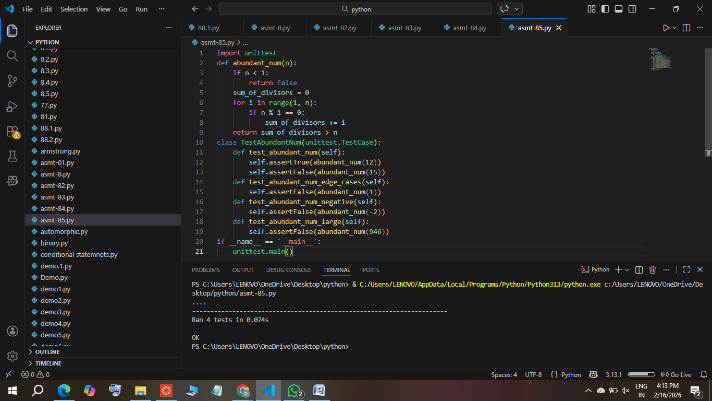
Task 7 (Deficient Number Checker – Test Case Design)
Task: Check if a number is deficient (sum of divisors <number).
Requirement: Validate correctness with pytest.
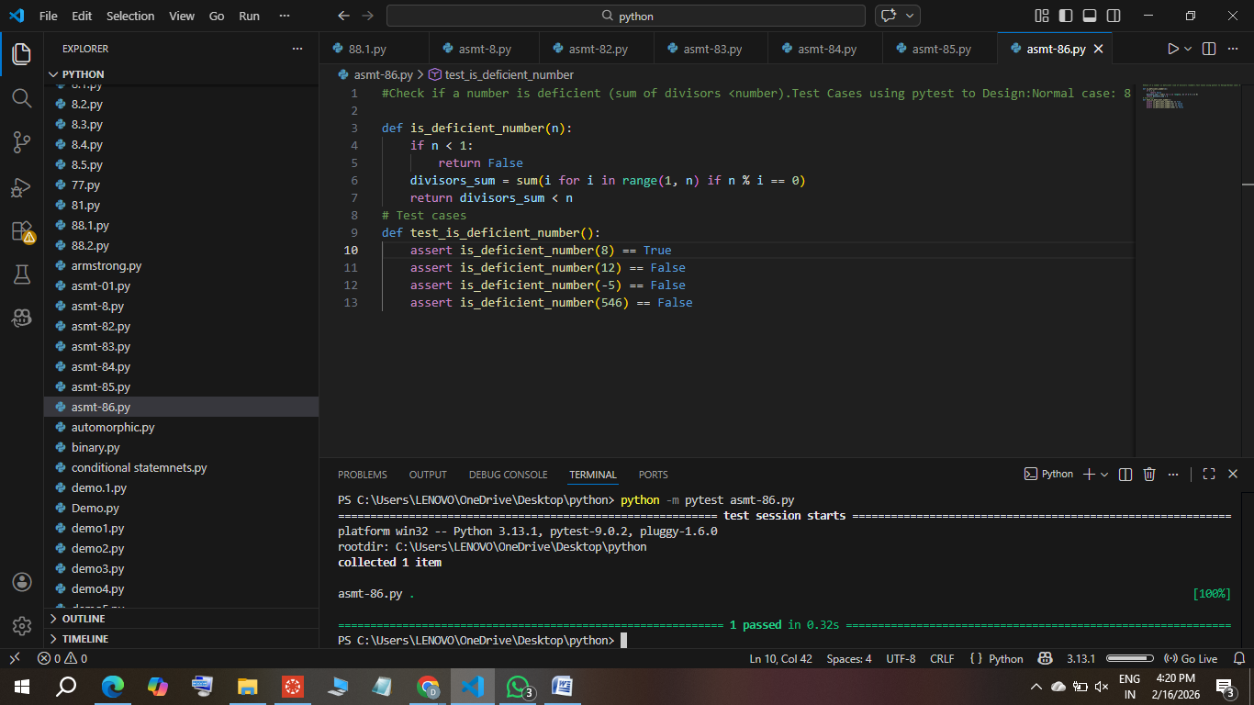

Task 8 :
Write a function LeapYearChecker and validate its implementation using 10 pytest test cases
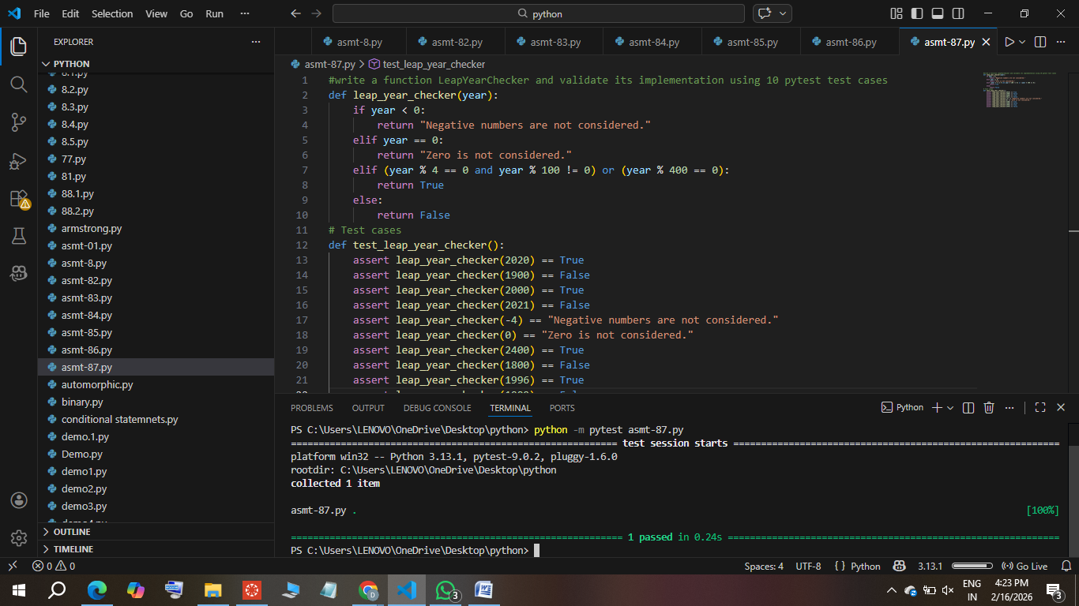

Task 9: Write a function SumOfDigits and validate its implementation
using 7 pytest test cases.
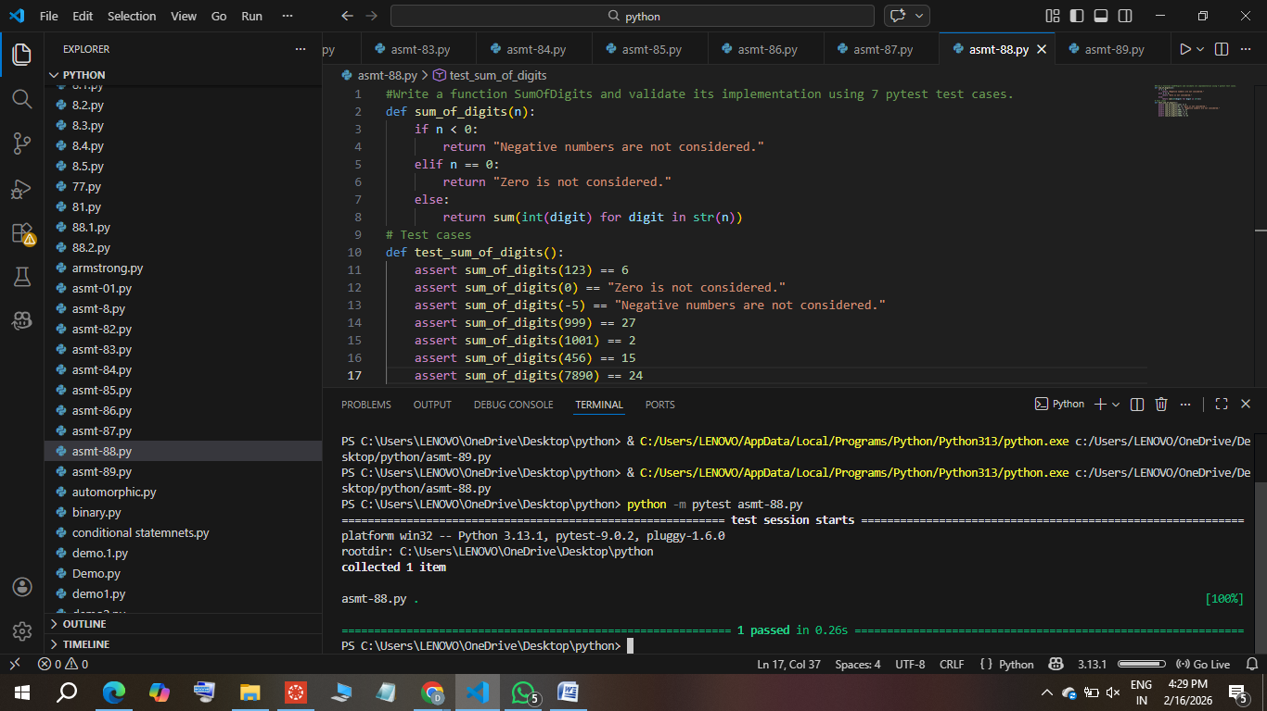

Task 10
Write a function SortNumbers (implement bubble sort) and validate its implementation using 25 pytest test cases.
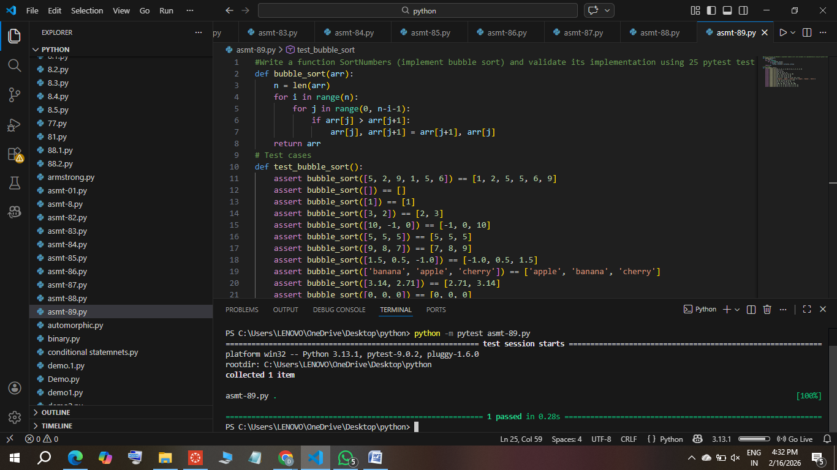
Task 11
Write a function ReverseString and validate its implementation using 5 unittest test cases
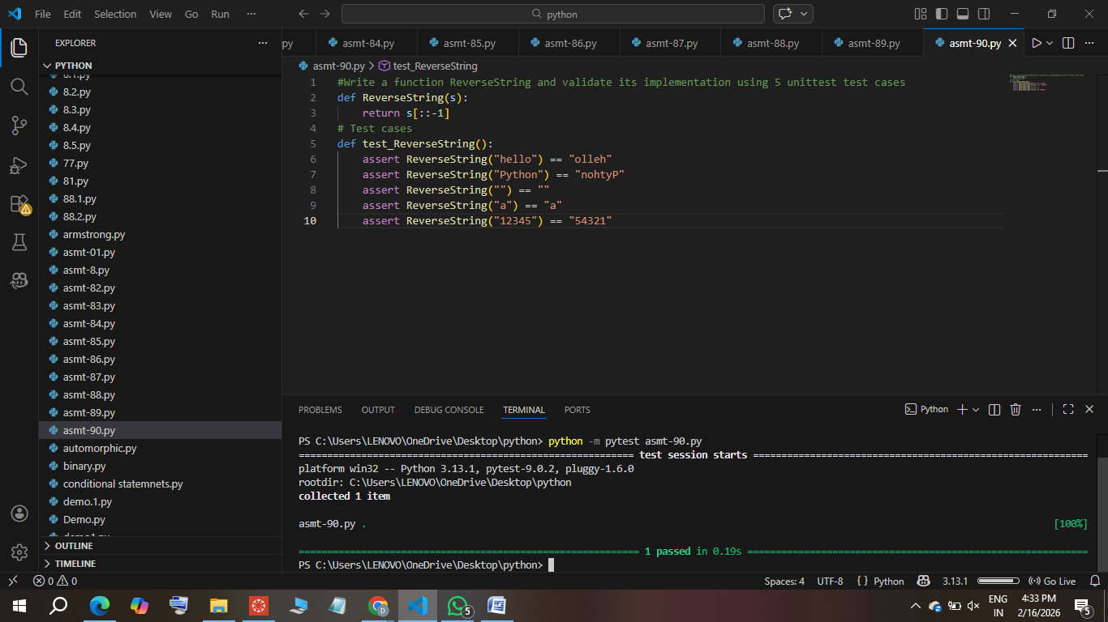
Task 12
Write a function AnagramChecker and validate its implementation using 10 unittest test cases.
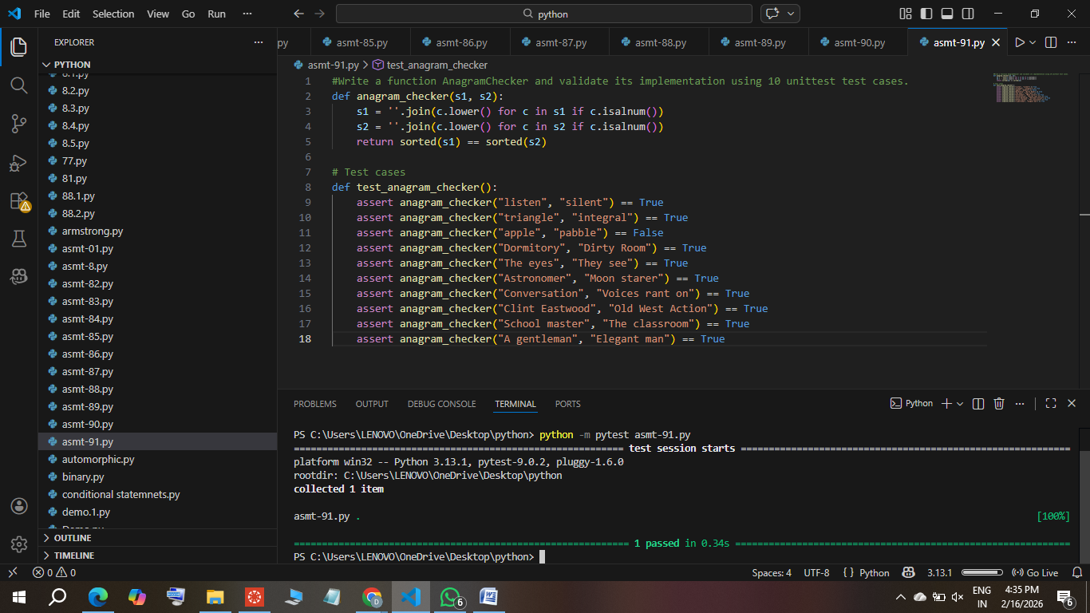

Task 13
Write a function ArmstrongChecker and validate its implementation using 8 unittest test cases.
