NAME: D.likhitha
HTNO: 2303A51009

AI ASSISTED CODING ASSIGNMENT-11.2

Task Description #1 – Stack Implementation
Task: Use AI to generate a Stack class with push, pop, peek, and is_empty methods. Sample Input Code:
class Stack:
pass
Expected Output:
- A functional stack implementation with all required methods and docstrings.
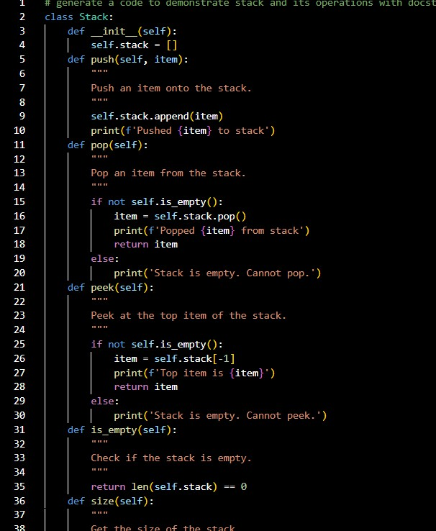

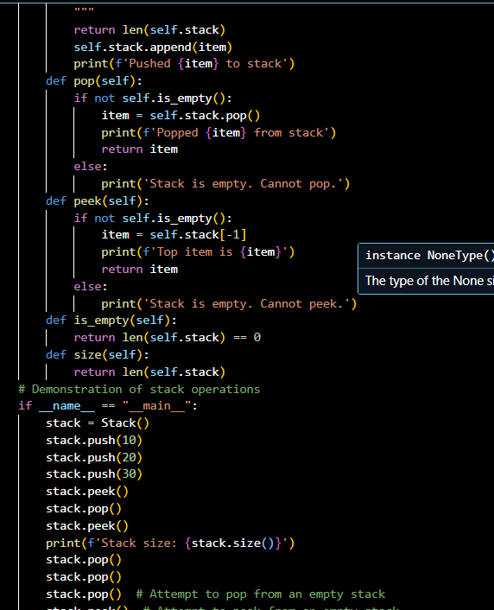
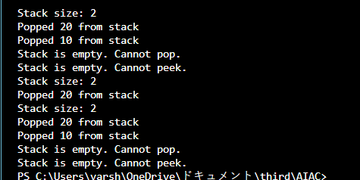

Task Description #2 – Queue Implementation
Task: Use AI to implement a Queue using Python lists. Sample Input Code:
class Queue:
pass
Expected Output:
- FIFO-based queue class with enqueue, dequeue, peek, and size methods.

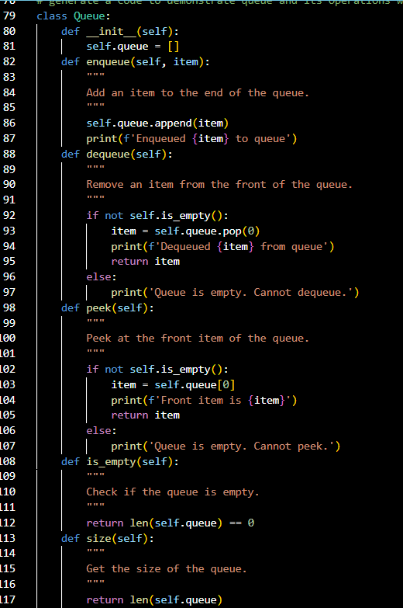
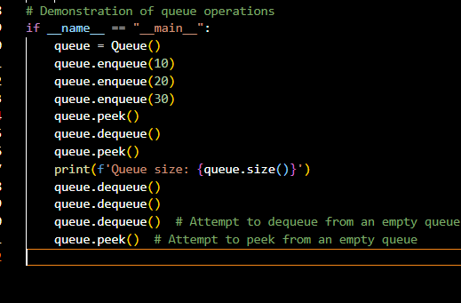

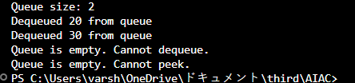

Task Description #3 – Linked List
Task: Use AI to generate a Singly Linked List with insert and display methods. Sample Input Code:
class Node:
pass
class LinkedList:
pass
Expected Output:
- A working linked list implementation with clear method documentation.
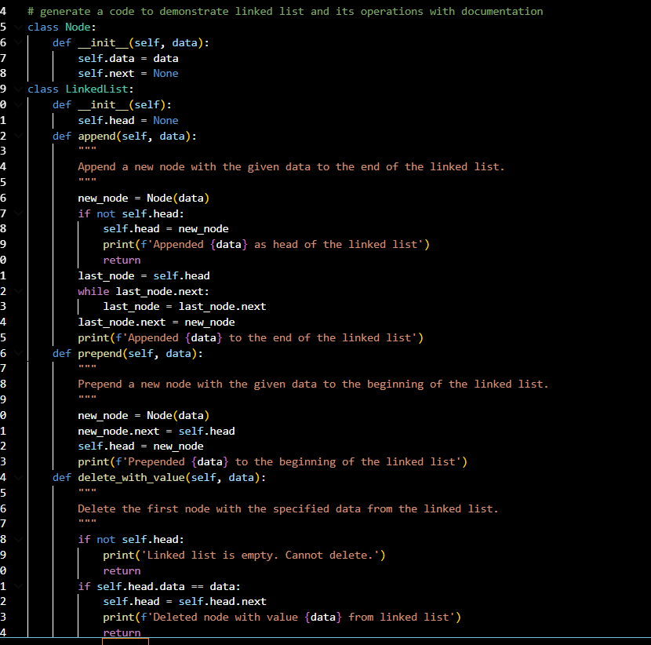

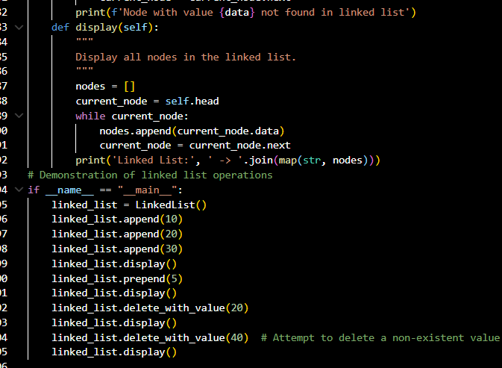
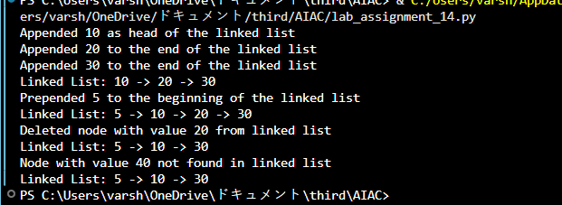

Task Description #4 – Binary Search Tree (BST)
Task: Use AI to create a BST with insert and in-order traversal methods. Sample Input Code:
class BST:
pass
Expected Output:
- BST implementation with recursive insert and traversal methods.

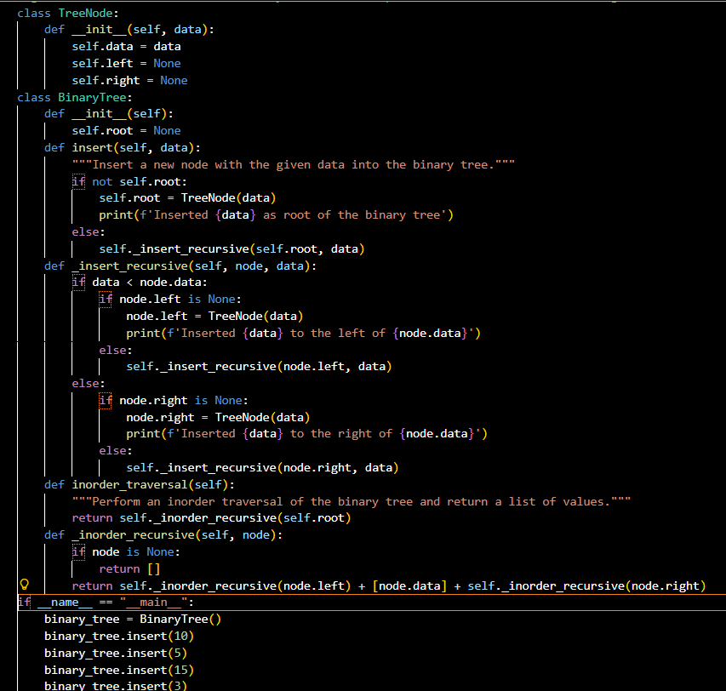
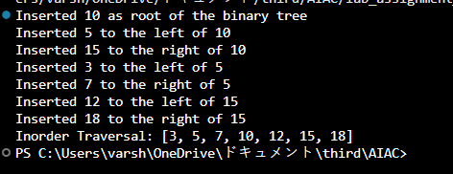

Task Description #5 – Hash Table
Task: Use AI to implement a hash table with basic insert, search, and delete methods.
Sample Input Code:
class HashTable:
pass
Expected Output:
- Collision handling using chaining, with well-commented methods.

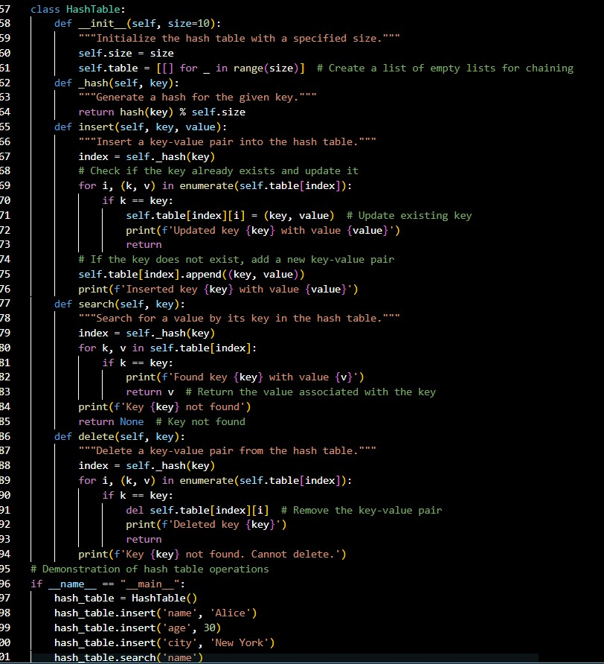
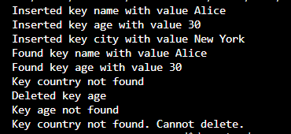

Task Description #6 – Graph Representation
Task: Use AI to implement a graph using an adjacency list. Sample Input Code:
class Graph:

pass
Expected Output:
- Graph with methods to add vertices, add edges, and display connections.
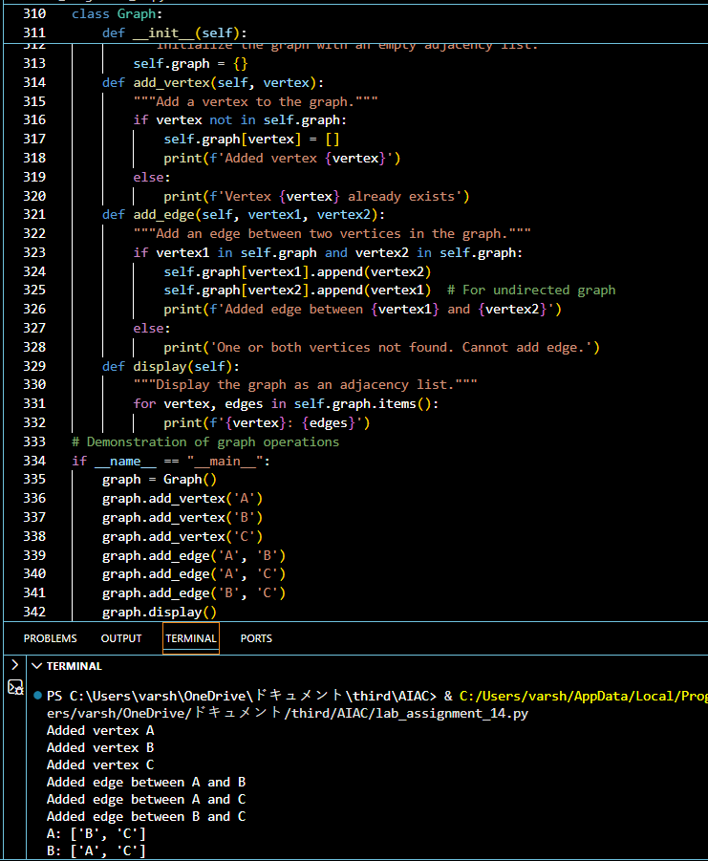

Task Description #7 – Priority Queue
Task: Use AI to implement a priority queue using Python’s heapq module.
Sample Input Code:
class PriorityQueue:
pass
Expected Output:
- Implementation with enqueue (priority), dequeue (highest priority),and display methods.

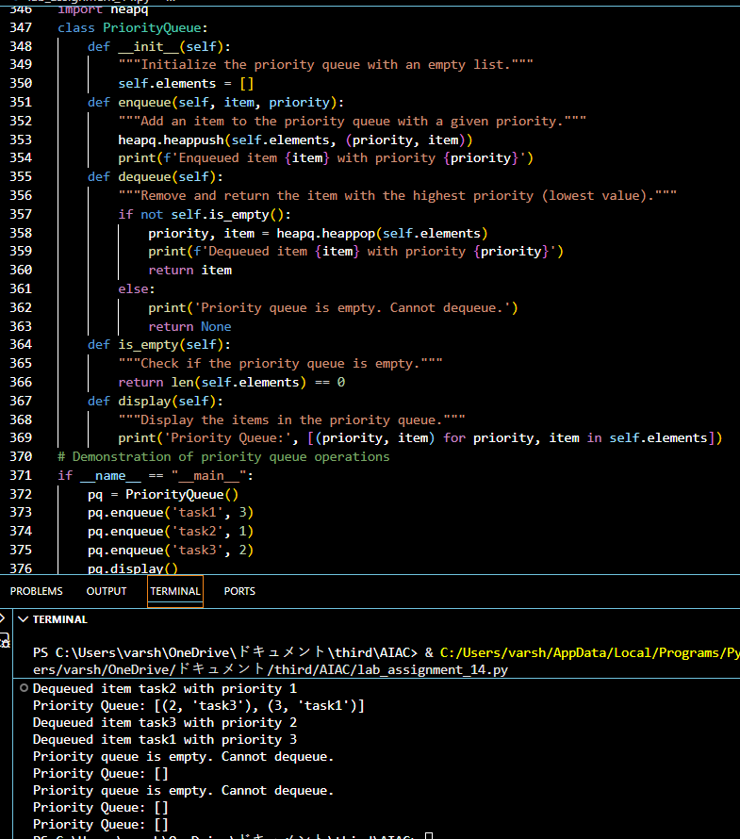

Task Description #8 – Deque
Task: Use AI to implement a double-ended queue using collections.deque.
Sample Input Code:
class DequeDS:
pass
Expected Output:
- Insert and remove from both ends with docstrings.

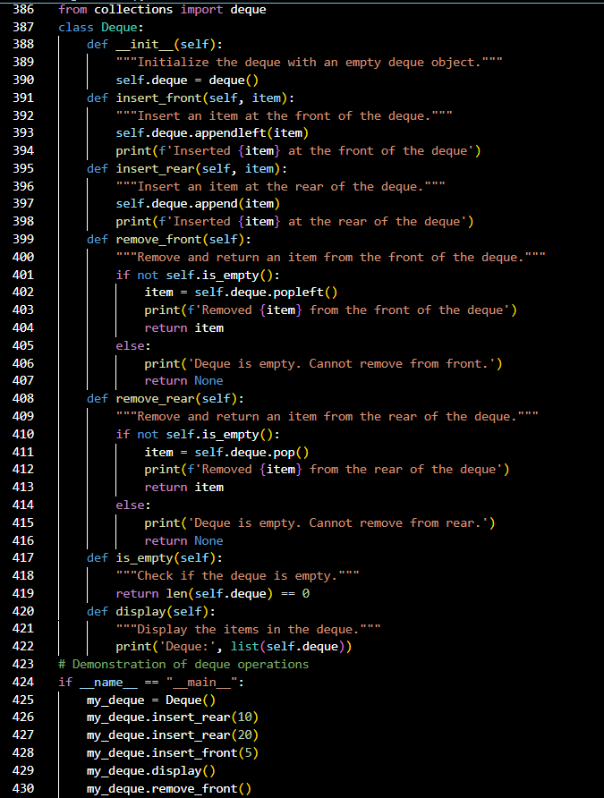
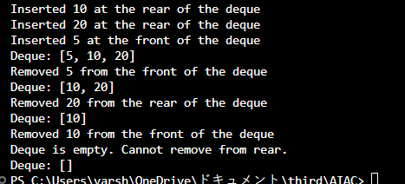

Task Description #9 Real-Time Application Challenge – Choose the Right Data Structure
Scenario:
Your college wants to develop a Campus Resource Management System that handles:
- Student Attendance Tracking – Daily log of students entering/exiting the campus.
- Event Registration System – Manage participants in events withquick search and removal.
- Library Book Borrowing – Keep track of available books and theirdue dates.
- Bus Scheduling System – Maintain bus routes and stopconnections.
- Cafeteria Order Queue – Serve students in the order they arrive. Student Task:
  - For each feature, select the most appropriate data structure fromthe list below:
- Stack
- Queue
- Priority Queue
- Linked List
- Binary Search Tree (BST)
- Graph
- Hash Table
- Deque
  - Justify your choice in 2–3 sentences per feature.
  - Implement one selected feature as a working Python program withAI-assisted code generation. Expected Output:
  - A table mapping feature → chosen data structure → justification.
  - A functional Python program implementing the chosen featurewith comments and docstrings.

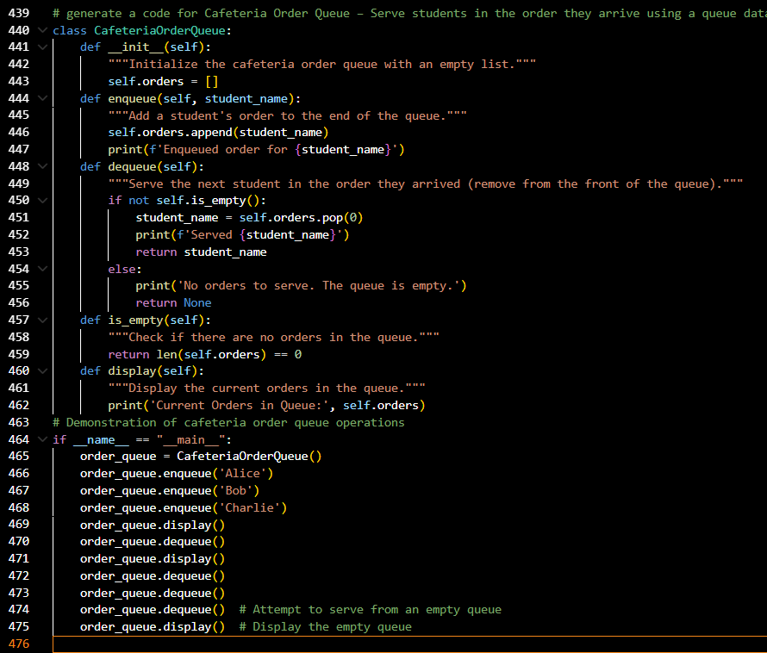
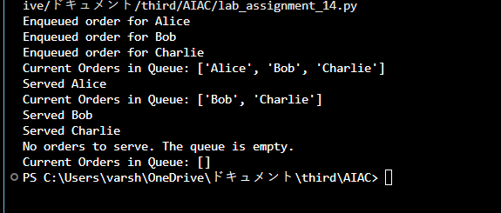

Feature | Chosen Data Structure | Justification
Student Attendance Tracking | Hash Table | A hash table allows fast insertion and lookup of student entries/exits by ID. It ensures efficient daily logging and quick verification of whether a student is currently on campus.

Feature | Chosen Data Structure | Justification
Event  Registration System | Binary Search Tree (BST) | A BST supports ordered storage of participants, enabling quick search, insertion, and removal. It is ideal for managing event participants where alphabetical or ID-based ordering is useful.
Library Book Borrowing | Priority Queue | A priority queue can track books by due dates, ensuring that the most urgent returns (earliest due dates) are prioritized. This helps librarians manage overdue books efficiently.
Bus Scheduling System | Graph | Bus routes and stop connections naturally form a graph, where stops are nodes and routes are edges. Graph traversal algorithms can be used to find shortest paths or optimize scheduling.
Cafeteria Order Queue | Queue | A queue ensures students are served in the order they arrive (FIFO principle). This matches the real-world cafeteria process where  fairness and order are maintained.
A Queue is the best fit because it follows the First-In-First-Out (FIFO) principle. This means students are served in the exact order they arrive, ensuring fairness and efficiency. Just like in a real cafeteria line, the first student to place an order will be the first to get served.

Task Description #10: Smart Hospital Management System – Data Structure Selection
A hospital wants to develop a Smart Hospital Management System that handles:
- Patient Check-In System – Patients are registered and treated in order of arrival.
- Emergency Case Handling – Critical patients must be treated first.
- Medical Records Storage – Fast retrieval of patient details using ID.
- Doctor Appointment Scheduling – Appointments sorted by time.
- Hospital Room Navigation – Represent connections between wards and rooms. Student Task
  - For each feature, select the most appropriate data structure from the list below:
- Stack
- Queue
- Priority Queue
- Linked List
- Binary Search Tree (BST)
- Graph
- Hash Table
- Deque

  - Justify your choice in 2–3 sentences per feature.
  - Implement one selected feature as a working Python program with AI-assisted code generation.
Expected Output:
  - A table mapping feature → chosen data structure → justification.
  - A functional Python program implementing the chosen feature with comments and docstrings.
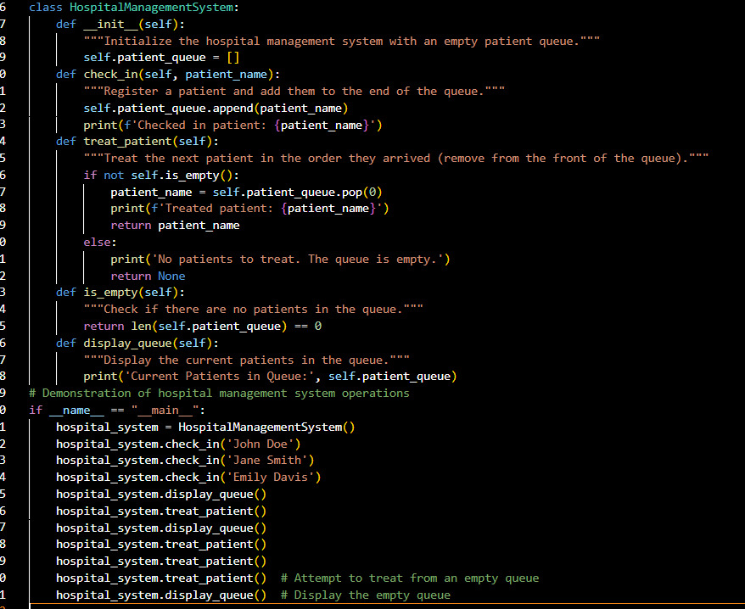
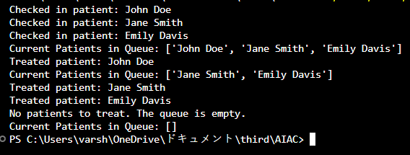

Feature | Data Structure | Justification
Patient Check-In System | Queue | Patients are treated in the order they arrive, which follows the FIFO (First-In-First-Out) principle. A queue ensures fair and sequential handling.
Emergency Case Handling | Priority Queue | Critical patients must be treated first. A priority queue allows  assigning urgency levels so higher-priority patients are handled before others.
Medical Records Storage | Hash Table | Patient details can be quickly retrieved using their unique ID. Hash tables provide O(1) average-time lookup.
Doctor Appointment Scheduling | Linked List | Appointments can be stored in sorted order by time. A linked list allows easy insertion and traversal in chronological order.
Hospital Room Navigation | Graph | Wards and rooms are interconnected. A graph represents these connections, enabling efficient navigation and shortest path finding.
Patients must be treated in the exact order they arrive. A queue ensures fairness by following the FIFO principle, so no one skips ahead unless marked as an emergency case (which would use a
priority queue instead).

Task Description #11: Smart City Traffic Control System
A city plans a Smart Traffic Management System that includes:
- Traffic Signal Queue – Vehicles waiting at signals.
- Emergency Vehicle Priority Handling – Ambulances and fire trucks prioritized.
- Vehicle Registration Lookup – Instant access to vehicle details.
- Road Network Mapping – Roads and intersections connected logically.
- Parking Slot Availability – Track available and occupied slots. Student Task
  - For each feature, select the most appropriate data structure from the list below:
- Stack
- Queue
- Priority Queue
- Linked List
- Binary Search Tree (BST)
- Graph
- Hash Table

- Deque
  - Justify your choice in 2–3 sentences per feature.
  - Implement one selected feature as a working Python program with AI-assisted code generation. Expected Output:
  - A table mapping feature → chosen data structure → justification.
  - A functional Python program implementing the chosen feature with comments and docstrings.
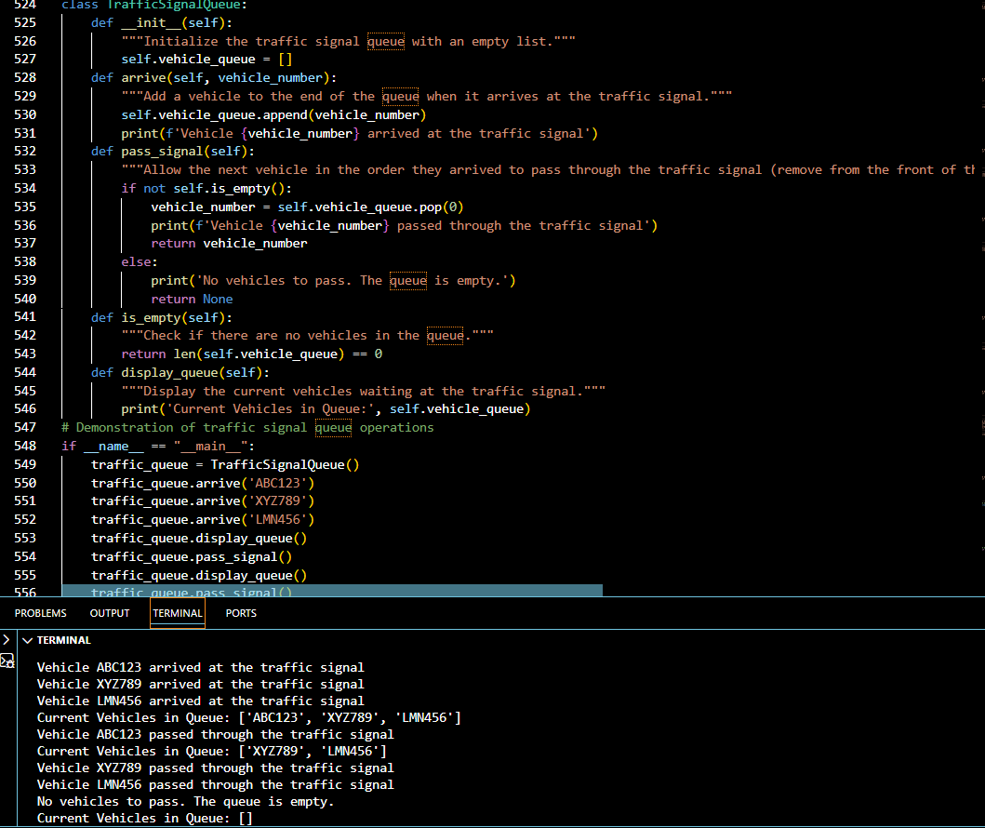

Feature | Data Structure | Justification
Traffic Signal Queue | Queue | Vehicles wait at signals in the order they arrive. A queue follows the FIFO principle, ensuring fair passage.
Emergency Vehicle Priority Handling | Priority Queue | Ambulances and fire trucks must be prioritized. A priority queue ensures vehicles with higher urgency are processed first.
Vehicle Registration Lookup | Hash Table | Vehicle details can be quickly retrieved using registration numbers. Hash tables provide O(1) average lookup time.
Road Network Mapping | Graph | Roads and intersections form a network. A graph represents connections, enabling shortest path and route planning.

Feature | Data Structure | Justification
Parking Slot Availability | Binary Search Tree (BST) | Parking slots can be tracked as available/occupied. A BST  allows efficient searching, insertion, and deletion of slots by number.

Vehicles at a traffic signal must move in the order they arrive. A queue ensures fairness and follows the FIFO principle, so no vehicle skips ahead unless marked as an emergency (which would use a priority queue).

Task Description #12: Smart E-Commerce Platform – Data Structure Challenge
An e-commerce company wants to build a Smart Online Shopping System with:
- Shopping Cart Management – Add and remove products dynamically.
- Order Processing System – Orders processed in the order they are placed.
- Top-Selling Products Tracker – Products ranked by sales count.
- Product Search Engine – Fast lookup of products using product ID.
- Delivery Route Planning – Connect warehouses and delivery locations. Student Task
  - For each feature, select the most appropriate data structure from the list below:
- Stack
- Queue
- Priority Queue
- Linked List
- Binary Search Tree (BST)
- Graph
- Hash Table
- Deque
  - Justify your choice in 2–3 sentences per feature.
  - Implement one selected feature as a working Python program with AI-assisted code generation.
Expected Output:
  - A table mapping feature → chosen data structure → justification.
  - A functional Python program implementing the chosen feature with comments and docstrings.

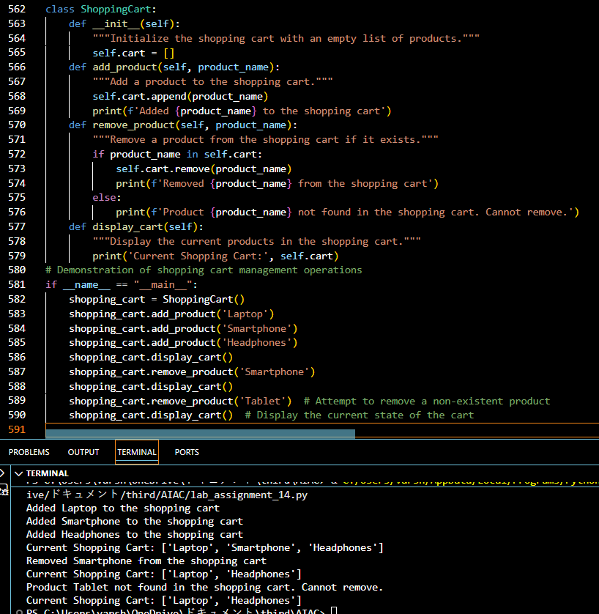

Feature | Data Structure | Justification
Shopping Cart Management | Linked List | Products can be added or removed dynamically. A linked list supports efficient insertion and deletion without shifting  elements.
Order Processing System | Queue | Orders must be processed in the order they are placed. A queue ensures FIFO (First-In-First-Out) handling.
Top-Selling Products Tracker | Priority Queue | Products can be ranked by sales count. A priority queue ensures the highest-selling products are always accessible first.
Product Search Engine | Hash Table | Products can be quickly retrieved using product IDs. Hash tables provide O(1) average lookup time.

Feature | Data Structure | Justification
Delivery Route Planning | Graph | Warehouses and delivery locations form a network. A graph  represents connections and supports shortest path algorithms.
A shopping cart needs dynamic addition and removal of products. A linked list is ideal because it allows efficient insertion and deletion without shifting elements, unlike arrays.

Task #13: Smart Logistics & Warehouse Management
Scenario:
A logistics company wants to implement:
- Shipment Processing
- Urgent Shipment Priority
- Product Lookup by Code
- Warehouse Network Connectivity
- Inventory Add/Remove Operations Student Task
  - For each feature, select the most appropriate data structure from the list below:
- Stack
- Queue
- Priority Queue
- Linked List
- Binary Search Tree (BST)
- Graph
- Hash Table
- Deque
  - Justify your choice in 2–3 sentences per feature.
  - Implement one selected feature as a working Python program with AI-assisted code generation. Expected Output:
  - A table mapping feature → chosen data structure → justification.
  - A functional Python program implementing the chosen feature with comments and docstrings.

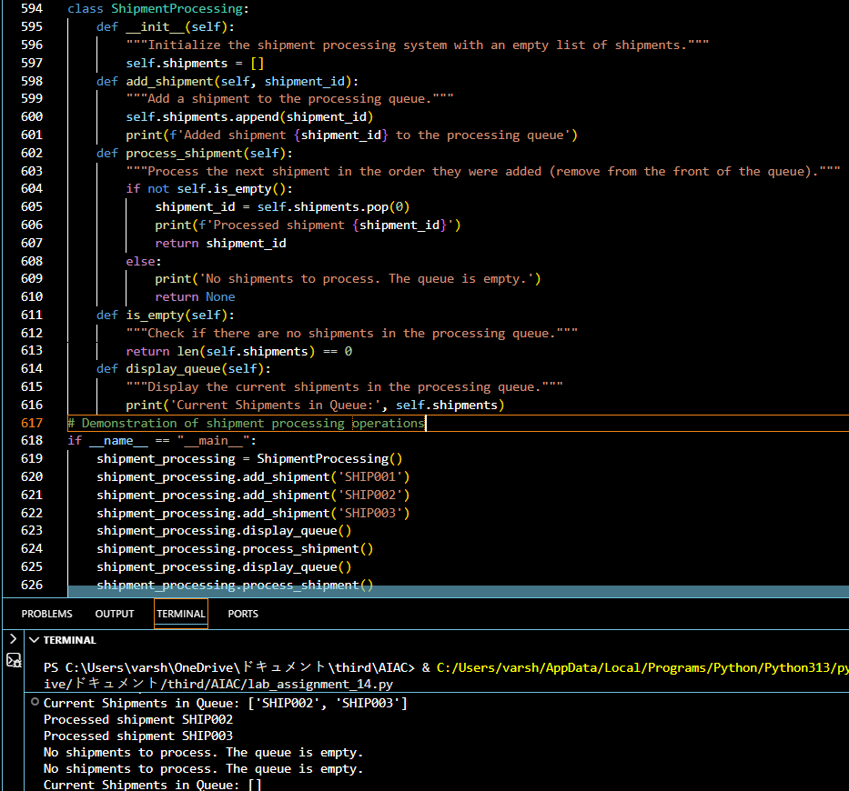

Feature | Data Structure | Justification
Shipment Processing | Queue | Shipments are processed in the order they arrive. A queue ensures FIFO (First-In-First-Out) handling.
Urgent Shipment Priority | Priority Queue | Urgent shipments must be handled first. A priority queue allows assigning urgency levels so critical shipments are processed before normal ones.
Product Lookup by Code | Hash Table | Products can be quickly retrieved using their unique code. Hash tables provide O(1) average lookup time.
Warehouse Network Connectivity | Graph | Warehouses and routes form a connected network. A graph represents these connections and supports shortest path  algorithms for efficient delivery.

Feature | Data Structure | Justification
Inventory Add/Remove Operations | Linked List | Inventory needs dynamic addition and removal of products. A linked list supports efficient insertion and deletion without  shifting elements.

Shipments must be processed in the order they arrive. A queue ensures fairness and follows the FIFO principle, so no shipment is skipped unless marked urgent (which would be handled by a priority queue).

Task Description #14: Smart Banking Management System – Data
Structure Challenge
A bank plans to develop a Smart Banking System that includes:
- Customer Service Token System – Customers are served in orderof arrival.
- Loan Approval Priority Handling – High-value or urgent loansprocessed first.
- Account Information Lookup – Fast retrieval of customer detailsusing Account Number.
- Transaction History Management – Maintain chronologicaltransaction records.
- ATM Network Connectivity – Represent connections betweenATMs across cities. Student Task:
  - For each feature, select the most appropriate data structure fromhe list below:
- Stack
- Queue
- Priority Queue
- Linked List
- Binary Search Tree (BST)
- Graph
- Hash Table
- Deque
  - Justify your choice in 2–3 sentences per feature.
  - Implement one selected feature as a working Python program with AI-assisted code generation.
Expected Output:
  - A table mapping feature → chosen data structure → justification.
  - A functional Python program implementing the chosen featurewith comments and docstrings.

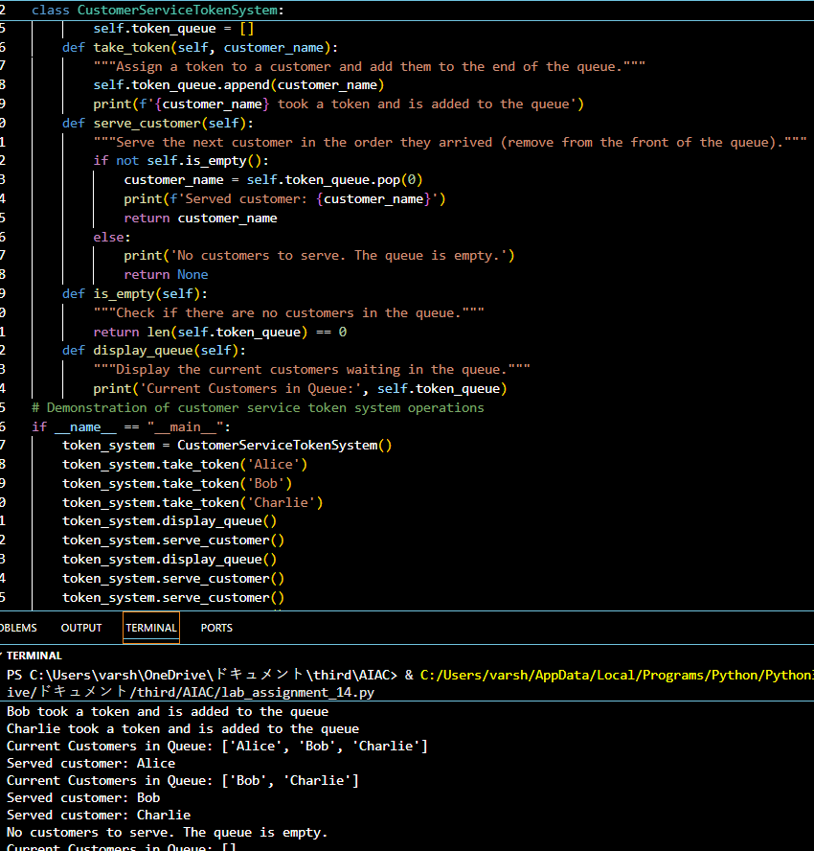

Feature | Data Structure | Justification
Customer Service Token System | Queue | Customers are served in the order they arrive. A queue ensures FIFO (First-In-First-Out) handling, maintaining fairness.
Loan Approval Priority Handling | Priority Queue | High-value or urgent loans must be processed first. A priority  queue allows assigning priority levels so urgent loans are handled before regular ones.
Account Information Lookup | Hash Table | Customer details can be quickly retrieved using account numbers. Hash tables provide O(1) average lookup time.

Feature | Data Structure | Justification
Transaction History Management | Linked List | Transactions are stored chronologically. A linked list allows efficient insertion at the end and traversal in order.
ATM Network Connectivity | Graph | ATMs across cities form a connected network. A graph represents these connections and supports shortest path algorithms for efficient routing.

Customers must be served in the order they arrive. A queue ensures fairness by following the FIFO principle, so no one skips ahead unless marked as urgent (which would use a priority queue).

Task Description #15: Online Learning Management System – Data Structure Selection
An online education platform wants to develop a Learning Management System that handles:
- Student Login Authentication – Quick validation of user credentials.
- Assignment Submission Queue – Submissions processed in order of upload.
- Top Performer Ranking – Rank students based on scores.
- Course Prerequisite Structure – Represent subject dependencies.
- Undo Feature in Online Editor – Reverse recent actions. Student Task:
  - Select the most appropriate data structure for each feature from the given list.
  - Justify your selection in 2–3 sentences per feature.
  - Implement one selected feature in Python using AI-assisted code generation. Expected Output:
  - Feature → Data Structure → Justification table.
  - Functional Python program with proper documentation.

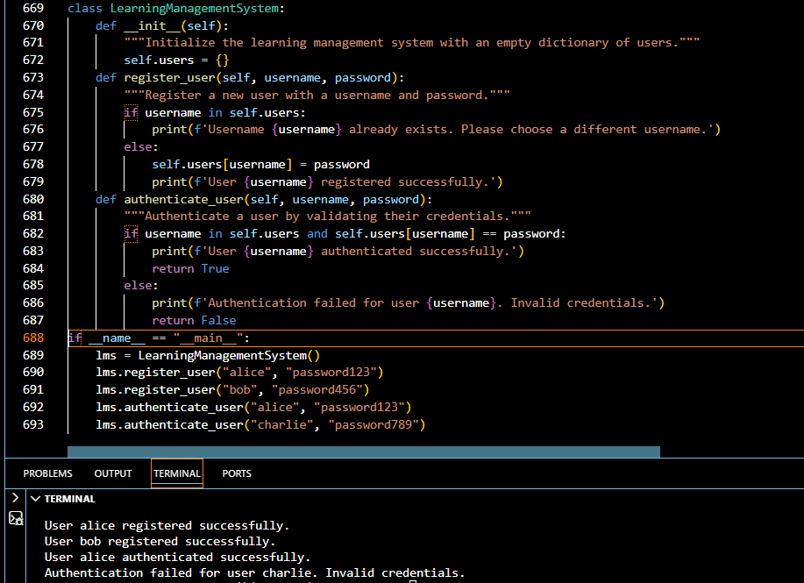

Feature | Data Structure | Justification
Student Login Authentication | Hash Table | User credentials (username, password) need quick validation. A hash table allows O(1) average-time lookup for authentication.
Assignment Submission Queue | Queue | Submissions must be processed in the order they are uploaded. A queue ensures FIFO (First-In-First-Out) handling.
Top Performer Ranking | Priority Queue | Students should be ranked by scores. A priority queue ensures the highest-scoring students are always accessible first.
Course Prerequisite Structure | Graph | Courses often depend on other courses. A graph represents subject dependencies and supports traversal for prerequisite checks.
Undo Feature in Online Editor | Stack | Undo operations require reversing recent actions. A stack follows LIFO (Last-In-First-Out), making it ideal for undo functionality.

Undo requires reversing the most recent action. A stack is perfect because it follows the LIFO principle, ensuring the last action performed is the first one undone.

Task Description #16: Smart Airport Management System – Data Structure Challenge An airport authority plans to implement:
- Passenger Check-In Queue – Process passengers in order of arrival.
- Emergency Landing Priority – Aircraft in emergency get priority.
- Flight Information Lookup – Fast search using Flight ID.
- Air Route Connectivity – Airports connected via routes.
- Boarding Process (Last-In First-Out Cabin Storage) – Overhead luggage management simulation. Student Task:
  - Choose suitable data structures from the provided list.
  - Provide 2–3 sentence justification per feature.
  - Implement one feature in Python with comments and docstrings using AI assistance. Expected Output:
  - Mapping table.
  - Working Python implementation.
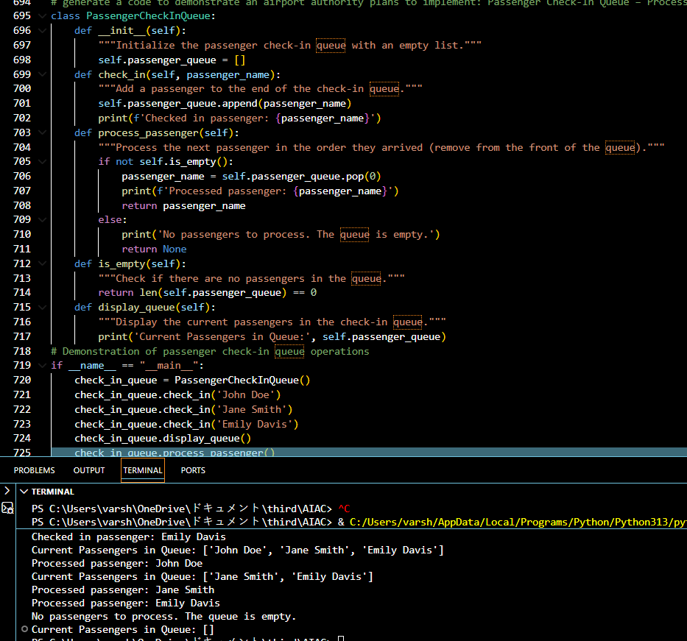

Feature | Data Structure | Justification
Passenger Check-In Queue | Queue | Passengers must be processed in the order they arrive. A queue ensures FIFO (First-In-First-Out) handling, maintaining fairness.
Emergency Landing Priority | Priority Queue | Aircraft in emergency situations must be prioritized. A priority queue ensures urgent landings are handled before regular ones.
Flight Information Lookup | Hash Table | Flight details can be quickly retrieved using flight IDs. Hash tables provide O(1) average lookup time.
Air Route Connectivity | Graph | Airports and routes form a connected network. A graph represents these connections and supports shortest path algorithms for efficient navigation.
Boarding Process (Cabin Storage) | Stack | Overhead luggage follows LIFO (Last-In-First-Out) since the last bag placed is the first one removed. A stack is ideal for simulating this process.
Overhead luggage storage works in a LIFO manner—the last bag placed is the first one removed. A stack perfectly models this behavior, making it the most suitable data structure.

Task Description #17: Smart Social Media Platform – Data Structure Selection
A social media company wants to develop a system that includes:
- News Feed Generation – Display posts chronologically.
- Trending Hashtags Tracker – Rank hashtags by usage frequency.
- User Profile Search – Quick lookup using username.
- Friend Network Representation – Represent user connections.
- Message Undo Feature – Allow last sent message to bewithdrawn. Student Task:
  - Select appropriate data structures from the list.
  - Justify your choices clearly.
  - Implement one selected feature as a Python program using AI-assisted code generation. Expected Output:
  - Table mapping features to data structures with justification.
  - Working Python code with docstrings and comments.

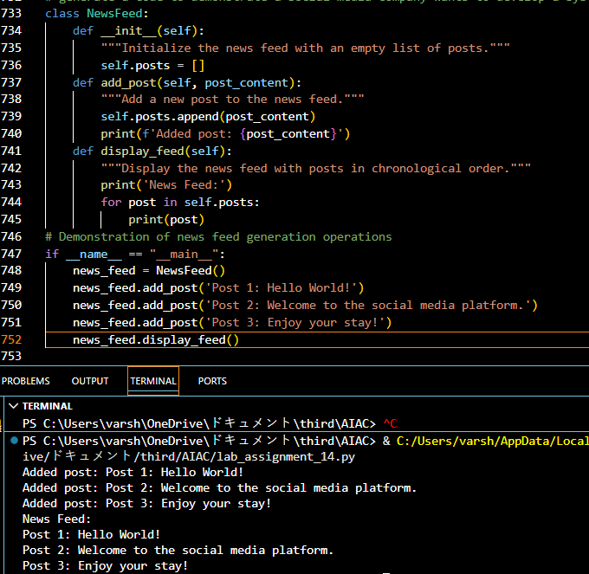

Feature | Data Structure | Justification
News Feed Generation | Linked List | Posts are displayed chronologically. A linked list allows efficient insertion at the end and traversal in order.
Trending Hashtags Tracker | Priority Queue | Hashtags must be ranked by usage frequency. A priority queue ensures the most frequently used hashtags are always accessible first.
User Profile Search | Hash Table | User profiles can be quickly retrieved using usernames. Hash tables provide O(1) average lookup time.
Friend Network Representation | Graph | Friend connections form a network. A graph represents relationships and supports traversal for mutual connections or recommendations.

Feature | Data Structure | Justification
Message Undo Feature | Stack | Undo requires reversing the most recent action. A stack follows LIFO (Last-In-First-Out), making it ideal for withdrawing the last sent message.

Undo requires reversing the most recent action. A stack is perfect because it follows the LIFO principle, ensuring the last message sent is the first one withdrawn.

Task #18: Smart University Hostel Management
Scenario:
A university wants to build a hostel management system that manages:
- Room Allotment
- Medical Emergency Handling
- Student Record Retrieval
- Hostel Block Connectivity
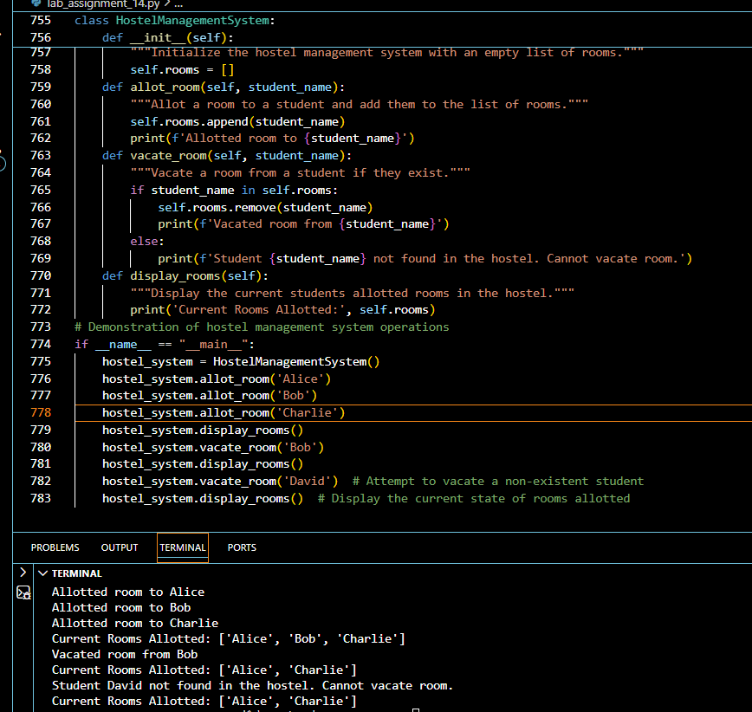
- Visitor Entry

Feature | Data Structure | Justification
Room Allotment | Binary Search Tree (BST) | Rooms can be allotted based on room numbers. A BST allows efficient searching, insertion, and deletion of rooms in sorted order.
Medical  Emergency Handling | Priority Queue | Emergency cases must be handled first. A priority queue ensures urgent medical needs are prioritized over normal requests.
Student Record Retrieval | Hash Table | Student details can be quickly retrieved using unique IDs. Hash tables provide O(1) average lookup time.
Hostel Block Connectivity | Graph | Hostel blocks and rooms form a connected network. A graph represents these connections and supports navigation or  shortest path finding.
Visitor Entry Log | Queue | Visitors are logged in the order they arrive. A queue ensures FIFO (First-In-First-Out) handling of entries.
Visitors must be logged and processed in the order they arrive. A queue ensures fairness by following the FIFO principle, so no visitor is skipped ahead.

Task #19: Smart Electricity Distribution System
Scenario:
An electricity board plans to develop a system that includes:
- Complaint Handling
- Fault Priority Handling
- Consumer Record Lookup
- Power Grid Connectivity
- Meter Reading History Tracking• Justify your choice in 2–3 sentences per feature.
  - Implement one selected feature as a working Python program with AI-assisted code generation. Expected Output:
  - A table mapping feature → chosen data structure → justification.
  - A functional Python program implementing the chosen feature with comments and docstrings.

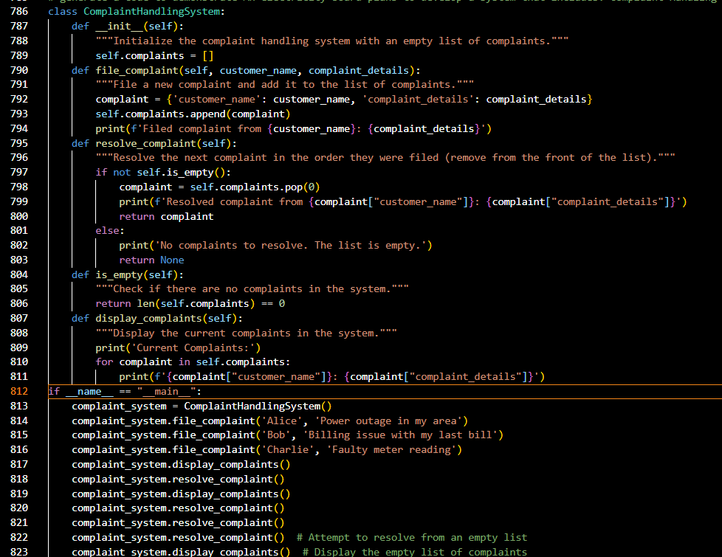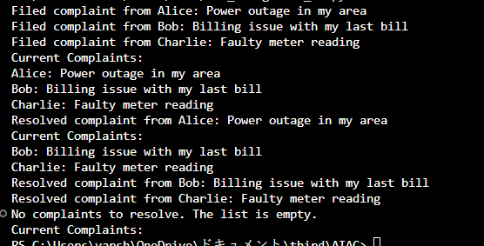

Feature | Data Structure | Justification
Complaint Handling | Queue | Complaints must be addressed in the order they are received. A queue ensures FIFO (First-In-First-Out) processing, maintaining fairness.
Fault Priority Handling | Priority Queue | Critical faults must be resolved first. A priority queue allows  assigning urgency levels so severe faults are handled before minor ones.

Feature | Data Structure | Justification
Consumer Record Lookup | Hash Table | Consumer details can be quickly retrieved using unique IDs. Hash tables provide O(1) average lookup time.
Power Grid Connectivity | Graph | Power grids and substations form a connected network. A graph represents these connections and supports shortest path or flow analysis.
Meter Reading History Tracking | Linked List | Meter readings are stored chronologically. A linked list allows efficient insertion at the end and traversal in order.

Complaints must be processed in the order they are received. A queue ensures fairness by following the FIFO principle, so no complaint is skipped ahead unless marked urgent (which would be handled by a priority queue).

