AI ASSISTED CODING ASSIGNMENT – 9.5
G. Siddartha (2303A51013)
BATCH-01
Problem 1: String Utilities Function
Consider the following Python function:
def reverse_string(text):
return text[::-1]
Task:
- 1. Write documentation in:
(a) Docstring
(b) Inline comments
(c) Google-style documentation
- Compare the three documentation styles.
- Recommend the most suitable style for a utility-based string library.
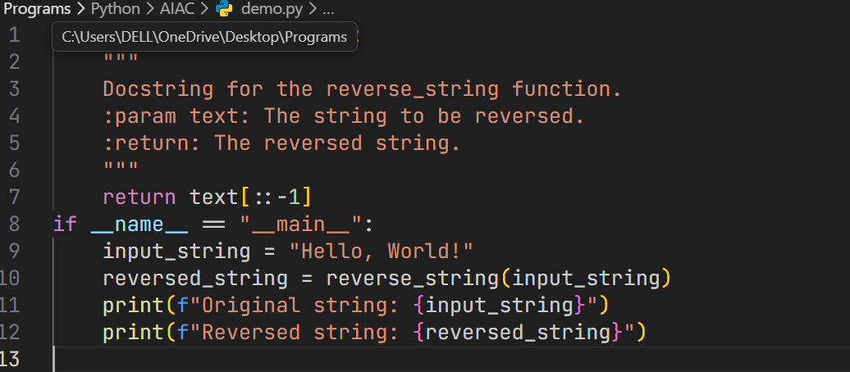
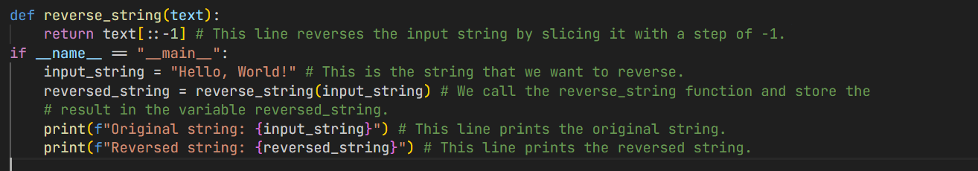
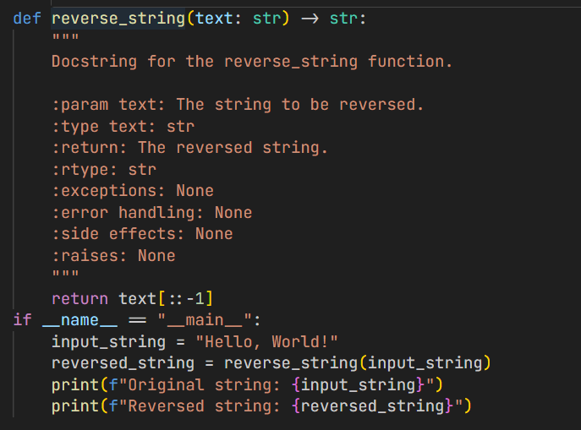
Output:
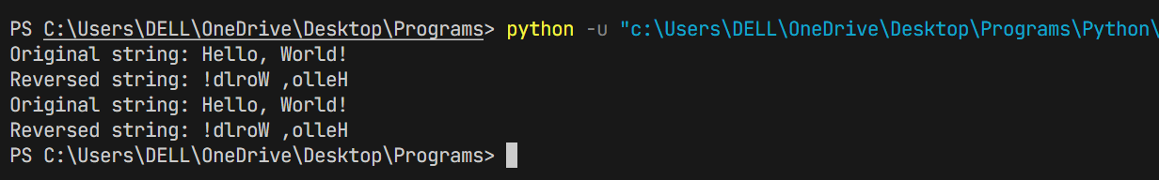

Problem 2: Password Strength Checker
Consider the function:
def check_strength(password):
return len(password) >= 8
Task:
- Document the function using docstring, inline comments, and Google style.
- Compare documentation styles for security-related code.
- Recommend the most appropriate style.
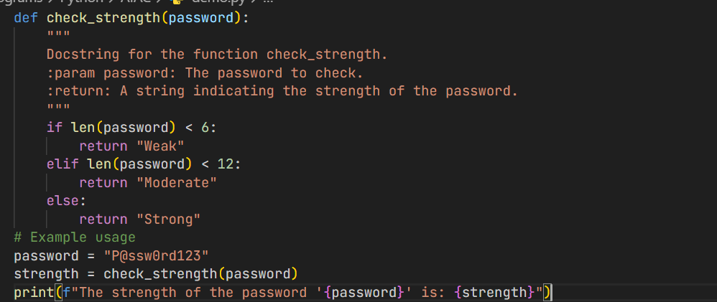
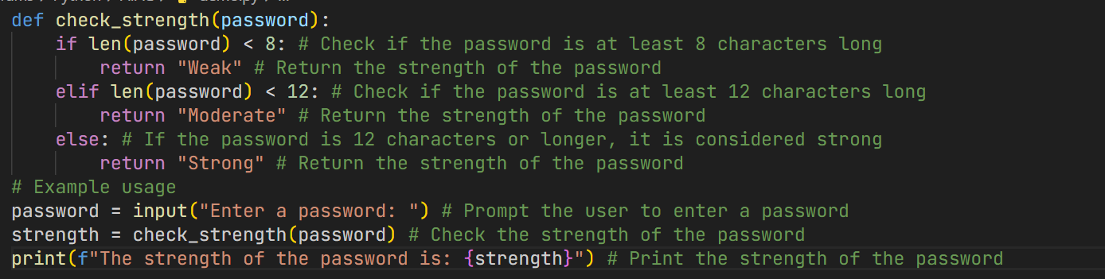
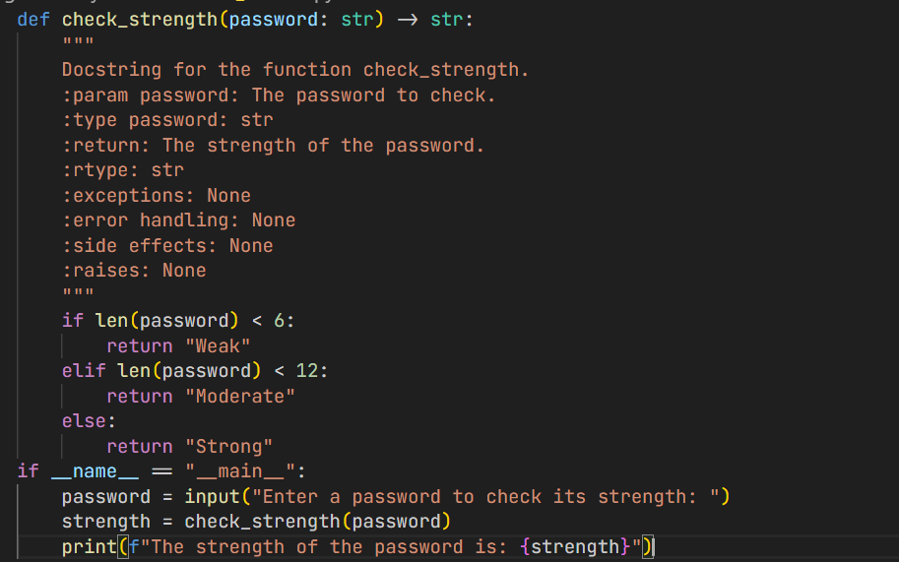
Output:
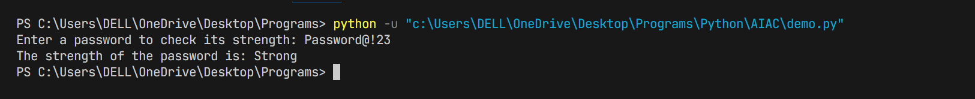
Problem 3: Math Utilities Module
Instructions:
- Create a module math_utils.py with functions:
square(n)
cube(n)
factorial(n)
- Generate docstrings automatically using AI tools.
- Export documentation as an HTML file.
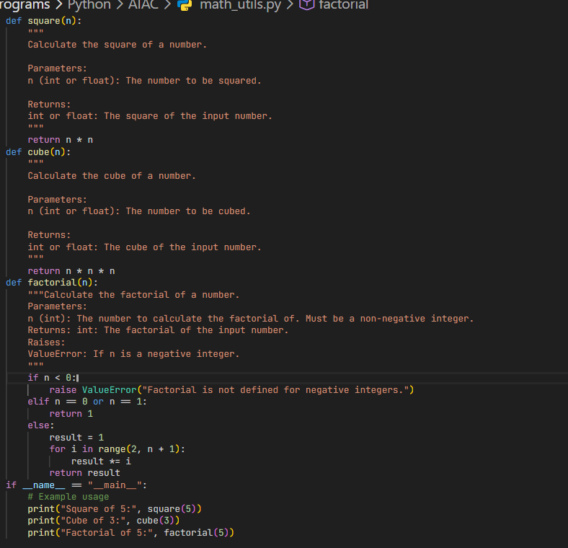
Output:
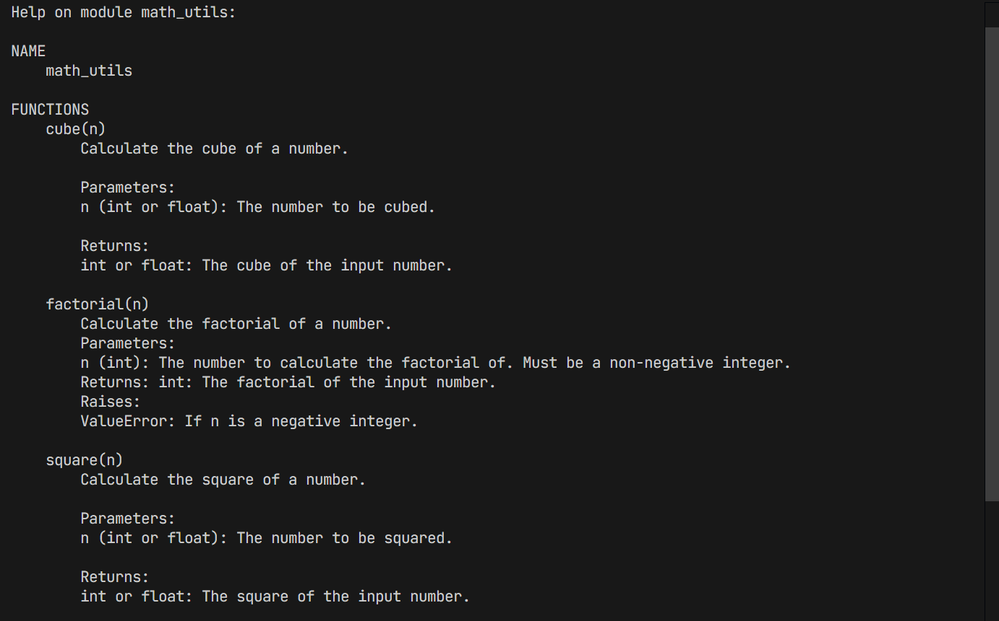
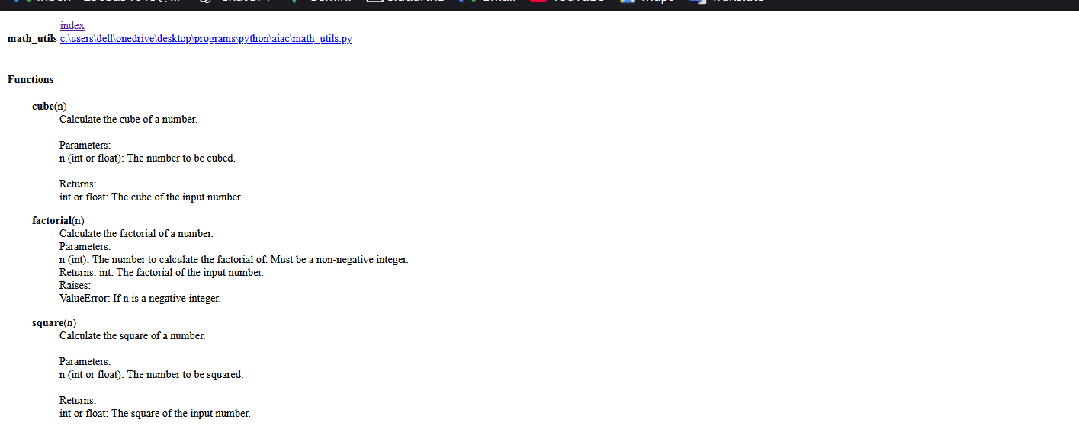
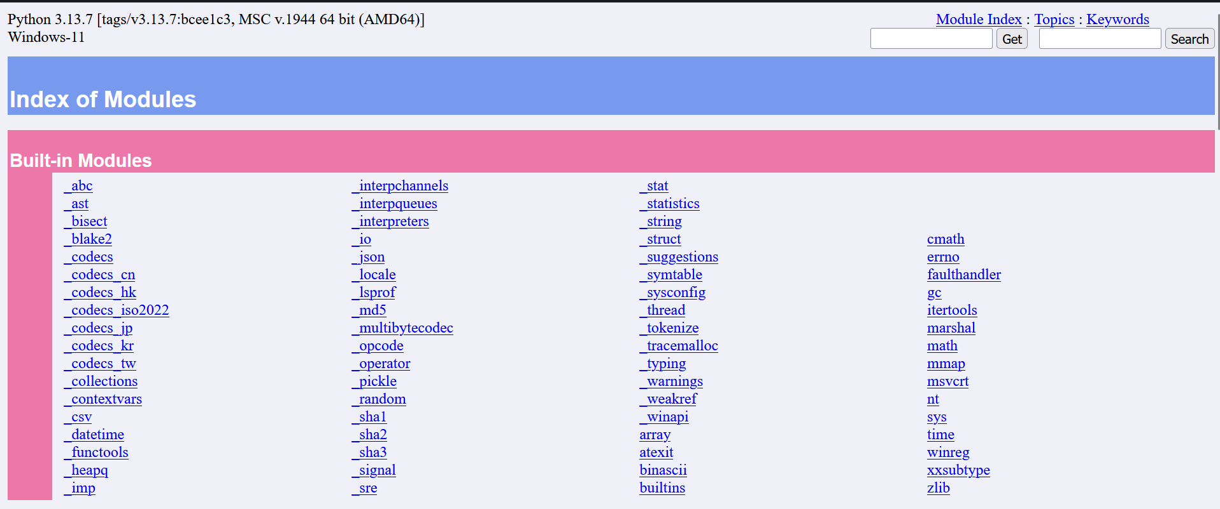
Problem 4: Attendance Management Module
Task:
- Create a module attendance.py with functions:
mark_present(student)
mark_absent(student)
get_attendance(student)
- Add proper docstrings.
- Generate and view documentation in terminal and browse
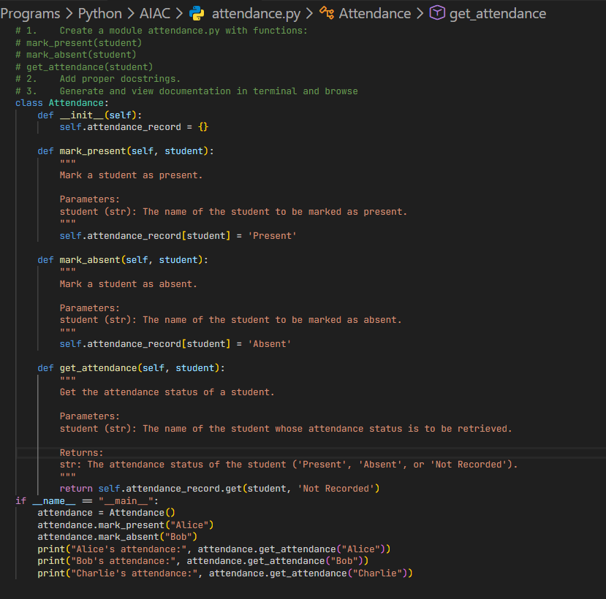
Output:
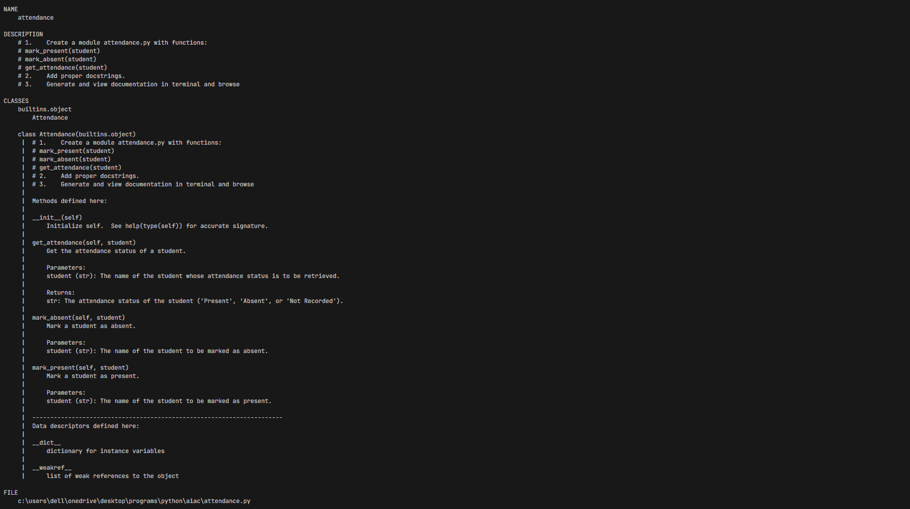
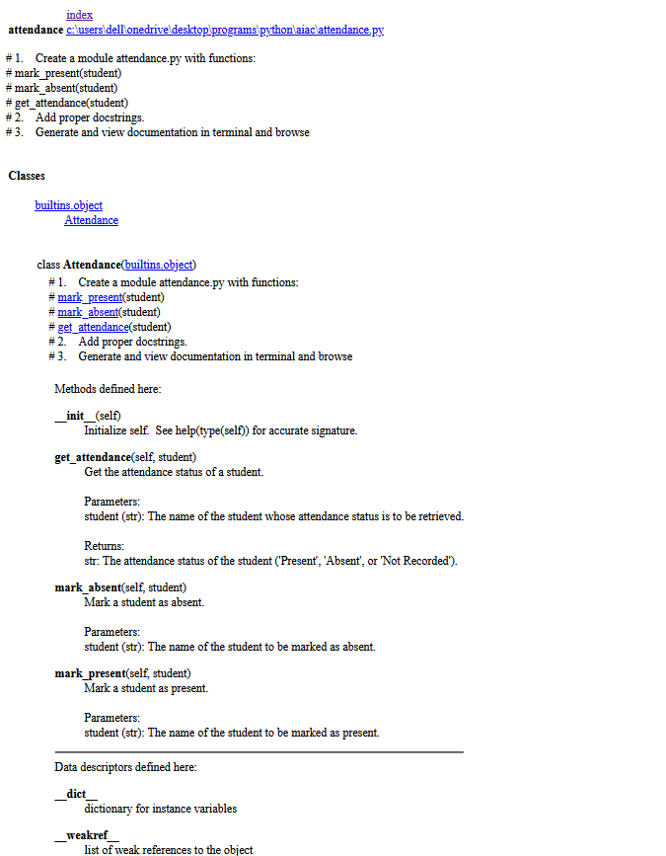
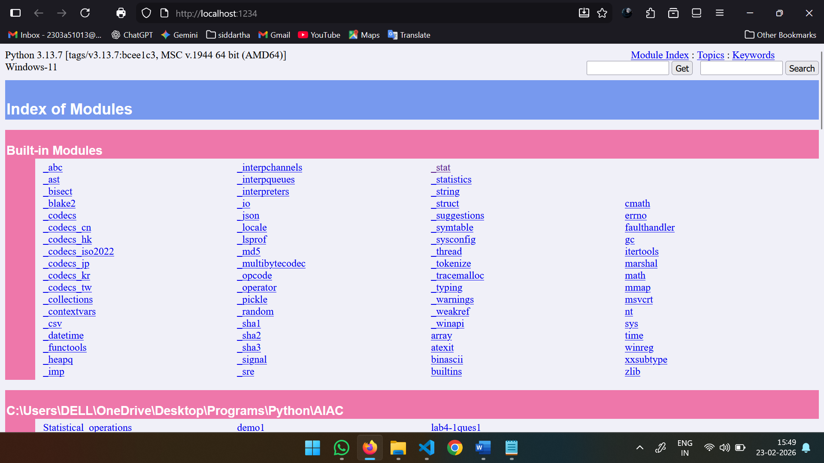

Problem 5: File Handling Function
Consider the function:
def read_file(filename):
with open(filename, 'r') as f:
return f.read()
Task:
- Write documentation using all three formats.
- Identify which style best explains exception handling.
- Justify your recommendation.
