AI ASSISTED CODING ASSIGNMENT - 3.5
G. Sarayu (2303A51014)
BATCH-01

Task Description
Design and refine prompts using different prompting strategies to generate Python programs for basic computational problems.

Question 1: Zero-Shot Prompting (Leap Year Check)
Write a zero-shot prompt to generate a Python function that checks whether a given year is a leap year.
• Task Description
➢ Record the AI-generated code.
➢ Test with years like 1900, 2000, 2024.
➢ Identify logical flaws or missing conditions.
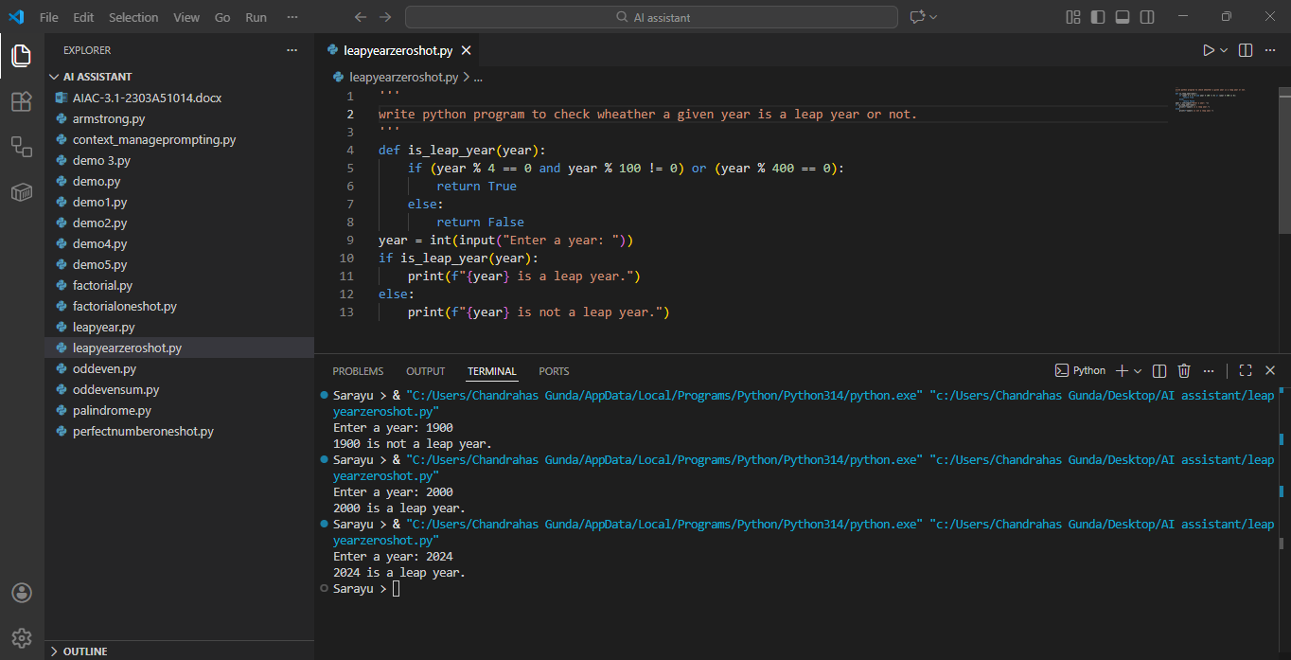

Question 2: One-Shot Prompting (GCD of Two Numbers)
Write a one-shot prompt with one example to generate a Python function that finds the Greatest Common Divisor (GCD) of two numbers.
• Example:
➢ Input: 12, 18 → Output: 6
• Task Description
➢ Compare with a zero-shot solution.
➢ Analyse algorithm efficiency.
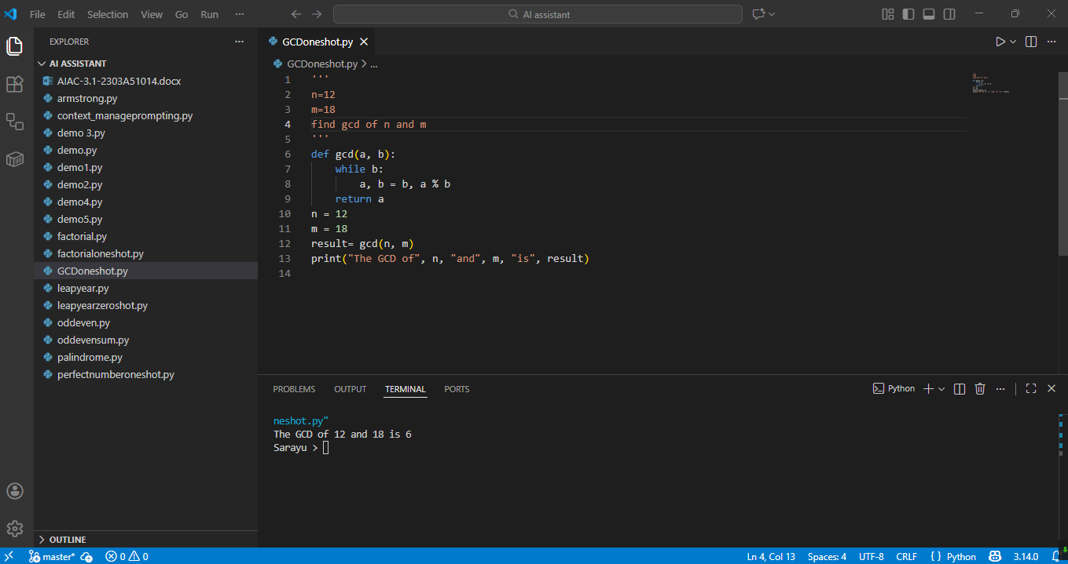
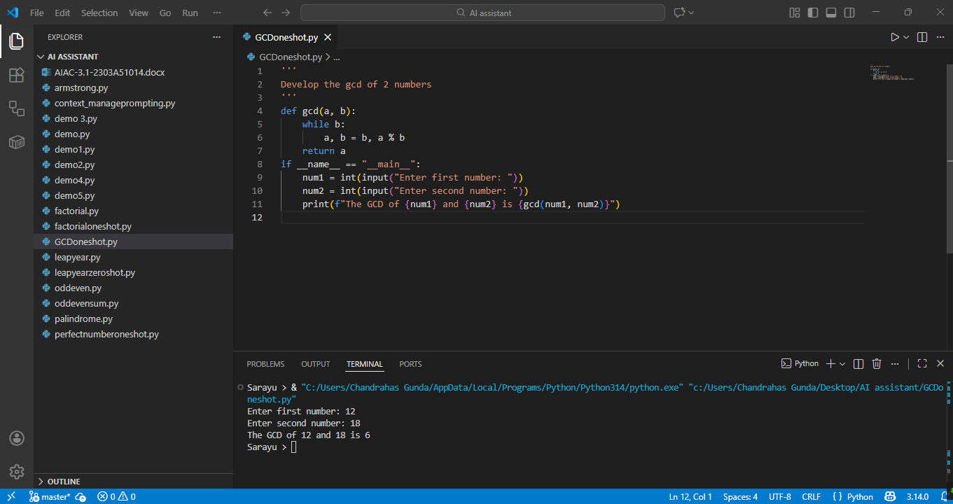

Question 3: Few-Shot Prompting (LCM Calculation)
Write a few-shot prompt with multiple examples to generate a Python function that computes the Least Common Multiple (LCM).
• Example:
➢ Input: 4, 6 → Output: 12
➢ Input: 5, 10 → Output: 10
➢ Input: 7, 3 → Output: 21
• Task Description
➢ Examine how examples guide formula selection.
➢ Test edge cases.
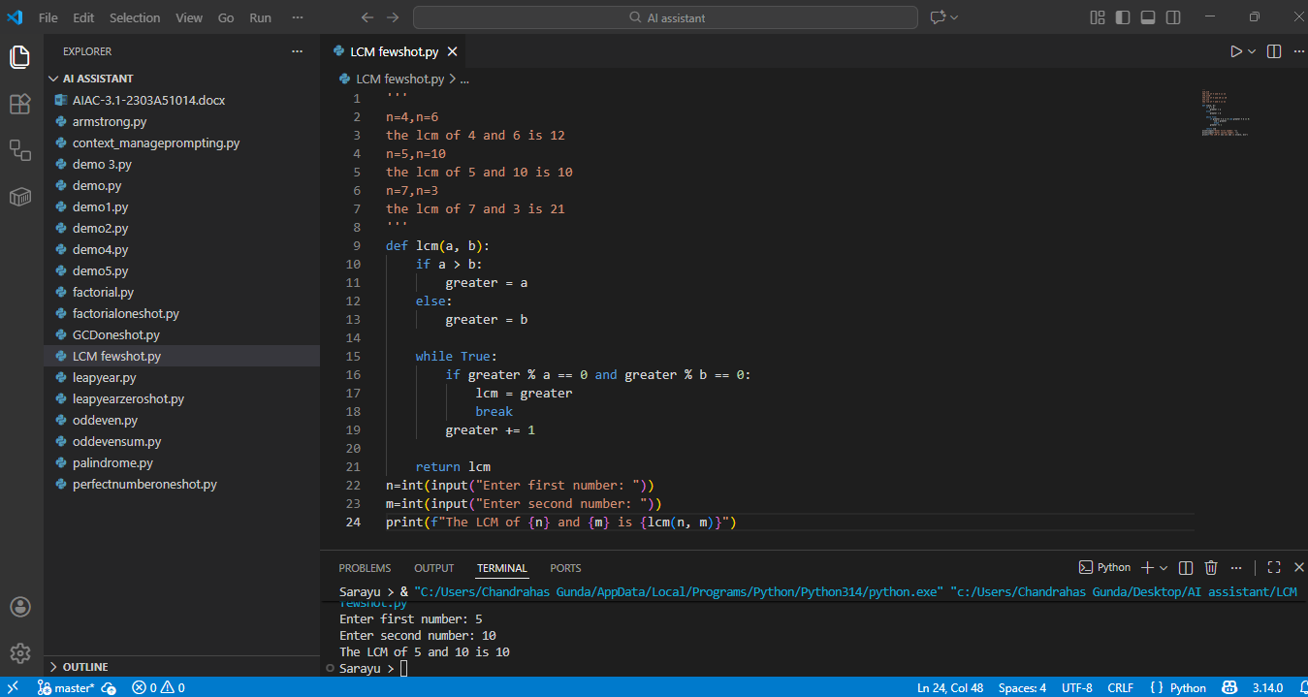

Question 4: Zero-Shot Prompting (Binary to Decimal Conversion)
Write a zero-shot prompt to generate a Python function that converts a binary number to decimal.
• Task Description
➢ Test with valid and invalid binary inputs.
➢ Identify missing validation logic.
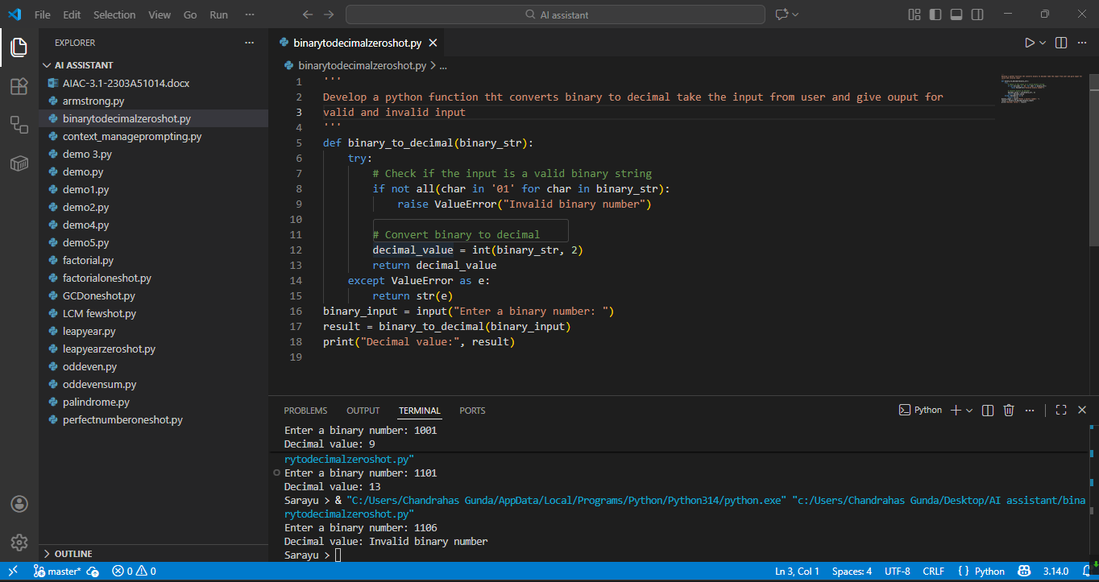

Question 5: One-Shot Prompting (Decimal to Binary Conversion)
Write a one-shot prompt with an example to generate a Python function that converts a decimal number to binary.
• Example:
➢ Input: 10 → Output: 1010
• Task Description
➢ Compare clarity with zero-shot output.
➢ Analyse handling of zero and negative numbers.

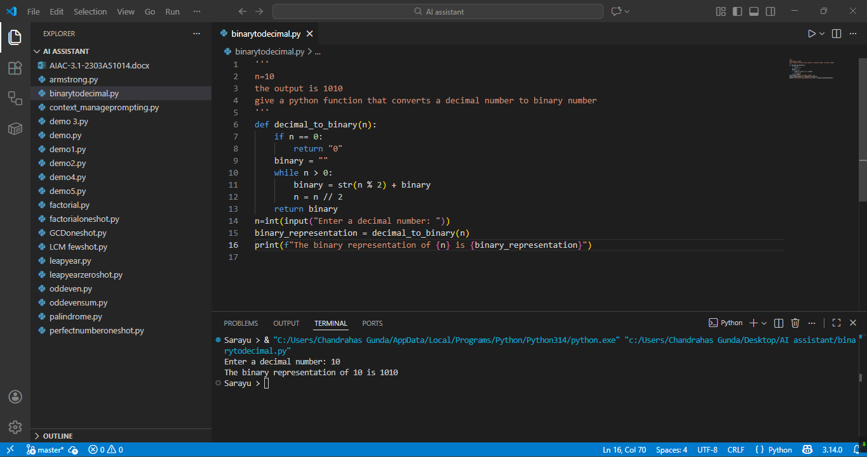

Question 6: Few-Shot Prompting (Harshad Number Check)
Write a few-shot prompt to generate a Python function that checks whether a number is a Harshad (Niven) number.
• Example:
➢ Input: 18 → Output: Harshad Number
➢ Input: 21 → Output: Harshad Number
➢ Input: 19 → Output: Not a Harshad Number
• Task Description
➢ Test boundary conditions.
➢ Evaluate robustness.
