AI ASSISTED CODING ASSIGNMENT - 2.1
G. Sarayu-(2303A51014)
BATCH-01

Task 1: Statistical Summary for Survey Data
• Scenario
You are a data analyst intern working with survey responses stored as numerical lists.
• Task Description
Use Google Gemini in Colab to generate a Python function that reads a list of numbers and calculates the mean, minimum, and maximum values.

• Expected Deliverables
➢ Correct Python function
- Yes, it is generated by Gemini
➢ Output shown in Colab
- Yes, mean, minimum and maximum are formed
➢ Screenshot of Gemini prompt and result
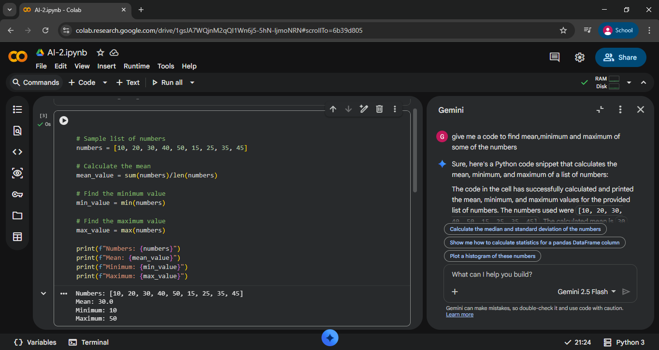

Task 2: Armstrong Number – AI Comparison
• Scenario
You are evaluating AI tools for numeric validation logic.
• Task Description
Generate Armstrong numbers checker using Gemini and GitHub Copilot.
Compare their outputs, logic style, and clarity.
• Expected Deliverables
➢ Side-by-side comparison
Feature | Google Gemini | GitHub Co-pilot
Code Correctness | Correct | Correct
Logic Style | Straightforward, beginner-friendly | Slightly optimized, cleaner variables
Readability | Good | Very good
Comments | Basic comments | Clear inline comments
Ease of Generation | Easy in chat | Very fast while typing
Output | Correct | Correct

➢ Screenshots of prompts and generated code
# Develop a Python program to check whether a number is an Armstrong number. Use a function, adding comments.

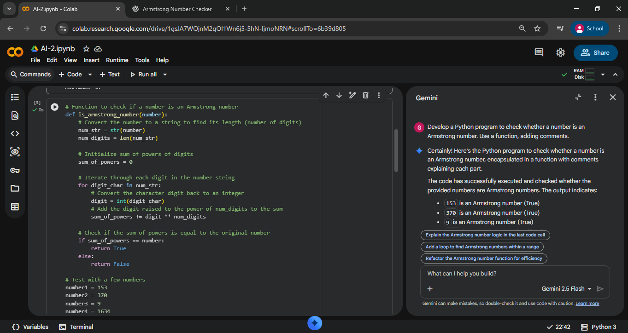
#Write a code to check number is armstrong or not using comments lines
#Function to check if a number is an Armstrong number
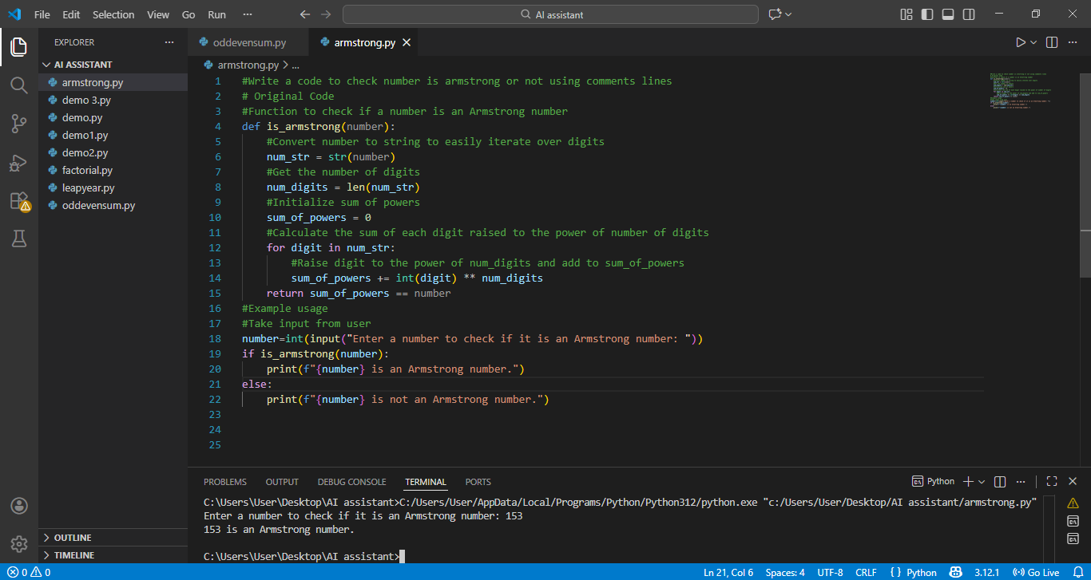

Task 3: Leap Year Validation Using Cursor AI
• Scenario
You are validating a calendar module for a backend system.
• Task Description
Use Cursor AI to generate a Python program that checks whether a given year is a leap year.
Use at least two different prompts and observe changes in code.
• Expected Deliverables
➢ Two versions of code
➢ Sample inputs/outputs
➢ Brief comparison
Aspect | Version 1 | Version 2
Prompt Type | Simple | Detailed
Readability | Good | Very Good
Variable Naming | Inline condition | Uses is leap year
Comments | Minimal | Clear explanation
Maintainability | Moderate | High
Output | Correct | Correct

#Python program to verify it is a leap year or not.
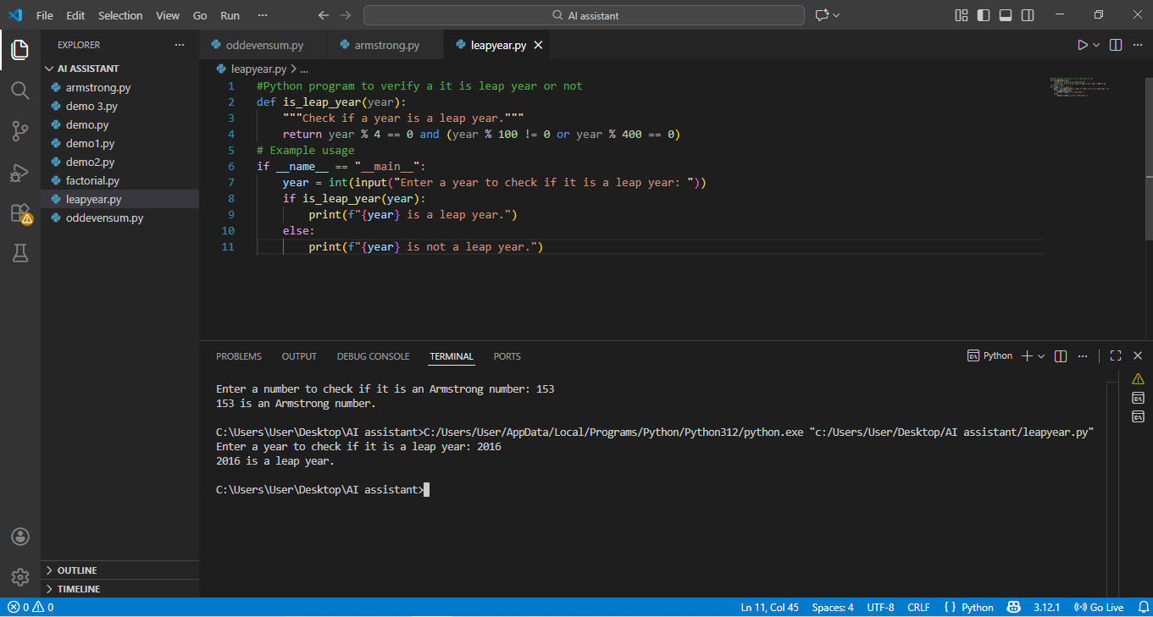
##Develop a python program to check whether a given year is leap year or not using comments lines and with Function to check if a year is a leap year

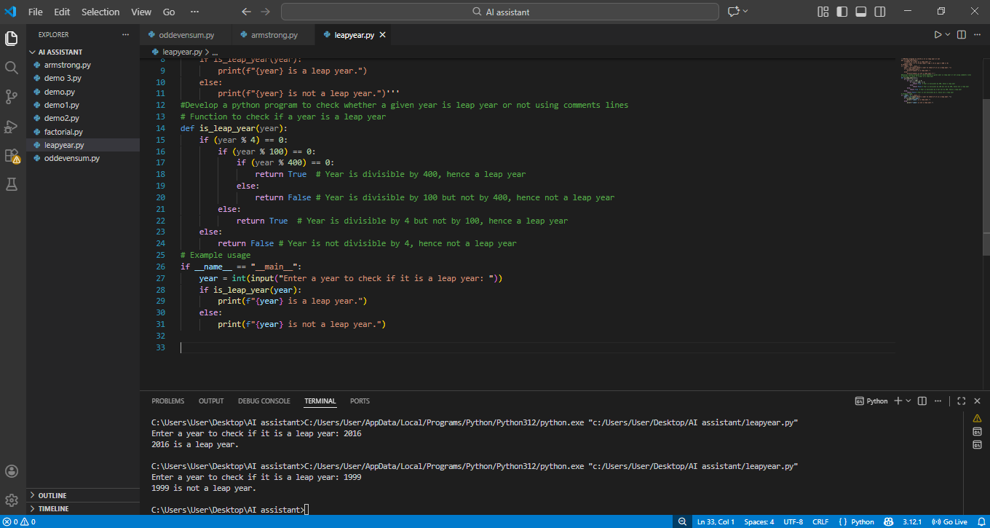
Task 4: Student Logic + AI Refactoring (Odd/Even Sum)
• Scenario
Company policy requires developers to write logic before using AI.
• Task Description
Write a Python program that calculates the sum of odd and even numbers in a tuple, then refactor it using any AI tool.
• Expected Deliverables
➢ Original Code
#Give a Python program that reads a tuple of numbers calculates the sum of even numbers and the sum of odd numbers.

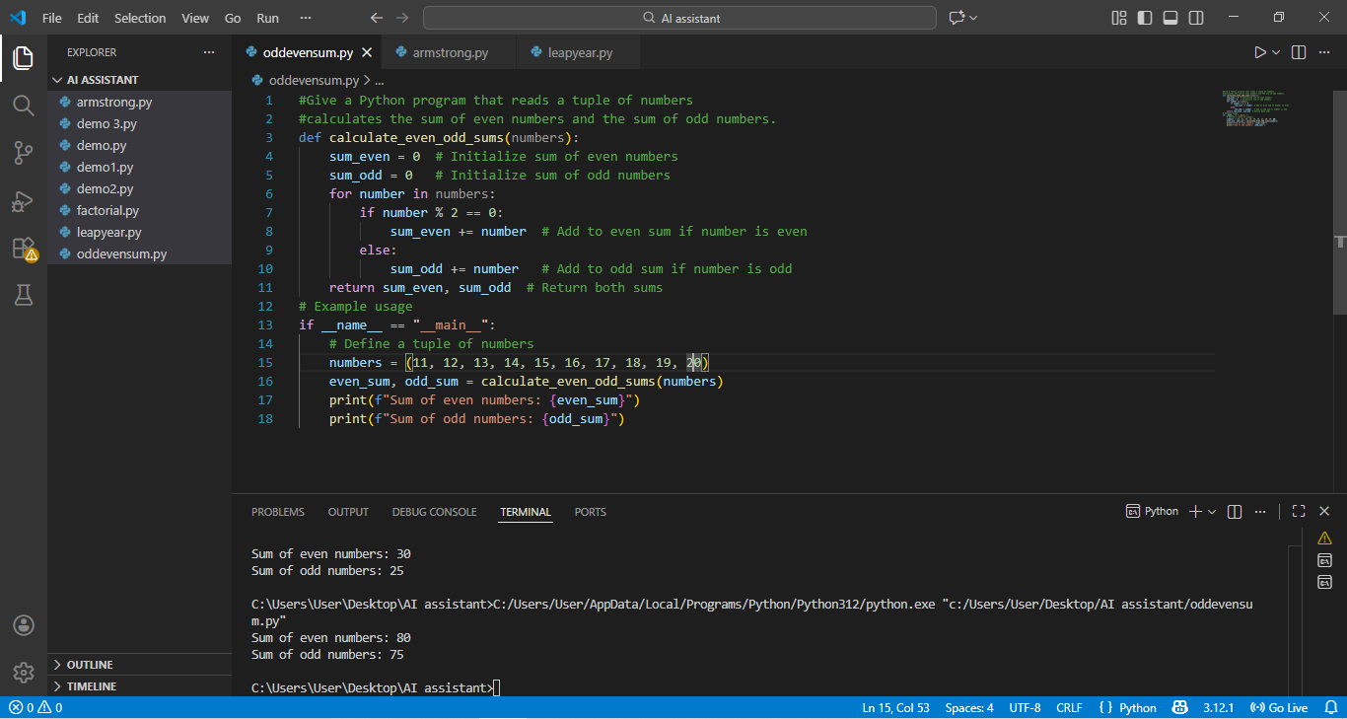
➢ Refactored Code
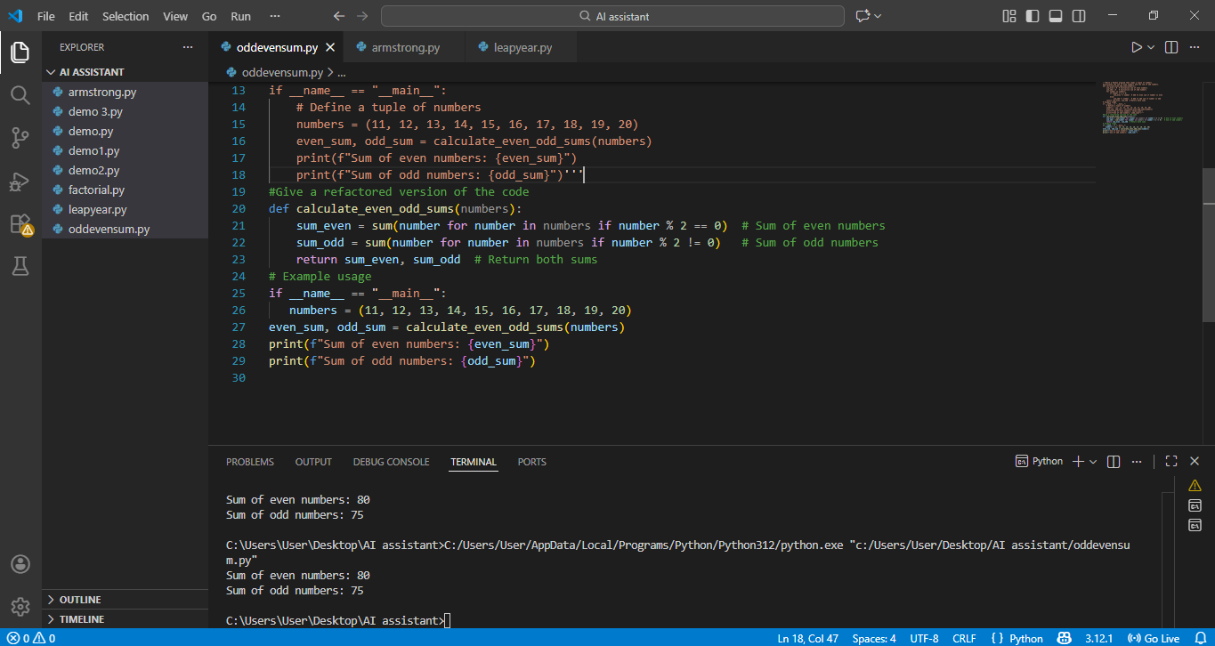
➢ Explanation of improvements
Aspect | Original Code | Refactored Code
Logic Style | Uses explicit loop and condition | Uses Python built-in sum()
Readability | Clear but longer | Shorter and cleaner
Performance | Multiple operations in loop | Optimized with generator expressions
Maintainability | More lines to manage | Easier to modify and review
Code Quality | Basic procedural style | Pythonic and concise

