AI ASSISTED CODING ASSIGNMENT - 2.1
K.Ashwitha (2303A51021)
BATCH-01

Task 1: Statistical Summary for Survey Data
• Scenario
You are a data analyst intern working with survey responses stored as numerical lists.
• Task Description
Use Google Gemini in Colab to generate a Python function that reads a list of numbers and calculates the mean, minimum, and maximum values.

• Expected Deliverables
➢ Correct Python function
- Yes, it is generated by Gemini
➢ Output shown in Colab
- Yes, mean, minimum and maximum are formed
➢ Screenshot of Gemini prompt and result
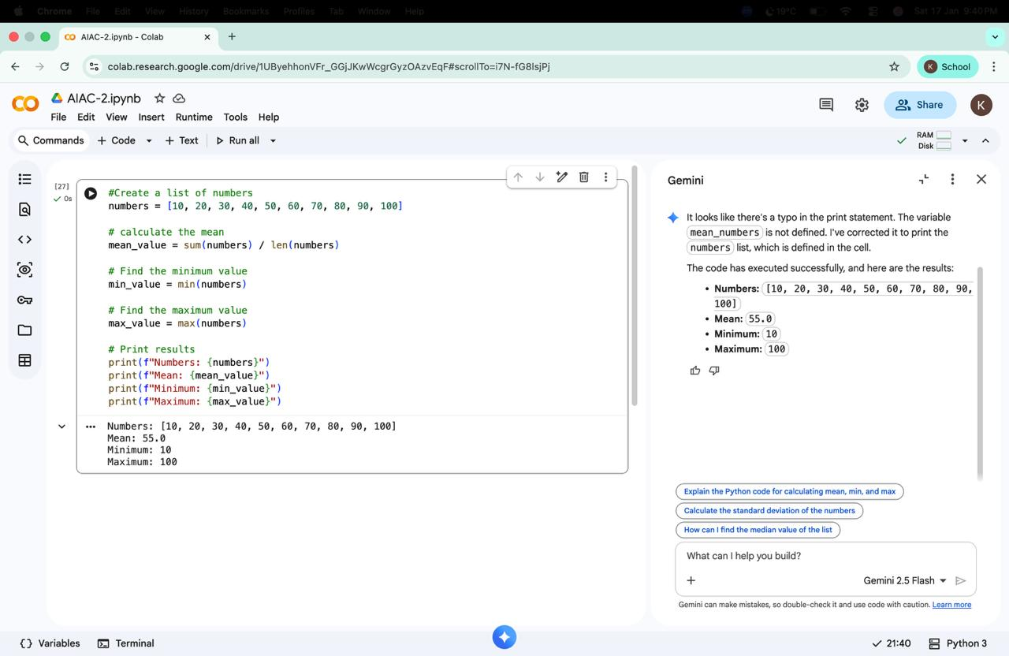

Task 2: Armstrong Number – AI Comparison
• Scenario
You are evaluating AI tools for numeric validation logic.
• Task Description
Generate Armstrong numbers checker using Gemini and GitHub Copilot.
Compare their outputs, logic style, and clarity.
• Expected Deliverables
➢ Side-by-side comparison
Feature | Google Gemini | GitHub Co-pilot
Code Correctness | Correct | Correct
Logic Style | Straightforward, beginner-friendly | Slightly optimized, cleaner variables
Readability | Good | Very good
Comments | Basic comments | Clear inline comments
Ease of Generation | Easy in chat | Very fast while typing
Output | Correct | Correct

➢ Screenshots of prompts and generated code
#Check whether the given number is Armstrong number or not. And also sue comments.
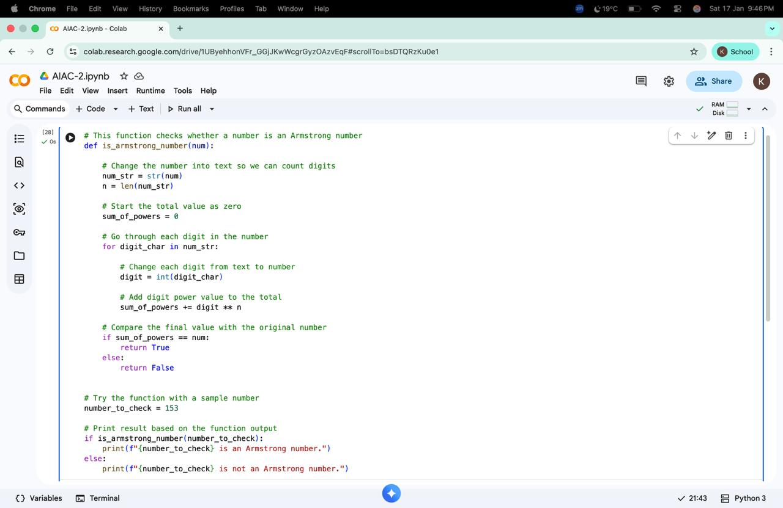

#Check whether the given number is Armstrong number or not. And also use comments.
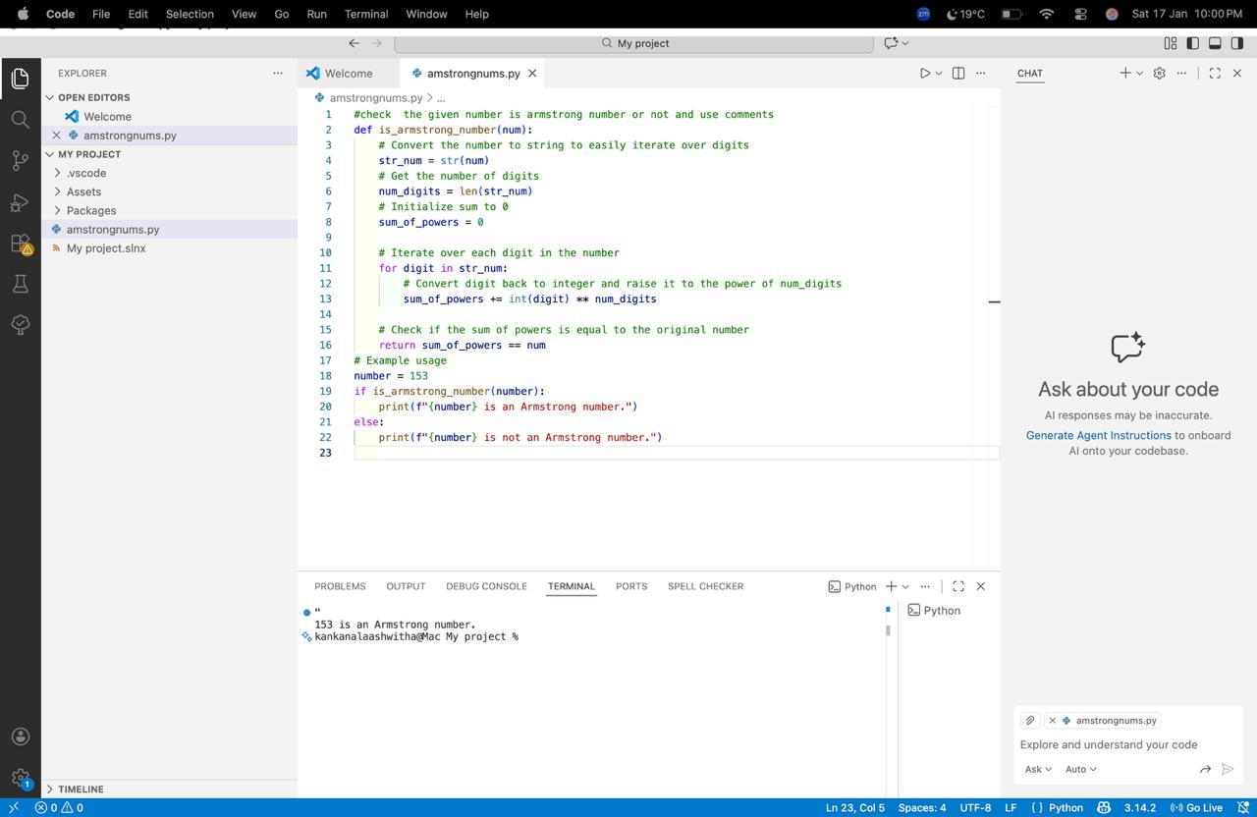
Task 3: Leap Year Validation Using Cursor AI
• Scenario
You are validating a calendar module for a backend system.
• Task Description
Use Cursor AI to generate a Python program that checks whether a given year is a leap year.
Use at least two different prompts and observe changes in code.
• Expected Deliverables
➢ Two versions of code
➢ Sample inputs/outputs
➢ Brief comparison
Aspect | Version 1 | Version 2
Prompt Type | Simple | Detailed
Readability | Good | Very Good
Variable Naming | Inline condition | Uses is leap year
Comments | Minimal | Clear explanation
Maintainability | Moderate | High
Output | Correct | Correct

#Write a python program to check whether a given year is a leap year
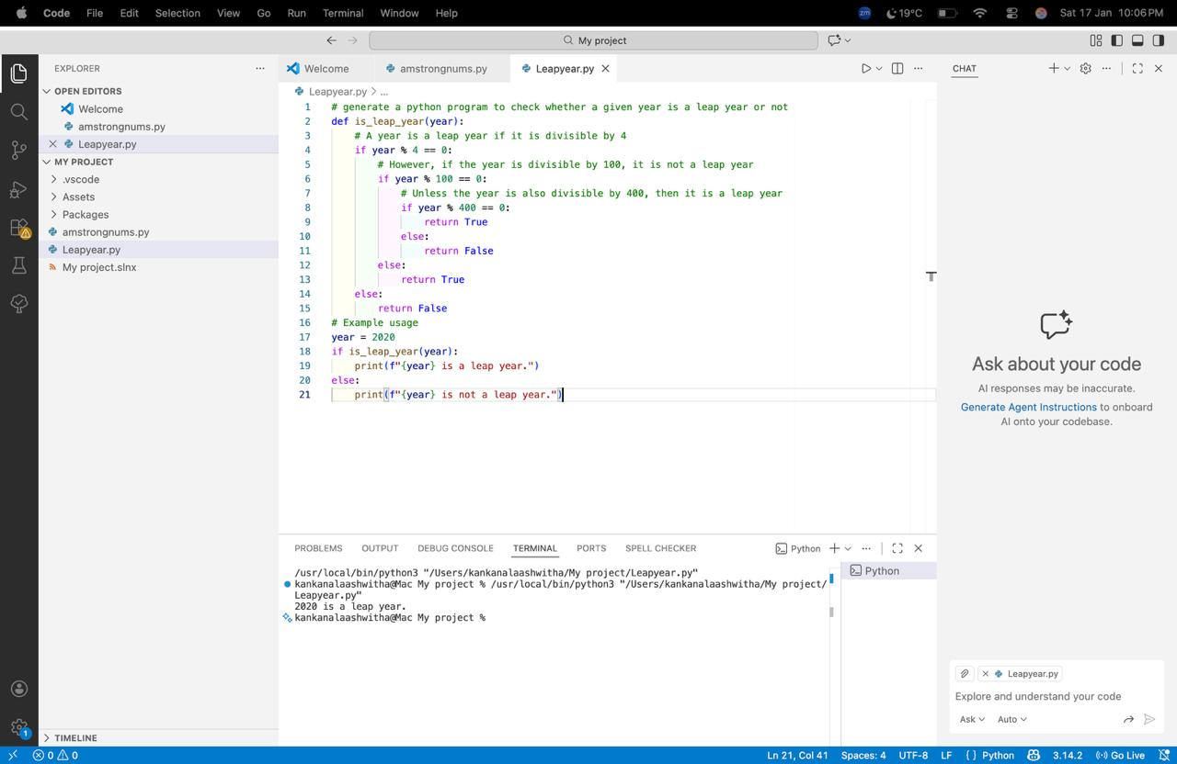
#Python program to validate leap year logic with meaningful variable names and comments
#Function to check if a given year is a leap year using meaningful variable names
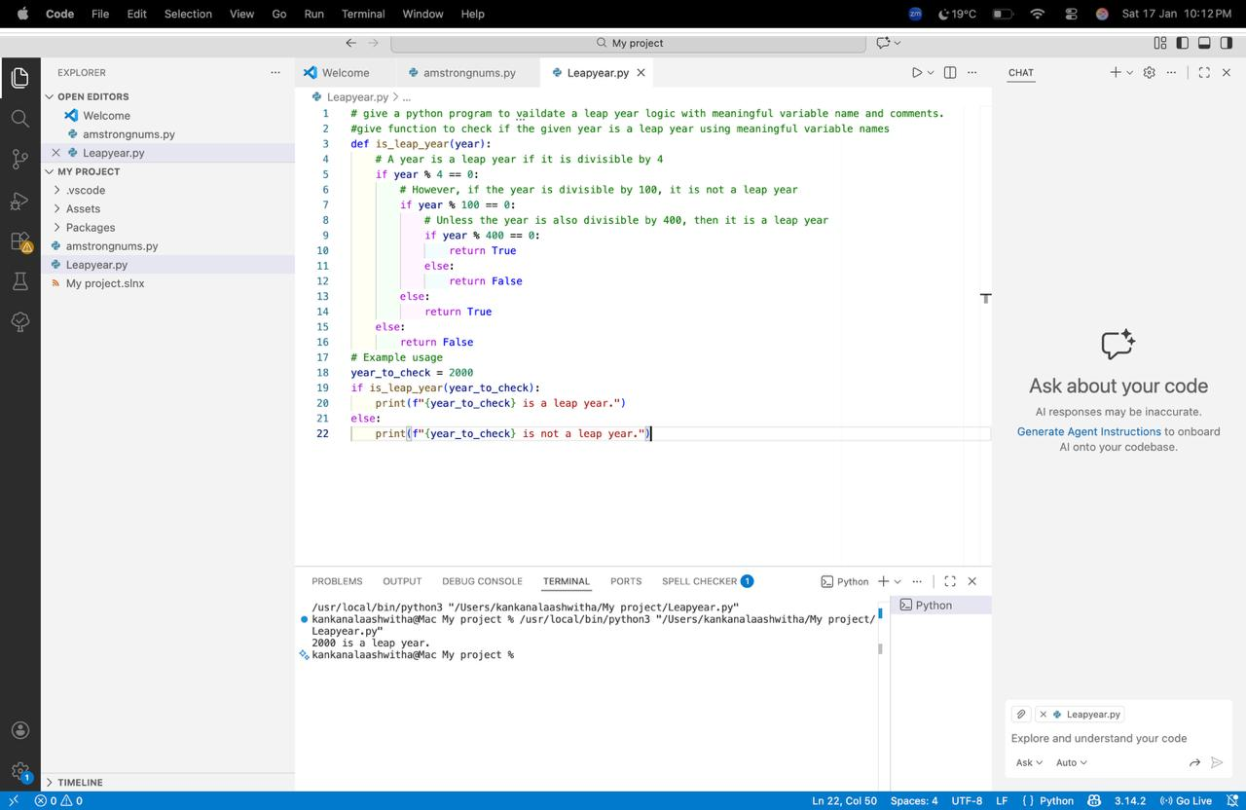
Task 4: Student Logic + AI Refactoring (Odd/Even Sum)
• Scenario
Company policy requires developers to write logic before using AI.
• Task Description
Write a Python program that calculates the sum of odd and even numbers in a tuple, then refactor it using any AI tool.
• Expected Deliverables
➢ Original Code
#Give a Python program that calculates the sum of odd and even numbers in a tuple, then refactor it using any AI tool.
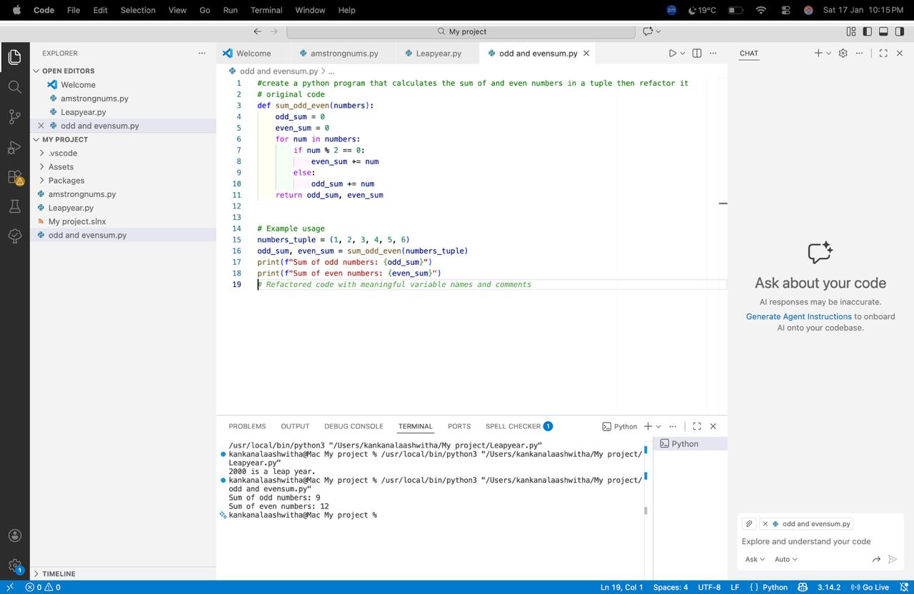
➢ Refactored Code
# Refactored Version (using list comprehensions)
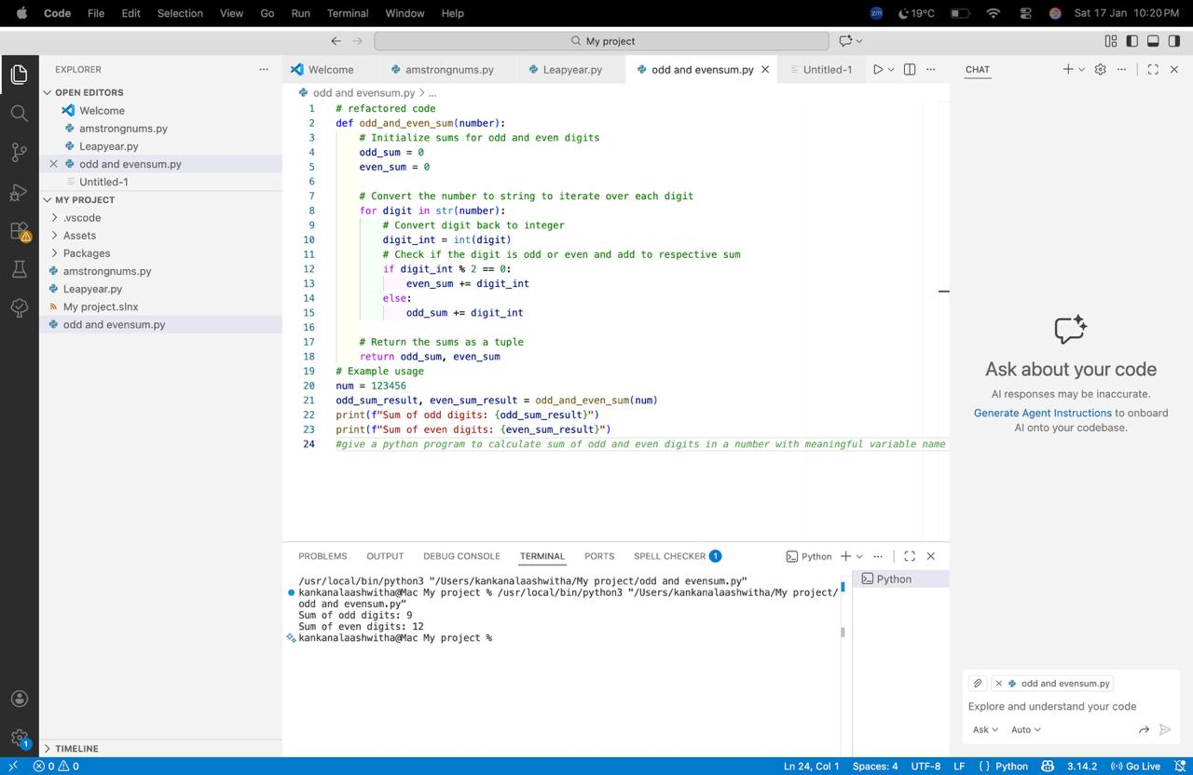
➢ Explanation of improvements
Aspect | Original Code | Refactored Code
Logic Style | Uses explicit loop and condition | Uses Python built-in sum()
Readability | Clear but longer | Shorter and cleaner
Performance | Multiple operations in loop | Optimized with generator expressions
Maintainability | More lines to manage | Easier to modify and review
Code Quality | Basic procedural style | Pythonic and concise

