Lab Assignment-19_1
Name : P.Chandra Vardhan Reddy
Hall ticket : 2303A51034
Batch No. : 01

Task 1 – Python to Java Conversion
Task:
Translate a simple Python class into Java using AI assistance.
Instruc ons:
- Prompt AI to convert a Python class with a ributes and methods into equivalent Java code.
- Verify that constructors, method signatures, and data types are properly handled.
- Run both versions (Python & Java) to compare expected outputs.
Expected Output:
- Equivalent working Java class translated from Python.
Screenshots:
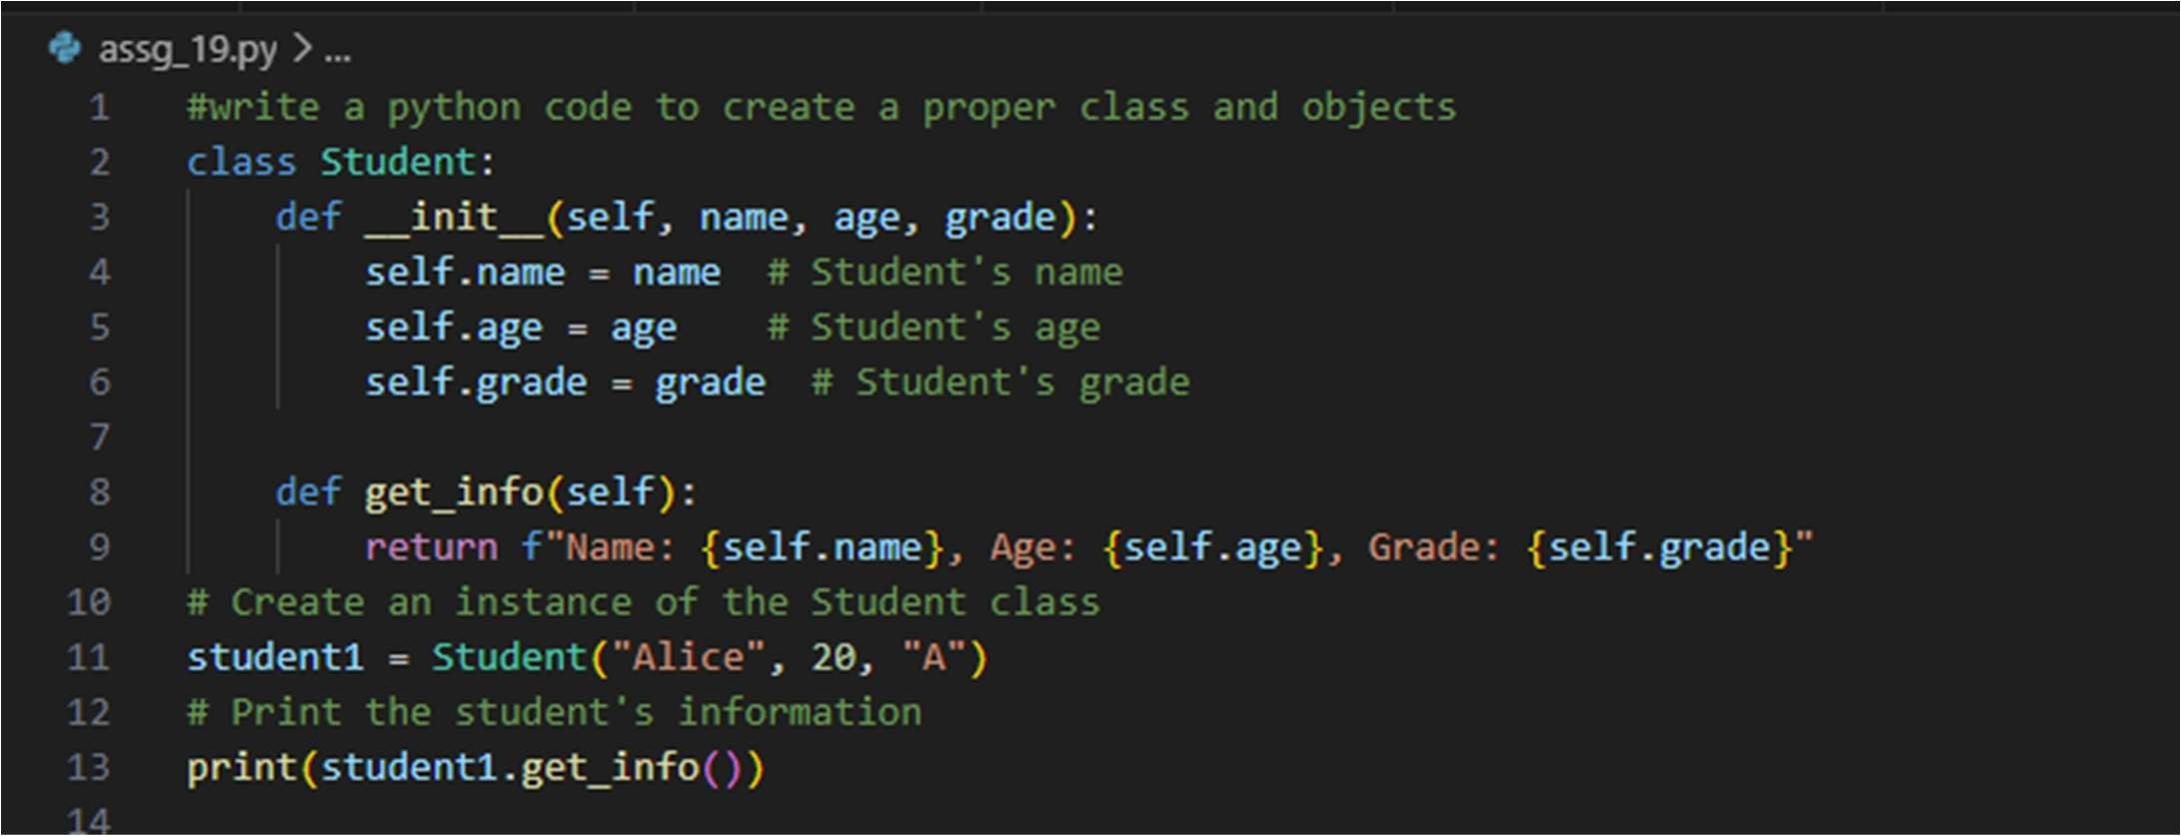
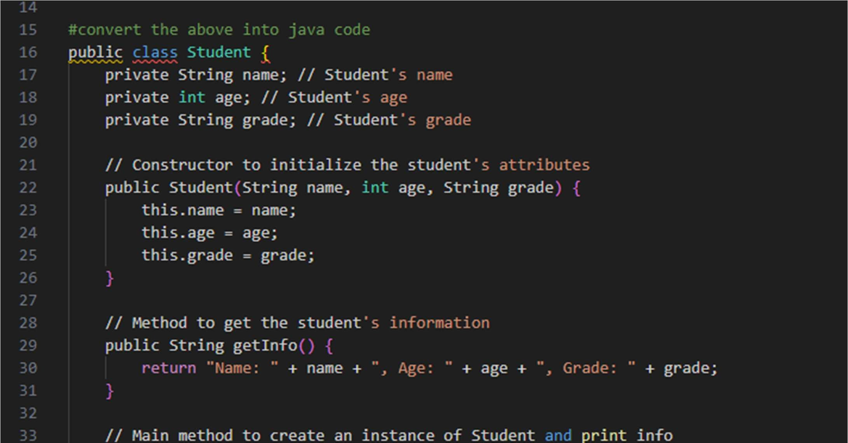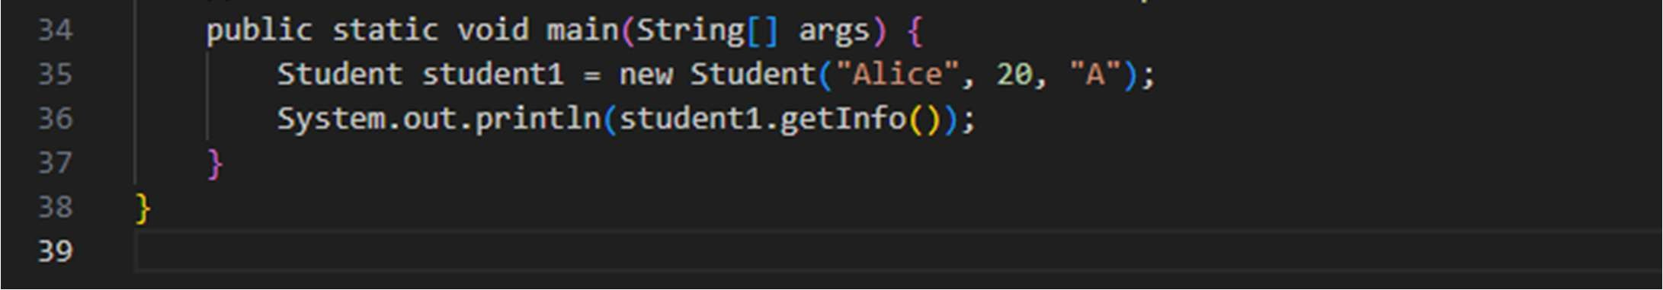
Output:

Task 2 – C++ to Python Func on Conversion
Task:
Convert a C++ func on for factorial calcula on into Python.
Instruc ons:
- Ask AI to translate a recursive C++ factorial func on into
Python.
- Validate correctness by tes ng with sample inputs.
- Ensure Python version follows Pythonic conven ons.
Expected Output:
- A correct Python implementa on equivalent to the original
C++ factorial func on.
Screenshots:
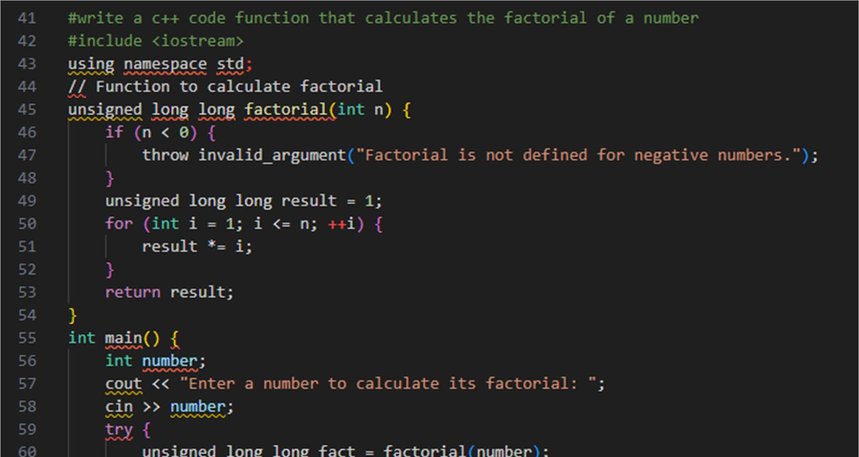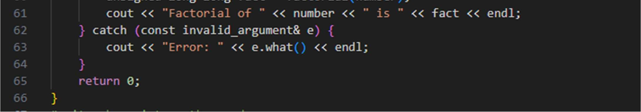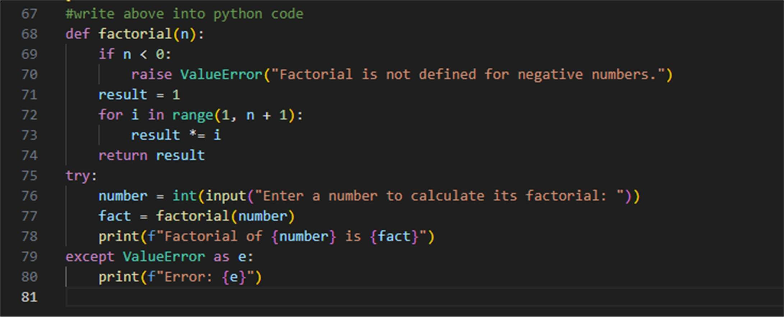
Output:
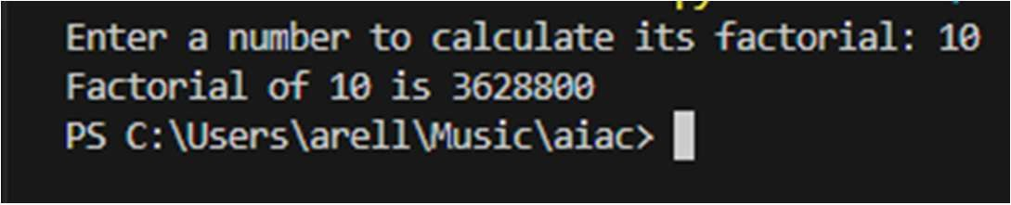

Task 3 – SQL to Pandas Query
Task:
Translate a SQL query into a Pandas DataFrame opera on in
Python.
Instruc ons:
- Provide AI with a SQL query (e.g., SELECT name, salary
FROM employees WHERE salary > 50000).
- Ask AI to generate equivalent Pandas code.
- Test the generated code on a sample DataFrame.
Expected Output:
- Equivalent Pandas query that retrieves the correct subset of data.
Screenshots:
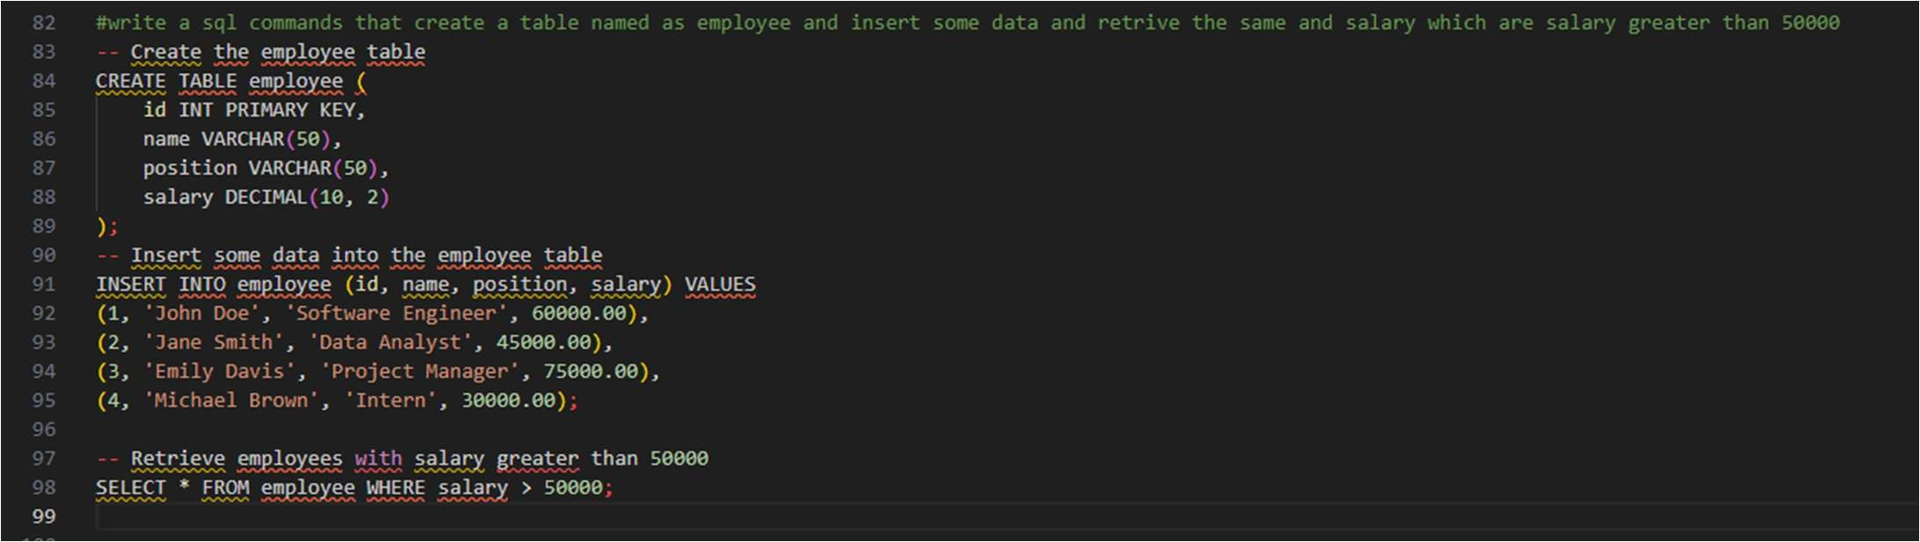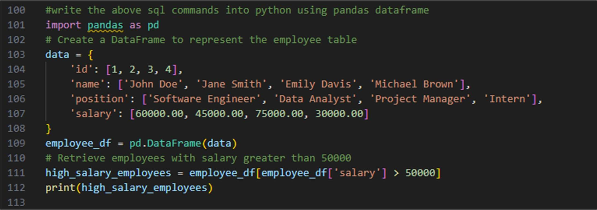
Output:
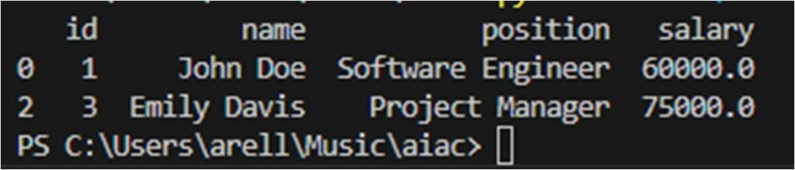

Task 4 – Real-Time Applica on: Mul -Language Snippet
Converter Scenario:
Students will choose a real- me use case where they need code in mul ple languages. Example:
- Conver ng a Python web scraping snippet into JavaScript for browser automa on.
- Transla ng a Java method into C# for enterprise applica ons.
Instruc ons:
- Prompt AI to translate code between two chosen languages.
- Test both implementa ons to ensure they produce the same
results.
- Document challenges faced during transla on (e.g., syntax,
libraries).
Expected Output:
- Working equivalent code snippets in at least two different programming languages.
SCREENSHOTS:
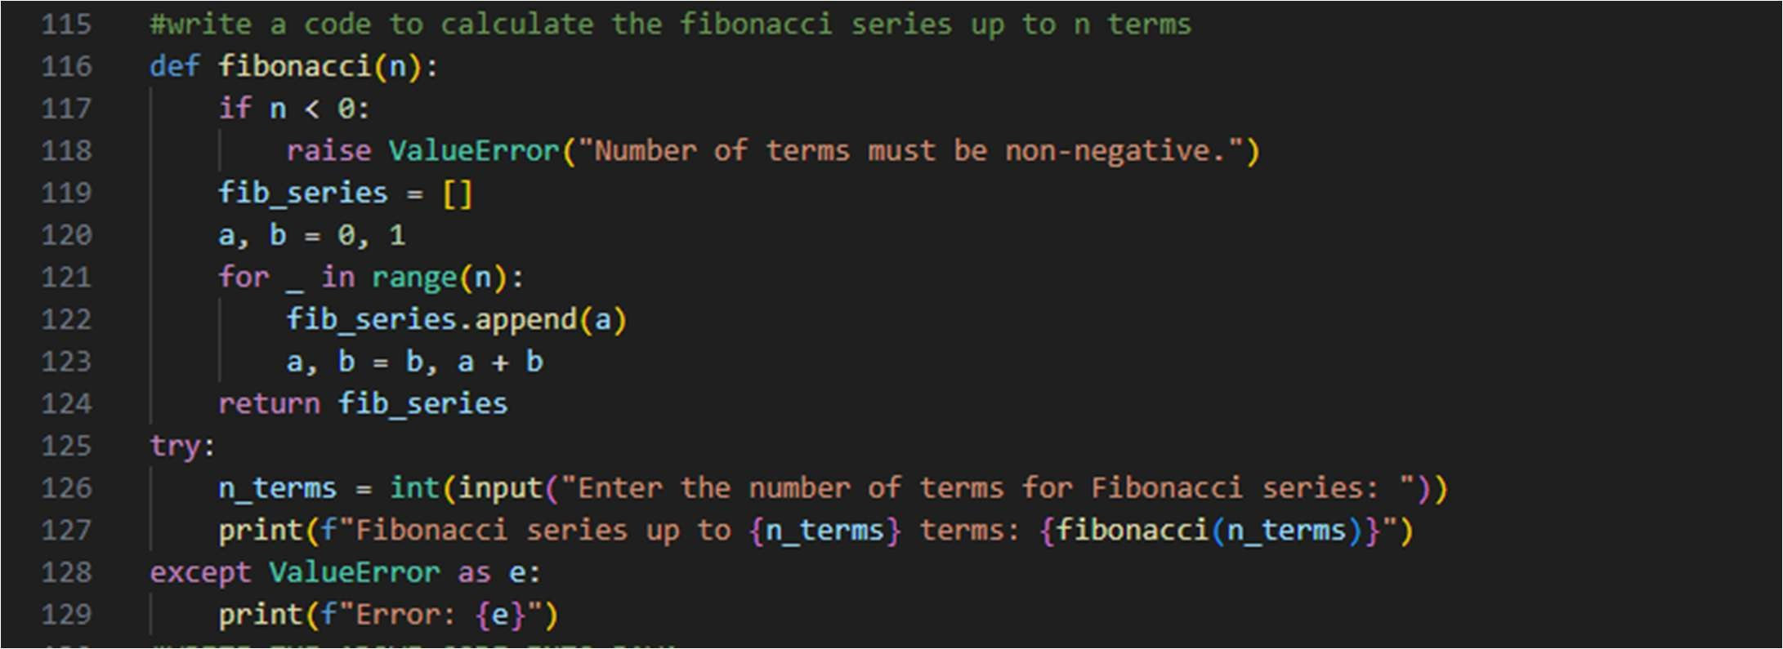
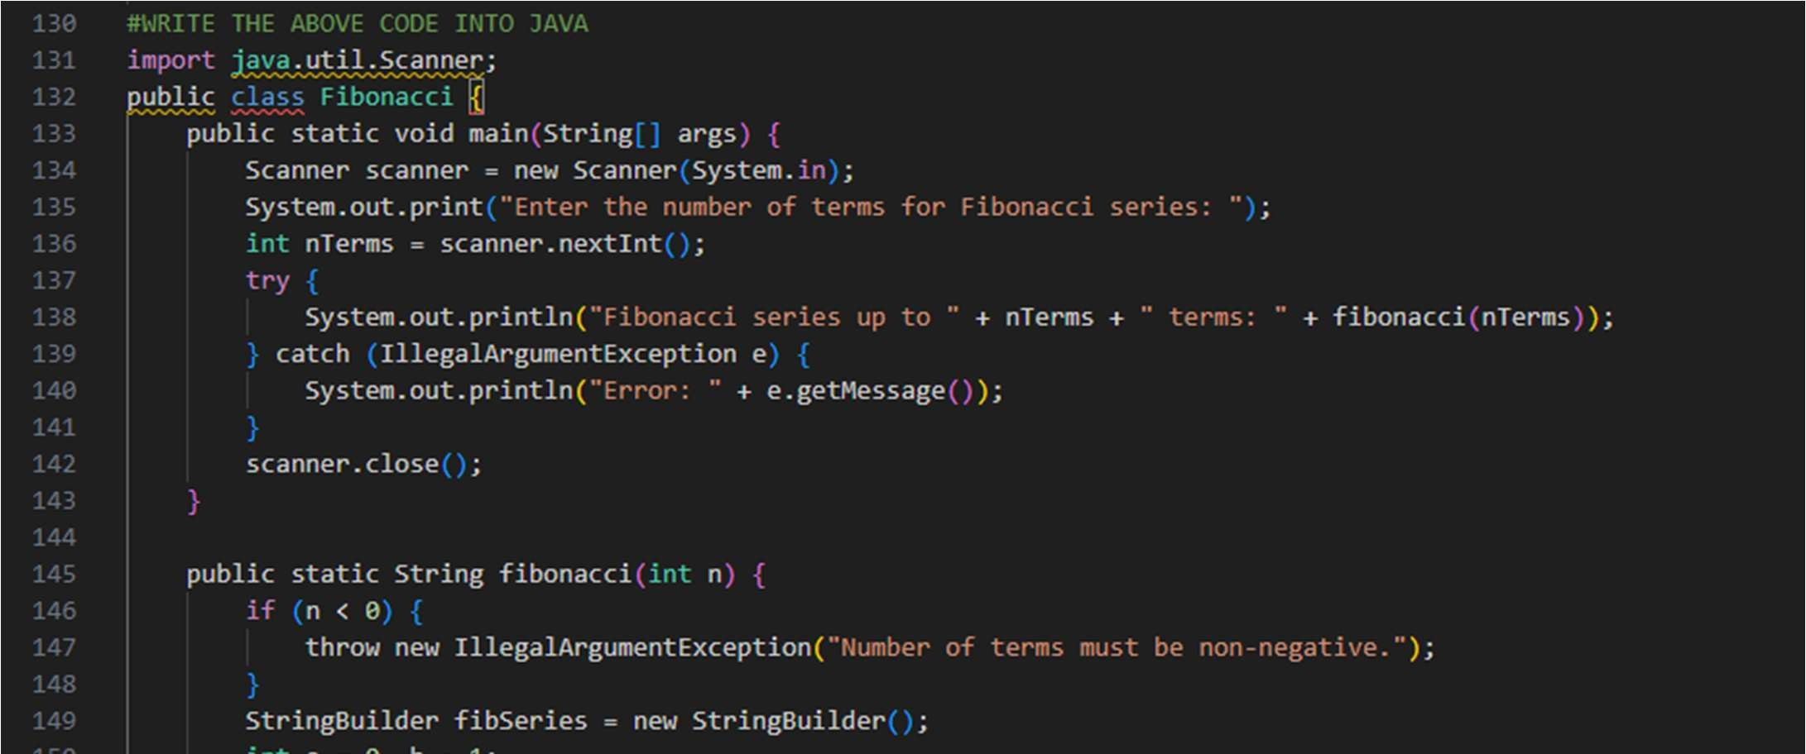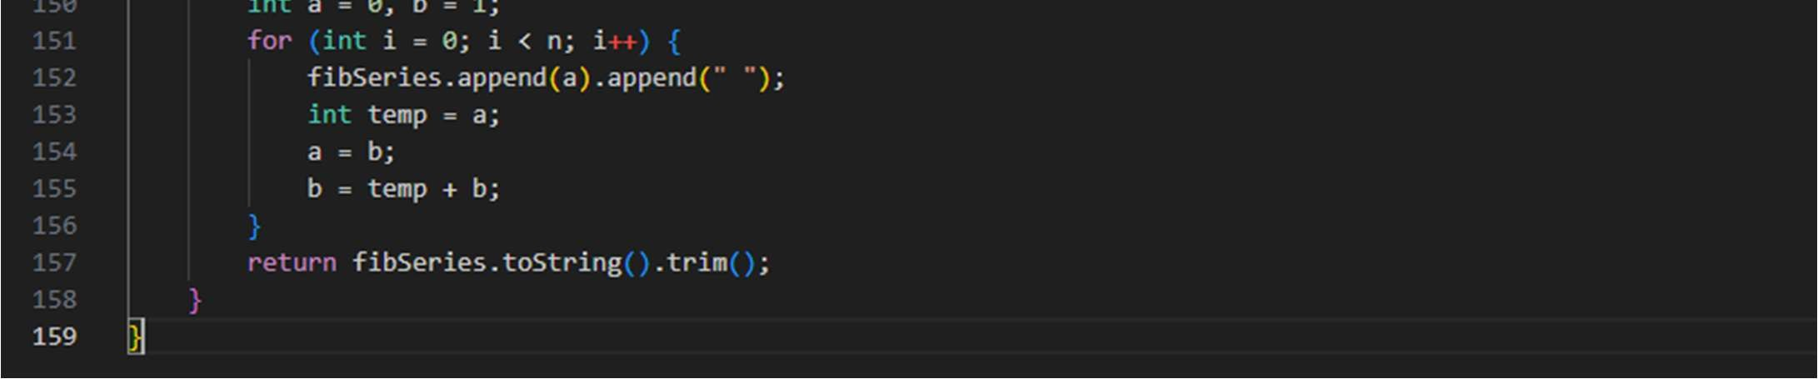
Output:
