Lab assignment -12_5
Name : P.Chandra Vardhan Reddy
Hall ticket : 2303A51034
Batch No. : 01

Task Descrip on #1 (Sor ng – Merge Sort Implementa on)
- Task: Use AI to generate a Python program that implements the Merge Sort algorithm.
- Instruc ons:
  - Prompt AI to create a func on merge_sort(arr) that sorts a list in ascending order.
  - Ask AI to include me complexity and space complexity in the func on docstring.
  - Verify the generated code with test cases.
- Expected Output:
o A func onal Python script implemen ng Merge Sort with proper documenta on.
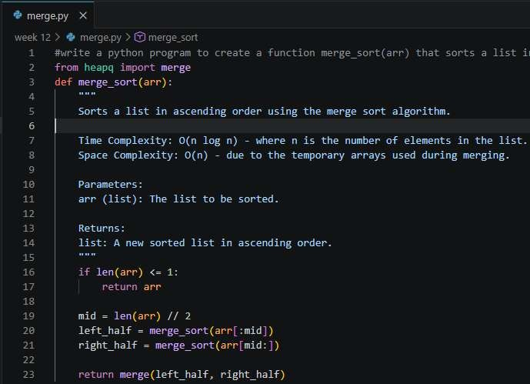
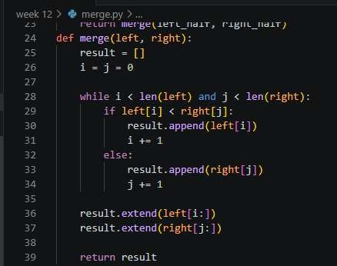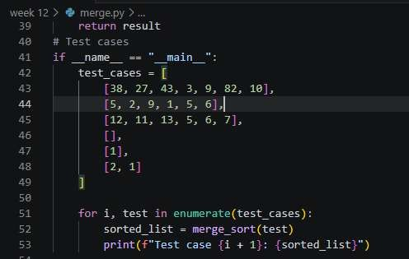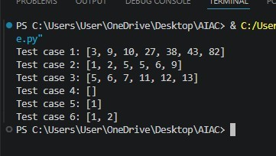
Task Descrip on #2 (Searching – Binary Search with AI
Op miza on)
- Task: Use AI to create a binary search func on that finds a target element in a sorted list.
- Instruc ons:
- Prompt AI to create a func on binary_search(arr, target) returning the index of the target or -1 if not found.
- Include docstrings explaining best, average, and worst-case complexi es.
- Test with various inputs.
• Expected Output:
o Python code implemen ng binary search with AI- generated comments and docstrings.
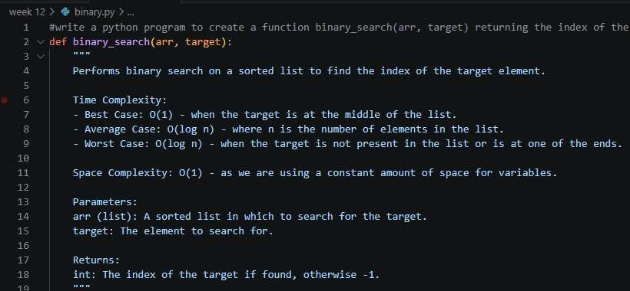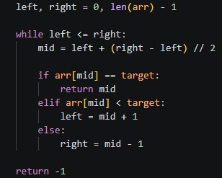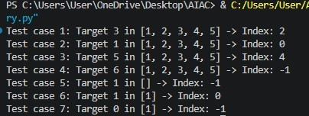

Task Descrip on #3: Smart Healthcare Appointment Scheduling
System
A healthcare pla orm maintains appointment records containing appointment ID, pa ent name, doctor name, appointment me, and consulta on fee. The system needs to:
- Search appointments using appointment ID.
- Sort appointments based on me or consulta on fee.
Student Task
  - Use AI to recommend suitable searching and sor ng algorithms.
  - Jus fy the selected algorithms.
  - Implement the algorithms in Python.

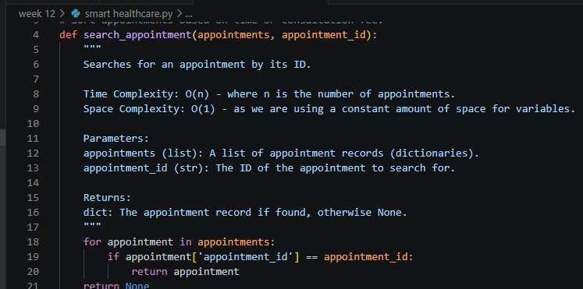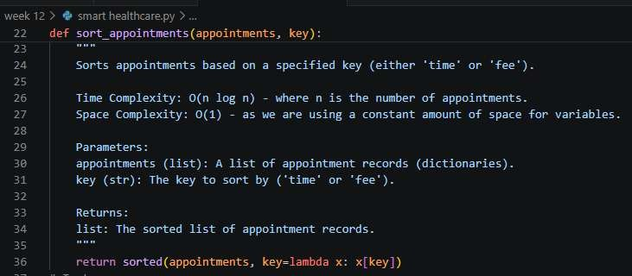

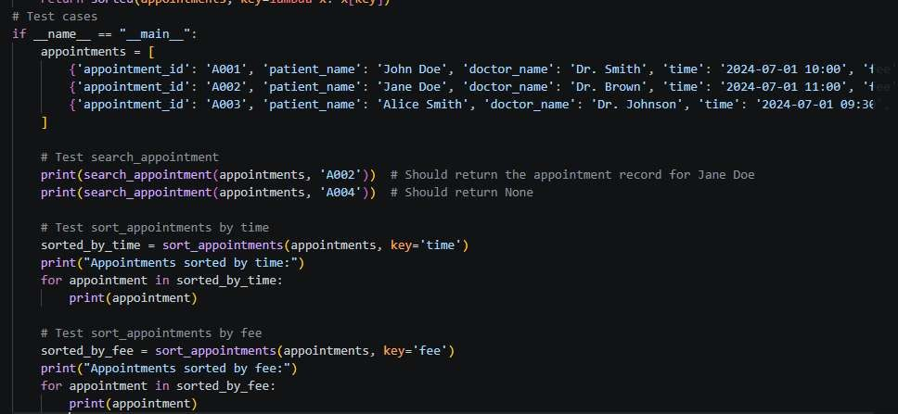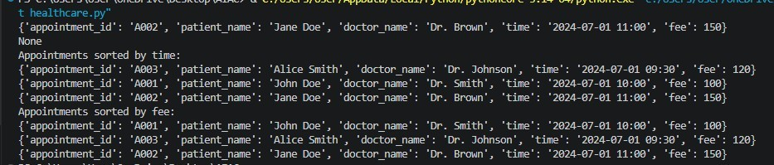

Task Descrip on #4: Railway Ticket Reserva on System
Scenario
A railway reserva on system stores booking details such as cket ID, passenger name, train number, seat number, and travel date. The system must:
- Search ckets using cket ID.
- Sort bookings based on travel date or seat number.
Student Task
    - Iden fy efficient algorithms using AI assistance.
    - Jus fy the algorithm choices.
    - Implement searching and sor ng in Python.
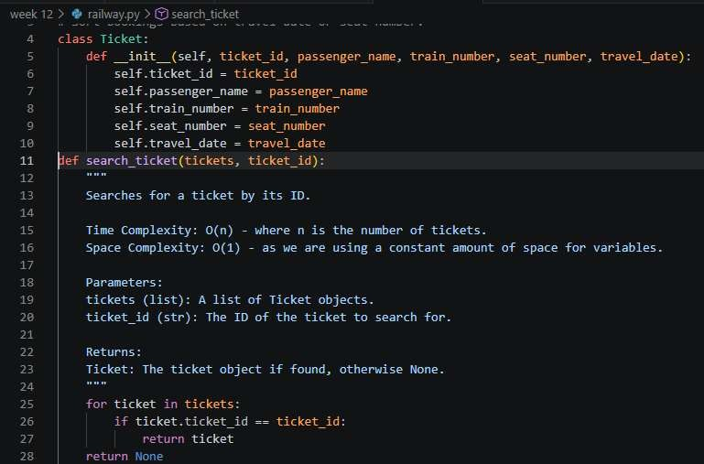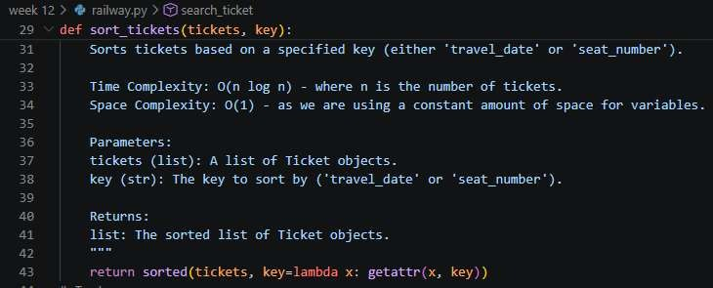

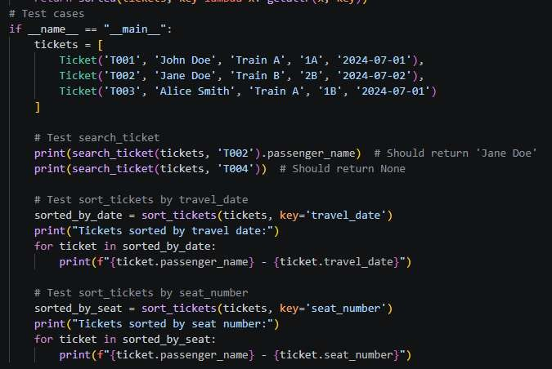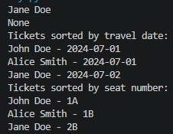

Task Descrip on #5: Smart Hostel Room Alloca on System A hostel management system stores student room alloca on details including student ID, room number, floor, and alloca on date. The system needs to:
- Search alloca on details using student ID.
- Sort records based on room number or alloca on date.
Student Task
  - Use AI to suggest op mized algorithms.
  - Jus fy the selec ons.
  - Implement the solu on in Python.
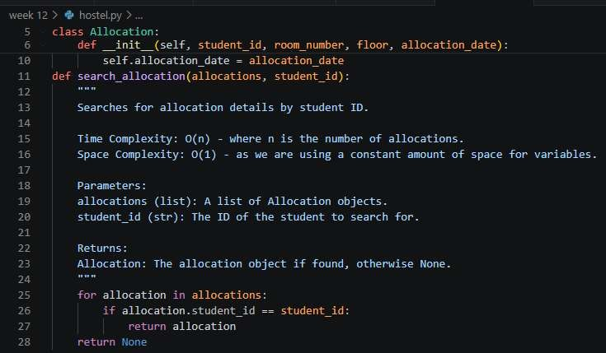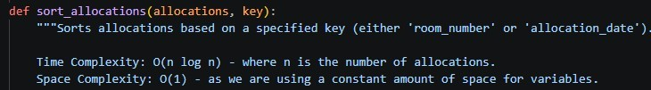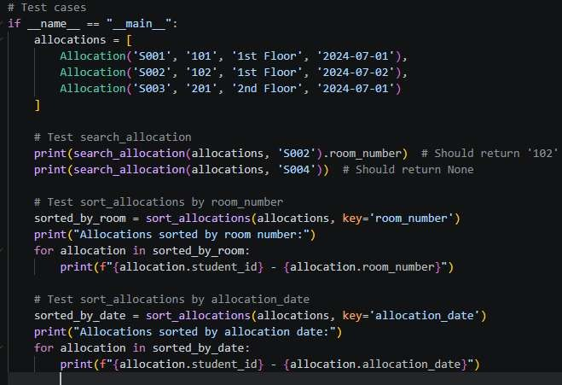

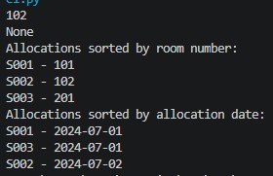
Task Descrip on #6: Online Movie Streaming Pla orm
A streaming service maintains movie records with movie ID, tle, genre, ra ng, and release year. The pla orm needs to:
  - Search movies by movie ID.
  - Sort movies based on ra ng or release year.
Student Task
    - Recommend searching and sor ng algorithms using AI.
    - Jus fy the chosen algorithms.
    - Implement Python func ons.
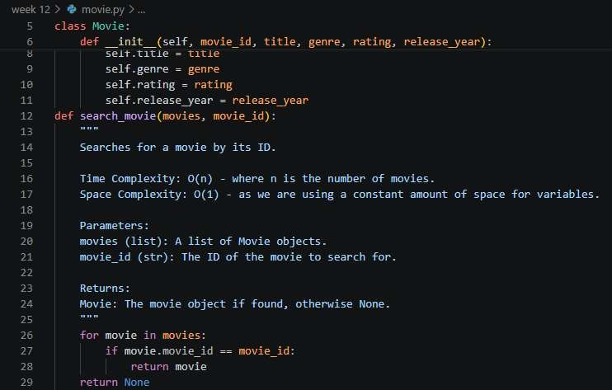
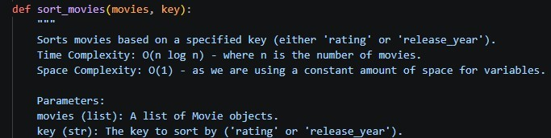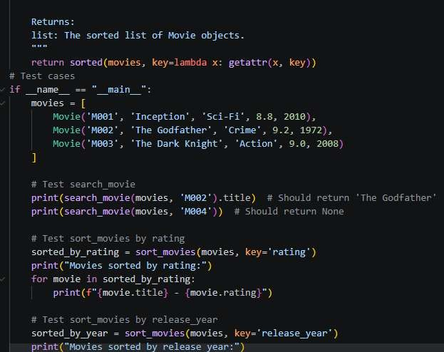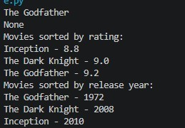

Task Descrip on #7: Smart Agriculture Crop Monitoring System An agriculture monitoring system stores crop data with crop ID, crop name, soil moisture level, temperature, and yield es mate. Farmers need to:
- Search crop details using crop ID.
- Sort crops based on moisture level or yield es mate.
Student Task
- Use AI-assisted reasoning to select algorithms.
- Jus fy algorithm suitability.
- Implement searching and sor ng in Python.
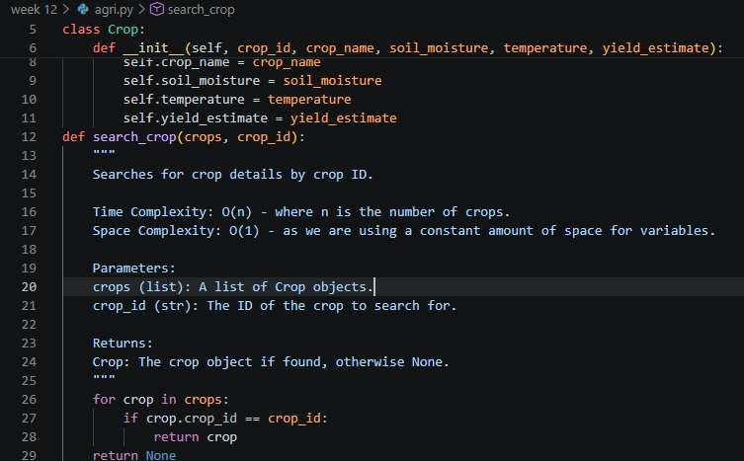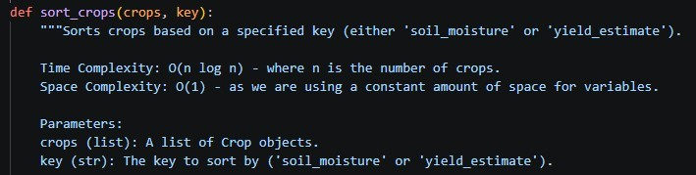
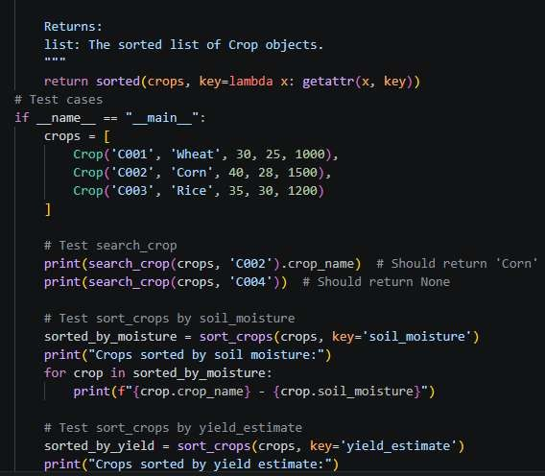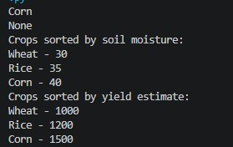

Task Descrip on #8: Airport Flight Management System An airport system stores flight informa on including flight ID, airline name, departure me, arrival me, and status. The system must:
- Search flight details using flight ID.
- Sort flights based on departure me or arrival me.
Student Task
- Use AI to recommend algorithms.
- Jus fy the algorithm selec on.
- Implement searching and sor ng logic in Python.
