Lab Assignment -14_5

Name : P.Chandra Vardhan Reddy
Hall ticket : 2303A51034
Batch No. : 01

Task 1 – Image Gallery Website Create an image gallery web page.
Requirements:
- Display images in a grid layout.
- Use AI to:
  - Op mize layout using CSS Grid. o Add hover zoom or overlay effects.
  - Ensure mobile responsiveness.
Screenshots:
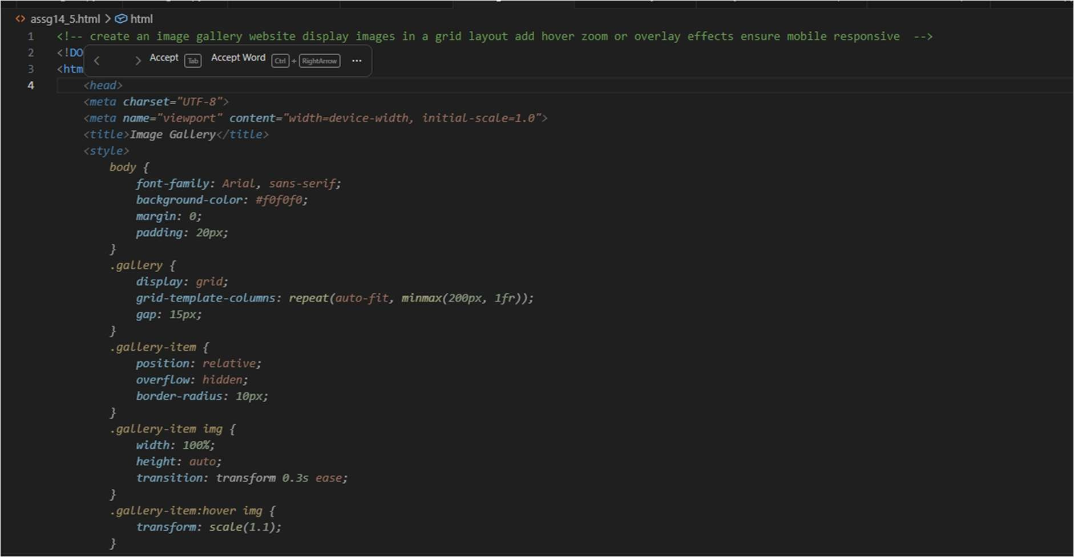


Task 2 – Profile Card Generator
Create a profile card web page.
Requirements:
- Display user image, name, role, and social media links.
- Use AI to:
  - Suggest modern UI colors and fonts.
  - Design the card using Flexbox.
  - Add hover anima on and shadow effects
screenshots:
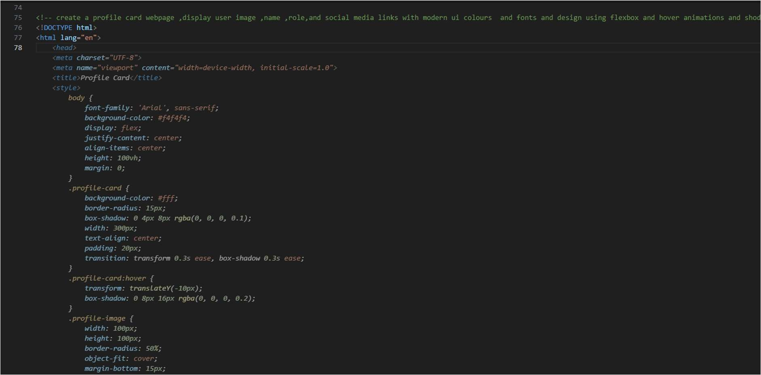

Task 3 -Develop a dynamic shopping cart system.
Requirements:
- Add, remove, and update product quan es.
- Display real- me total price.
- Use AI to:
  - Manage cart state using JavaScript objects.
  - Persist cart data in localStorage.
Screenshots:
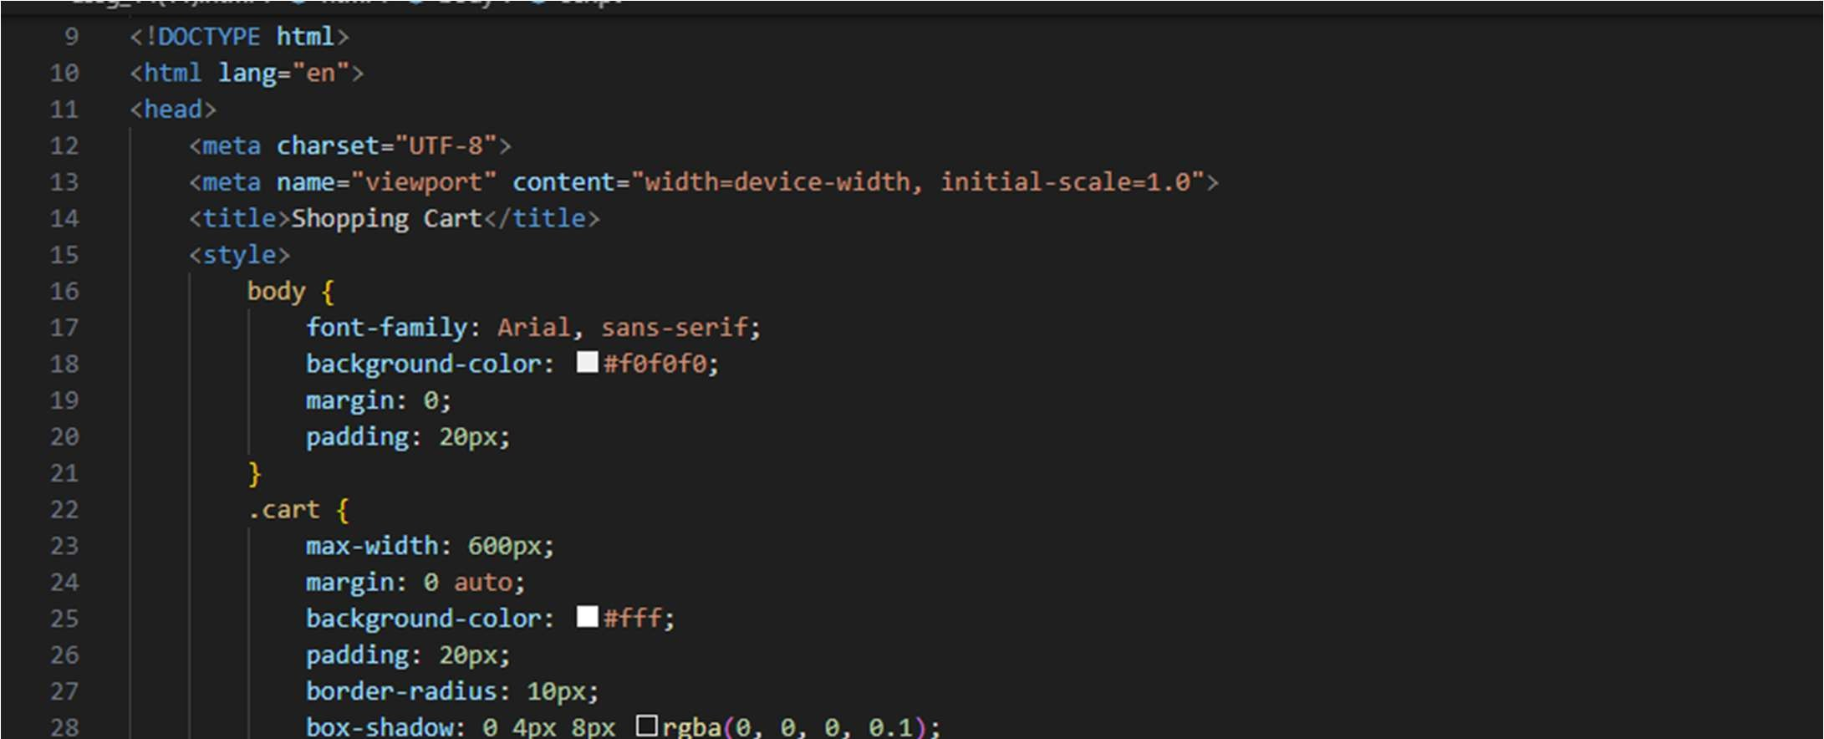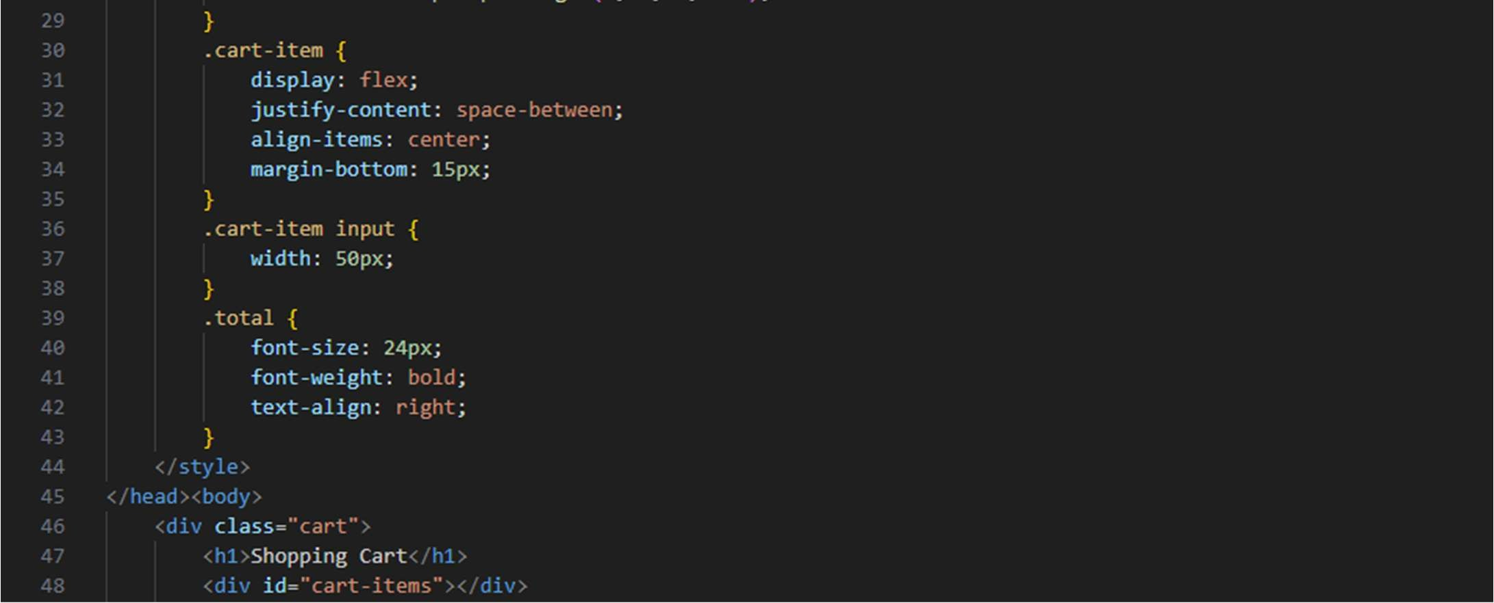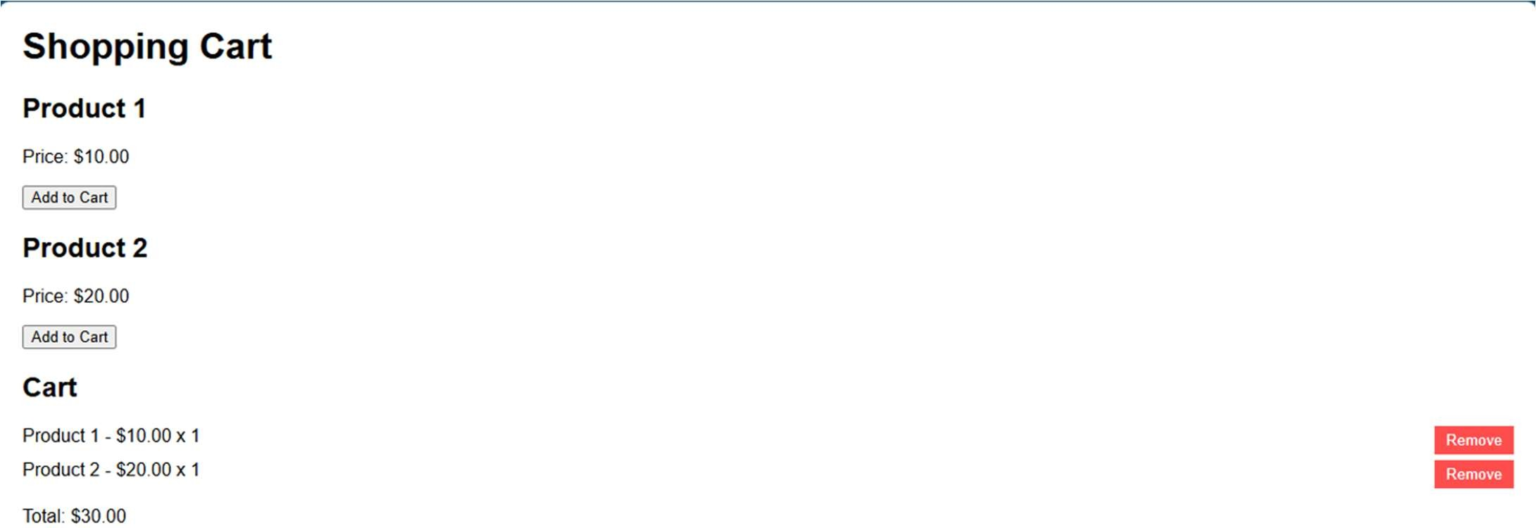
Task 4 – Role-Based Access Control Applica on
Create a role-based web applica on.
Requirements:
- Admin, Editor, User roles.
- Condi onal UI rendering.
- Use AI to:
  - Design access control logic.
  - Maintain secure state transi ons. o Create scalable UI components.
Screenshots:
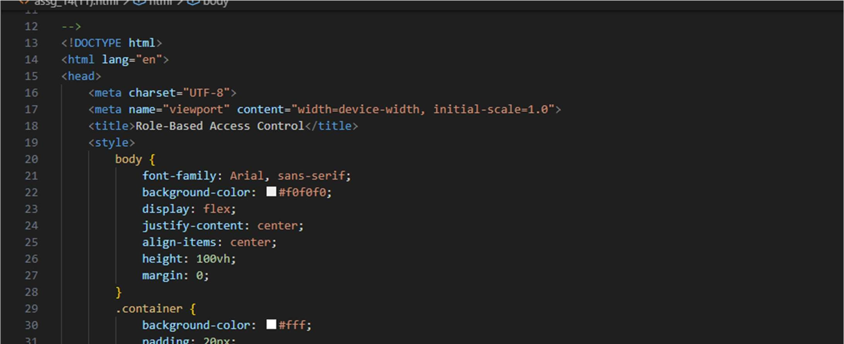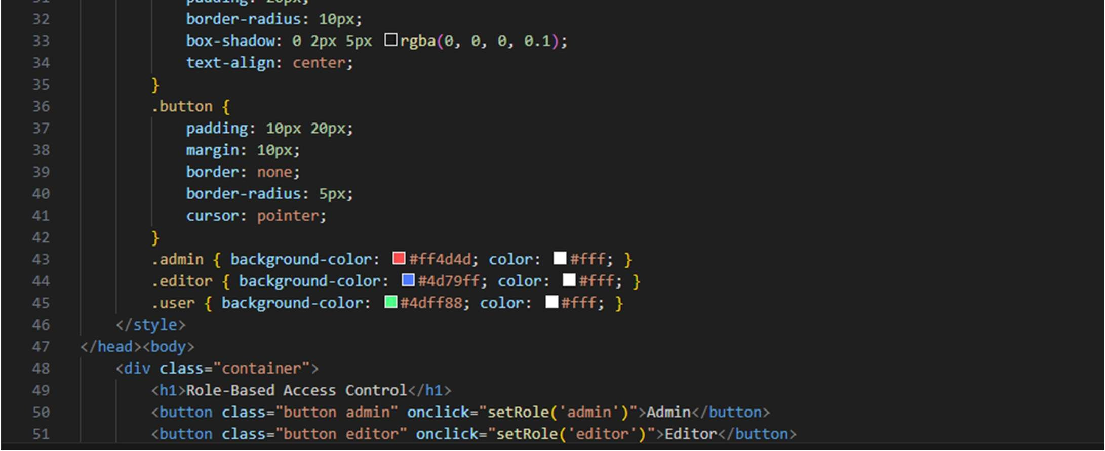


Task 5 – Mul -Language Website
Design a mul lingual website.
Requirements:
- Switch languages dynamically.
- Persist language preference.
- Use AI to:
  - Structure transla on files. o Handle RTL/LTR layouts. o Improve accessibility.
Screenshots:
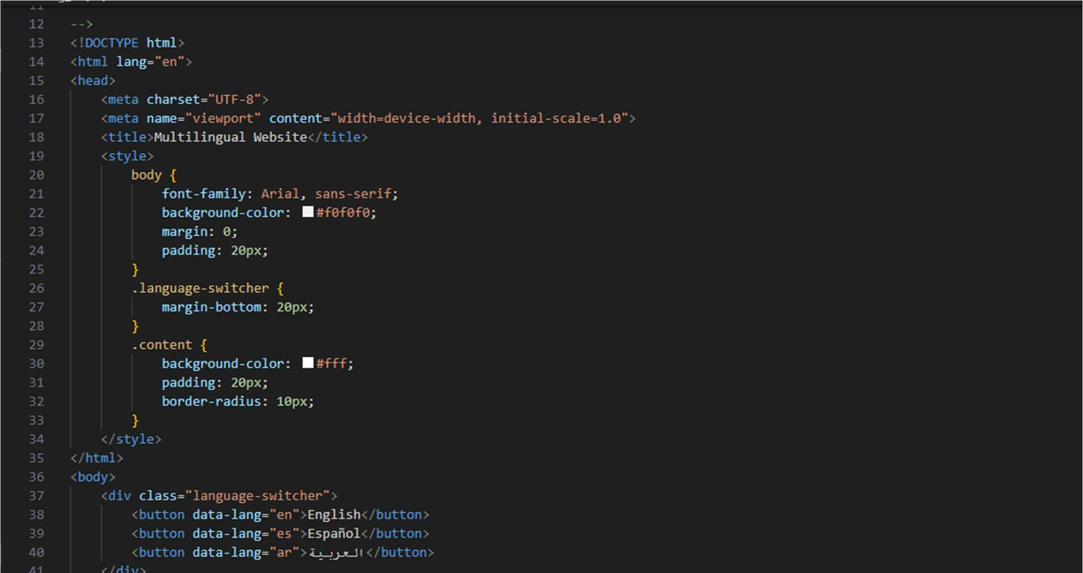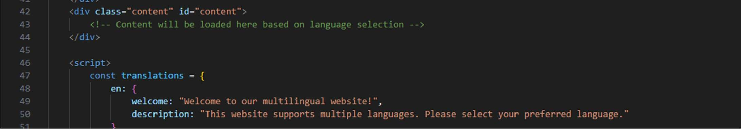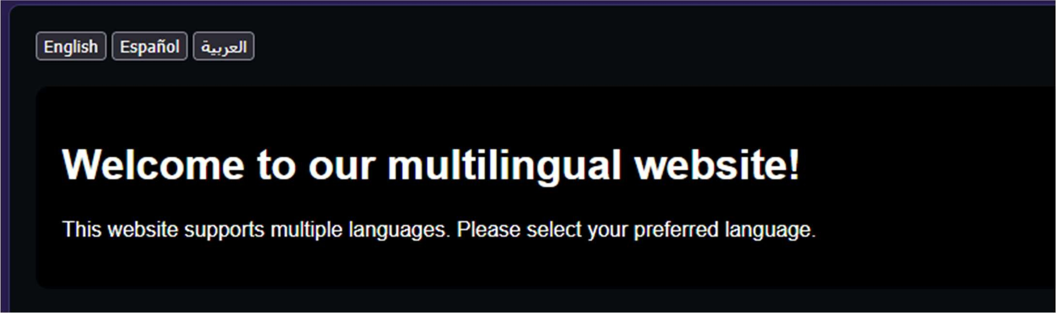
Task 6 – Online Examina on System Create an online exam interface.
Requirements:
- Timer, ques ons, and submission.
- Prevent mul ple submissions.
- Use AI to:
o Manage exam state. o Improve exam UX. o Ensure accessibility.
Screenshots:
