Lab Assignment -20
Name : P.Chandra Vardhan Reddy
Hall ticket : 2303A51034
Batch No. : 01

Lab 20 – Security Testing: Idenfying Vulnerabili es in AI- Generated Code
Lab Objec ves:
- Understand how to test AI-generated code for common security vulnerabili es.
- Learn to apply secure coding principles while analyzing AI outputs.
- Prac ce detec ng risks such as SQL injec on, XSS, hardcoded creden als, and weak encryp on.
- Enhance code reliability and safety by using AI for secure refactoring.

Task 1 – Password Storage Vulnerability Check
Task: Analyze an AI-generated signup script for insecure password storage.
Instruc ons:
- Prompt AI to generate a Python user registra on program.
- Check whether passwords are stored in plain text.
- Improve the script using hashing (bcrypt or hashlib).
Expected Output:
- A secure registra on script with hashed password storage.
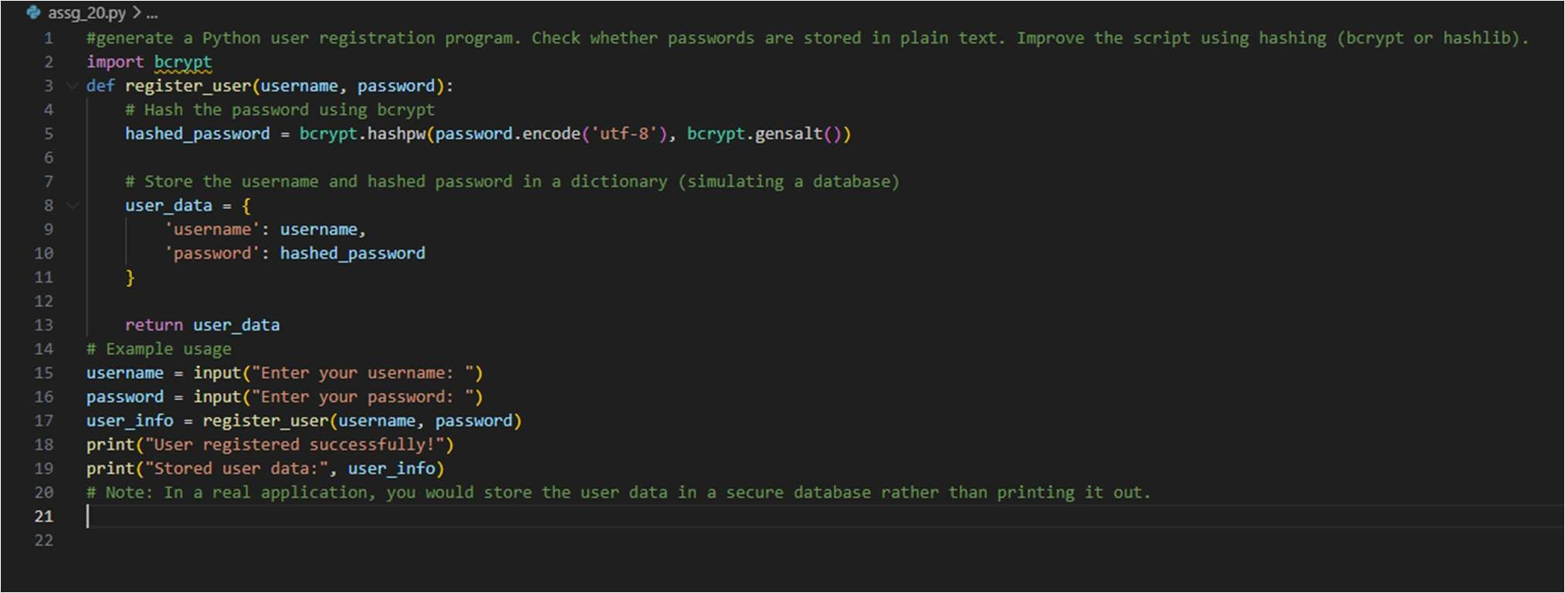
Output :
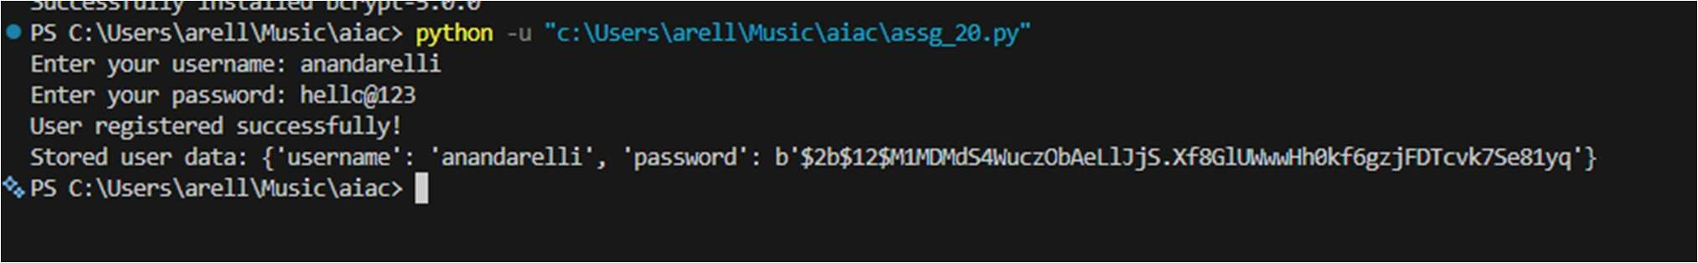

Task 2 – Hardcoded Secrets Detec on
Task: Evaluate AI-generated code for hardcoded API keys or creden als.
Instruc ons:
- Ask AI to generate a script that connects to an external API.
- Iden fy if API keys/passwords are wri en directly in code.
- Refactor using environment variables or config files.
Expected Output:
- A secure script with secrets managed properly.
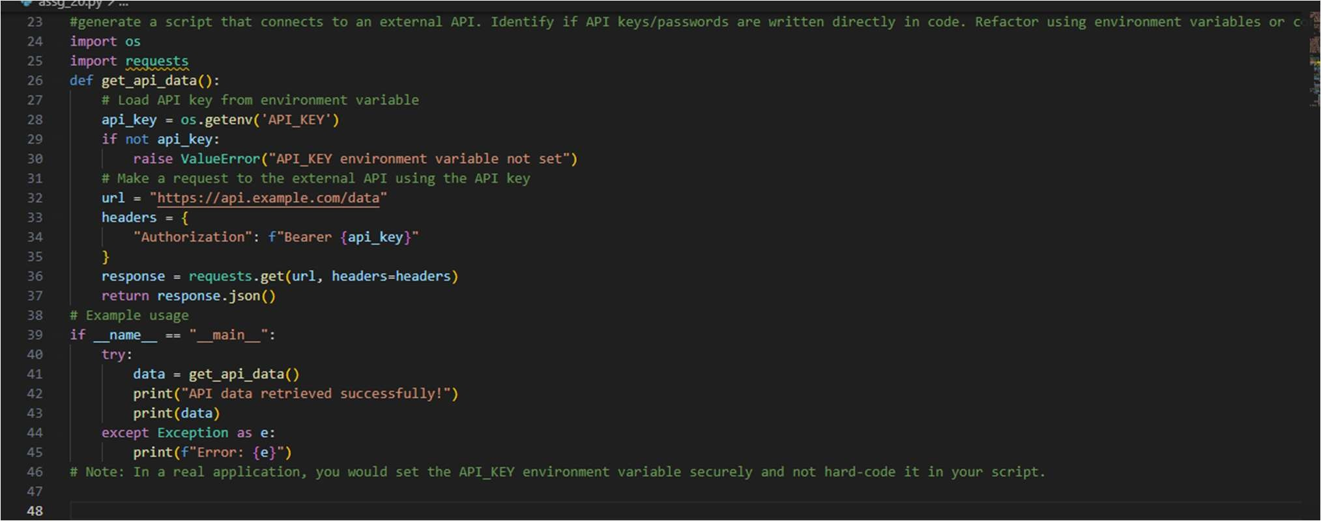
Output :
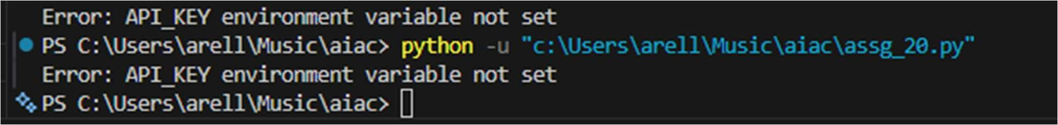

Task 3 – File Upload Security Valida on
Task: Test an AI-generated file upload program for unsafe file handling. Instruc ons:
- Prompt AI to generate a Flask file upload example.
- Check for vulnerabili es like uploading executable files.
- Add valida on for file type, size, and secure filename Handling.
Expected Output:
- A secure file upload implementa on.
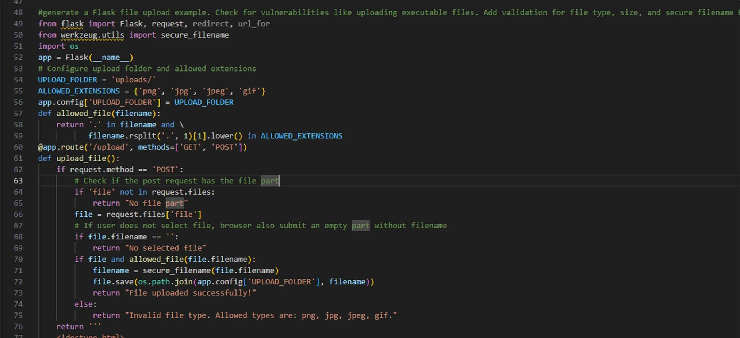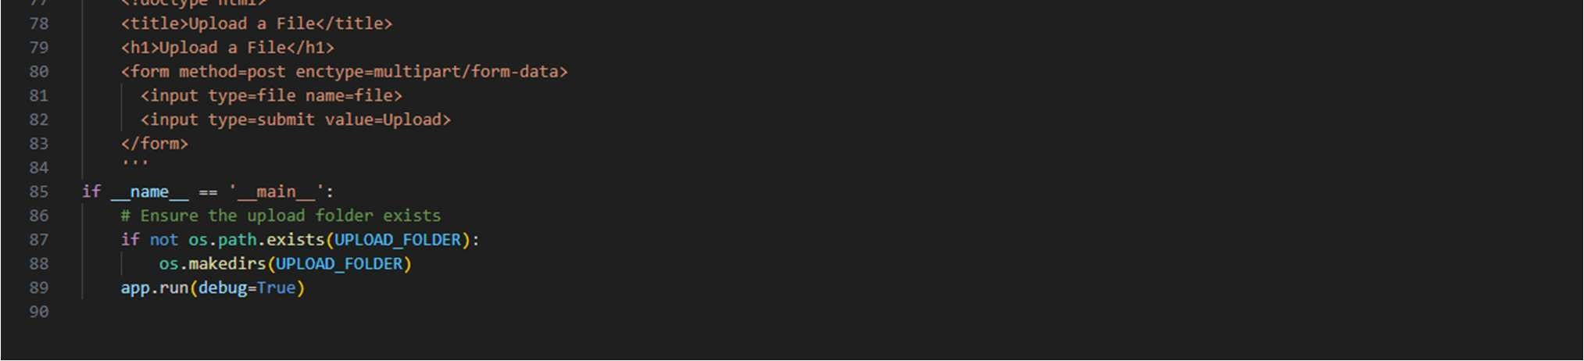
Output :
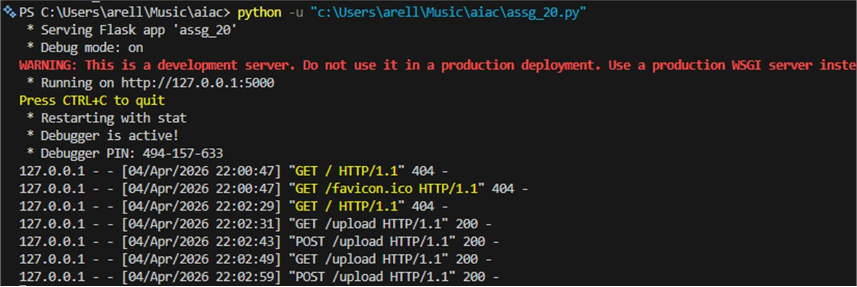
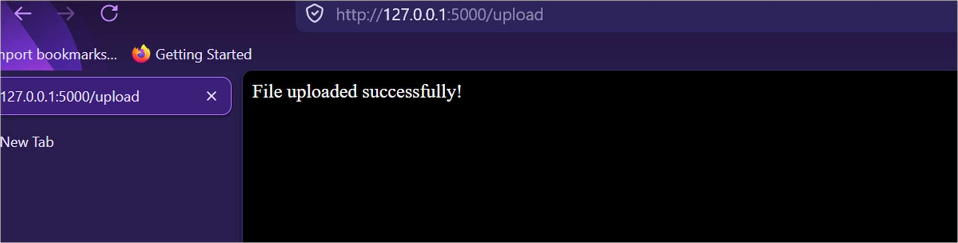

Task 4 – Command Injec on Preven on
Task: Analyze an AI-generated Python script that executes system commands.
Instruc ons:
- Ask AI to generate code using os.system() or subprocess.
- Iden fy command injec on risks with user input.
- Fix using safe subprocess calls and input valida on.
Expected Output:
- A secure command execu on script.

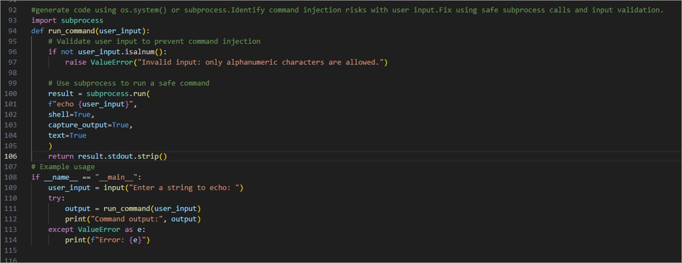
Output :

Task 5 – Secure Input Handling in Web Forms
Task: Check AI-generated web form code for improper input valida on. Instruc ons:
- Ask AI to generate an HTML + Flask feedback form.
- Iden fy missing valida on and unsafe rendering.
- Fix using server-side valida on and sani za on.
Expected Output:
- A secure form resistant to injec on a acks.

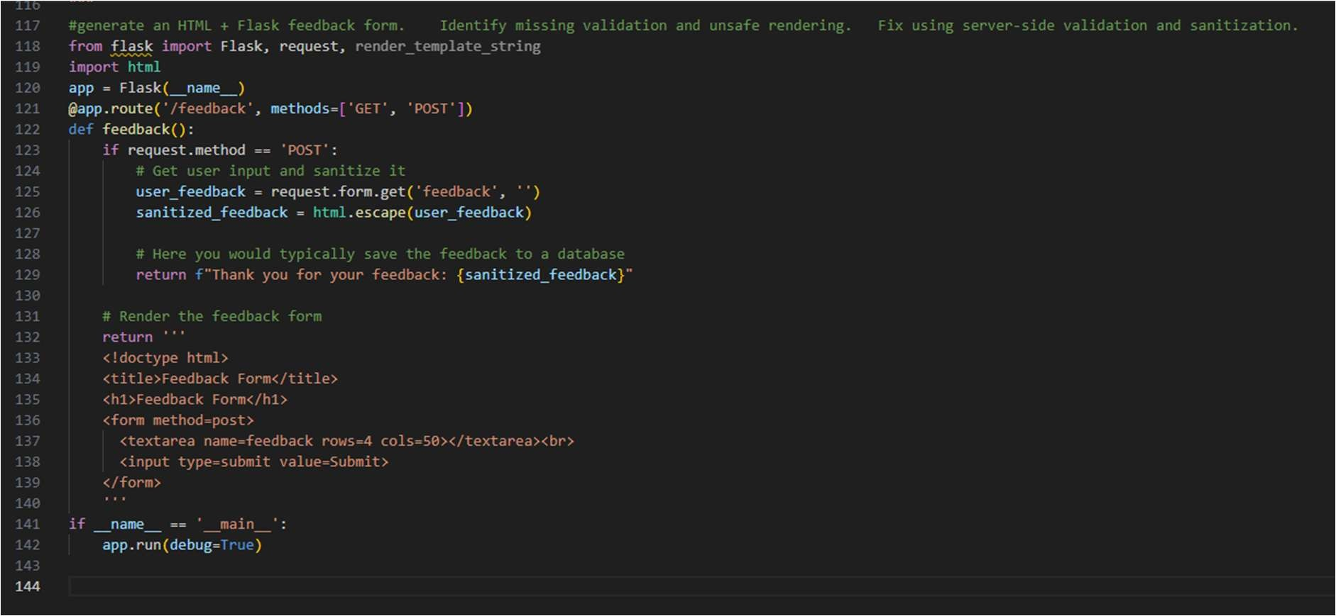
Output :
