Lab Assignment 3.5
Name: P.Chandra Vardhan Reddy
Hallticket:2303A51034
Batch:01

Question 1: Zero-Shot Prompting (Leap Year Check)
Write a zero-shot prompt to generate a Python function that checks whether a given year is a leap year.
Task:
- Record the AI-generated code.
- Test with years like 1900, 2000, 2024.
- Identify logical flaws or missing conditions.
Prompt:
#write a python function that checks wheather a given year is leap year ..

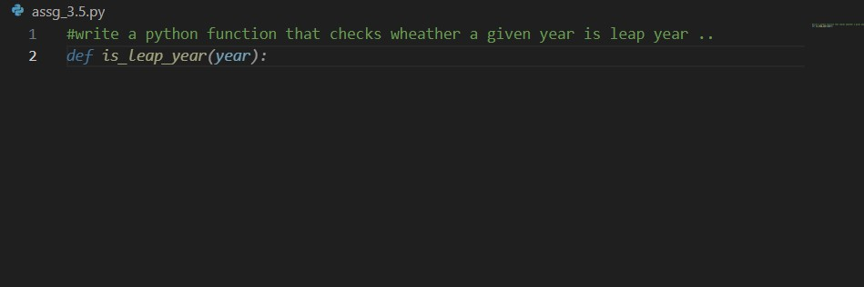
Code:
#write a python function that checks wheather a given year is leap year .. def is_leap_year(year): if (year % 4 == 0 and year % 100 != 0) or (year % 400 == 0):
return True else:
return False try:
year = int(input("Enter a year to check if it's a leap year: ")) if year < 0:
print("Invalid input. Please enter a positive integer for the year.") else: if is_leap_year(year):
print(f"{year} is a leap year.") else:
print(f"{year} is not a leap year.") except ValueError:
print("Invalid input. Please enter a valid integer for the year.")

input/ouput:
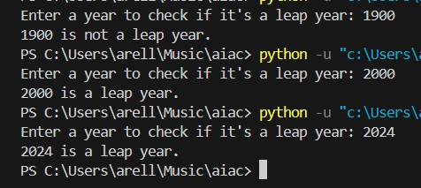

Question 2: One-Shot Prompting (GCD of Two Numbers)
Write a one-shot prompt with one example to generate a Python function that finds the Greatest Common Divisor (GCD) of two numbers.
Example:
Input: 12, 18 → Output: 6
Task:
- Compare with a zero-shot solution.
- Analyze algorithm efficiency.

Prompt:
input=12,18 ouput=6 write a python code to find the gcd of two numbers.
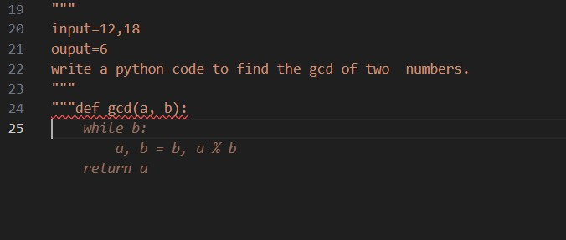
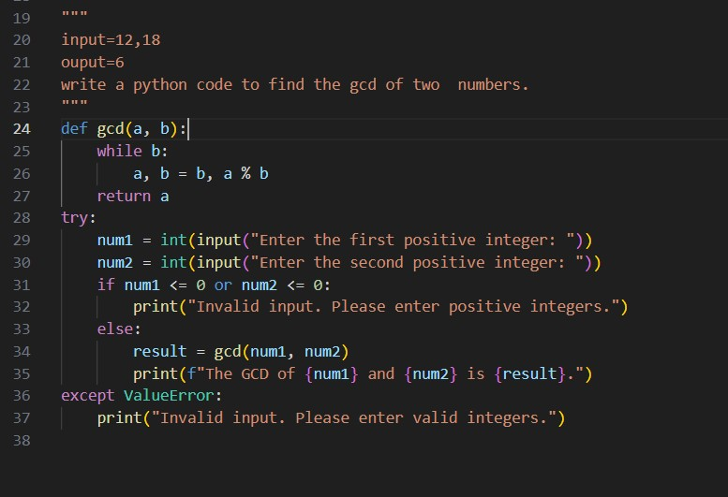
Code:
def gcd(a, b): while b: a, b = b, a % b return a try:
num1 = int(input("Enter the first positive integer: ")) num2 = int(input("Enter the second positive integer: ")) if num1 <= 0 or num2 <= 0:
print("Invalid input. Please enter positive integers.") else:
result = gcd(num1, num2) print(f"The GCD of {num1} and {num2} is {result}.")
except ValueError: print("Invalid input. Please enter valid integers.")

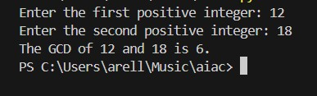
- Compare with a zero-shot solution.
- Analyze algorithm efficiency.
A zero-shot solution for finding the GCD checks all numbers from 1 to the minimum of the two inputs and finds the greatest common divisor, which takes linear time. In contrast, the given code uses the Euclidean algorithm, which repeatedly reduces the problem using the modulo operation. This approach is much more efficient, with a time complexity of O(log min(a, b)), while both methods use constant space. Hence, the implemented solution is faster and more suitable for large inputs.

Question 3: Few-Shot Prompting (LCM Calculation)
Write a few-shot prompt with multiple examples to generate a Python function that computes the Least Common Multiple (LCM).
Examples:
- Input: 4, 6 → Output: 12
- Input: 5, 10 → Output: 10
- Input: 7, 3 → Output: 21
Task:
- Examine how examples guide formula selection.
- Test edge cases.
Prompt:
input=4,6 ouput=12 input=5,10 ouput=10 input=7,3 ouput=21 write a python code to find the lcm of two numbers.
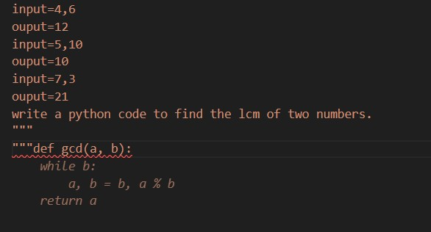
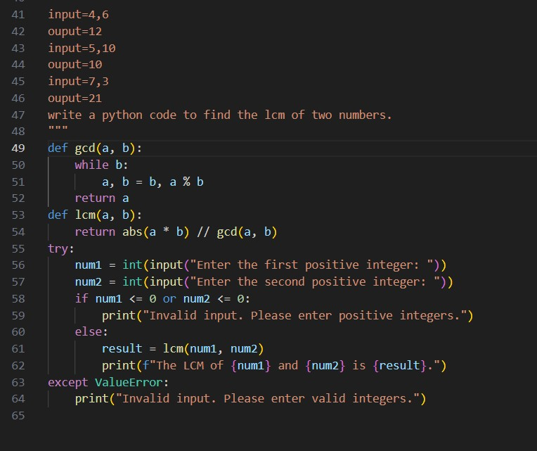

Code:
def gcd(a, b): while b:
a, b = b, a % b
return a def lcm(a, b):
return abs(a * b) // gcd(a, b) try:
num1 = int(input("Enter the first positive integer: ")) num2 = int(input("Enter the second positive integer: ")) if num1 <= 0 or num2 <= 0:
print("Invalid input. Please enter positive integers.") else:
result = lcm(num1, num2) print(f"The LCM of {num1} and {num2} is {result}.") except ValueError:
print("Invalid input. Please enter valid integers.")

input/output:
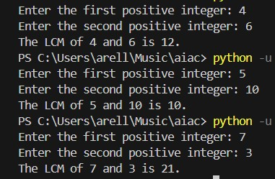
- Examine how examples guide formula selection.
- Test edge cases.
From the given examples (4,6 → 12; 5,10 → 10; 7,3 → 21), we can observe that the LCM is the smallest number divisible by both inputs, which guides us to use the standard formula LCM(a, b) = (a × b) / GCD(a, b). The code correctly applies this formula using the Euclidean algorithm for efficiency. Edge cases such as zero, negative values, and non-integer inputs are handled by input validation, ensuring the program works only for positive integers and avoids invalid results.

Question 4: Zero-Shot Prompting (Binary to Decimal Conversion)
Write a zero-shot prompt to generate a Python function that converts a binary number to decimal.
Task:
- Test with valid and invalid binary inputs.
- Identify missing validation logic.

Prompt:
#write a python function that converts decimal to binary number

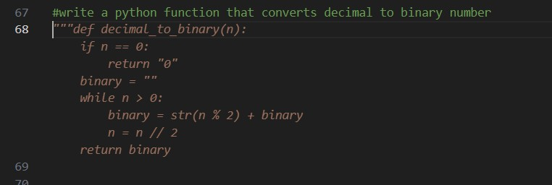
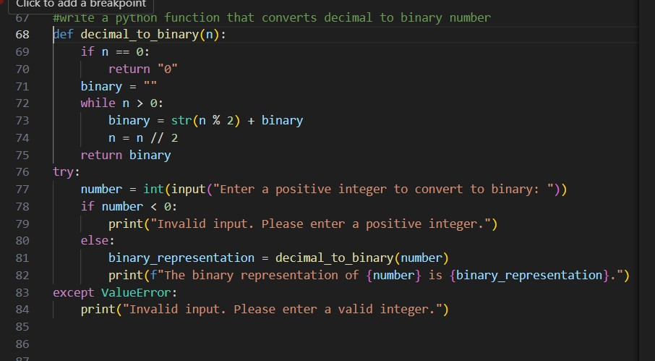
Code:
def decimal_to_binary(n): if n == 0: return "0" binary = "" while n > 0: binary = str(n % 2) + binary n = n // 2 return binary try:
number = int(input("Enter a positive integer to convert to binary: ")) if number < 0:
print("Invalid input. Please enter a positive integer.") else:
binary_representation = decimal_to_binary(number) print(f"The binary representation of {number} is
{binary_representation}.") except ValueError:
print("Invalid input. Please enter a valid integer.")

input/ouput:

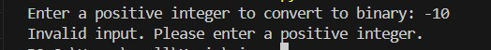

Question 5: One-Shot Prompting (Decimal to Binary Conversion)
Write a one-shot prompt with an example to generate a Python function that converts a decimal number to binary.
Example:
Input: 10 → Output: 1010
Task:
- Compare clarity with zero-shot output.
- Analyze handling of zero and negative numbers.

Prompt:

input=10 output=1010 write a python code to convert decimal number to binary number

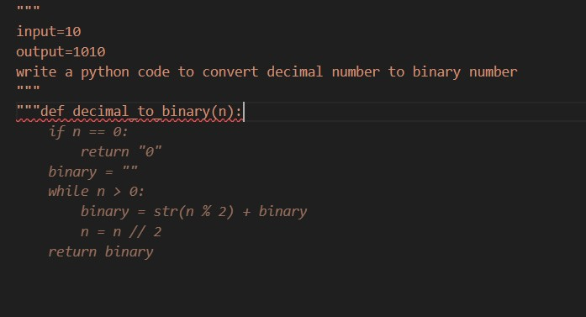

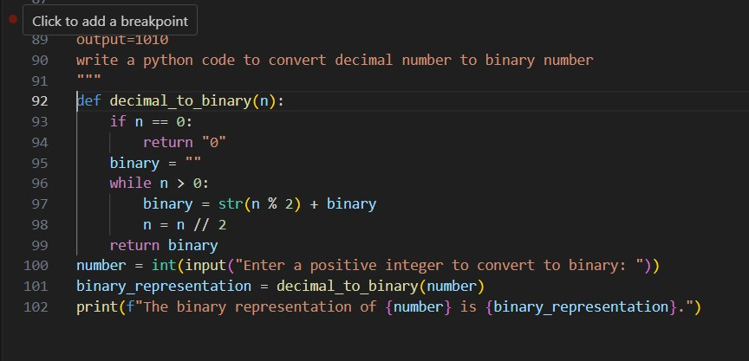
Code: def decimal_to_binary(n):
if n == 0: return "0" binary = "" while n > 0: binary = str(n % 2) + binary n = n // 2 return binary number = int(input("Enter a positive integer to convert to binary: ")) binary_representation = decimal_to_binary(number)
print(f"The binary representation of {number} is {binary_representation}.")

input/output:
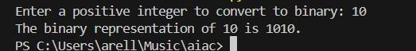
Task:
- Test boundary conditions.
- Evaluate robustness

Compared to a zero-shot output, this implementation is clearer and more readable because it explicitly shows each step of the decimal-to-binary conversion process. However, while the function correctly handles the case when the input is zero by returning "0", it does not handle negative numbers. Without validation, negative inputs would result in incorrect behavior, so additional checks are needed to restrict the input to non-negative integers.

Question 6: Few-Shot Prompting (Harshad Number Check)
Write a few-shot prompt to generate a Python function that checks whether a number is a Harshad (Niven) number.
Examples:
- Input: 18 → Output: Harshad Number
- Input: 21 → Output: Harshad Number
- Input: 19 → Output: Not a Harshad Number
Task:
- Test boundary conditions.
- Evaluate robustness

Prompt:
input=18 ouput=harshad number input=21 ouput=harshad number input=19 ouput=not a harshad number
write a python code to check wheather a given number is harshad number or not

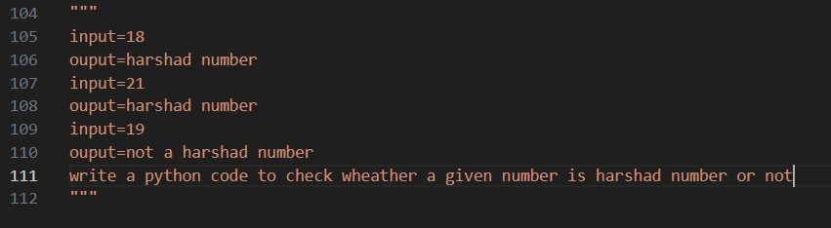

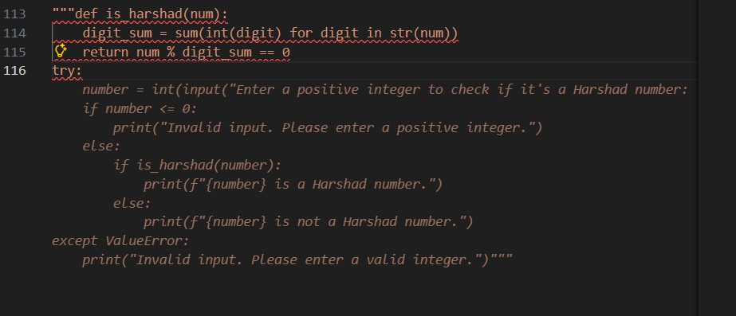
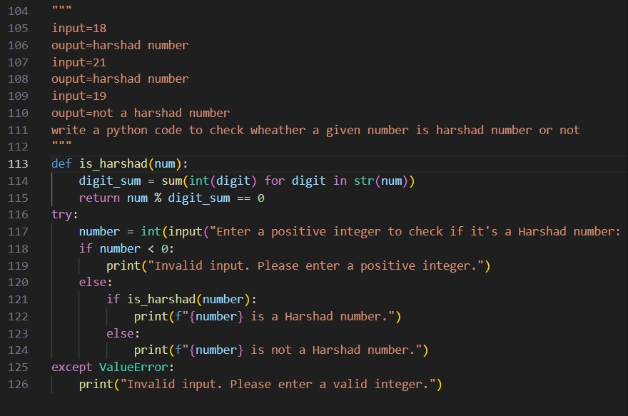
Code:
def is_harshad(num):
digit_sum = sum(int(digit) for digit in str(num)) return num % digit_sum == 0 try:
number = int(input("Enter a positive integer to check if it's a Harshad number: ")) if number < 0:
print("Invalid input. Please enter a positive integer.") else: if is_harshad(number):
print(f"{number} is a Harshad number.") else:
print(f"{number} is not a Harshad number.") except ValueError:

input/output:
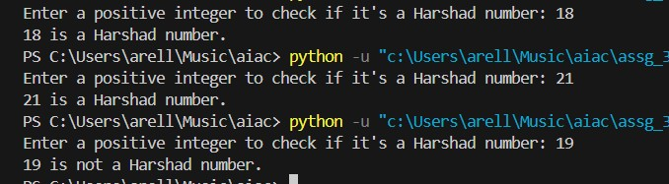
Task:
- Test boundary conditions.
- Evaluate robustness
The code correctly identifies Harshad numbers for valid inputs such as 18 and 21, and correctly reports non-Harshad numbers like 19. It also handles invalid inputs such as negative numbers and non-integer values using input validation and exception handling. However, the logic does not explicitly handle the edge case where the input is 0, which would cause a division by zero error. Adding a specific check to reject 0 would complete the validation logic and make the program more robust.

