Lab Aasignment-5.1
Name: P.Chandra Vardhan Reddy
Hallticket:2303A51034
Batch-01
Task 1:
Employee Data:
Create Python code that defines a class named
`Employee` with the following attributes: `empid`, `empname`,
`designation`, `basic_salary`, and `exp`. Implement a method `display_details()` to print all employee details. Implement another method `calculate_allowance()` to determine additional allowance based on experience:
- If `exp > 10 years` → allowance = 20% of `basic_salary`
- If `5 ≤ exp ≤ 10 years` → allowance = 10% of `basic_salary`
- If `exp < 5 years` → allowance = 5% of `basic_salary`
Finally, create at least one instance of the `Employee` class, call the
`display_details()` method, and print the calculated allowance.
Screenshots:
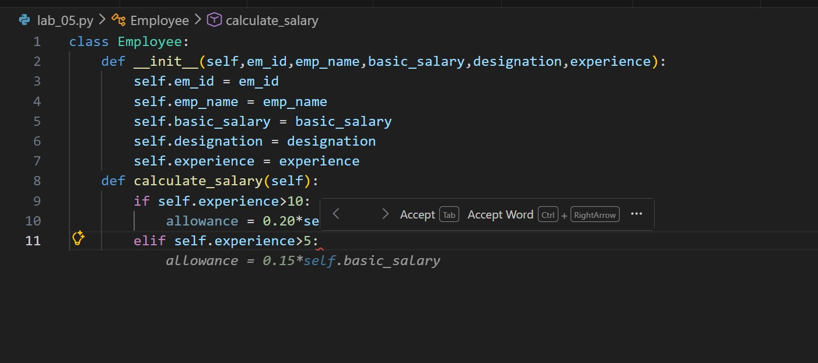
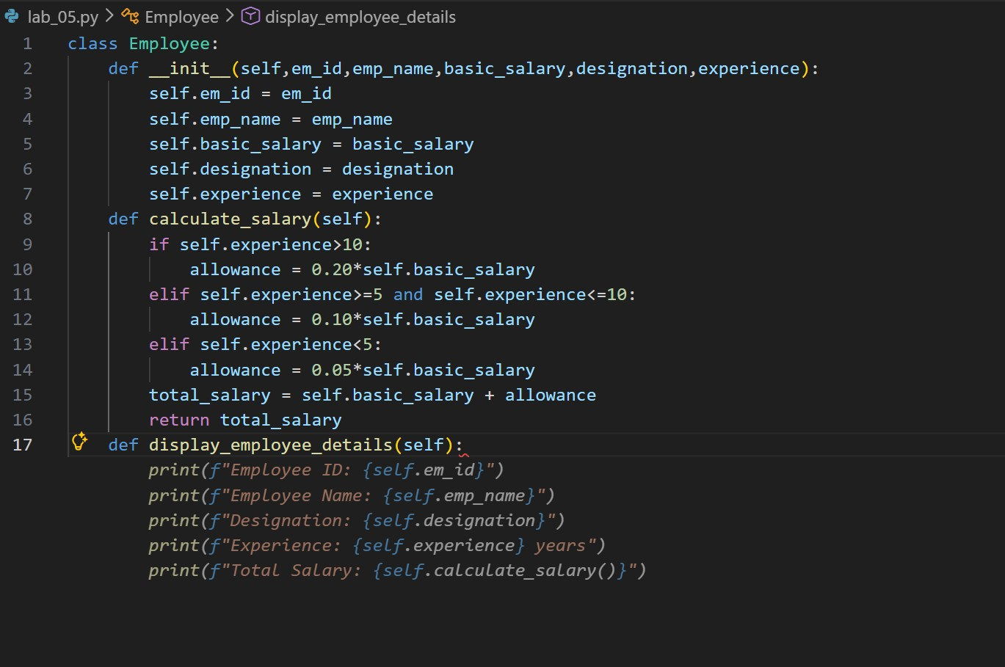
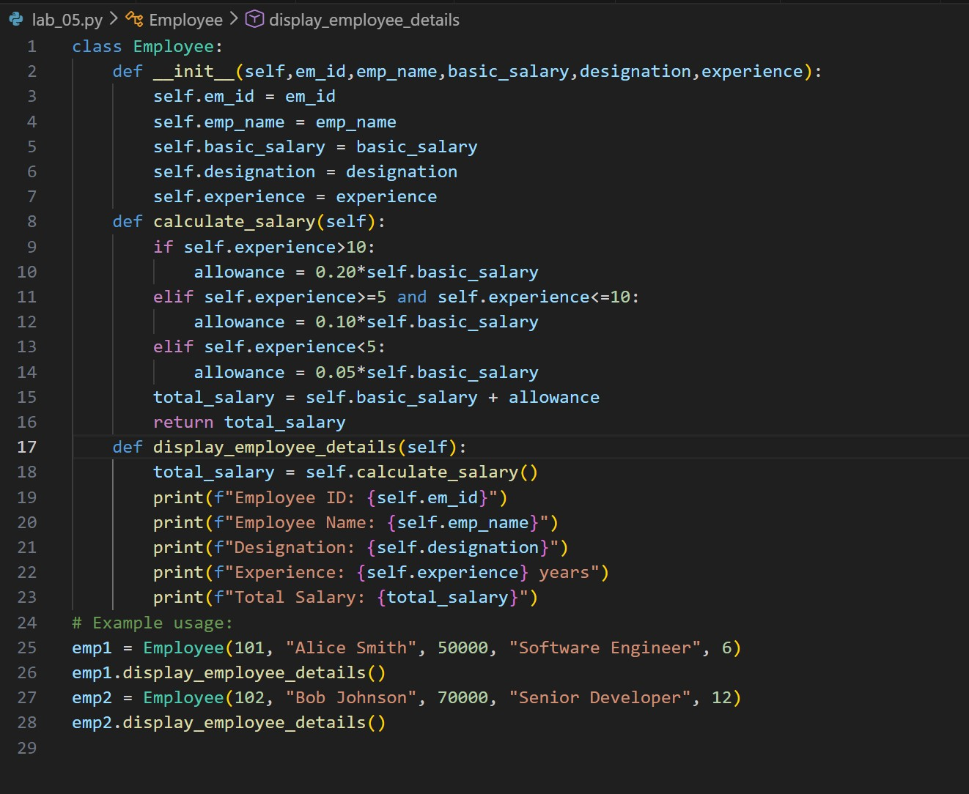
Code:
class Employee: def __init__(self,em_id,emp_name,basic_salary,designation,experience):
self.em_id = em_id self.emp_name = emp_name self.basic_salary = basic_salary self.designation = designation self.experience = experience def calculate_salary(self): if self.experience>10:
allowance = 0.20*self.basic_salary elif self.experience>=5 and self.experience<=10:
allowance = 0.10*self.basic_salary elif self.experience<5:
allowance = 0.05*self.basic_salary total_salary = self.basic_salary + allowance return total_salary def display_employee_details(self):
total_salary = self.calculate_salary() print(f"Employee ID: {self.em_id}") print(f"Employee Name: {self.emp_name}") print(f"Designation: {self.designation}") print(f"Experience: {self.experience} years") print(f"Total Salary: {total_salary}") # Example usage: emp1 = Employee(101, "Alice Smith", 50000, "Software Engineer", 6) emp1.display_employee_details()
emp2 = Employee(102, "Bob Johnson", 70000, "Senior Developer", 12) emp2.display_employee_details()

output:
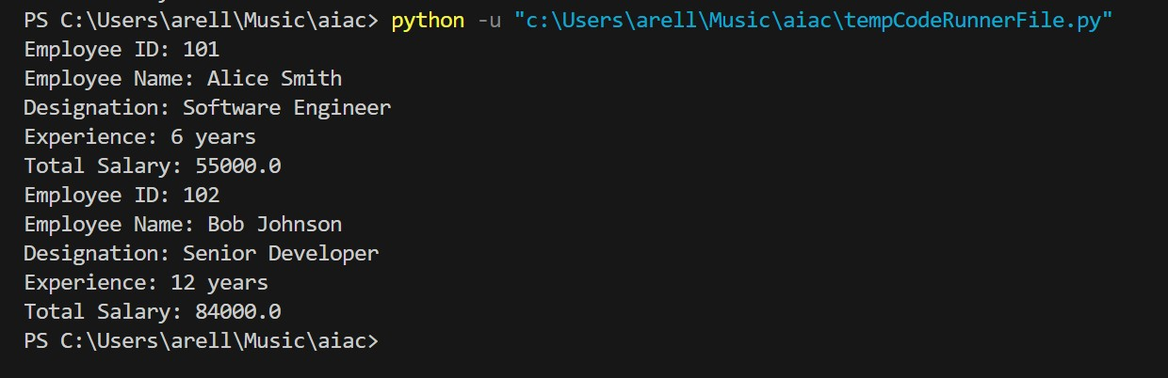
Task 2:
Electricity Bill Calculation- Create Python code that defines a class named `ElectricityBill` with attributes: `customer_id`, `name`, and
`units_consumed`. Implement a method `display_details()` to print
customer details, and a method `calculate_bill()` where:
- Units ≤ 100 → ₹5 per unit
- 101 to 300 units → ₹7 per unit
- More than 300 units → ₹10 per unit
Create a bill object, display details, and print the total bill amount.

Screenshots:
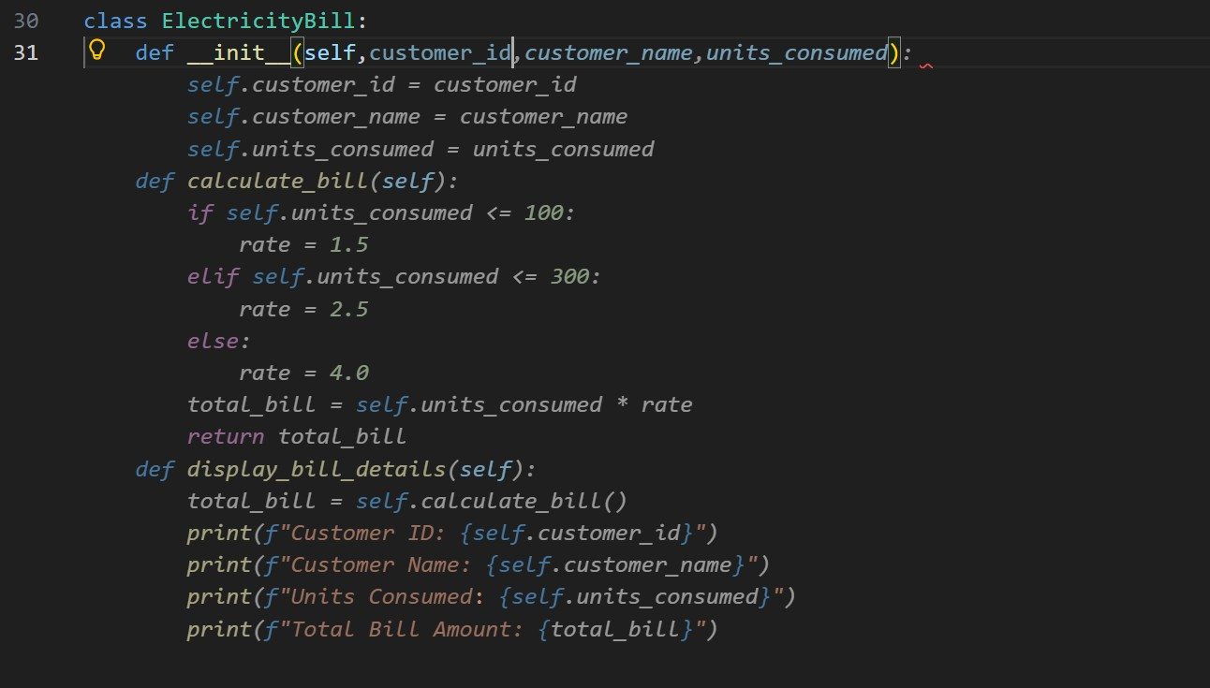

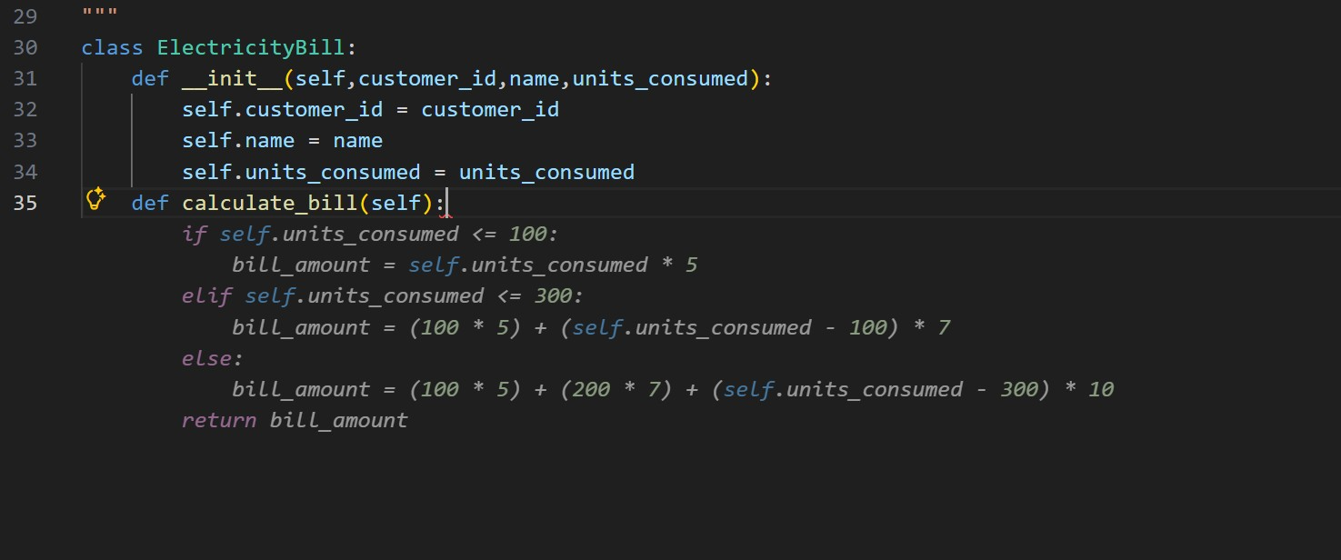
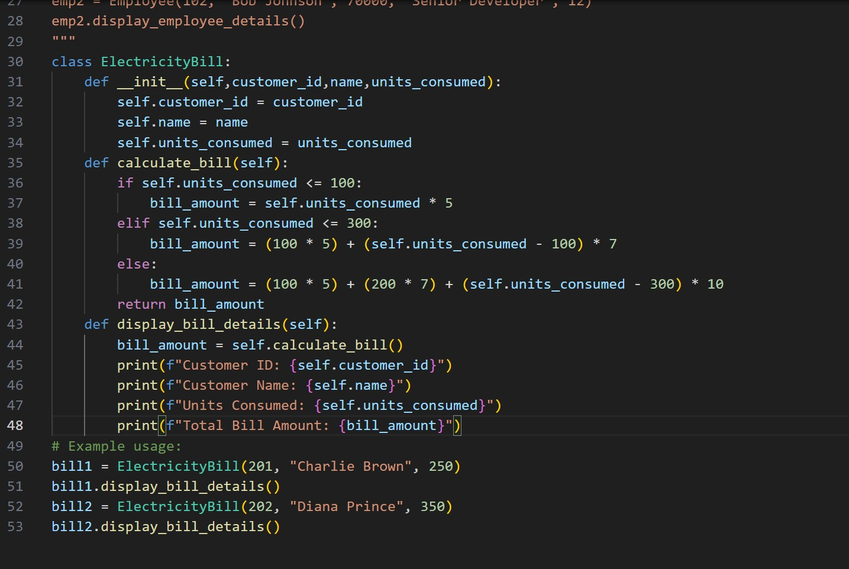
Code:
class ElectricityBill: def __init__(self,customer_id,name,units_consumed):
self.customer_id = customer_id self.name = name self.units_consumed = units_consumed def calculate_bill(self): if self.units_consumed <= 100:
bill_amount = self.units_consumed * 5 elif self.units_consumed <= 300:
bill_amount = (100 * 5) + (self.units_consumed - 100) * 7 else:
bill_amount = (100 * 5) + (200 * 7) + (self.units_consumed - 300)
* 10 return bill_amount def display_bill_details(self):
bill_amount = self.calculate_bill() print(f"Customer ID: {self.customer_id}") print(f"Customer Name: {self.name}") print(f"Units Consumed: {self.units_consumed}") print(f"Total Bill Amount: {bill_amount}") # Example usage:
bill1 = ElectricityBill(201, "Charlie Brown", 250)
bill1.display_bill_details()
bill2 = ElectricityBill(202, "Diana Prince", 350) bill2.display_bill_details()

output:
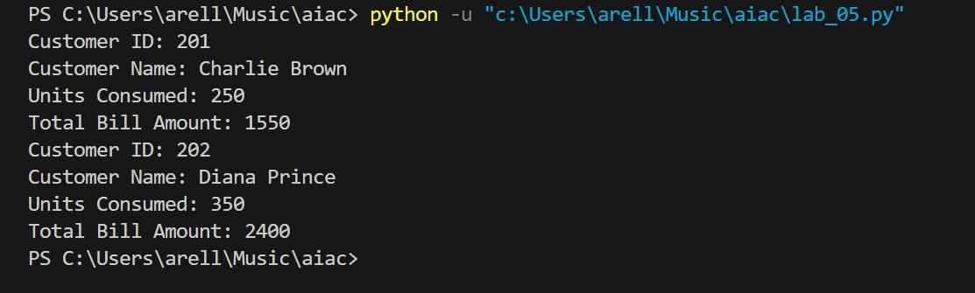

Task 3:
Product Discount Calculation- Create Python code that defines a class named `Product` with attributes: `product_id`, `product_name`, `price`, and `category`. Implement a method `display_details()` to print product details. Implement another method
`calculate_discount()` where:
- Electronics → 10% discount
- Clothing → 15% discount
- Grocery → 5% discount
Create at least one product object, display details, and print the final price after discount.
Screenshots:
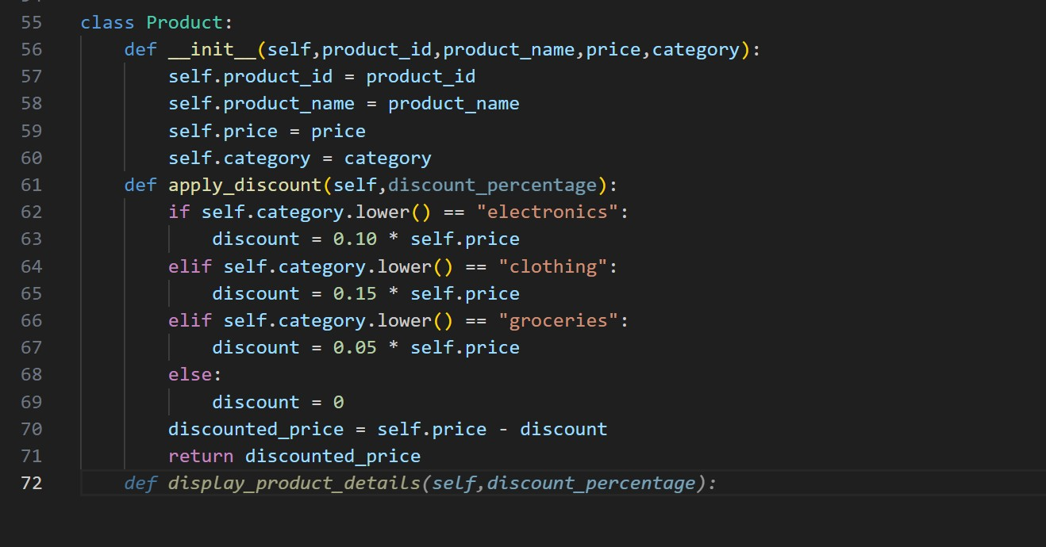
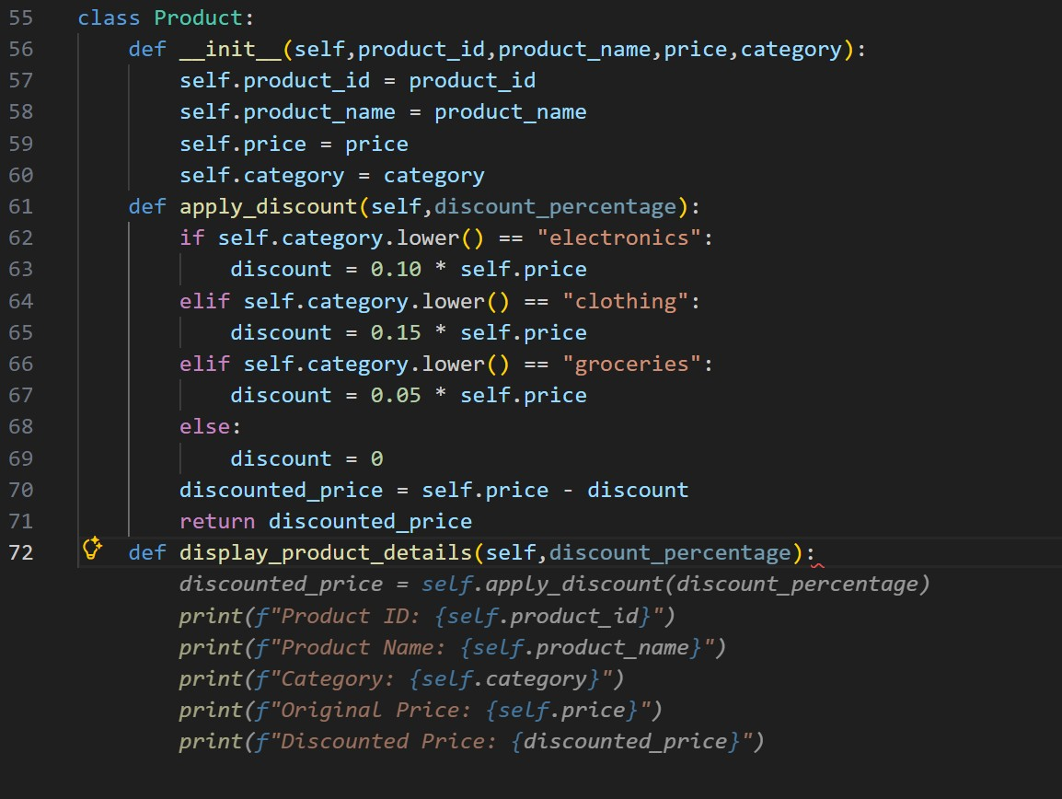
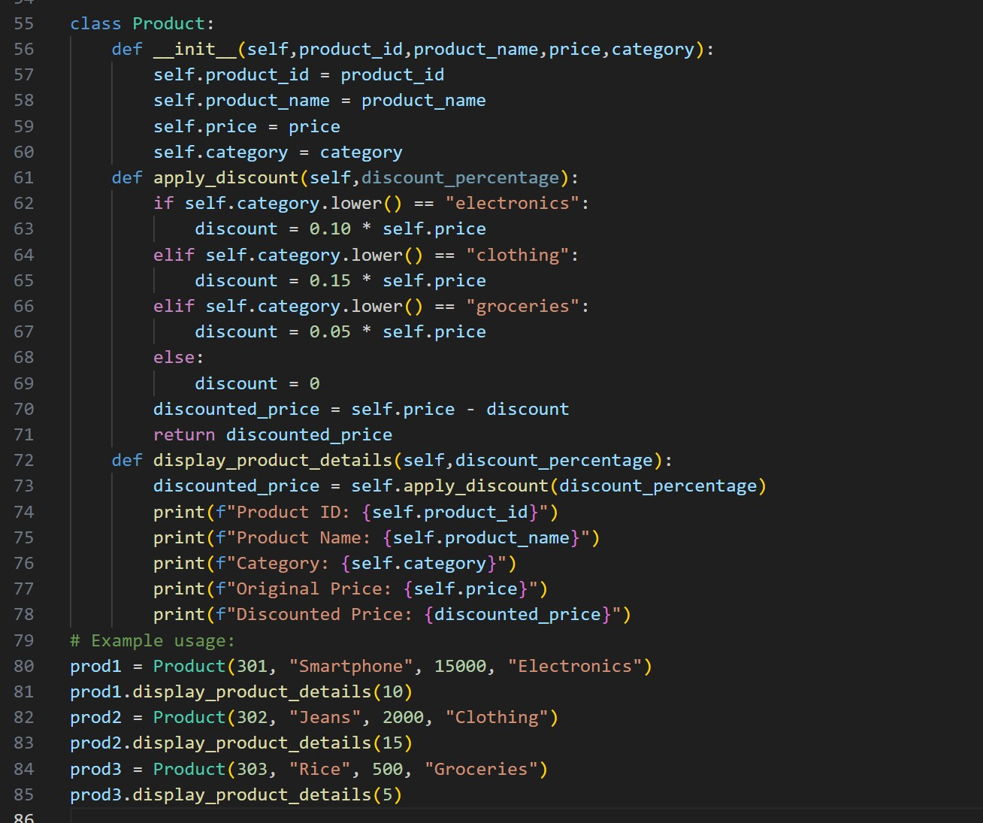
Code:
class Product: def __init__(self,product_id,product_name,price,category):
self.product_id = product_id self.product_name = product_name self.price = price self.category = category def apply_discount(self,discount_percentage): if self.category.lower() == "electronics":
discount = 0.10 * self.price elif self.category.lower() == "clothing":
discount = 0.15 * self.price elif self.category.lower() == "groceries":
discount = 0.05 * self.price else:
discount = 0 discounted_price = self.price - discount return discounted_price
def display_product_details(self,discount_percentage):
discounted_price = self.apply_discount(discount_percentage) print(f"Product ID: {self.product_id}") print(f"Product Name: {self.product_name}") print(f"Category: {self.category}") print(f"Original Price: {self.price}") print(f"Discounted Price: {discounted_price}") # Example usage: prod1 = Product(301, "Smartphone", 15000, "Electronics") prod1.display_product_details(10) prod2 = Product(302, "Jeans", 2000, "Clothing") prod2.display_product_details(15) prod3 = Product(303, "Rice", 500, "Groceries") prod3.display_product_details(5)

output:
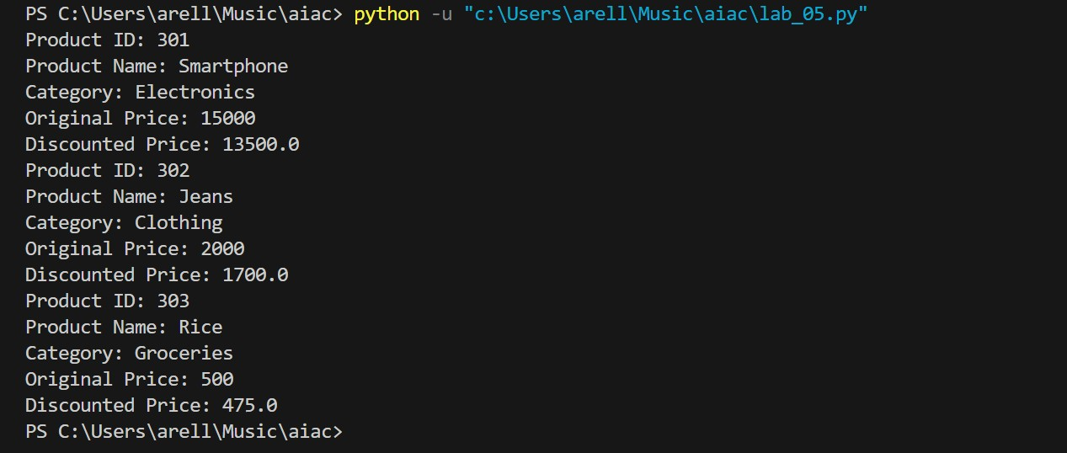
Task 4:
Book Late Fee Calculation- Create Python code that defines a class named `LibraryBook` with attributes: `book_id`, `title`, `author`, `borrower`, and `days_late`. Implement a method `display_details()` to print book details, and a method `calculate_late_fee()` where:
- Days late ≤ 5 → ₹5 per day
- 6 to 10 days late → ₹7 per day
- More than 10 days late → ₹10 per day
Create a book object, display details, and print the late fee.
Screenshots:
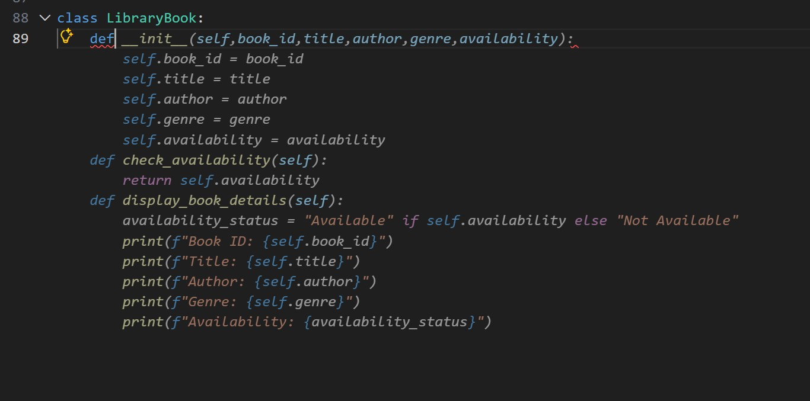
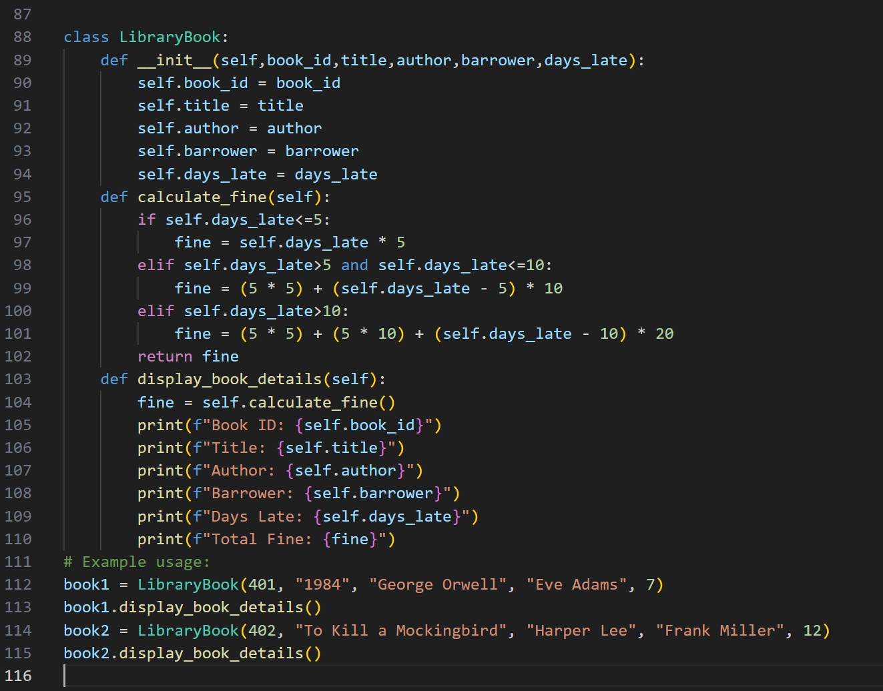
Code:
class LibraryBook: def __init__(self,book_id,title,author,barrower,days_late):
self.book_id = book_id self.title = title self.author = author self.barrower = barrower self.days_late = days_late def calculate_fine(self): if self.days_late<=5:
fine = self.days_late * 5 elif self.days_late>5 and self.days_late<=10: fine = (5 * 5) + (self.days_late - 5) * 10 elif self.days_late>10:
fine = (5 * 5) + (5 * 10) + (self.days_late - 10) * 20 return fine def display_book_details(self): fine = self.calculate_fine() print(f"Book ID: {self.book_id}") print(f"Title: {self.title}") print(f"Author: {self.author}") print(f"Barrower: {self.barrower}") print(f"Days Late: {self.days_late}") print(f"Total Fine: {fine}") # Example usage: book1 = LibraryBook(401, "1984", "George Orwell", "Eve Adams", 7) book1.display_book_details()
book2 = LibraryBook(402, "To Kill a Mockingbird", "Harper Lee", "Frank Miller", 12)
book2.display_book_details()

output:
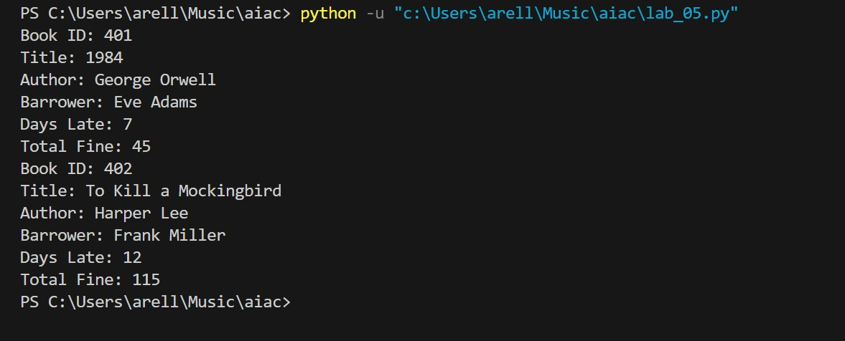

Task 5:
Student Performance Report - Define a function
`student_report(student_data)` that accepts a dictionary containing student names and their marks. The function should:
- Calculate the average score for each student
- Determine pass/fail status (pass ≥ 40)
- Return a summary report as a list of dictionaries
Use Copilot suggestions as you build the function and format the output.

Screenshots:
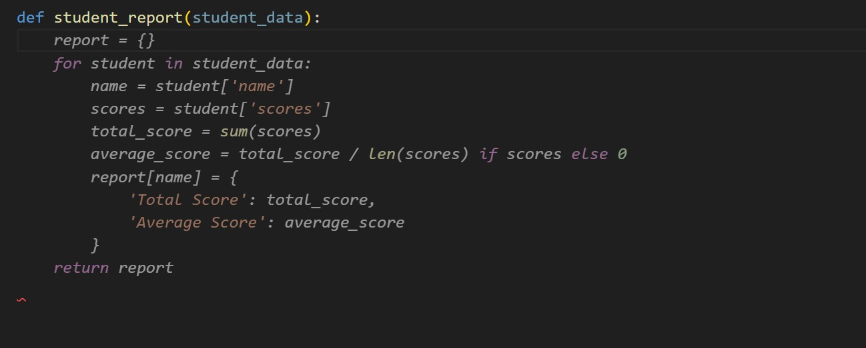
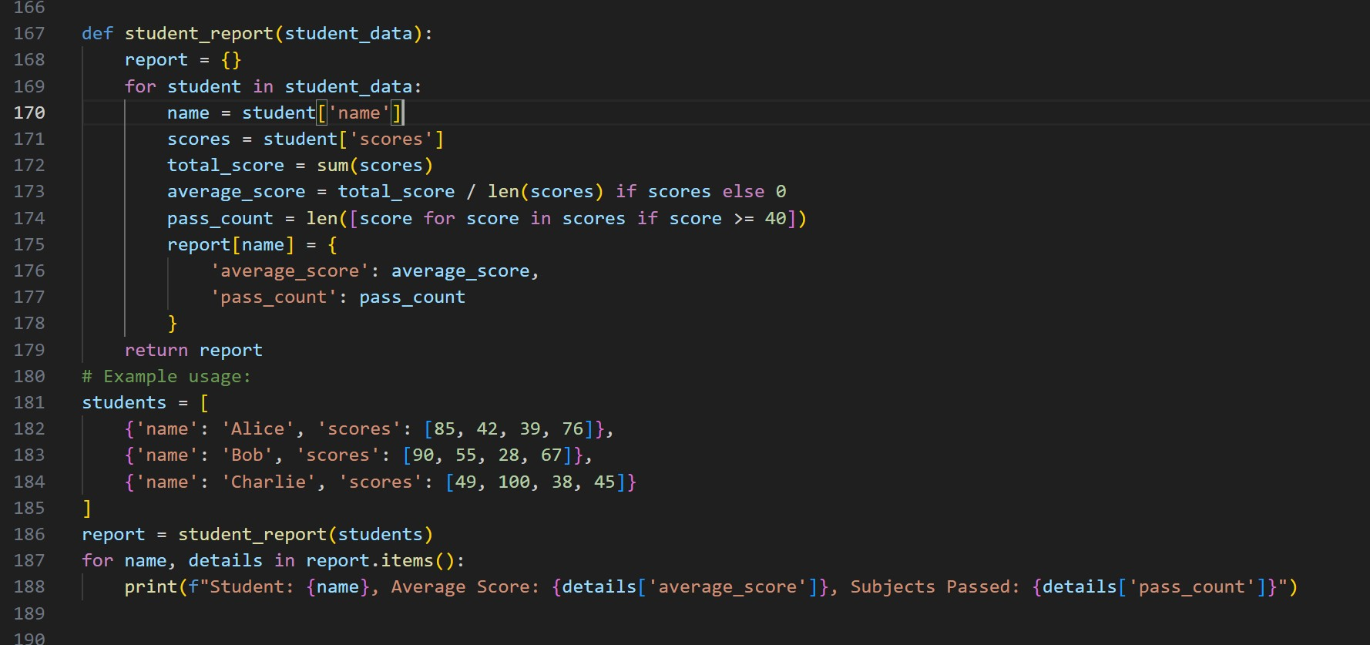
Code:
def student_report(student_data):
report = {} for student in student_data: name = student['name'] scores = student['scores'] total_score = sum(scores) average_score = total_score / len(scores) if scores else 0 pass_count = len([score for score in scores if score >= 40]) report[name] = {
'average_score': average_score,
'pass_count': pass_count
} return report # Example usage:
students = [
{'name': 'Alice', 'scores': [85, 42, 39, 76]},
{'name': 'Bob', 'scores': [90, 55, 28, 67]},
{'name': 'Charlie', 'scores': [49, 100, 38, 45]}
]
report = student_report(students) for name, details in report.items():
print(f"Student: {name}, Average Score: {details['average_score']}, Subjects Passed: {details['pass_count']}")

Output:
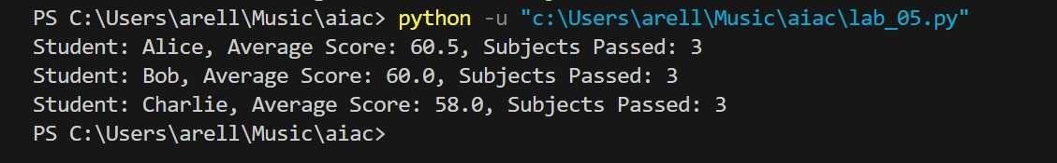

Task 6:
Taxi Fare Calculation-Create Python code that defines a class named `TaxiRide` with attributes: `ride_id`, `driver_name`, `distance_km`, and `waiting_time_min`. Implement a method `display_details()` to print ride details, and a method `calculate_fare()` where:
- ₹15 per km for the first 10 km
- ₹12 per km for the next 20 km - ₹10 per km above 30 km
- Waiting charge: ₹2 per minute
Create a ride object, display details, and print the total fare.
Screenshots:

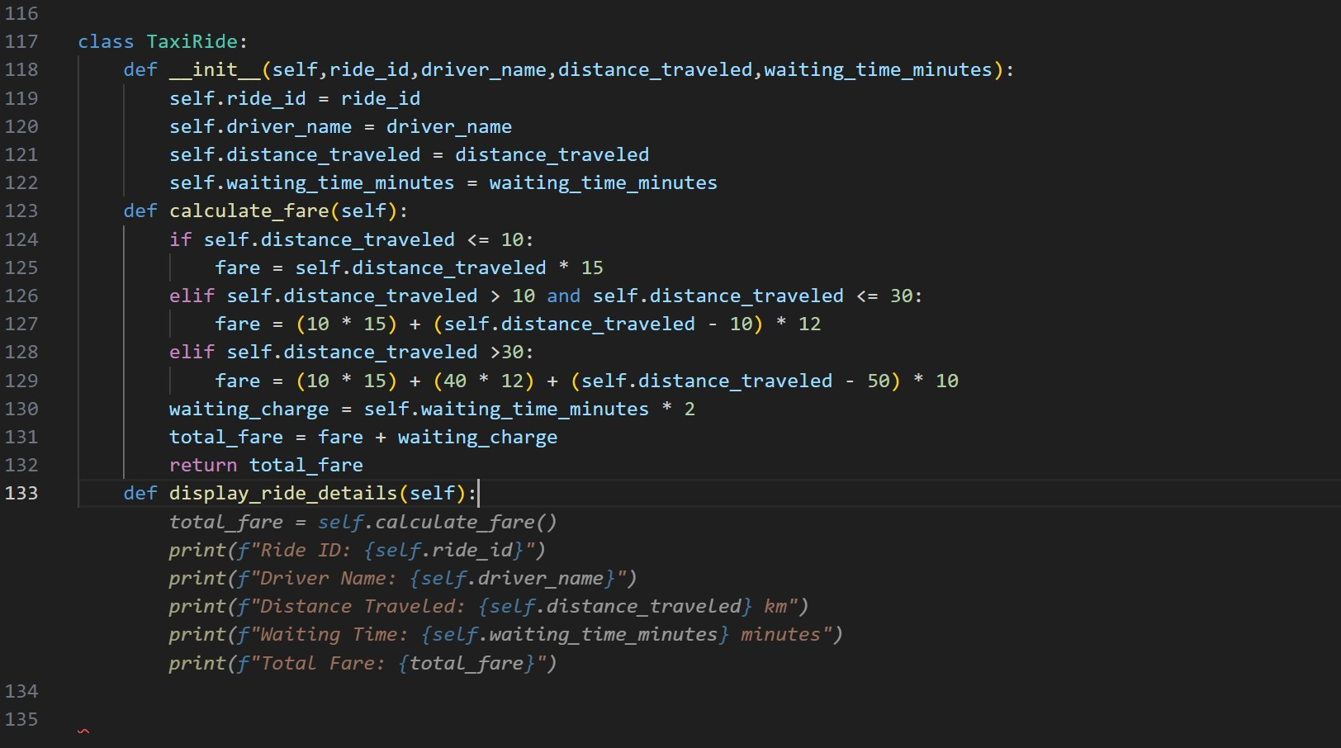
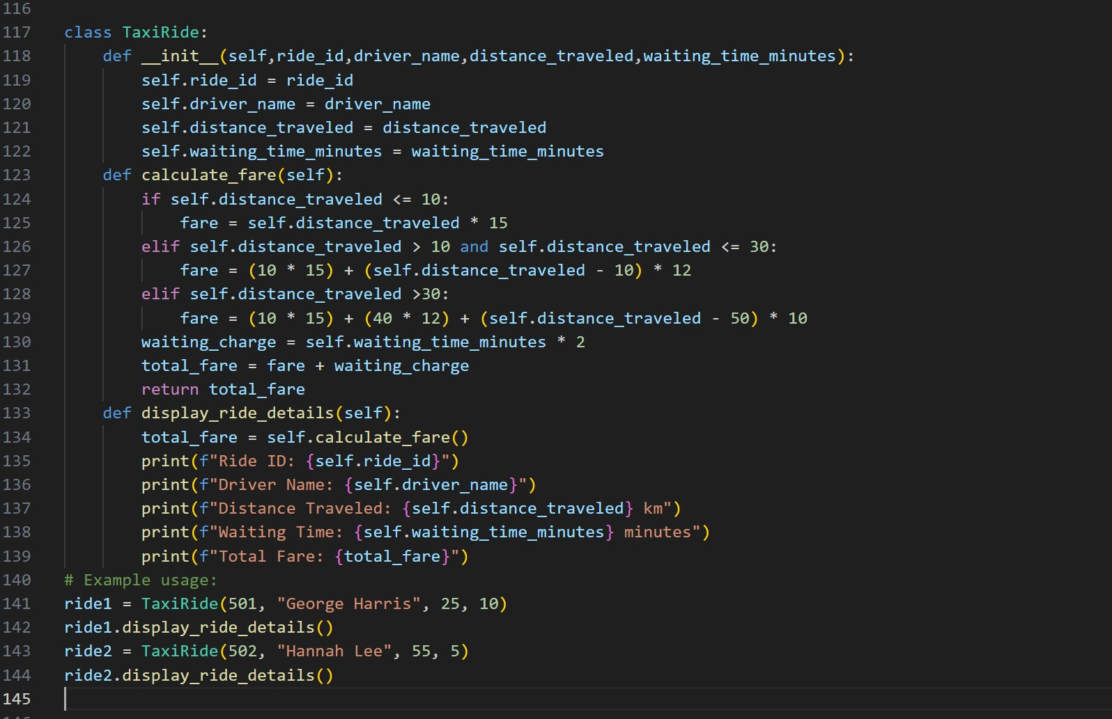
Code:
class TaxiRide:
def
__init__(self,ride_id,driver_name,distance_traveled,waiting_time_minutes):
self.ride_id = ride_id
self.driver_name = driver_name self.distance_traveled = distance_traveled self.waiting_time_minutes = waiting_time_minutes def calculate_fare(self): if self.distance_traveled <= 10:
fare = self.distance_traveled * 15 elif self.distance_traveled > 10 and self.distance_traveled <= 30:
fare = (10 * 15) + (self.distance_traveled - 10) * 12 elif self.distance_traveled >30:
fare = (10 * 15) + (40 * 12) + (self.distance_traveled - 50) * 10 waiting_charge = self.waiting_time_minutes * 2 total_fare = fare + waiting_charge return total_fare def display_ride_details(self):
total_fare = self.calculate_fare() print(f"Ride ID: {self.ride_id}") print(f"Driver Name: {self.driver_name}") print(f"Distance Traveled: {self.distance_traveled} km") print(f"Waiting Time: {self.waiting_time_minutes} minutes") print(f"Total Fare: {total_fare}") # Example usage: ride1 = TaxiRide(501, "George Harris", 25, 10) ride1.display_ride_details()
ride2 = TaxiRide(502, "Hannah Lee", 55, 5) ride2.display_ride_details()

output:
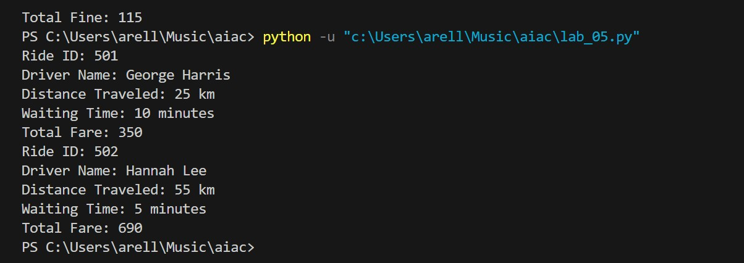

Task 7:
Statistics Subject Performance - Create a Python function
`statistics_subject(scores_list)` that accepts a list of 60 student scores
and computes key performance statistics. The function should return the following:
- Highest score in the class
- Lowest score in the class
- Class average score
- Number of students passed (score ≥ 40)
- Number of students failed (score < 40)
Allow Copilot to assist with aggregations and logic
Screenshots:
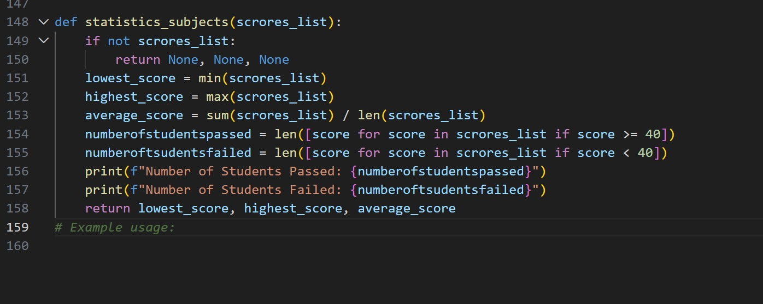
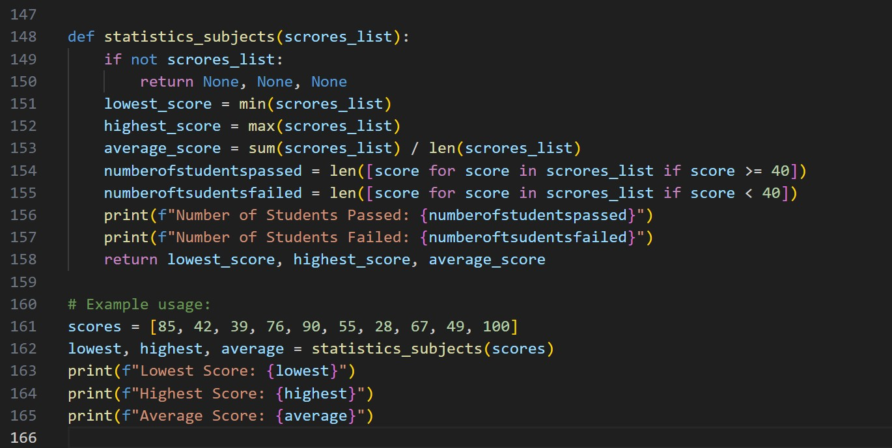
Code:
def statistics_subjects(scrores_list): if not scrores_list:
return None, None, None lowest_score = min(scrores_list) highest_score = max(scrores_list) average_score = sum(scrores_list) / len(scrores_list) numberofstudentspassed = len([score for score in scrores_list if score >=
40]) numberoftsudentsfailed = len([score for score in scrores_list if score <
40]) print(f"Number of Students Passed: {numberofstudentspassed}") print(f"Number of Students Failed: {numberoftsudentsfailed}") return lowest_score, highest_score, average_score

# Example usage: scores = [85, 42, 39, 76, 90, 55, 28, 67, 49, 100] lowest, highest, average = statistics_subjects(scores) print(f"Lowest Score: {lowest}") print(f"Highest Score: {highest}") print(f"Average Score: {average}")

Output:
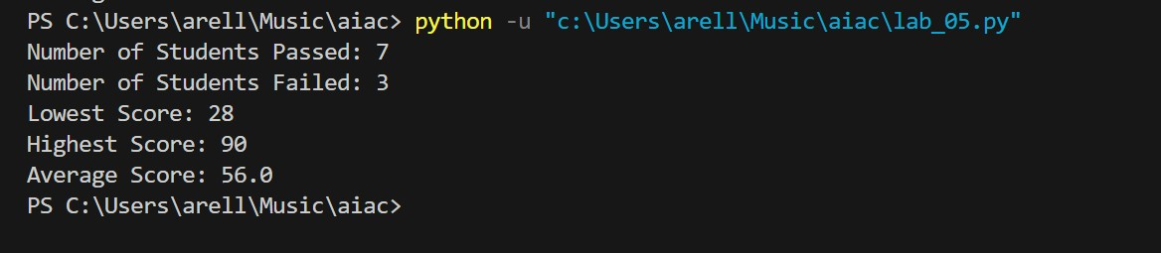
Task Description #8 (Transparency in Algorithm Optimization)
Task: Use AI to generate two solutions for checking prime numbers:
- Naive approach(basic)
- Optimized approach
Prompt:
“Generate Python code for two prime-checking methods and explain how the optimized version improves performance.”
Expected Output:
- Code for both methods.
- Transparent explanation of time complexity.
- Comparison highlighting efficiency improvements.
Prompt:
#write a python code to print prime or not using basic method in an basic level of code without any function in native approach

Screenshots:
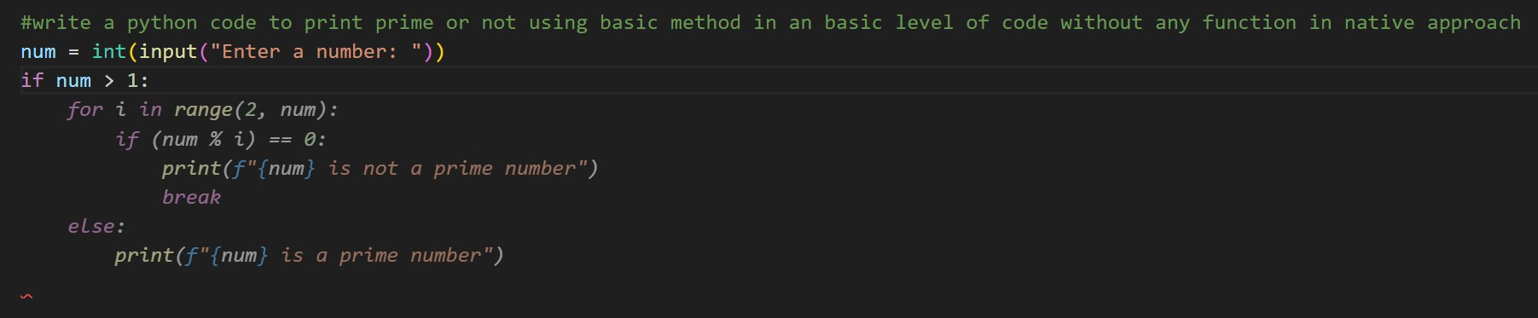
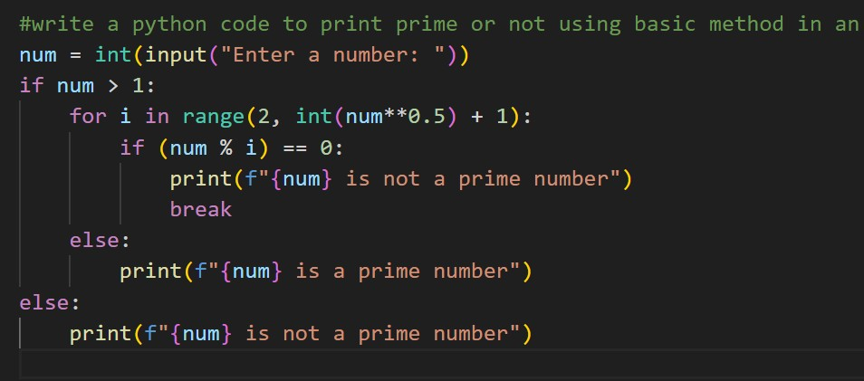
Code:
#write a python code to print prime or not using basic method in an basic level of code without any function in native approach num = int(input("Enter a number: ")) if num > 1: for i in range(2, int(num**0.5) + 1): if (num % i) == 0:
print(f"{num} is not a prime number") break else:
print(f"{num} is a prime number") else:
print(f"{num} is not a prime number")

optimized code : prompt:
#write a python code to print weather the gievn number is prime or not in function method and in optimized way

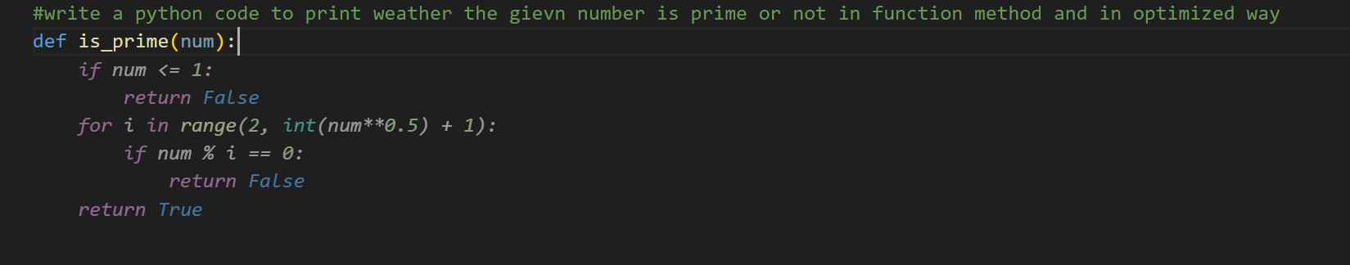
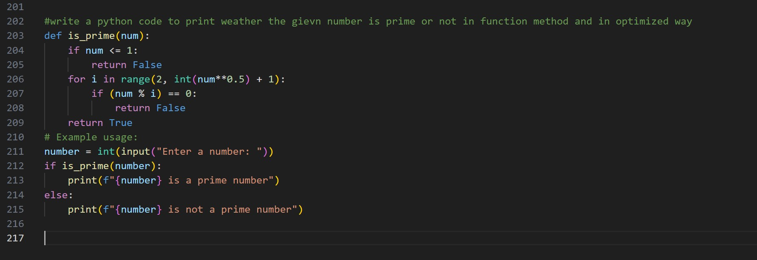
Code:
#write a python code to print weather the gievn number is prime or not in function method and in optimized way def is_prime(num): if num <= 1:
return False for i in range(2, int(num**0.5) + 1): if (num % i) == 0: return False return True # Example usage: number = int(input("Enter a number: ")) if is_prime(number):
print(f"{number} is a prime number") else:
print(f"{number} is not a prime number")

output:
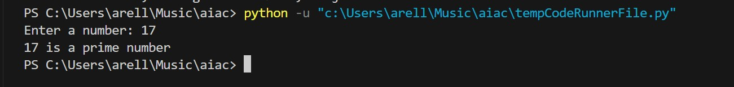
Explaination :
The first method uses a basic native approach without functions, where it directly checks if a number is prime by iterating from 2 to the square root of the number and breaking out of the loop immediately upon finding a divisor, printing the result inline within the control flow structure. The second method is an optimized function-based approach that encapsulates the prime-checking logic into a reusable is_prime() function that returns a boolean value (True or False) for the given number; while both methods use the same efficient algorithm of checking only up to the square root of the number, the function-based approach is cleaner, more modular, and easier to reuse across multiple calls, whereas the first approach directly ties the logic to I/O operations and makes it difficult to reuse the logic without code duplication.
Task Description #9 (Transparency in Recursive Algorithms) Objective: Use AI to generate a recursive function to calculate
Fibonacci numbers.
Instructions:
- Ask AI to add clear comments explaining recursion.
- Ask AI to explain base cases and recursive calls.
Expected Output:
- Well-commented recursive code.
- Clear explanation of how recursion works.
- Verification that explanation matches actual execution.
Prompt:
#write a recursive function to calculate Fibonacci series up to n terms and explain the code and recurision in comments

Screenshots:
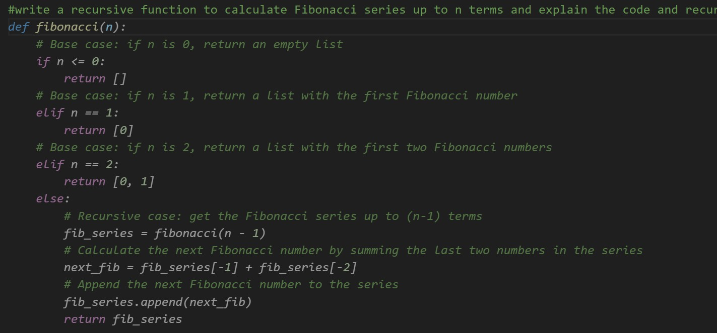
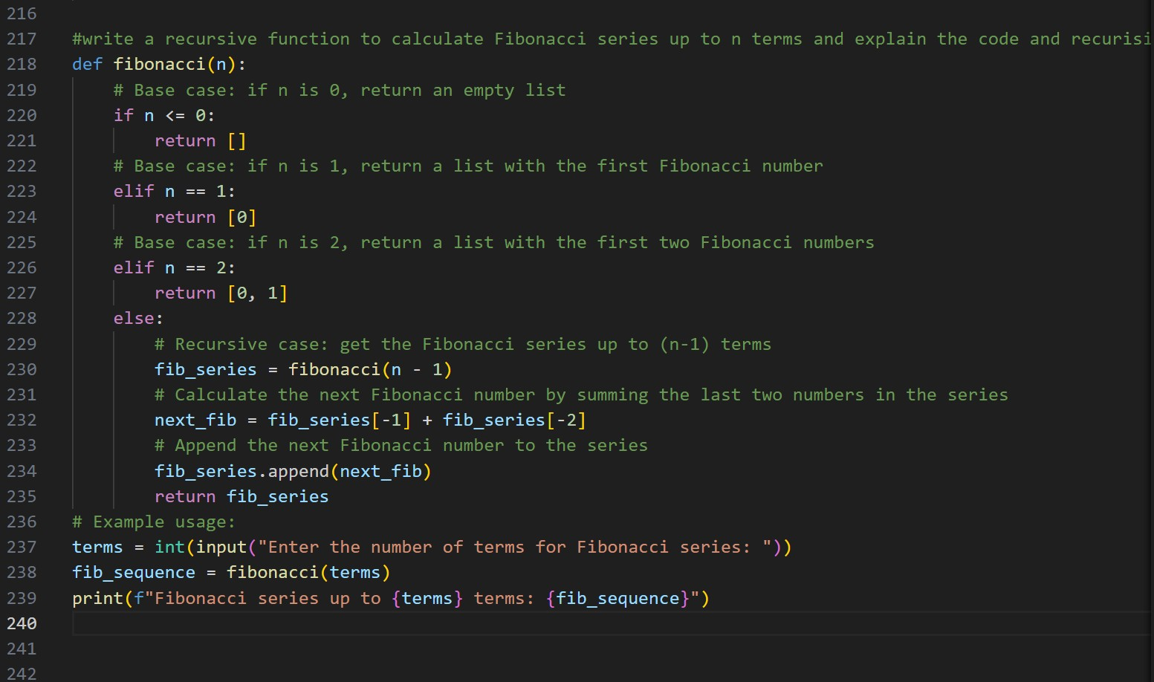
Code:
#write a recursive function to calculate Fibonacci series up to n terms and explain the code and recurision in comments def fibonacci(n):
# Base case: if n is 0, return an empty list if n <= 0: return []
# Base case: if n is 1, return a list with the first Fibonacci number elif n == 1: return [0]
# Base case: if n is 2, return a list with the first two Fibonacci numbers elif n == 2:
return [0, 1] else:
# Recursive case: get the Fibonacci series up to (n-1) terms fib_series = fibonacci(n - 1)
# Calculate the next Fibonacci number by summing the last two numbers in the series next_fib = fib_series[-1] + fib_series[-2] # Append the next Fibonacci number to the series fib_series.append(next_fib) return fib_series # Example usage: terms = int(input("Enter the number of terms for Fibonacci series: ")) fib_sequence = fibonacci(terms) print(f"Fibonacci series up to {terms} terms: {fib_sequence}")

output:
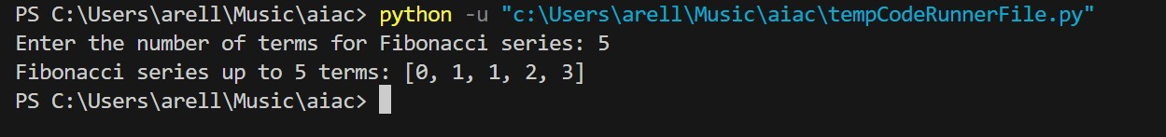
Explanation:
Comments explain the why and intent behind code, not just the what, so future readers (including you) can understand decisions, assumptions, and tricky logic quickly without re-deriving it. They make maintenance, debugging, and collaboration easier by clarifying purpose, edge cases, and expected behavior, especially when the code is complex or not self-explanatory.
Task Description #10 (Transparency in Error Handling)
Task: Use AI to generate a Python program that reads a file and processes data.
Prompt:
“Generate code with proper error handling and clear explanations for each exception.”
Expected Output:
- Code with meaningful exception handling.
- Clear comments explaining each error scenario.
- Validation that explanations align with runtime behavior.
Prompt:
#write a python program that reads a text file and processes the data Generate code with proper error handling and clear explanations for each exception

Screenshots:
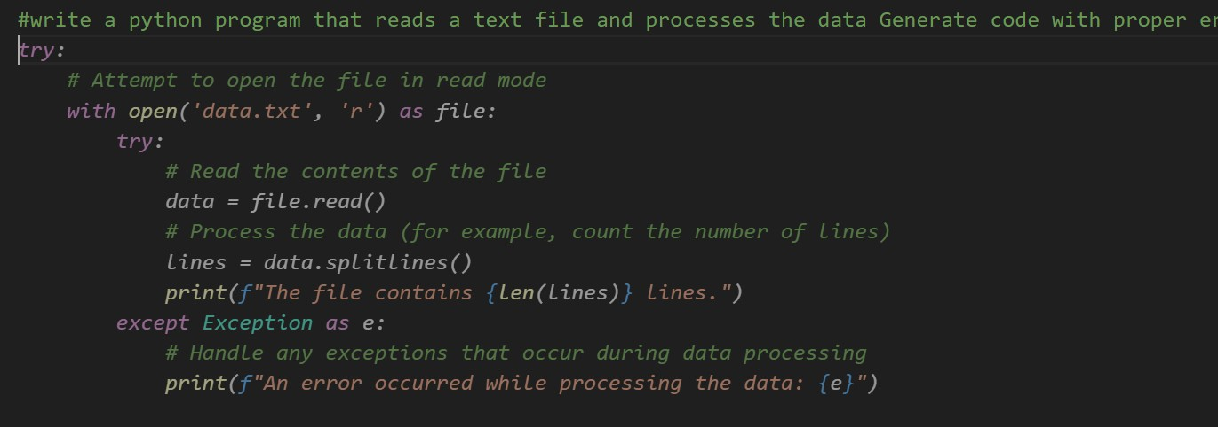
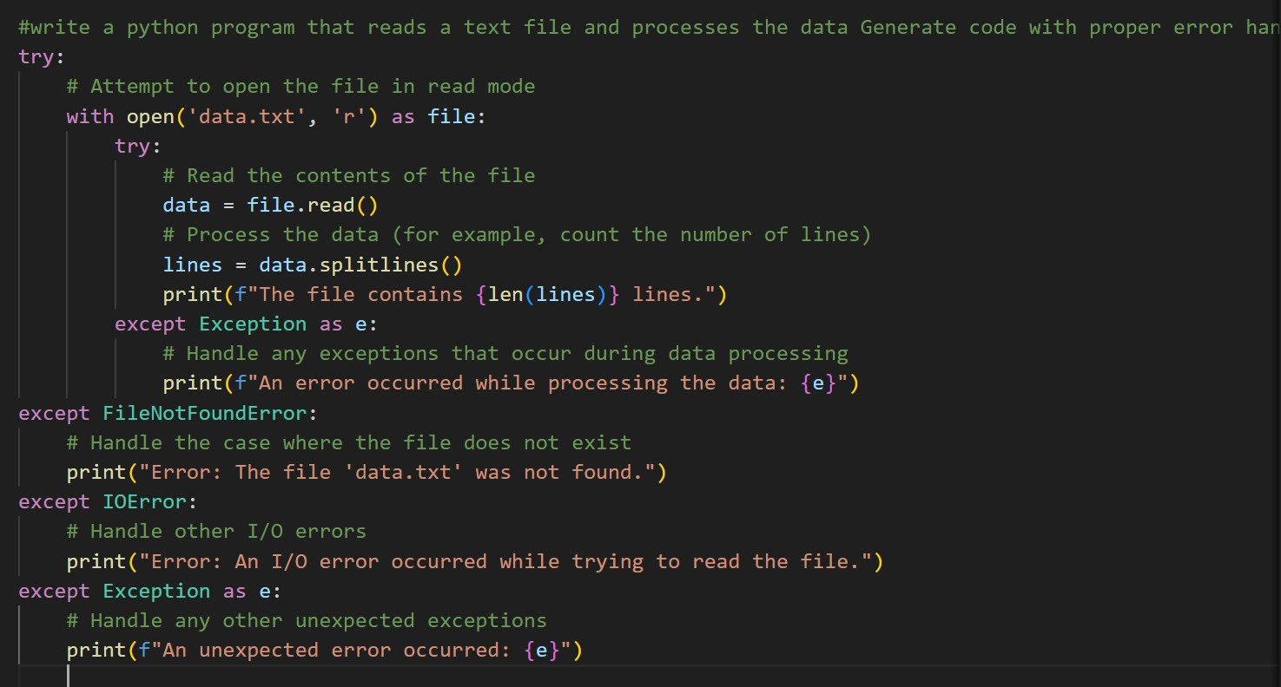

Code:
#write a python program that reads a text file and processes the data Generate code with proper error handling and clear explanations for each exception try:
# Attempt to open the file in read mode with open('data.txt', 'r') as file: try:
# Read the contents of the file data = file.read()
# Process the data (for example, count the number of lines) lines = data.splitlines() print(f"The file contains {len(lines)} lines.") except Exception as e:
# Handle any exceptions that occur during data processing print(f"An error occurred while processing the data: {e}") except FileNotFoundError:
# Handle the case where the file does not exist print("Error: The file 'data.txt' was not found.") except IOError:
# Handle other I/O errors print("Error: An I/O error occurred while trying to read the file.") except Exception as e:
# Handle any other unexpected exceptions print(f"An unexpected error occurred: {e}")

output:
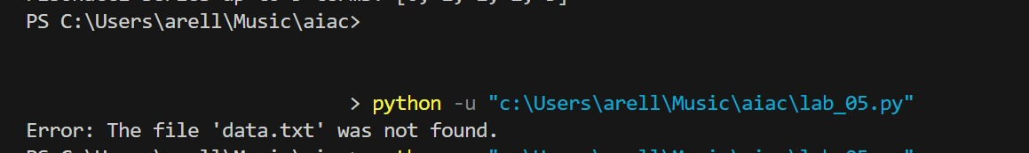
Explanation:
That error-handling block tries to open data.txt and read it safely: the outer try opens the file, and if it’s missing it catches FileNotFoundError, while other I/O problems are caught by IOError. Inside, a nested try handles problems that might occur while processing the file content (like splitting or counting), and any unexpected issues fall to the final generic Exception handler, so the program fails gracefully with clear messages instead of crashing.

