Lab Assignment-16-01
Name : P.Chandra Vardhan Reddy
Hall ticket : 2303A51034
Batch No. : 01

Task 1 – Student Informa on System Schema
Task:
Design a database schema for a Student Informa on System and generate queries using AI.
Instruc ons:
- Tables: Students, Courses, Enrollments.
- Define primary keys, foreign keys, and rela onships.
- Generate queries:
- Insert a new student record.
- Fetch all courses enrolled by a student. o Count number of students in each course.
Expected Output:
• SQL CREATE TABLE statements and queries for student– course rela onships.

Screenshots:
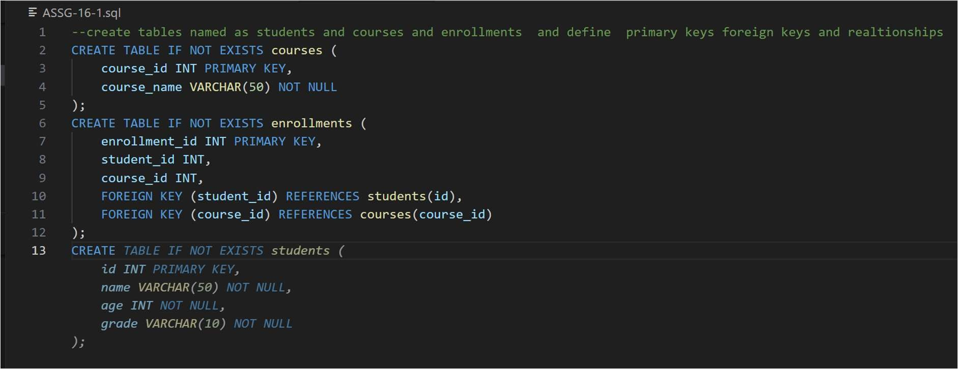
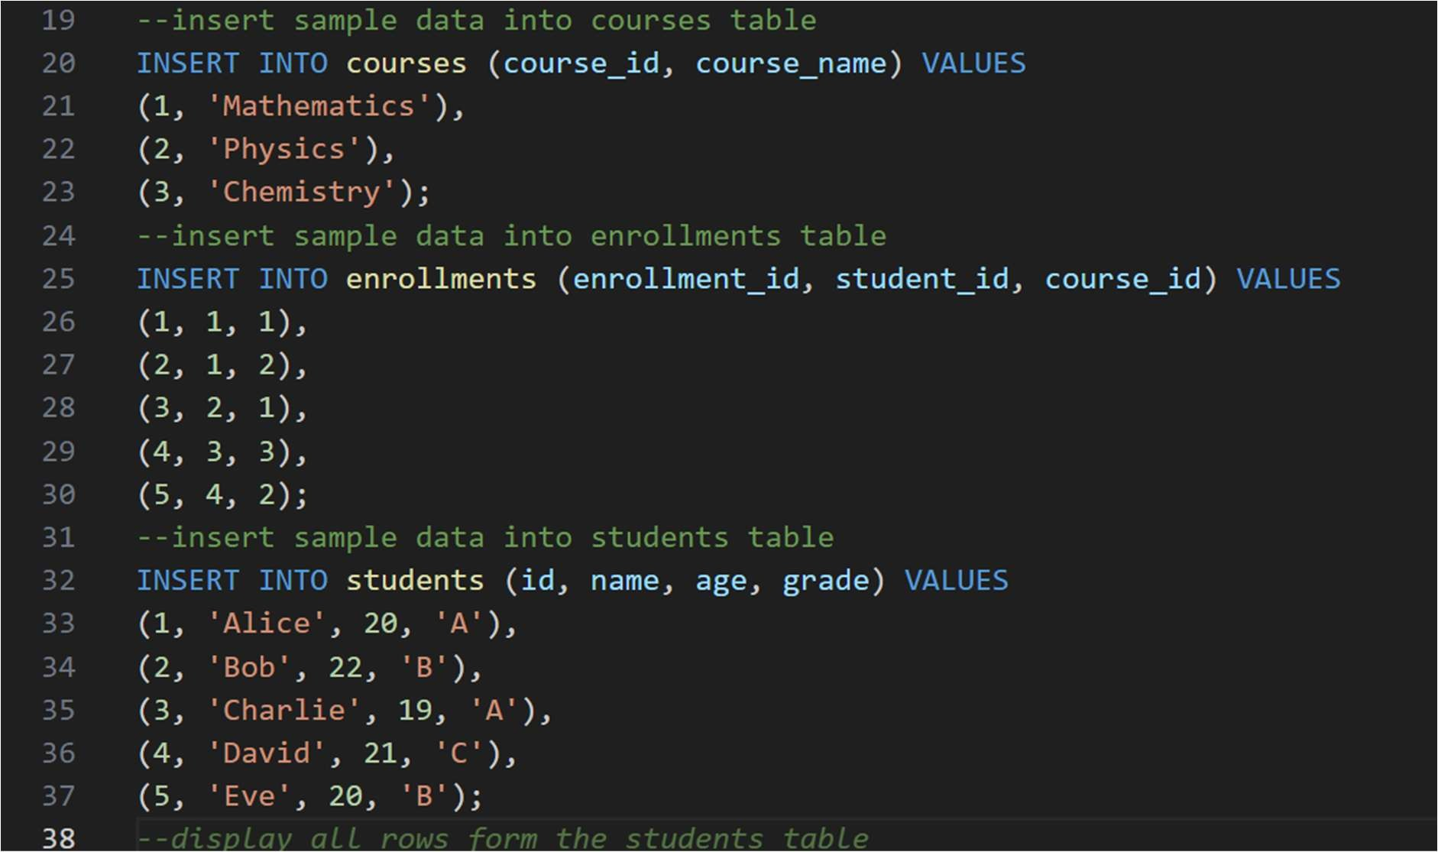
Output:
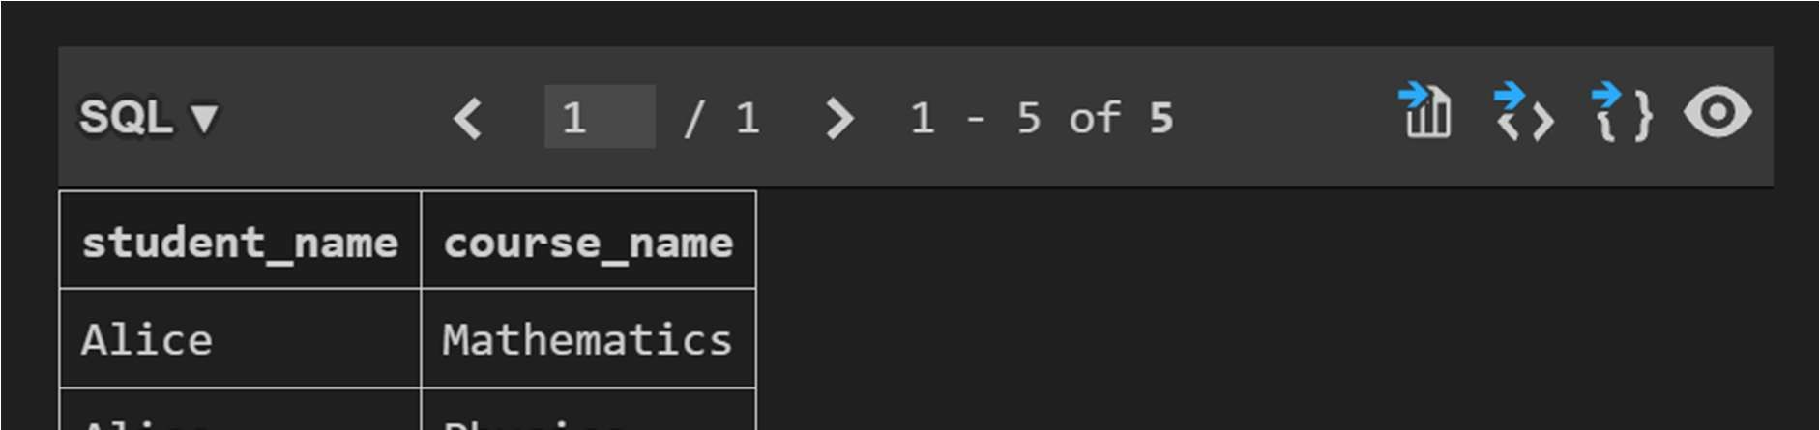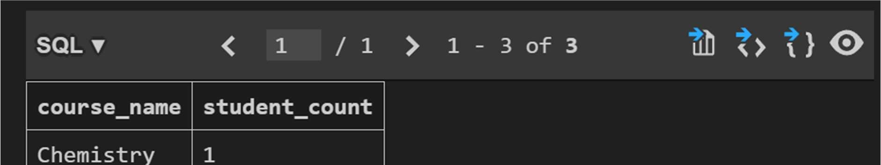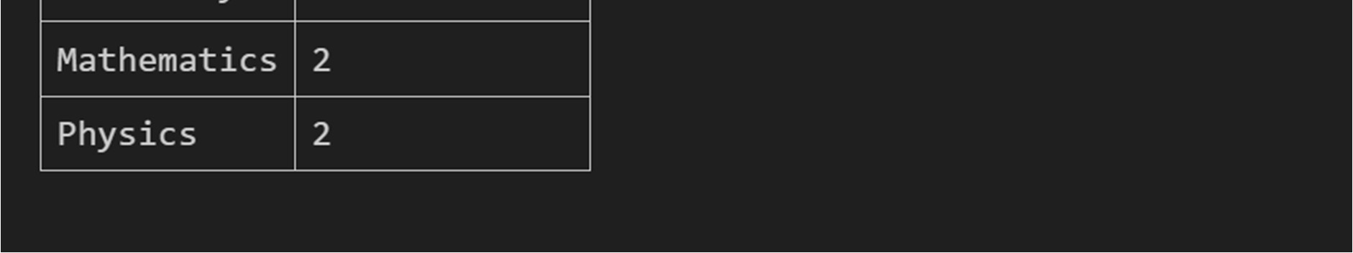

Task 2 – Hospital Management Database
Task:
Create schema and queries for a Hospital Management System.
Instruc ons:
- Tables: Doctors, Pa ents, Appointments.
- Use AI to define constraints (unique IDs, valid dates).
- Generate queries:
  - List all appointments for a specific doctor. o Retrieve pa ent history by pa ent ID.
  - Count total pa ents treated by each doctor.
Expected Output:
- Normalized schema and SQL queries with joins.
Screenshots:
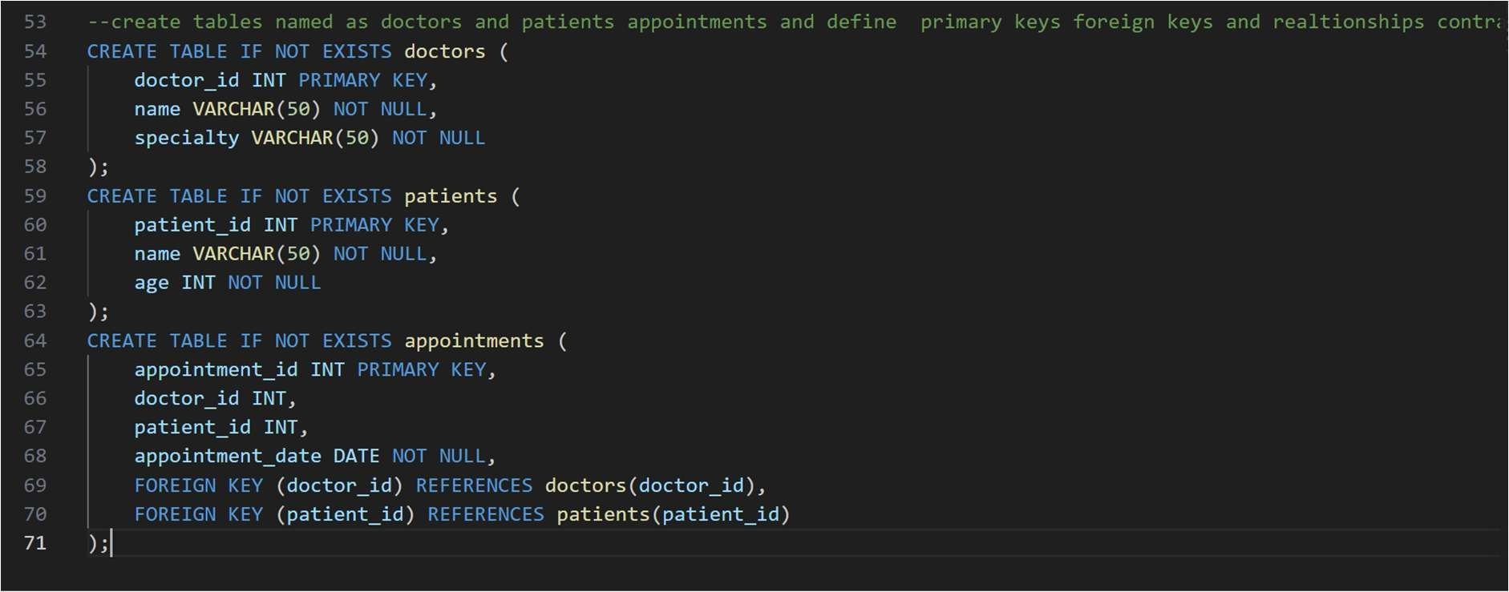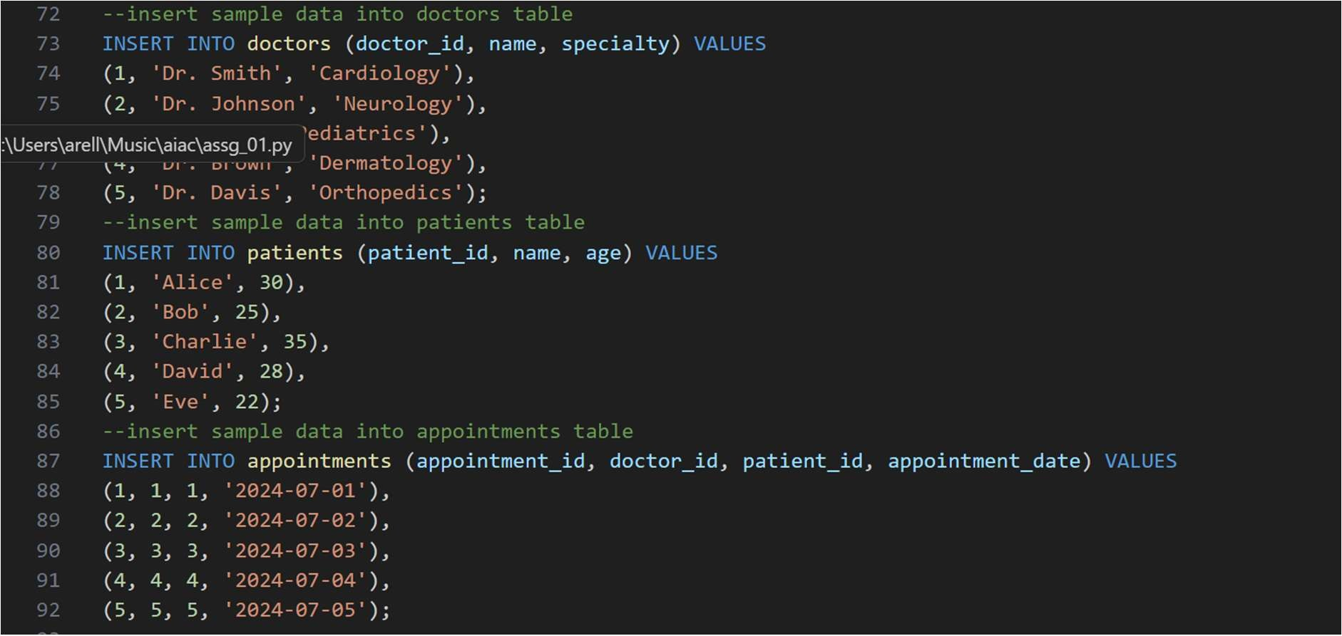
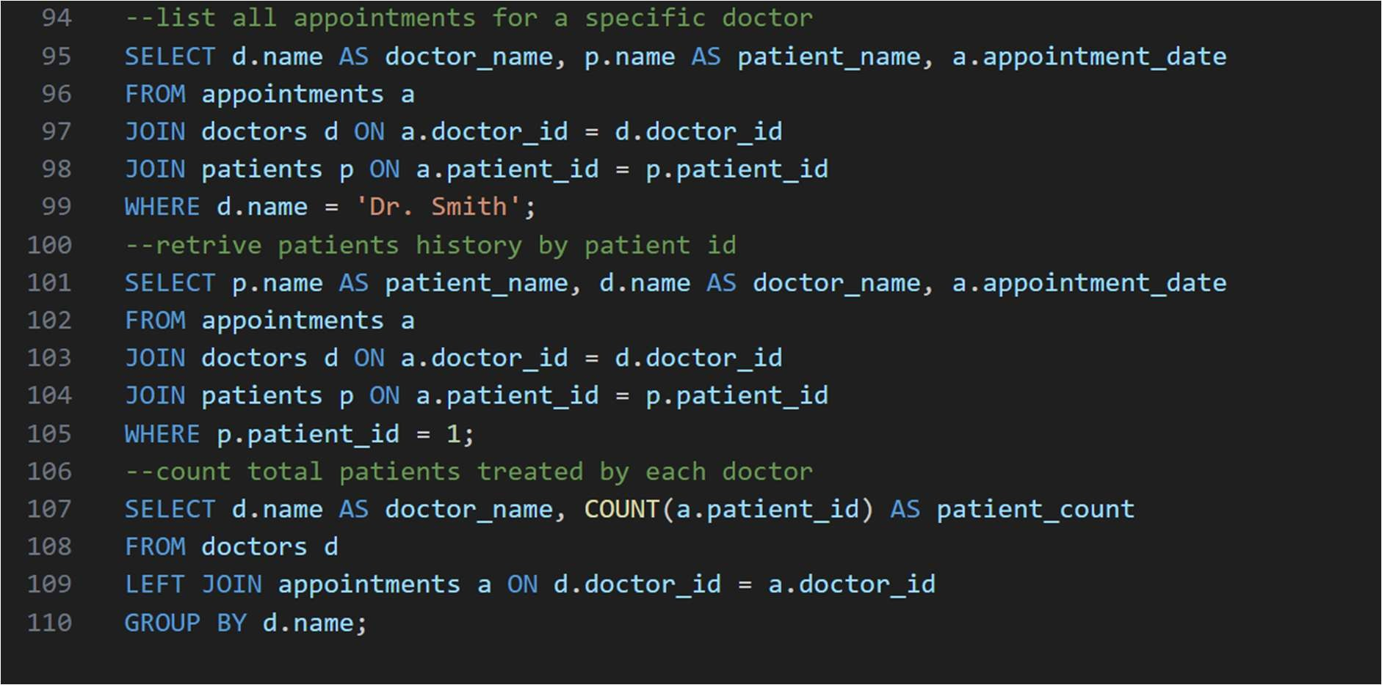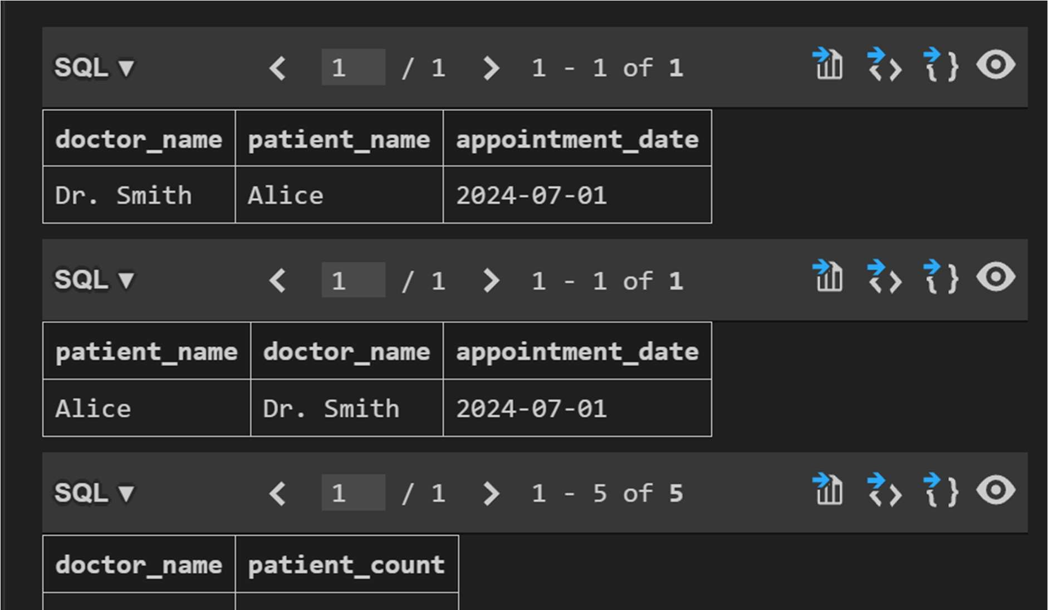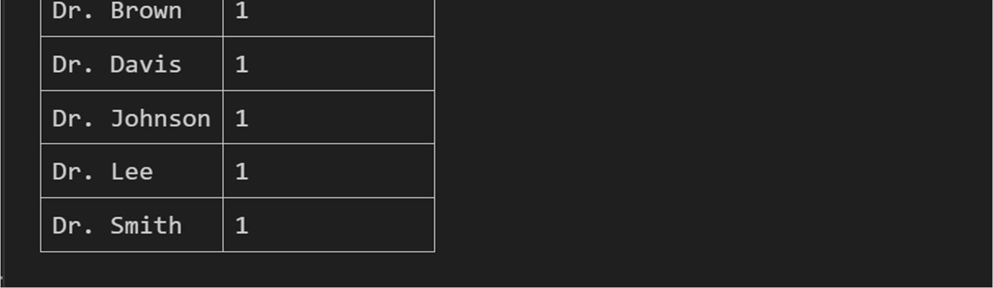

Task 3 – Library Database
Task:
Design schema for a Library Management System.
Instruc ons:
- Tables: Books, Members, Loans.
- Use AI to suggest indexing strategy for faster queries.
- Generate queries:
- Retrieve all books currently issued.
- Find overdue books (loan date > 30 days).
- Count number of books loaned by each member.
Expected Output:
- Schema + SQL queries demonstra ng joins and condi ons.
Screenshots:
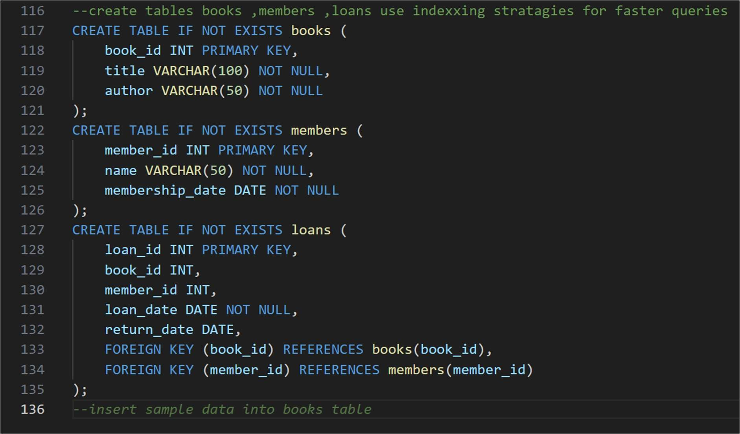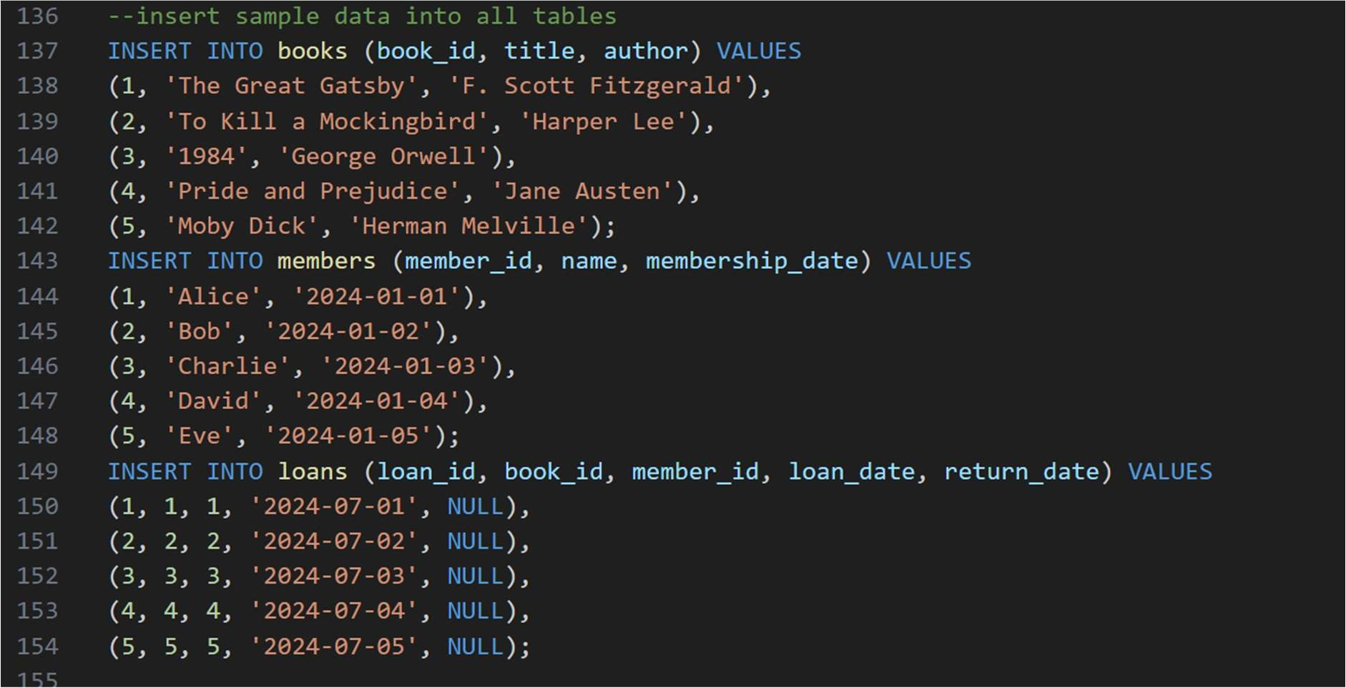
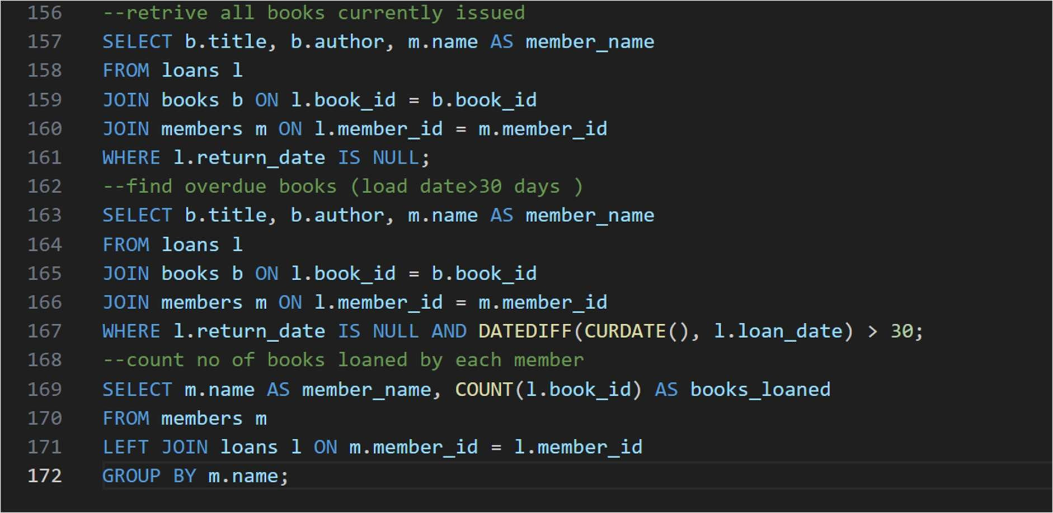
Output:
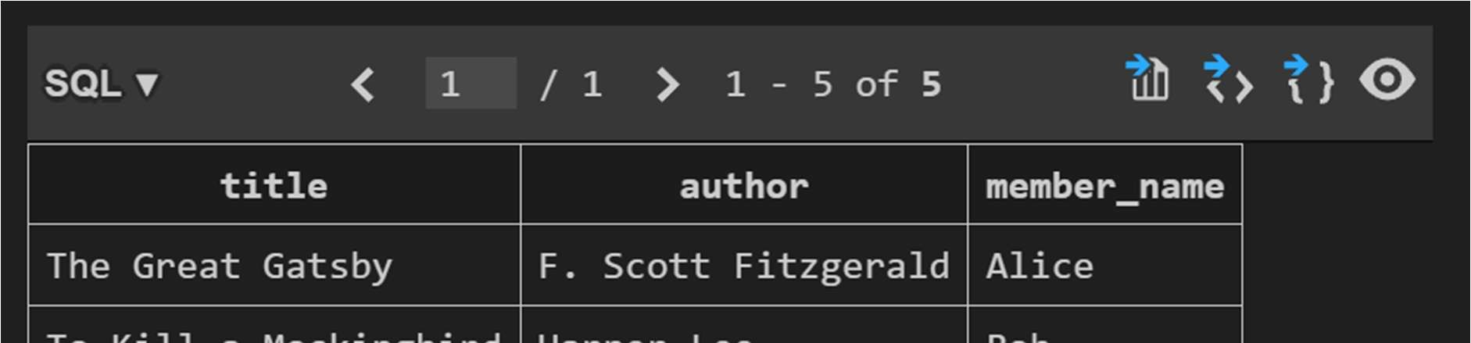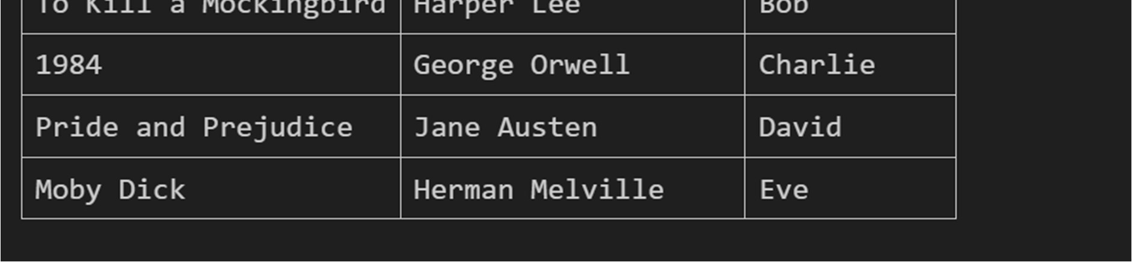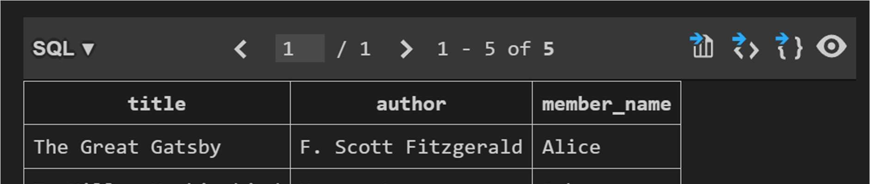
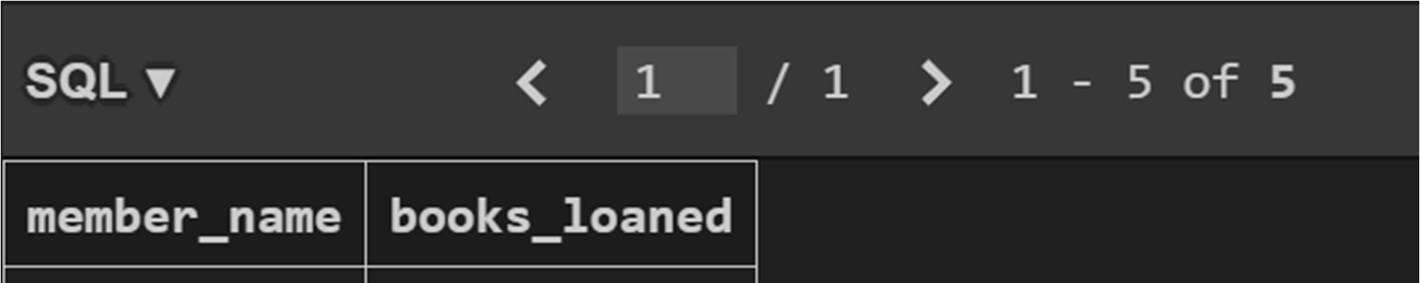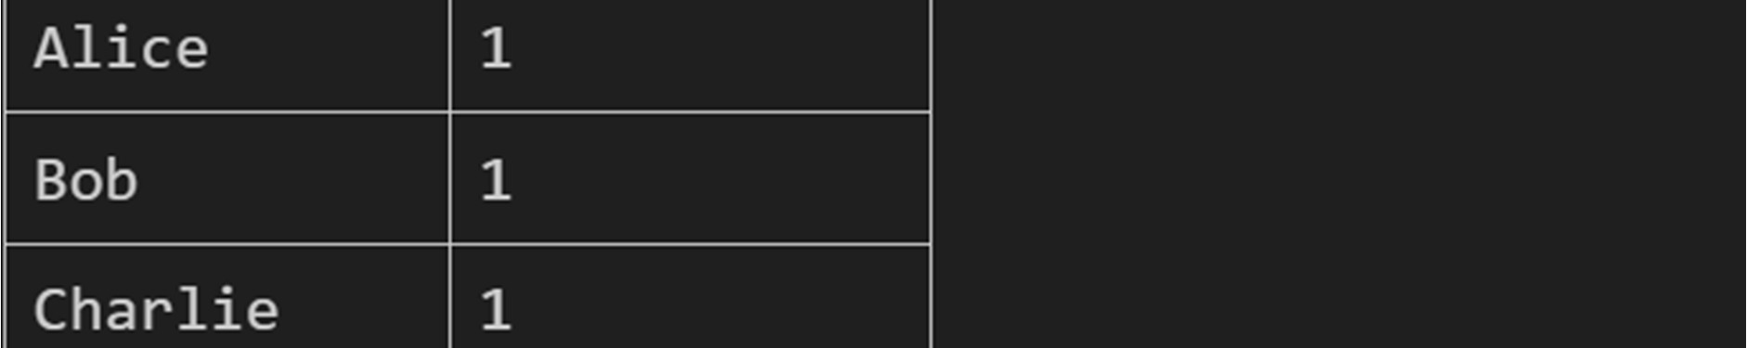
Task 4 – Real-Time Applica on: Online Shopping Database
Scenario:
Design a database for an E-commerce pla orm.
Requirements:
- Tables: Users, Products, Orders, OrderDetails.
- Generate queries to:
  - Retrieve all orders by a user.
  - Find the most purchased product.
  - Calculate total revenue in a given month.
- AI should also suggest normaliza on improvements and query op miza on.
Expected Output:
- Complete schema with rela onships + SQL queries for analy cs.

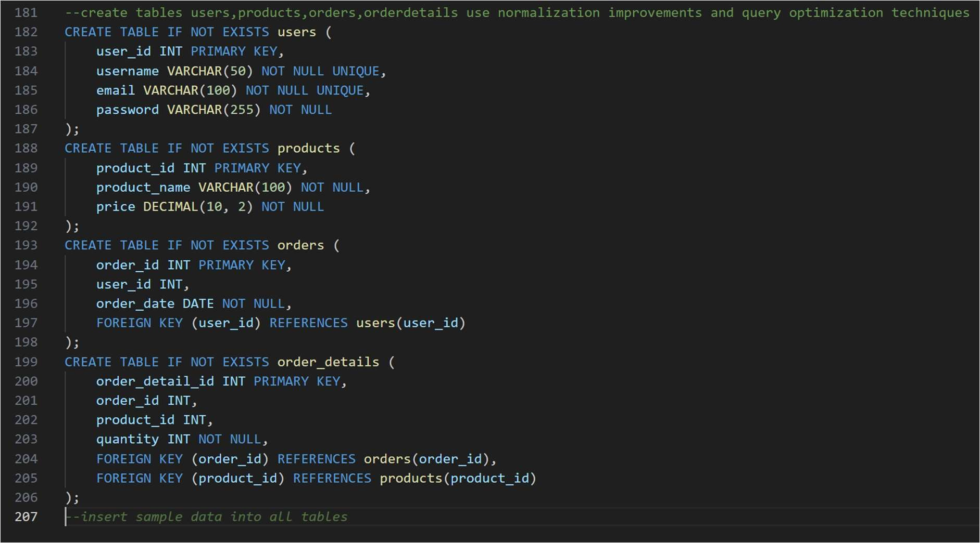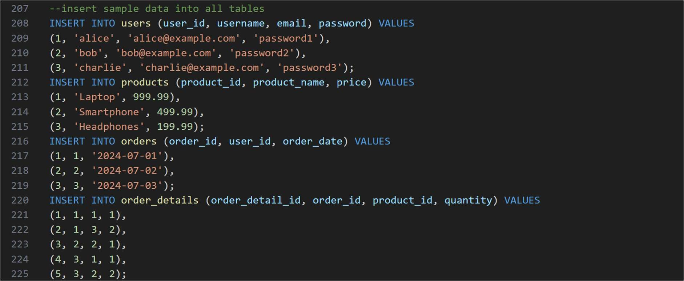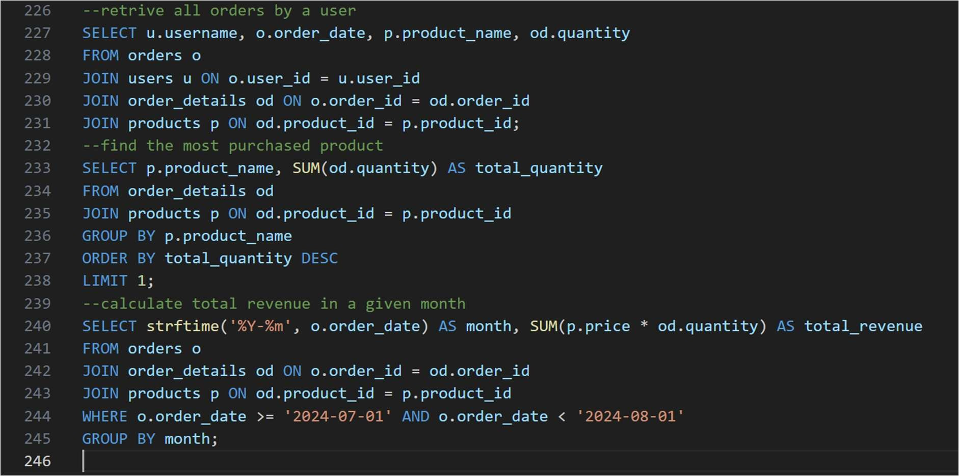
Output:
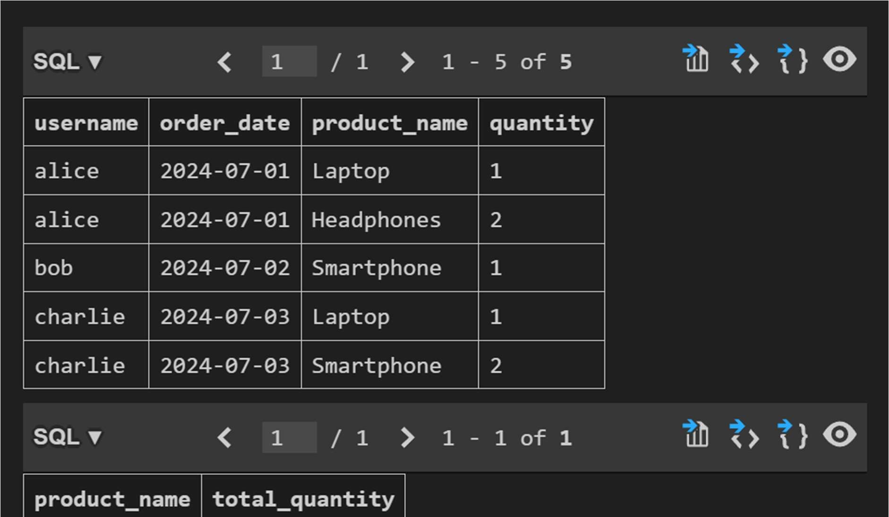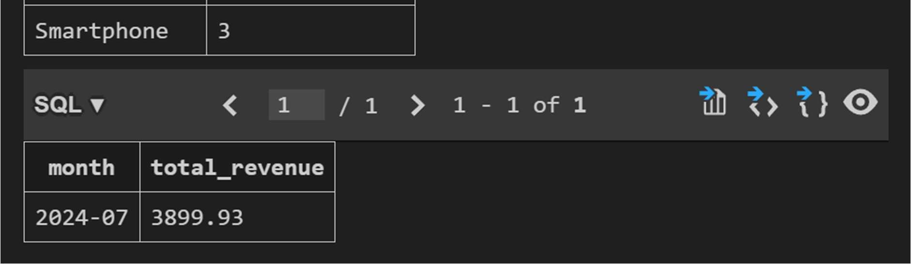
Task 5 – University Examina on Database
Design a database schema for a University Examina on System and generate SQL queries using AI.
Instruc ons:
- Tables: Students, Subjects, Exams, Results.
- Define primary keys, foreign keys, and referen al integrity constraints.
- Generate queries:
o Insert examina on results for a student. o Retrieve subject-wise marks for a student. o Calculate average marks for each subject.
Expected Output:
• Normalized schema and SQL queries involving aggrega on and
joins.
Screenshots:
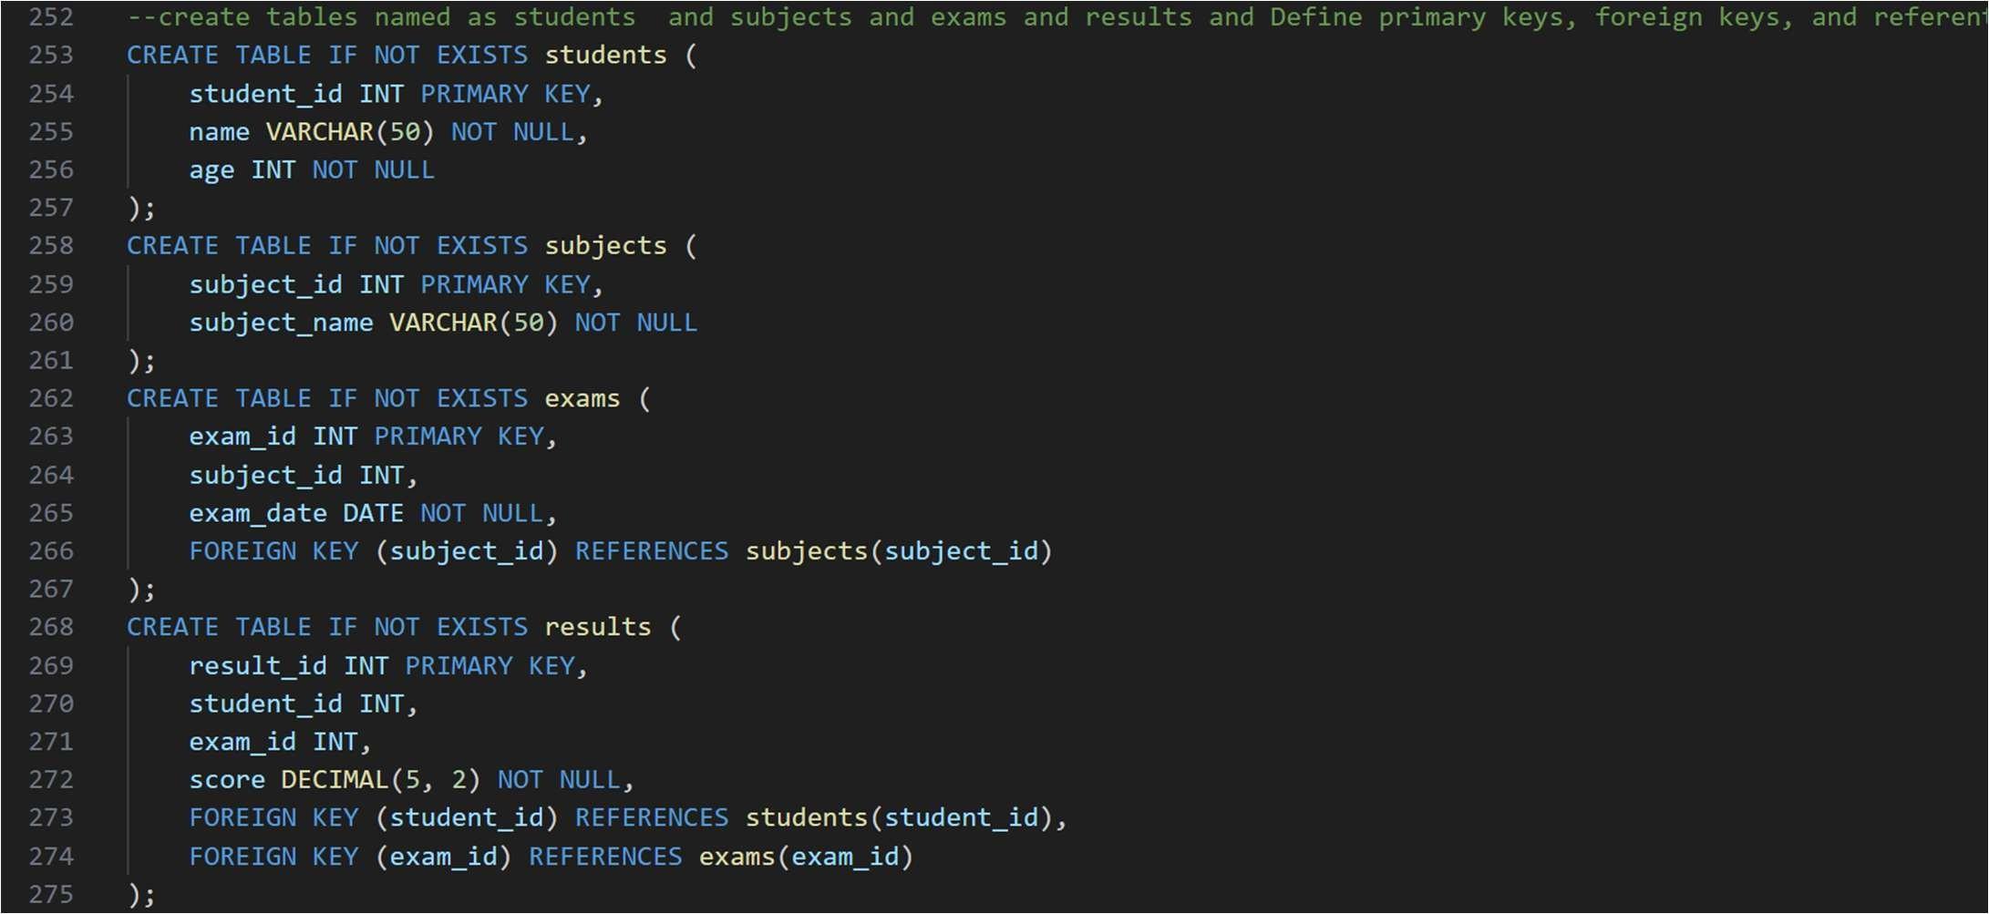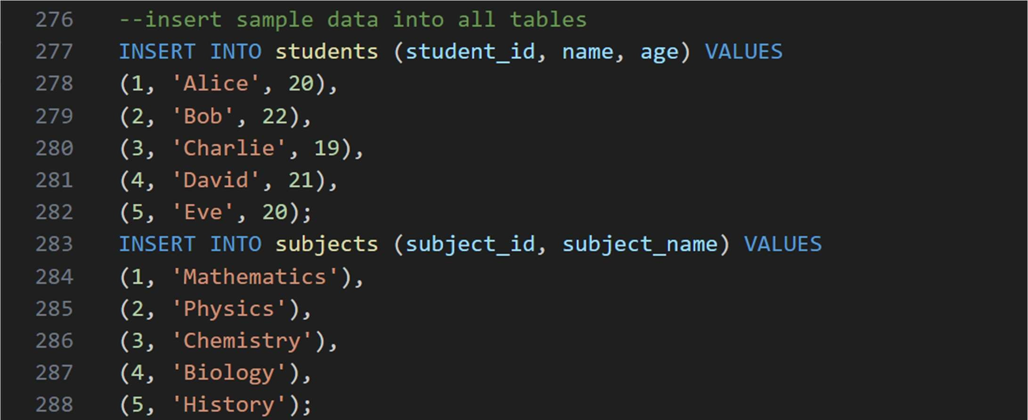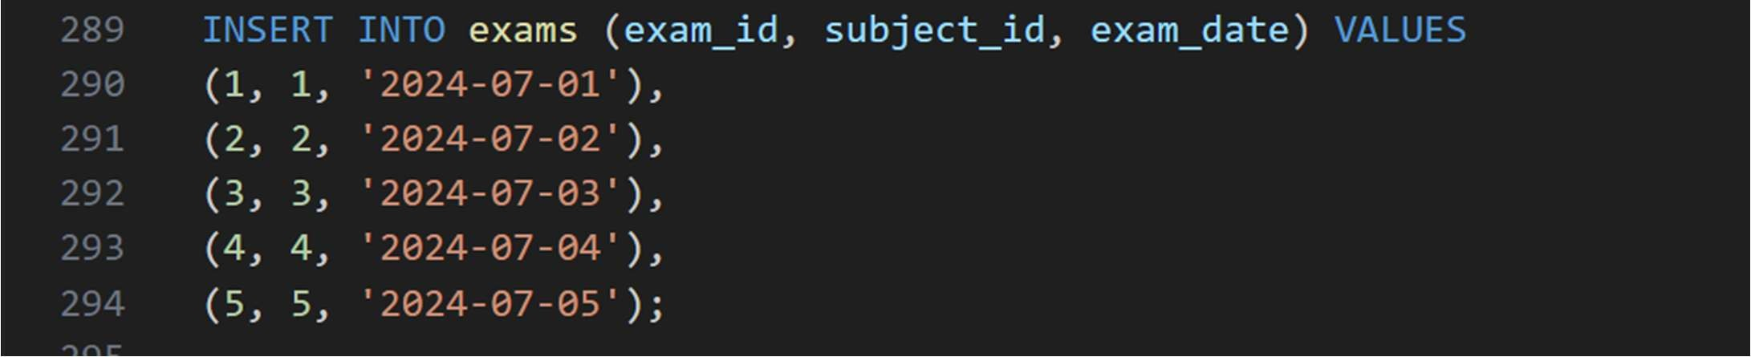
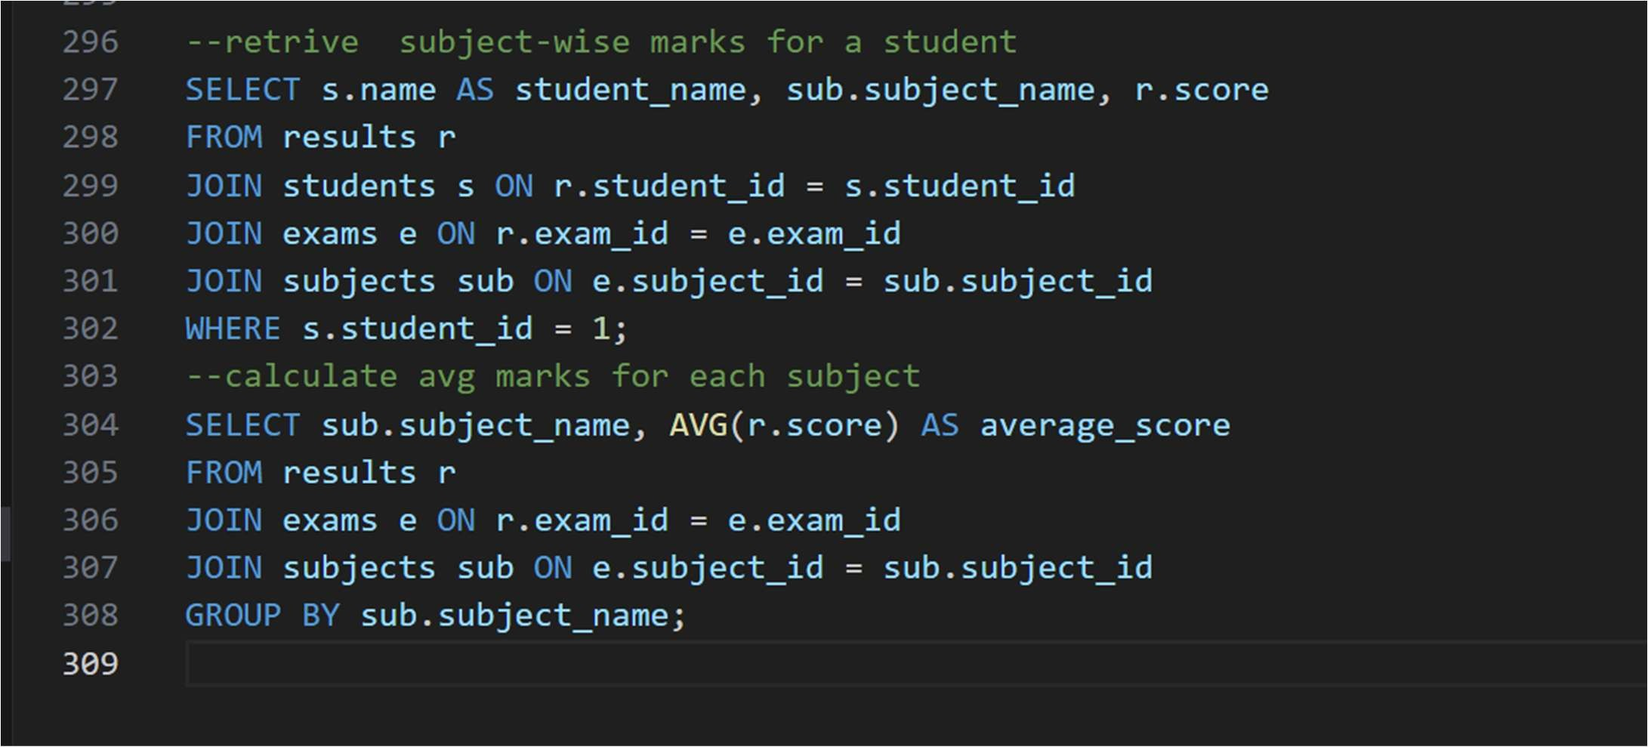
Output:
