Lab Assignment-7.5
Name:P.Chandra Vardhan Reddy
Hallticket:2303A51034
Batch:01

Task 1 (Mutable Default Argument – Function Bug)
Task: Analyze given code where a mutable default argument causes unexpected behavior. Use AI to fix it. # Bug: Mutable default argument def add_item(item, items=[]):
items.append(item) return items print(add_item(1)) print(add_item(2))
Expected Output: Corrected function avoids shared list bug.

Screenshots:
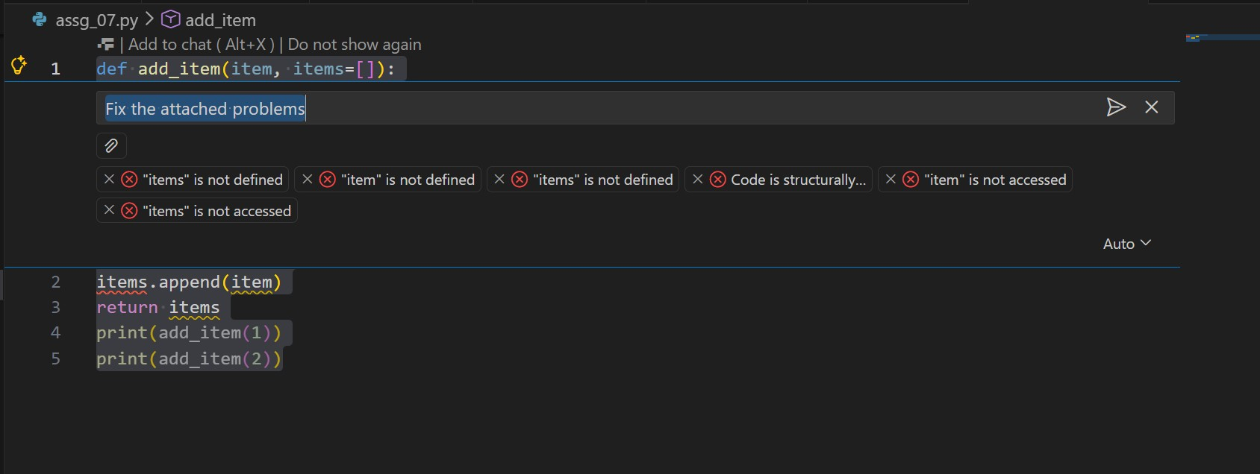
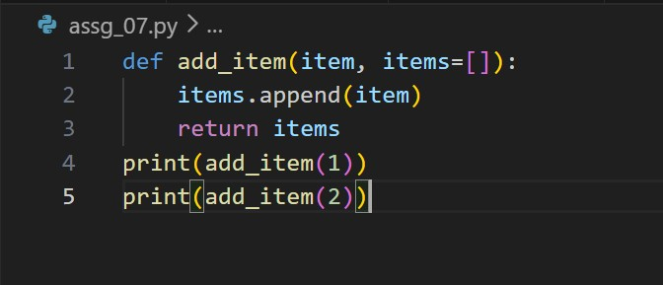
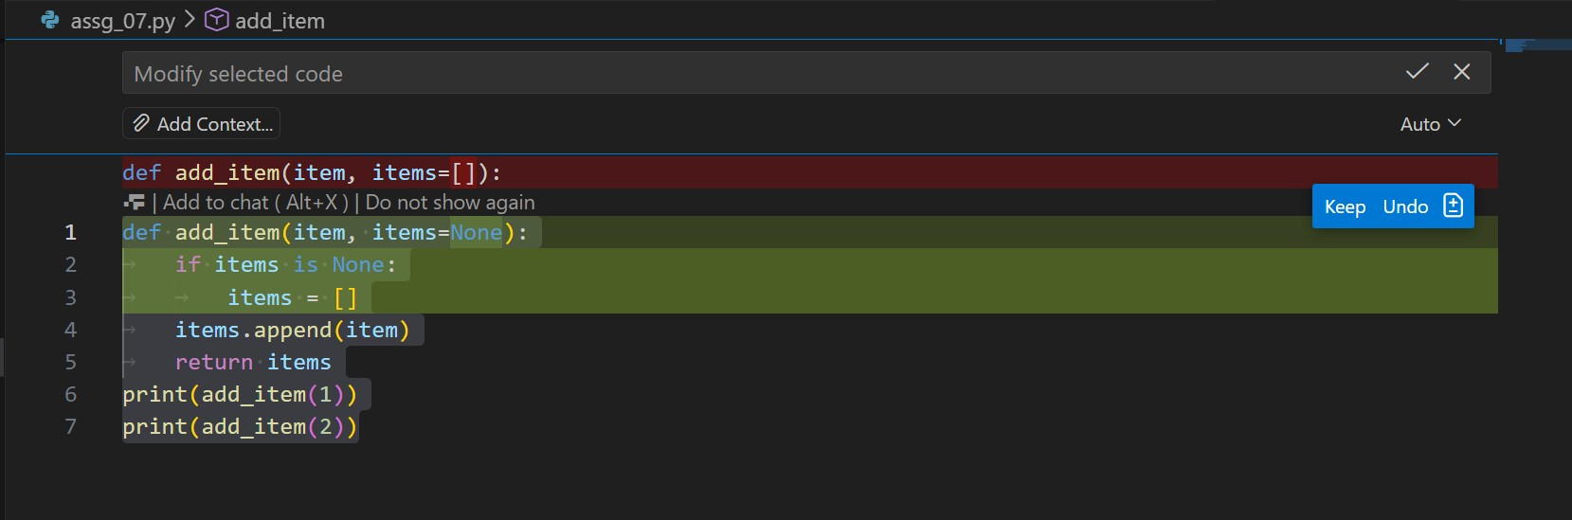
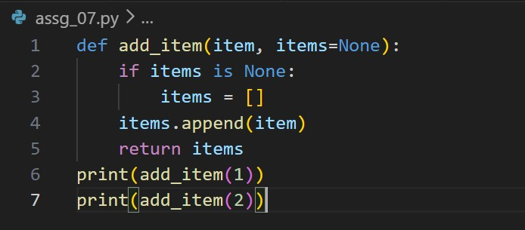
Code:
def add_item(item, items=None): if items is None: items = [] items.append(item)
return items print(add_item(1)) print(add_item(2))

output:
Task 2 (Floating-Point Precision Error)
Task: Analyze given code where floating-point comparison fails.
Use AI to correct with tolerance. # Bug: Floating point precision issue def check_sum(): return (0.1 + 0.2) == 0.3 print(check_sum())
Expected Output: Corrected function

Screenshots:
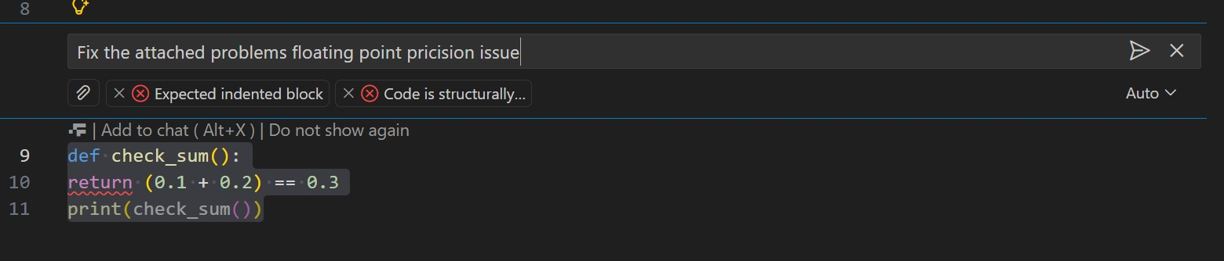
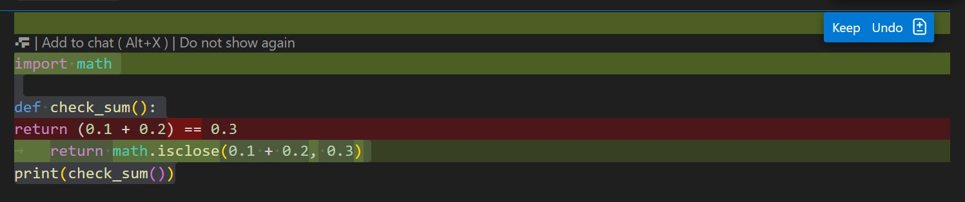
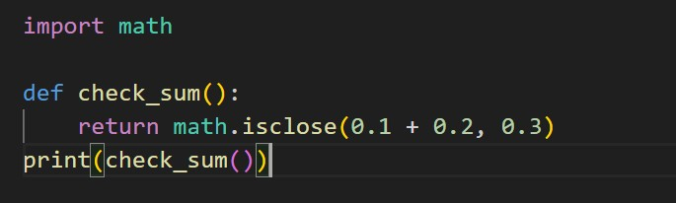
Code:
import math

def check_sum(): return math.isclose(0.1 + 0.2, 0.3) print(check_sum())

output:
Task 3 (Recursion Error – Missing Base Case)
Task: Analyze given code where recursion runs infinitely due to missing base case. Use AI to fix.
# Bug: No base case def countdown(n):
print(n) return countdown(n-1) countdown(5)
Expected Output : Correct recursion with stopping condition.

Screenshots:
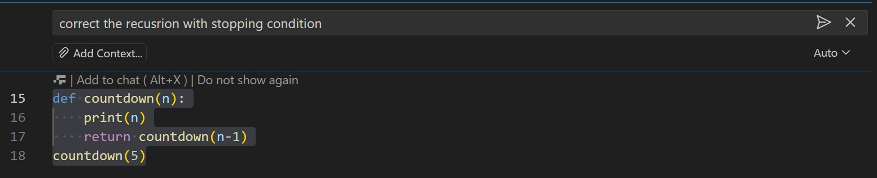
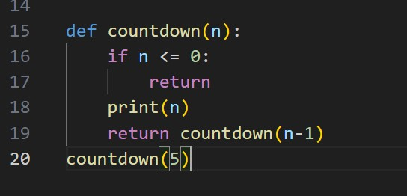
Code:
def countdown(n): if n <= 0: return print(n) return countdown(n-1) countdown(5)

output:
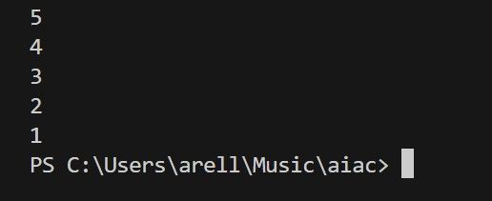
Task 4 (Dictionary Key Error)
Task: Analyze given code where a missing dictionary key causes error. Use AI to fix it.
# Bug: Accessing non-existing key def get_value(): data = {"a": 1, "b": 2} return data["c"] print(get_value())
Expected Output: Corrected with .get() or error handling.

Screenshots:
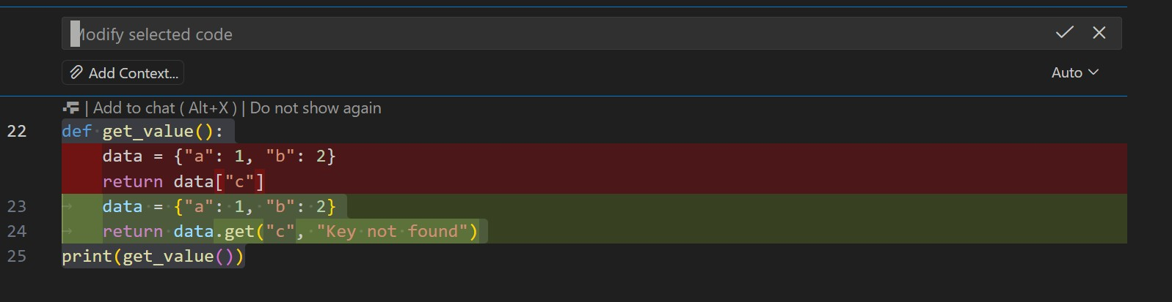
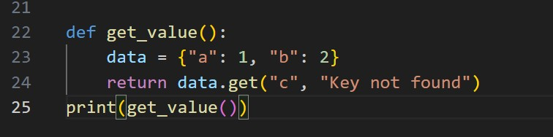
Code:
def get_value():
data = {"a": 1, "b": 2}
return data.get("c", "Key not found") print(get_value())

output:
Task 5 (Infinite Loop – Wrong Condition)
Task: Analyze given code where loop never ends. Use AI to detect
and fix it.
# Bug: Infinite loop def loop_example():
i = 0 while i < 5: print(i)
Expected Output: Corrected loop increments i.

Screenshots:
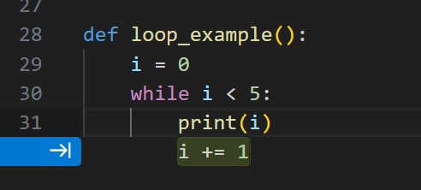
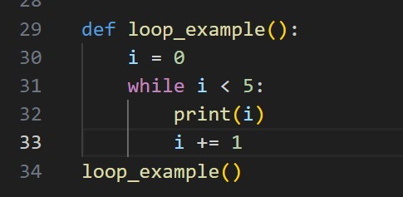
Code:
def loop_example():
i = 0 while i < 5: print(i) i += 1 loop_example()

output:
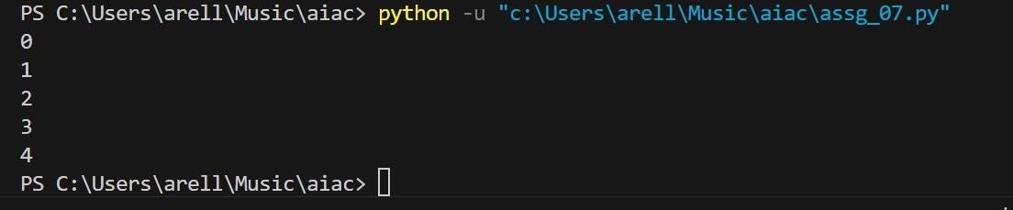

Task 6 (Unpacking Error – Wrong Variables)
Task: Analyze given code where tuple unpacking fails. Use AI to
fix it.
# Bug: Wrong unpacking
a, b = (1, 2, 3)
Expected Output: Correct unpacking or using _ for extra values.

Screenshots:
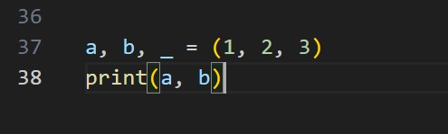
Code:
a, b, _ = (1, 2, 3) print(a, b)

output:

Task 7 (Mixed Indentation – Tabs vs Spaces)
Task: Analyze given code where mixed indentation breaks execution. Use AI to fix it. # Bug: Mixed indentation def func():
- = 5
- = 10
return x+y
Expected Output : Consistent indentation applied.

Screenshots:
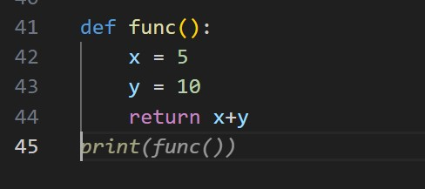
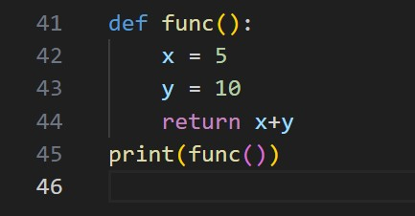
Code:
def func(): x = 5 y = 10
return x+y print(func())

output:
Task 8 (Import Error – Wrong Module Usage)
Task: Analyze given code with incorrect import. Use AI to fix.
# Bug: Wrong import import maths print(maths.sqrt(16))
Expected Output: Corrected to import math

Screenshots:
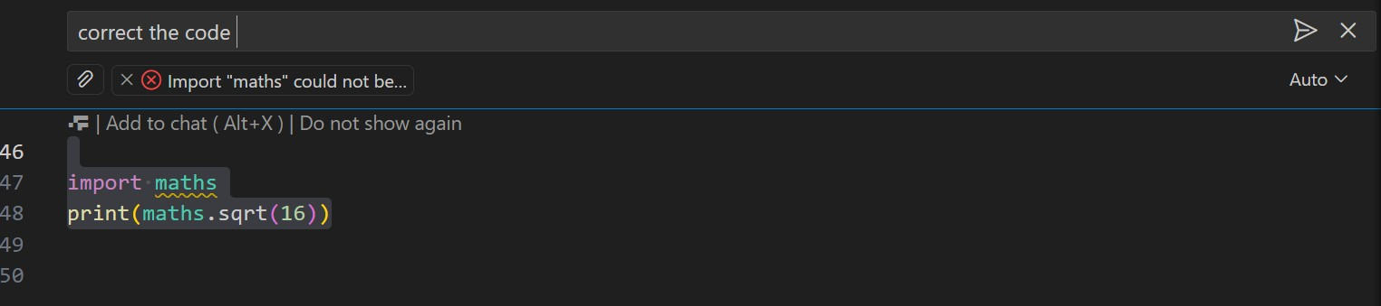
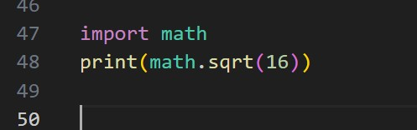
Code:
import math
print(math.sqrt(16))

output:

Task 9 (Unreachable Code – Return Inside Loop)
Task: Analyze given code where a return inside a loop prevents full iteration. Use AI to fix it. # Bug: Early return inside loop def total(numbers): for n in numbers:
return n
print(total([1,2,3]))
Expected Output: Corrected code accumulates sum and returns after loop.

Screenshots:
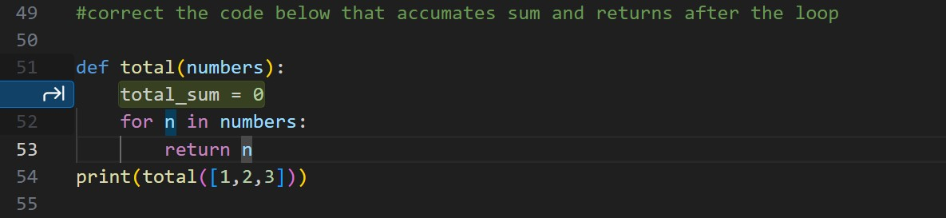
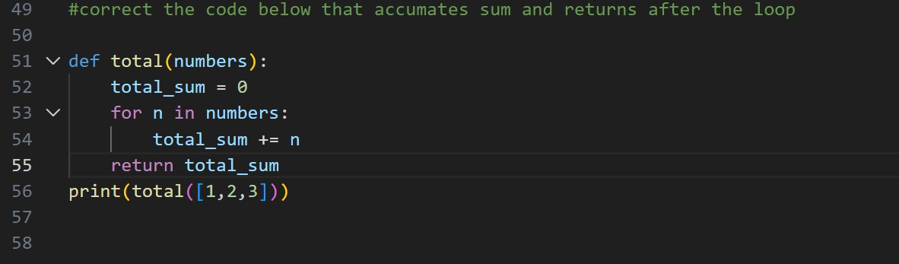
Code:
def total(numbers): total_sum = 0 for n in numbers: total_sum += n return total_sum print(total([1,2,3]))

output:
Task 10 (Name Error – Undefined Variable)
Task: Analyze given code where a variable is used before being defined. Let AI detect and fix the error.
# Bug: Using undefined variable def calculate_area(): return length * width print(calculate_area())
Requirements:
- Run the code to observe the error.
- Ask AI to identify the missing variable definition.
- Fix the bug by defining length and width as parameters.
- Add 3 assert test cases for correctness.
Expected Output :
- Corrected code with parameters.
- AI explanation of the bug.
Successful execution of assertions.

Screenshots:
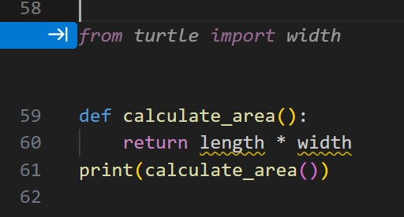
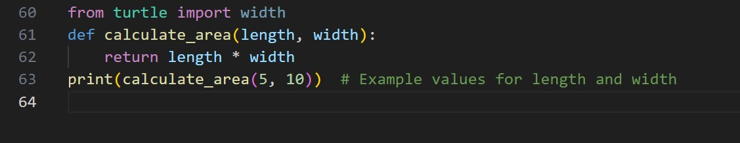
Code:
from turtle import width
def calculate_area(length, width):
return length * width
print(calculate_area(5, 10)) # Example values for length and width

output:
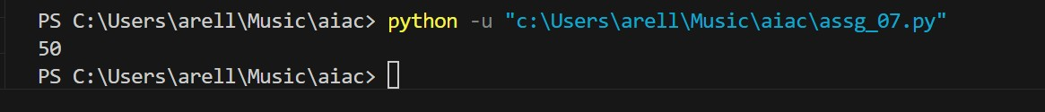
Task 11 (Type Error – Mixing Data Types Incorrectly)
Task: Analyze given code where integers and strings are added incorrectly. Let AI detect and fix the error.
# Bug: Adding integer and string def add_values(): return 5 + "10" print(add_values())
Requirements:
- Run the code to observe the error.
- AI should explain why int + str is invalid.
- Fix the code by type conversion (e.g., int("10") or str(5)).
- Verify with 3 assert cases.
Expected Output #6:
- Corrected code with type handling.
- AI explanation of the fix.
Successful test validation.

Screenshots:
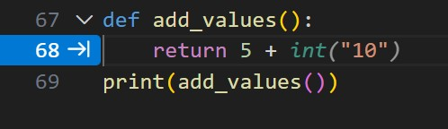
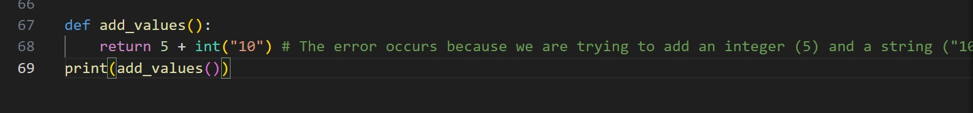
Code:
def add_values():
return 5 + int("10") # The error occurs because we are trying to add an integer (5) and a string ("10"). To fix this, we need to convert the string "10" to an integer using the int() function before performing the addition. print(add_values())

output:
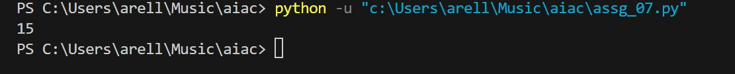

Task 12 (Type Error – String + List Concatenation)
Task: Analyze code where a string is incorrectly added to a list.
# Bug: Adding string and list def combine(): return "Numbers: " + [1, 2, 3] print(combine())
Requirements:
- Run the code to observe the error.
- Explain why str + list is invalid.
- Fix using conversion (str([1,2,3]) or " ".join()).
- Verify with 3 assert cases.
Expected Output:
- Corrected code
- Explanation
- Successful test validation

Screenshots:
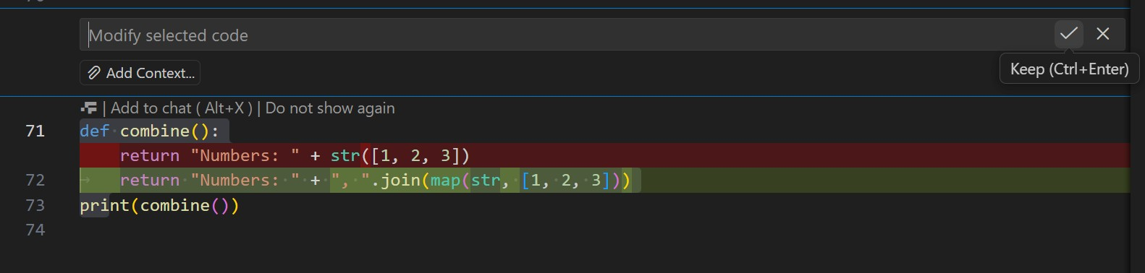
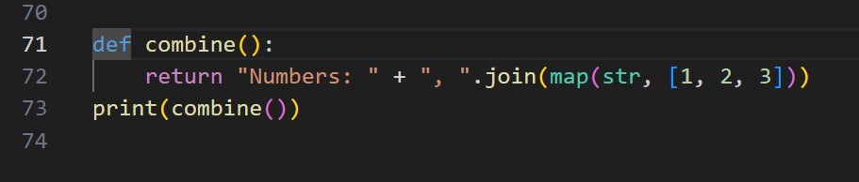
code:
def combine(): return "Numbers: " + ", ".join(map(str, [1, 2, 3])) print(combine())

Output:
Task 13 (Type Error – Multiplying String by Float)
Task: Detect and fix code where a string is multiplied by a float.
# Bug: Multiplying string by float def repeat_text(): return "Hello" * 2.5 print(repeat_text()) Requirements:
- Observe the error.
- Explain why float multiplication is invalid for strings.
- Fix by converting float to int.
- Add 3 assert test cases.

Screenshots:
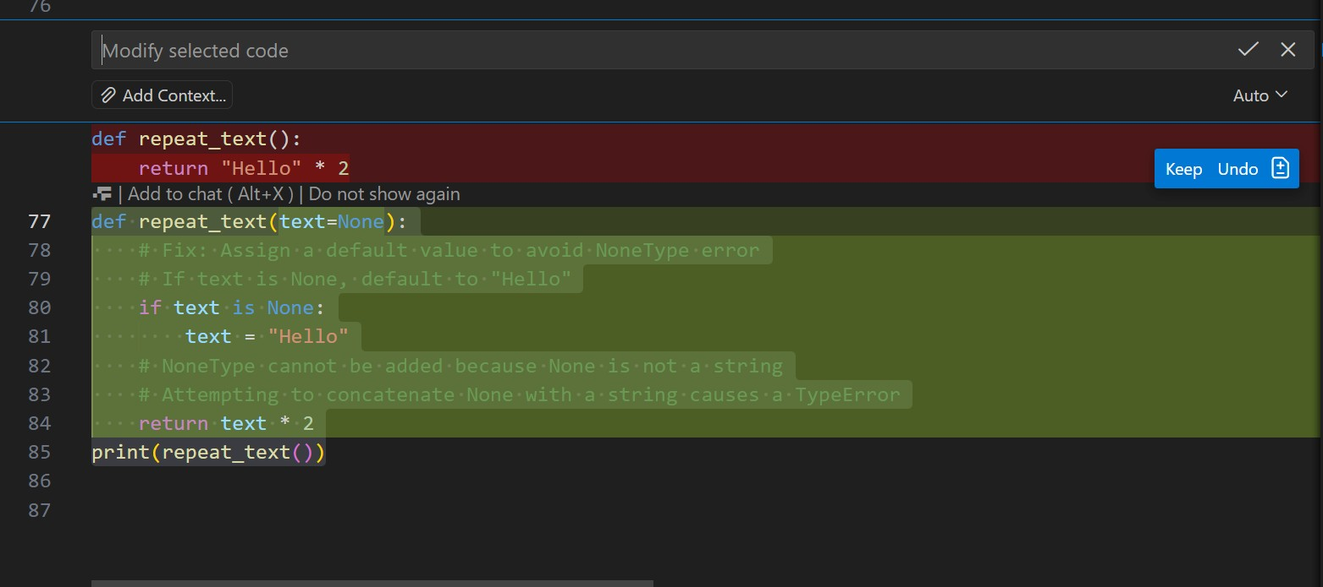
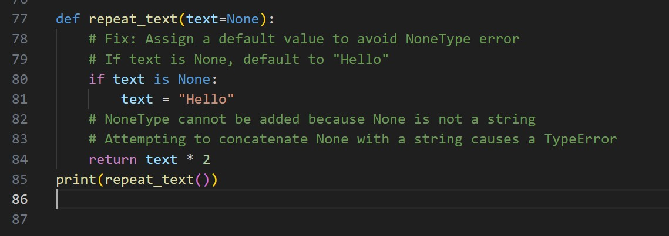
Code:
def repeat_text(text=None):
# Fix: Assign a default value to avoid NoneType error
# If text is None, default to "Hello" if text is None: text = "Hello"
# NoneType cannot be added because None is not a string
# Attempting to concatenate None with a string causes a TypeError return text * 2 print(repeat_text())

output:
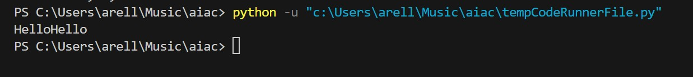
Task 15 (Type Error – Input Treated as String Instead of
Number)
Task: Fix code where user input is not converted properly.
# Bug: Input remains string def sum_two_numbers():
a = input("Enter first number: ") b = input("Enter second number: ") return a + b print(sum_two_numbers())
Requirements:
- Explain why input is always string.
- Fix using int() conversion.
- Verify with assert test cases.

Screenshots:
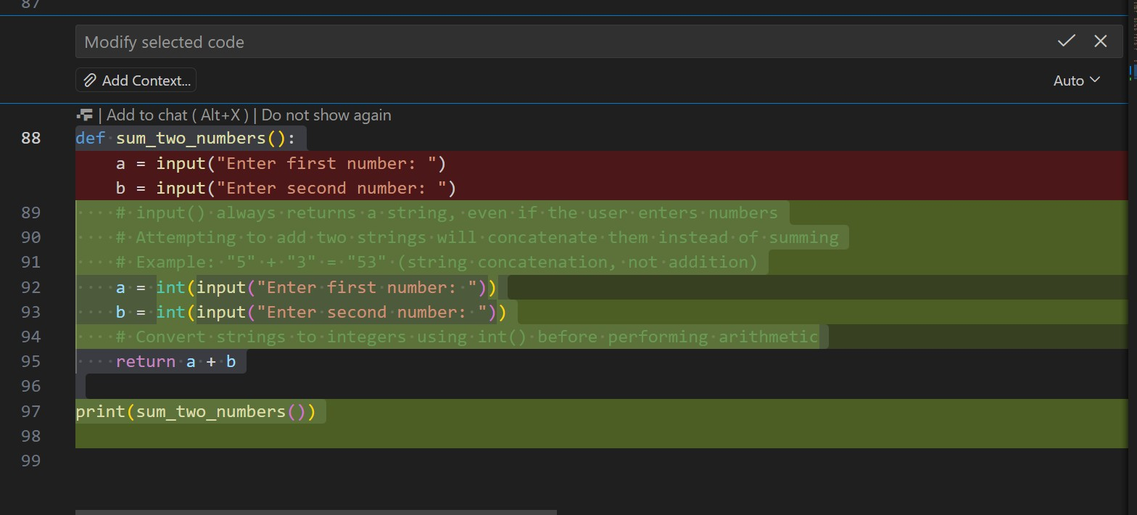
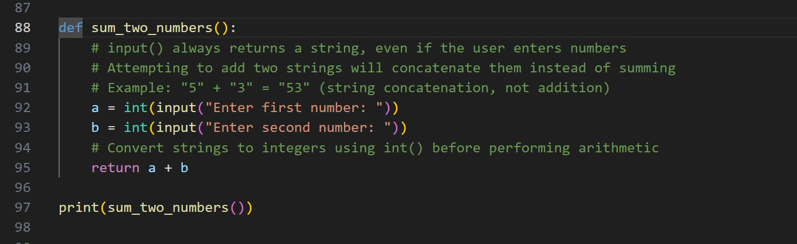
Code:
def sum_two_numbers():
# input() always returns a string, even if the user enters numbers
# Attempting to add two strings will concatenate them instead of summing
# Example: "5" + "3" = "53" (string concatenation, not addition) a = int(input("Enter first number: ")) b = int(input("Enter second number: "))
# Convert strings to integers using int() before performing arithmetic return a + b

print(sum_two_numbers())

output:
