AI ASSISTED CODING ASSIGNMENT - 1.1
V. Akshara (2303A51041)
BATCH-01
Task 0: Install and configure GitHub Copilot in VS Code. Take screenshots of
each step.
Expected Output:
● Install and configure GitHub Copilot in VS Code. Take screenshots of
each step.
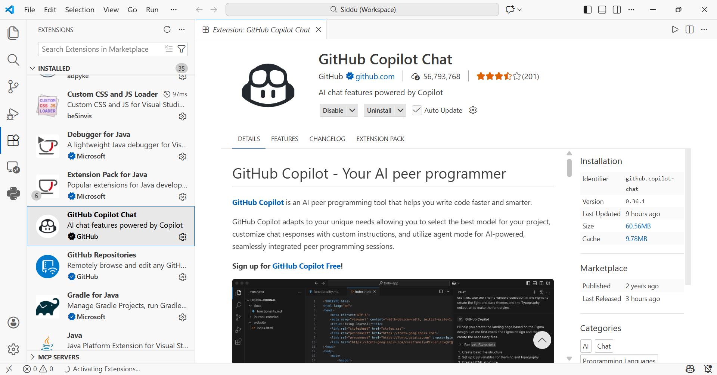
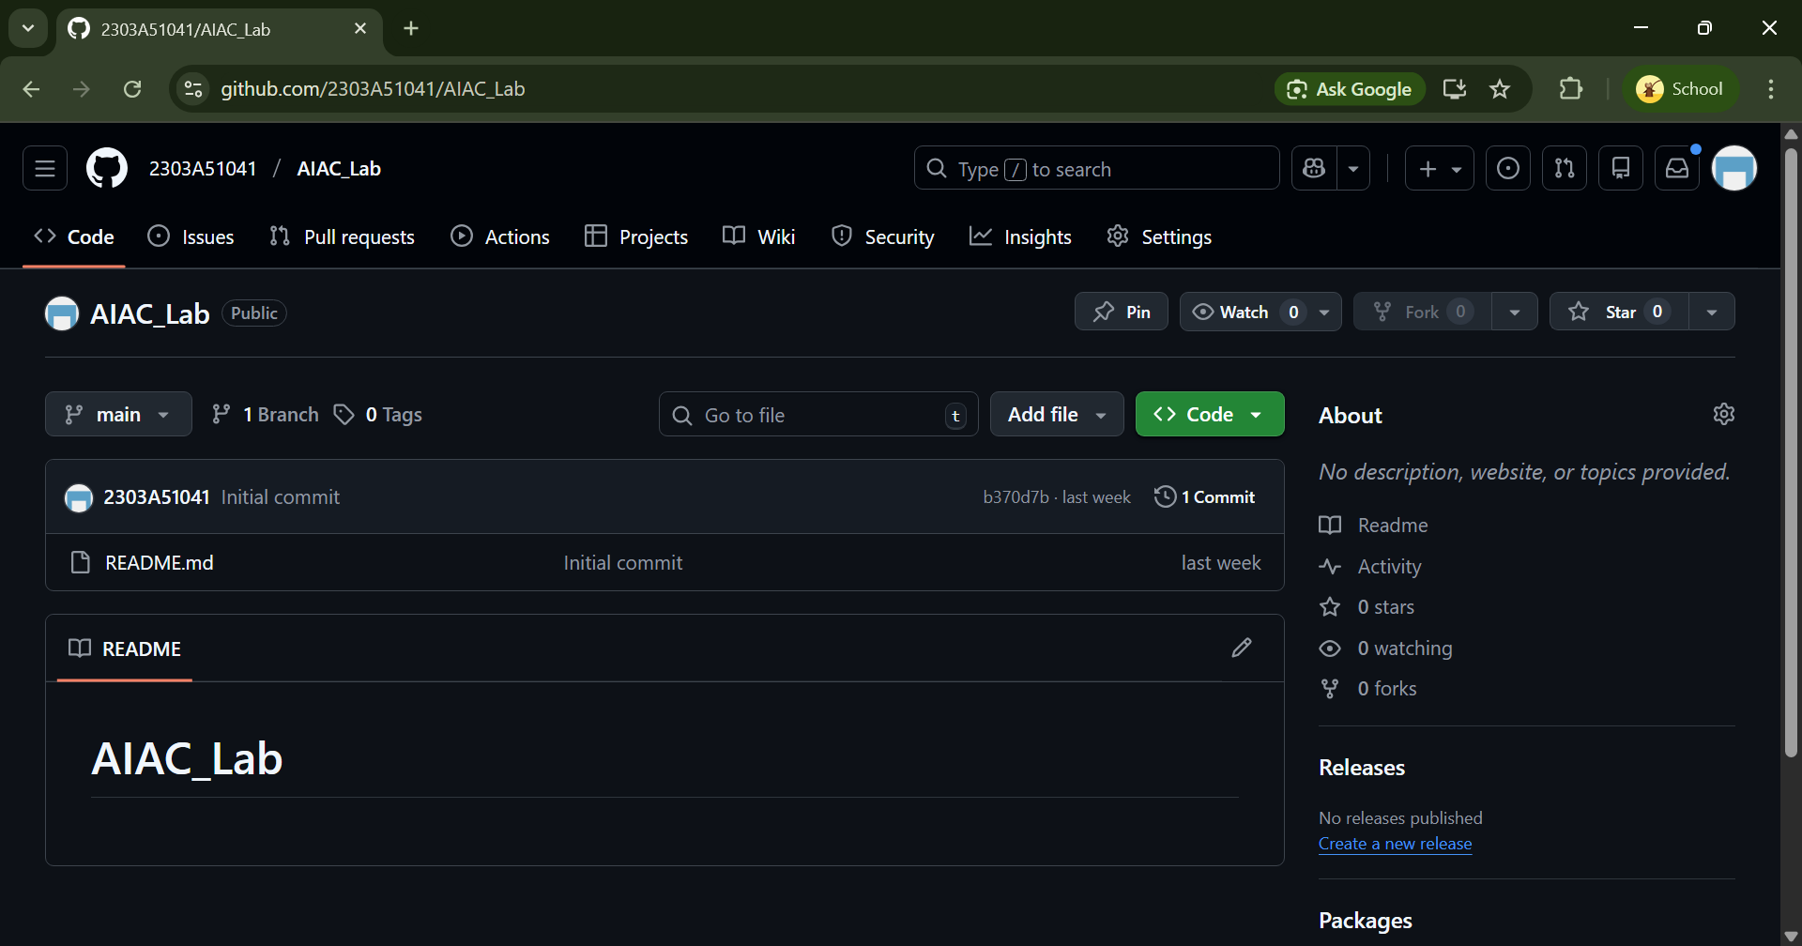

Task 1: AI-Generated Logic Without Modularization (Factorial without Functions)
• Scenario
You are building a small command-line utility for a startup intern onboarding task. The program is simple and must be written quickly without modular design.
• Task Description
Use GitHub Copilot to generate a Python program that computes a mathematical product-based value (factorial-like logic) directly in the main
execution flow, without using any user-defined functions.
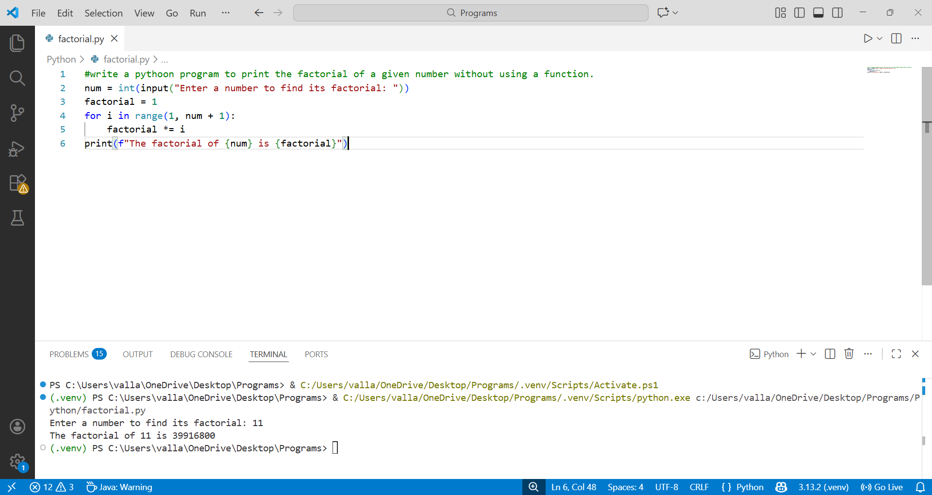
Task 2: AI Code Optimization & Clean-up (Improving Efficiency)
• Scenario
Your team lead asks you to review AI-generated code before committing it to
a shared repository.
• Task Description
Analyse the code generated in Task 1 and use Copilot again to:
 Reduce unnecessary variables
 Improve loop clarity
 Enhance readability and efficiency
Hint:
Prompt Copilot with phrases like
“Optimize this code”, “simplify logic”, or “make it more readable”

• Expected Deliverables
 Original AI-generated code
 Optimized version of the same code
 Side-by-side comparison
 Written explanation:
▪ What was improved?
▪ Why the new version is better (readability, performance,
maintainability.
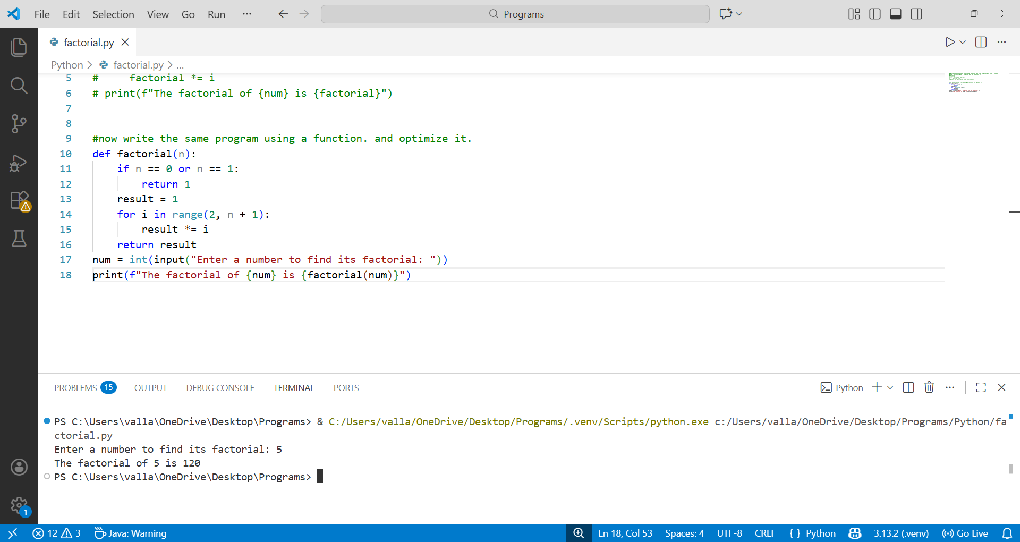
Original | Optimized
Hard coded for loop | Functional abstraction
Single use of logic | Higher use of code  (reusability)
Can be used at one place  Only | Portable and works  anywhere
Slightly big and clumsy | Cleaner

Task 3: Modular Design Using AI Assistance (Factorial with Functions)
• Scenario
The same logic now needs to be reused in multiple scripts.
• Task Description
Use GitHub Copilot to generate a modular version of the program by:
 Creating a user-defined function
 Calling the function from the main block
• Constraints
 Use meaningful function and variable names
 Include inline comments (preferably suggested by Copilot)
• Expected Deliverables
 AI-assisted function-based program
 Screenshots showing:
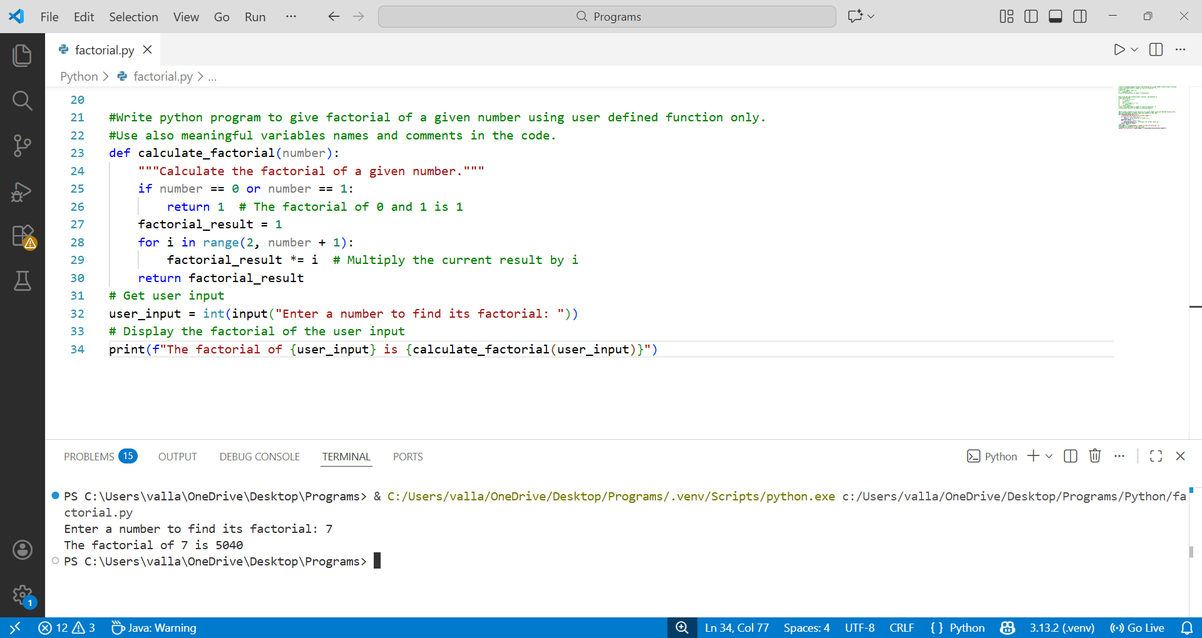
- Prompt evolution
# Write python program to give factorial of a given number using user defined function only.
# Use also meaningful variables names and comments in the code.

- Copilot-generated function logic
Factorial =1
for i in range(1, number + 1):
Factorial *= i
 Short note:
- How modularity improves reusability
Using modular design allows the factorial logic to be reused across multiple programs without rewriting code.
Task 4: Comparative Analysis – Procedural vs Modular AI Code (With vs
Without Functions)
• Scenario
As part of a code review meeting, you are asked to justify design choices.
• Task Description
Compare the non-function and function-based Copilot-generated
programs on the following criteria:
 Logic clarity
 Reusability
 Debugging ease
 Suitability for large projects
 AI dependency risk
• Expected Deliverables
Choose one:
 A comparison table:
Criteria | Procedural Code (Without Functions) | Modular Code (With Functions)
Logic Clarity | Logic is written in one continuous flow, which is easy for small programs but becomes harder to follow as code grows. | Logic is clearly separated into a function, making the program easier to read and understand.
Reusability | Logic cannot be reused easily and must be copied into other scripts. | Function can be reused in multiple scripts by calling it, reducing code duplication.
Debugging Ease | Debugging is harder because all logic is mixed together in one block. | Debugging is easier since issues can be isolated within the function.
Suitability for Large Projects | Not suitable for large projects as code becomes lengthy and difficult to manage. | Highly suitable for large projects due to better structure and separation of concerns.
AI Dependency Risk | High risk: developers may blindly accept AI-generated code without structure. | Lower risk: modular design encourages understanding and reviewing AI-generated logic.

Task 5: AI-Generated Iterative vs Recursive Thinking
• Scenario
Your mentor wants to test how well AI understands different
computational paradigms.
• Task Description
Prompt Copilot to generate:
An iterative version of the logic
A recursive version of the same logic
• Constraints
Both implementations must produce identical outputs
Students must not manually write the code first
• Expected Deliverables
Two AI-generated implementations
Execution flow explanation (in your own words)
- #Function starts with result = 1
- Loop runs from 2 to n
- Multiplies result step by step
- Returns final value
Comparison covering:
 Readability
 Stack usage
 Performance implications
Criteria | Iterative Approach | Recursive Approach
Readability | Easier to understand for beginners | Cleaner mathematical representation
Stack Usage | Uses constant memory | Uses call stack for each function call
Performance | Faster and memory-efficient | Slower due to function call overhead

 When recursion is not recommended.
Input size is large (e.g., factorial of 10,000)
Stack memory is limited
Performance is critical
Iterative solution is simpler

