AI ASSISTED CODING ASSIGNMENT – 5.1 & 6
V. Akshara (2303A51041)
BATCH-01
Task 1:
Employee Data: Create Python code that defines a class named `Employee` with the following attributes: `empid`, `empname`, `designation`, `basic_salary`, and `exp`. Implement a method `display_details()` to print all employee details. Implement another method `calculate_allowance()` to determine additional allowance
based on experience:
- If `exp > 10 years` → allowance = 20% of `basic_salary`
- If `5 ≤ exp ≤ 10 years` → allowance = 10% of `basic_salary`
- If `exp < 5 years` → allowance = 5% of `basic_salary`
Finally, create at least one instance of the `Employee` class, call the `display_details()` method, and print the calculated allowance.
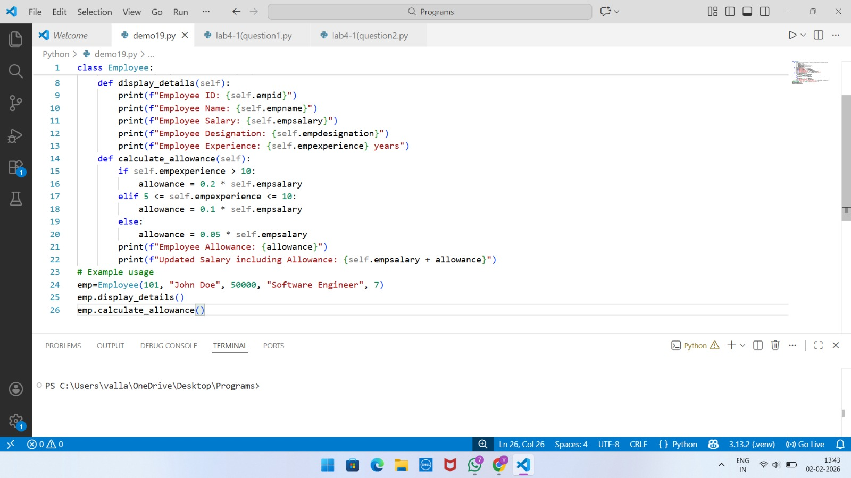
Output:
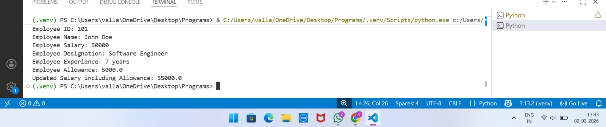

Task 2:
Electricity Bill Calculation- Create Python code that defines a class named `ElectricityBill` with attributes: `customer_id`, `name`, and `units_consumed`. Implement a method `display_details()` to print customer details, and a method `calculate_bill()` where:
- Units ≤ 100 → ₹5 per unit
- 101 to 300 units → ₹7 per unit
- More than 300 units → ₹10 per unit
Create a bill object, display details, and print the total bill amount.
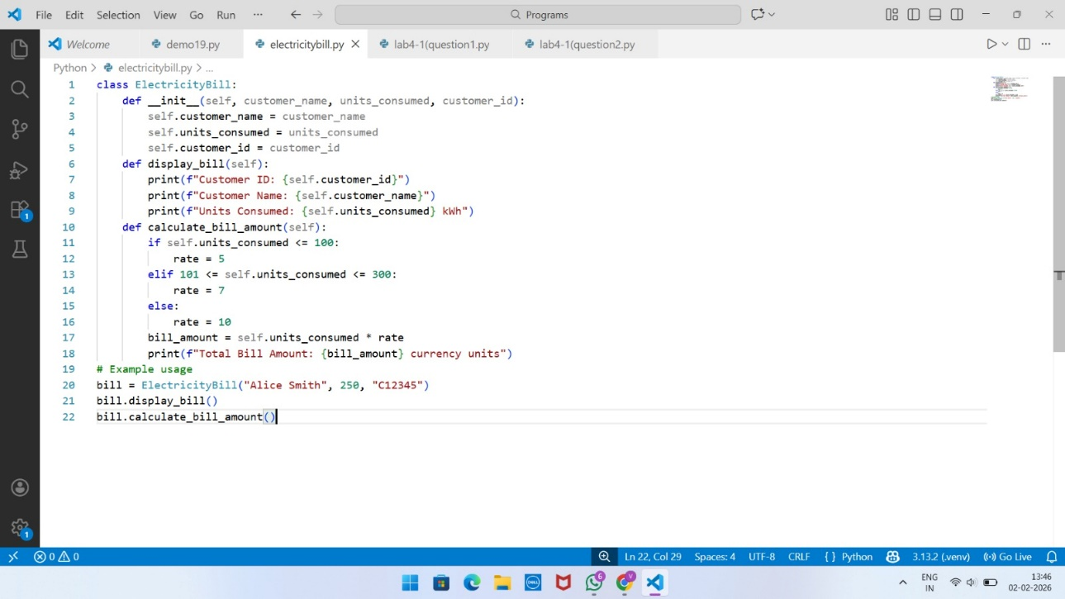
Output:
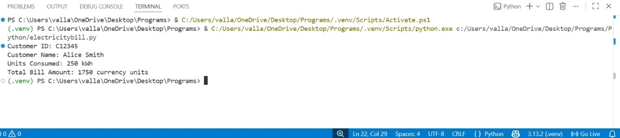

Task 3:
Product Discount Calculation- Create Python code that defines a class named `Product` with attributes: `product_id`, `product_name`, `price`, and `category`. Implement a method `display_details()` to
print product details. Implement another method `calculate_discount()` where:
- Electronics → 10% discount
- Clothing → 15% discount
- Grocery → 5% discount
Create at least one product object, display details, and print the final price after discount.
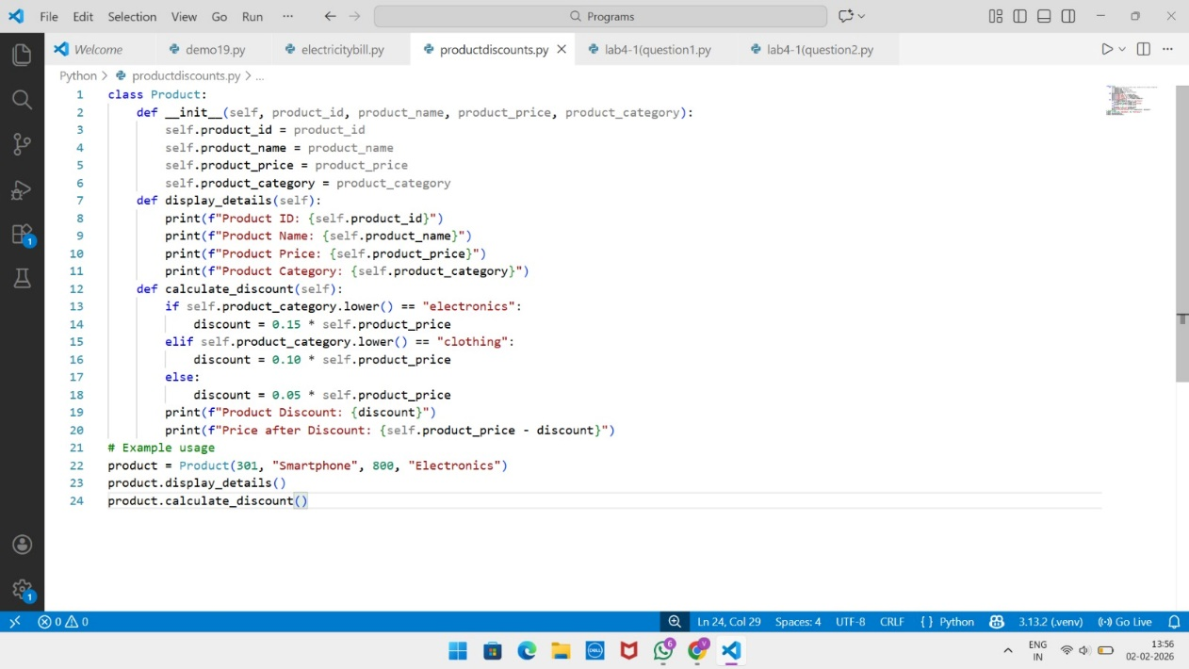
Output:
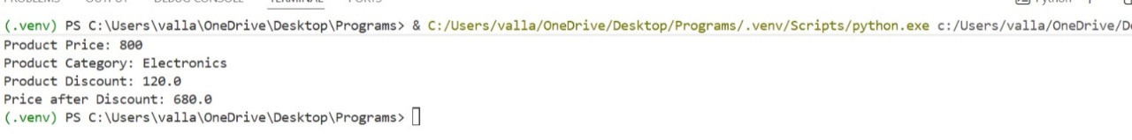
Task 4:
Book Late Fee Calculation- Create Python code that defines a class named `LibraryBook` with attributes: `book_id`, `title`, `author`, `borrower`, and `days_late`. Implement a method `display_details()`
to print book details, and a method `calculate_late_fee()` where:
- Days late ≤ 5 → ₹5 per day
- 6 to 10 days late → ₹7 per day
- More than 10 days late → ₹10 per day
Create a book object, display details, and print the late fee.
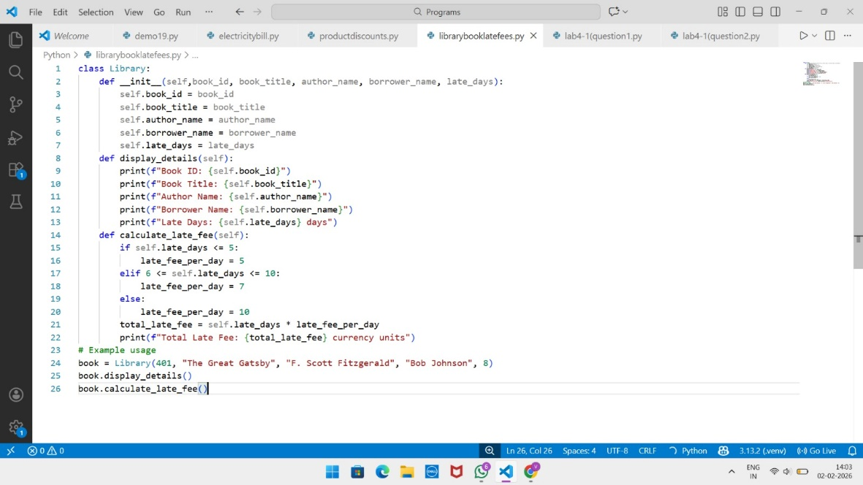
Output:
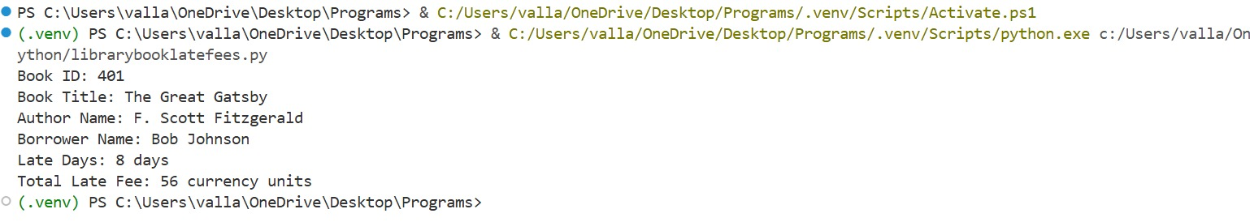
Task 5:
Student Performance Report - Define a function `student_report(student_data)` that accepts a dictionary containing student names and their marks. The function should:
- Calculate the average score for each student
- Determine pass/fail status (pass ≥ 40)
- Return a summary report as a list of dictionaries
Use Copilot suggestions as you build the function and format the output.
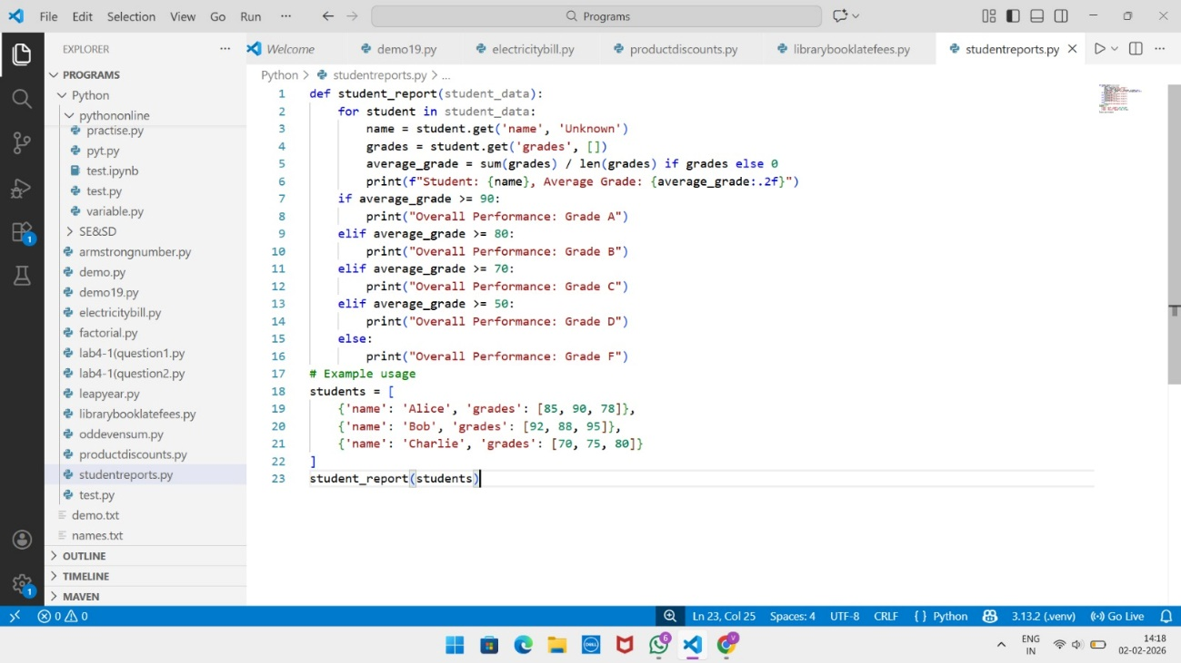
Output:
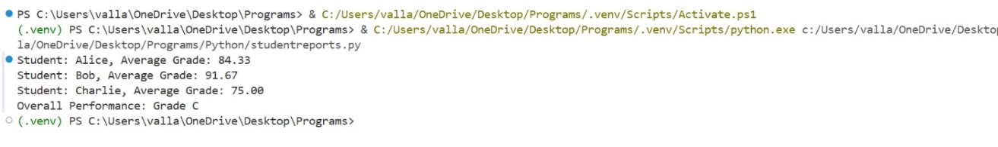
Task 6:
Taxi Fare Calculation-Create Python code that defines a class named `TaxiRide` with attributes: `ride_id`, `driver_name`, `distance_km`, and `waiting_time_min`. Implement a method `display_details()` to
print ride details, and a method `calculate_fare()` where:
- ₹15 per km for the first 10 km
- ₹12 per km for the next 20 km
- ₹10 per km above 30 km
- Waiting charge: ₹2 per minute
Create a ride object, display details, and print the total fare.
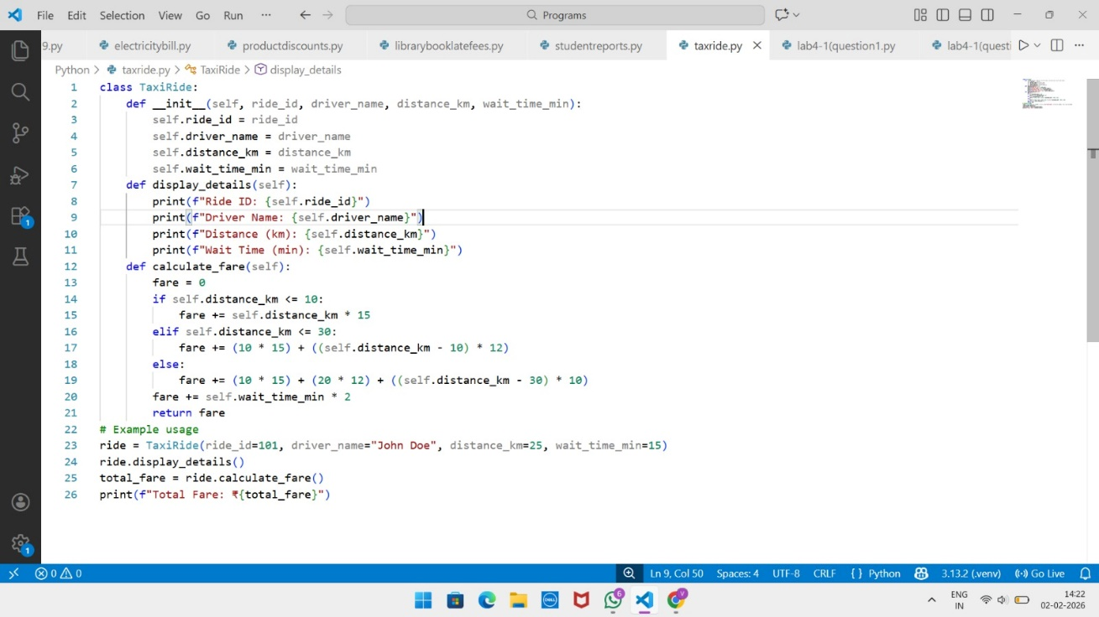
Output:
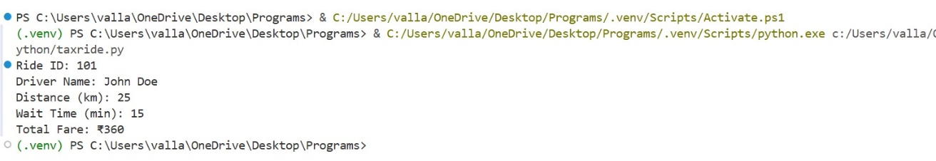
Task 7:
Statistics Subject Performance - Create a Python function `statistics_subject(scores_list)` that accepts a list of 60 student scores and computes key performance statistics. The function should return the following:
- Highest score in the class
- Lowest score in the class
- Class average score
- Number of students passed (score ≥ 40)
- Number of students failed (score < 40)
Allow Copilot to assist with aggregations and logic
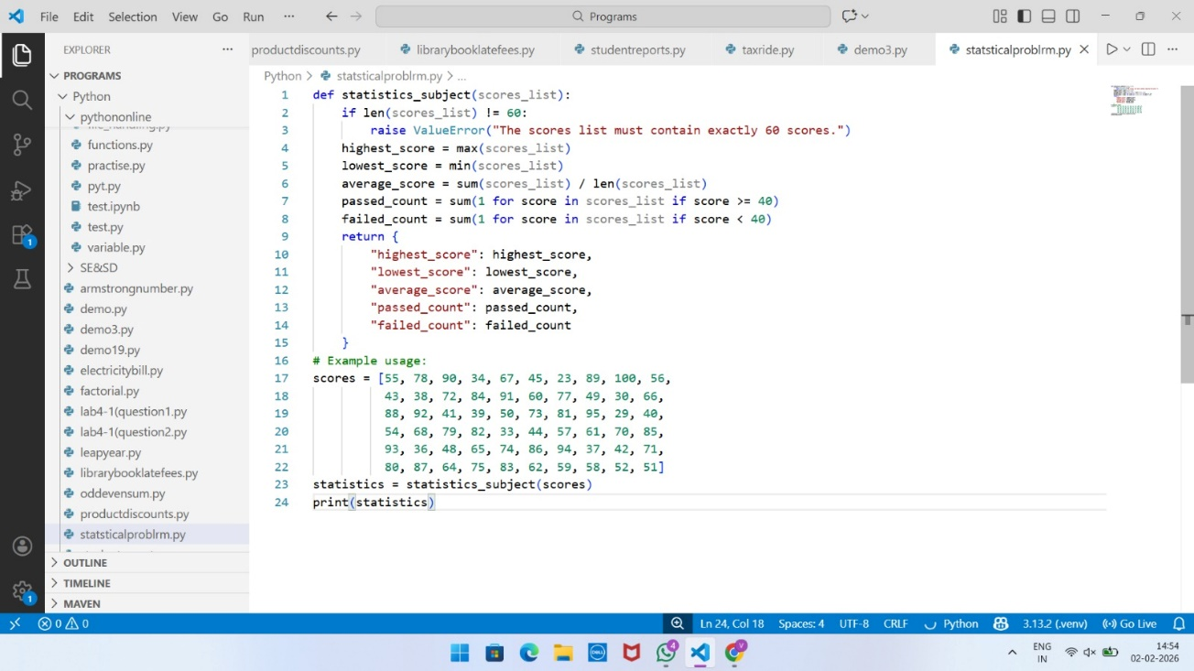
Output:
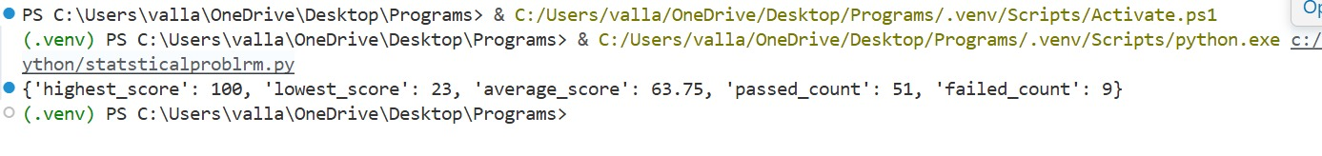
Task Description #8 (Transparency in Algorithm Optimization)
Task: Use AI to generate two solutions for checking prime numbers:
• Naive approach(basic)
• Optimized approach
Prompt:
“Generate Python code for two prime-checking methods and explain how the optimized version improves performance.”
Expected Output:
• Code for both methods.
• Transparent explanation of time complexity.
• Comparison highlighting efficiency improvements.
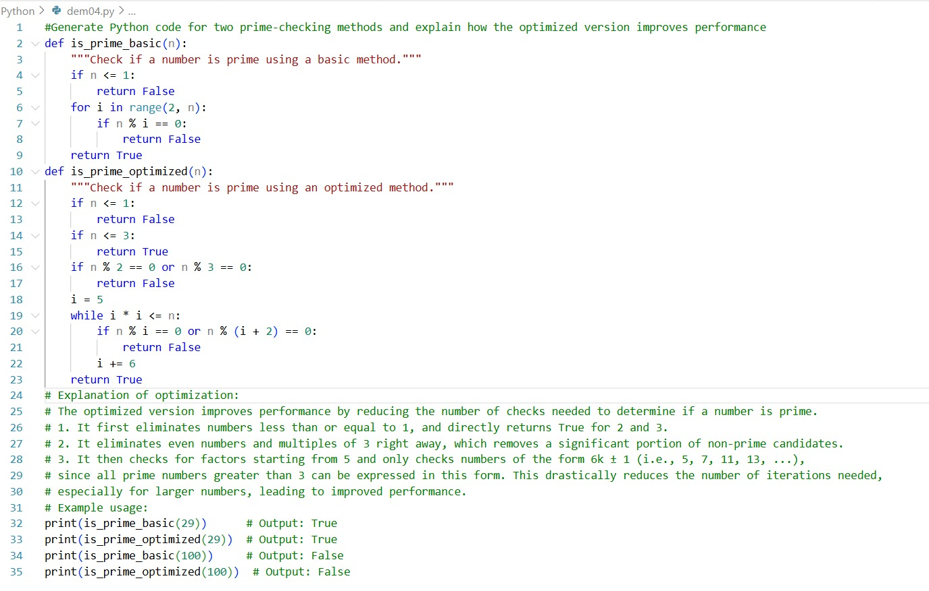
Output:
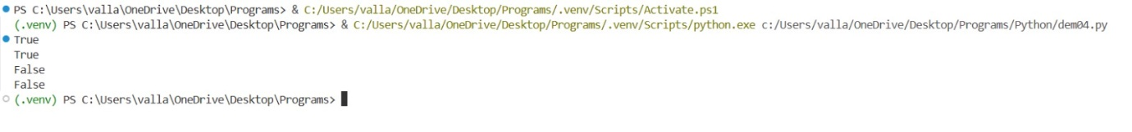
Task Description #9 (Transparency in Recursive Algorithm)
Task: Use AI to generate a recursive function to calculate Fibonacci numbers.
Instructions:
- Ask AI to add clear comments explaining recursion.
- Ask AI to explain base cases and recursive calls
Expected Output:
• Well-commented recursive code.
• Clear explanation of how recursion works.
• Verification that explanation matches actual execution.
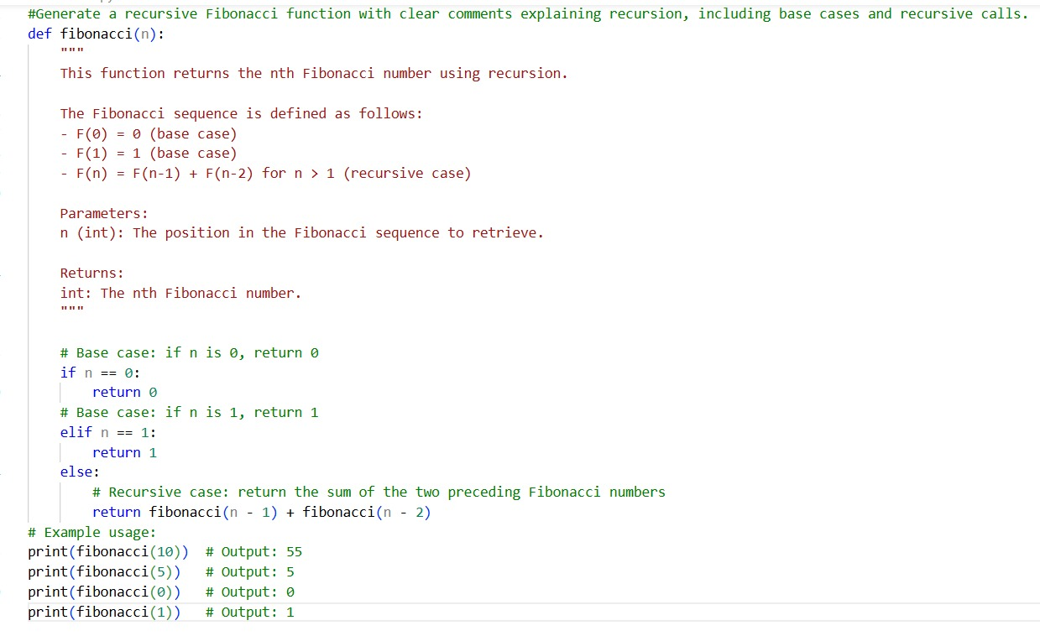
Output:
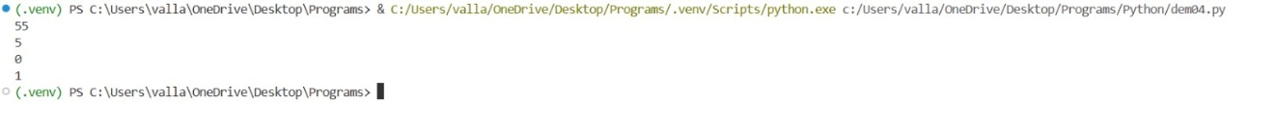
Task Description #10 (Transparency in Error Handling)
Task: Use AI to generate a Python program that reads a file and processes data.
Prompt:
“Generate code with proper error handling and clear explanations for each exception.”
Expected Output:
• Code with meaningful exception handling.
• Clear comments explaining each error scenario.
• Validation that explanations align with runtime behaviour.
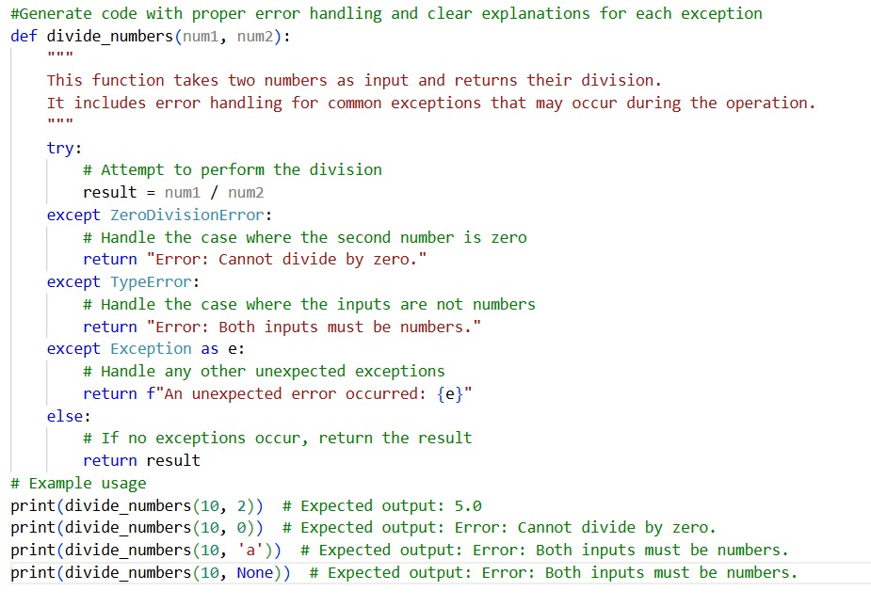
Output:

