AI ASSISTED CODING ASSIGNMENT – 8.1
V.Akshara (2303A51041)
BATCH-01
Task 1 (Password Strength Validator – Apply AI in Security Context)
Task: Apply AI to generate at least 3 assert test cases for is_strong_password(password) and implement the validator function
Requirements:
- Password must have at least 8 characters.
- Must include uppercase, lowercase, digit, and special character.
- Must not contain spaces.
Example Assert Test Cases:
- assert is_strong_password("Abcd@123") == True
- assert is_strong_password("abcd123") == False
- assert is_strong_password("ABCD@1234") == True
Expected Output:
- Password validation logic passing all AI-generated test cases.
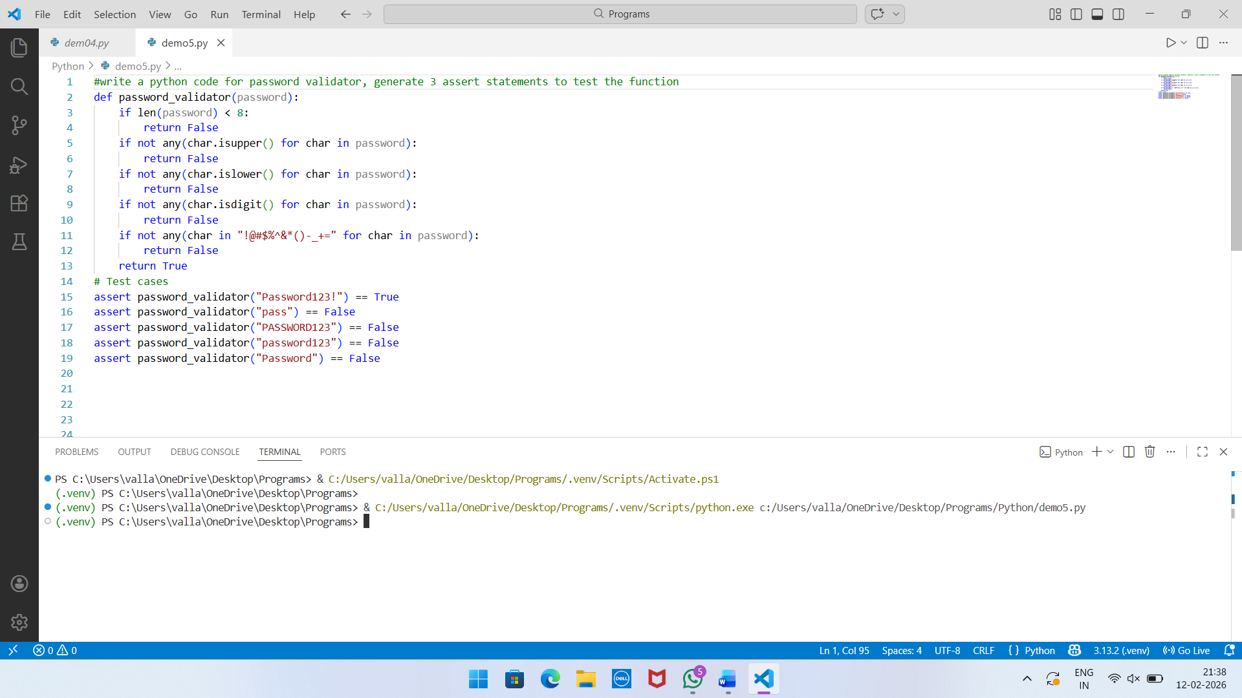

Task 2 (Number Classification with Loops – Apply AI for Edge Case Handling)
Task: Use AI to generate at least 3 assert test cases for a classify_number(n) function. Implement using loops.
Requirements:
- Classify numbers as Positive, Negative, or Zero.
- Handle invalid inputs like strings and None.
- Include boundary conditions (-1, 0, 1).
Example Assert Test Cases:
- assert classify_number(10) == "Positive"
- assert classify_number(-5) == "Negative"
- assert classify_number(0) == "Zero"
Expected Output:
- Classification logic passing all assert tests.

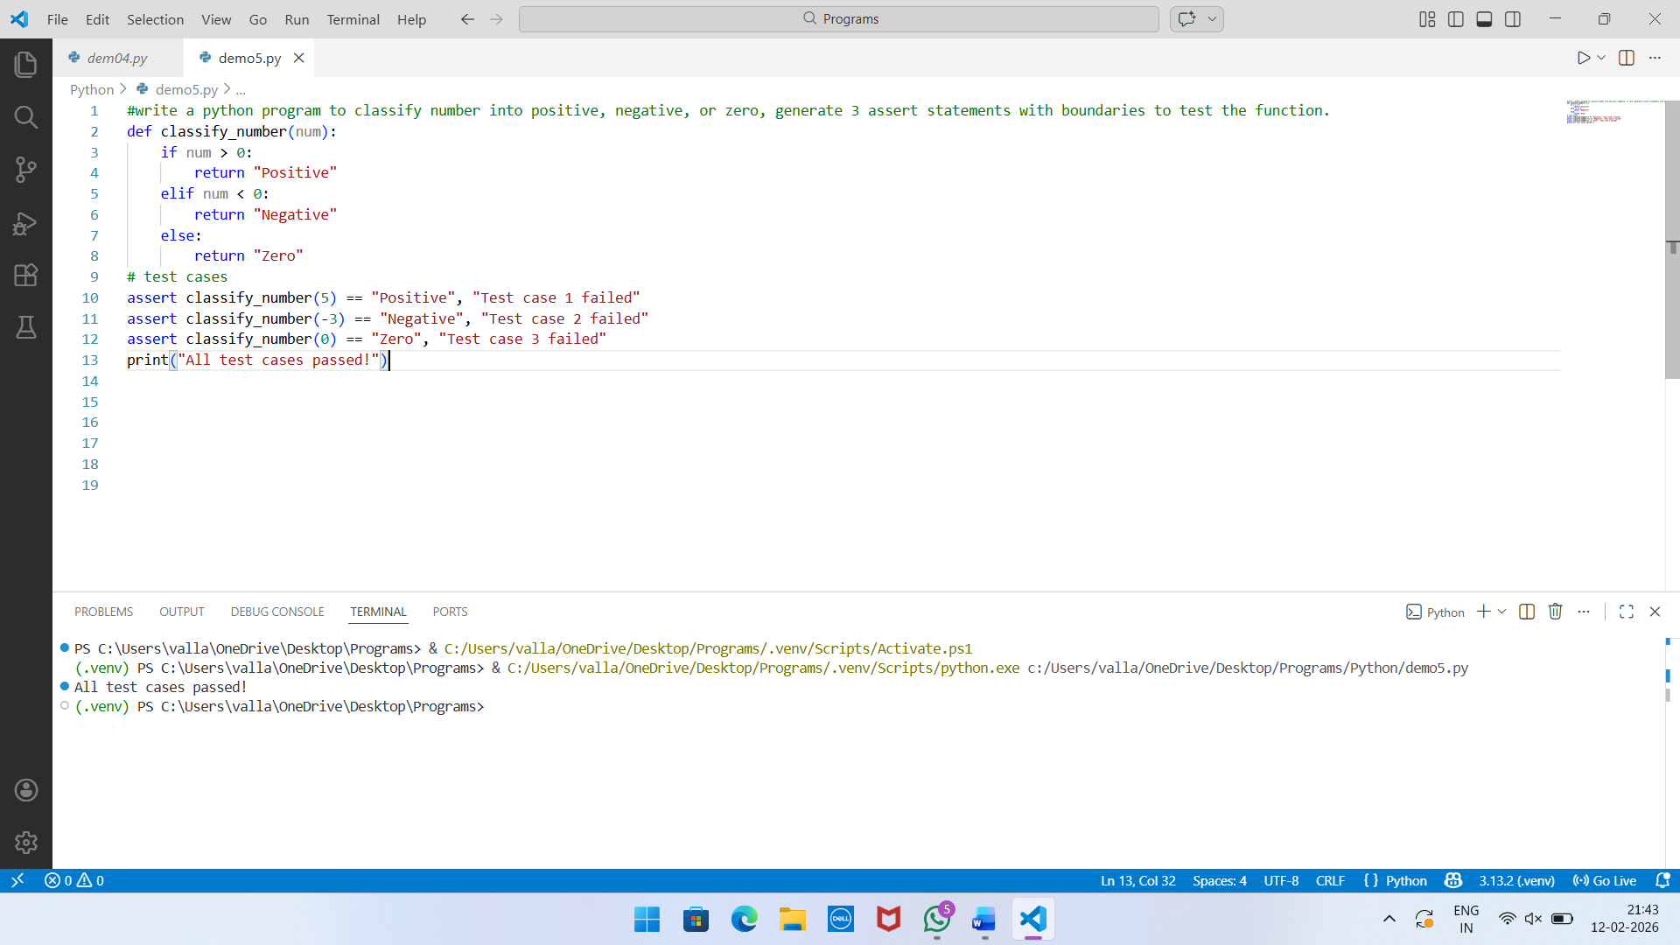

Task 3 (Anagram Checker – Apply AI for String Analysis)
Task: Use AI to generate at least 3 assert test cases for is_anagram(str1, str2) and implement the function.
Requirements:
- Ignore case, spaces, and punctuation.
- Handle edge cases (empty strings, identical words).
Example Assert Test Cases:
- assert is_anagram("listen", "silent") == True
- assert is_anagram("hello", "world") == False
- assert is_anagram("Dormitory", "Dirty Room") == True
Expected Output:
- Function correctly identifying anagrams and passing all AI-generated tests.
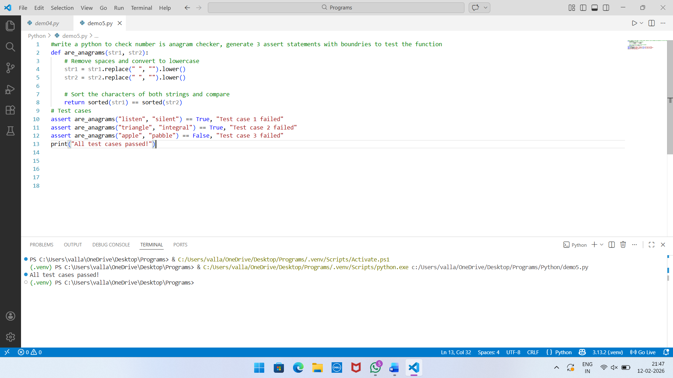

Task 4 (Inventory Class – Apply AI to Simulate Real-World Inventory System)
Task: Ask AI to generate at least 3 assert-based tests for an Inventory class with stock management.
Requirements:
- add_item(name, quantity)
- remove_item(name, quantity)
- get_stock(name)
Example Assert Test Cases:
- nv = Inventory()
- inv.add_item("Pen", 10)
- assert inv.get_stock("Pen") == 10
- inv.remove_item("Pen", 5)
- assert inv.get_stock("Pen") == 5
- inv.add_item("Book", 3)
- assert inv.get_stock("Book") == 3
Expected Output:
- Fully functional class passing all assertions.

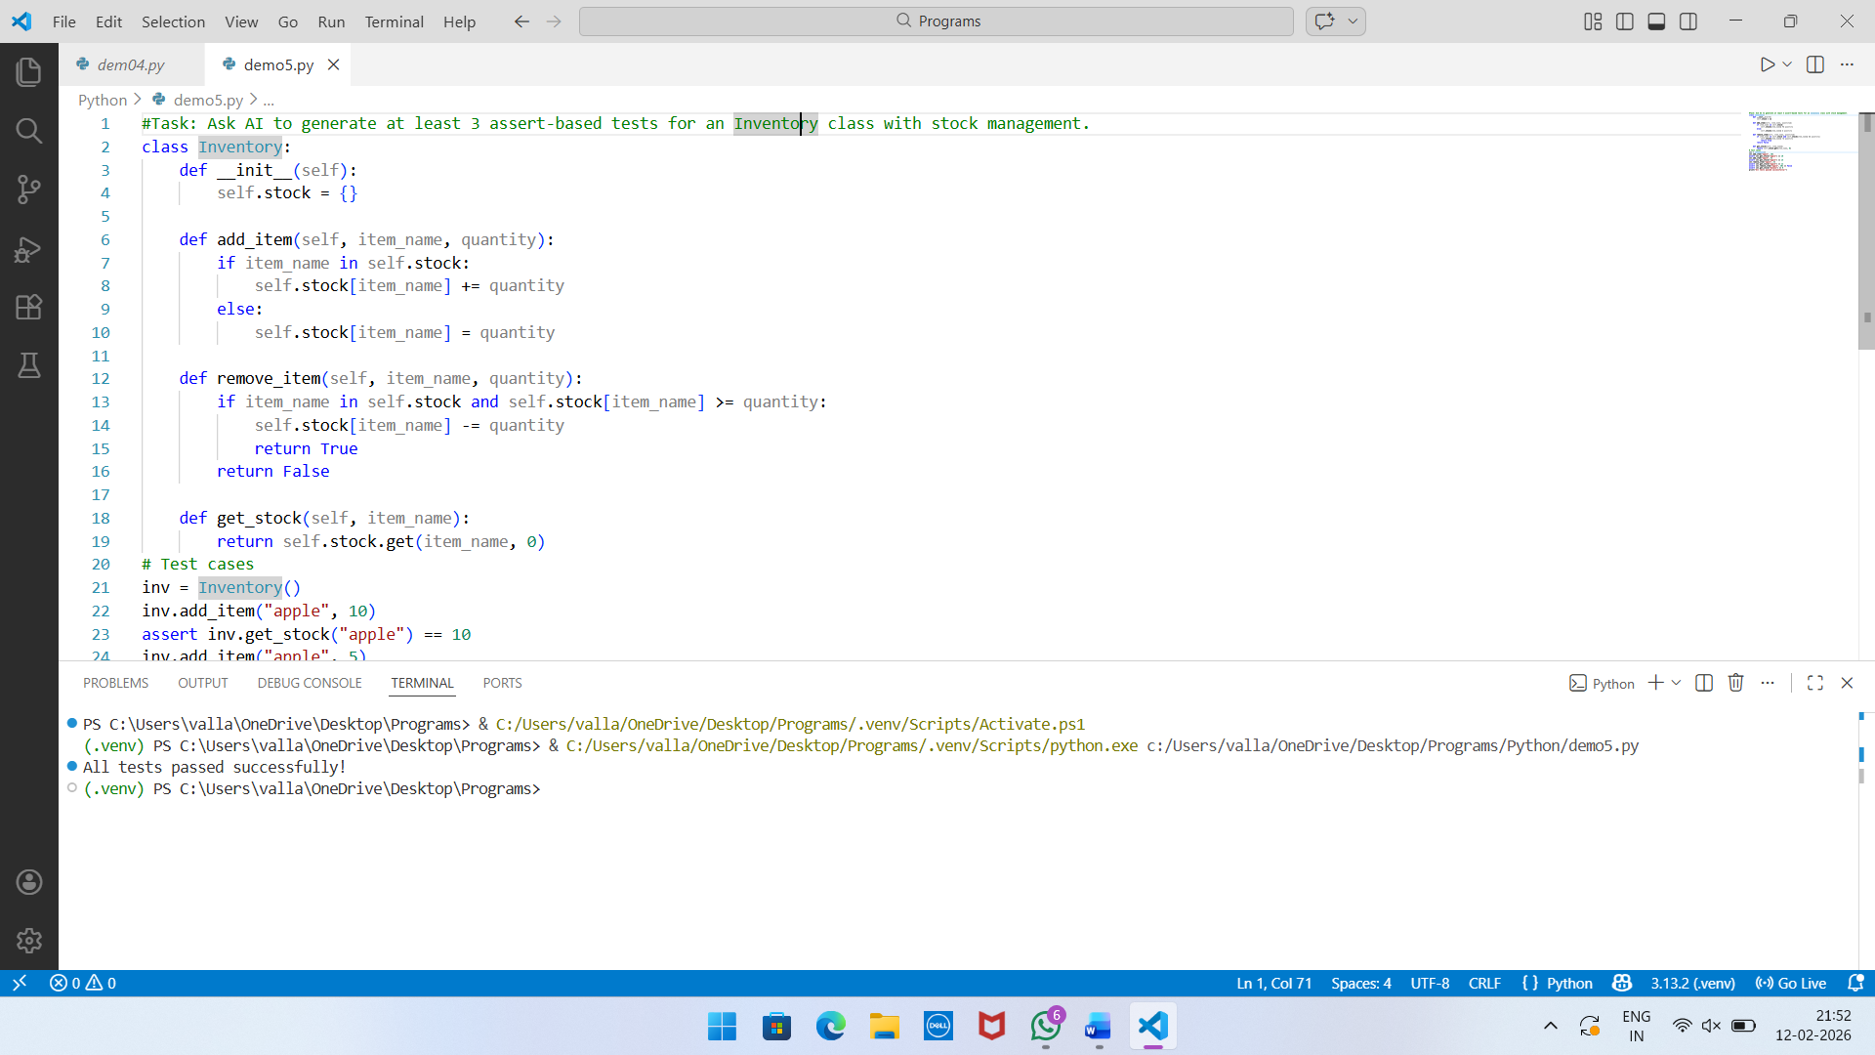
Task 5 (Date Validation & Formatting – Apply AI for Data Validation)
Task: Use AI to generate at least 3 assert test cases for validate_and_format_date(date_str) to check and convert dates.
Requirements:
- Validate "MM/DD/YYYY" format.
- Handle invalid dates.
- Convert valid dates to "YYYY-MM-DD"
Example Assert Test Cases:
- assert validate_and_format_date("10/15/2023") == "2023-10-15"
- assert validate_and_format_date("02/30/2023") == "Invalid Date"
- assert validate_and_format_date("01/01/2024") == "2024-01-01"

Expected Output:
- Function passes all AI-generated assertions and handles edge cases.
