Task 1: AI-Generated Logic Without Modularization (Factorial without Functions)

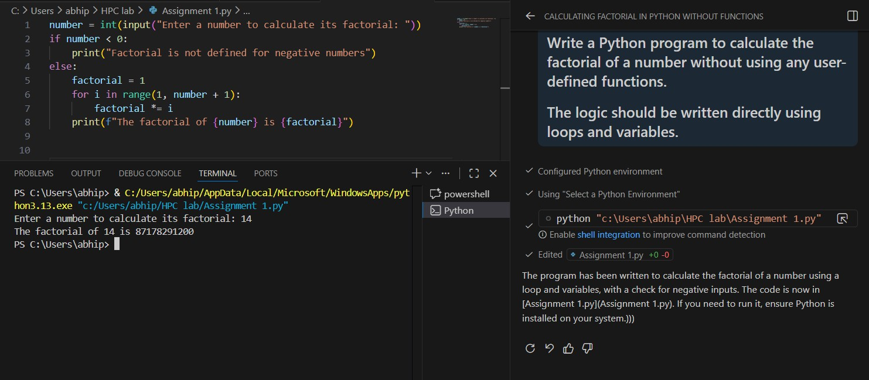
Task 2: AI Code Optimization s Cleanup (Improving Efficiency)

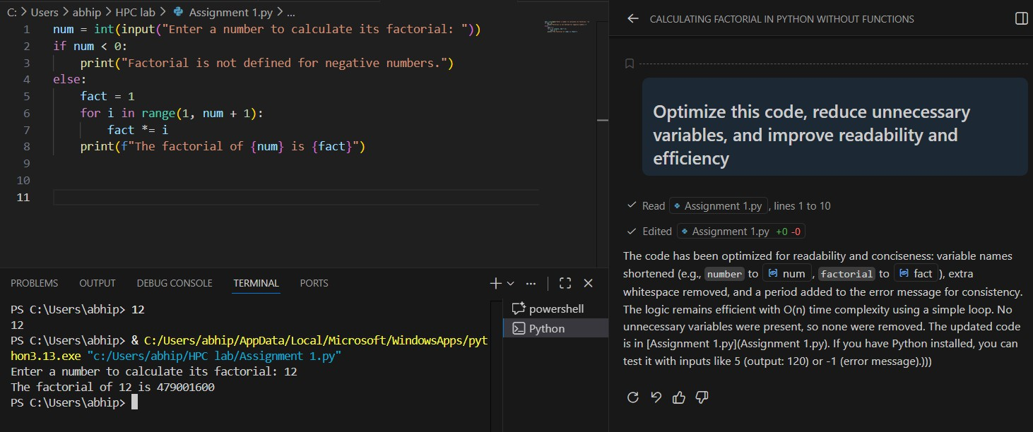
Task 3: Modular Design Using AI Assistance (Factorial with Functions)

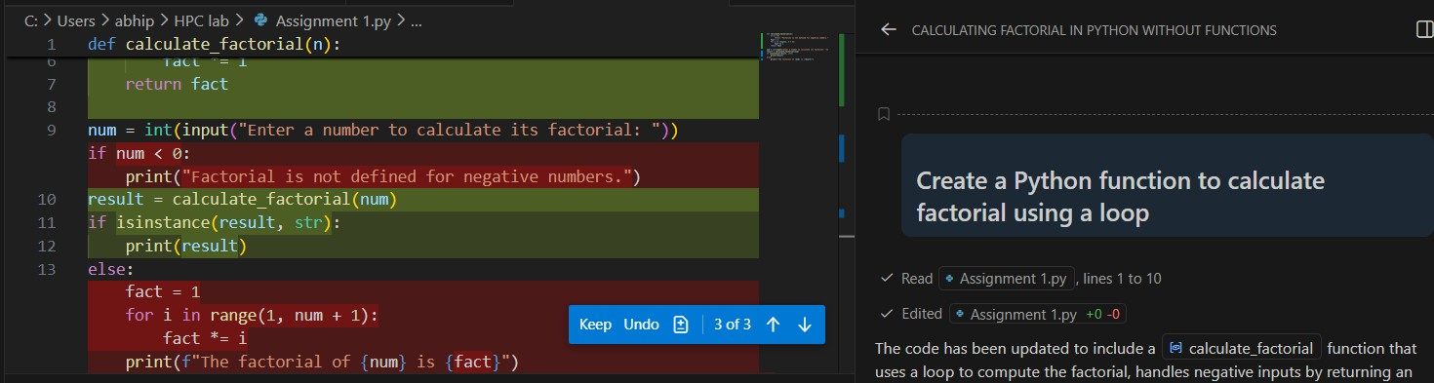

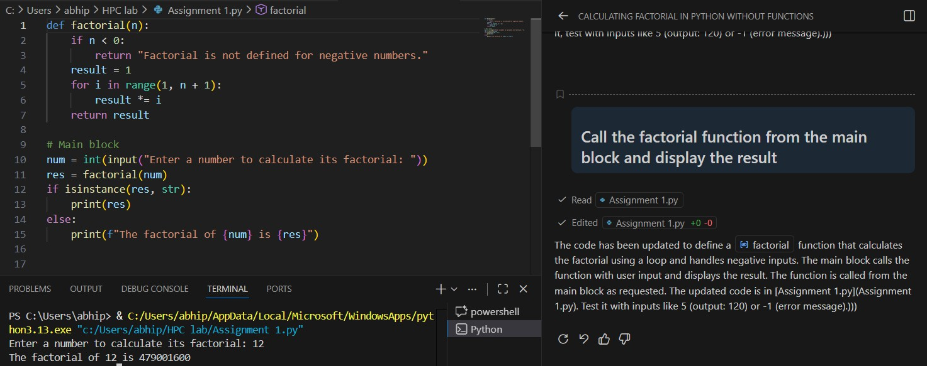
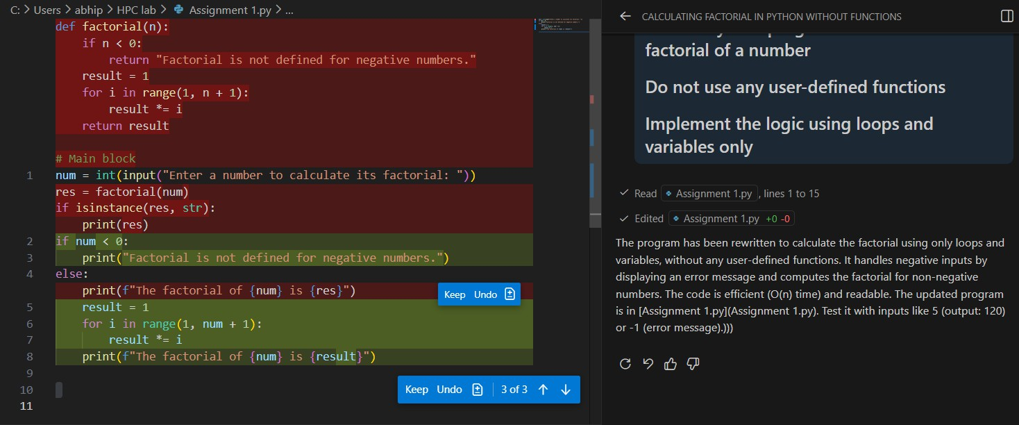
Task 4: Comparative Analysis – Procedural vs Modular AI Code

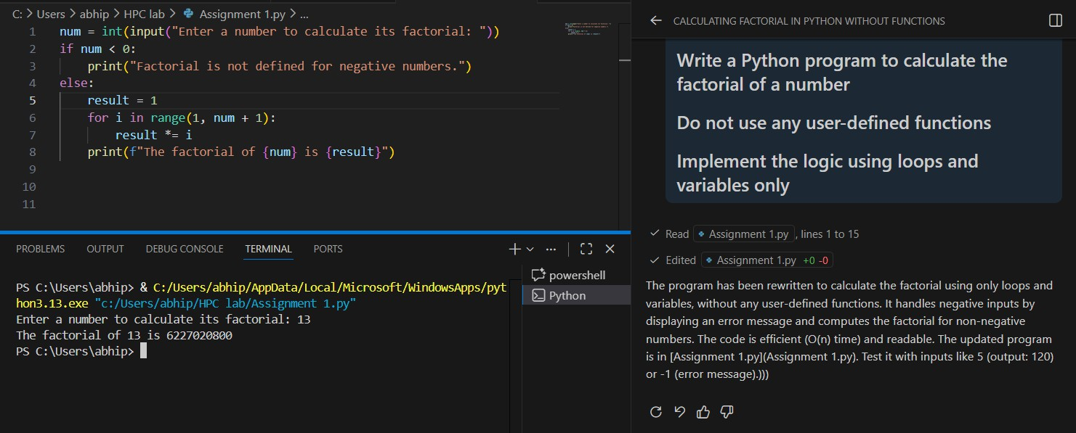

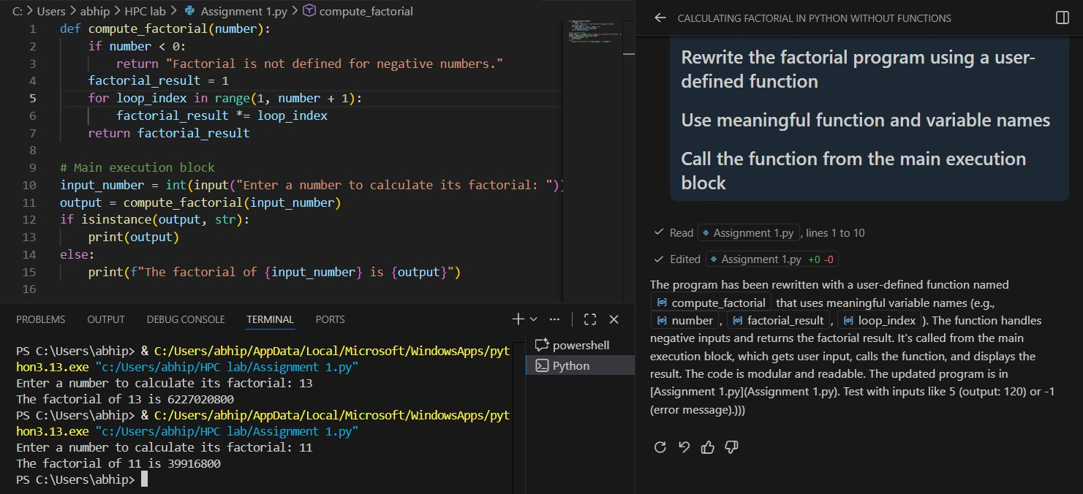
Task 5: AI-Generated Iterative vs Recursive Thinking
